

Thomas A. Harwood

Design and Fabrication of an Explosive Plane Wave Generator for use in Explosive Formulation Testing.

School of Applied Computer
Technical Research and Development of Ordnance, Munitions and Explosives

Academic Year: 2023 - 2024

Supervisor: Gareth Collett
Associate Supervisor: Dave Holley
March 2024

School of Applied Computing
Technical Research and Development of Ordnance, Munitions and Explosives

Bachelor of Science BSc

Academic Year 2023 - 2024

Thomas A. Harwood

Design and Fabrication of an Explosive Plane Wave Generator for use in Explosive Formulation Testing.

Supervisor: Gareth Collett
Associate Supervisor: Dave Holley
March 2024

This thesis is submitted in partial fulfilment of the requirements for the degree of Technical Research and Development of Ordnance, Munitions and Explosives
(NB. Remove if the degree award is based solely on examination of the thesis)

© UWTSD 2024. All rights reserved. No part of this publication may be reproduced without the written permission of the copyright owner.

Academic integrity declaration
I declare that:
- the thesis submitted has been written by me alone.
- the thesis submitted has not been previously submitted to this university or any other.
- that all content, including primary and/or secondary data, is true to the best of my knowledge.
- that all quotations and references have been duly acknowledged according to the requirements of academic research.
I understand that to knowingly submit work in violation of the above statement will be considered by examiners as academic misconduct.

Abstract
This report details the process of the design and analysis of a Single Point Initiated Planar Wave Generator from initial research through to 3 dimensional simulation. An initial search into potential methods of achieving a planar wave resulted in a design that drew inspiration from two methods titled Dual Energetic Triangle and Mouse Trap. This was completed by developing 2-D and 3-D simulations through a Linux based numerical modelling software package. The design function was optimised by altering the apex angles and type of explosive, evaluating the design’s performance differences using the assessment criteria of the Time of Arrival difference and the Curvature of the Wave Front. Ultimately, creating a Planar Wave that exceeded the success criteria in both assessment metrics.

Keywords:
Line Wave, Explosive Lens, Mouse Trap, Energetics, Wave Front, Simulation, 2-D, 3-D, Single Point Initiation, Numerical Model, Equation of State, Jones-Wilkins-Lee.

Acknowledgements
I would like to acknowledge a member of my family who has been a one of my driving factors during this project, Anthony (Tony) Sydenham (Bampa) you are inspiration to us all. Despite everything that has been thrown in your direction you continue to bring the positivity and happiness that drives this family.

Table of Contents
Academic integrity declaration i
Abstract ii
Acknowledgements iii
List of Figures vi
List of Tables vii
List of Equations viii
List of Abbreviations ix
1 Introduction 10
1.1 Background 10
1.2 Literature Review 12
1.2.1 DSTO Explosive Lens Paper 15
1.2.2 Mouse Trap Original Paper 17
2 Methodology 18
2.1 DET Selection 18
2.2 Mouse Trap Selection 20
2.3 Energetic Deliberation 20
2.4 Angle and Design Deliberation 21
2.5 CAD Development 22
2.6 Modelling Setup 22
2.6.1 2 Dimensional 24
2.6.2 3 Dimensional 28
3 Results 31
3.1 2 Dimensional 31
3.1.1 DET 180 mm Primasheet 32
3.1.2 DET 180 mm Formex/Hexosheet 35
3.1.3 DET 240 mm Primasheet 36
3.1.4 Mouse Trap 39
3.2 3 Dimensional 40
3.2.1 DET 240 mm Primasheet 41
3.2.2 Mouse Trap 42
3.3 Full System 42
4 Discussion 43
4.1 Dual Energetic Triangle 43
4.2 Mouse Trap 47
4.3 Full System 51
5 Conclusion 53
6 Reflection 53
6.1 Modelling Success 53
6.2 Change of Scope of Project 54
6.3 The Superior Version 54
7 Further Work 55
8 References 56
Appendices 58
Appendix A – Submission Script Definitions 58

List of Figures
Figure 1 - Example of Explosive Material Hugoniot curve [1] 11
Figure 2 - Planar Wave Generator Method by J.N. Fritz [7] 13
Figure 3 - Air-Metal Planar Wave Generator Method [9] 14
Figure 4 - Ring Planar Wave Generator Method [10] 14
Figure 5 - DSTO's Perforated Triangle - Sheet explosive {Left}, Cutting Template {Right} [11] 15
Figure 6 - DSTO Explosive Lens Trial Set-up [11] 16
Figure 7 - Simple Mouse Trap Representation - Metal Sheets {Grey}, Sheet Explosive {Green}, Specified Angle {Orange} 17
Figure 8 -- Simple Mouse Trap Representation - Steel Confinement {Grey}, Sheet Explosive Type 1 {Light Green}, Sheet Explosive Type 2 {Dark Green}, Specified Angle {Orange} 19
Figure 9 - CAD Models for Dual Energetic Triangle {Left} and Mouse Trap {Right} 22
Figure 10 – Visualisation Output initial Output for DET 25
Figure 11 - Visualisation Output Midway Output for DET 26
Figure 12 - Visualisation Output initial Output for Mouse Trap 26
Figure 13 - Visualisation Output Midway Output for Mouse Trap 27
Figure 14 - Blown up image of Mouse Trap curvature 27
Figure 15 - 3-D Visualisation Output initial Output for DET 29
Figure 16 - 3-D Visualisation Output initial Output for Mouse Trap 29
Figure 17 - Initial Visualisation Output for Full System 30
Figure 18 - Schematic of 3-D Tracer Array or Mouse Trap and Full System 41
Figure 19 - Graph Displaying Shape of Planar Wave from 2-D Simulations 46
Figure 20 - 2-D Extracted Simulation Data 47
Figure 21 - a) 14.5° 3-D Mouse Trap Data, b) 14.5° Trial Data from Firing 12 of the 2006 Report [12] 48
Figure 23 - Scatter Graph and 3-D Surface from 3-D 15° Mouse Trap Simulation 50
Figure 24 - Scatter Graph from Full System Simulation 51
Figure 25 - 3-D Surface Graph from Full System Simulation 52

List of Tables
Table 1 - 2-Dimensional Simulation Optimisation Test Plan 28
Table 2 - 3-Dimensional Simulation Test Plan 30
Table 3 - Colour Key for Figure 17 31
Table 4 - DSTO Trials Data [11] 43
Table 5 - 2-D DET ToA and Wave Curvature Values 45

List of Equations
Equation 1 - Jones-Wilkins-Lee 1973 Equation [3] 12
Equation 2$– DET Angle Equation$ 19

List of Abbreviations
IT | Information Technology

Introduction

Background
The aim of this project was to design a proprietary method of achieving a planar wave that could be deployed in energetic characterisation trials. This will be used to produce reputable data to be entered into simulation modelling equations for use in future modelling based research. This method of achieving a planar wave was required to be precise, cost effective and reproducible. As the Commercial Off the Shelf (COTS) has a high cost per unit due to the complex manufacturing techniques and is also not produced to the dimension specifications required for the characterisation trials. The planar wave generator designed within this project was set to be used within wedge characterisation testing. Whereby, a wedge of a specified explosive undergoes a Shock to Detonation Transition (SDT) initiated by a planar detonation/shock wave, its performance within this test is used to determine the Hugoniot curves and the detonation transitional point for the specified explosive. This enables an assessment to be made of the point at which the waves transition from the speed of sound to the Velocity of Detonation (VoD). It also presents the run to detonation distance based on the thickness of the wedge and the breakout point. The resulting data informs improved explosive modelling equations of state and the production of Pop Plots for the specified energetic material, Pop Plots are an important component of the characterisation of high explosive for reactive burn models. The brief for this project required the proposed design to be single point initiated, single point initiation was required as it enables a more linear and simplistic design over multi point initiated. The brief also required the design to produce a planar wave of a minimum 150 x 180 mm, this was required to match the size of the wedge being tested. Further to the size requirements initial success criteria were defined for two testing metrics, the first being the difference in Time of Arrival (ToA) this was measured in microseconds (μs) across a length of 150 mm. The target was set that the Planar Wave must have a maximum difference in ToA of 1.2 μs. The second success criteria was the Wave Curvature this was measured in mm across the same 150 mm in length. The target set for the Wave Curvature of the Planar Wave was a maximum of 8.5 mm. A section of the testing for this project will be conducted in half symmetry by simulation modelling software in order to reduce the computing power required. Throughout this section the difference in ToA and Wave Curvature is represented across 75 mm unless stated as otherwise.
A Hugoniot Curve for an explosive can be represented on a graph that displays the pressure against the velocity seen within the material, this can be used for energetics characterisation in order to calculate the point at which a system transitions from deflagration to detonation. An example of an energetic Hugoniot curve can be seen in figure 1 [1].
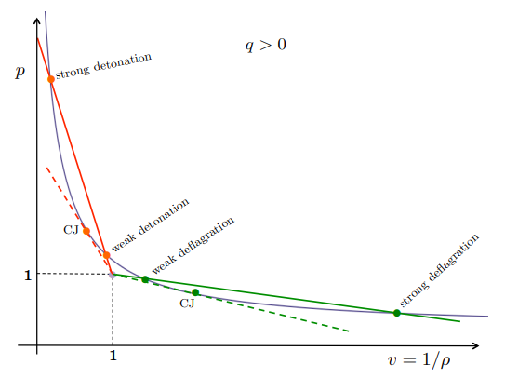
Figure 1 - Example of Explosive Material Hugoniot curve [1]

Figure 1 displays the Hugoniot curve with markers on the curve that denote Strong and Weak Detonation and Deflagration, further points can be seen titled ‘CJ’ these denote the Chapman Jouguet conditions of the curve. The CJ condition of an explosive is the area whereby the detonation propagates, the point at which the reactionary gases reach sonic velocity and the transition from shock to detonation [2]. The data that is extrapolated from an explosive’s Hugoniot curve is then used to develop an Equation of State (EoS) for that explosive, for the simulations conducted within this project the Jones-Wilkens-Lee (JWL) EoS was used to accurately represent the energetic properties of the materials used within the simulations.
The JWL EoS was derived to simulate the behaviour of explosives and their detonation products, the coefficients for these equations were populated for specific explosives using data produced from cylinder tests, expansion behaviour and calorimetric analysis. [3] Resulting in the equation below.

Equation 1 - Jones-Wilkins-Lee 1973 Equation [3]
$$P=A\left(1- \frac{ω}{R_{1}V}\right)e^{-R_{1}V}+B\left(1- \frac{ω}{R_{2}V}\right)e^{{-R}_{2}V}+ \frac{ωE}{V}$$
The equation above is referenced from a 1973 report originally defined in 1965 [4], so current working versions of the JWL EoS may have slight function differences, along with an improvement in testing methods may have changed the data collection process. Equation 1 is utilised when there is a requirement to calculate the expansion of reactionary products during a detonation from an initial Chapman Jouguet state of chemical equilibrium [5]. For High Explosive (HE) detonation the Isotropic CJ state is a crucial component for simulating applications, this state is integral for generating the thermal components of the explosives JWL EoS [6].

Literature Review
The literature Review for this project consisted of one main subject matter Methods of Achieving a Planar Wave. This subject area was selected as this would enable an assessment of the open source methods of achieving a planar wave. The viability of each method is to be assessed in this section resulting in some of the methods inspiring the final design process. Two main search engines were explored in order to compile the available open source material for methods of achieving a Planar Wave. These areas were Google Scholar and Publisher Online libraries such as ResearchGate and Science Direct. There were five methods for achieving a Planar Wave that stood out during the search of available source material, the first is defined in a 1990 report [7]. A schematic of the final design described within this report is found in Figure 2
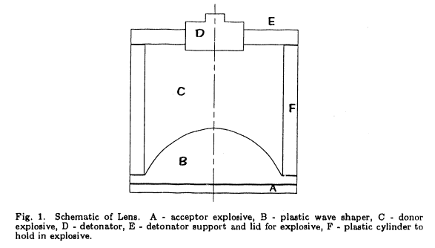
Figure 2 - Planar Wave Generator Method by J.N. Fritz [7]
The report by J.N.Fritz [7] critically evaluates the performance of the explosive lens seen in figure 2, suggesting that despite the tested version of this system displaying an arrival-time difference of 50 ns across a length of 4 inches (101.6 mm) [7]. Although the report suggests that an arrival-time deviation of 10ns is possible with further optimisation. Further experimental tests were documented on the ‘Fritz method’ of achieving a Planar Wave in 2020 report [8], whereby a 3-D printed version of ‘Fritz method’ 1990 set-up produced arrival-time difference of 20 ns across a length of 25.4mm. These results were produced using either Primasheet 1000 or PBX9407 the report did not specify which explosive material [8].
The second method assessed for achieving a Planar Wave is titled “Air-Metal Barrier” and was evaluated within a 2014 report [9], this report utilised the 2-D Autodyne software to simulate the behaviour and performance of this Planar Wave Generator, a schematic of the set-up is seen in Figure 3.
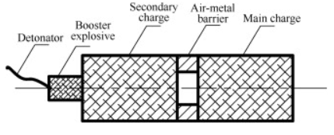

Figure 3 - Air-Metal Planar Wave Generator Method [9]

The report concludes with values for the arrival-time difference of 5 μs across a diameter of 35 mm, further explaining that this was measured across 70 percent of the main charge. This suggests the main charge had a diameter of 50 mm. This method contained two types of energetic material: Comp B and RDX as its two main charges, utilising the difference in VoDs to alter the shape of the wave front.
The third type of Planar Wave Generator assessed was titled ‘Ring Plane Wave Generator’ which was evaluated during a 2017 report [10]. This set-up contained two cylindrical explosive charges and a metal ring as a wave former, the report further compares the experimental data with results produced by an LS_DYNA software simulation. A schematic of this set-up can be found in Figure 4.
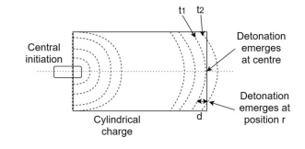

Figure 4 - Ring Planar Wave Generator Method [10]

This method for achieving a Planar Wave utilised a TNT donor charge and an A-IX-I acceptor charge, this report does not state any values for the performance of this planar wave generator. It concludes by stating that the ‘Ring Planar Wave Generator’ does not influence the shape of the wave front.

DSTO Explosive Lens Paper
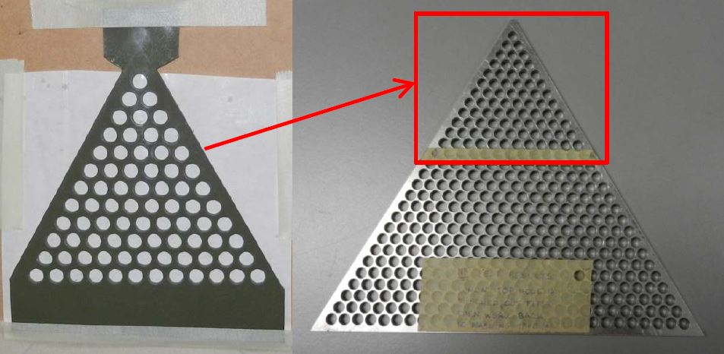
The final open source method for achieving a planar wave was developed in a paper Titled “Explosive Line Wave Generators” published by the Defence, Science and Technology Organisation (DSTO) in 2013 [11]. This paper evaluated two concepts of achieving planar waves from single point initiation. The two concepts used sheet explosive in a triangular shape to generate the planar wave. The first set-up evaluated in the report was titled “Perforated Triangle” [11], this concept used an isosceles triangle of a single type of sheet explosive with circular cut outs in a designated pattern. This method would cause a planar wave due to the edge effects created by the circular cut outs to reflect the blast wave as it propagates through the sheet explosive. The experimental set-up can be found in Figure 5 below.
Figure 5 - DSTO's Perforated Triangle - Sheet explosive {Left}, Cutting Template {Right} [11]
The Perforated Triangle method was tested using two types 3 mm of sheet explosive Primasheet 1000 and Primasheet 2000, the results produced by these tests were compared using high speed video analysis to assess the planarity of the wave.
The second concept evaluated in the DSTO Report was titled “Explosives Lens”, this method combined two types of sheet explosive with different VoD’s in an isosceles triangle shape to generate a sheet explosive. Steel confinement was used on the two equal sides of the triangle to channel the blast wave to the open edge of the triangle. The experimental set-up of this method can be seen in figure 6 below.
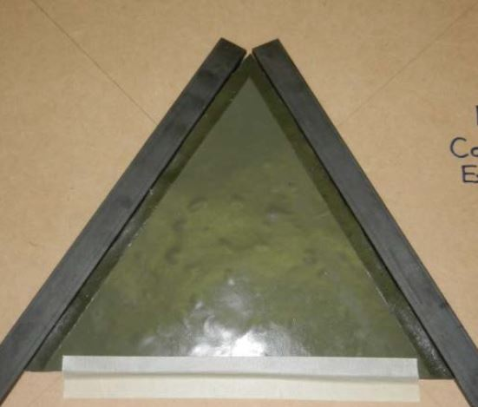
Figure 6 - DSTO Explosive Lens Trial Set-up [11]

The Explosives Lens set-up was tested multiple times using two methods to evaluate the performance. Method one was high speed video analysis similar to the Perforated Triangle set-up, method two used a donor wedge of explosive at the open edge of the triangle with three piezo-electric pins embedded at specified locations to gather the time of arrival data of the blast wave. The open edge of the triangle in the Explosive Lens set-up had a length of 240 mm, with the planarity of the blast wave being measured over 180 mm. At the end of the report the author indicates that both concepts produced positive results with further research being conducted in the future.

Mouse Trap Original Paper
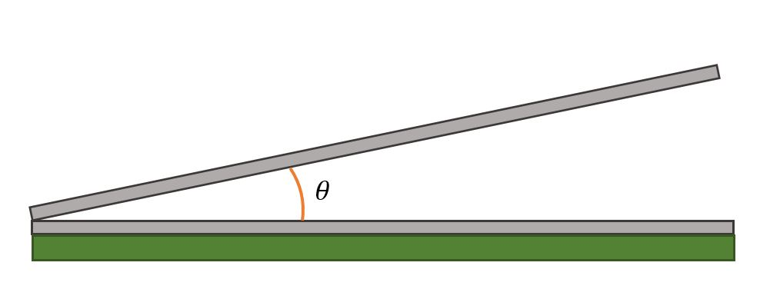
Another method of achieving a planar wave that was identified initially by the projects technical reviewer was presented in an experimental trial’s report published in 2006 by a UK based research facility. This evaluated multiple variations of a planar wave generating concept title ‘Double Mouse Trap’ [12]. This trial included 17 firings of a double mouse trap concept with the each firing having a slight variation from the previous firing. A single mouse trap concept is set up with a rectangle of sheet explosive attached to a Metal Donor Sheet (MDS) which is angled to a Metal Contact Sheet (MCS). The sheet explosive deployed in this trial was the in-service UK sheet Explosive at the time SX2. In order to analyse the planarity of the mouse trap piezo-electric pins were placed on the top side of the MCS, a simplified representation of this set-up can be seen in figure 7.
Figure 7 - Simple Mouse Trap Representation - Metal Sheets {Grey}, Sheet Explosive {Green}, Specified Angle {Orange}

The Mouse Trap functions from a line detonation on the open side of the sheet explosive, which collapses the MDS as the detonation propagates through the sheet explosive. The MDS collides with the MCS triggering the piezo-electric pins with the timing of these triggers indicating the time of arrival and thus the planarity of the wave. The 2006 trial report presents the planarity of each firing in two graph types, a simple two axis scatter graph which displays the pin row location and the average time of arrival for that row. The second graph type is a 3 axis graph which displays each individual pin location and its time of arrival data. The report displayed continuous improvement in the mouse trap design throughout with firing 16 and 17 display the best planarity.

Methodology
Initial research and development
Following the completion of the literature review, methods for achieving a planar wave were assessed. During this down selection process concepts and ideas were discarded due to a variety of factors, these factors included:
- Complexity of the Design.
- Time Required to Produce.
- Amount of Energetics Required.
- Type of Energetics Required.
- Level of Reproduction and Repeatability.
These factors lead to the selection of a two-step process to achieve the desired effect of the planar wave generator.

DET Selection
The first section in the design is titled “Dual Energetic Triangle” (DET), drawing inspiration from the ‘Explosive Lens’ set-up deployed in DSTO’s 2013 Report “Explosive Line Wave Generators” [11]. The main reasons that inspiration was taken from this concept was due to its simplicity of manufacture and its reliance on tangible explosive characteristics for its performance.
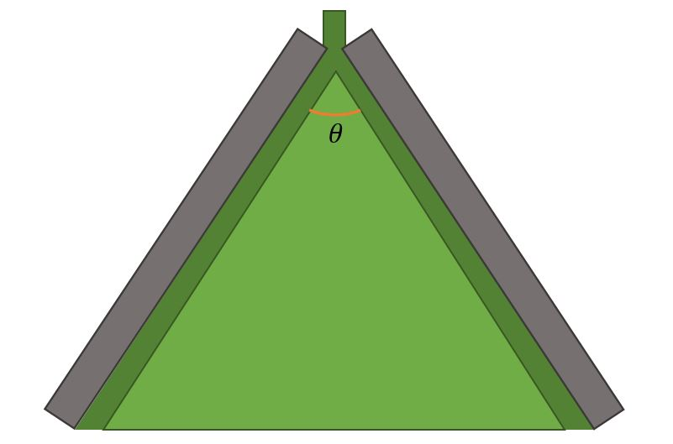

Figure 8 -- Simple Mouse Trap Representation - Steel Confinement {Grey}, Sheet Explosive Type 1 {Light Green}, Sheet Explosive Type 2 {Dark Green}, Specified Angle {Orange}

Figure 8 displays a simplified illustration of the DET, the theory behind this method achieving a planar wave is by utilising the difference in VoD of the two sheet explosives to manipulate the shape of the shockwave cause by the single point initiation. This theory is used in practice by having an inner Isosceles triangle of a slower VoD sheet explosive combined with an inverted V-shape of the faster VoD explosive sheet on the equal length sides of the triangle. Which is initiated by an EBW detonator at the point of the V shape of the faster explosive. Theoretically, the Faster VoD of the edge explosive will force the slower edges of the shockwave into matching the time of arrive of the centre point of the shockwave as it propagates through the rest of the sheet explosive. In order to channel the explosive reaction steel rectangles were added to the two equal sides of the explosive sheet. To achieve this phenomenon a specific central angle of the triangle is required (apex angle), the ideal apex angle can be calculated by using the basic trigonometric function seen in Equation 2.
Equation 2$– DET Angle Equation$
$$θ=\cos^{-1}{\frac{V_{1}}{V_{2}}}$$
Whereby, θ is the ideal apex angle,$V_{1}$ is the VoD of the internal explosive and $V_{2}$ is the VoD of the external explosive. Although the actual apex angle may differ from the ideal apex angle due to the condition of the specific sheet explosive used in the test.

Mouse Trap Selection
The second section in design is titled ‘Mouse Trap’, drawing inspiration from the technique used in a ‘Double Mouse Trap’ set-up from a 2006 report [12]. The main reasons for the inspiration taken from this concept were its simplicity and its single variable set-up. A simplified illustration of a single mouse trap setup can be seen in figure 7. In order to achieve the planarity requirements using a mouse trap concept the internal angle of the acceptor plate must be established. To continue the development of the design an initial internal angle was designated from the available results in the 2006 “Double Mouse Trap” report [12]. This angle would only be relevant if the type of sheet explosive used in the original double mouse trap trial was replicated in the new set-up.

Energetic Deliberation
The types of sheet explosive used within the individual sections of the planar wave generator would alter its overall size and shape. Due to this the types of explosive selected for use had to be made early in the development process, the DET section of the set-up required two types of sheet explosive with different VoDs. In the DSTO paper were this concept originated a PETN based sheet explosive was used in combination with an RDX based sheet explosive. The specific type were Primasheet 1000 (PETN) and 2000 (RDX), these sheet explosives have manufacturer stated VoDs of 7100 m/s and 8200 m/s respectively. Primasheet is produced by the Ensign-Bickford Aerospace & Defense Company based in the United States, this was compared with European based Eurenco’s sheet explosives Formex (PETN based) and Hexosheet (RDX based). These sheet explosives had manufacture stated VoDs of 6200 m/s and 8000 m/s respectively. Each set of sheet explosives will be evaluated during the simulation modelling stage.
The choice of sheet explosive for the Mouse Trap section of the Planar Wave Generator came down to whether there was SX2 available to be used, this was because SX2 was replaced as the UK in-service sheet explosive in around 2011 by SX4. At the time of its replacement a large amount of SX2 was purchased by the organisation in order to be used in future energetic trials, because at the time it was still being used in certain weapon systems. This enabled a proportion of that stock to be potentially used within the Planar Wave Generator design.

Angle and Design Deliberation
The two step planar wave generator requires two main parameters to be identified in order to achieve the desired effect, these parameters are the apex angle of the DET and the internal angle of the Mouse Trap. Initial baseline angles were selected from analysing the data produced from the 2013 DSTO and 2006 Mouse Trap trials report. The initial baseline angle for the DET step of the Planar Wave Generator was selected as 60 degrees; however further analysis indicated that to improve the planarity from this 60 degree baseline, the angle should be reduced in specified increments to associate the performance changes. Due to the possibility of changing the specific type of sheet explosive used within the DET of the Planar Wave Generator, a baseline angle was also selected for the Formex/Hexosheet version. This angle was identified by using the equation referenced in Equation 2 and then rounded to the nearest whole number to enable the accurate reproduction if required. The baseline angle calculated for the Formex/Hexosheet version was 82 degrees.
The initial baseline angle for the Mouse Trap step was identified as 14 degrees, for further improvement of the performance of the Mouse Trap it was decided that smaller and greater angles should be evaluated. The performance of each angle should be documented if improved performance is found. Following this the baseline angles were then implemented into the initial Computer Aided Design (CAD) development section of the design phase, following the CAD development the baseline angles were used to create the initial numerical models used within the simulation process.

CAD Development
The development of a CAD model for the Planar Wave Generator was the initial step taken to create a visual representation of the full system. This was created using SolidWorks 2021 CAD software using a Part file for the individual steps, which were then combined for the full system in an Assembly file. Screen captures of the two individual steps can be seen in Figure 9.
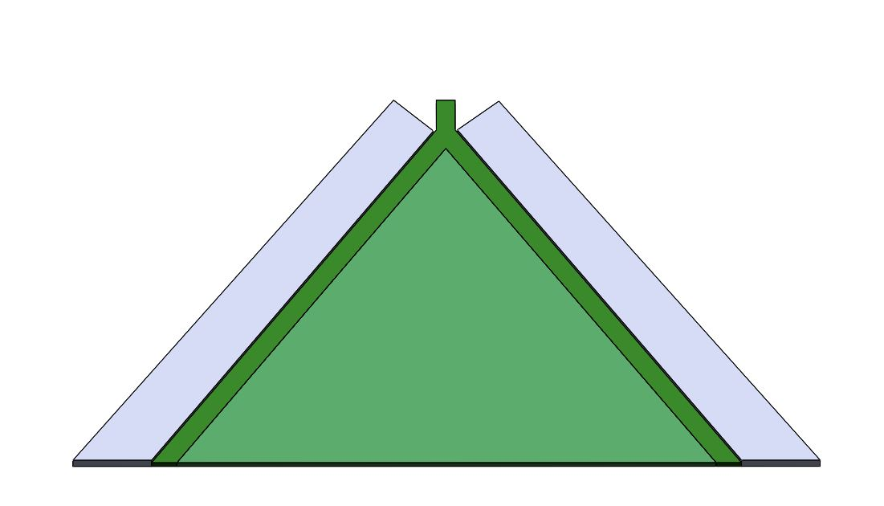
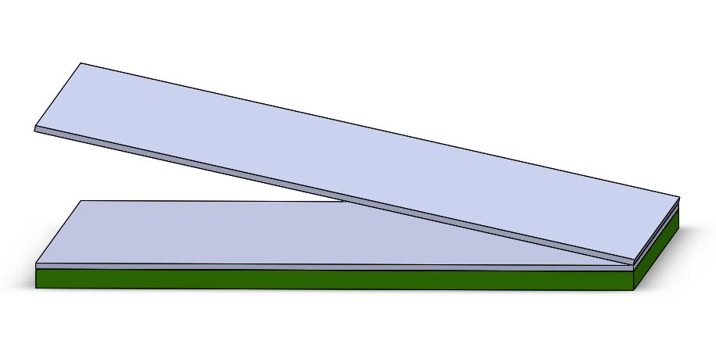
Figure 9 - CAD Models for Dual Energetic Triangle {Left} and Mouse Trap {Right}

Modelling Setup
In order to truly asses the capability and performance of the planar wave generator, numerical simulation modelling was selected as the best methods to achieve this target. The modelling method chosen for this task was a Eulierian based software that generates simulations from a Linux terminal submission script. A Eulierian modelling method utilises a fixed referenced grid to define the meshed area within a simulation, whereby the modelled object is set within that defined area. The density of the mesh can be altered to increase or decrease the overall resolution of a simulation, throughout the modelling process the resolution of the mesh was tuned to promote the efficiency of the simulation while also ensuring high quality results. The selected modelling package utilises JWL parameters as the explosive’s EOS to produce accurate representations for the chosen materials. For the Planar Wave Generator the following materials were selection from the available material database Aluminium T6061, Steel, CompC4 and PETN. CompC4 was selected as the best representation for the RDX based sheet explosives with the VoD of the explosive altered to align with the physical specification of the sheet explosive manufacturer. Similarly the PETN EOS data was selected as the best representation for the PETN based sheet explosive. In order to achieve the required detonation train the simulation requires a burn type to be chosen. The two types of burn mechanism used within the selected software package are HEBurn and HVRB [13]. The HEBurn model requires all explosive materials within the simulated model to have a detonation point and specified time step, this method ensures that all energetic materials are detonated when expected. Whereas the HVRB method only requires the first explosive material within a model to have a detonation point and time step, with the other explosives materials reacting to the pressure of that first detonation in order to detonate this is calculated using a historical variable reactive burn model. This theory can be titled sympathetic detonation, although the use of the HEBurn method can produce more consistent initiation ensuring all explosive material is detonated by the end of the simulation. The HVRB method provides a similar initiation train to that of a real explosive detonation transition, this method requires the explosive material to have a specified pressure to which it would detonate for the simulation to function.

2 Dimensional
The next phase of this project was to create a simulation script for the two sections of the Planar Wave Generator. A 2 dimensional simulation set-up was selected as the best method to start with in order to create an efficient simulation script. This was due to the probability of errors occurring during the simulation script development phase, with 3 dimensional simulation of both steps was conducted later in the project.
The process to run a 2 dimensional simulation using the selected modelling software required a submission script to be written. The script required a variety of headings along with detailed information in order for the task to be completed as requested, the required headings for this simulation were:
• Control.
• Mesh.
• Diatom.
• Equation of State.
• Material Strength.
• Tensile Fracture.
• Programmed Burn.
• Tracer.
• Time Step.
• Boundary Conditions.
• Visualisation Output.
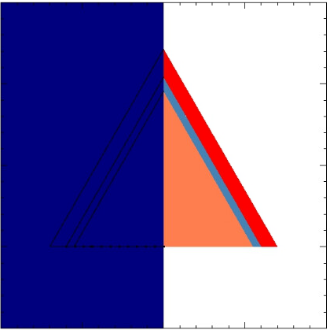
Further information on the required entry into each of these headings can be found in Appendix A. Once the script is complete it can be submitted through the software package. While the software package simulates the model it produces an visual output of simulation for every elected time step. An example of the DET simulation imagery output can be seen in figure 10.

Figure 10 – Visualisation Output initial Output for DET
As can be seen from figure 10, the DET set-up is split in half with the left side displaying a blued covered version and the right side shows the different material colours. The reason the display outputs are presented in this format is because the model was generated in half symmetry with the set-up being mirrored on the y-axis. This method enables an illustration of two chosen metrics, for this task the right side displays the propagation of the detonation through the material, and the left side displays the pressure of the system. A midpoint time step of the same simulation can be found in figure 11.
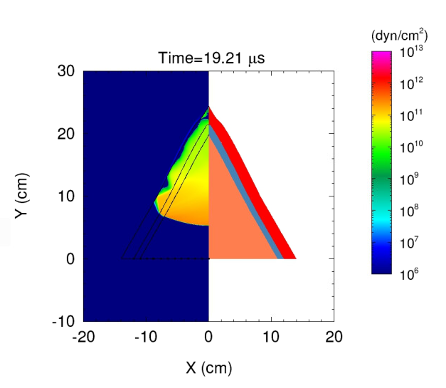
Figure 11 - Visualisation Output Midway Output for DET

The Mouse Trap numerical model is slightly different to that of the DET, as the system was not built in half symmetry as there was no requirement in this 2 dimensional set-up. An example of the Mouse Trap simulation imagery can be seen in figure 12.
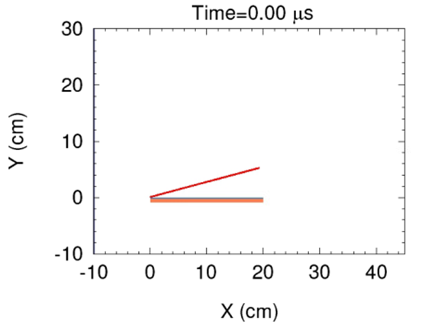
Figure 12 - Visualisation Output initial Output for Mouse Trap

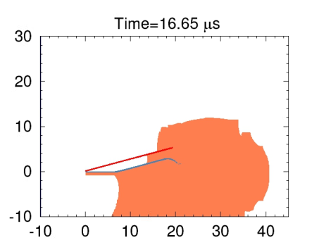
As is seen in figure 12, the mouse trap output only displays the coloured version of the simulation set-up, this was selected as there is only one type of explosive material so the pressure imagery is not as pertinent. The optimisation focus for the mouse trap was solely on the internal angle of the trap as this determines the transfer planarity of the way from the donor plate to the contact plate. A midpoint time step of the same simulation can be seen in figure 13.
Figure 13 - Visualisation Output Midway Output for Mouse Trap

As the detonation wave propagates through the sheet of explosive the donor plate collapses towards the contact plate. From the initial simulation it was identified that due to the power of the initial detonation, a curve formed at the open side of the Mouse Trap as the contact plate collapses. This can be seen as a blown up image in figure 14. Due to this occurrence the overall size of the mouse trap had to be increased in order to mitigate the effect of this curvature.

Figure 14 - Blown up image of Mouse Trap curvature
Following on from the creation of the 2 dimensional systems, an initial testing plan was decided for the 2-D models in order to fully assess the system’s performance before creating 3 dimensional models. This testing plan can be found in Table 1.

Table 1 - 2-Dimensional Simulation Optimisation Test Plan
Dual Explosive Triangle 180 mm | Dual Explosive Triangle 240 mm | Mouse Trap
27.5° | 30° | 14°
25° | 27.5° | 12°
20° | 20° | 15°

The reason a 2 dimensional testing plan was completed prior to development of the 3 dimensional submission scripts was due to the volume of 2 dimensional models allowing for the system to be fully optimised prior to conducting the more complex 3-D simulations. This would also reduce the amount of 3 dimensional models required to be completed, therefore reducing the amount of time and computing power required to complete the task.

3 Dimensional
Following on from the completion and analysis of the 2-D simulations, the two submission scripts had to be adapted from 2 dimensional to 3 dimensional. Although the submission scripts could remain relatively similar there were some key changes that were required in order for the software to read the scripts correctly. The main changes included adapting the diatom from 2-D co-ordinates to 3-D, adapting the mesh to incorporate a larger area which required a courser mesh due to the size of the simulation, and adding further tracers to the Mouse Trap set-up to gather the planarity data over 2 dimensions.
The DET 3-dimensional submission script was simpler to adapt from its 2-D version as the only major changes required were to add the set-up’s thickness and alter the detonation point to accommodate for the new thickness. Once this was complete the submission script could be run by the software, the initial imagery output can be found in figure 15.
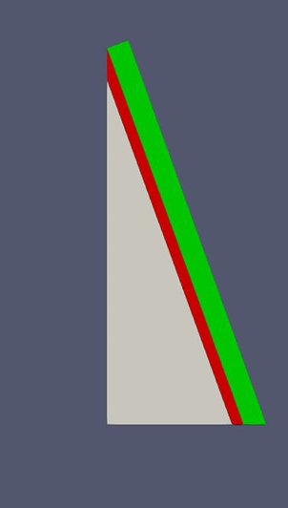

Figure 15 - 3-D Visualisation Output initial Output for DET

Unlike the DET submission script, the Mouse Trap submission script required more complex adaptations in order to transfer it from 2-D to 3-D. This was because the thickness of the system is more integral to the performance analysis and the amount of data produced. The initial output produced by the 3 dimensional Mouse Trap simulation can be seen in Figure 16.
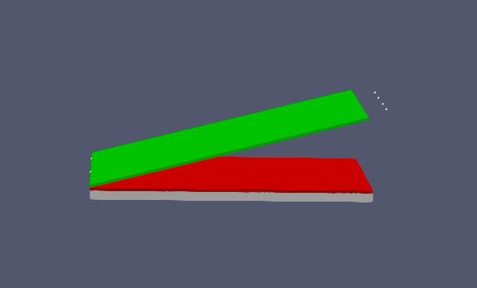
Figure 16 - 3-D Visualisation Output initial Output for Mouse Trap

Once the adaptations were completed and the submission scripts functioned correctly, a testing plan was generated for the 3 dimensional systems. Due to the optimisation completed during the 2-D simulations the 3-D testing plan was more concise with less simulations required to be analysed.
Table 2 - 3-Dimensional Simulation Test Plan
Dual Explosive Triangle 240 mm | Mouse Trap
20° | 15°
Following on from the completion of the 3 dimensional testing plan, the final step in the project was creating a full system submission script. In order to combine the two steps into the full system it required complex adaptation to the diatom, and alterations to the detonation points and tracer locations. Due to the optimisation completed from the two previous testing plans only one full system simulation was required, the initial imagery output for this can be found in figure 17.
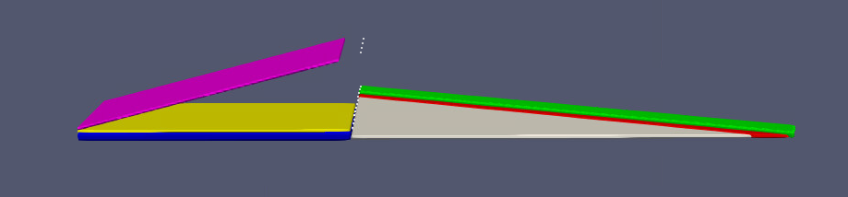Figure 17 - Initial Visualisation Output for Full System
Table 3 - Colour Key for Figure 17
Aluminium Contact Plate 3mm
Aluminium Donor Plate 3mm
RDX Sheet Explosive Mousetrap 6.4 mm
PETN Sheet Explosive Lens 3 mm
RDX Sheet Explosive Lens 3 mm
Steel Confinement Sheet 5mm

Results
In order to gather data from the simulations tracers were used in specified locations in each modelling set-up to gather time of arrival of the wave, this data was then used to calculate the overall curvature of the wave front. The tracers are used in these numerical models to replicate the presence of piezo-electric pins.

2 Dimensional
In the all of the 2-D DET simulations 11 tracers were used to assess the planarity, these were split into two groups of 2 and 9. The group of 2 tracers are located at 0 mm and 75 mm labelled A and B, the group of 9 tracers are located every 10 mm from 0 to 80 mm are labelled 0-8. The reason the tracers were split in to two groups is because the data gather from the group of two tracers will be used to calculate the curvature of the wave front along with the difference in time of arrival. Whereas, the group of 9 tracers were used to assess the overall shape of the wave front and the change in time of arrival at narrower intervals. In all of the 2-D Mouse Trap simulations 8 tracers were also used, all 8 of the tracers were located on the top side of the aluminium contact plate. Approximately located every 30 mm between 0 and 210 mm and are labelled 1-8.

DET 180 mm Primasheet

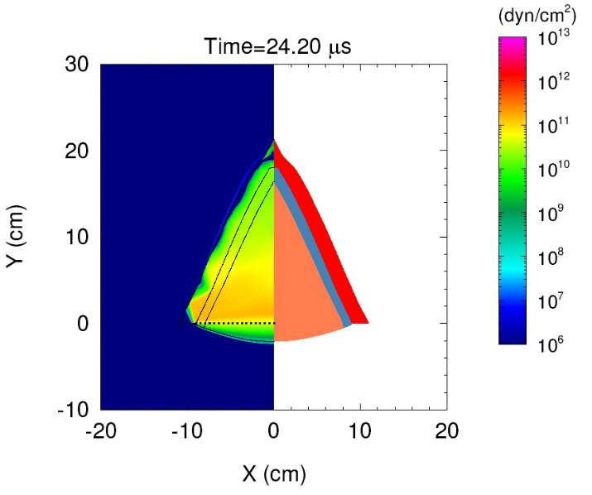
27.5°

Pin ID | A | B | 0 | 1 | 2 | 3 | 4 | 5 | 6 | 7 | 8
Approx. Distance from centre (mm) | 0 | 75 | 0 | 10 | 21.1 | 31.7 | 42.3 | 52.9 | 63.5 | 74.1 | 84.7
ToA (μs) | 21.3 | 23 | 21.3 | 21.3 | 21.4 | 21.6 | 21.8 | 22.2 | 22.5 | 22.9 | 23.1
Delta t from axis (us) | 0 | 1.7 | 0 | 0.0 | 0.1 | 0.3 | 0.5 | 0.9 | 1.2 | 1.6 | 1.8

25°
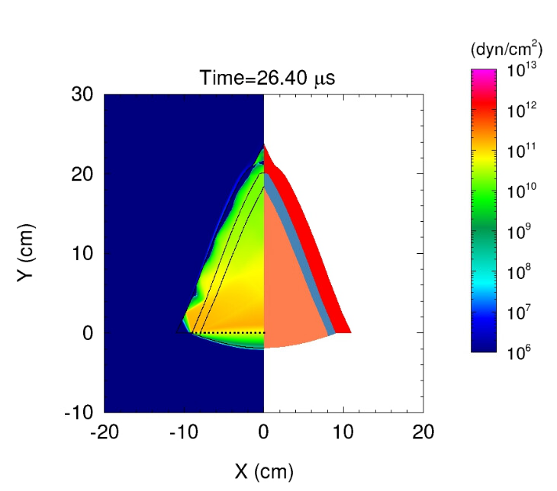

Pin ID | A | B | 0 | 1 | 2 | 3 | 4 | 5 | 6 | 7 | 8
Approx. Distance from centre (mm) | 0 | 75 | 0 | 10 | 21.1 | 31.7 | 42.3 | 52.9 | 63.5 | 74.1 | 84.7
ToA (μs) | 23.7 | 25.4 | 23.7 | 23.8 | 23.9 | 24 | 24.3 | 24.6 | 24.9 | 25.3 | 25.5
Delta t from axis (us) | 0 | 1.7 | 0 | 0.1 | 0.2 | 0.3 | 0.6 | 0.9 | 1.2 | 1.6 | 1.8

20°
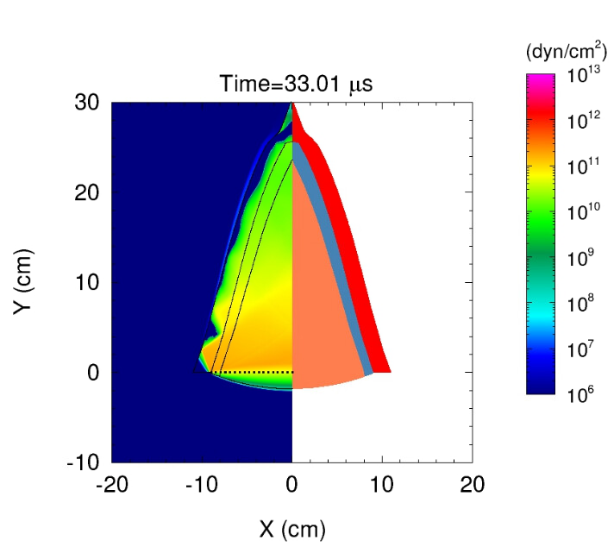

Pin ID | A | B | 0 | 1 | 2 | 3 | 4 | 5 | 6 | 7 | 8
Approx. Distance from centre (mm) | 0 | 75 | 0 | 10 | 21.1 | 31.7 | 42.3 | 52.9 | 63.5 | 74.1 | 84.7
ToA (μs) | 30.5 | 31.9 | 30.5 | 30.5 | 30.5 | 30.7 | 30.9 | 31.1 | 31.4 | 31.8 | 32.4
Delta t from axis (us) | 0 | 1.4 | 0 | 0.0 | 0.0 | 0.2 | 0.4 | 0.6 | 0.9 | 1.3 | 1.9

DET 180 mm Formex/Hexosheet

41°

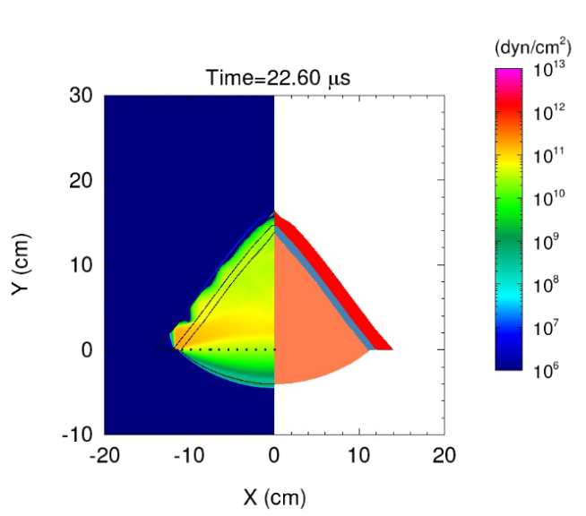

Pin ID | A | B | 0 | 1 | 2 | 3 | 4 | 5 | 6 | 7 | 8
Approx. Distance from centre (mm) | 0 | 75 | 0 | 10 | 21.1 | 31.7 | 42.3 | 52.9 | 63.5 | 74.1 | 84.7
ToA (μs) | 17.1 | 19.1 | 17.1 | 17.2 | 17.3 | 17.6 | 18.0 | 18.4 | 18.7 | 19.1 | 20.3
Delta t from axis (us) | 0 | 2 | 0 | 0.1 | 0.2 | 0.5 | 0.9 | 1.3 | 1.6 | 2 | 3.2

DET 240 mm Primasheet

30°
The following results for the 30° 240 mm Primasheet simulation, are presented differently to the rest of the DET models. This is because it was created as a validation model to validate the simulation data against the trial data from the 2013 “Line Wave Generator” report by DSTO. Due to this the tracers are in altered locations and are as follows. A and B tracers are at 0 and 90 mm respectively, 0-10 tracers are located at equidistant locations between 0 and 100 mm.
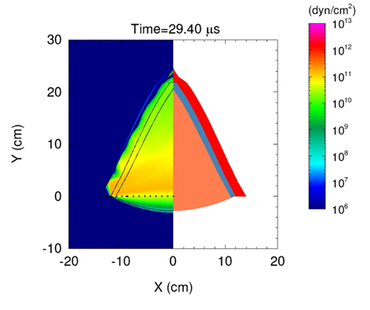

Pin ID | A | B | 0 | 1 | 2 | 3 | 4 | 5 | 6 | 7 | 8 | 9 | 10
Approx. Distance from centre (mm) | 0 | 90 | 0 | 10 | 20 | 30 | 40 | 50 | 60 | 70 | 80 | 90 | 100
ToA (μs) | 25.6 | 27.7 | 25.6 | 25.7 | 25.8 | 25.9 | 26.1 | 26.4 | 26.7 | 27.1 | 27.6 | 27.7 | 28.5
Delta t from axis (us) | 0 | 1.7 | 0 | 0.0 | 0.1 | 0.3 | 0.5 | 0.9 | 1.2 | 1.6 | 1.8 | 2.1 | 2.9

27.5°
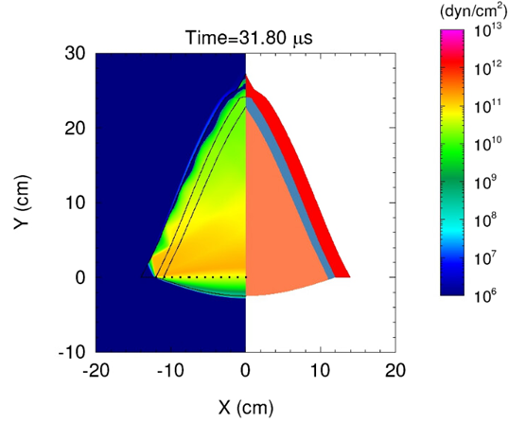

Pin ID | A | B | 0 | 1 | 2 | 3 | 4 | 5 | 6 | 7 | 8
Approx Distance from centre (mm) | 0 | 75 | 0 | 10 | 21.1 | 31.7 | 42.3 | 52.9 | 63.5 | 74.1 | 84.7
ToA (μs) | 28.4 | 29.8 | 28.4 | 28.4 | 28.5 | 28.6 | 28.8 | 29.1 | 29.4 | 29.8 | 30.2
Delta t from axis (us) | 0 | 1.4 | 0 | 0.0 | 0.1 | 0.2 | 0.4 | 0.7 | 1.0 | 1.4 | 1.8

20°
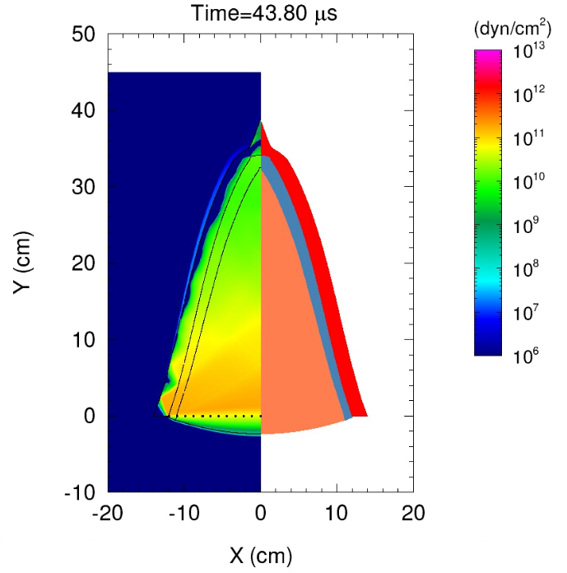

Pin ID | A | B | 0 | 1 | 2 | 3 | 4 | 5 | 6 | 7 | 8
Approx. Distance from centre (mm) | 0 | 75 | 0 | 10 | 21.1 | 31.7 | 42.3 | 52.9 | 63.5 | 74.1 | 84.7
ToA (μs) | 40.6 | 41.6 | 40.6 | 40.6 | 40.7 | 40.8 | 40.9 | 41.1 | 41.4 | 41.6 | 42
Delta t from axis (us) | 0 | 1.0 | 0 | 0.0 | 0.1 | 0.2 | 0.3 | 0.5 | 0.8 | 1.0 | 1.4

Mouse Trap

14°
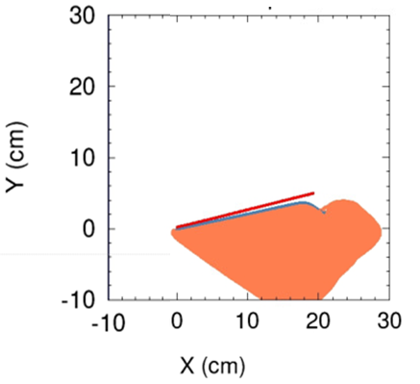

Approx. Distance from Point of Angle
Pin 1  0 mm | Pin 2  +30 mm | Pin 3  +60 mm | Pin 4  +90 mm | Pin 5  +120 mm | Pin 6  +150 mm | Pin 7  +180 mm | Pin 8  210 mm
25μs | 24.2μs | 22.μs | 16.8μs | 11μs | 5.2μs | 2.6μs | 0.2μs

15°
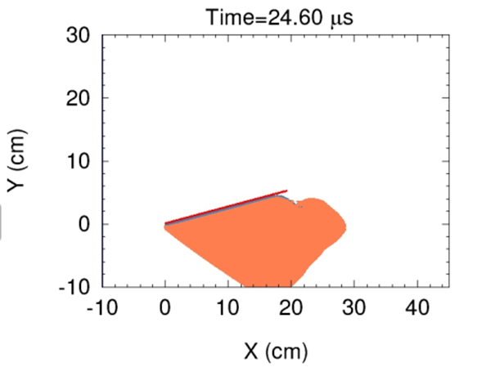

Approx. Distance from Point of Angle
Pin 1  0 mm | Pin 2  +30 mm | Pin 3  +60 mm | Pin 4  +90 mm | Pin 5  +120 mm | Pin 6  +150 mm | Pin 7  +180 mm | Pin 8  210 mm
24.6μs | 23.2μs | 22.4μs | 21.8μs | 21.2μs | 20.4μs | 20μs | 12μs

3 Dimensional
The tracers for the 3-D DET simulations were located in a nearly identical place to that of the 2-D DET simulations, the only change to the tracer location is they were placed at 1.5mm depth in the 3mm thickness of the triangle. The tracers for the 3-d Mouse trap simulation were located on the top side of the contact plate similar to the 2-D simulation, the tracers for the 3-D simulation were arranged in 4 rows of 8 tracers located every 30 mm between 0 and 210 mm. Each row of tracers were located every 25 mm across the 75 mm contact plate. A Schematic of the set-up can be found in figure 18.
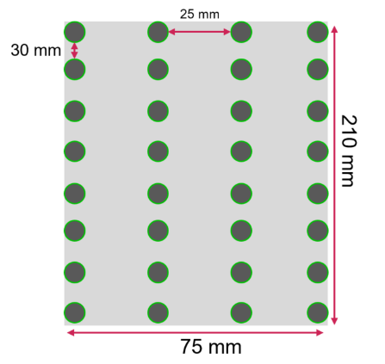
Figure 18 - Schematic of 3-D Tracer Array or Mouse Trap and Full System

DET 240 mm Primasheet

20°
Pin ID | A | B | 0 | 1 | 2 | 3 | 4 | 5 | 6 | 7 | 8
Approx Distance from centre (mm) | 0 | 75 | 0 | 10 | 20 | 30 | 40 | 50 | 60 | 70 | 80
ToA (μs) | 38.7 | 39.6 | 38.7 | 38.8 | 38.9 | 39.1 | 39.3 | 39.3 | 39.4 | 39.6 | 40.4
Delta t from axis (us) | 0 | 0.9 | 0 | 0.1 | 0.2 | 0.4 | 0.6 | 0.6 | 0.7 | 0.9 | 1.7

Mouse Trap

15°
Approx. Distance from Point of Angle
 | Pin 1  0 mm | Pin 2  +30 mm | Pin 3  +60 mm | Pin 4  +90 mm | Pin 5  +120 mm | Pin 6  +150 mm | Pin 7  +180 mm | Pin 8  210 mm
Row 1  0 mm | 24.6μs | 23.2μs | 22.4μs | 21.8μs | 21.2μs | 20.4μs | 20μs | 12μs
Row 2  25 mm | 24.6μs | 23.2μs | 22.4μs | 21.8μs | 21.2μs | 20.4μs | 20μs | 12μs
Row 3  50 mm | 24.6μs | 23.2μs | 22.4μs | 21.8μs | 21.2μs | 20.4μs | 20μs | 12μs
Row 4  75 mm | 24.6μs | 23.2μs | 22.4μs | 21.8μs | 21.2μs | 20.4μs | 20μs | 12μs

Full System
The tracers for the full system were located in identically to that of the 3-D simulations, as the full system was a combined version of the two set-ups in total the full system included 32 tracers in identical locations to that of the 3-D Mouse Trap simulation. A schematic of tracer set-up can be found in Figure 18.
Pin Number | Pin 1 | Pin 2 | Pin 3 | Pin 4 | Pin 5 | Pin 6 | Pin 7 | Pin 8
Pin Location (mm) | 0 | 30 | 60 | 90 | 120 | 150 | 180 | 210
Row 1 (μs) | 54.2 | 54.6 | 54.8 | 54.7 | 54.6 | 54.4 | 54.2 | 41.2
Row 2 (μs) | 54.3 | 54.8 | 55 | 54.8 | 54.8 | 54.5 | 54.4 | 41.4
Row 3 (μs) | 54.7 | 55.2 | 55.2 | 55 | 55 | 54.8 | 54.6 | 41.6
Row 4 (μs) | 54.9 | 55.2 | 55.3 | 55.3 | 55.3 | 55 | 54.6 | 42.1
Average Time (μs) | 54.525 | 54.95 | 55.075 | 54.975 | 54.925 | 54.675 | 54.45 | 41.575

Discussion

Dual Energetic Triangle
To get a true understanding of the success of the planar wave generator all simulations and individual steps require analysis. As the Dual Energetic Triangle is the first step in the systems, it is the most logical place to start the analysis. As the design of the DET was inspired by the 2013 DSTO report [11], the trial results from that report can be compared to the performance of the 2 dimensional 30° DET simulation.
Table 4 - DSTO Trials Data [11]
 | Pin 1  (-90 mm) | Pin 2  (Centre) | Pin 3  (+90 mm)
Test #1 | ----- | 22.6 μs | 24.8 μs
Test #2 | 20.8 μs | 19.4 μs | 19.8 μs
The DSTO report also states the wave curvature of the two tests with Test #1 having a curvature of 16 mm and Test #2 has a 10 mm curvature. If the mean average of the difference of time of arrival and wave curvature is calculated along with a level of random uncertainty resulting in the following values.
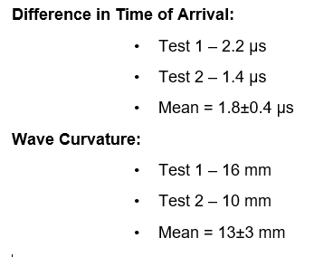

These values can be compared to the data produced by the 2-D simulation of the 240 mm 30° DET, the values for the difference in time of arrival and Wave curvature produced by the simulation are shown below.
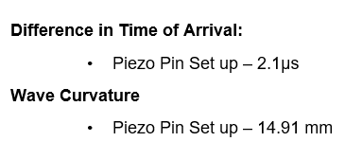

Comparing the values produced by the DSTO Trial data with that of the 2-D modelling data, it is clear that the numerical model produced data that aligns within the specified uncertainty of the values produced by the DSTO trial data. This assessment provides a significant level of validation to the models produces along with a high level of confidence in the modelling software. Following on from the validation of the DET numerical model, a comparison of the difference between the types of explosives were assessed. This comparison could be seen as ambiguous as the models being compared share little similarities, the purpose of the comparison is to compare the performance of the ideal apex angle set-ups of the Primasheet DET and the Formex/Hexosheet DET. This is in order to provide evidence of the viability of the Formex/Hexosheet version as this version may be required if a full scale trials was to be conducted. The values used to assess this viability is the difference in Time of arrival and the Wave curvature of both versions. As seen above the Difference in ToA and the Wave Curvature for the Primasheet version are 2.1μs and 14.91 mm respectively, the values produced by the 41° baseline Formex/Hexosheet set-up can be found below.
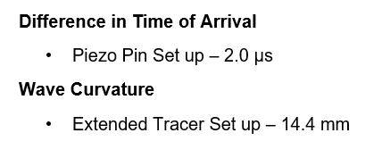

As can be seen from the above values, the baseline model for the Formex/Hexosheet set-up displays similar test metrics to that of the Primasheet baseline model. In order for the Formex/Hexosheet version to be used in a trial set-up further optimisation simulations should be ran in order to improve the planarity of the set-up.
Following on evaluation of sheet explosive type, the 2 dimensional testing plan was finalised and can be found in table 1. Once complete this testing can enable an assessment of the performance of each of the specified angles of the DET set-up. In order to evaluate the angle the three testing metrics used were the difference in ToA, the wave curvature values and a graph to display the wave shape.

Table 5 - 2-D DET ToA and Wave Curvature Values
Set-up Name | Central Pin (μs) | Edge Pin (μs) | Curvature (mm)
HVRB 30 240 Model | 25.6 | 27.7 | 15.12
HVRB 27.5 180 Model | 21.3 | 23 | 12.24
HVRB 25 180 Model | 23.7 | 25.4 | 12.24
HVRB 20 180 Model | 30.5 | 31.8 | 9.36
HVRB 27.5 240 Model | 28.4 | 29.8 | 10.08
HVRB 20 240 Model | 40.6 | 41.6 | 7.2
HEBurn 29 240 Model | 20 | 20.2 | 1.44
From this table an assessment can be made of the planarity of each of the 2-D simulations and a comparison of the values to get improved understanding of the best performing set-up. There were three main trends that could be concluded from the data in table 5, the first trend was that that as the as the angle decreases, the propagation time of the wave increases. This was due to the decrease in angle increasing the overall distance from detonation point to edge of the triangle. The second trend was that for the most part as the angle is decreased the difference of ToA also decreases, this trend was the critical point of optimisation for this set-up. The final trend is that when there is a reduction in difference in ToA a comparative reduction is seen in the curvature of the wave front. Further on, from this data it can be seen that the two best performing set-up are titled “HVRB 20 180 Model” and “HVRB 20 240 Model”. When comparing the values from these set-ups it is clear that of all the DET simulations the best performing angle for this type of system is 20 degrees. Furthermore, it presented that the larger 240 mm set-up displayed an improvement over the smaller 180 mm set-up in both the difference in ToA and Wave Curvature metrics. The difference in results between the two set-ups was 0.3 μs and 2.16 mm respectively, further analysis of the planarity of the 2-D simulations can be conducted using a graph to assess the shape of the wave.
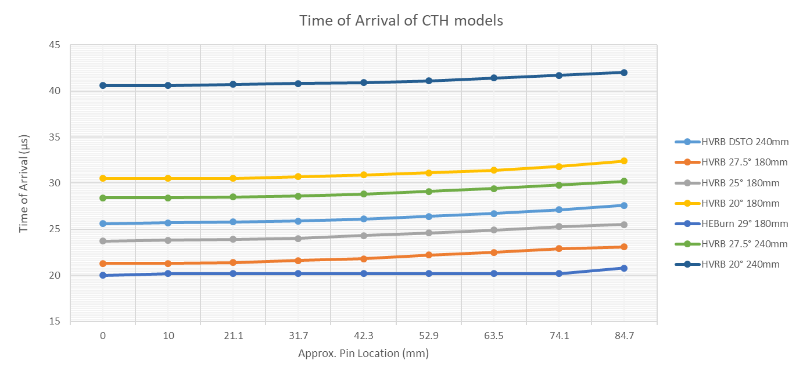

Figure 19 - Graph Displaying Shape of Planar Wave from 2-D Simulations

From figure 19 the planarity and shape of the 2-D DET simulations are displayed, this graph supports the previous analysis that the best performing DET simulations is that of the 240 mm 20 degree set-up. This analysis was then used to inform the angle and size selection for the 3-D simulations which were developed, the results from the 3-D Det simulations mirror the results of the 2-D simulations. Displaying that adding the 3rd dimension of 3 mm thickness to the DET set-up did not have a large effect on the overall output of the simulation. Although the results produced by the 3-D simulations did display a minor improvement to both the difference in ToA and the Wave Curvature with values of 0.9 μs and 6.48 mm respectively. The true reason for this improvement is unknown, it could be because of the now 3mm thick DET producing a larger number of reflections and edge effects with the steel confinement as the wave propagates through the sheet of explosive.

Mouse Trap
The initial step of evaluation of the Mouse Trap section of the Planar Wave Generator is to assess the planarity of the 2 dimensional simulations. The original inspiration for the Mouse Trap section was drawn from the 2006 report, within this report it was indicated that the apex angle for a mouse trap set-up would be somewhere 12-17 degrees. The 2-D simulations Mouse Trap that have been present within this report were the 14 Degree and 15 Degree Set-ups, these were chosen due to the 14 degree being the initial angle and the 15 degree displaying improved performance. During the 2-D Mouse Trap Simulation process a total of 4 further angles were tested ranging from 12-16 degrees but were disregarded as their performance was overmatched by that of the 15 degree simulation. A comparison between the initial 14 degree simulation and the 15 degree simulation displays a sizeable improvement in planarity, this is presented on a scatter graph with ToA on the x-axis and Distance from angle on the y-axis. These can be found in figure 20.
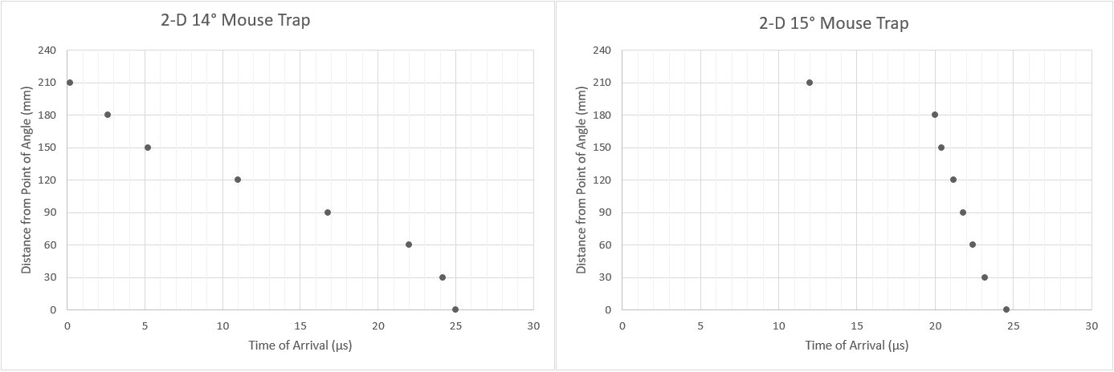
Figure 20 - 2-D Extracted Simulation Data

Extracting further information from these graphs it is visible that over a distance of 180 mm the 14° degree simulation has an approximate difference in ToA just below 23 μs. Whereas, the 15° degree simulation has an approximate difference in ToA around 5 μs. This indicates that an increase of 1 degree to the Mouse Trap angle reduces the difference in ToA by a factor of 4.6, this result then informed the production of the 3-D Mouse Trap that followed. Prior to assessing the performance of the 3 dimensional Mouse Trap simulations, a brief comparative study can be undertaken od the planarity difference between a 3-D 14.5 degree Mouse Trap simulation and the 14.5 degree mouse trap trial data can be conducted. In order for an equal comparison, the simulation set-up was built to replicate the set-up used within the trial to as identical as possible, with the largest caveat being that ideal and pristine material properties were used within the simulation. Within the trial report the data produced is presented on a 3-D graph that displays the distance from the open side of the Mouse Trap on the x-axis, the distance across the mouse trap on the z-axis and the ToA on the y-axis. In order for a fair comparison this graph was replicated for the data produced by the 3-D simulation. The data produced by the 14.5 degree set-ups can be found below in figure 21.
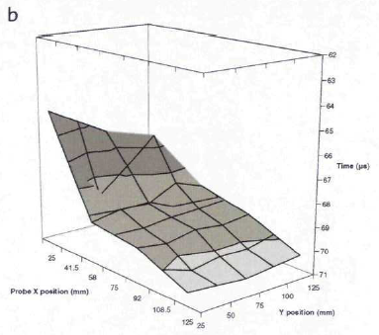
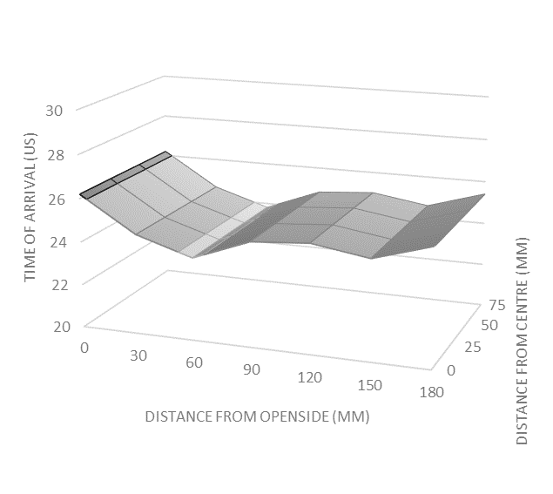
a

Figure 21 - a) 14.5° 3-D Mouse Trap Data, b) 14.5° Trial Data from Firing 12 of the 2006 Report [12]

The graphs displayed in figure 21 presents the planar wave shape produced by the respective simulation or trial firing, from the data presented within the trials report from 2006 firing 12 display a difference in ToA of 7.9 μs compared to the simulations 2.6 μs. A further comparison can be made by calculating the wave curvatures of the systems with the wave curvature of the trials data is estimated at 66.5 mm, whereas the curvature of the simulation wave is estimated at 21.3 mm. Despite the identical set ups between the simulation and trial there is drastic differences between the results. Of course as the simulation is based off ideal and pristine materials this will cause an unmeasurable level of discontinuity when comparing the results. Also the mouse trap data present from the report was part of a larger system which will have also an unmeasurable effect on the planarity of the produced wave.
Following on from the optimisation of the Mouse Trap section from the 2-D Simulations, only a single simulation was required for the 3-D Mouse Trap set-up in order to inform the Full System Simulations. This was due to the data produced by the initial 3-D simulation displaying an ample level of planarity which could be taken forward to the Full System. To assess the planarity of the 3-D Mouse Trap data was extrapolated from two graphs. The first being a scatter graph displaying an average of the ToA for the specified row of pins on the x-axis and then the pin row location on the y-axis. The second graph is a 3-D surface graph that displays the specific pin location on the x and y axis, with the ToA displayed on the Z-axis.
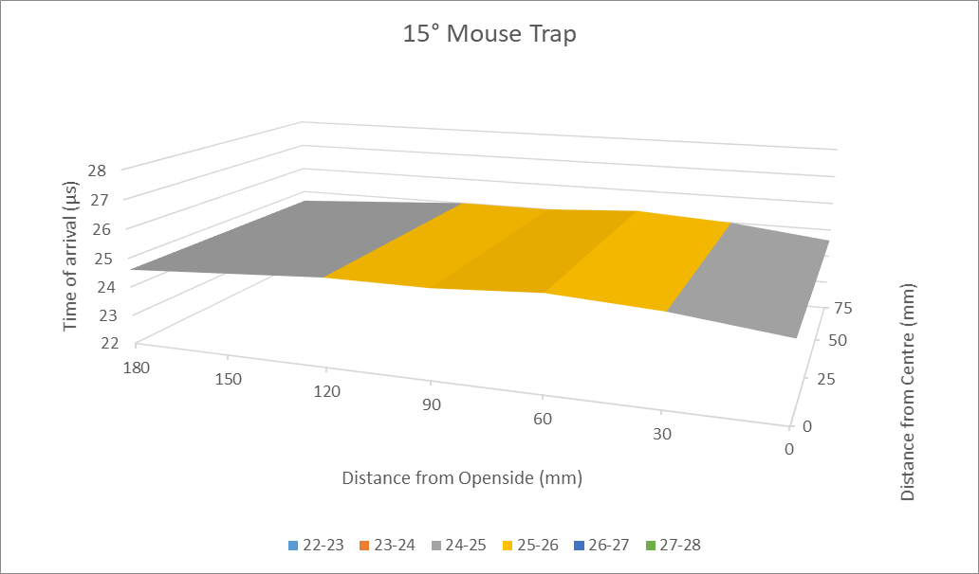
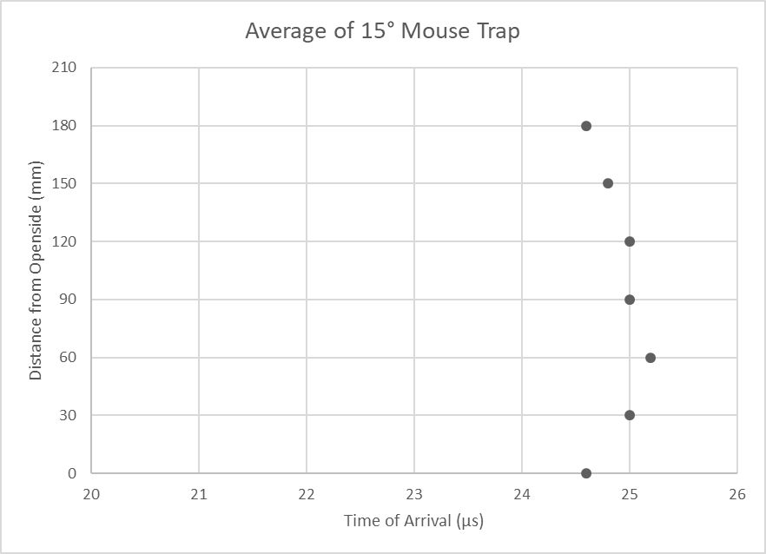
Figure 23 - Scatter Graph and 3-D Surface from 3-D 15° Mouse Trap Simulation

From the graphs displayed in Figure 22 and 23, it is evident that the planarity of the 15° 3-D Mouse Trap falls within the acceptable range of the success criteria. This is apparent as the value for the Difference in ToA across 180 mm is calculated at 0.6 μs. Further the resulting Wave Curvature was calculated at 4.3 mm which also exceeds the requirements of the success criteria.

Full System
Following the analysis of the 2-D and 3-D simulations, analysis of the performance full system using the same success metrics of ToA and Wave Curvature along with a visual assessment of the resulting Planarity is required. In order to complete this analysis two graph were generated from the data produced by the simulation. Previous examples of the style graphs chosen can be found in Figures 23, The Scatter graph and 3-D Surface graph produced from the data from Full System can be found in Figures 24 and 25 below.
Figure 24 - Scatter Graph from Full System Simulation

From these two graphs the three success metrics can be assessed, in order for full comprehension of the success of this Full System simulation the two main success criteria are revaluated along with visual analysis of the systems planarity.
Figure 25 - 3-D Surface Graph from Full System Simulation
From the data produced by the simulation full system a maximum difference in ToA can be calculate. This value is will indicated whether the system is truly successful in achieving the success criteria, the value for the maximum difference in ToA for the full system is 1.1 μs exceeding the requirements set at the start of this project. Similarly, the maximum wave curvature can be assessed from the data produced, his value was calculated to be 7.92 mm which also exceeds the initial performance requirements.
Visual analysis can be useful tool to illustratively display a dataset. Although visual analysis can be subjective and can often be manipulated to support the bias of the author. In this case visual analysis can be used to display the planarity of the specified set-up in its full format, this is done by using the 3-D surface graph seen in Figure 25. From this graph it presents the planarity to be fairly consistent across the whole surface, but with a slight increase in curvature through the central pins of row 4.

Conclusion
The objective of this project was to design and evaluate a proprietary single point initiated planar wave generator. Within this objective further success criteria were set to produce a planar wave of a minimum of 150 x 180 mm that has a ToA difference of less 1.2 μs and that has an average wave curvature of below 8.5 mm. This success criteria drove the optimisation and development of the design; which included a combination of the Dual Energetic Triangle and Mouse Trap set-up through the 2-D and 3-D simulations that resulted in the full system producing results that exceeded the original success criteria. The overall best performing set-up was the 20° 240 mm DET in combination with a 15° degree Mouse Trap that produced a difference in ToA of 1.1 μs and a Wave Curvature of 7.92 mm. As all of the DET simulations were conducted in half symmetry, in practice the set-up would be a 40° 240 mm DET combined with the 15° Mouse Trap.

Reflection
Following the completion of this project there is a large amount of reflection that can be completed, the reflection can be broken down into three main subject areas. The modelling success of this project, the change of scope of the project and a superior version.

Modelling Success
Overall the performance of simulations exceeded my initial expectations, as at the start of this project I was fairly unfamiliar with this type of numerical modelling. I was especially unfamiliar with the software package as I had never used it prior to the initiation of this project, which resulted in a lot of errors and learning curves at the start of the work. This required a lot of rapid inductive learning in order to become competent enough with the software package and its requirements to produce high quality of data that could inform further complex models as the project progressed. Ultimately the initial version of the modelling produced within this project were set to inform the design of the Planar Wave Generator prior to a full scale experimental trial in order to gather true planarity data. Unfortunately, there was an alteration to the original scope of the project part way through this modelling phase leading to it becoming the only source of data for this project.

Change of Scope of Project
The original scope of this project was defined within the project proposal and outlined the production and delivery of a full scale experimental trial, evaluating the developed Planar Wave Generator design. Unfortunately, in October of 2023 I was informed that the Project Manager and Technical Lead had decided to retract the funding due to a change in priorities. I was informed of this decision after it had been finalised, resulting in the scope of this project becoming purely modelling and research based. This removed the vast majority of support and requirement for success, this decision occurred after I had started discussions regarding the procurement of energetic material with external suppliers along with the initial design of the experimental set-up.

The Superior Version
Ultimately, this decision was to the detriment of the quality of data produced by this project and thus the failure to meet the original project objectives. After being updated on the change of scope for this project, I was informed that one of the discerning factors for the change was that an international partnering organisation (IPO) had recently developed Planar Wave Generating method that supposedly overmatched the expected performance of this project [14]. Further it was also stated that the IPO’s version could be scaled from their tested set-up of 1 inch (25.4 mm) with minimal performance loss. The stated performance of this IPO’s version was between 15.24 and 81.28 ns across the test diameter of 25.4 mm. The reduction in scope of the project required me to adapt to the new scope and re-assess the testing plans in order to widen the data set and scope of the simulations.

Further Work
In order to continue the progress of this project, the main aim must be to fulfil the requirements set within the original scope of the project. When reviewing the original aims and objectives there is one stand out objective that would propel the progress towards the completion of this project, that objective is to conduct and gather data from a full scale energetics trials to assess the performance of the performance of this Planar Wave Generator. In order gather a true assessment of the performance characteristics of this design, each step should be analysed individually prior to the assessment of the full system. As the data gathered within this report was using ideal pristine material models, an effort should be made to re-assess the apex angles of both the Dual Explosive Triangle and the Mouse Trap, the testing of the DET should begin using the original 60° angle as an initial baseline and reducing the angle in specified following the performance of the 60° test. Similarly, the Mouse Trap testing should start with a baseline angle of 14.5° and the further angle alterations should be done in accordance with the performance of the baseline test. These optimisation test should be complete prior to trialling the full system. From the experience of conducting this project, the estimate for the best performing set up would be a 54° DET Combined with a 15° Mouse Trap.

References

[1] | M. Matalon, “Notes Lecture 4,” 2013. [Online]. Available: https://cefrc.princeton.edu/sites/g/files/toruqf1071/files/Files/2013%20Lecture%20Notes/Matalon/Notes-Lecture-4.pdf. [Accessed 02 February 2023].
[2] | P. Cooper, Explosives Engineering, New York: Wiley, 2018.
[3] | E. Lee, M. Finger and W. Collins, “JWL EQUATION OF STATE COEFFICIENTS FOR HIGH EXPLOSIVES,” LAWRENCE LIVERMORE LABORATORY, Livermore, CA, 1973.
[4] | J. W. Kury, E. L. Lee, H. C. Hornig, J. L. McDonnel, D. L. Ornellas, M. Finger, F. M. Strange and M. L. Wilkins, “Metal Acceleration by Chemical,” Fourth Detonation Symposium, 3–13, 1965.
[5] | C. M. Tarver, “Jones−Wilkins−Lee Unreacted and Reaction Product Equations of State for Overdriven Detonations in Octogen and Triaminotrinitrobenzene-Based Plastic-Bonded Explosives,” Journal of Physical Chemistry, vol. 124, no. 7, pp. 1399-1408, 2020.
[6] | R. Menikoff, “JWL Equation of State,” Los Alamos National Laboratory, Los Alamos, NM, 2016.
[7] | J. Fritz, “A Simple Plane-Wave Explosive Lens,” Los Alamos National Laboratory, Los Alamos, NM, 1990.
[8] | J. P. Lichthardt, B. C. Tappan, P. R. Bowden, M. W. Olinger and D. L. McDonald, “A simple 3D printed plane wave explosive lens based on Fritz parameters,” Los Alamos National Laboratory, Los Alamos, NM, 2020.
[9] | W. Xiong, X.-f. Zhang, Z.-w. Guan, Y. He, L. Qiao and L.-l. Guo, “Study of simple plane wave generator with an air-metal barrier,” Defence Technology, vol. 10, no. 2, pp. 190-197, 2014.
[10] | A. C. Anastacio, J. Selesovsky, J. Kucera and J. Pachman, “Ring Plane Wave Generator,” University of Pardubice, Pardubice, Czech Republic, 2017.
[11] | S. A. Weckert, J. Freundt and S. Stojko, “Explosive Line Wave Generators,” Defence Science and Technology Organisation, Edinburgh, South Australia, 2013.
[12] | D. J. Mann, “UK Wedge Tests on Rowanex 1000,” QinetiQ Ltd, Farborough, United Kingdom , 2006.
[13] | L. W. Tuttlel, J. W. LaJeunessel, R. G. Schmitt and E. N. Harstadl, “Evaluation of XHVRB for Capturing Transition to Detonation as Measured by Embedded Gages,” Sandia National Laboratories, Albuquerque, NM, 2019.
[14] | E. J. Walle, Canonical Detonation Phenomena and Novel Tools for Characterization, United States: AFRL, 2021.
[15] | B. Nadykto, “Equations of state of unreacted explosives: PETN, RDX, HMX, TATB,” EDP Sciences, Sarov, Russia, 2010.
[16] | G. Baudin, “Review of Jones-Wilkins-Lee equation of state,” EDP Sciences, Gramat, France, 2010.
[17] | S. Jacobs, T. Liddiard and B. Drimmer, “The shock-to-detonation transition in solid explosives,” Symposium (International) on Combustion, vol. 9, no. 1, pp. 517-529, 1963.

Appendices

– Submission Script Definitions
• Control
The first section of a script includes the Tstop which is the time for the simulation will stop recording data.
• Mesh
This section includes the number of blocks required for this script along with their specified geometry i.e. 3dr, this represents a 3 dimensional simulation that can be reflected on a specified axis (X,Y,Z).
This section also includes the resolution for the simulation which includes the size of the simulation in centimetres for each axis along with the number of nodes per cm of mesh area.
• Diatom
This section is where the designer specifies the shapes required for the simulation, there are a variety of pre-defined shapes that can be specified here, along with the defined shapes material number and its pressure.
• Equation of State
This section includes all of the materials required within the script, each material is give a material number and its behaviour within the simulation is defined by an equation of state pre-set which is defined within the software’s database.
• Material Strength
This section is required if the script includes any materials that the designer wants to manipulate I.e. the steel for a target plate. It is defined using a pre-set material strength assigned to the material number.
• Tensile Fracture
Similar to material strength, this section is only required if the designer requires a part of the script to fracture or deform during the simulation.
• Programmed Burn
This section is required if the script includes an explosive component with the scripts I have used I have only used the HEBurn type for this section. In this section a material number is assigned its detonation velocity, detonation point, detonation radius and time to detonate.
• Tracer
This section includes the points where the designer wants to record their data outputs from, such like a piezo electric pin to analyse time of arrival of a blast wave.
• Time Step
This section allows the designer to define a minimum cut off value for the models self-calculated step time, such that it doesn’t grind due to possible errors within the simulation.
• Boundary Conditions
This section is the boundaries for each of the scripts defined blocks, if a section of the shape was to travel outside a transmissive (open) boundary it would be disregarded from the simulation.
• Visualisation Output
This section includes the code for what type of data the designer wishes to collect i.e. Velocity in X, Velocity in Y, Pressure. This section also produces an image output for each time step for this the designer must specify the Material Colours, the axis limits in X,Y,Z and the Colour Map Range for the pressure representation.

