Blogging To Communicate

Introduction
Rolls-Royce is an international car brand that has been serving the industry for a long time. Rolls-Royce is a British extravagance auto producer. The brand has international recognition in terms of value and quality of the car. This assignment is going to discuss all the potential factors of marketing and the ways the brand uses the content marketing in forms of the blog to attract more clients. This assignment is the summary of the marketing practises of Rolls-Royce using the content as a tool.
Blog 1 :
The sky is just a limit with the Rolls-Royce Cullinan - touch the sky
The world is moving fast. None has any time to lose or waste. In this faster-growing world, driving your old car not only slows down your pace but also impacts your lifestyle. Perceiving the gravity of the situation, Roll-Royce has brought you the most luxurious option in the form of Rolls-Royce Cullinan. It is not just a car but the symbol of status and beauty that not only helps you to keep your class but also gives you the experience you never have.
How Rolls-Royce Cullinan smoothen your journey
Coming with the 1 petrol engines of 6750 ccs, the car comes with the ultimate specifications of the automatic transmission. The car comes with an attractive mileage of 9.5 kmpl.
The car comes with 12 cylinders having a length of 5341mm (Rolls-Royce, 2021).
However, the mileage of the car depends on its variation and models. Suppose, you want a car that gives you the privilege of being sophisticated along with being rough, this car is your ultimate option.
The specialty of this car is that it is designed for the family carriage. The car comes with 5 seater arrangements.
Why Rolls-Royce Cullinan
This car gives you the vibe of riding in something that is royal. If you are someone who loves to explore the serenity of the mountains or the silence of the forest with your family or friends or are you, someone who loves to attend lavishing parties or someone who has to attend the office meeting in royal attire, this car gives you the freedom to choose your style and pace of life.
Why wait! Make your dream happen in reality and purchase the best car ever in the market to add more volume to your garage.
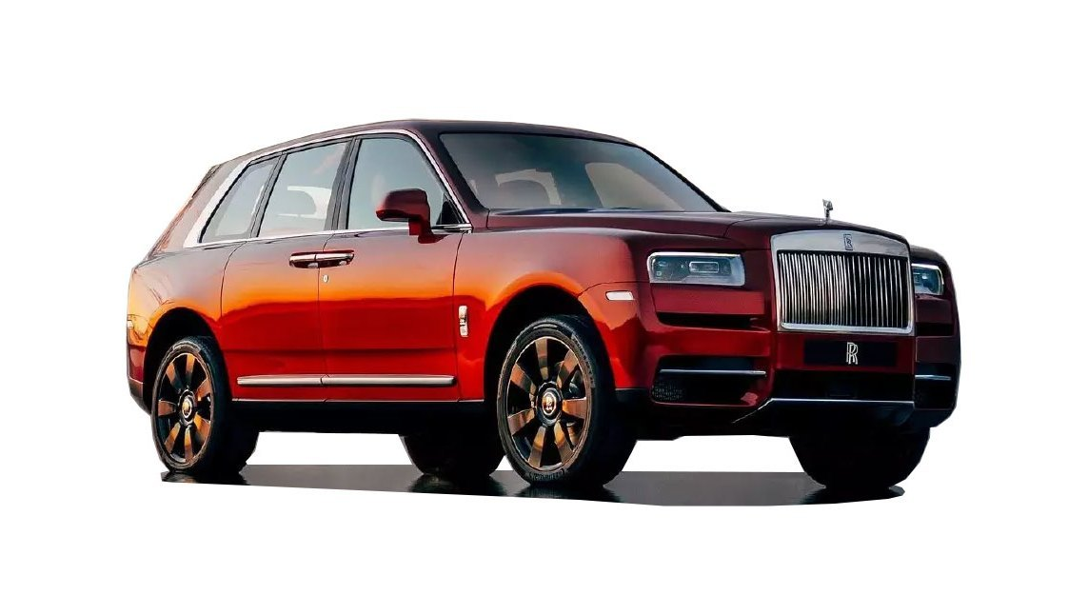
Figure 1: Rolls-royce cullinan model
(Source: Rolls-Royce, 2021)
Blog 2:
Keep your royalty intact with the Rolls-Royce Cullinan
Are you someone who loves to carry the royalness in the attitude? In this case, having a car that is specially built to keep the royalty intact is important. Rolls-Royce, one of the most trusted motor brands in the global market, has launched a royal item named Rolls-Royce Cullinan. The company has been trusted by the lots of customers for the intact performance.
The brand has its branches globally and is famous for delivering the top notch products in the market. The speciality of this car is not just bound to the top-notch features but the car also possesses a highly extensive exterior coming in the different variants and colours.
The 5 seater car helps in keeping the royal attitude in your characters and the most important factor of the car is that it comes with the top-notch features like.
- Power Steering assists the car to have better control.
- Power Windows Front gives the owner an easier control over the windows.
- Air Conditioner keeps the interior of the car cool and conditioned.
- Anti Lock Braking System assists in preventing the wheels from getting locked and enables features like safe braking.
- Passenger Airbags ensure the safety of people riding in the car. This airbag plays a vital part in keeping the passenger safer.
- Alloy Wheels decline unsprung weight and in this way communicate less dormancy to the springs, accordingly permitting the suspension to follow the landscape all the more effectively, subsequently giving better hold
- Automatic Climate Control helps the car to possess the control over surrounding that keeps the atmosphere of the car intact and makes the place more comfortable.
- Driver Airbag ensures the safety of the driver and moreover, it protects the pilot in the time of emergency.
- Fog Lights - Front is a sort of auto light that helps the driver find before the vehicle.
This is the car in which you can get all the features intact. You will feel like a king who has all the facilities in his own palace. Don’t wait and book your chariot to enjoy the royal ride.
Blog 3:
Touch the taste of liberty with Rolls-Royce
Life's not about sitting in your home and enjoying the beauty of nature through the glass of your television. You have to step out to the real world and feel its beauty yourself. Planning your next trip to the mountain will get easier with the Rolls-Royce. The brand has different kinds of cars’ variants that come with different specifications. Among them, Rolls-Royce Cullinan is one of the most trusted options for buyers. This car comes with the toughness of the stone and its exterior has the clarity of the sky.
How can you get the taste of liberty with the Rolls-Royce?
While riding this car, you are safe from all hazards of the external world and enjoy your liberty at your fullest amidst nature.
The brand has the ultimate specifications featured with all the modern day technology and advantages like ARAI Mileage of 9.5 kmpl, Seating Capacity of five people, Fuel Type of petrol, 12 cylinders, automatic transmission and many more.
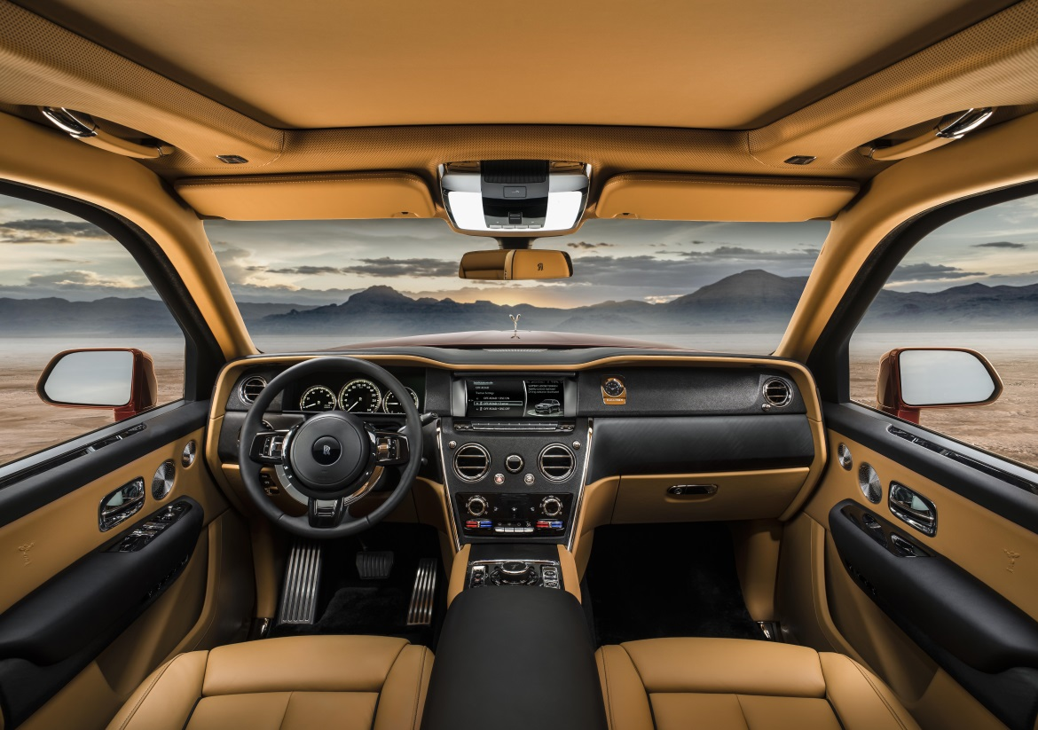
Figure 2: The interior of the car
(Source: Rolls-Royce, 2021)
How the car meets all the modern day requirements
The features of the car are already mentioned. Suppose, you and a card that possesses all the modern day features like high end sitting features. High speed pace and a beautiful exterior design, this car can be your best choice.
The brand has such popularity that it hardly requires a promotional approach but it doesn’t mean that the brand doesn’t follow the promotional ads (Mallik and Farhan 2018). However, the promotional approach of the Rolls Royce is rather subjective and that leads the more clients to the car brand.
However, the brand is well-known and makes sure all the products manufactured under this brand come in top-notch quality. This brand is the epitome of trust and reliability. Don’t waste more time on thinking but purchase your copy within your budget.

Blog 4:
Have the POTENCY AND PACE in your car - Rolls-Royce
Want to purchase a car that comes with the ultimate potency and pace? If yes, the Rolls Royce can be your ultimate choice. The brand comes with reliability and trust of the years that makes it popular among the buyers. This car is the ultimate choice to keep your comfort intact.
Pace and Potency
From Scottish high countries to Arabian deserts, form Austrian mountains to the epic scenes of the United States. Cullinan vanquishes three mainlands and 12,000 miles of the world's hardest landscape to grandstand its incomparable ability – in organisation with National Geographic.
- Cullinan is an off-road, the entire season SUV. Drivers venture in certainty, realising that Cullinan's boundless exhibition ability supports each outing. Inside Cullinan's liberal lodge, travellers are protected, secure, and especially agreeable.
- Controlled by the expert engineers, the principal Rolls-Royce all-wheel drive moves with easy balance.
- The car sees Cullinan go up against the hardest slopes and conditions with no sweat. Watch as it vanquishes every impediment with considerable power, taking zenith travel to new territory.
Authority
The Final Challenge is a campaign to limits – of landscape, of height and of climate. In this film, Cullinan aces each challenge easily; its extraordinary Rolls-Royce aluminium space outline, back hub directing and all-wheel drive capacity making smooth work of the most unpleasant conditions.
However, the brand follows The Principle of Marketing by Kotler and Armstrong that serves the important idea for viable showcasing techniques. The 15 th and 16 th release of The Principle of Marketing talks about the compelling advertising approach.
Wrapping Up
Are you looking for the best car that suits all your requirements related to the topic? In this case, you might opt for Rolls-Royce Cullinan.

Blog 5:
Have the taste of ultimate smoothness during driving with Rolls-Royce
Do you want to purchase a top-notch car that comes with the smoothness of a feather? In this case, Rolls-Royce Cullinan is your ultimate choice. The car comes with comfortable sittings. A liberal design for two travellers
The Immersive Seating choice permits you to just recline and loosen up as the back rub seats baby you in extreme extravagance. Then, at that point, toast the event with a beverage from the Champagne cooler or whisky decanter housed in the mid control area, which likewise contains either two Rolls-Royce champagne woodwinds or whisky glasses. Along with this, you can enjo the following features.
- At the dash of a button, two perfectly completed calfskin seats and a mixed drink table are designed from the gear compartment. The Bespoke Viewing Suite gives you the best seat for the best perspectives on the planet, as you partake in the vista in preeminent extravagance.
- Cullinan's Immersive Seating choice makes Cullinan the main SUV with a glass segment between gear compartment and back travellers. Extreme refinement, guaranteeing unmatched sound establishment and continuous solace. This is your private retreat to organise as you wish.
- A Rolls-Royce is in excess of an engine vehicle. It is a masterpiece, hand-specially made only for you, by our group of profoundly talented craftspeople and architects. Whatever you envision your optimal engine vehicle to be, rejuvenate your vision with Rolls-Royce Bespoke.
Drive more intensely into the scope of customised services and choices that are accessible to you, or contact our experts to talk about how we can understand your vision to success (Smith-Gillespie et al. 2018.). However, if you are planning for your dream car this year, Rolls Royce is the vehicle you are looking for. Feel free to reach the website to check out more features that ensure the ultimate smoothness.

Blog 6:
Why Rolls-Royce Cullinan is your ultimate destination for authenticity
Are you planning to purchase your next car soon? However, you are confused about which car to buy or which to leave as there are lots of cars in the market. In this case, purchasing the Rolls-Royce model can be beneficial.
Regardless of your requirements, the brand comes with all the features that are essential to ensure a luxurious ride to the owners and however, the brand being the symbol of trust and beauty, ensures the ultimate quality in terms of the quality and price.
Engineering OF LUXURY
A remarkable aluminium space frame supports Cullinan, alongside new Rolls-Royce frame innovation, to convey the mark Rolls-Royce wizardry cover ride. The driving experience is superior, whatever the conditions, as you enjoy an extravagant SUV excursion of unrivalled solace.
ROLLS-ROYCE RIDE QUALITY
Making a great many computations consistently, self-evening out air suspension pads against the hardest surfaces, all proactively acclimating to speed increase, directing signs and camera knowledge. While the twofold wishbone front hub and five-interface back hub convey spryness and steadiness.
PRESS TO GO ANYWHERE
The Off Road Button releases Cullinan's full rough terrain capacity. All-wheel drive effectively draws in, giving continuous force to each of the four wheels for exact, dependable execution on dry, wet, blanketed or frosty surfaces. Suspension raises 40 mm to offer extra ground leeway. Brake and speed increase reactions adjust for more noteworthy control and responsiveness on lopsided landscapes. When drawn in, the rough terrain setting can be custom-made for ideal execution on any territory, slope, or surface quality.
However, the brand follows the marketing theories of Kotler & Armstrong to ensure the ultimate efficiency in terms of marketing too (Amanah et al. 2018). The Rolls Royce ensures the brand value as well as beauty under the same roof. Don’t wait, grab your car now.
Conclusion
The international brand Rolls Royce has used the process of content marketing to promote its newly launched products such as Rolls-Royce Cullinan. The brand has efficiently used the blogs to highlight the products of the brand. The assignment discusses all the basic aspects of blog marketing and marketing policies that have helped the brand to improve the marketing policies of the company.

Reference
Amanah, D., Hurriyati, R., Gaffar, V., Layla, A.A. and Harahap, D.A., 2018. Effect of Price and Product Completeness to Consumer Purchase Decision at Tokopedia. com. In Proceedings of the 2nd Global Conference on Business, Management and Entrepreneurship 2017 (Vol. 1, pp. 34-37).
Mallik, A. and Farhan, S.N., 2018. Customer Centric Approach Using 7ps of Marketing Mix. International Journal of Innovative Knowledge Concepts, 6(11), pp.136-149.
Smith-Gillespie, A., Muñoz, A., Morwood, D. and Aries, T., 2018. ROLLS-ROYCE: A Circular Economy Business Model Case.
Rolls-royce. (2021). Models. Available at https://www.rolls-roycemotorcars.com/chennai/en_GB/showroom.html?utm_source=google&utm_medium=cpc&utm_campaign=brandrecall&gclid=Cj0KCQiAk4aOBhCTARIsAFWFP9GSizk4YfawARvjvy2GqZwodFi-A2tq0VyewQMrwUCheuKQiAd5WwUaAreSEALw_wcB (Accessed 12 December 2021)

