Thermodynamics and Combustion

ACHA5011

Engine Cycle Simulation

Oscar Davis
2410215

Task 2

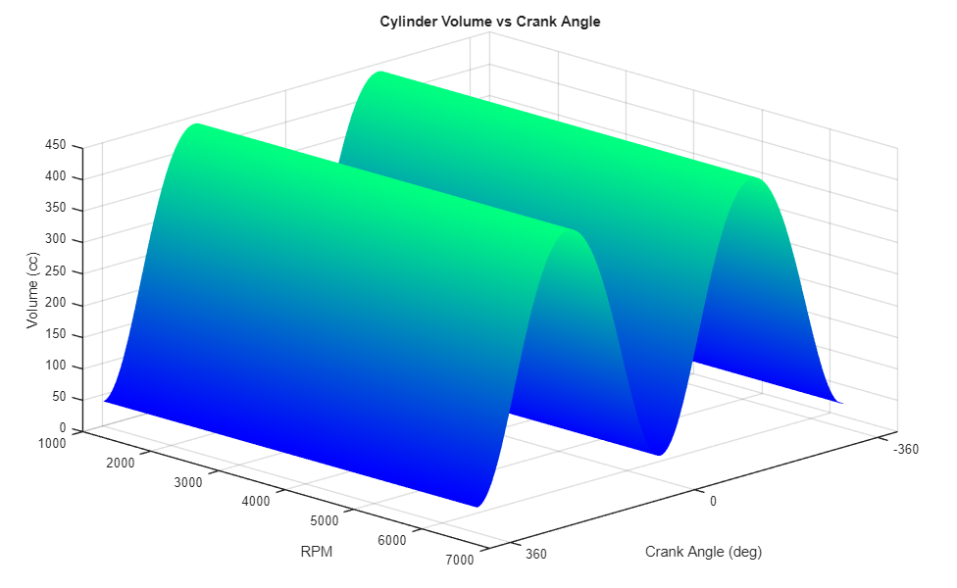

Cylinder Volume vs Crank Angle
This graph shows how the cylinder volume changes with crank angle during one complete engine cycle from -360 to 360 degrees. Volume changes with the piston position between top dead centre (TDC) and bottom dead centre (BDC). This is not a linear change as the piston slows down around -360, 0, 360 (TDC) and -180, 0, 180 (BDC) because of the connecting rod. The maximum volume (Vmax) appears at BDC, and the minimum volume (Vmin) occurs at TDC. Volume remains constant the over every RPM due to the engine’s fixed geometry.

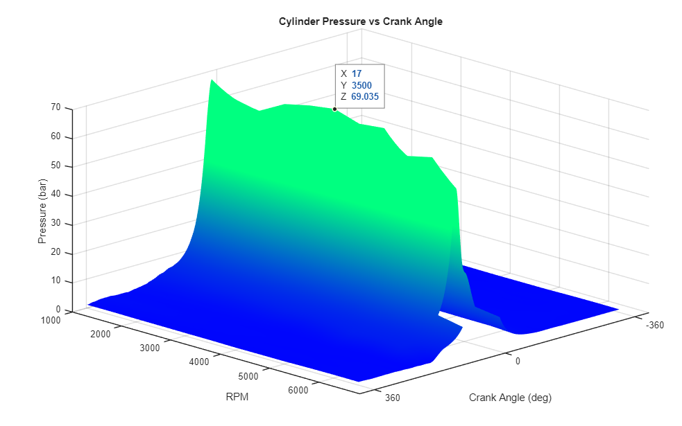

Cylinder Pressure vs Crank Angle
This graph shows cylinder pressure changing with crank angle over a range of different engine speeds. The pressure rapidly increased after top dead centre at approximately 17 degrees, this is where pressure peaks at 69.035 bar and applies the maximum force on the piston. After the peak, pressure decreases rapidly toward bottom dad centre, showing that pressure and combustion timing change with crank angle and engine speed to output the most efficient engine performance.

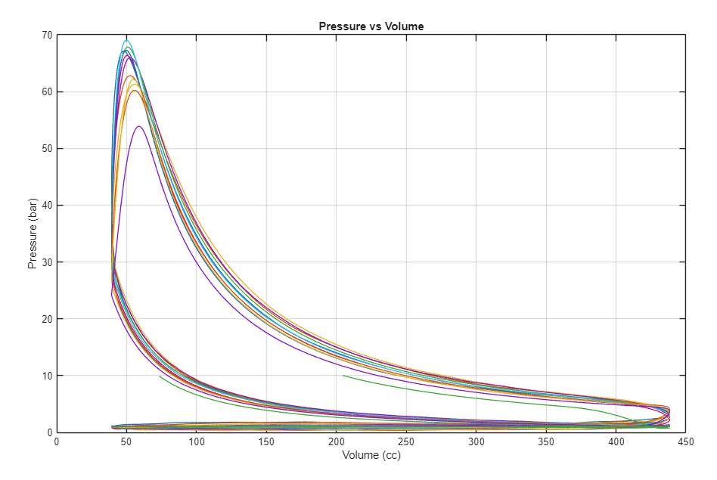
4

3

2
1

Pressure vs Volume
The graph above display cylinder pressure variation with volume over a range of different RPM’s. The line from point 1 to 2 shows the engine’s intake stroke followed by the compression from point 2 to 3. Point 3 marks the beginning of the pressure rise from the fuel combustion. Point 4 then marks the point of peak pressure after the fuel has combusted. From point 4 to point 2, the gases within the cylinder begin to expand and volume increases. Point 2 to 1 shows the exhaust stroke of the engine. Valve overlap occurs at point 2, the exhaust valve still open as the intake valve opens to extract any remaining ages in the cylinder. The area between 2 to 3 represents work done to move the intake and exhaust air. However, the area between 2, 3, and 4 shows the force delivered to the crank shaft.
Because this engine is naturally aspirated, the intake stroke pressure sits slightly below atmospheric while the exhaust stroke sits slightly above, creating a small pumping loop that represents a net work loss to the system. On a turbocharged engine this reverses — pressurised intake charge does positive work on the piston, while exhaust gases overcome turbine backpressure, increasing pumping losses but improving overall power output through greater air-fuel mass flow. (x-engineer.org, 2024)

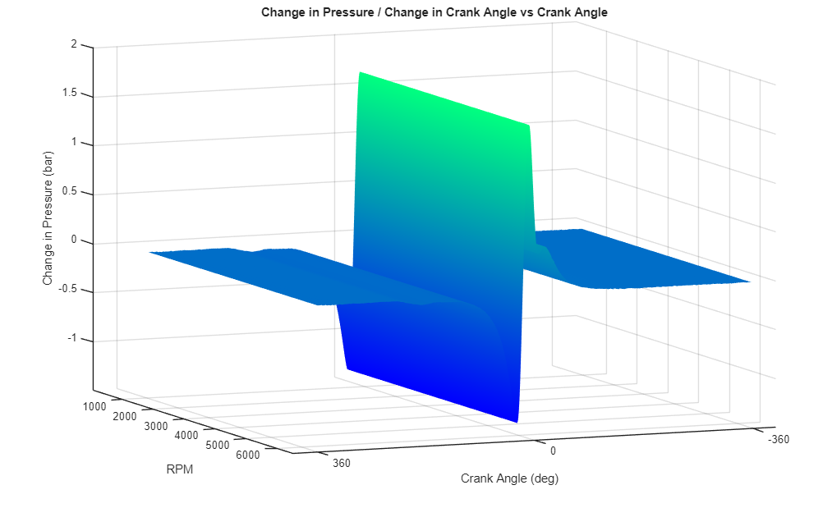

Change in Pressure vs Crank Angle and RPM
This graph displays the rate of change in cylinder pressure with respect to crank angle across the engine’s RPM range. The sharp spike occurring shortly after top dead centre represents the rapid increase in pressure caused by combustion of the air–fuel mixture. This is where the pressure rise rate is highest due to the rapid release of heat from combustion. Before this point the pressure increase is mainly due to compression during the compression stroke. After the peak, the rate of pressure change becomes negative as the gases expand and cylinder pressure decreases during the expansion stroke. The behaviour across RPM indicates that combustion occurs within a similar crank angle region, although the magnitude of pressure change can vary with engine speed.

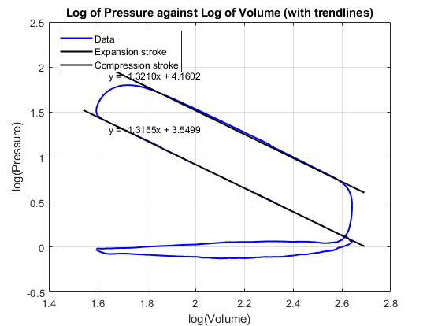

This graph shows the logarithm of cylinder pressure plotted against the logarithm of cylinder volume for a single RPM, used to determine the polytropic index (n) for the compression and expansion strokes. Plotting in log-log space linearises the polytropic relationship PV^n = C, meaning the gradient of a fitted trendline directly equals n. Trendlines were fitted to the clean linear regions of each stroke, deliberately excluding the start and end of combustion, valve events, and data noise at TDC and BDC. This method follows the approach outlined by Grau et al. (2002). The resulting values are n_compression = 1.3155 and n_expansion = 1.3210, both falling within the range of n = 1.3 ± 0.05 reported by Heywood (1988), confirming the validity of the analysis. The marginally higher expansion index reflects additional energy losses during expansion due to heat transfer to the cylinder walls and incomplete combustion effects.

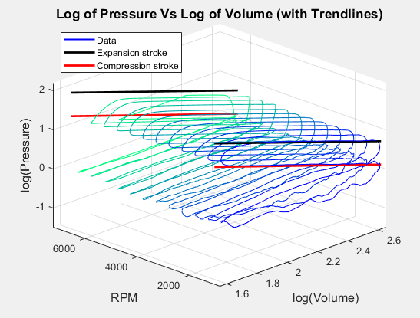

This graph shows the logarithm of cylinder pressure plotted against the logarithm of cylinder volume across the full RPM range. The upper surface represents the compression and expansion strokes, while the lower surface corresponds to the gas exchange strokes where pressure remains near atmospheric. The polytropic coefficient during the compression cycle of a reciprocating engine depends on the instantaneous values of pressure and volume, and the consistent surface shape across all engine speeds confirms that polytropic behaviour is largely independent of RPM. (Lapuerta et al., 2003)

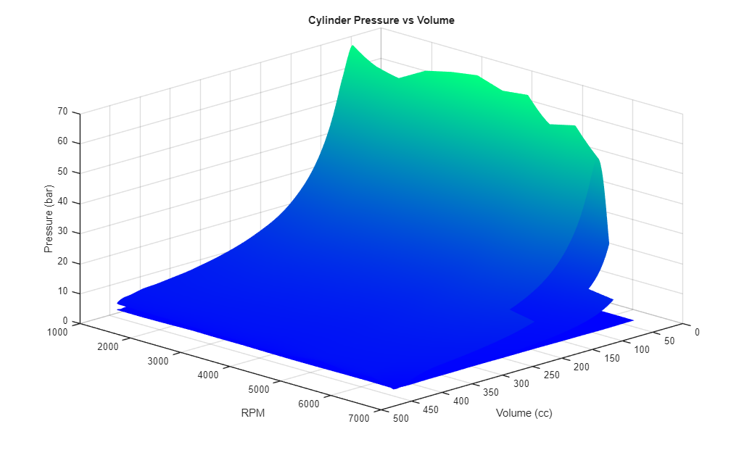

Cylinder Pressure vs Volume and RPM (3D Surface)
This graph shows the variation of cylinder pressure with cylinder volume across a range of engine speeds. At smaller volumes, near top dead centre, the pressure increases significantly due to the compression of the air–fuel mixture followed by combustion. The peak pressure region represents the point where the combustion gases exert the maximum force on the piston. As the piston moves toward bottom dead centre the volume increases and pressure gradually decreases as the gases expand. Across the RPM range the general pressure–volume relationship remains similar, although slight variations can occur due to changes in combustion dynamics and engine operating conditions.
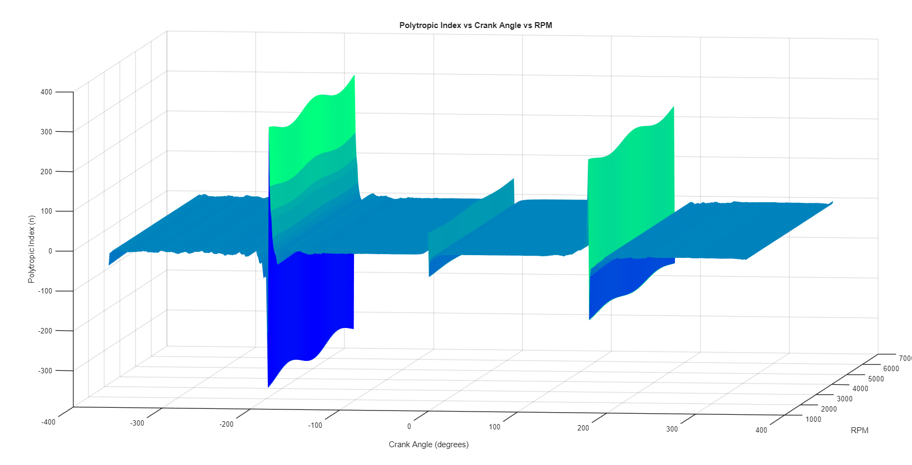

Polytropic Index vs Crank Angle and RPM
This graph illustrates how the polytropic index changes with crank angle for different engine speeds. The polytropic index describes the thermodynamic behaviour of the gas during compression and expansion. During the compression stroke the index tends to approach values close to the ratio of specific heats, indicating near-adiabatic compression. Around the combustion region the index changes rapidly due to heat release and the complex thermodynamic processes occurring in the cylinder. During the expansion stroke the value stabilises again as the high-pressure gases expand and transfer energy to the piston. Variations across RPM show how engine speed can influence heat transfer and combustion characteristics.
The large spikes visible at TDC and BDC occur because the piston momentarily stops at these positions, causing both pressure and volume to change very slowly. This makes the denominator in the polytropic formula (ln V₂ − ln V₁) approach zero, producing numerically unstable and physically meaningless values at these points. These spikes should therefore be disregarded when interpreting the polytropic behaviour of the cycle.

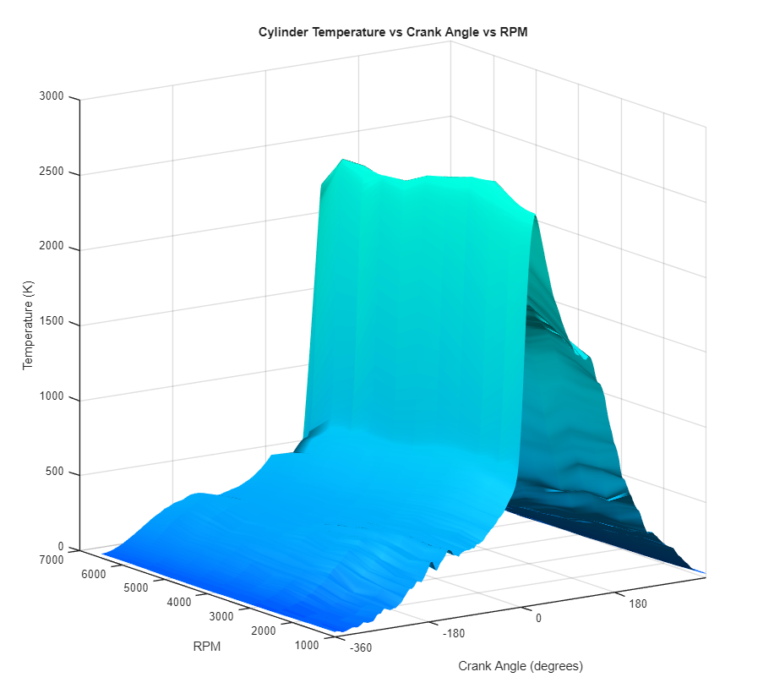

Cylinder Temperature vs Crank Angle and RPM
This graph shows how cylinder temperature varies with crank angle across different engine speeds. Temperature is calculated from the ideal gas law, rearranged as: T = (P × V) / ((m_air + m_fuel) × R).
The temperature remains relatively low during the intake stroke as fresh air enters the cylinder. During the compression stroke the temperature rises as the air–fuel mixture is compressed. A sharp increase occurs shortly after top dead centre when combustion takes place, producing the highest temperatures within the cycle. After this peak, the temperature gradually decreases as the gases expand and perform work on the piston during the power stroke. The trend across RPM indicates that while the timing of peak temperature remains similar, the magnitude can vary slightly depending on engine speed and combustion efficiency.
The peak cylinder temperatures visible in the graph significantly exceed the melting point of aluminium (~660°C), which underlines the critical importance of engine cooling systems in preventing structural damage to the cylinder head and piston crown during sustained operation.

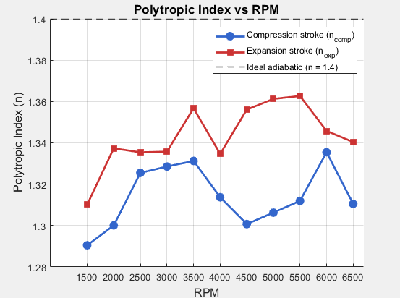

This graph shows how the polytropic index n varies with engine speed for both the compression and expansion strokes. n_comp ranges between 1.29–1.33 and n_exp between 1.31–1.36, with expansion consistently higher due to greater post-combustion heat transfer to the cylinder walls. Both fall below the ideal adiabatic value of n = 1.4, and at higher RPM both indices trend upward as less time is available for heat loss per cycle. The values n_comp = 1.3155 and n_exp = 1.3210 are consistent with the range of 1.25–1.35 reported for spark ignition engines by Lapuerta et al. (2003).

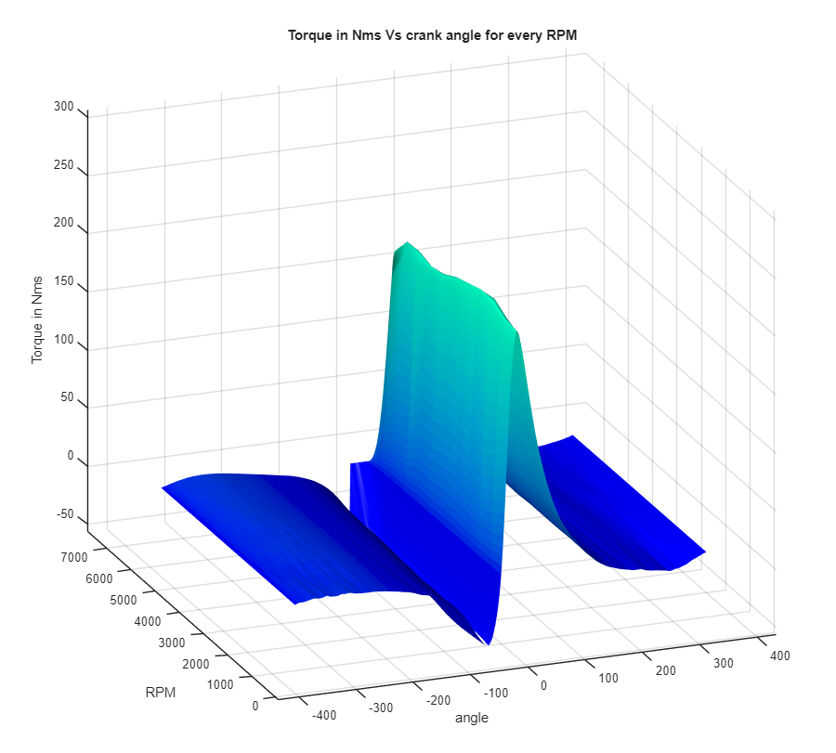

Torque vs Volume and Crank Angle (per RPM)
This graph shows the relationship between torque, cylinder volume, and crank angle across the engine’s operating speeds. This is calculated per degree as: τ = Pressure × Change in Volume (dV).
Torque production is closely linked to the pressure generated during combustion and the mechanical advantage of the crank mechanism. The highest torque occurs shortly after top dead centre where the cylinder pressure is high and the crank angle allows the expanding gases to exert maximum force on the piston and crankshaft. As the piston moves toward bottom dead centre the pressure decreases and the torque contribution reduces. Across different RPM values the peak torque region remains within a similar crank angle range, reflecting the engine’s combustion timing and mechanical design.
During the intake and exhaust strokes, torque becomes negative as the engine must do work to pump gases in and out of the cylinder rather than extracting work from them. The net positive torque per cycle, obtained by integrating the torque curve, represents the indicated work output of the engine in Joules.
(The code for this graph was lost and I couldn’t recreate it, therefore the new code works but gives a different graph.)

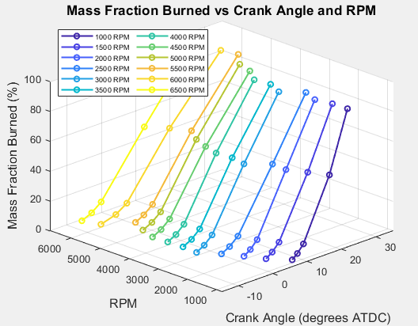

This graph shows the crank angle at which 2%, 5%, 10%, 50% and 90% of the fuel has burned across the RPM range. MFB50 shifts from approximately 18° ATDC at 1000 RPM to around 10° ATDC at higher RPM as ignition timing advances. Burn duration increases in degrees with RPM as there is less time per revolution for combustion to complete. (Bonatesta et al., 2013)

Task 3
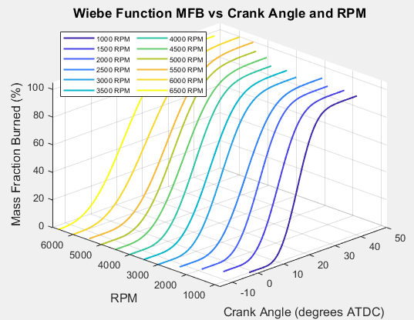

The Wiebe function was fitted to the measured MFB data using constants a = 5 and m = 2, reproducing the S-shaped burn progression across all RPM. The surface shifts earlier with increasing RPM, consistent with advancing ignition timing. These fitted parameters are used in Task 3 to calculate heat release per degree. (Yeliana et al., 2025)

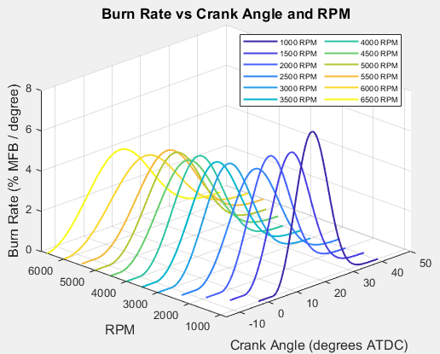

This graph shows how quickly fuel is burned per degree of crank rotation. The burn rate peaks near TDC before declining as combustion completes during the expansion stroke. At higher RPM the peak occurs slightly earlier due to advanced ignition timing. (Khoa and Lim, 2022)

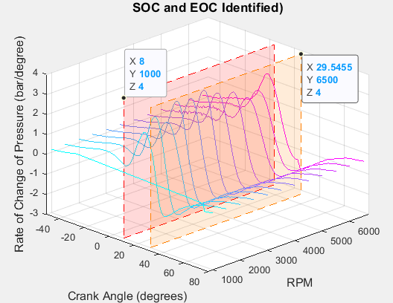

This graph shows two pressure surfaces plotted against crank angle across the RPM range. The lower surface is the simulated pressure without combustion, rising and falling purely due to compression and expansion. The upper peaked surface shows the simulated pressure with combustion added, which is significantly higher due to the heat released from burning fuel near TDC. The clear separation between the two surfaces demonstrates the contribution of combustion to cylinder pressure.

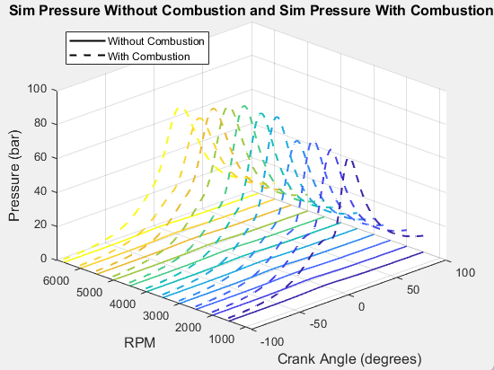

This graph shows the rate of pressure change across the full RPM range with SOC and EOC marked. The spike after TDC represents rapid pressure rise from combustion. SOC occurs at approximately 8.5° ATDC and EOC at approximately 29.6° ATDC, giving a combustion duration of approximately 21°. (Bonatesta et al., 2013)

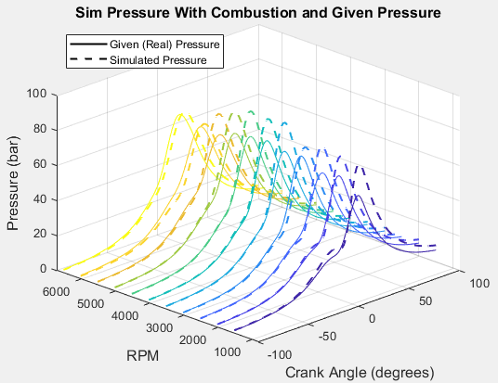

This graph overlays the simulated pressure with combustion against the real measured Sigma data to validate the model. The two surfaces follow a similar shape and magnitude across the RPM range, with peak pressures of approximately 67–69 bar aligning well near TDC. The simulated SOC of approximately 8.5° ATDC and combustion duration of approximately 21° are consistent with the real data identified in Task 2. Some deviation is visible on the expansion stroke where the simulation slightly overestimates pressure, likely due to the assumption of constant gamma and no heat transfer losses. (Bonatesta et al., 2013)

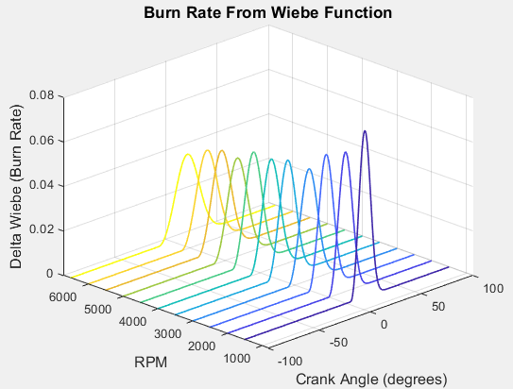

This graph shows the rate of change of the Wiebe function per degree, representing how quickly fuel is burned at each point in the cycle. The burn rate rises sharply from the start of combustion, peaks near TDC, then declines as combustion completes during the expansion stroke. Multiplying the burn rate by fuel mass and calorific value gives the heat released per degree, which is the key input to the combustion pressure calculation. (Khoa and Lim, 2022)

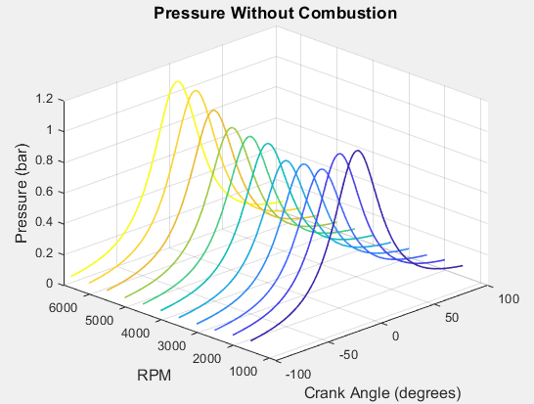

This graph shows the simulated cylinder pressure calculated without any combustion using the polytropic relationship P2 = P1(V1/V2)^n with the real polytropic indices n_comp = 1.3155 and n_exp = 1.3210 determined in Task 2. The pressure peaks at only approximately 25–30 bar at TDC, confirming that compression alone cannot account for the high pressures seen in the real data and that combustion heat release is the dominant factor driving peak cylinder pressure. (Lapuerta et al., 2003)

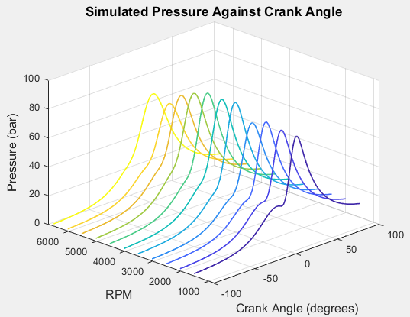

This graph shows the final simulated cylinder pressure with combustion plotted against crank angle across the full RPM range. Peak pressure occurs just after TDC, consistent with the SOC of approximately 8.5° ATDC identified in Task 2, and increases with RPM due to advancing ignition timing. The shape closely matches the real measured data, demonstrating the refined model is a significant improvement over the ideal Otto cycle from Task 1. (Bonatesta et al., 2013)

Model Refinement
The ideal model developed in Task 1 used a fixed gamma of 1.4, assumed instantaneous heat addition at TDC, and used polytropic indices of n_comp = 1.33 and n_exp = 1.27 with a fixed start of combustion at -15° and burn duration of 40°. For Task 3 these were refined using the real data from Task 2. Gamma was updated to 1.35, n_comp was updated to 1.3155 and n_exp to 1.3210 from the log P vs log V analysis, and the Wiebe function was fitted to the real MFB data at each RPM so that SOC and burn duration varied realistically across the rev range rather than using fixed assumed values.

Validation and Comparison
Comparing the simulated pressure against the real Sigma data shows good overall agreement across the RPM range. Peak pressures of approximately 67–69 bar occur near 17° ATDC in both the real and simulated data, and the shape of the pressure trace through combustion and expansion is well reproduced. The simulated SOC of approximately 8.5° ATDC and combustion duration of approximately 21° are consistent with the real data identified in Task 2. Some deviation is visible on the expansion stroke where the simulation slightly overestimates pressure, likely due to the assumption of constant gamma and no heat transfer losses. (Bonatesta et al., 2013)

Modelling Limitations and Suggested Improvements
The model makes several simplifying assumptions that limit accuracy. Gamma is fixed at 1.35 throughout the cycle, whereas in reality it varies with temperature as combustion progresses. Heat transfer to the cylinder walls is ignored, which causes the simulation to overestimate pressure during the expansion stroke. Volumetric efficiency is fixed at 0.85 rather than varying with RPM, which affects the accuracy of the air and fuel mass calculations particularly at low and high engine speeds. Blow-by and friction losses are also not modelled. To improve accuracy, a temperature-dependent gamma could be implemented, a heat transfer model such as the Woschni correlation could be added, and volumetric efficiency could be mapped against RPM using real airflow data from the Sigma engine. (Khoa and Lim, 2022)

References

Bonatesta, F., Chiappetta, E. and La Rocca, A. (2013) ‘Part-load intake valves timing effects on fuel economy and combustion in a spark ignition engine’, Applied Energy, 110, pp. 196–207.
Grau, J.H. et al. (2002) ‘Determination of the polytropic index in reciprocating engines’, Proceedings of the SAE International.
Heywood, J.B. (1988) Internal Combustion Engine Fundamentals. McGraw-Hill, New York.
Khoa, N.X. and Lim, O. (2022) ‘Influence of combustion duration on the performance and emission characteristics of a spark-ignition engine’, ACS Omega, pp. 1–12. Available at: https://pubs.acs.org/doi/10.1021/acsomega.1c05759 [Accessed 8 March 2026]
Lapuerta, M., Armas, O. and Molina, S. (2003) ‘Study of the compression cycle of a reciprocating engine through the polytropic coefficient’, Applied Thermal Engineering, 23(3), pp. 313–323.
x-engineer.org (2024) The pressure-volume (pV) diagram and how work is produced in an ICE. Available at: https://x-engineer.org/pressure-volume-pv-diagram/ [Accessed 7 March 2026]
Yeliana, Y. et al. (2025) ‘Wiebe function parameter determination for mass fraction burn calculation in an ethanol-gasoline fuelled SI engine’, Academia.edu. Available at: https://www.academia.edu/34751425 [Accessed 8 March 2026]

