Student name: |  | Student ID number:
Programme: | International Hotel Management (BA)
Module: | International Meetings Management for the Hotel Industry
Module code: | BMIH6007 |  | Contribution to Overall Module Assessment (%): |  | 50%
Lecturers: | Kathryn Flynn (Module Lead) Jemma Smith (Lecturer) |  | Internal Verifier: |  | Lisa Bassler
Assignment Title: | Assignment 1: Feasibility Plan for an International Meeting.  Individual Presentation (50%) |  | Word count (or  equivalent): |  | 15-Minute Presentation
Submission deadline: | Presentations to be  Completed Week Of 6th May 2024 (In-Class).  Draft Deadline  Week of:29th April 2024 |  | Return date of  provisional marks & written feedback: (20 working days) |  | Friday r June 2024 23:59pm

Student Name: Bruma Daniela Ionela
ID:2138799
Table of Contents

Cover Page 3
Introduction 4
Event Concept and Theme 5
Feasibility Study Overview 7
Situational Analysis and Research 9
Operational Factors 11
Financial Factors 13
Feasibility Analysis and Justification 15
Conclusion 17
References 18

Cover Page


Introduction
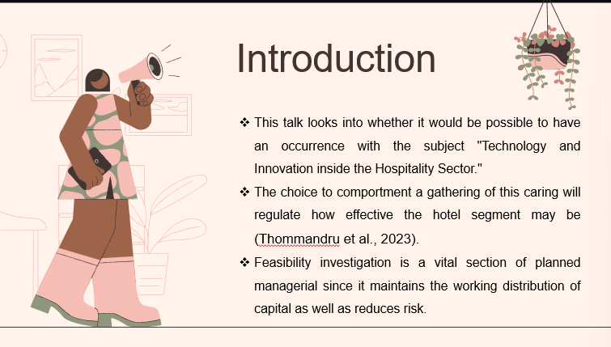
Throughout this presentation, will cover a wide-ranging variety of subjects related to the viability of this occurrence, including market dynamics, functioning trials, and financial feasibility. By critically investigating these problems, it wants to throw into importance the practical essentials of the growth of an effective event that is in line with the skill and development theme (Thommandru et al., 2023).

Event Concept and Theme
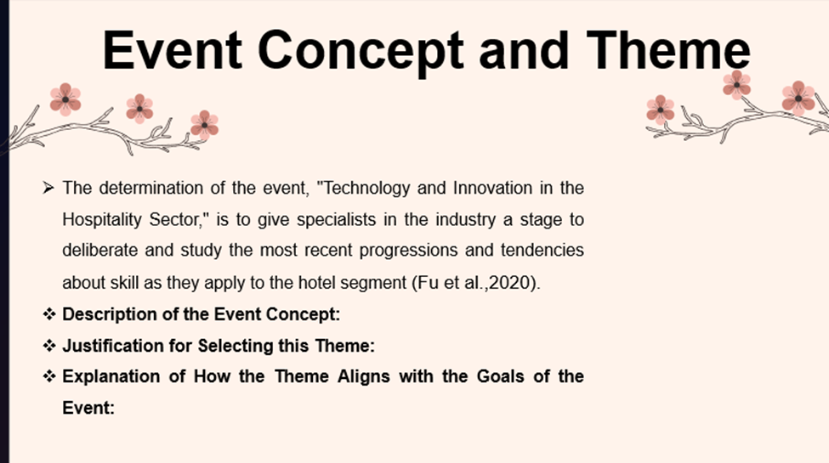

Description of the Event Concept: Through collaborating shops, important talks, panel considerations, and technical exhibits, attendees will get a consideration of how innovative skills are transforming the hotel business. Among the topics that will be covered are virtual reality, artificial intellect, smart hotel systems for organisation, ecologically approachable measures, and digital advertising plans personalised to the hospitality segment (Fu et al.,., 2020).
Justification for Selecting this Theme: The result of making "Technology and Innovation within the Hospitality Sector" the theme of the seminar event was interest in the fast progression of skill and its notable effect on the hotel business. Hotels and other hospitality trades must hold technical innovation to continue modestly and content with the changing demands and prospects of modern companies. By intent on this topic, the event hopes to endorse innovation, cooperation, and information distribution within the segment (Lee et al., 2021).
Explanation of How the Theme Aligns with the Goals of the Event:
The theme of technology and invention aligns perfectly with the all-embracing objectives of the event, which comprise:
• Providing a stage where subject-matter authorities might stay up to date on the latest growths and fashions in skill (Boz et al., 2020).
• Endorsing networking and teamwork amongst business players in the hospitality segment.
• Providing contributors with the determination and capital essential to hold innovation and influence skills to improve visitor involvement, the sustainability of the organisation, and operative efficiency.
• Promoting supposed management and distribution top methods for leveraging skill to provide the hotel business with a competitive advantage and incentive development.
Overall, the event theme of "Technology and Innovation within the Hospitality Sector" not only reflects the present landscape of the business but also helps as a substance for driving optimistic alteration and development within the segment (Huang et al., 2022).

Feasibility Study Overview
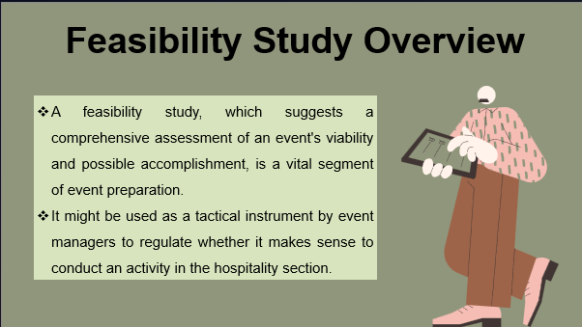
- Explanation of the Purpose of a Feasibility Study:
- In the overall arrangement of event growth, a feasibility study's main impartial is to measure an event idea's feasibility. This means doing a thorough inspection of several problems, such as monetary issues, market demand, and working difficulties. Event managers use the consequences of a feasibility study to select whether to continue with the event or not. It helps regulate whether the occasion idea is applied and aligns with it.
- Significance of Critically Analysing Feasibility Factors:
- To ensure the achievement of the event, a thorough examination of the feasibility basics is essential.
- Through a careful valuation of these attributes, event managers can identify potential roadblocks, risks, and opportunities related to the event (Nussbaumer et al., 2023).
- This allows the application of careful alterations that lower possible risks and increase the likelihood that a condition will prosper.
- When it comes to organising and carrying out an occurrence, event planners face the risk of overlooking vital features that might influence the consequence and consequence in unforeseen issues if viability issues are not thoroughly inspected.

Situational Analysis and Research

- Overview of the Components to be covered in the Feasibility Study:
- There are numerous workings to the feasibility learning, all of which are essential to measure the activity's feasibility as well as deliver valuable data for the executive.
- These workings comprise (Nussbaumer et al., 2023).
- Market Analysis:
- Measuring target market demographics, preferences, as well as behaviour (Shahbaznezhad et al., 2021).
- Analysing the demand of the market for the event idea and classifying potential contestants.
- Assessing trends and business growths that may influence the event (Shahbaznezhad et al., 2021).
- Target Market: The target marketplace for the event contains individuals and investors in the hospitality segment, comprising hotels, restaurateurs, as well as managers of measures, technology providers, and business authorities. Representatives from adjacent businesses like tourism, travel, as well as technology might also be a share of the target spectators (Camiller, 2020).
- Demand for the Event: The hospitality subdivision has an important need for information-focused proceedings due to the rapid progression of skill and its cumulative prominence in improving guest skills, cumulative operative competence, and driving commercial growth. Industry specialists are keen to stay up to date on the latest progress, trends, as well as best practices to stay pertinent and meet developing customer prospects.
- Competition Analysis: The hotel business might be the emphasis of more sessions and proceedings, while rivalry in the field of invention and knowledge might be less penetrating. However, potential participants may be:
- Main business sessions or trade shows with innovation as well as technology-related topics (Fuente-Robles et al., 2020).
- Competing events targeted at comparable spectators but with dissimilar themes or emphases.
- Webinars or connected conferences with alike networking and gratified. By contributing unique material, informed speakers, communicating workshops, as well as beneficial networking chances personalised to the target spectator’s requirements and tastes, the event will distinguish itself from the rivalry. To increase consciousness of the event and attract attendees, innovative advertising plans and partnerships with prominent business personalities will be working (Farida and Setiawan, 2022).

Operational Factors
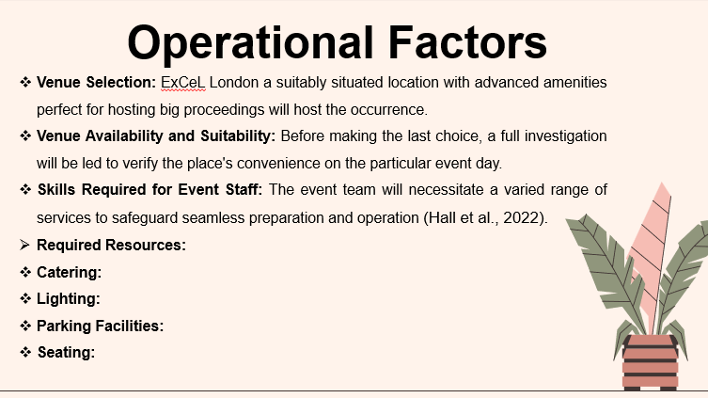
- Operational Planning:
- Identification of appropriate venues for the proceedings and measuring the accessibilities and appropriateness (Boz et al., 2020).
- To determine the resource requirements that include the equipment, staffing and logistical support.
- To properly evaluate transportation, accommodation, as well as other logistical considerations for attendees.
- These might involve practical ability with audiovisual skills, event arranging and supervision, crisis organisation, purchaser provision, and logistical administration.
- To make sure they have the information and skills essential to do their responsibilities efficiently, staff associates will get briefing and preparation sessions (Gupta et al., 2022).
- Required Resources:
- Catering: To ensure that attendees are content and comfortable, catering facilities are successfully set up to deliver food as well as refreshments throughout the event.
- Lighting: A visually appealing as well as dynamic situation that is perfect for networking as well as gaining information will be shaped with the use of practised lighting apparatus.
- Parking Facilities: There will be adequate parking spots obtainable to accommodate guests' vehicles as well as permits for simple entrance and exit from the site (Hall et al., 2022).
- Seating: Comfortable seating preparations will be provided to improve contributor comfort through lectures, sessions, and networking activities.
- Skills Required for Event Staff:
- When defining the venue's appropriateness for the result, issues such as its competence, organisation, accessibility, and facilities will be taken into interpretation to accommodate the predictable number of attendees contentedly. Those existences are obtainable for the program since it is arranged for April 30 (2024)Also, the site is suitable for attendees, making it simple for them to get there as well as take part in the occurrence (Shaikh et al., 2021).
- Venue Availability and Suitability:
- There is plenty of space at the site for sessions, presentations, and networking accomplishments. Modern audiovisual equipment is also used to improve the knowledge of visitors.

Financial Factors
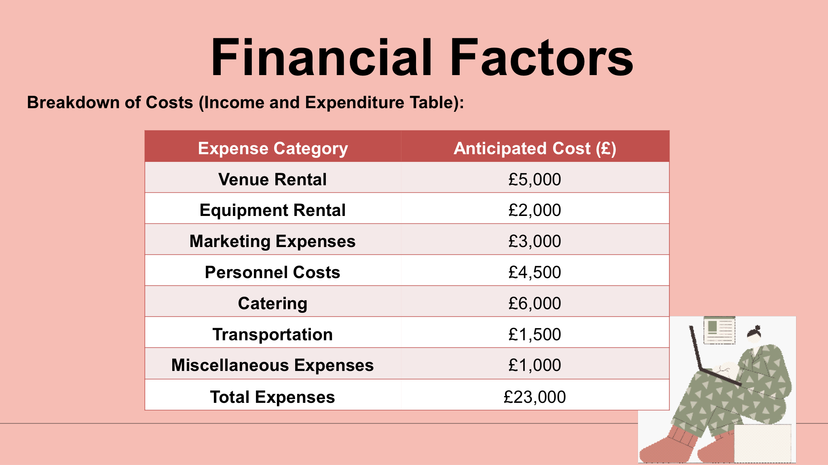
- Operational Planning:
- Identification of appropriate venues for the proceedings and measuring the accessibilities and appropriateness (Boz et al., 2020).
- To determine the resource requirements that include the equipment, staffing and logistical support.
- To properly evaluate transportation, accommodation, as well as other logistical considerations for attendees.
- These might involve practical ability with audiovisual skills, event arranging and supervision, crisis organisation, purchaser provision, and logistical administration.
- To make sure they have the information and skills essential to do their responsibilities efficiently, staff associates will get briefing and preparation sessions (Gupta et al., 2022).
- Required Resources:
- Catering: To ensure that attendees are content and comfortable, catering facilities are successfully set up to deliver food as well as refreshments throughout the event.
- Lighting: A visually appealing as well as dynamic situation that is perfect for networking as well as gaining information will be shaped with the use of practised lighting apparatus.
- Parking Facilities: There will be adequate parking spots obtainable to accommodate guests' vehicles as well as permits for simple entrance and exit from the site (Hall et al., 2022).
- Seating: Comfortable seating preparations will be provided to improve contributor comfort through lectures, sessions, and networking activities.
- Skills Required for Event Staff:
- When defining the venue's appropriateness for the result, issues such as its competence, organisation, accessibility, and facilities will be taken into interpretation to accommodate the predictable number of attendees contentedly. Those existences are obtainable for the program since it is arranged for April 30 (2024)Also, the site is suitable for attendees, making it simple for them to get there as well as take part in the occurrence (Shaikh et al., 2021).
- Venue Availability and Suitability:
- There is plenty of space at the site for sessions, presentations, and networking accomplishments. Modern audiovisual equipment is also used to improve the knowledge of visitors.

Feasibility Analysis and Justification
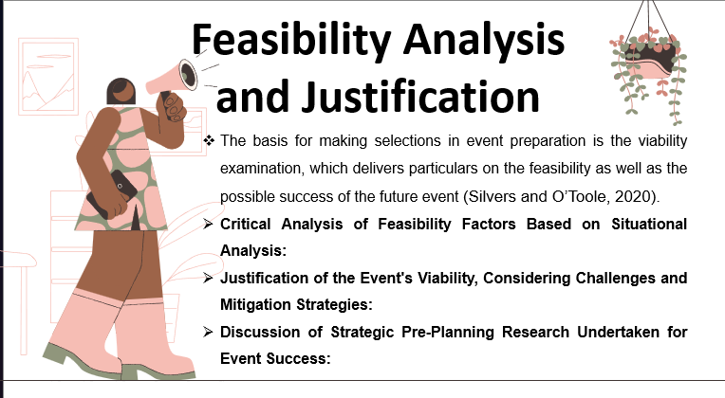
Critical Analysis of Feasibility Factors Based on Situational Analysis: Based upon the prior situational examination, a complete assessment of the viability basics is compulsory. To control the event's viability, this involves measuring monetary forecasts, operational variables, and market tendencies. By carefully examining these characteristics, we can find any roadblocks, risks, and chances that, can disturb the achievement of the result (Silvers and O’Toole, 2020).
Justification of the Event's Viability, Considering Challenges and Mitigation Strategies: Even in the expression of likely barricades discovered throughout the feasibility valuation, the event's viability might be ensured with the aid of strategic development and justification plans. Taking care of logistical concerns like venue access and resource allocation and putting backup plans together in case of surprising monetary circumstances, can raise the likelihood that an event will prosper. That might lower monetary risk and deliver more help by cooperating with business associates and using sponsorship chances (Niessen and Bocken, 2021).
Discussion of Strategic Pre-Planning Research Undertaken for Event Success:
The basis of an effective event is the pre-planning investigation. This means observing into possible sites, negotiating positive agreements, and doing widespread market examination to comprehend customer preferences and business tendencies. Furthermore, founding influences with powerful individuals and building companies will help the event get more legality and attention, which will recover its general achievement. Utilising investigation answers in development of development, may predict issues and take benefit of chances to ensure a positive and outstanding result (Bisoi et al., 2020).

Conclusion
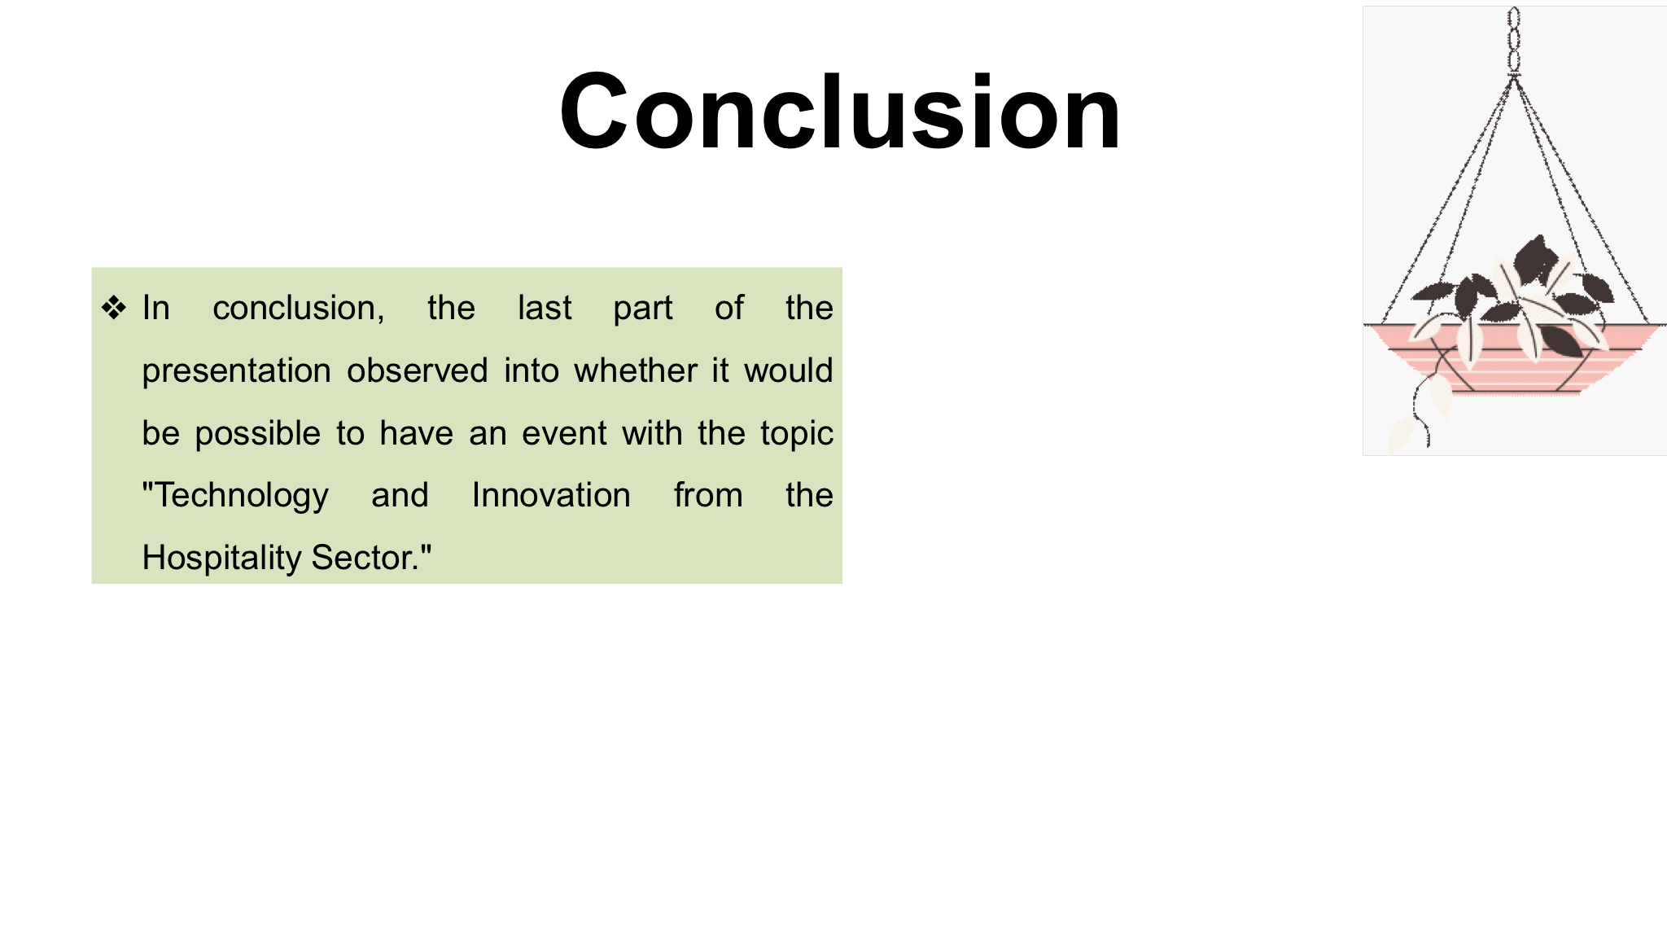
Those have covered the key components of a viability study, comprising monetary forecasts, market dynamics, and work concerns. The event's feasibility and significance have been established by the careful inspection of these basics, the importance of it's possible to endorse teamwork and industrial innovation. That can surely state that can possess the information compulsory to overcome trials and grasp prospects for a positive event, placing us in a beneficial position to strategy and carry out proceedings.

References


