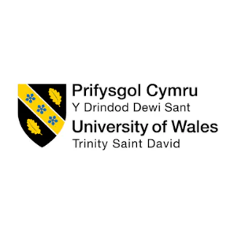
Integrated Human Capital Blueprint
Programme: Master of Business Administration
Module: Human Capital Management
Module nr: LCMB7023

Individual report – HR strategy

Student Name: Florina Maria Vlad
Student ID: 2227241

Table of Contents
Introduction 1
Talent Ecosystem in the Tech Industry 2
Defining the Talent Ecosystem 2
Key Industry Trends Affecting Talent 2
Implications for Aether 3
Strategic Build and Buy Talent Model for Aether 4
Theoretical Foundation 4
When to "Build" Talent 5
When to "Buy" Talent 5
Proposed Hybrid Model for Aether 5
Structured Mentorship Framework 7
Career Structure and Leadership Pathways 7
Lifelong Learning & Reskilling 7
Integration: Building a High-Performance Talent Environment 9
Conclusion 10
Reflection: Development Strategy and My Learning Journey (Gibbs’ Reflective Cycle) 11
Updated in the Age of AI 13
References 14

AI Acknowledgement
I acknowledge the use of the AI tool (ChatGPT) to find any grammatical mistakes in my essay from 11th February 2026 to 14th February 2026 with the following prompt.
• Please look through my paper and find any grammatical mistakes that can be observed.
However, I confirm that no AI-generated text is incorporated throughout the report, and I have properly cited all sources.

Introduction
Aether Innovations is on flat growth, high turnover, and decreasing customer satisfaction symptoms of a decentralised and responsive talent strategy. Sustainable performance in the technology sector is not just about innovation but also a strong talent ecosystem that keeps coming up with and retaining high potential employees. This report contends that Aether needs to restructure its talent structure using a build-versus-buy model that is based on mentorship, leadership opportunities, and lifelong learning to remodel people's capability in line with long-term business performance.

Talent Ecosystem in the Tech Industry

Defining the Talent Ecosystem
A modern talent ecosystem is not limited to recruitment and training activities. It integrates the external talent markets, learning systems, leadership pipelines, and the external workforce as more of an interconnected system than individual HR practises. The internal workforce reflects on the current capabilities, employee interest, and culture. External talent markets consist of universities, professional networks, global contractors, and digital talent markets. Learning systems guarantee renewal of capability at any given time, whereas leadership pipelines guarantee succession and continuity of strategy. In competitive labour markets, the attractiveness of organisations is determined by employer branding.
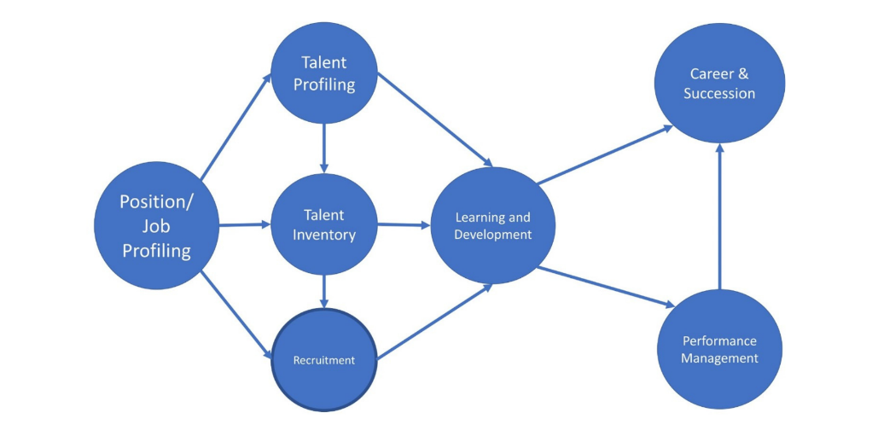
Image 1: Talent ecosystem (Madhani, 2009)
Theoretically, Human Capital Theory places skills and knowledge of employees as productive resources that create economic value (Becker, 2008). The Resource-Based View (RBV) makes a similar claim, contending that the continued existence of competitive advantage is due to valuable, rare, inimitable, and non-substitutable resources- especially human capital unique to the firm (Madhani, 2009).

Key Industry Trends Affecting Talent
AI, data science, and cloud computing are acutely short of skills in the technology sector, exacerbating the competition for highly qualified professionals (Nigar et al., 2025). At the same time, remote and global recruiting have broadened labour market borders, which have added competition and opportunity. The emergence of portfolio careers and gig-based workers has changed the demand for flexibility and autonomy. Furthermore, the high rate of technological change has reduced the duration of the skill lifecycle, and therefore, reskilling has to be continuous (Souto-Otero, Brown, and Freebody, 2023).

Implications for Aether
Against this backdrop, low growth and high turnover of Aether are indicative of a reactive hiring model that is short-term vacancy oriented as opposed to strategic capacity planning. The lack of internal mobility and small leadership pipeline implies that the firm lacks an adequate investment in firm-specific human capital, which is contrary to the RBV principles. Lack of good retention of high-potential workers is an indication of a breach of the psychological contract, where the expectation of development was not fulfilled. Importantly, the lack of alignment between the talent strategy and business growth goals limits the capacity for innovation and directly affects customer satisfaction.

Strategic Build and Buy Talent Model for Aether

Theoretical Foundation
The strategic build-versus-buy model should be based on the developed HRM theory in order to be sustainable in the long run (Winsborough, 2025). The conceptualisation of the Human Capital Theory views the skills of the employees, knowledge, and capabilities as an investment with economic returns. The Resource-Based View (RBV) contends that sustainable competitive advantage is the result of resources that are valuable, rare, inimitable, and organisationally embedded. The internally trained talent, which is highly socialised into the organisational culture and processes, tends to fit these requirements better than the employees who are hired outside the company.
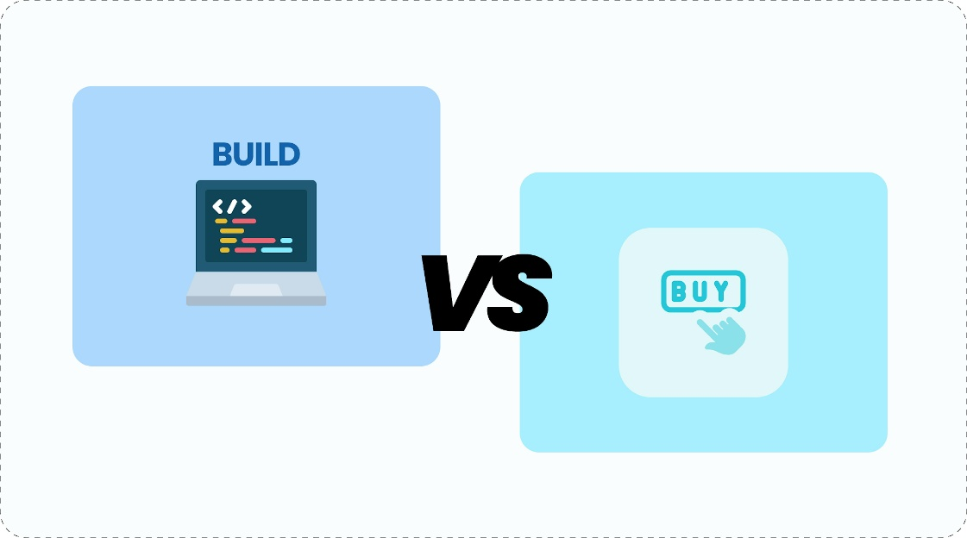
Image 2: Strategic Build vs. Buy Talent Model (Winsborough, 2025)
Strategic Workforce Planning makes sure that the decisions made about talent are related to the future business capabilities as opposed to urgent vacancies (Tucker, 2021). In the meantime, the Psychological Contract Theory puts emphasis on the unspoken obligations between the employer and the employee. A combined build-versus-buy strategy thus establishes a long-term competitive edge through a balanced approach to capability building and strategic external acquisition, both in terms of stability and flexibility.

When to "Build" Talent
Aether must focus on developing core innovation positions, succession leadership, positions that are culture-critical, and strategic capabilities. These functions determine the intellectual property, customer relations, and organisational culture.
The ability to build talent also increases engagement (Ngozi and Edwinah, 2022). When employees feel in place to witness internal promotion avenues, they tend to be willing to work harder at their workplaces, enhancing organisational commitment. In-house training cultivates institutional memory and cross-functional teamwork, which are important in technology companies in terms of innovation (Akuffo, 2020). Further, strategic leadership succession planning helps to reduce the risk of disruption and ensure continuity of strategic direction.

When to "Buy" Talent
Regardless of the benefits of internal development, strategic external hiring is still a necessity. Purchasing talent is suitable when Aether needs new niche capabilities, quick up-scale, expertise in market entry, or transformational leadership to re-orient the organization (Akuffo, 2020). Outside recruits offer a quick and direct shot at capability. This is especially in areas that demand rapid innovation. To illustrate, AI or sophisticated analytics, where internal competencies might be outpaced by market changes.
There is, however, a risk in depending on buying talent. The misalignment of culture may compromise the productivity of a team. Outsourced leaders can find it difficult to manoeuvre the informal networks that are already in place, or they can be disruptive to the system without proper onboarding. Hence, talent acquisition should be focused and strategically based instead of being reactive.

Proposed Hybrid Model for Aether
Aether ought to take a hybrid approach of between 60-70% focus on developing internal talent, with a focus on target externality. High-potential employees (HiPos), technical experts, and leadership-track candidates should be separated in terms of talent and development to do so, to make sure that they receive the specific development pathways. Performance management systems need to incorporate the notion of succession planning, whereas forecasting and capability mapping need to be informed by workforce analytics.
Importantly, this model should be a system that works as a unit and not as a solitary hiring decision. There should be coordination between recruitment, development, performance evaluation, and succession planning in order to match human capital investment with long-term business strategy and innovation renewal.

Structured Mentorship Framework
Aether ought to use a formalised mentorship model that incorporates technical mentoring as well as leadership mentoring. The engineers in their early career and high-potential employees must be assigned to experienced professionals to hasten the process of acquiring skills and socialisation in the organisation. Simultaneously, reverse mentoring, where junior digital-native employees tell senior leaders about the developing technological knowledge, can encourage innovation and eliminate hierarchical obstacles. Collaborative learning should also be institutionalised by innovation communities of practice (Srivastava, 2025). Such a strategy is based on the Social Learning Theory, which focuses on learning by observing and engaging, and the Engagement Theory that accentuates the inspirational effect of meaningful workplace relationships.

Career Structure and Leadership Pathways
Aether needs to create two career paths to maintain a variety of talent profiles: a technical professional route and a management leadership route. High-performing technologists leave organisations when they consider that advancing within the organisation is pegged on managerial promotion. Providing parallel progression paths will retain expertise in a specialist area but will also develop leadership potential. It must have an internal mobility system that enables employees to transfer within projects and departments to enhance the breadth of capabilities and the agility of the organisation.
This architecture is consistent with the Talent Pipeline Theory in terms of continuity of critical roles, the Transformational Leadership Theory in terms of creating visionary and change-oriented leaders, and the Career Development Theory in terms of long-term growth aspirations. The effects are multiple: better retention of high potentials, less expensive use of external recruitment, and greater organisational commitment based on apparent development prospects.

Lifelong Learning & Reskilling
Aether should institutionalise lifelong learning due to the rapid change in technology. With the help of AI and digital academies, a powerful Learning Management System (LMS) can provide specific upskilling in the emerging fields (Singer and Gupta, 2025). The inclusion of learning KPIs in the performance review is an indication that the development is not a choice but a strategy.
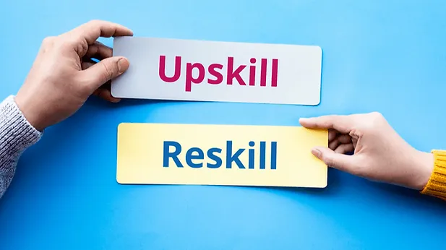
Image 3: Reskill and Upskill (Singer and Gupta, 2025)
This implies the Learning Organisation theory, where ongoing renewal of the capability is highly valued, and the Self-Determination Theory, where intrinsic motivation is associated with autonomy and mastery. As a part of High-Performance Work Systems (HPWS), continuous learning reinforces the flexibility, revitalises the innovation potential, and improves the employee value proposition within competitive labour markets.

Integration: Building a High-Performance Talent Environment
In the case of Aether, the competitive advantage will be based on integration and not isolated HR initiatives. Recruiting needs to be done in conjunction with strategic capability forecasting; development systems are to feed succession pipelines; performance management is to reward innovation and learning; and compensation systems are to support engagement and retention.
Human capital practises under the Strategic HRM alignment model are directly aligned to the business goals. Mutually reinforcing practises within an HPWS framework to increase productivity and commitment at the same time. Employee experience is enhanced, voluntary turnover is reduced, more innovation is generated, and customer satisfaction is enhanced when the recruitment system, development system, performance management system, and rewards system are integrated into an interconnected system that, in turn, reinstates sustainable growth.

Conclusion
The weaknesses in the performance of Aether can be attributed to the disjointed talent strategy that is not in line with strategic expansion. The organisation will be able to convert human capital into a long-term competitive edge through an adapted integrated build-versus-buy model, enhanced mentorship and leadership opportunities, and a system of lifelong learning embedded on a high-performance basis. Laying recruitment, development, and performance management on the same path is a way of guaranteeing capability renewal, greater engagement, and better retention. Finally, customer satisfaction and innovation will be enhanced in case the talent strategy is a coherent, strategically aligned ecosystem instead of separate HR practises.

Reflection: Development Strategy and My Learning Journey (Gibbs’ Reflective Cycle)
My study into Human Capital Management has changed my perception towards the relationship between people's strategy and organisational performance. Applying the reflective cycle presented by Gibbs to the situation, i.e., description, feelings, evaluation, analysis, conclusion, and action plan, I can critically evaluate how this module has changed my thoughts and future growth (University of Cumbria, 2020).
I had an operationalist vision of HRM at first. The significance of HR to me was linked to recruitment, training organisation, and performance appraisals. Nevertheless, discovering the ideas of the Strategic HRM alignment, the High-Performance Work Systems (HPWS), and the Resource-Based View (RBV), I started to perceive human capital as a key driver of competitive advantage, but not as a support system. The concept of long-term advantage based on valuable, rare, inimitable, and organisationally entrenched resources has facilitated my reconsideration of the assumptions I had before and prompted me to think of talent as a source of strategic value instead of a cost centre. The change proved to be thought-provoking but rather awkward, since it meant that I had to redefine my previous assumptions regarding organisational priorities.
Reflecting on the learning experience, I have identified the combination of theory and practise as one of the most effective. As an example, the knowledge of Human Capital Theory (Becker) allowed me to admire the reason why an organisation might spend so much money on employee development: the skills and knowledge can produce tangible economic payoffs. Equally, reading Psychological Contract Theory made me more aware of the manner in which engagement and trust can be destroyed due to the failure to meet development expectations. These learnings brought out the inseparable nature between leadership behaviour, employee motivation, and organisational outcomes.
Analytically, I realise that my personal growth should be based on the principles promoted in the module. When learning organisations are successful with continuous capability renewal (Senge), I have to embrace a lifelong learning attitude. I have discovered that innovation is not an unplanned by-product of creativity but a planned learning, experimentation, and reflection. The notion of a growth mindset also explains that skills are trainable with a conscious effort, which supports my position that being adaptable is a strategic requirement and not a desirable character trait. This view has encouraged me to take challenges as a learning experience instead of a challenge to my competence.
To sum up this reflection, the module has equipped me with the understanding to formulate my own Learning and Development (L&D) strategy. To develop the culture of innovation myself, I will implement the aspects of HPWS principles: stretch goals, cross-functional exposure, and constant skill development. In addition, I will seek mentorship ties, as a mentee as well as becoming a mentor in the future, to solidify social learning and sharing knowledge.
In my action plan, I will enrol in advanced analytics and leadership courses, engage in innovation-related projects, and establish quarterly learning goals that will be aligned with my career goals. I will also make reflective practise a part of my routine, whereby after a while, I will evaluate what skills I have acquired and their weaknesses. Aligning my personal development with the concept of strategic thinking, I would like to reflect the concepts of innovation, resilience, and growth mindset, which have been highlighted during this module.

Updated in the Age of AI

With the ever-growing process of automation of routine and analytical duties through artificial intelligence, strategic differentiation is the only way an individual can be professionally relevant. I do not see AI as a threat. Studies indicate that technological displacement tends to boost the demand for higher order cognitive and interpersonal skills. Consequently, I will be working on enhancing distinctly human skills, i.e., critical thinking, ethical judgement, emotional intelligence, and strategic decision-making.
I will apply for an AI to support myself and not to replace it. An example of this is that AI can be used to help in data analysis, trend forecasting, and administrative efficiency, and I can focus on interpretation, contextualisation, and strategic synthesis. I am able to preserve value beyond automation because I am using AI to process information and remain responsible for generating insights and communication with stakeholders.
In addition, I will constantly deepen my digital literacy to get to know the abilities and limitations of AI. This is in line with the idea of adaptive expertise, in which professionals can incorporate the use of technological tools in their operations without becoming reliant on them. In conclusion, I want to become a strategic partner of AI. In this case, I will utilise it to be more productive, but creativity, empathy, and moral leadership should be considered purely human values.

References
Akuffo, I.N. (2020) ‘Cross-functional teams and innovation performance: the case of multinational enterprises’, International Journal of Export Marketing, 3(3), p. 204. Available at: https://doi.org/10.1504/ijexportm.2020.107720
Becker, G.S. (2008) Human capital: a theoretical and empirical analysis with special reference to education. Population (French Edition), 22(2), p. 330. Available at: https://doi.org/10.2307/1528521
Madhani, D.P. (2009) Resource based view (RBV) of competitive advantage: an overview. Available at: https://www.academia.edu/download/51134694/Resource_Based_View_RBV_of_Competitive20161231-2424-3tlmyg.pdf (Accessed: 14 February 2026).
Ngozi, D.-E. and Edwinah, A. (2022) ‘Employee engagement and talent retention: a review’, South Asian Research Journal of Biology and Applied Biosciences, 4(5), pp. 188–197. Available at: https://doi.org/10.36346/sarjbm.2022.v04i05.003
Nigar, M., Juli, J.F., Golder, U., Alam, M.J. and Hossain, M.K. (2025) ‘Artificial intelligence and technological unemployment: understanding trends, technology’s adverse roles, and current mitigation guidelines’, Journal of Open Innovation: Technology, Market, and Complexity, p. 100607. Available at: https://doi.org/10.1016/j.joitmc.2025.100607
Singer, V. and Gupta, V. (2025) Reskilling and upskilling: lifelong learning opportunities. World Economic Forum. Available at: https://www.weforum.org/stories/2025/01/ai-and-beyond-how-every-career-can-navigate-the-new-tech-landscape/ (Accessed: 14 February 2026).
Souto-Otero, M., Brown, P. and Freebody, S. (2023) ‘High skilled workplaces, technological change and employment: can educational reform do it?’, International Journal of Educational Research, 122, p. 102265. Available at: https://doi.org/10.1016/j.ijer.2023.102265
Srivastava, S. (2025) ‘Collaborative learning in digital environment’, International Journal of Research and Analytical Reviews, 12(1), pp. 392–404. Available at: https://www.researchgate.net/publication/387906764_Collaborative_Learning_in_Digital_Environment (Accessed: 14 February 2026).
Tucker, E. (2021) Strategic workforce planning: from closing skills gaps to optimizing talent. Available at: https://www.emerald.com/shr/article-abstract/21/1/14/354032/Strategic-workforce-planning-from-closing-skills?redirectedFrom=PDF (Accessed: 14 February 2026).
University of Cumbria (2020) Gibbs’ reflective cycle. Available at: https://my.cumbria.ac.uk/media/MyCumbria/Documents/ReflectiveCycleGibbs.pdf (Accessed: 14 February 2026).
Winsborough, D. (2025) The great talent dilemma: build or buy? Forbes. Available at: https://www.forbes.com/sites/davewinsborough/2025/02/17/the-great-talent-dilemma-build-or-buy/ (Accessed: 14 February 2026).

