
Video Link: LDE-Self-Evaluation-_Assignment_2-2.pptx

UNIVERSITY OF WALES TRINITY SAINT DAVID
LONDON CAMPUS
Module Name: Learning in the Digital Era
Module Code: ACCA 4025

Student Name: Nufeesa Imran
Student ID: 2538126
Group:3

Lecturer’s Name: Anees Baqir
Assignment 2
Learning in the Digital Era

Table of Contents
Introduction 2
Main Body 2
Slide 1 COVER PAGE 2
Slide 2 CONTENTS 2
Task 1- Self Evaluation 3
Slide 3 Gibbs Reflective Model 3
Slide 4 Strengths and weaknesses 4
Slide 5 Traits gained from self-reflection 5
Task 2 – Professional Development plan- Software Engineering 5
Slide 6 PDP 6
Slide 7- Evidence for SMART Goal 1 7
Slide 8- Evidence for SMART Goal 2 and 3 7
Task 3 - Unit 4 Topic- Unpacking experiences 8
Slide 9 Reflection and Reflexivity 8
Slide 10 Conclusion 9
Slide 11 References 10
Conclusion 10
References 11

Introduction

This report accompanies my video presentation for Assignment 2. It documents the three tasks covered in the presentation: a self-evaluation of my learning experiences using Gibbs’ reflective cycle, a professional development plan setting SMART goals towards a career in software engineering, a summary of a topic from Unit 4 on reflection and reflectivity.[1] Each section below presents a screenshot of the relevant slides alongside a brief written explanation, followed by an overall conclusion and list of references used throughout.

Main Body

Video Link: LDE-Self-Evaluation-_Assignment_2-2.pptx

Slide 1 COVER PAGE
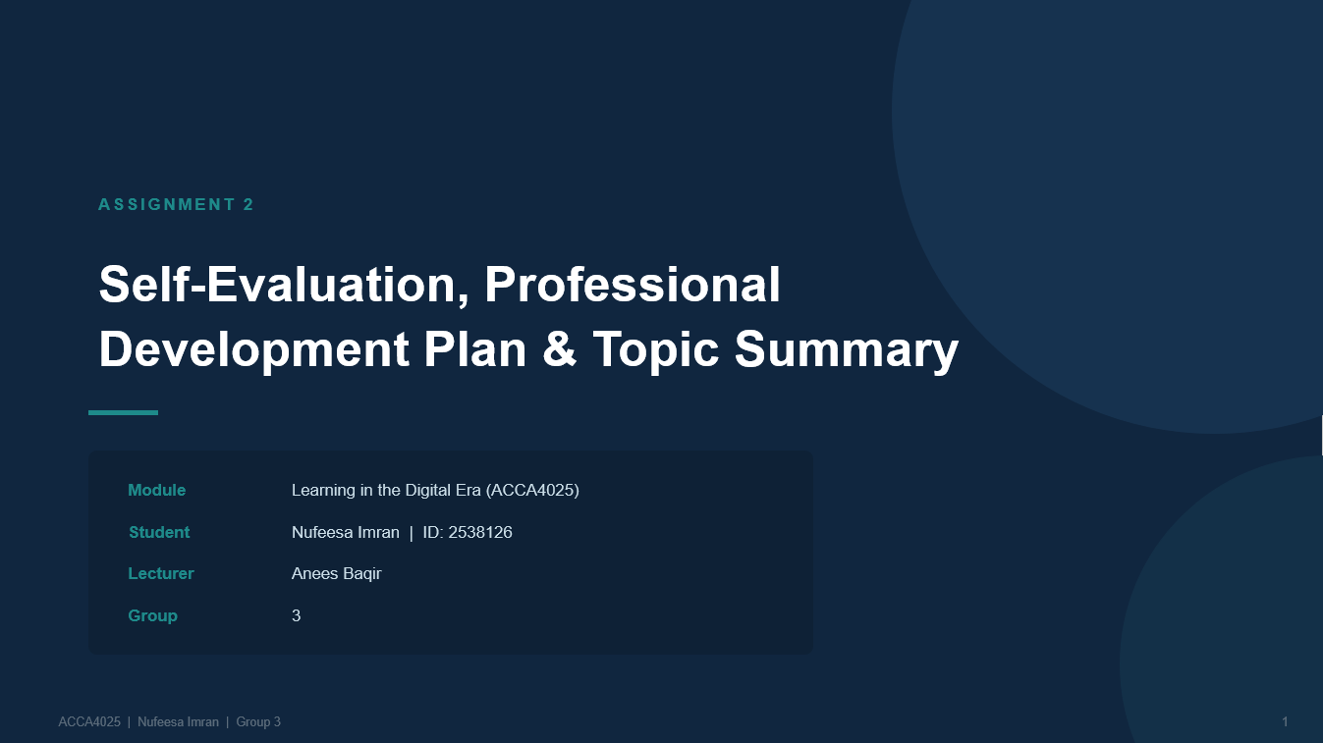

Slide 2 CONTENTS

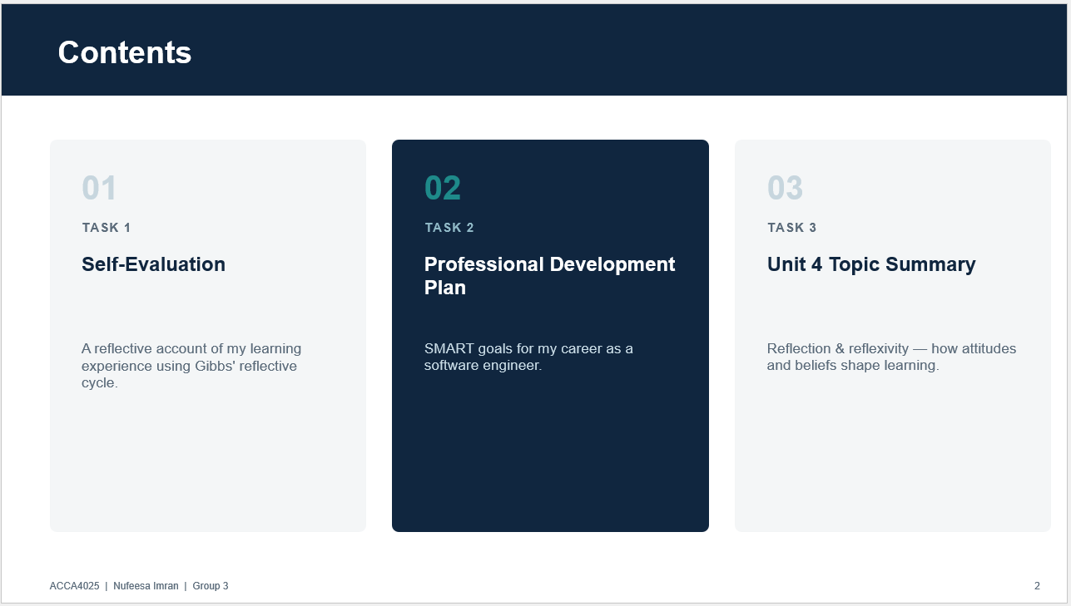

Task 1- Self Evaluation

Slide 3 Gibbs Reflective Model
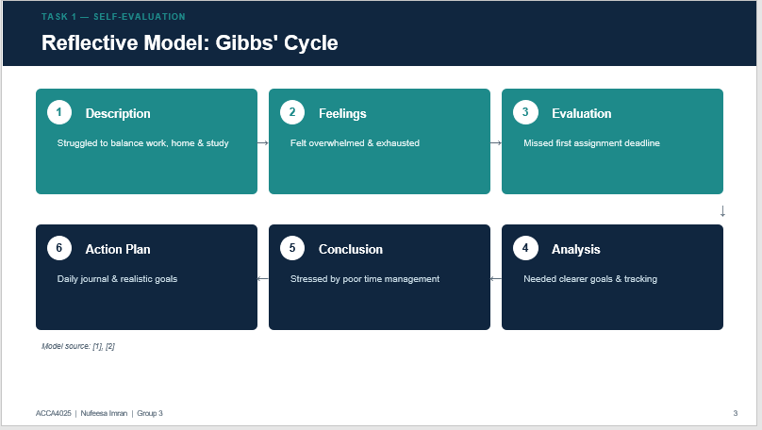
For my self-evaluation I used Gibbs' reflective cycle, which has six stages. I will explain each stage with an example of when I joined this course. In the description, although I felt confident when I enrolled, I quickly struggled to balance work, home and study. In terms of feelings, I felt overwhelmed and exhausted, which affected both my work and home life. My evaluation showed that poor time management caused me to miss my first assignment deadline, which was stressful. Analyzing this, I realized I needed clearer goals and to track my daily activities. In conclusion, poor time management left me stressed and unbalanced. My action plan is to keep a daily journal, allocate time for coursework, and set realistic goals going forward.[1]

Slide 4 Strengths and weaknesses
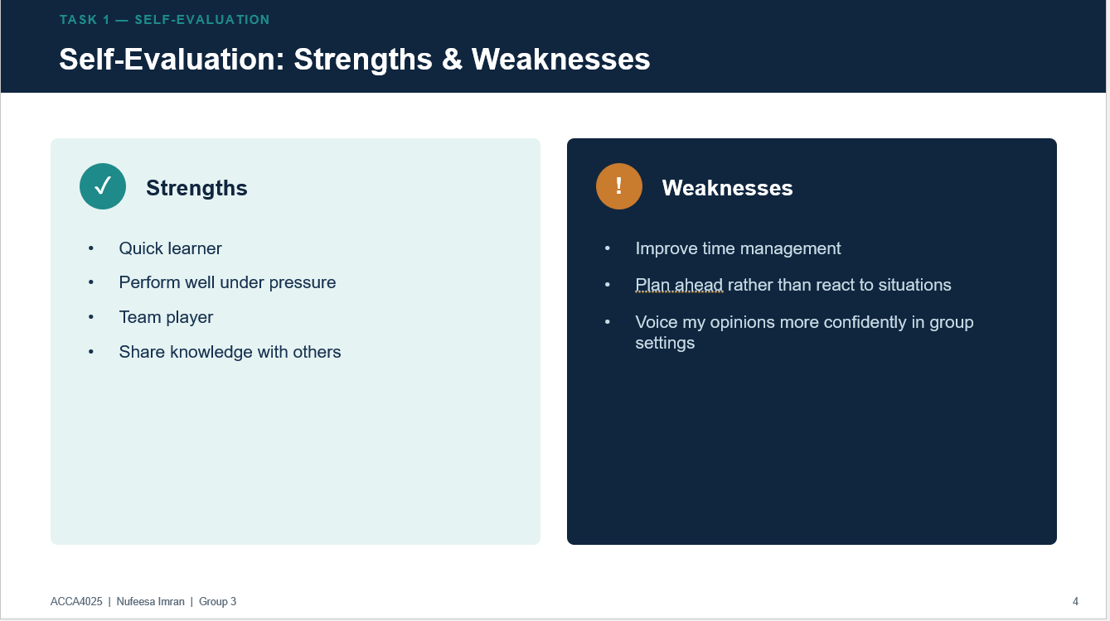
Through this process of self-reflection, I have gained several valuable traits. I now have better self-awareness, recognizing how stress and poor balance affected my performance. I have also developed stronger time management skills, learning to plan, prioritize and structure my day more effectively. Finally, I have built a more proactive approach to reflective practice, analyzing my experiences, drawing conclusions, and creating actionable plans to keep improving.

Slide 5 Traits gained from self-reflection
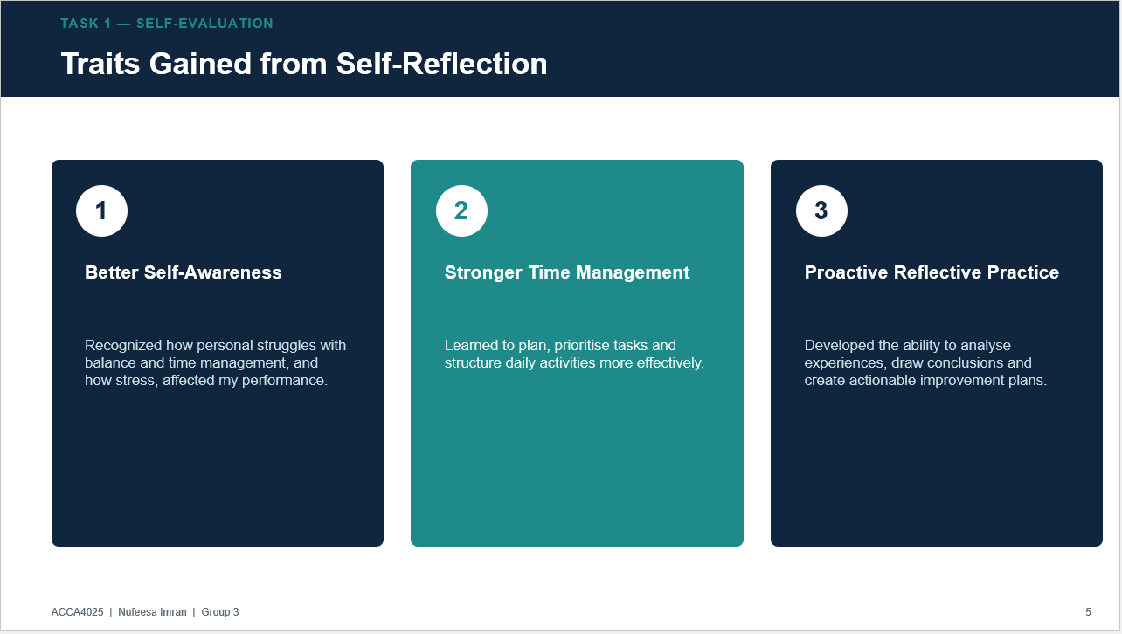
Brief explanation: Through this process of self-reflection, I have gained several valuable traits. I now have better self-awareness, recognizing how stress and poor balance affected my performance. I have also developed stronger time management skills, learning to plan, prioritize and structure my day more effectively. Finally, I have built a more proactive approach to reflective practice, analyzing my experiences, drawing conclusions, and creating actionable plans to keep improving.

Task 2 – Professional Development plan- Software Engineering

Slide 6 PDP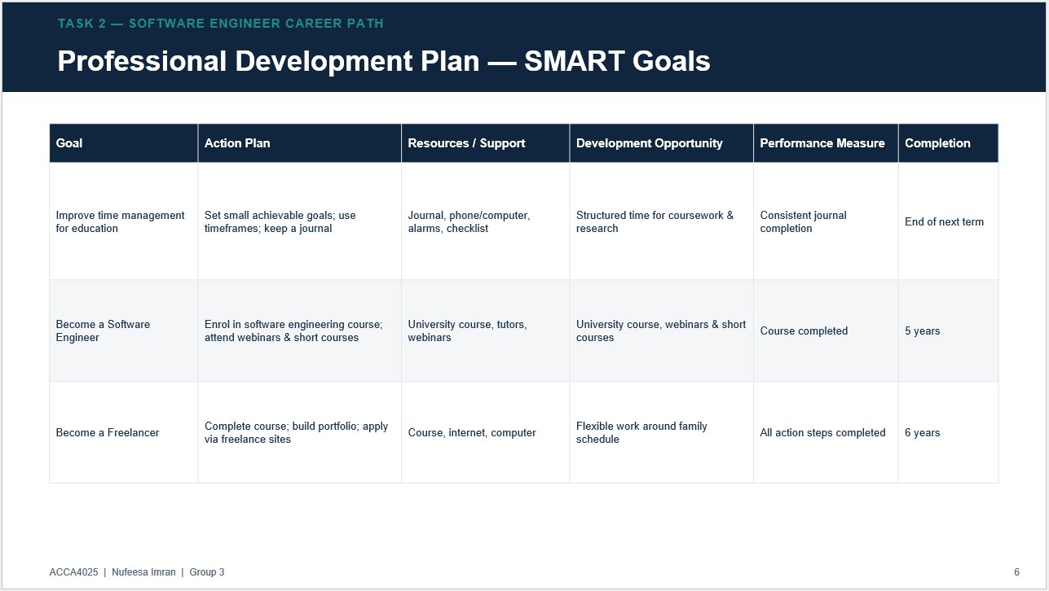

Brief explanation: My professional development plan sets three SMART goals. First, improving my time management for education through journaling and structured schedules. Second, becoming a qualified software engineer by completing a university course, webinars and short courses. Third, working towards freelance software engineering allows me to balance my career with family life. Each goal includes clear actions, required resources, and a realistic timeframe for completion.

Slide 7- Evidence for SMART Goal 1
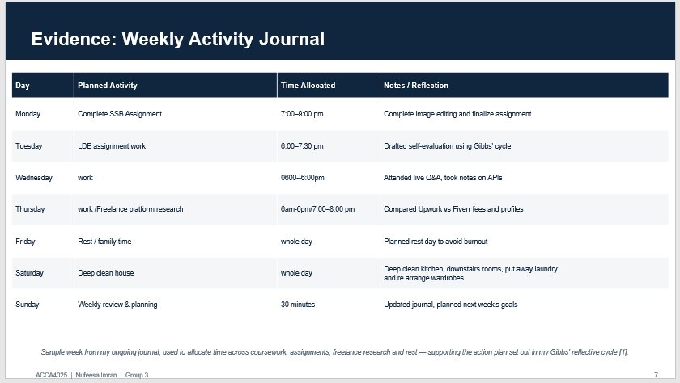
Brief Explanation: As evidence of my professional development plan, I have kept a weekly activity journal. This sample week shows how I allocate time across completing my SSB assignment, LDE assignment work, freelance platform research, work, housework and rest. Keeping this journal directly supports the action plan from my Gibbs' reflective cycle, helping me manage my time more consistently and track my progress towards my SMART goals

Slide 8- Evidence for SMART Goal 2 and 3

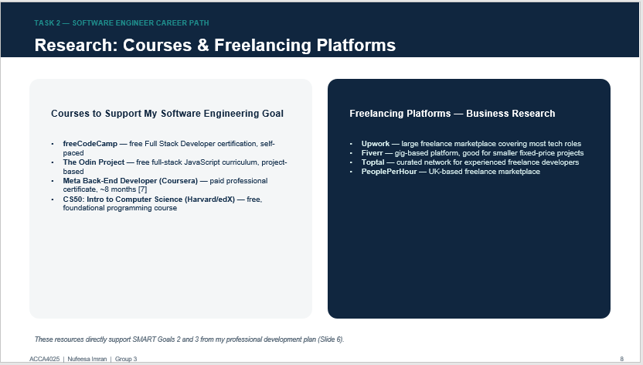
Brief Explanation: As part of my research towards my professional development plan, I looked into several courses that could support my goal of becoming a software engineer, including freeCodeCamp, The Odin Project, the Meta Back-End Developer certificate on Coursera, and Harvard's CS50. I also researched freelancing platforms such as Upwork, Fiverr, Toptal and PeoplePerHour to understand how I could eventually work as a freelance software engineer, which supports Goal 3 of my SMART plan.

Task 3 - Unit 4 Topic- Unpacking experiences

Slide 9 Reflection and Reflexivity

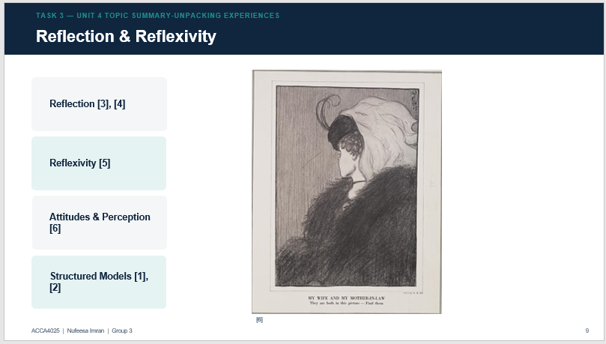

Brief explanation: For Task 3, I chose to summarize the topic of Unpacking experiences from Unit 4, which talks about Reflection and reflexivity. Reflection involves consciously thinking back on our experiences to learn from them[2] Reflexivity goes further, asking us to question our own assumptions and biases [3]. Our attitudes and beliefs shape how we perceive situations[4. 4. 5], and structured models like Gibbs' (1988) reflective cycle help us turn these experiences into meaningful learning[1]. In the image some may see a young woman and some may see an older woman, it all depends on our experiences from the past which then form our perception.

Slide 10 Conclusion
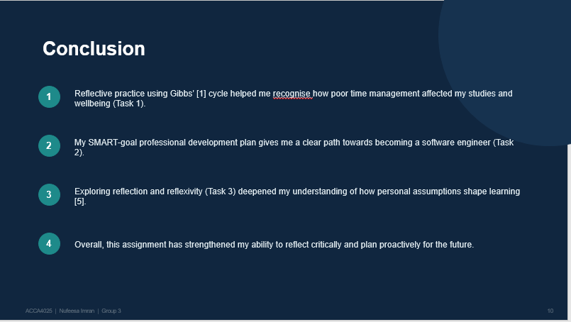
Brief explanation:
In conclusion, this presentation has brought together three key pieces of learning. My self-evaluation using Gibbs' reflective cycle helped me recognize how poor time management was affecting my studies and wellbeing. My professional development plan gives me a clear, structured path towards becoming a software engineer. Finally, exploring reflection and reflexivity deepened my understanding of how personal assumptions shape the way we learn. Overall, this assignment has strengthened both my reflective and planning skills.

Slide 11 References
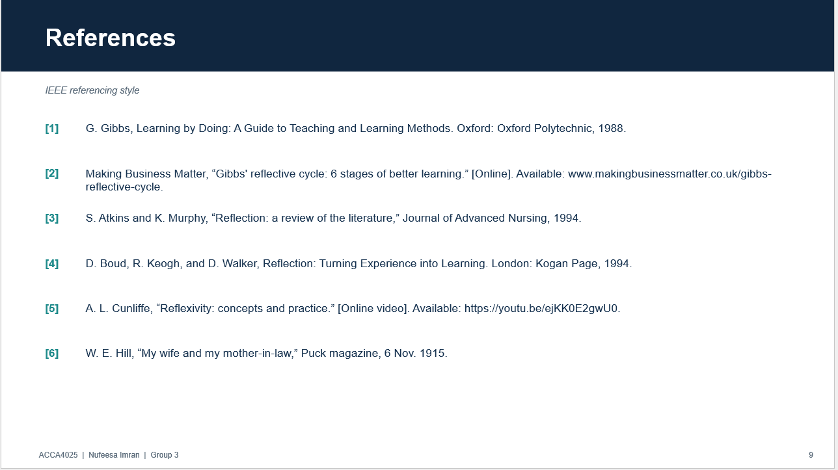

Conclusion
In conclusion, this presentation has brought together three key pieces of learning. My self-evaluation using Gibbs' reflective cycle helped me recognize how poor time management was affecting my studies and wellbeing. My professional development plan gives me a clear, structured path towards becoming a software engineer. Finally, exploring reflection and reflexivity deepened my understanding of how personal assumptions shape the way we learn. Overall, this assignment has strengthened both my reflective and planning skills.

References

References
[1] G. Gibbs, "Learning by doing: A guide to teaching and learning methods," 1988,
[2] S. Atkins and K. Murphy, "Reflection: a review of the literature," J.Adv.Nurs., vol. 18, no. 8, pp.1188–1192, 1993,
[3] A. L. Cunliffe,. "A. L. Cunliffe, “Reflexivity: concepts and practice." Youtube. Accessed: 13/08 2026. [Online]. Available: https://A. L. Cunliffe, “Reflexivity: concepts and practice.” [Online video]. Available: https://youtu.be/ejKK0E2gwU0
[4] Charles Smith. "Gibbs Reflective Cycle: 6 Stages of Better Learning." Making Business Matter. Accessed: 13/08 2026. [Online]. Available: https://Making Business Matter, “Gibbs' reflective cycle: 6 stages of better learning.” [Online]. Available: www.makingbusinessmatter.co.uk/gibbs-reflective-cycle.
[5] H. WE, "My wife and my mother-in-law," vol. 16, no. 11, 1915,

