

Assessment 1 – Reading Task Template
PART 1: Upload your photo of your A3 in-class notes here:
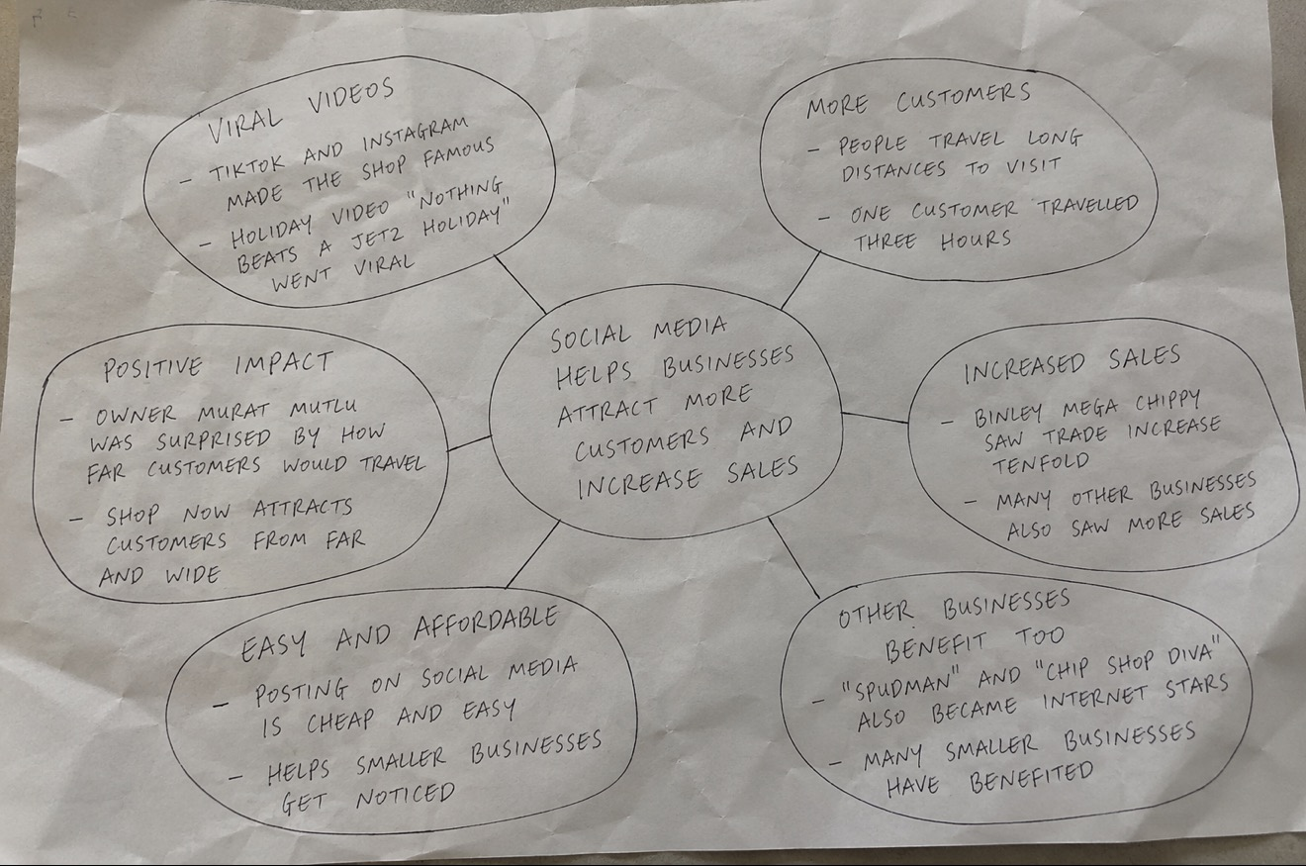

PART 2:
- Answer every question below in 1-3 full sentences.
- Use your own words. Do not use generative AI to answer these questions.
- Include a specific detail from the text when asked.
REMINDER
- The main idea is the overall message of the whole text.
- A key point helps to explain the main idea.
- A specific detail or example from the text shows that the key point is true.

- What is the main idea of the whole text?
The main idea of the text is that social media can help smaller or local businesses become more successful and help increase their sales.

- What is one key point that supports the main idea, and which specific example from the text shows this?
A key point is that social media can help businesses bring in new customers. A good example of this is Murat Mutlu’s shop gaining attention from people who had seen it online, with some even travelling hours to visit the store. This shows how TikTok and other platforms can help smaller businesses reach a wider audience.

- What is a different key point that supports the main idea, and which specific example from the text shows this?
A different key point is that social media can increase demand for a business. Murat Mutlu’s shop became busier and now has five members of staff to help him manage the shop. This shows that the social media attention has had a positive impact on his business.

- Which part of the text do you think is most important, and why?
I think the most important part of the text is that people were willing to travel three hours from their home to eat at Murat Mutlu’s shop. This shows how far the influence from TikTok has reached. Social media can make a small local business known to people who may never have heard of it before.

Reflection:
- What did you find difficult in this task (including in-class components), and why was it difficult?
I found it difficult to decide which information from the article was relevant and what wasn’t. I noticed there were various details about Murat, his shop and the effect social media had. I didn’t want to include too much information or repeat the same points. I tried to choose the strongest examples.

- What helped you with this difficulty, and how did it help you?
Making the mind map helped me sort the information from the article into smaller groups. I could put the main idea in the middle and then add different key points and examples around it. This helped separate relevant information and avoid repeating the same points.

