

Kieran Howells

Study Skills Assignment

UWTSD
OME

BEng
Academic Year: 2024 - 2029

Supervisor: Enter the name of your supervisor
Associate Supervisor: Enter the name or delete if not applicable
11/2024

UWTSD
OME

BEng

Academic Year 2024 - 2029

Kieran Howells

Study Skills Assignment

Supervisor: Enter the name of your supervisor
Associate Supervisor: Enter the name or delete if not applicable
11/2024

This thesis is submitted in partial fulfilment of the requirements for the degree of OME
(NB. Remove if the degree award is based solely on examination of the thesis)

© UWTSD 2024. All rights reserved. No part of this publication may be reproduced without the written permission of the copyright owner.

Academic integrity declaration
I declare that:
- the thesis submitted has been written by me alone.
- the thesis submitted has not been previously submitted to this university or any other.
- that all content, including primary and/or secondary data, is true to the best of my knowledge.
- that all quotations and references have been duly acknowledged according to the requirements of academic research.
I understand that to knowingly submit work in violation of the above statement will be considered by examiners as academic misconduct.

Abstract
Click here to enter abstract text of not more than 300 words.

Keywords:
Individual
Reflection
Torpex
Evaluation
Skills
Summary

Acknowledgements
Click here to enter acknowledgement text.

Table of Contents
Academic integrity declaration i
Abstract ii
Acknowledgements iii
List of Figures v
List of Abbreviations vi
1 Presentation 1
1.1 Overview 1
1.2 Screenshots 1
1.3 Points of Development 3
1.4 Skills to develop 4
2 Skills Evaluation 5
2.1 Identifying Skills 5
2.1.1 Soft Skills 5
2.1.2 Hard Skills 6
2.1.3 Transferable Skills 6
2.2 Skills Evaluation 7
2.2.1 Personality Quiz 7
3 Application 11
3.1 Data Protection 11
3.2 Time Management 12
4 Conclusions 17
References 24

List of Figures
Figure 1
Figure 2
Figure 3

List of Abbreviations
IT | Information Technology
TNT | Trinitrotoluene
RDX | Research Development Explosive
WW2  DC | World War 2  Depth Charge

Presentation

Overview
The student’s name is Kieran Howells, they are 19 and from Caldicot. The student enjoys many different Hobbies such as skiing, hiking and carpentry to others such as metalwork and music. They express these hobbies by going places such as France and Italy to ski and the Lake District and Brecon beacons to hike. They also show their other hobbies by referring to their creations in metalwork and woodwork along with concerts they have seen to show their interest in music. The student also discusses their future goals in life along with where they foresee themselves being in the next few years. The goals they discuss follow short term such as obtaining a motorbike licence to longer term such as completing their apprenticeship and obtaining their BEng in OME.

Screenshots
Basic Introduction
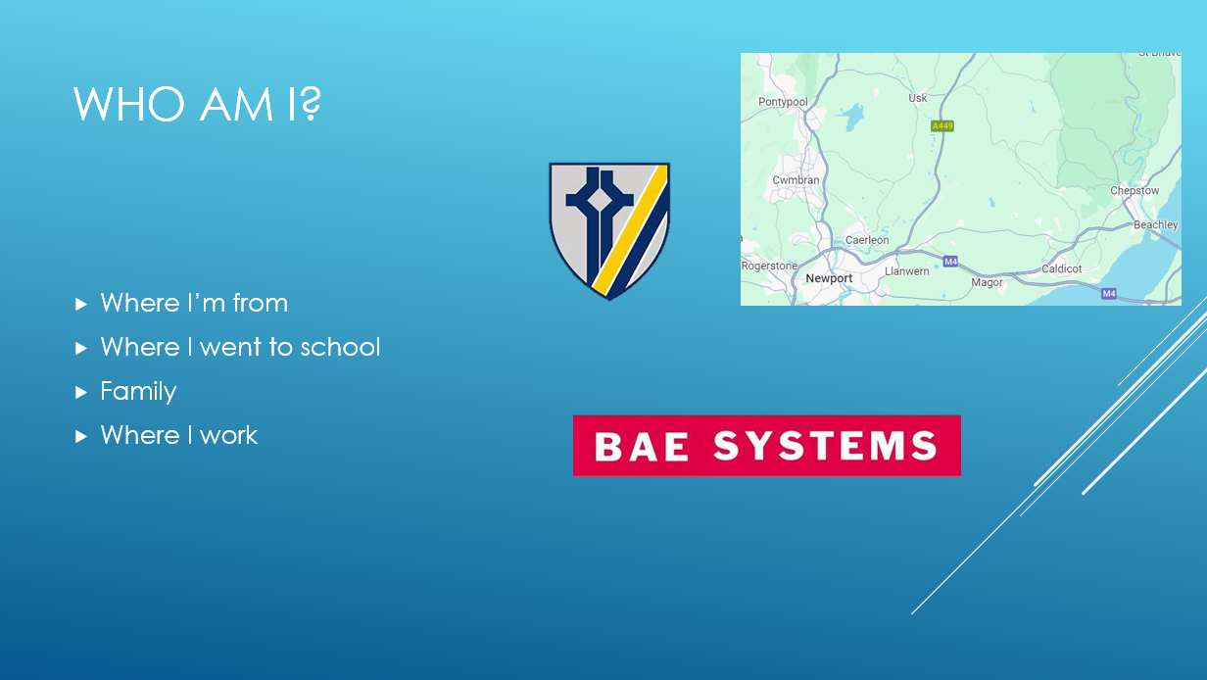
Figure 1
Hobbies
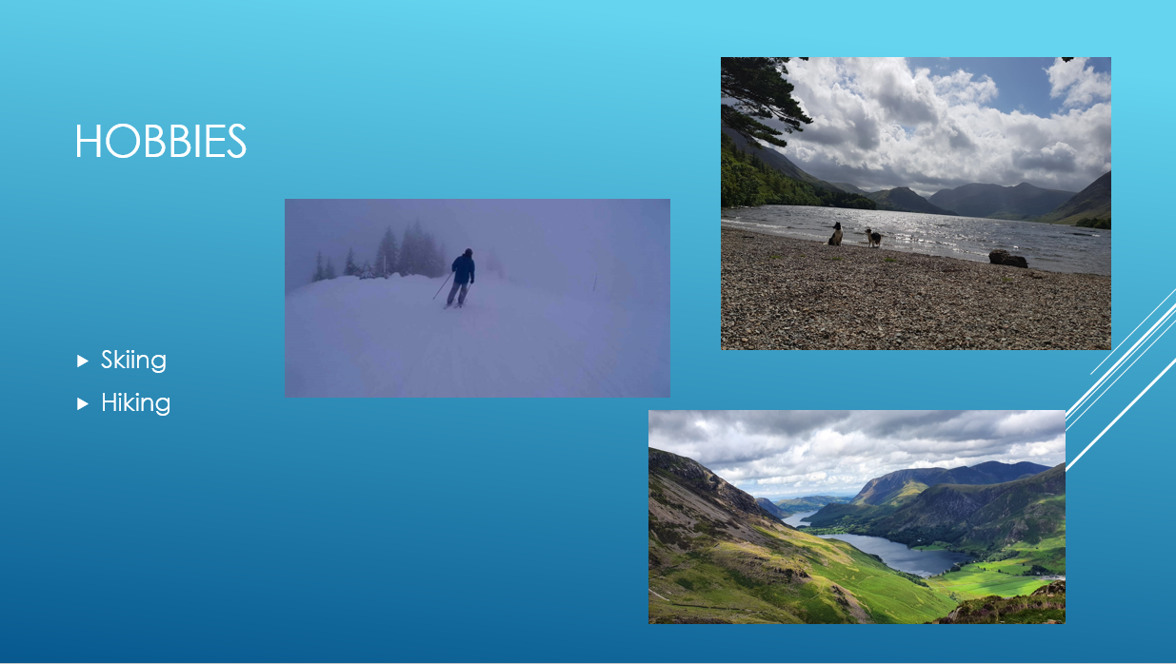
Figure 2
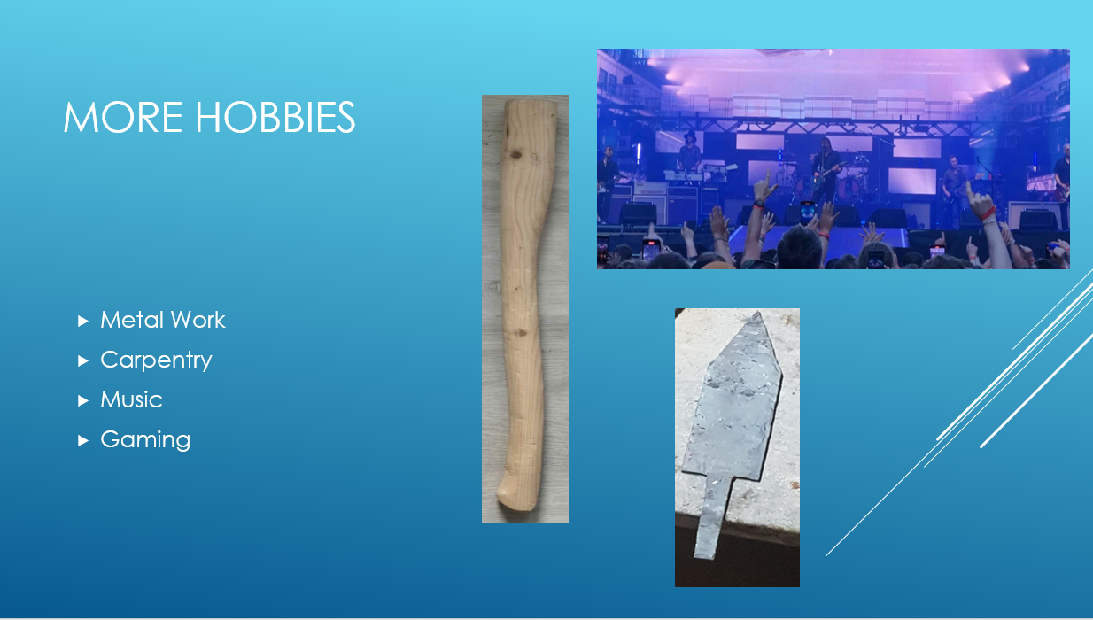
Figure 3
Travel

Points of Development
While the student was developing their PowerPoint, many different points and skills were developed. The first of these being that during the creation of the PowerPoint they were introducing information and pictures on the same slide but learnt that the amount of each of these is critical in creating a successful presentation. There cannot be too many pictures or too much information of the same slide otherwise; the audience would have a harder time following the presentation.
The second skill that they developed during the creation of the PowerPoint was pacing. The student could not have too much information to talk about on each slide. That includes them only giving headings to talk through as they originally tried to put all of their hobbies into one slide but quickly found that when practicing the presentation that it took too long to talk through each point. This was a problem as this could cause the audience to lose interest or overwhelm them with information. The student then split the information onto separate slides to reduce the time spent on each slide.
The next skill the student developed was during their practice of their complete presentation. Preparation was key to delivering a successful presentation. The student found that during their practice they would give the presentation differently each time and sometimes would lose the order in which the slides appeared. To remedy this the student practices what they would say specifically in each slide but also left room for small comments or anecdotes that could keep the audience’s attention.
The final skill that the student learnt during the presentation was body language. The student found that during their practice they would pace about and avoid looking towards different areas of the room where the audience would be during the actual presentation. They then focused on this and made an active attempt during the presentation to avoid this behaviour. The student still paced around but not as much as before and made and active attempt to make eye contact with the members of the audience to try to engage them. They also kept their body open and spoke with confidence rather than close up and appear to be uncomfortable.

Skills to develop
After delivering the presentation, the student then took time to assess how they felt they performed. After looking into what they were satisfied with they then looked to the areas in which they need to develop their presenting skills. First, they looked to the presentation itself. The content could have covered more about the student, as it was an introduction but left much of their early life out. The student should have made more eye contact during the presentation rather than looking down at the laptop before them. This would have made the presentation more engaging. Another idea given by a peer would be to use questions to engage the audience more as the majority of the time was spent with the student explain who they are without room for questions until the very end. Another good idea given by a peer was to include a content page at the beginning of the presentation and give a brief overview on the topics that would be covered in the presentation instead of jumping from topic to topic without the audience know what the student was talking about as it may not have been clear.

Skills Evaluation

Identifying Skills
Many skills are required in order to be successful in higher education. These skills may vary in who often or how little they will be utilised depending on what discipline people pursue within higher education. Different skill types and methods of using each skill may vary depending on discipline such as hard skills could find more use in an engineering discipline whereas soft skills may find more use within an arts or language discipline.

Soft Skills
Soft skills include interpersonal and social skills meaning people based skills that are vital to how people operate within business or in education. [1] The Conference in reference states that soft skills include skills such as problem solving, creativity and innovation, leadership and many more. These skills are a fundamental part of higher education for students to both learn and develop before leaving their education. [1] These skills find their way into most university work and after that employment with them being the key to success. Research has found that skills such as communication, teamwork and commitment to work to be the most important soft skills that students develop in higher education and students themselves believe that these help them to be successful. [1]
Communication
Communication is a critical skill within higher education. As a skill, it is something that both the institution and students need in order to achieve a healthy education system. [2] In order for students to succeed, they should communicate with both their fellow students to help and support each other and the lecturers to gain support and advice when I comes to their work. This is important as if there is a lack of communication it is very likely that a student will be unaware of a deadline or a lecturer may be unaware of an issue that is preventing the student from completing the assigned task. This in turn would cause either a drop in grade or a total fail when it comes to work. Clear communication is vital in higher education as it give students the information they need in order to plan their studies. An example of this could be a student receives a task well in advance along with the deadline then the student can plan the steps they need to take in order to reach that goal within good time and to a high quality. [3]
Teamwork
Teamwork is one of the most important skills that universities help develop in students before they move on to their chosen career paths. [4] The ability to work within a team efficiently and effectively is a skill that universities help grown in order to prepare you for the working world. [4] For students to succeed in higher education they will need teamwork skills for tasks such as a group project or presentation that could be done as a team but also the ability to work with others and help each other progress is an important part of university learning.

Hard Skills
Hard Skills are technical skills required for the specific job or role one may be doing.

Transferable Skills
Transferable skills are skills that are adaptable to many situations. These skills, obtained through classes or through experience, find themselves useful in many situations. These skills help towards one academic achievements such as academic writing or a group project but also ones professional career such as team building, writing reports for clients or working with data/information. [5] Transferable skills have three categories: working with people, working with things and working with data/information [5]. Working with people brings many skills that are useful in both professional and academic life. These skills include negotiating, organising and training. These are only a handful of skills but are vital to a student’s success in academic life and career after. Negotiating or discussions are important to understand someone else’s perspective on something and for you to be able to convey your own opinion effectively on the matter. Training is vital, as learning from those around you in both academic and professional life is the key to developing. Study groups as students provide the chance for people to teach their strengths to those who struggle reinforcing their own knowledge and helping others

Skills Evaluation
There are many different ways in which a student can evaluate their own skills whether what be via conduction tests in order to identify skills that the student is confident in or tests that assess weakness. Personality tests and skills tests can be useful to the student to find out what tasks and roles they are best suited to and what they may struggle with in both the academic and professional world. This would then allow the student to allocate more time to these tasks in order to account for how they may struggle or give themselves less time to do a task, as they are confident that they would be able to complete the task within good time.

Personality Quiz
The student conducted a personality test in order to find out what personality type they are out of the 16 types. The student found that they are an INTP-A or Logician. The logician is someone who finds puzzles and problem solving along with theoretical problems and analytics attractive. [6] They often find themselves using logic and reasoning to solve problems quickly and like to inquire and discuss different topics. They also enjoy learning different methods of how to complete a task and welcome different and new methods of thinking. [6] The student mostly agrees with this finding, as they believe that the description of a logician describes their own thought process accurately. Specifically how the logician goes about learning new topics through inquiry and discussion whether that be using the internet to find the answers the student is looking for or in a debate amongst peers. A notably trait for logicians is how they think and debate about topics that most would not think to question, as they are just aspects of everyday life. [6] The student agrees with this description being accurate with how they think and approach life.
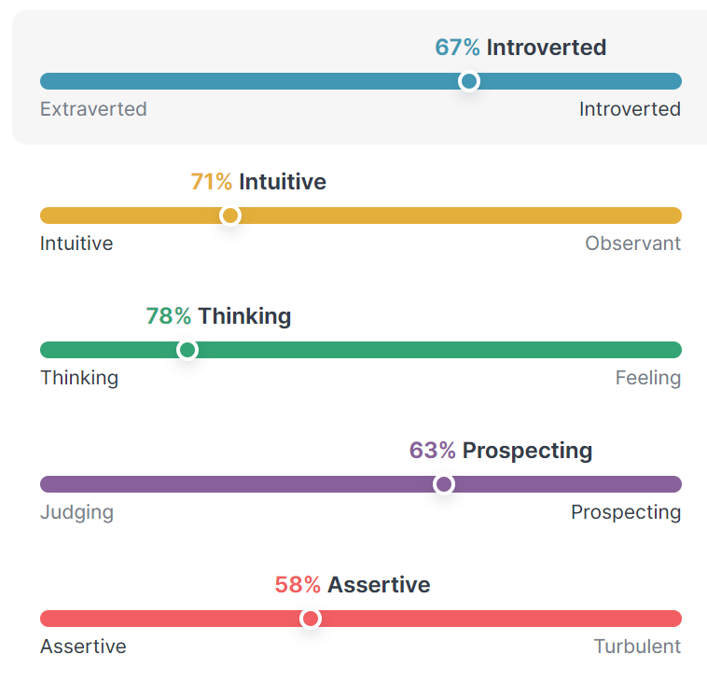
Figure 4

When looking into what career the student was reccomended the student conducted an online survey from the BBC which returned the result of looking for careers in science. The student believes this is an acurate representaion of the career choice that they have made as withing the course physics and chemisty are fundimental to the how and why withing the course.
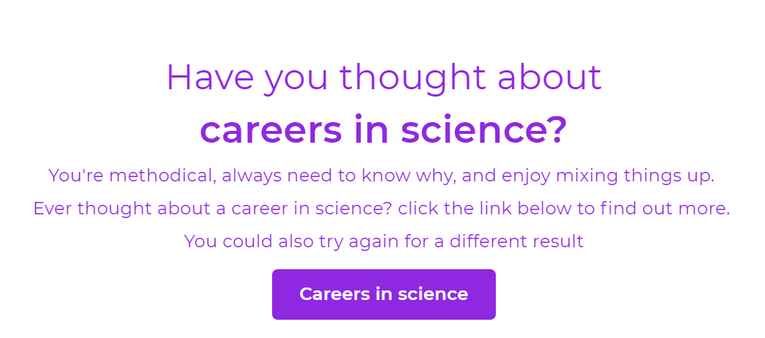
Figure 5

The student conducted another online survey looking at the strengths and weaknesses of the student and how those affect them and how they can be developed. Beginning with strengths, the student found that they are numerically talented and enjoy using numbers and data along with logic. The weaknesses that were uncovered are that the student struggles with time management and planning which could lead to stress in the future. After considering this, the student decides to put these in their development plan in order to help increase their strengths and reduce their weaknesses.
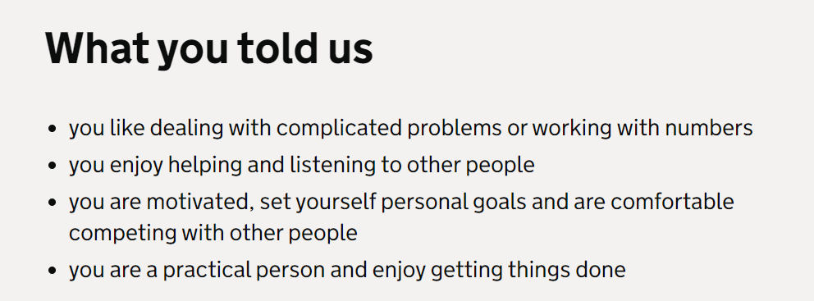
Figure 6
The goals that were set follow the SMART goal idea. SMART is an acronym for setting effective goals. SMART means specific, measurable, achievable, relevant and time bound. [8] The goals that the student set all follow the SMART method for effective goals. The first goal being to achieve a degree in OME. This goal is specific to the student’s job role and can be measured by the grades that they achieve on their path towards achieving this goal. It is achievable and relevant to work role and within the next five years possible to achieve making the goal time bound. The next goal being develop skills to become a qualified engineer. This goal also follow SMART as it is specific in what the student wants to achieve, manageable as this can be done over the course of the students career but many of the skills will be developed now in the early stages of the students career. The goal is achievable whether it be short or long term in how they develop their skills. The goal is relevant to their job role and will help them in creating their brand and portfolio. Finally, the goal is time bound as each skill that the student want to develop can be set as a separate task under a et time as some skills take longer to develop than others.

Application

Data Protection
Backing up data is very important for anyone not just those in higher educational studies. Whether it be for work or for education having a backup is important in case of data loss. If a report that has a 3-month time to complete gets lost, it is very unlikely that a student will be able to recreate a report of the same calibre within a short amount of time. Many different types of data protection exist from USB drives to cloud storage, these method both have their difficulties. The student uses three different data protection methods other than the main file. The first and most convenient is cloud storage. This allows the student to access their work from any location so long as there is internet. This method is secure and recover of data is requires a download of the data. The only difficulty with this method is the size of files that can be stored on cloud storage as the student uses it for most important files meaning that storage can fill up. This then creates the issue of space and the possibility of running out which is why other methods are used along with this as a precaution. The next method used is USB drives as they can store large amounts of data and are easily transported with data recover being instant, as one only has to copy files over to the main device. The drawback with USB drives is that there is always the possibility of losing the drive as they are small and can be misplaced. Damage is another possibility with USB drives whether that be physical or file corruption. These may not be likely but the chance is always there. The final method used to back up data is computer internal storage. In some modern computers, there are two internal storage devices. These being solid state drives (SSDs) and internal hard drives. Theses can store large amounts of data and by storing copies of important files on both drives even if one becomes corrupt or damaged data recovery is still possible. Damage to the PC itself only slows data recovery, as a hard drive reader will be able to recover the data so long as it is not corrupted. These methods align with the 3 – 2 – 1 method of data backups. Having three copies, two types of media and one copy off site or in the cloud. [7]

Time Management
It is best practice in life to manage ones time well so they can complete their tasks in good time and without interruption or delay. In higher education, many students find it useful to create action plans and tools in order to help balance their social and student life. Apprentices may find this skill is more important as unlike average students, apprentices also have work to do on top of their studies and social lives. For some managing, this time is difficult, as it seems they may not have enough time in any of the three aspects. It takes a full breakdown in order to accurately manage their time effectively and how they will complete their tasks in an orderly manner.
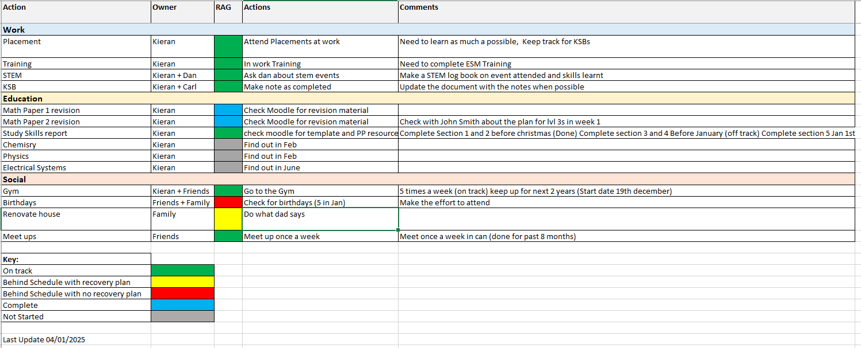
Figure 7
The student uses this spreadsheet to manage time by setting deadlines and updating it every weekend to compile the weeks work. The student finds this method more effective than calendars or standard planners as with an action tracker it requires input to be effective. This means that the student will look at the document weekly and alter the document to update each new task, completed task or event in future. The colour coding makes it clear on what is done and what needs to be completed.

The next steps for the student was to begin to create their brand and to do that they use an E-portfolio. This lets the student keep track of their professional growth and goals along with skills that they have developed. The E-portfolio that was created by the student shows how their current professional training and previous academic activities have been developed.
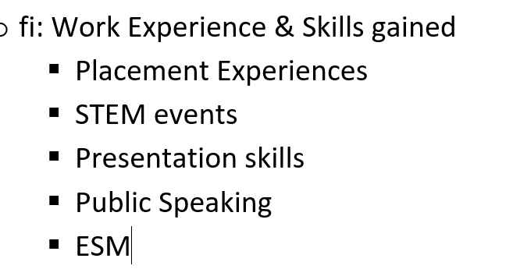
Figure 8
The Placement Experience refers to the work that the student does professionally and how they have been learning new skills through those experiences. STEM events is something that the student volunteers for to promote STEM careers. This has been developing the student’s public speaking along with how to deliver a presentation to a wide audience while keeping each of them engaged. Presentation skills is something that has been developed in all setting whether that be professional or academic. A requirement from the employer of the student is to complete training related to the safety management and handling of products created at work, this is called ESM training.
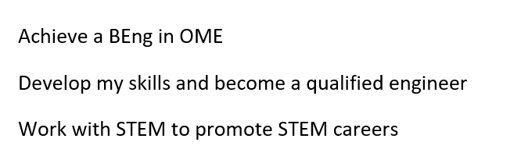

3.3 Independent Study of Torpex
3.3.1 Development
First, it is important to get the background of this high explosive and the reasons for its creation. Torpex (TORPedo EXplosive) is a secondary explosive made up of a mixture of RDX, TNT and aluminium powder giving it a 50% stronger explosive yield than TNT by weight. [9] When creating torpex one has to mix Trinitrotoluene (TNT), Research Development Explosive (RDX) and aluminium powder in a ratio of (40/40/20% w/w). [9] At the time RDX, production was in ROF (Royal ordinance factory) Bridgewater where they found the raw composition to be too sensitive and therefore they began to mix other materials to reduce the sensitivity. In the case of bomb fills, RDX required the introduction of TNT during the pour and fill of the bomb. For demolition charges RDX required soft inert materials to reduce the sensitivity. [10] Further issues occurred as the supply of aluminium was becoming low in the early stages of WW2. This meant that the testing and production of aluminized explosives struggled and thus prioritising one project over another became necessary. In the case of torpex, the production continued for naval purposes such as depth charges and torpedoes. The RAF conducted tests in 1941 on whether or not the use of torpex would be beneficial as a bomb fill but due to the poor method of measuring blast pressure, they concluded that this project was not a priority. [10] Development began to make progress again in 1943 as the Battle for the Atlantic came to a close. With aluminium now arriving in the UK the testing of torpex in bombs began again and this time found to be better than the RDX and TNT combination currently used. The Air ministry opened a program in the production of torpex bombs. [10]
3.3.2 The uses of torpex
Over the course of WW2, the uses of torpex broadened. Originally, it was an underwater explosive used in depth charges and torpedoes. In the Mark VIII aerial depth charge there was a torpex fill of 250lb which was said to be equivalent to a 420lb Mark VII filled with amatol. [10] The introduction of this lightweight but powerful Aerial DC was a turning point for naval warfare. Up until this point in the war U-boats had be terrorising the allied convoys and supply chain. With these lighter weight depth charges, it allowed planes that previously could not carry DC or planes that could to carry more. With the new and improved aerial DC’s it marked a turning point on the war against the U-boats. The airborne variants of depth charges include the Mark VIII and Mark XI, which were both 250lb torpex filled explosives. These weapons were devastating against the problem that was the U-Boats. The design of these weapons meant that they would detonate at a depth of 25ft, catching any submerging submarine in the blast. [10] With the size of the ordinance, planes could carry multiple sets of the depth charges at once and drop multiple around a target to maximise damage. Before the introduction of torpex into small antisubmarine weapons for every one U-boat that was sunk 100,000 tons of shipping were lost to them. After the introduction of torpex, the number changed to 10,000 for one U-boat. Torpex was key in the destruction of the German submarine fleet of WW2. [10]
Depth charges and torpedoes were only the explosives first use. After Dr Barnes Wallis designed the “Tallboy” bomb, there was a new use for torpex. The Tallboy high capacity bomb was a 12,000lb bomb designed to penetrate the surface if the target and explode with a delayed fuse. It quickly earned the nickname “Earthquake bomb”. The idea that Wallis had was damaging the reinforced structure. The prime example of this was La Coupole in France. [11] The RAF dropped these bombs all around the concrete structure where three landed at the tunnels entrance, one underneath the main structures support and the final two in the rocket vertical entries. The detonation had so much force it caused the hill to shift and collapse underneath the structure making the whole thing unusable due to the instability. [11] The final example of the power of torpex is the sinking of the Bismarck’s sister ship called the Tirpitz. This was the second Bismarck class battleship that Germany created during the war. The Navy could not sink it so they called upon bomber command who sent the squadron known as the “Dambusters”. [12] Tasked with sinking the ship they were equipped with Lancaster Bombers carrying tallboy bombs. In their first raid, they only damaged the ship lightly. The second raid began by one tallboy falling right through the deck and causing the ship to take on water. Another bomb landed next to the ship and the sheer force of the blast caused the ship to capsize. [12] The creation and use of torpex was a key point for the UK in WW2 allowing them to not only hunt their infamous wolf packs but destroy some of the most reinforced and well-made structures with ease. [12]

Conclusions
There were many conclusions that the student found in each section discussed within this report. To begin with the presentation the student found that they should not focus so much on the content and order of the presentation but on the audience and how engaged and interested they were in hear what the student had to say. This also relates to the students confidence in speak before an audience. Although the student spoke with confidence, the pace and material covered with the lack of interactivity with the audience left the presentation feeling dull.
The student had researched many skills to do with employment and higher education and how these skills may affect over the next few years of study. The student found that skills such as teamwork and communication we crucial in a professional setting but teamwork would not help them in a one-person project such as writing a report. The student looked into more skills such as problem solving and how important it is for both the academic and professional worlds to be able to effectively solve problems and thus determining this skill to be very important. The student also looked into soft skills which some of the skills previously mentioned fall into. These skills are useful in all aspects of work and academics meaning that these skills are especially important compared to hard skills, which are skills that are only important writing a professional setting.
The student then conducted evaluations of their own skills to determine what jobs and personality type they are suited for. The student was critical in their findings on what personality type they were agreeing with most of the description give (INTP). The skills assessment gave details on the student’s strengths in critical thinking and problem solving and showed their weaknesses of creative thinking and time management. This allowed the student to create a plan on how to further progress the strengths found and to help improve the weaknesses.
The student then discussed future goals of obtaining a BEng and improving their skills as an engineer. The student assessed these goals against the idea of SMART goals finding that these goals were fair and should be achievable within good time.
The student then discussed data protection methods for work and academic materials. The student found that it is incredible important to back up data as a loss without a backup can seriously damage the potential grades and cause unnecessary stress. The student then found multiple effective ways of protecting data and made a plan to use them when creating materials.
The student then created a plan that would help them manage their time. This plan would be one that needs to be altered regularly as the student already struggles with time management so by using this method it helps to develop this skill. The student found this to be of great importance as they student needed to finish this assignment within good time.
The student then conducted a review on an old explosive called torpex. The conclusions that the student came to were that torpex was a crucial part off the allied war effort during the Second World War and without it the war may have dragged on longer making it an extremely important explosive historically.

References

[1] | M. S. Kalauz, G. Hudec and V. Kirinic, “Soft skills perception among students: importance and performance,” in Central European Conference on Information and Intelligent Systems, Varazdin, 2015.
[2] | N. E. Dunbar, C. F. Brooks and T. Kubicka - Miller, “Oral Communication Skills in Higher Education: Using a Performance-Based Evaluation Rubric to Assess Communication Skills,” Innovative Higher Education, vol. 31, no. 1, pp. 115 - 128, 2006.
[3] | Z. H. Iksan, E. Zakira, T. S. M. Meerah, K. Osman, D. K. C. Lian, S. N. D. Mahmud and P. Krish, “Communication Skills among University Students,” Procedia - Social and Behavioral Sciences, vol. 59, no. Special Issue, pp. 71 - 76, 2012.
[4] | E. Britton, N. Simper, A. Leger and J. Stephenson, “Assessing teamwork in undergraduate education: a measurement tool to evaluate individual teamwork skills,” Assessment & Evaluation in Higher Education, vol. 42, no. 3, pp. 378 - 397, 2015.
[5] | S. Rosita, “Diversity Career Opportnuities & Inights,” Transferable Skills, vol. 4, no. 3, p. 26, 2002.
[6] | J. Jankowski, The Logician: Your Guide to the INTP Personality Type, LOGOS MEDIA, 1900.
[7] | F. Magnusson, Implementing a Backup-Scheme with the 3-2-1 Strategy: A Comparison of the Active Solution with a New Implemented 3-2-1 Backup-Scheme, Mid Sweden University, 2018.
[8] | L. Macleod, “Making SMART Goals Smarter,” Physician Executive, vol. 38, no. 2, pp. 68-70, 2012.
[9] | N. Turner, S. Murray, M. Sloan, A. Carp, I. Scattergood, S. Hiscock, G. Hooper, P. Gill, M. Parker, J. Fellows and P. Cheese, Services Textbook of Explosives textbook, N/A: DOSG Energetics Group, 1988.
[10] | C. F. Baxter, The Secret History of RDX: The Super-Explosive that Helped Win World War II, Lexington: University Press of Kentucky, 2018.
[11] | S. Flower, The Dam Busters: An Operational History of Barnes Wallis' Bombs, Amberley: Amberley Publishing Limited, 2013.
[12] | M. R. D. Foot, The Oxford Companion to World War II, Oxford: Oxford University Press, 2001.

