University of Wales
Trinity Saint David

STUDENT NAME – Marian Dragos Beaca
STUDENT ID NUMBER – 1917126
MODULE TITLE: INTRODUCING THE MODERN WORKPLACE
ASSIGNMENT TITLE: INTRODUCING THE MODERN WORKPLACE
ASSESSMENT 1
LCBB4003 – A1
LEVEL 4/TERM 2/GROUP 1
MODULE LECTURER’S NAME: Dr. John Paul Okeke

People Management and Leadership at Microsoft

Contents
Introduction: 4
Microsoft: 4
Organisational performance parameters: 5
Managerial functions and process: 8
Managerial Theories: 9
Behavioural theories of management: 10
Conclusion: 11
References: 11

Exective summary : This report is about the leadership stye at Microaoft and its manner in which certain chnages have come into one of the world’s largest technologival compnaies. The beginign of the assignmant specifies the introduction and the pupose of the assignment. Then a summary intio Microaoft as an organisation and its fucntions. The topics of analyis are in the follwing order. Organisational performance parameters - Culture and performance, People and performance, Structure and performance. Managerial functions and process - Managerial Theories, Leadership theories. Behavioural theories of management.

Introduction:
Working in a modern big brand corporate organisation is always the dream of everyone. Every individual, when they enter such organisations, they have certain expectation from the latter. Based on the same, the individuals work out their future career growth path. On the other hand, the organisation has to take into consideration the aspirations of their human resources but accordingly to the goals and objectives of the former. Both have to be balanced and they cannot be taken differently. It is the responsibility of the frontline managers and human resource heads to ensure that people and organisations move together and in the same direction. The human assets, working style, culture, leadership pattern play an important role. Even if it is one of the most powerful brand names like Microsoft, it is equally valid (Dent and Bozeman, 2014).

Microsoft:
Microsoft is a name which hardly anyone in this planet would not have heard of. They develop applications and software, licenses, personal computers, electronics. The most famous of its products is the Microsoft Windows, operating system, Office suite utility package, internet explorer browser and more recently Xbox video games console. The organisation is ranked as part of the “Big Five” tech giants of the world.
Most of the software for desktops, laptops, tablets and smart phone devices are developed by Microsoft. It includes the consumer and the solution based enterprise market. The cloud computing technology Azure offered by Microsoft is powering many hosted applications around the globe. Other offerings having large scale daily usage include MSN web services, Visual studio programming tool, Hololens mixed reality.
Similar to other global brands, Microsoft has gone on a growth strategy through acquisitions of other technology organisations. Some of its most famous and also biggest takeovers have been in recent times. These were the 2016 takeover of LinkedIn, the 2011 takeover of Skype, acquisition of telecom company Nokia, the 2018 buyout of Source code management platform Github, the 2014 purchase of the popular game Mojang (Infographic: Microsoft's Biggest Acquisitions, 2020).
Microsoft head office is located in Washington USA. It has global offices, development centres in many parts of the world. The total revenues, as of 2020 is to the tune of $ 143 billion. The company has a workforce of about 1.52 lacs across the world. Many of them are in technical and development roles. A 2018 survey ranked Microsoft as the 21st in the world as the best place to work (Koetsier, 2020).
The founder of Microsoft is Bill Gates who is as well-known as the brand. The fame is not just as the owner-founder of one of the biggest technological brands but also as a philanthropist The role of Bill Gates in eradication of polio across the world has been lauded by many countries. The present CEO is Satya Nadella.

Organisational performance parameters:

Culture and performance -
It is the shared values, beliefs, ideas, working style and it has a definitive impact on performance. Some of the main theories are –
Geert Hofstede’s cultural dimension theory: It is the most accepted and practiced model in terms of people behaviour within an organisation. The theory has six dimensions. Each one of them is ranked on a score of high or low (Hofstede, 2018).
Power distance – The extent to which people are ready or do not accept power
Individualism Vs collective – Importance to self or society
Uncertainty avoidance – Planning for the future
Masculinity Vs Femininity - Exhibiting qualities of male or female in terms of outlook.
Long term vs short term orientation – Searching for results and reliance on values.
Indulgence vs restraint – Fulfilling wants or sacrificing them.
Daniel Denison Model: The culture can be internally influenced or externally. At the same time the work culture can be stable as against a constantly changing one. In other words, scenarios and happenings play and important role. The four dimension are mission, adaptability, involvement and consistency (Ahmady, Nikooravesh and Mehrpour, 2016).
Charles Handy – In this model, the structure of the organisation strongly influences the culture as well. The culture in itself is based on power, role, task and person.
Microsoft scenario:
A typical Microsoft office in USA, Canada or Australia will have people from different countries, societies and regions. They come from various religious backgrounds as well. It may not be possible for a manager to change the overall working style according to people. But through a combination of these theories a balance can be brought about. It is very necessary to do this in a diverse employee base.
People and performance -
This is known as the people and performance model and it also goes by different titles. It is more recent in its origins and is being closely studied by many organisations. Especially those with large and diverse group of employees. The people profiling is done through a two into two matrixes.

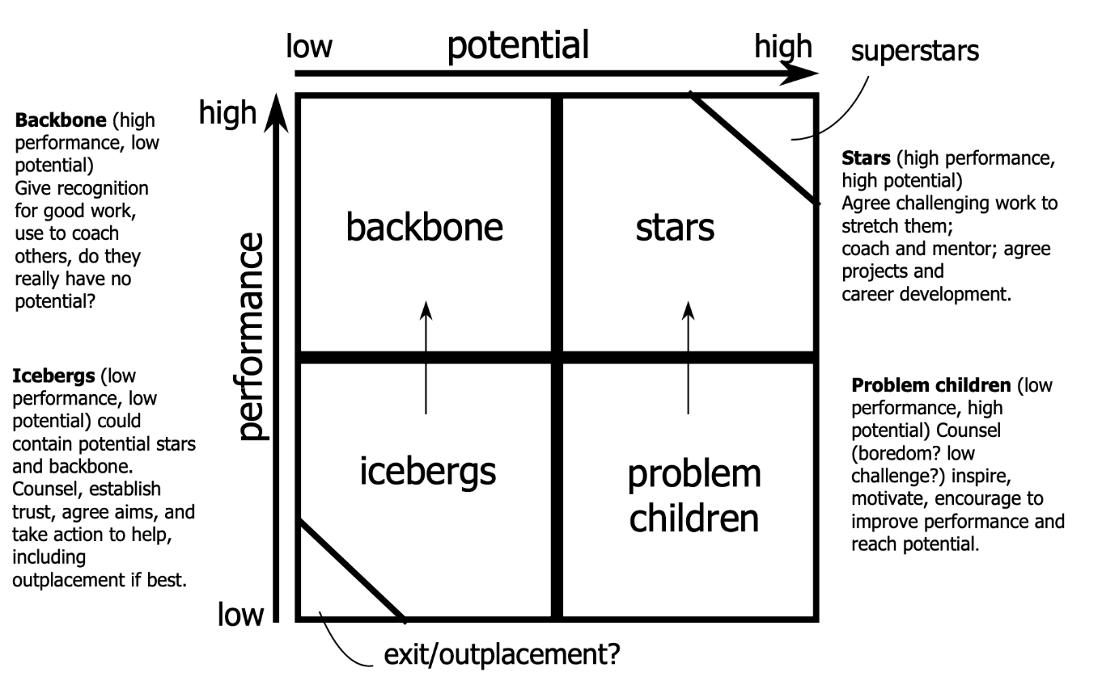
Figure 1.0 - (People–Performance–Potential Model – BusinessBalls.com, 2020)
Definition as per matrix
Stars – These are the self-motivated performers and have enormous capabilities. They are best present and future manpower assets. Such people need to be given proper career development opportunities and leadership responsibilities.
Backbone – It is categorized as high performance and low potential. The employees with hidden potential has to be discovered. Accordingly, they have to be groomed with challenges and special tasks.
Iceberg- Such employees have a low performance and low potential. Their development should be done with fitting and filtered roles and certain purpose. Sometimes they may also need to be moved out as last resort.
Problem children – Low performance and high potential. By trust building measures, the hidden potential needs to be brought out. Inspiration can come from stars or backbone.
Microsoft application: Each manager has to handle their team according to the mix of potential they receive. It will differ in every case.
Structure and performance -
Very small entities that are owner controlled will run on sharing of roles and tasks. However Most of the growing organisations in the world can be broadly classified into the following structures as and when they start growing.
Functional structure – Employees are part of a department according to the job profile and role. It is done so that people with similar skills can work effectively and as a team.
Divisional structure - A certain product or service is given importance as per to the demand of the industry or the prevailing conditions. Accordingly, divisions are created to focus on such products. It may be temp or permanent.
Matrix structure –People from functional roles are taken to support a special task and project. The workforce in this might even have a dual reporting to the existing and new heads.
Microsoft scenario:
In a large and complex organisation like Microsoft, it is always necessary to have all the structures. The core set up will be that of functional. For example, since the company is deeply expanding into the games segment, divisional focus is required. Again functional teams like coding will have support new development projects.

Managerial functions and process:
A leader or a manger has certain core functions to carry out. It may be the role of leading a small team or that of the entire organisation. Still the functions as given below remain same –
Planning – The very purpose of the organisation and the goals to be achieved by it is determined. It will also include the mission and the vision. The long term and short term objectives is detailed here (Kitana, 2016).
Organising – The necessary resources have to be put in place towards the achievement of the objectives. It includes human and asset resources. The stage wise activity and delegation comes into picture here.
Leading – The employees have to be motivated into getting the defines results. It is possible only through good leadership and influencing skills.
Controlling and monitoring – As the implementation proceeds, managers have to keep on monitoring the growth path and provide new solutions or change of directions if required.
Management process is the method used by managers to ensure the fulfilment of the given functions. These are series of interrelated activities that has to lead to desired growth of the organisation. These process defined takes into consideration, the size, scale of operations, resource availability, people and culture. It will have to be changed if the desired objectives are not being met. Every process is a tool for the manager to aid their functions and hence they need to be flexible and practical as well.

Managerial Theories:
Scientific management – This theory by Fredrick Taylor states that people should be given work in a scientific manner rather judgement of the manger or leader. Task simplification is the main method.
Administrative management – This theory is developed based on the situation faced by manager and their ultimate goals. It runs on a series of principals through which the functions can be achieved. These principles however should not be rigid and finally it is the discretion of the mangers to use it effectively. The principles include initiative equity, remuneration, unity, order, stability, authority, discipline of work, centralization, subordination. Etc. It uses a combination of individual wishes and organisational goals to get the results (Calás, and Smircich, L. 2019).

Bureaucratic management - In this theory proposed by management expert Max Weber, organisations should faction in a clear hierarchical manner. It will thereby set in tune a proper governance pattern. It puts in place the desired chain of command, division of labour, rules and procedures, documentation, record maintenance, standard procedures. These are the parameters on which every entity should be run.

Systems management – In this managerial theory, an organisation is a combination of different components. Al these components should work smoothly with one another in order for the entire structure also to function smoothly. The similarity is to a body part. Managers should closely evaluate the events and the series to finalise a certain approach.
Microsoft scenario – The scientific management theory does not hold too much value in a dynamic technology development company such as Microsoft. The reason is that technology changes are very fast. Microsoft has to take certain elements of the functional theory according to the new market demands. The Bureaucratic management approach is very much necessary due to the sheer size of its manpower and operations.
Leadership theories:
Democratic, autocracy, and laissez affair – Traditional models of participative, power concentrated and total free approaches.
Situational: The leader does not depend on any particular style and all decisions are taken based on the development level of the team. Here, leaders do not try to influence the team into their pattern of thinking. Rather it is the other way round.
Transactional – The leader aims to reach the organisational goals and objectives through each specific task as and when it comes up.
Transformational – A proactive approach is taken by the leader understanding the overall requirement of the team and the need for development of employees.
Authentic – This is a more recent model. These leaders are totally goal ware and will drive towards it reach. They understand things in a loner view and will take action accordingly (Kelloway, and Gilbert, 2017).

The typical leadership styles like democratic, autocracy, and laissez affair is totally inapplicable in the case of Microsoft. It may be used within certain teams or group and that also for a specific project. The growth of the organisation depends on the central leadership shown by the tech giant. Such a pattern is the exercised by CEO Satya Nadella. He has changed the culture by making it employee friendly through a new framework of policies. The outlook is based on transforming the very culture of work. The approach is that of a learn-it-all philosophy and a total change from the traditional know-it-all way of Microsoft. The result has been miraculous (Transforming culture at Microsoft: Satya Nadella sets a new tone, 2020).

Behavioural theories of management:
It is also known as the human relation theory since it focuses on the factors of human motivation that lead to maximum productivity.
Maslow hierarchical theory of needs – It is a human resource theory which has set the tone for the behavioural model approach. According to this, all individuals go through multiple layers of needs in a pyramid like structure. The highest level is self-actualisation and the beginning layer is survival needs.
Herzberg’s two factor theory of motivation – An Individual looks at job satisfaction as well as proper working conditions. Any imbalance is a cause of dissatisfaction.
Both the theories are valid in the case of Microsoft.

Conclusion:
As can be seen, global organisations like Microsoft will always need to have a reactive approach in its leadership and this has to start right from the top level. The need to open up and accept a new culture in working style can be very well seen under new leadership of CEO Satya Nadella.

References:
Ahmady, G.A., Nikooravesh, A. and Mehrpour, M., 2016. Effect of organizational culture on knowledge management based on Denison model. Procedia-Social and Behavioral Sciences, 230, pp.387-395.
Businessballs.com. 2020. People–Performance–Potential Model – Businessballs.Com. [online] Available at: <https://www.businessballs.com/performance-management/people-performance-potential-model/> [Accessed 23 August 2020].
Calás, M.B. and Smircich, L. eds., 2019. Postmodern management theory. Routledge.
CB Insights Research. 2020. Infographic: Microsoft's Biggest Acquisitions. [online] Available at: <https://www.cbinsights.com/research/infographic-microsoft-biggest-acquisitions/> [Accessed 23 August 2020].
Dent, E.B. and Bozeman, P., 2014. Discovering the foundational philosophies, practices, and influences of modern management theory. Journal of Management History.
Hofstede, G., 2018. Hofstede insights. Retrieved November, 27, p.2018.
Intheblack.com. 2020. Transforming Culture At Microsoft: Satya Nadella Sets A New Tone. [online] Available at: <https://www.intheblack.com/articles/2018/06/01/satya-nadella-transforming-culture-microsoft> [Accessed 23 August 2020].
Kelloway, E.K. and Gilbert, S., 2017. Does it matter who leads us?: The study of organizational leadership. An introduction to work and organizational psychology: An international perspective, pp.192-211.
Kitana, A., 2016. Overview of the managerial thoughts and theories from the history: Classical management theory to modern management theory. Indian Journal of Management Science, 6(1), p.16.
Koetsier, J., 2020. Facebook, Google, Apple Sink In ‘Best Place To Work’ Rankings; Microsoft Rises. [online] Forbes. Available at: <https://www.forbes.com/sites/johnkoetsier/2019/12/11/facebook-google-apple-sink-in-best-place-to-work-rankings-microsoft-rises/#31dd2ed01ca7> [Accessed 23 August 2020].

