Apply the principles and practices of Data security,
Governance and Compliance based on a given scenario.
——Lang Yan(2200468)
——ACCA7028

When people talk about information security, the security of information in corporate enterprises will probably be the majority of situations discussed. Based on the scenario on CoffeeBlend, The availability of a complete and comprehensive information security framework may determine the direction of a company.
An information security model is used to describe precisely and formally the security characteristics of an information system and the rationale used to explain the security-related behaviour of the system. It is useful for accurately describing important aspects of security in relation to system behaviour, for increasing the level of understanding of the successful implementation of critical security requirements, and for developing a set of security assessment guidelines, and key descriptive variables from them. (Roald et al., 2022)
The following will discuss the basic framework of the Information Security Assurance System. The security protection system is integrated and correlative, not just as a technical issue, however as a combination of three major elements: people, management and technology. Through the three elements of people, management and technical means, it constitutes a dynamic information and network security framework model to realize the security protection of the system. The five components have a temporal relationship and a dynamic closed-loop feedback relationship.
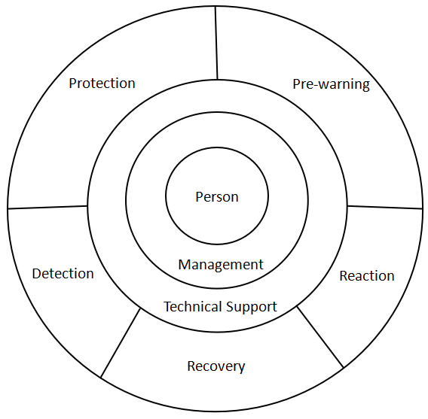
Prewarning: Use the simulation technology provided by the remote security assessment system to examine the vulnerability of the system that exists and can be exploited, collect and test where the security risks of the network and information lie, and report in an intuitive way, providing recommendations for solutions, and after analysis, understand the trend of risk changes and serious risk points, thus effectively reducing the overall risk of the network and protecting critical business and data. (Zauwiyah et al., 2019)
Protection: Protection is usually achieved by using proven information security technologies and programme to secure networks and information, mainly firewalls, authentication, authorization, encryption, etc.
Detection: Detecting and monitoring networks and systems to identify new vulnerabilities and threats and enforcing management policies. Intrusion detection, malicious code filtering and other such techniques are used in this process to form a dynamic detection system and to create a auxiliary reporting mechanism to promote the real-time state of detection. (Kahyaoglu et al., 2018)
Reaction: After security breaches and security events are detected the correct response must be made in time so that the system can be adjusted to a secure state. For this purpose, corresponding alarm, tracking and processing systems are required, where processing includes subsystems such as warning, blocking and reporting.
Recovery: A recovery system is a system that is recovered to general status in the shortest possible time through some pivotal technical methods (e.g. redundancy, backup, repair, etc.) when the network, data and services have been disturbed and damaged or affected.
A technical model of the security architecture is needed for the company's complex network information and network databases. The need for security cannot be addressed by any single security technology and a suitable security architecture model should be selected. The information and network security assurance system consists of three levels: security services, protocol levels and system units, and each level contains elements of security management. (Peng et al., 2022)
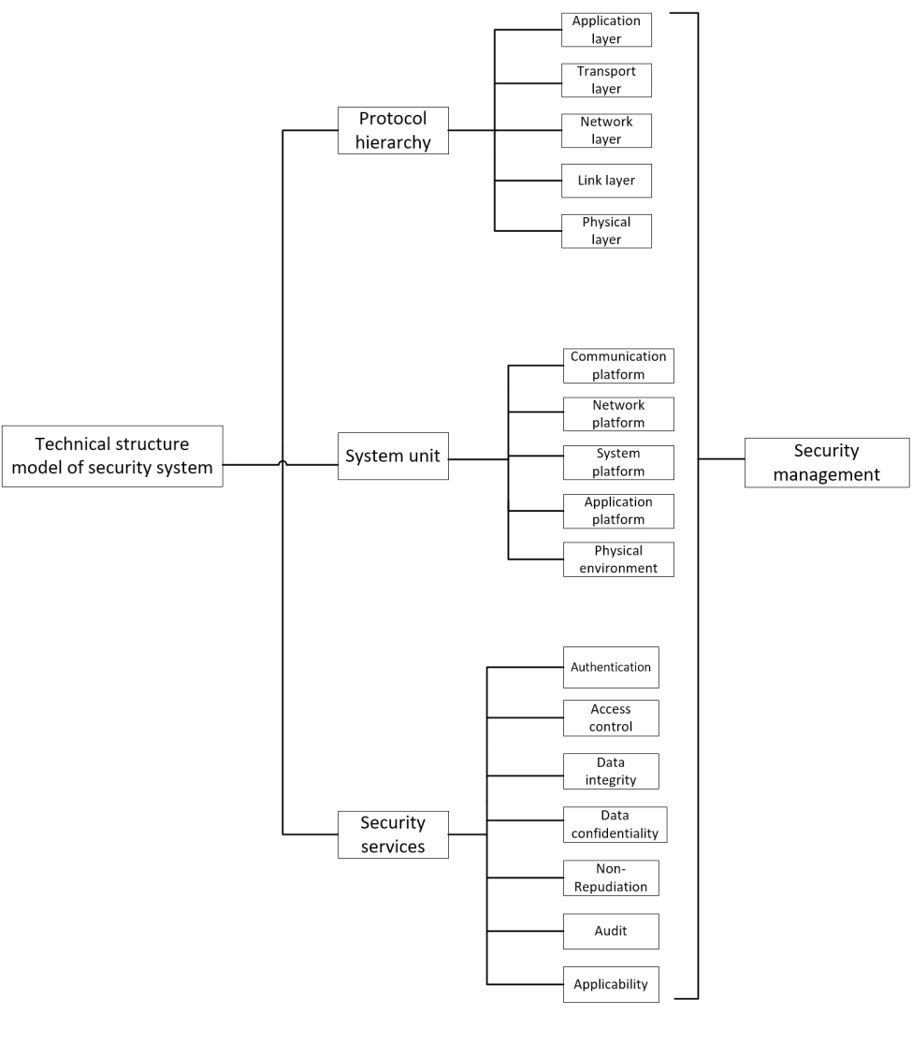
Based on the delineation of security zones, authorities should develop targeted security strategies.
1. Conduct regular audit assessments of critical areas to establish a baseline of security risks.
2. For critical areas, install distributed intrusion detection systems.
3、Deploy anti-virus systems to prevent malicious scripts, vulnerability attacks and viruses
4. the establishment of systems for backup and disaster recovery
5、Establishing a single sign-on system for unified authorization and authentication.
6、Configuring network devices to prevent Denial of service(DOS).
7、Regular security vulnerability scanning and network auditing of critical areas, and system reinforcement in response to scanning results.
When coming to network information security, except conducting the technical methods mentioned in the previous statement, strengthening security management of the network and establishing regulations and rules will probably be of vital significance in ensuring the safe and reliable operation of the network. Security management is a very important part of the security system construction. Any technical security measures must ultimately be implemented into specific management rules and regulations as well as specific management personnel responsibilities, and be realized through the work of the management personnel. (Yong et al., 2022)
Safety management follows the international standard ISO 17799, which focus on the comprehensive aspects of management systems and aims to provide reliable and practical solutions for organizations which hope to achieve safety management effect. Each unit uses this as a reference to establish its own information security management system, which can be designed and traded off according to its own practical situation on the basis of the experience of others, in order to achieve the aim of good management of information. (Calder et al., 2011) Information security is not only a technical issue, but more importantly a management issue. The best way to protect an asset is to establish a complete, scientific management system for it. Establishing and implementing an information security management system (ISMS) is an important measure to ensure information security for enterprises, institutions and government agencies. The majority of governments in the world, including China, have signed agreements to support and endorse the ISO 17799 standard.
In addition, there are a number of common cyber security frameworks and models. (Changseob et al., 2019)

- PDR model (based on the time dimension)
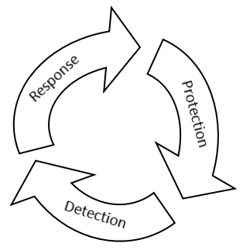
The representative model of the dynamic network security system proposed by the American company ISS, PDR (Protection-Detection-Response, PDR) model idea: acknowledge the vulnerability, face up to the threat, take moderate protection, strengthen the detection work, implement the response, and establish the protection against the threat to secure the system. The Protection-Detection-Response (PDR) model is a time-based provable security model based on the concepts of Protection and its protection time Pt (the time a system survives a hacking attack), Detection and its detection time Dt (the time between the start of a hacking attack and its discovery), and Response and its response time Rt (the time between the discovery of an attack and an effective response). (time from detection of the attack to a valid response)
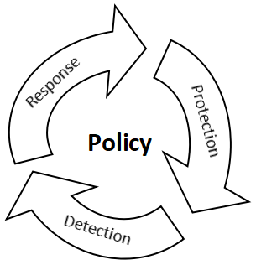
- P2DR model
PPDR model (Policy-Protection-Detection-Response, PPDR) core: all protection, detection, response is based on the implementation of security policy. p2dr model will be carried out with the indication and regulation of the core security policy, in the integrated use of protection measures, at the same time, the use of detection tools (such as vulnerability assessment, intrusion detection and other systems) to assess the security status of the system to maintain the system in the lowest risk state. The P2DR model presents a new concept of security, i.e. security cannot rely on static protection alone, nor can it rely on technical means alone. The P2DR model introduces a new concept of security, which means that security cannot be achieved by purely static protection or by purely technical means.
- The PDRR Model
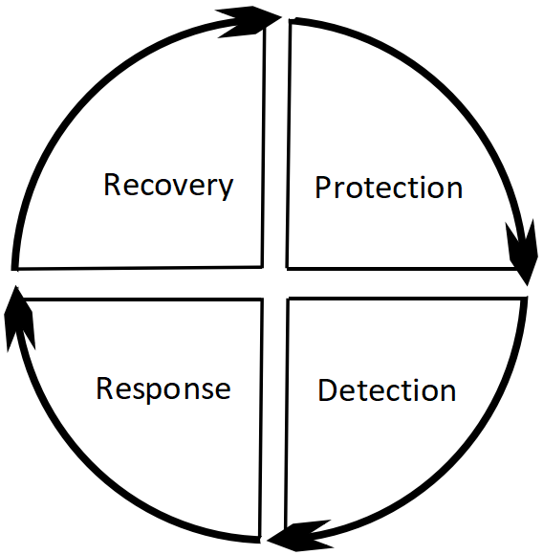
The PDRR model was proposed by the US Department of Defense (DOD) and stands for Detection, Protection, Response, and Recovery. It optimize on the former single security defence idea of focusing simply on protection and points out four significant sections of PDRR for ensuring the security of controlling information .
4. IPDRR Model
It is NIST network security framework core element. IPDRR capability framework model includes risk identification (Identify), security defense (Protect), security detection (Detect), security response (Response) and security recovery (Recovery) five capabilities. "The IPDRR capability framework covers the whole process, from the original model with protection capability as the core, to a model with detection capability as the core, supporting identification, prevention, detection and response, etc., changing from passive to active, until the adaptive (Adaptive) security capability.
5. PADIMEE Model
The model considers the business and technical requirements of clients and analyses the "Lifecycle" of information security for the customer, reflecting the constant operations of ensuring information for secure in seven core areas, consisting of the following main components: security policy, security analysis, establishing/programming, implementation/realization, controlling/monitoring, critical feedback and security training. (Lambrechts et al., 2020)

ITIL: the Information Technology Infrastructure Library, a socially recognized reliable and effective service solution for IT management.
ITIL 4 Foundation focuses on making users understand and learn the contemporary IT management service system, making people know the basic common language and basic concepts, and introducing them to how the technology works and the work of their organizations through indicative information. ITIL 4 also provides a holistic end-to-end approach, incorporating Lean, Agile, and DevOps as part of the framework. (CLAIRE et al., 2021)
Traditionally, IT was merely conducted for use of supporting, however IT presently becomes a kind of services. With the aim of diminishing expenses, improving productivity and promoting quality, ITIL has now set off a frenzy around the world. With the trend of the market situation that providing technical guidance has gradually evolved into the situation of providing services, the demand for IT service management is also increasing day by day, which is of great help in standardizing and synchronizing IT processes with business and improving processing efficiency.
The ITIL certification has become one of the most sought-after qualifications in the global IT industry, and obtaining ITIL certification has become the best way for outstanding IT managers to develop their careers, and an effective shortcut to share the best practices in global IT management.
The development of ITIL has not only been strongly supported by its originator in the UK, but has also created a frenzy in Europe, North America or New Zealand and Australia. The number of ITIL certified people worldwide has already exceeded 300,000 (60,000 of which are in the Asia Pacific region), and the number is growing year on year, with some government departments even stipulating that IT-related personnel will not be employed without an ITIL certificate. (CLAIRE et al., 2021)
ITIL certification can provide us with the following benefits.
Firstly, process management. Nowadays, it has become an inevitable trend for enterprises to carry out an effective management of internal processes and redesign business functions, which can efficiently reduce enterprise costs, shorten the turnaround time, and can well improve customer satisfaction. This allows the company to react to changes in finance, marketing, manufacturing and sales in a timely manner and to respond efficiently.
Secondly, forward-looking management. In the market, once there are any changes, the enterprise must react quickly and provide effective solutions, otherwise the enterprise will lag behind. In traditional enterprises, the response to such changes is relatively slow, and when problems are found and then solved, it is too late.
Thirdly, team management. In ITIL, it is clearly required to establish a team with a sense of responsibility, multi-skilled, cross-organizational cooperation, the team can deepen understanding of mutual trust, there will be no mutual blame, to achieve mutual promotion mode, better on team management.

ISO/IEC 27000 standard is the general name of a series of related standards established by the International Organization for Standardization specifically for information security management systems, and has reserved a total of 60 standard numbers from ISO/IEC 27000 to ISO/IEC 27059. So far, there are eight officially released information security management system (ISMS) standards, two of which have been transformed into national standards.
The ISO/IEC 27000 family of standards (also known as the ISO/IEC 27000 family of standards, the "Information Security Management System Family of Standards", or "ISO27K" for short) was collectively created by ISO and IEC. ISO/IEC 27000 can be used as a criterion for judging organizational capabilities which is to measure whether the information security requirements of individuals, organizations or laws are met. (Meriah et al., 2019)
The significance of establishing ISMS for enterprises can be understood by referring to some introductions to the information security management model, establishing a comprehensive system based on the latest information security management guidelines and constantly improving it, choosing a lower cost option, to try to reduce the risk coefficient of information and the degree of possible harmful results and to implement preventive methods to prevent risks from disrupting business. Establishing, implementing and maintaining an information security management system will: 1) strengthen the information security awareness of employees and regulate the organization's information security behaviour; 2) provide comprehensive and systematic protection of the organization's critical information assets and maintain a competitive advantage; 3) ensure business continuity and minimize damage in the event of an information system breach; and 4) provide confidence to people's business partners and customers.
Adopting the ISO/IEC 27000 standard and getting certified is certainly a certain factor that organizations need to measure. The benefits include the following: First, preventing information security incidents, ensuring the continuity of the organization's business and enabling the organization's critical information assets to be protected in line with their value. Second, saving money. A qualified and excellent ISMS not only requires the ability to avoid security incidents, but also can make a reasonable and comprehensive expenditure plan for the organization. Third, carefully and strictly operate the organization, create a good brand reputation in the public environment, improve the comprehensive competitiveness, focus on the return on investment ratio, and seize all business opportunities. Forth, improve goodwill and credence and reliance of customers, partners and other related parties.
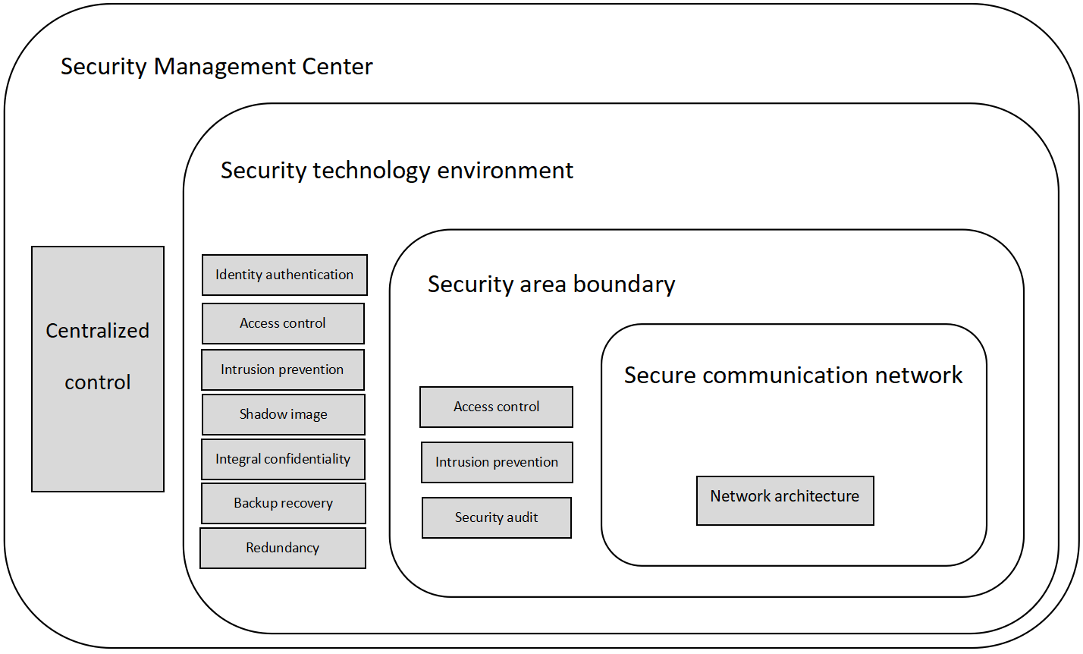
Based on the case studies provided, this paper is based on the "triple protection" system framework under the management of the "One Centre" to build security mechanisms and policies to form the security protection environment of the graded system. The environment consists of four parts: a secure computing environment, a secure area boundary, a secure communication network and a secure management centre. (Ross et al., 2021)
The "One Centre" refers to the Security Management Centre and the "Triple Protection" stands for computing security environment, secure area boundary, secure communication network. "One centre" means the security management centre, which is a platform or area for the unified management of network security and an important network security defence system. Triple protection" should be changed from passive protection to active protection, from static protection to dynamic protection, from single point protection to overall protection, from rough protection to precise protection. This security protection system, the cloud computing, Internet of things, mobile Internet, industrial control systems, big data and other new technologies into the scope of protection.
The design is focused on the following four areas:
1. Design of the Secure Computing Environment
(1) User identification
User identification and user authentication should be supported.
(2) Autonomous access control
Within the control of the security policy, users are given access to the objects they create, and this access can be authorized on a user-by-user basis. This can be specific to the specific operation against the object being accessed.
(3) Tagging and mandatory access control
Visitors and visitors can be marked for security on the basis of identity identification, to achieve control over the operation of the subject's access to the object.
(4) System security audit
A complete audit of the access behavior, the audit includes the contents of the access object, the object being accessed, the behavior of the access, time, etc.
(5) User data integrity protection
The integrity of data is protected against tampering using backup and HASH methods.
(6) User data confidentiality protection
Confidentiality protection mechanisms supported by passwords and other technologies are used to protect the confidentiality of user data stored and processed in the secure computing environment.
(7) Object security reuse
Object security reuse means that the object being accessed should not retain the characteristics of the object being accessed, so as to avoid the leakage of information between the objects being accessed due to the access of different access objects.
(8) Trusted program execution protection
Trusted computing technology is used to ensure that the process of program execution is trusted. Trustworthiness is a complex aspect, however it can be achieved within a focused server computing environment. Trustworthiness can be achieved within a focused server computing environment.
2. Design of Safety Zone Boundary
(1) Area boundary access control
Requires control at the zone boundary to prevent unauthorised access.
(2) Area boundary packet filtering
Requires packet filtering detection measures at the zone boundary.
(3) Regional boundary security auditing
Requires security auditing measures at the regional boundary to ensure internal and external data auditing.
(4) Zone boundary integrity protection
Detectors, such as external detection software, should be set up at the regional boundary to detect illegal outreach and human intrusions, and to ensure the integrity of the regional city. illegal outreach and human intrusion, and report them to the security management centre in a timely manner.
3. Design of Secure Communication Network
(1) Communication network security auditing
An auditing mechanism is set up in the secure communication network, which is centrally managed by the security management centre and alarms are provided for confirmed violations.
(2) Communication network data transmission integrity protection
Network transmission data integrity inspection and protection. To ensure the security of network transmission data.
(3) Communication network data transmission confidentiality protection
Transmission confidentiality of network data.
(4) Trusted access protection for communication networks
Trusted access protection is applied to the communication network. Secure communication network design is mainly for the confidentiality requirements of the communication network, the use of network encryption technology can achieve all the requirements, VPN technology can be used to achieve the protection of the communication network and data.
4. Design of the Security Management Centre
(1) System administration
The system can identify and authorize the actions of system administrators, allowing them to access only specific interfaces and specific systems. In most cases, system administrators can be divided into network administrators, host administrators and storage administrators. Network administrators primarily perform policy configuration for network devices. Host administrators primarily manage and configure server operating systems. In most cases, host administrators are further divided into PC server administrators and small machine administrators; storage administrators mainly maintain and manage storage devices.
(2) Security Management
Identification and authorization of security administrators. As we all know, the security administrator is only the management of the security equipment, security equipment and involves the entire computing system in all aspects, the management of the security administrator has become particularly important, most security equipment have LOG record function, while providing a convenient interface can be authorized to manage.
(3) Audit management
According to the information security level three protection requirements for security auditors to identify and manage, security auditors have to deal with a variety of devices, how to ensure that the behavior of security auditors to control is also a complex requirement.

In order to adapt to the changing internal and external environment, the business management regulations and standards has to make appropriate adjustments in response to the changing environment. For example, in China, the age of the standard is 5 years. With the development and application of technology, manufacturing and new raw materials, the old standard cannot meet the current form, therefore, the standard needs to be revised after a certain period of time, hence the term age of the standard. (Oliver et al., 2021)
Standard age: from the date of implementation of the standard, to the standard review re-confirmation, revision or abolition of the time, known as the validity of the standard, also known as the standard age. The validity period of a standard varies from country to country. For example, ISO standards are reviewed every five years, with an average age of 4.92 years.
First, changes in the external environment require regulations and standards to be updated.
On the one hand, social development and technological change will greatly change the operation and management mode of the company. New technologies and techniques provide new solutions for the transformation of the company's brand and framework, and assist them to create and update the business systems that correspond to them. On the other hand, companies and enterprises need to change and update their internal policies in accordance with national and government laws and policies and processes to meet the requirements of legal and compliant operations.
Second, changes in the concept of enterprise management require that the regulations and standards must be revised.
Within the enterprise, the establishment of new concepts will widely change the process and plan for establishing some systems. For example, if new personnel resource management mode replaces the old personnel department operation mode, the overall structure and working trend of the management system will change and the original systems such as personnel assessment and evaluation, wages and rewards, knowledge dissemination mode is going to be rectified and reformed. Some new systems will have to be added, such as job turnover and career planning, etc. The introduction of advanced information and concepts in management provides a practical framework of ideas for revising and improving existing systems and establishing more impeccable systems.
Third, changes in the way enterprises manage their activities require that regulations and standards must be adjusted.
When an enterprise's business objectives and operating methods are adjusted, the original code of conduct may not be suitable for or even impede the achievement of objectives and the development of business, and for this part of the regulations and standards will inevitably have to be revised and updated. Changes in strategic objectives can also lead to changes in a range of management measures. For example, if a company's business objective is changed to "gaining a differentiated advantage and increasing sales through the provision of quality services", this may be achieved by employing more sales staff and providing sales staff with more detailed market information.

In short, business management regulations and standards are constantly being revised, supplemented and innovated in response to changes in the external environment and internal conditions.

Reference

Alan Calder(2011).International IT Governance:An Executive Guide to ISO 17799/ISO 27001.Kogan Page.

AGUTTER CLAIRE(2021).ITIL® 4 Create, Deliver and Support (CDS):Your companion to the ITIL 4 Managing Professional CDS certification.IT Governance Publishing.

AGUTTER CLAIRE(2021).ITIL® 4 Direct, Plan and Improve (DPI):Your companion to the ITIL 4 Managing Professional and Strategic Leader DPI certification.IT Governance Publishing.

Changseob, C. & Yongtae, S. (2019).A Study on Improvement of Cyber Security Framework for Security Operations Center. Jouranl of Information and Security(1).
DOI:10.33778/kcsa.2019.19.1.111.

Kahyaoglu, S.B. & Caliyurt, K. (2018).Cyber security assurance process from the internal audit perspective. Managerial Auditing Journal(4). DOI:10.1108/MAJ-02-2018-1804.

Lambrechts, L. (2020).Information Lifecycle Governance (ILG). Journal of Telecommunications and the Digital Economy(3).
DOI:10.18080/jtde.v2n3.284.

Meriah, I. & Rabai, L.B.A. (2019).Comparative Study of Ontologies Based ISO 27000 Series Security Standards. Procedia Computer Science(C).
DOI:10.1016/j.procs.2019.09.447.

Oliver, S. & Christian, C. (2021).Should We Re-think Regulations and Standards for Lighting at Workplaces? A Practice Review on Existing Lighting Recommendations . Frontiers in Psychiatry.
DOI:10.3389/FPSYT.2021.652161.

Peng, Q., Wei, L. & Ke, D. (2022).A Big Data Security Architecture Based on Blockchain and Trusted Data Cloud Center. Wireless Communications and Mobile Computing.
DOI:10.1155/2022/7272405.

Roald, V.G., Diana, D., Thomas, P., Kris, S. & An, B. (2022).Flexible and Efficient Security Framework for Many-to-Many Communication in a Publish/Subscribe Architecture. Sensors(19).
DOI:10.3390/S22197391.

Ross, I.(2021).Multi-level Security and Security Policy. Journal of Defense Management(6).
DOI:10.35248/2167-0374.21.11.223.

Yong, W., Mengyao, X., Dong, C. & Tao, T. (2022).Information Security Strategies for Information-Sharing Firms Considering a Strategic Hacker. Decision Analysis.
DOI:10.1287/DECA.2021.0442.

Zauwiyah, A., Song, O.T., Hui, L.T. & Mariati, N. (2019).Security monitoring and information security assurance behaviour among employees:An empirical analysis. Information and Computer Security(2).
DOI:10.1108/ics-10-2017-0073.

