Understanding and Engaging in the Customer

Student name:Corneliu Iacoban
Student id:1813024
Module code:BMSW5103-LON
Lecturer name:Ze Zook

Executive Summary
This report aims to analyze a company's service quality control for this Amazon has been chosen. In the first section of this report detail information about Amazon has been provided. In the next section, some important models which are PESTLE analysis, SWOT analysis, GAP Model and SERVEQUAL Model have been critically analyzed. In the third section, Amazon's internal factors are analyzed with SWOT analysis and Amazon's external factors are analyzed with PESTLE analysis and their impact on Amazon's quality service has been analyzed. In the last section for customer relationship management in this COVID situation, two Models are critically explored which are GAP and SERVEQUAL Model.

Table of Contents
Introduction 1
1. Company Overview 2
2. Key marketing theories for service quality control 3
3. Direct and indirect variables such as COVID-19 impact the quality processes and controls of Amazon for consumers 4
3.1 PESTLE Analysis 4
3.2 SWOT Analysis 6
4. Amazon tackles the new situation and accomplishes the corporate priorities by building and sustaining strong relationships with customers 8
4.1 GAP Model 8
4.2 SERVEQUAL Model 12
Conclusion 15
References 16

Table of Figures
Figure 1: PESTLE Analysis 4
Figure 2: SWOT Analysis 6
Figure 3: GAP Model 9
Figure 4: SERVEQUAL Model 12

Introduction
The Quality System is called the roadmap of an enterprise. It describes the business framework and procedures, sends insight about how their employees will collaborate to accomplish things, and sets quality standards (Ainslie and Wills, 2016). This report is going to discuss how internal and external factors impact the quality control for customers of Amazon. Amazon.com, Corporation, is a Washington-based American international tech giant focused on e-commerce, cloud services, internet streaming, and machine intelligence (Amazon.com, 2020). For buyers, retailers, and content producers, Amazon is indeed a global e-commerce marketplace. Also; this report is going to show how effectively Amazon is meeting their customer relationship in this crisis. Throughout the third part, SWOT analysis will analyzes Amazon's internal influences and PESTLE analysis will analyze the external forces of Amazon and analyzes their effect on Amazon's providing customer needed quality. And finally the reports last segment will be analyzed with some important and useful marketing service model which are GAP and SERVEQUAL Model to find out how Amazon is satisfying and maintaining their relationship in this crisis situation. GAP and SERVEQUAL both models are highly effective for finding out customers’ relationship management with any company and how the company negatively or positively maintain their relationship with their customers.

1. Company Overview
Amazon is the leading retail corporation. When Jeff Bezos began offering book electronically in 1994, he realized that growing strong and powerful was the only key to survival digitally (Amazon.com, 2020)! He decided he needed to establish some sort of digital store at the moment, yet he had been not certain what else to offer. He decided with books after plenty of studies. The corporation offers everything now, including books to cargo trading facilities. This has been a one-stop-shop as well as its potential has several aspirations. Its stronger convenience has been the uniqueness that Amazon.com now has to sell. Amazon was built around the concept of shipping customer order straightforwardly anywhere within the planet to consumer's destination.
The customer care policy lies in Amazon's Genes. Amazon grew beyond that to sell technology products, computer games, applications, home renovation tools, gifts, sports, and even more. The suggested product feature was yet another breakthrough Amazon created for its consumers. Amazon helped to enhance its sales even further by selling other items to upsell, given past transactions by the consumer. The inclusion of brand feedback from customers actually served to promote some kind of "user community" which rendered the website and its goods more accessible to prospective new buyers (Amazon.com, 2020). Amazon also provided the platform for consumers to reach into the knowledge of the masses to get the service quality by running various platforms. The advantages are various. Amazon's sales agents can manage consumer inquiries at a higher rate as consumers support each other. And those people who support each other also get the happiness that brings with realizing that they have been a member of a family.

2. Key marketing theories for service quality control
Marketing frameworks are designed for a reason, make predictions on just what they reflect, and generally consist of variables describing the interactions of concern. The model of quality of service explains how services should obtain the optimal quality (Besterfield, 2014). Achieving the required level of service varies from actual goods, as the measurement is focused more on preferences and behaviours than on performance results. For analyzing the quality control for the customer in Amazon during the time of COVID-19, here four major theories will be analyzed which are PESTLE analysis, SWOT analysis, SERVQUAL model and GAP model.
PESTLE Assessment is a form of strategy by which a company may analyze major external variables impacting its business to gain a competitive advantage in the marketplace. PESTLE assessment is an essential method for recognizing the rise or deterioration of the industry and therefore, the role, capacity and development of a corporation for ensuring their quality (Emerald Group., 2017). PESTLE is another term for the political-economical, technical and social indicators used by a company or institutional entity to determine the competition.
SWOT analytics is the application of the strengths, vulnerabilities, opportunities and challenges of the business for ensuring the quality of the service. The main aim of the SWOT review is to make organizations gain a complete understanding of all the variables that affect business judgment (Ishikawa, 2016).
SERVQUAL is a cross-analysis methodology intended to catch customer preferences and opinions of service around the 5 factors which are assumed to reflect consumer satisfaction. As being the most commonly used technique for assessing service efficiency, SERVQUAL was to evaluate the attitudes of consumers before a perceived value and their impressions of the real service rendered (Hofbruckerová and Václavík, 2019). The distinctive service features were among the factors for the production of this model.
GAP model allows one to grasp customer loyalty is the Distance Concept of Service Efficiency. The model reveals the 5 big differences in the satisfaction which companies must resolve when attempting to fulfil consumer needs (Langevin, 2017). A satisfied customer is primarily a feature of understanding in the Distance Measuring Service Quality. If the consumer understands that perhaps the service satisfies their criteria, they will indeed be pleased. They'll become disappointed if not.

3. Direct and indirect variables such as COVID-19 impact the quality processes and controls of Amazon for consumers
Factor are some variables which impact an organization's overall function and also quality control policy. Factors can be divided into two categories mainly internal and external. Here internal factors of Amazon will be analyzed with SWOT Analysis and external factors of Amazon will be analyzed with PESTLE analysis for overviewing the impact on Amazon's service quality.

3.1 PESTLE Analysis
This Amazon.com Inc. PESTLE research shows the importance of expanding activities into more countries to sustain the globalisation of the e-commerce sector (Thielsch, 2017). The influence of external factors on Amazon's quality management will be evaluated here using pest analysis.
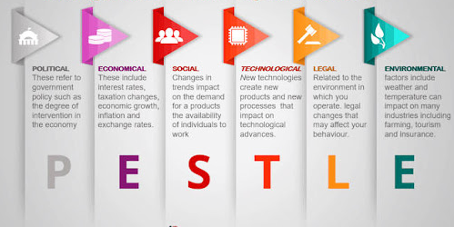
Figure 1: PESTLE Analysis
Source: (Thielsch, 2017)
Political Impact: Amazon is an e providing an online listing of items for consumers all over the world. Amazon must comply with political laws in each area since they work overseas. But all of these can conflict with transactions made digitally. Amazon depends on government funding, all due to globalization, to introduce, sell, and benefit. And they are moving into physical spaces today (Rosander, 2016). However this organization depends strongly on government system and e-commerce funding (in both nations), but they are still impacted by protection measures to ensure the consistency of their operation.
Environmental Impact: One of the major environmental elements now every company including Amazon has to deal with is COVID-19 issue. Throughout this global pandemic, Amazon has undoubtedly been the standout performer and has performed an important role in supplying accessibility to the goods and essentials vital for everyday life (Besterfield, 2014). As much of the companies, efforts to identify alternatives to how COVID-19 has transformed buying patterns, markets and parts of the economy have been centred.
Social Impact: Social causes, patterns and habits may have beneficial and detrimental effects on Amazon's success. Amazon made many people idle, let them sit on the couch, and anything like watching a movie, grocery shopping will be taken care of by Amazon distribution system (Amazon.com, 2020). This proportion has changed with fast internet connectivity and handheld devices. Amazon's online ordering service will also be used for elderly people who cannot move or do not want to travel outdoors. These days, internet purchases have become a sport. Amazon is willing to build on this ability to meet ever more individuals around the world.
Technological Impact: The cornerstone of Amazon is their technology. Technology has rendered Amazon is among the world's most high-quality companies. In the case of cloud infrastructure, Amazon relies on technologies to attract its customers. In this COVID-19 pandemic, Amazon Prime Air is indeed a potential future logistics method to send goods to consumers via Unidentified Flying Devices, often recognized to drones, that facilitate touchless delivery (Amazon.com, 2020). In required to conform to its specifications and develop a viable air traffic control scheme, Amazon is partnering with regulatory agencies.
Legal: The corporate practices of Amazon fully conform to numerous laws and regulations. For instance, anti-trust rules, equality laws, customer protection legislation for e-commerce firms, data security legislation, etc. Amazon will be influenced by multiple legal considerations. Counterfeit products legislation and customer needs are essential. This could be seen as a possibility for Amazon to improve its attempts to reduce the e-commerce system's fraudulent revenues (Thielsch, 2017). Amazon has established an anti-counterfeit program current regulatory. Any item sold on the Amazon website by retailers must've been genuine. It is specifically illegal to market certain types of goods.
Economical: Amazon will develop rapidly unless the economic factors in the regions where it works are favourable. Retailing is indeed a means by which manufacturers sell customers their goods and services. Under every economic scenario, customers purchase from stores and often the retail sector persists and in the toughest economic circumstances. Disposable revenue for customers is growing, which is a tremendous opportunity for Amazon.com. Higher discretionary profit indicates that clients can shop for their preference of items (Ishikawa, 2016). In this COVID period, Chinese economic growth has slowed these times, so this Chinese depression is seen as a challenge to the growth of Amazon's sector.

3.2 SWOT Analysis
With the help of SWOT analysis, the internal factors impact on a business's quality control can be analysed. Here mainly strength analysis and weakness analysis will focus on the internal factors of a company and how they are influencing them. SWOT analysis on Amazon will be analyzed to control their quality for their customers.
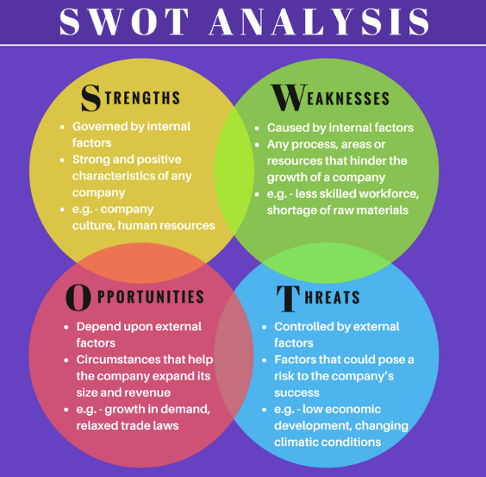
Figure 2: SWOT Analysis
Source: (Ainslie and Wills, 2016)
Strength Analysis of Amazon
Amazon has a good role and a powerful brand presence in the industry as a major e-commerce leader. Amazon appeals to a wide variety of clients at low rates for daily needs. This has enabled it a consumer-focused company. As an aggressive drone distribution provider, Amazon regularly adds new concepts and groundbreaking improvements to its range of products and new services. As the world's largest online marketplace, Amazon draws its capabilities largely from such a three-pronged competitive emphasis on expense control, competitiveness, and concentration (Rosander, 2016). This approach led the company to enjoy the rewards of this decision and allowed its owners to gain profit from the business.
Weakness Analysis of Amazon
In recent times, Amazon has already been "going to spread too thinly" as the continuation of its long term growth policy, implying that this has caused its attention to waver in its main online book expertise and enabled it to explore new focal points (Langevin, 2017). Although this may be a smart approach from the viewpoint of risk diversifying, since it steps away from the dominant expertise, Amazon needs to be mindful of sacrificing its competitive edge. As Amazon offers its consumers with free delivery, that's in the risk of sacrificing its earnings and will also not be prepared to maximize costs with this policy (Thielsch, 2017). One of the greatest drawbacks and is something critics and market observers have always speculated with is that Amazon works with relatively close marketing strategies that have seriously damaged its productivity and even if the competitiveness has punctured.

4. Amazon tackles the new situation and accomplishes the corporate priorities by building and sustaining strong relationships with customers
COVID-19 has greatly affected everything and everyone around the world. Companies are specially going through a really hard time to come back in the position before COVID. But some companies gained huge fame during this period and utilize their time. COVID-19's effect on consumer preferences was profound and pervasive in all markets (Deloitte Canada, 2020). In the previous six months, customer behaviour has shifted dramatically in all markets and segments. Perceptions have risen as goals have changed first to personal protective equipment, which has readjusted essential humanity and convictions in effect(Peelen, 2017). As a consequence, what had been historically perceived to be perfect customer service is now no longer sufficient enough and nearly all organizations were forced to reorganize their customer strategy.
Amazing is from the very start trying to gain their customer satisfaction by offering them better customer experience than ever before. Here some important and effective service quality models will be analyzed in light with COVID 19 impact on customer experience.

4.1 GAP Model
The GAP Service Concept allows the organization to recognize consumer satisfaction. The Distance method is usually used throughout the service sector to explain the different variations that exist throughout the service encounter for potential clients (Buttle, 2015). The GAP Framework aims to define the differences in between service experienced as well as the service anticipated. The GAP model involves five differences.

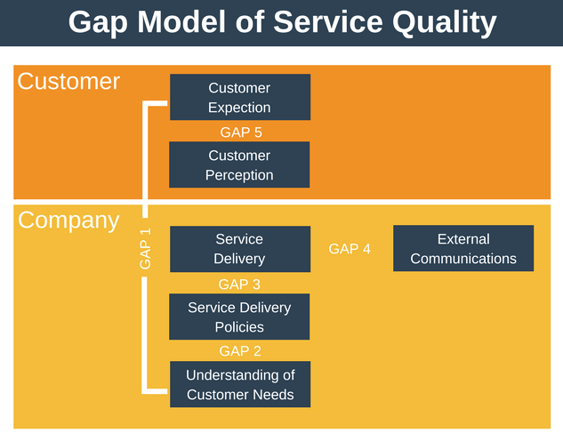
Figure 3: GAP Model
Source: (Peelen, 2017)
Knowledge Gap; Difference between Consumer Expectation and Management Assumption
This difference occurs when what client expects or requires is not properly analyzed by the organization. Owing to inadequate coordination between touch workers and superiors, this often happens. Marketing strategy is lacking. This disparity is caused by inadequate market analysis. If there is an information gap, it can mean that firms are attempting to fulfil inaccurate or non-existent customer desires (Brink and Berndt, 2016). It is necessary to provide a good view of the user's demand for support in a customer-oriented organization. To narrow the distance between the demands of the customer for services and the understanding of the quality of service by the administration would take extensive market analysis (Peelen, 2017).
Amazon always strives to understand customer desires by the moment the customer begins shopping at Amazon's online marketplace. Amazon builds a market identity from where a consumer initially allows a list of products and tries to deliver additional products which might impress the consumer (Amazon.com, 2020). The further the Amazon user buys, the further the corporation wants to define its interests and desires.

Policy Gap; Difference between the specification of service quality and understanding of management
This discrepancy happens where the manager may realize whatever the client wants right, but it may not establish a production level. It could be caused by bad project architecture, physical data unacceptable, new service delivery mechanism unspecific (Buttle, 2015). This discrepancy represents the inaccurate interpretation of the strategy formulation by management into workplace regulations and instructions. Any firms face difficulties converting customer preferences into concrete execution of service quality. This could entail bad configuration of service, inability to sustain and continuously upgrade their exceptional customer service system or merely lack of standardization (DR.K.VANITHA, 2019). This difference could see customers looking somewhere else for a comparable product with good value.
Amazon has developed benchmarks for how easily consumers are alerted whenever an item is inaccessible, particularly during COVID case, how rapidly consumers are alerted if this is difficult to find an item, how shortly and easily can exchange products (30 days) and if customers incur import duties on an exchange (Amazon.com, 2020). For several things at Amazon, from shipping to contact customer service, certain standards exist.
Delivery Gap; The difference between the specification of the quality of service and delivery of the service
In circumstances that exist for service members, this difference can occur. Due to insufficient preparation, incapacity or struggling to manage the service requirements set, it can happen. That may be attributed to inadequate methods of measurement and reimbursement. The principal reason for this discrepancy is inadequate recruiting. The deficiency in employee's performance is revealed by this void (DR.K.VANITHA, 2019). The service needed to serve customers may be specified by companies with a Distribution Gap who have consequently neglected to educate their staff, bring good practices and recommendations into effect. As a consequence, workers are poorly prepared to manage the needs of customers.
Amazon ensures that the concept is internalized by employees in the organization. Many Amazon workers have chances to undergo two weeks of call centre practice, either at the entry-level or executives. Amazon aims to get them to understand how and when to hear, not simply to communicate to clients. The main priority of Amazon is to protect the security and welfare of its workers, and they plan to spend over $4 billion for COVID-related measures to supply consumers with goods and keep workers safe, which motivates them to provide customers with better service (Deloitte Canada, 2020).
Communication Gap; External communications and service delivery discrepancies
Consumer preferences are heavily affected by the corporation's announcements and ads. This difference occurs where the standards presumed are not reached at the point of service implementation. In some situations, consumers' perceptions are increased by commitments made by businesses through advertised press and contact (Goldsmith, 2015). Where overpromising ads don't really align with the current service delivery, a contact disparity is established. Publicity and contact pledge is a source of dissatisfaction to customers when the promised service isn't really compatible with the planned service and should then pursue alternate suppliers of the commodity. Where overpromising ads don't really align with the current service delivery, a contact gap is established (Brink and Berndt, 2016). Customers are frustrated if the quality promised may not meet the planned service and will thus pursue alternate suppliers of goods.
Supported product advertisements in Amazon are good to practically catch up to the majority of the offerings. This gives consumers the idea that the commercial is at the peak of searching results since it is common and valuable rather than a paying ad (Amazon.com, 2020). Amazon includes feedbacks from the actual users of their products and encourages every user to share their feedback about their purchased products which actually helps other people to know more about the products and the authenticity and reliability of the product from the user panel.
Customer Gap; The difference between the expectations of customers and the perceptions of customers
The disparity between consumer preferences and client experiences is the consumer divide. This discrepancy exists when consumers do not necessarily realize what the service has accomplished for them and then misunderstand the quality of the service. The understanding of the consumer is entirely subjective and dependent on the relationship of the consumer with service (DR.K.VANITHA, 2019). Perception is extracted from the happiness of the consumer with the current service as well as the quality of their services. The consumer distance is by far the most noticeable gap, as the convenience factor must be nearly equivalent to perceptions of customers in such a perfect environment. Providing premium service with a given product in a customer-oriented approach should be focused on a good view of the consumer market (Peelen, 2017). The easiest way to decrease the void may be to consider consumer desires and recognize client preferences.
Amazon always tries to deliver the quality of their service better than the customer's expectation. Amazon provides its customers with user-friendly services and provides excellent quality services to their doorsteps ensuring 100% authenticity what customers expect (Amazon.com, 2020). Also with their easy return policy, they capture their customer's trust and ensure them that their customers can rely on them in whatever happens mostly in the COVID-19 pandemic.

4.2 SERVEQUAL Model
The SERVQUAL (Business Quality) system or quality of service discrepancy model is used to examine the differences and identify multiple reasons contributing to a disparity between customer desired services as well as the real services rendered by the organization (Peelen, 2017). Here the implication of SERVEQUAL model on Amazon’s quality control will be analyzed.
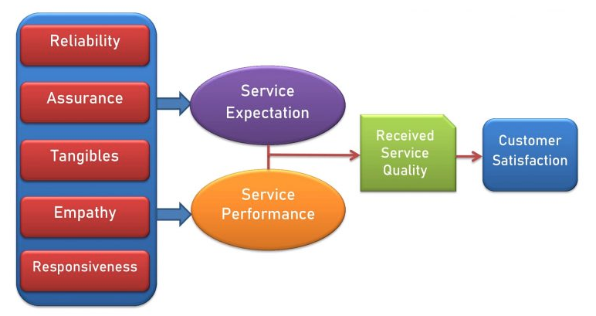
Figure 4: SERVEQUAL Model
Source: (Goldsmith, 2015)
Tangibles
The infrastructure, structures, contact materials, and staff are illustrated in this aspect. Over everything, Amazon is among the world's largest Internet-focused companies based on sales production. This online empire caters around the world, with greater than 600,000 workers operating for Amazon (Amazon.com, 2020). Besides, workers are one of the company's main tangible elements. Another factor is connectivity, and Amazon utilizes a range of channels to communicate including its clients. This can be split widely into 2 groups; conventional and non-traditional forms of communication (Buttle, 2015). News outlets, directories, television, telephones, and broadcast are common media. Social networking and web search promotions, across the other side, contain non-traditional networks.

Reliability
Reliability describes the organization's capacity to supply customers with precise and accurate offerings. By proposing policies and rules to its vendors, Amazon has assured customers of quality goods. The company also focuses on its comprehensive customer engagement (DR.K.VANITHA, 2019).
Besides, Amazon's mission statement also identifies the emphasis on customer journey by enabling them to offer a wide range of products and accessibility with low prices. Amazon fulfils its commitments, including such providing stock levels and on-time order tracking (Amazon.com, 2020). This innovation and general merchandise company also focus on the importance of technologically advanced insights to recognize the needs of its customers.
Responsiveness
The responsiveness element of the SERVQUAL framework demonstrates the eagerness of the corporation's staff to assist their consumers to have a stronger service encounter. Tracking and acknowledging feedback from customers to enhance services is indeed a primary consideration at Amazon. Responsiveness is among Amazon's company's main distinguishing variables (Deloitte Canada, 2020). Few of pledges of Amazon which raise its standard of care involve a complete refund of the item in the event of damage, without any added charge to clients, periodic market research, the remedy of customer complaints, reviewing the client on the advancement of their shipment.
Assurance
The assurance factor stresses the expertise of the workers who have made a significant contribution to winning its customers' respect and commitment. To learn as to its operations, Amazon frequently offers educational and career learning activities with its staff and vendors.
Amazon had found that rural Indian customers tend to make their transactions offline since they can't trust Amazon's assurances. Customers figured it would not be easy to keep the online company accountable in the event of injury. Many projects were introduced by Amazon, such as Chai Cart, Vendor Coffee shops, Network Operator etc. These projects were under 'Udaan Project' which had been introduced since May 2015 to extend the presence of Amazon in regional as well as semi-urban areas in India (Amazon.com, 2020).

Empathy
This component of the SERVQUAL framework describes to its consumers care and consideration provided by the business. Similarly, Amazon insists on fulfilling its customer commitments. This guarantees that the deliveries meet their corresponding customers within the specified time (Brink and Berndt, 2016). To guarantee that customers are happy with their orders, Amazon carefully tracks and assesses the reviews and points of view. Besides, their return policy however has allowed the business to increase loyalty amongst the consumers.

Conclusion
Amazon is greatly serving their customers with greater quality and assurance in no matter what happens. Many of the companies are falling apart in this pandemic situation but Amazon is holding their position by making them reliable support to their users and providing protective measures for their community and customers and is not compromising with their quality at all. After analyzing the report it has come to light that all it's internal and external factors are positively being handled by Amazon which is reflecting in their quality of service they are offering and they are successfully managing their customer relationship with their quality offerings. PESTLE analysis has shown that all of the external factors are actually positively impacting Amazon and helping them improving their quality of service even more. The SWOT analysis has give the overview on the internal factors from those some are acting as Strengths and some are acting as weakness for Amazon in their delivery of service. On the other hand, GAP Model has helped to find out the areas where Amazon still needs some improvements to satisfy their customers but mostly shown that Amazon is already fulfilling those Gaps. Lastly, with the SERVEQUAL Model the important customer satisfaction variables are analyzed in light of Amazons recent activities to render greater customer relationship in this pandemic period too.

References
Ainslie, M. and Wills, G., 2016. Designing a quality action learning process for managers. Journal of Workplace Learning, 9(3), pp.100-110.
Amazon.com. 2020. Amazon.Com: Online Shopping For Electronics, Apparel, Computers, Books, Dvds & More. [online] Available at: <https://www.amazon.com/> [Accessed 15 December 2020].
Besterfield, D., 2014. Quality Control. London: Pearson.
Brink, A. and Berndt, A., 2016. Customer Relationship Management & Customer Service. Landsdowne, South Africa: Juta.
Buttle, F., 2015. Customer Relationship Management. London: Taylor and Francis.
Deloitte Canada. 2020. COVID-19: Maintaining Customer Loyalty And Trust During Times Of Uncertainty | Deloitte Canada. [online] Available at: <https://www2.deloitte.com/ca/en/pages/finance/articles/covid-19-maintaining-customer-loyalty-trust-during-uncertainty.html> [Accessed 15 December 2020].
DR.K.VANITHA, D., 2019. Customer Relationship Management on Customer Satisfaction. International Journal of Scientific Research, 3(4), pp.1-3.
Emerald Group., 2017. Service Quality. Bradford: Emerald Group Publishing.
Goldsmith, R., 2015. The Goals of Customer Relationship Management. International Journal of Customer Relationship Marketing and Management, 1(1), pp.16-27.
Hofbruckerová, Z. and Václavík, M., 2019. Analysis of the Possibility of Parallel Implementation of the Quality Management System and of the Corporate Social Responsibility System into a New Organization. Quality Production Improvement - QPI, 1(1), pp.201-205.
Ishikawa, K., 2016. Guide To Quality Control. Tokyo: Asian Productivity Organization.
Langevin, R., 2017. Quality Control In The Service Industries. New York: AMACOM.
Peelen, E., 2017. Customer Relationship Management. Amsterdam: Pearson Education.
Rosander, A., 2016. Applications Of Quality Control In The Service Industries. New York, N.Y.: Dekker.
Thielsch, H., 2017. Quality Control and Service Performance. Journal of Engineering for Power, 86(4), pp.451-464.

