

Student Name: Netsanet yadergal
Student Number: 24131569
Module Code: BMHP5015
Module Title: Changemakers: Building your personal brand for sustainable Employment
Date of Submission: Friday 10 July 2026
Submit to: Caroline Salami

Table of content

- Task 1 Unit 1: Brand You............................................................................3
- Introduction.........................................................................................3
- Autonomy....................................................................................3
- Goal Setting..........................................................................................4
- Self-Awareness................................................................................4
- Task 2 – Reflection on Unit 2: It's a Small World.....................................5
- Task 3 – Reflection on Unit 3: Opportunity Knock...................................7
- Task 4 – Reflection on Unit 4: The Pursuit of Happiness .......................8
- Reference .................................................................................................11

Task 1 Unit 1: Brand You
- 1,Introduction
This reflection looks at what I learned in Unit 1, Brand You. I will talk about four ideas from the lectures and forum tasks: autonomy, goal setting, self-awareness, and emotional intelligence. I will explain what each idea means and how it helped me understand personal branding better, especially for my work in health and social care.
- 2 Autonomy
The first idea was autonomy. Self-determination theory (Deci & Ryan, 2000) states that instead of feeling forced or pressured by others, people must believe that their activities are self-directed and freely selected (i.e., self-determined) (Deci, E. L., & Ryan, R. M. 2000). Say that autonomy is one of the most important things people need to feel motivated and to grow. Learning about this made me realise that a strong personal brand starts with making your own decisions and owning them, instead of waiting for someone else to tell you what to do.
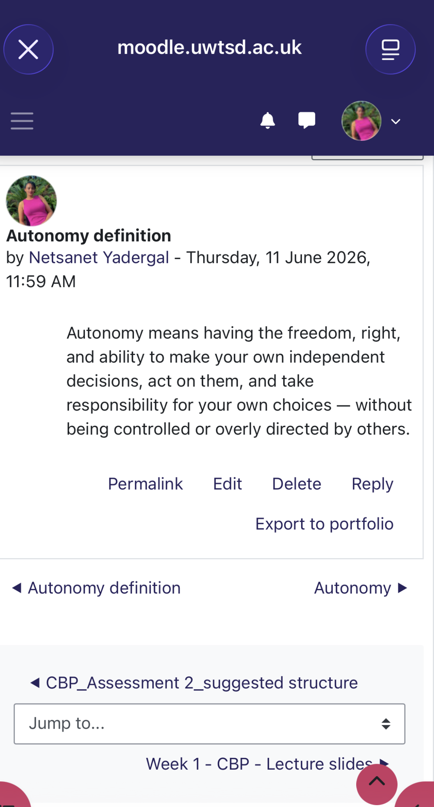
Forem screenshot 1: Autonomy

- 3 Goal Setting
The second idea was goal setting. This means turning your dreams into clear steps you can follow. Explain that clear and specific goals work better than vague ones (Locke, E. A., & Latham, G. P. 2002). In my own forum post, I planned to open a domiciliary care business in two years. To get there, I said I need to finish my current course and take extra training in confidence, leadership, and communication. This task showed me how helpful it is to break a big goal into smaller steps.
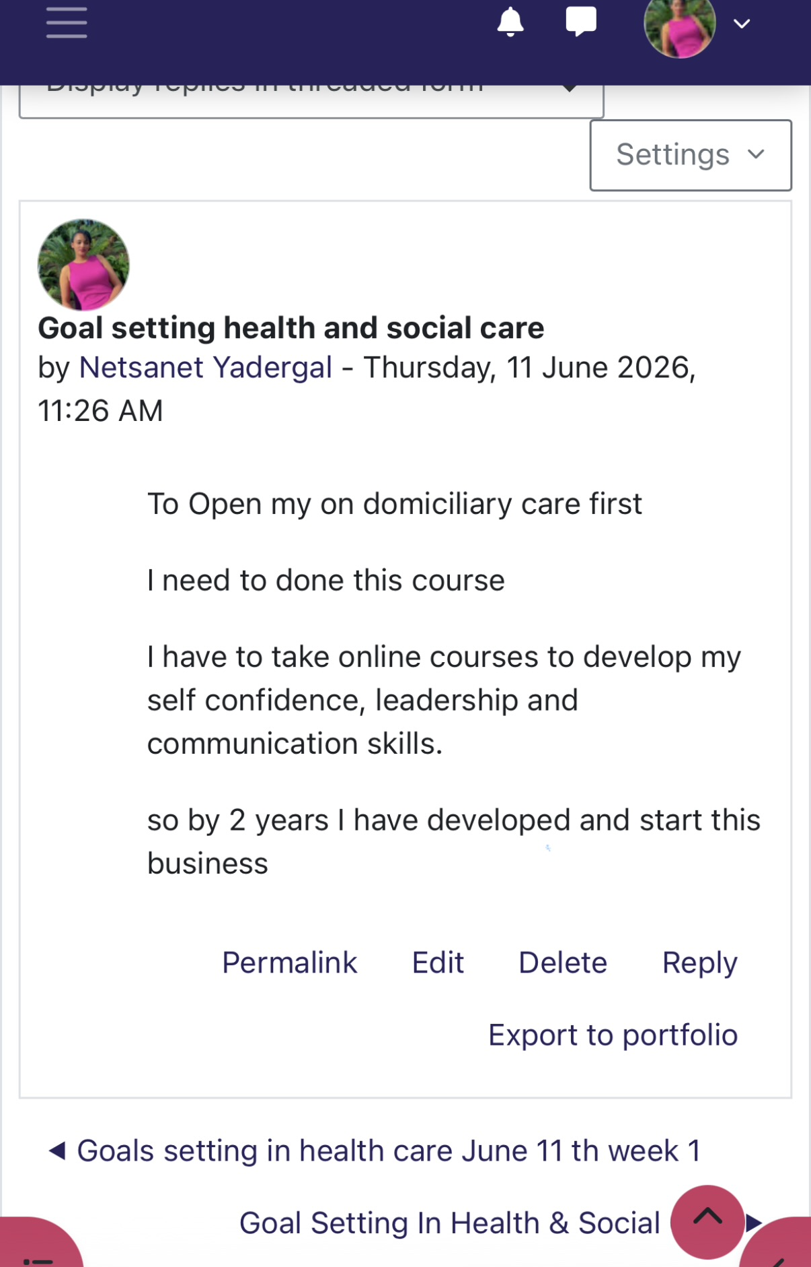
Forem screenshot 2: Goal Setting
- 4 , Self-Awareness
Self-awareness was the third concept. This is being aware of your own emotions, values, and strengths and realising how they influence how you interact with others. The ability to understand and consider one's own thoughts, feelings, and behaviours is known as self-awareness, and it fosters decision-making and personal growth (PositivePsychology 2020).
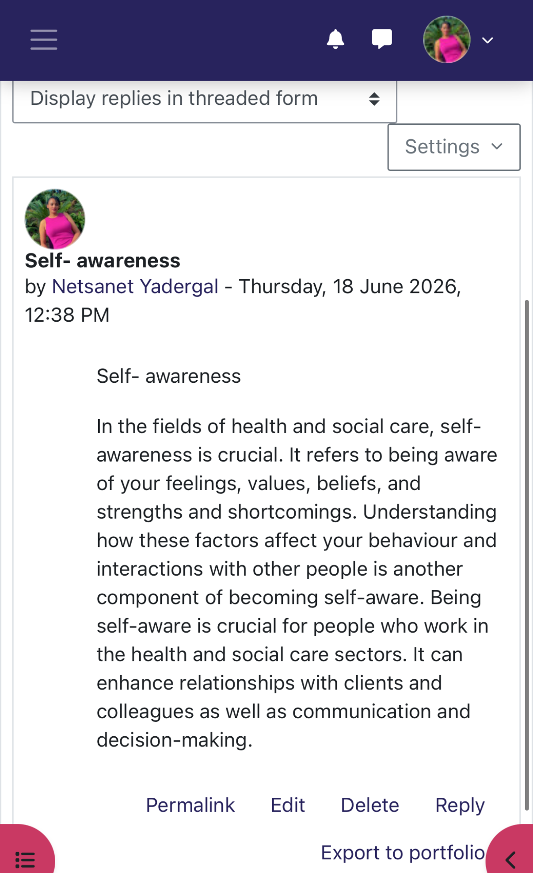
Forem screenshot 3: Self-Awareness

1.5, Emotional Intelligence
The last idea was emotional intelligence. Salovey and Mayer define emotional intelligence as "the ability to recognise emotion, integrate emotion to facilitate thought, understand emotions, and to regulate emotions to promote personal growth." For them to work for us rather than against us, they thought it was possible to develop the capacity to recognise and understand emotions (NHS 2019). This is very important in busy care settings. In my forum post, I wrote about simple ways to show emotional intelligence, like speaking calmly, being kind, and listening without interrupting.
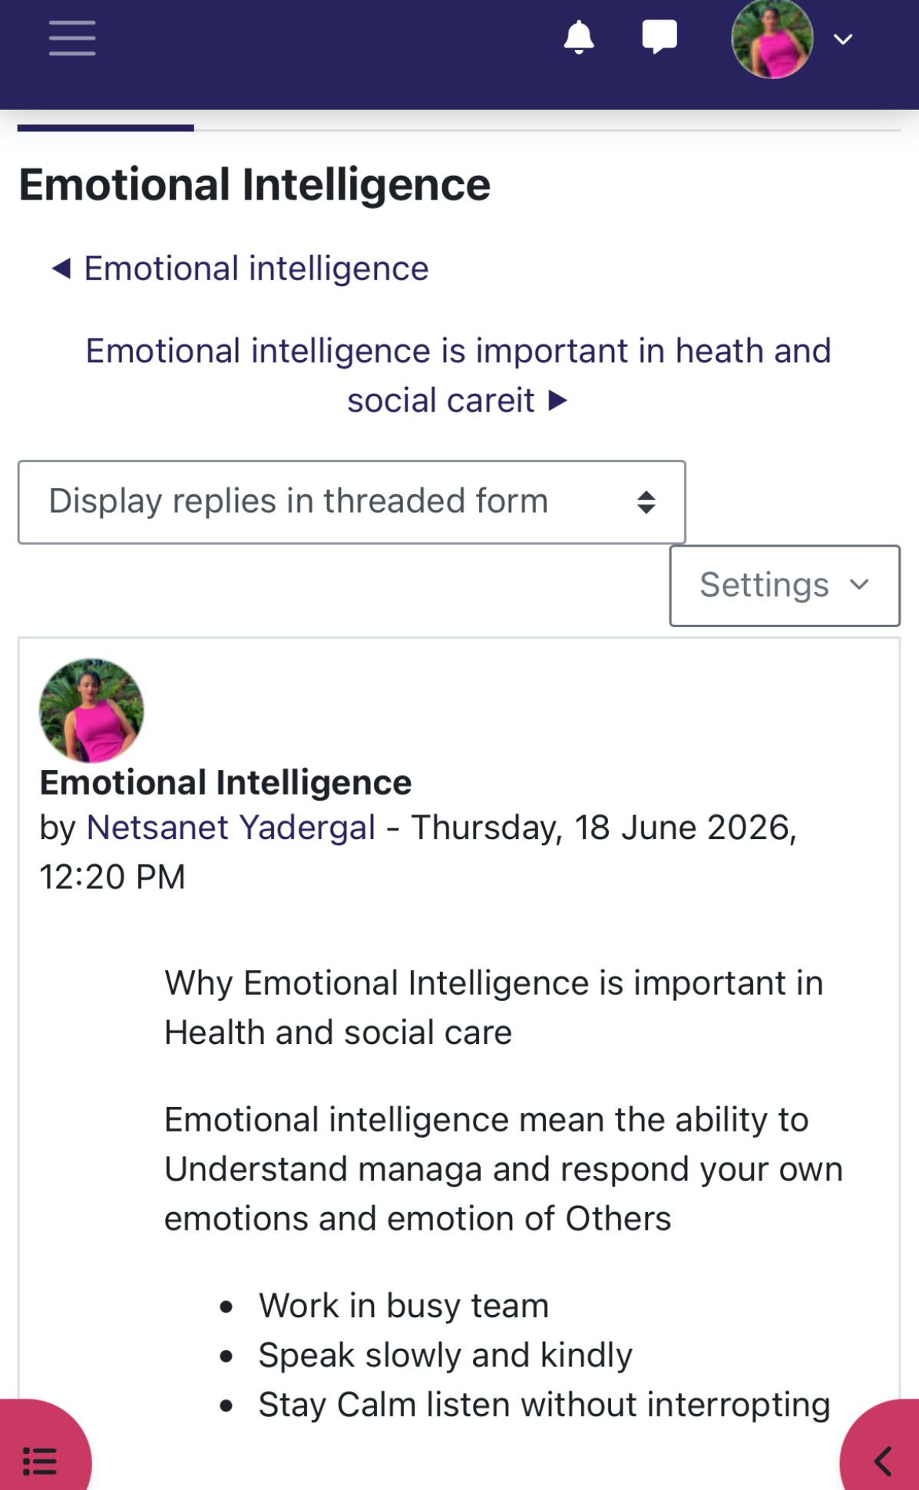
Forem screenshot 4: Emotional Intelligence

All things considered, these four concepts made it clearer to me that personal branding involves more than how you look. It involves self-awareness, goal-setting, and effective emotional regulation.

Task 2 – Reflection on Unit 2: It's a Small World

Unit 2, ‘It’s a Small World’, introduced me to networking, evaluation, and diversity in professional relationships, and it changed how I see my own role in health and social care. Working through the topics in order, from defining networking to applying it in a real case study, helped the ideas stick rather than stay abstract.
According to Gibson, Hardy, and Buckley, networking is "goal-directed behaviour which occurs both inside and outside of an organization, focusing on creating, developing, and using relationships with other people (NIH, 2026). Most definitions include relationships to exchange resources, opportunities, advantages, influence, and expertise for mutual gain (NIH, 2026). This made me realise that networking is a conscious talent rather than something that just happens.
The topic ‘Variety is the Spice of Life’ then challenged me to look beyond my usual contacts. Granovetter’s (1973) idea that weak ties, connections outside our immediate circle, often carry the most valuable information helped me appreciate colleagues and contacts outside my direct role
.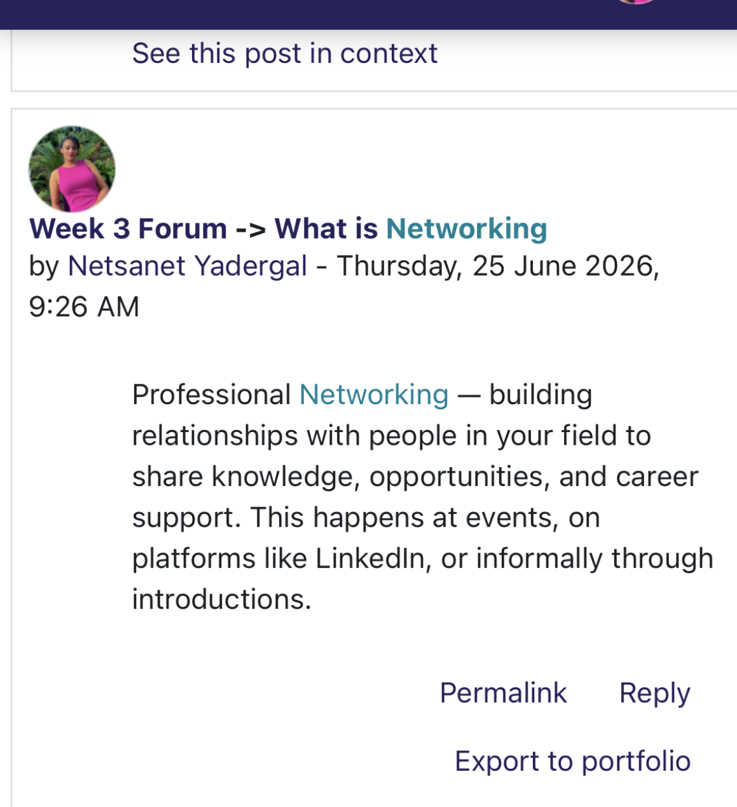
Forem screenshot 5: Networking

I applied this during the Sheela case study, whereI built a networking map that included midwives, health visitors, GP surgeries, and local councils. It showed me that questions in health and social care rarely stay within one profession, and that diverse networks produce richer, more sustainable support for service users.

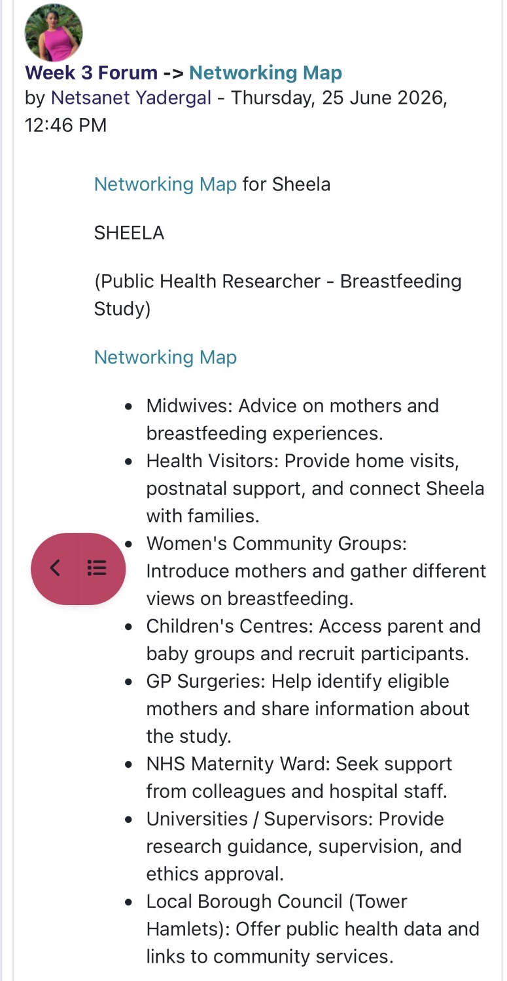

Forem screenshot 6: Networking Map

I also explored bureaucracy and hierarchy, explaining bureaucracy as a structure governed by set policies and hierarchy as a system that ranks people by authority . This helped me see that hierarchies give clear accountability while networks give flexibility, and that both coexist within the NHS and local authority settings (Health and Care Act, 2022).

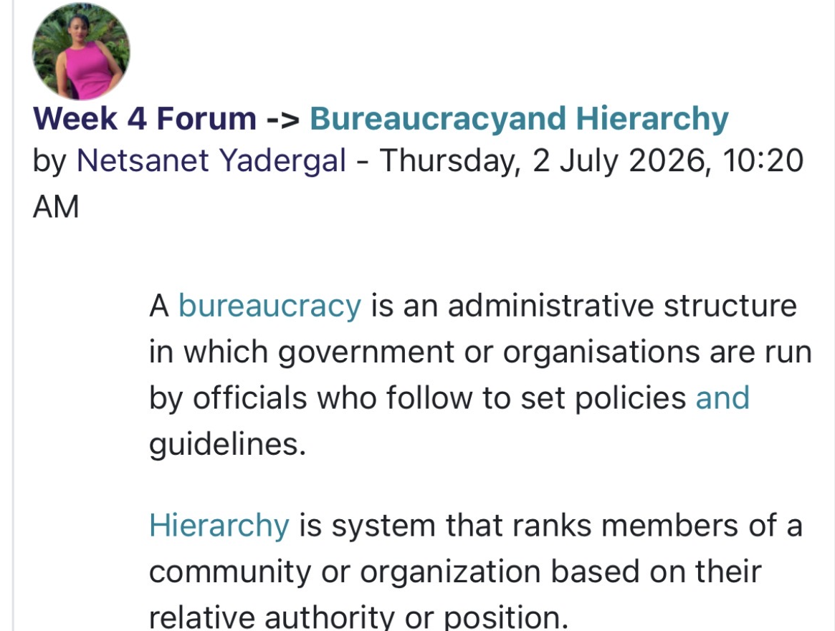

Forem screenshot 7: Bureaucracy and Hierarchy,
The final topics, Network Society and Making Connections, showed me how digital platforms have expanded professional networks globally. I linked this to Webber Connecting People model and NHS England’social prescribing approach, both of which use networking directly to improve wellbeing rather than as a side benefit (NHS England, 2024).
Overall, I now understand networking as an ongoing responsibility rather than a passive outcome. As I wrote on the forum, increasing networking in health and social care improves the safety and coordination of care for the people we support (see Figure 8). Moving forward, I plan to build my own network deliberately, stepping outside my comfort zone to better support the children and families I work with.
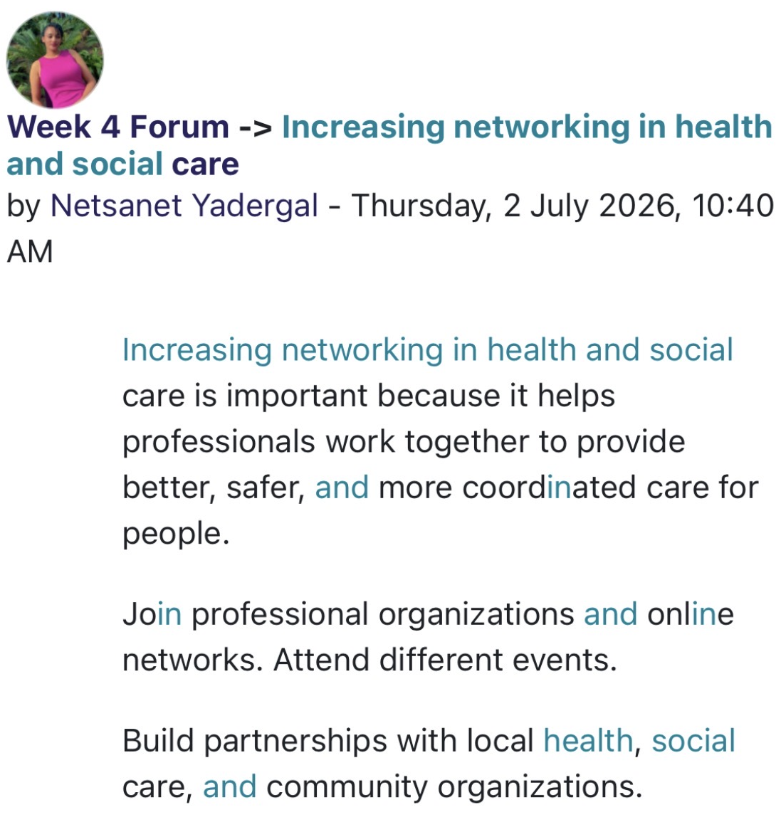
Forem screenshot 8: Increasing networking in health and social care

Task 3 – Reflection on Unit 3: Opportunity Knocks

I learned from lesson 3, "Opportunity Knocks," that career advancement is not just a question of luck but can be actively shaped by behaviour, talents, and mindset. The unit's opening theme, "changing perspective," struck me as being especially pertinent to my work as a care worker. Wells talks about how administrative professionals, and their teams may succeed by adopting a growth attitude. Fostering a culture of growth and development is a critical task for administrative professionals and those they assist in the quickly changing workplace (Cobo-Rendón, 2024).
It makes the case that moving the focus from individual illness to the larger social determinants of health promotes ongoing improvement in the delivery of care, and I could see how using this broader lens in my own practice would enable me to respond more adaptably to the needs of children and families rather than relying on fixed assumptions. Through coaching-style discussions that put well-being first, people are supported and encouraged to take charge of their own professional growth in this person-centred approach (NHS, 2023).
The discussion of luck and success changed my perspective on opportunity. shows that what is sometimes referred to as "luck" in a caring profession is driven by communication, organization, resilience, and networking. Explain a surprise mindset as the capacity to recognise and embrace good possibilities that were not actively searched for, which is a more organised and intentional procedure than depending just on chance. This struck something with my personal experience of taking on additional duties at the care Cen Encouraging hiring and retaining the services of healthcare professionals is a top operational and strategic focus (NHS, 2023). ter, which unintentionally sparked discussions regarding additional training. define stretch goals as purposefully challenging objectives that push people outside of their comfort zones; I now view setting a stretch goal, like moving closer to one, as a means of creating my own opportunities rather than waiting for them.
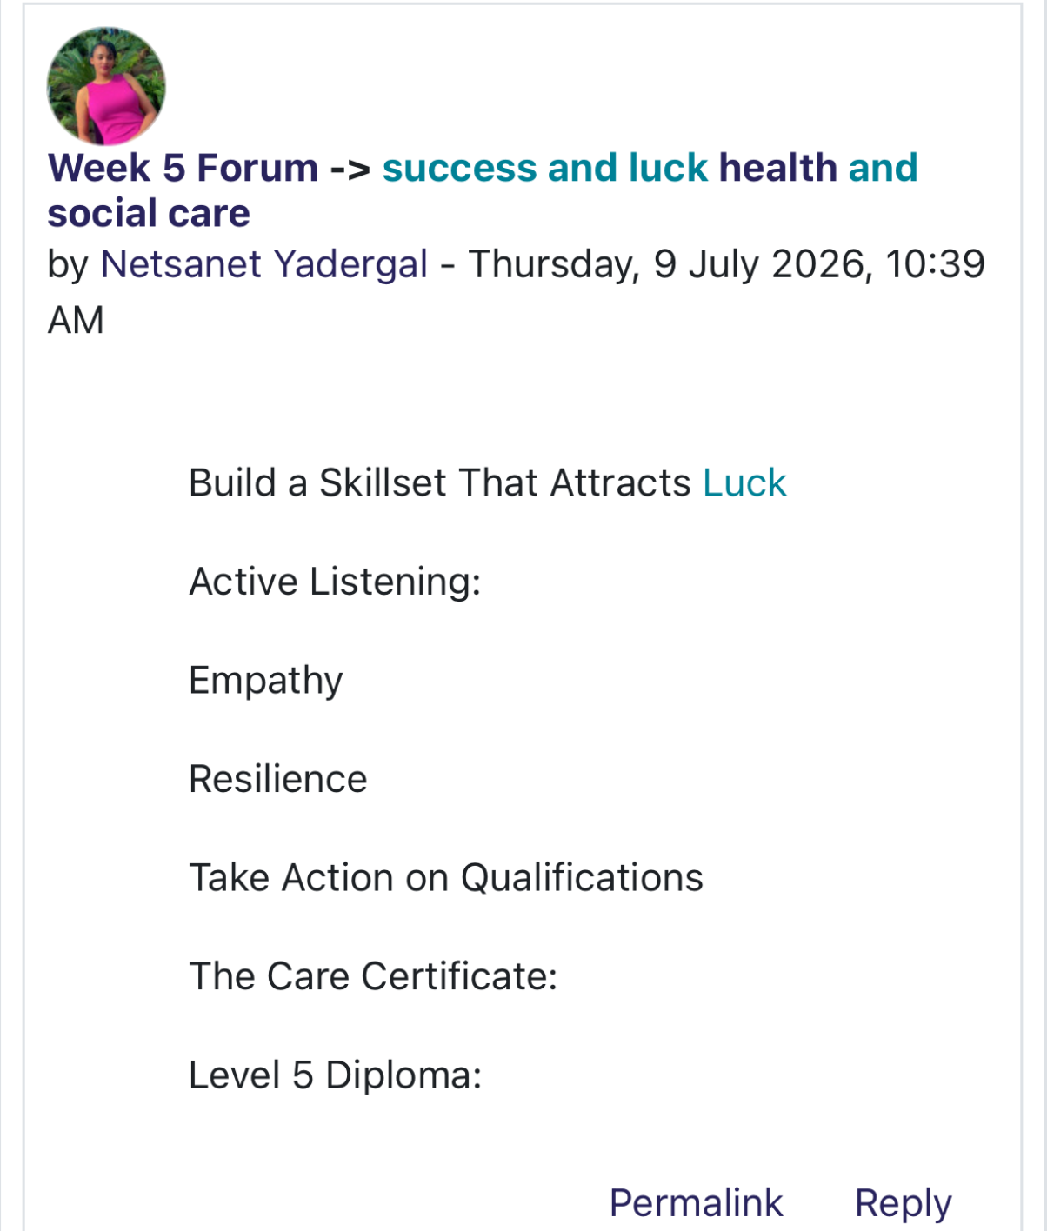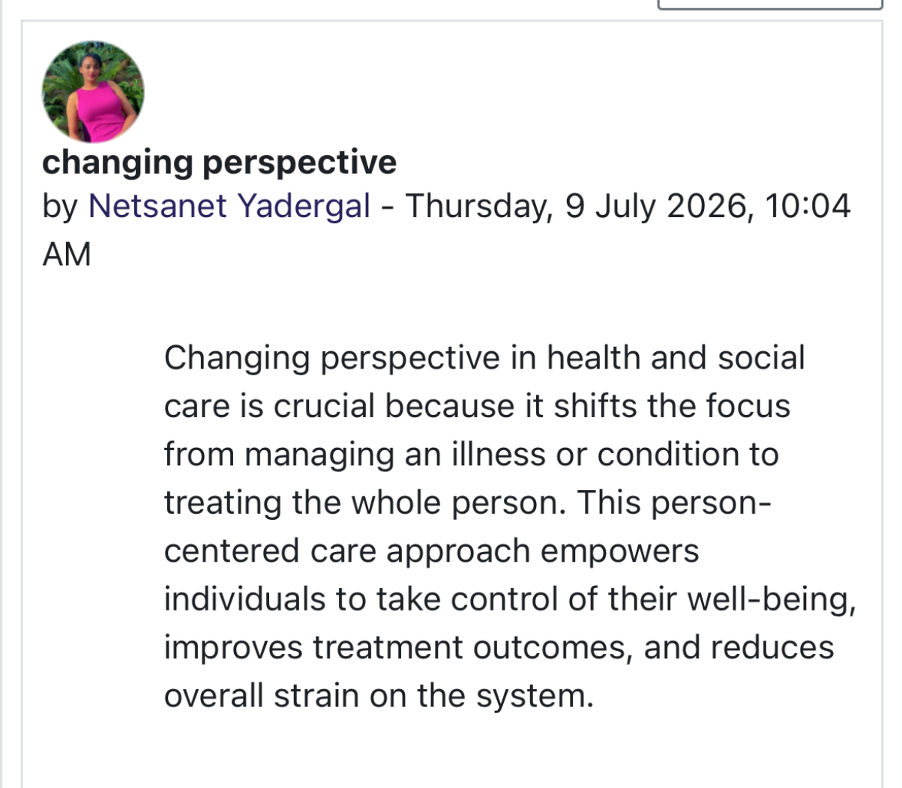
Forem screenshot 9: success and luck and changing perspective

I became aware of the usefulness of networking, a current CV, and ongoing skill development after learning about traditional versus modern recruitment and how to open doors for employment prospects. Explain how blogging facilitates professional reflection and information sharing. (NHS, 2026). Writing a little blog post of own provided a tangible understanding of how an online presence can demonstrate competence in line with increasing professional visibility.

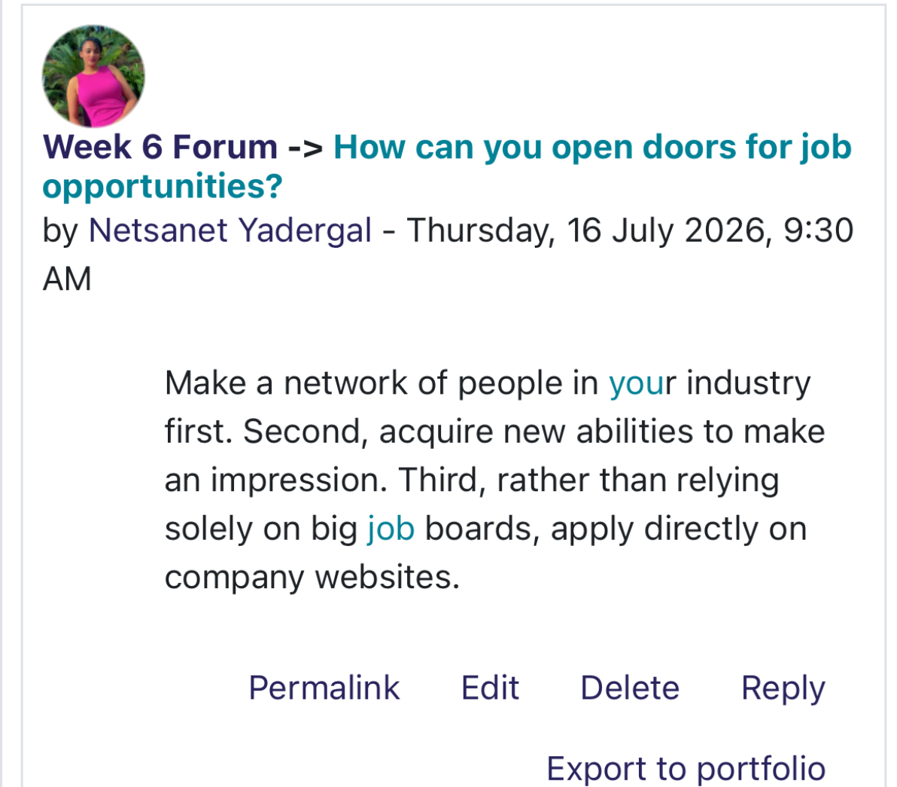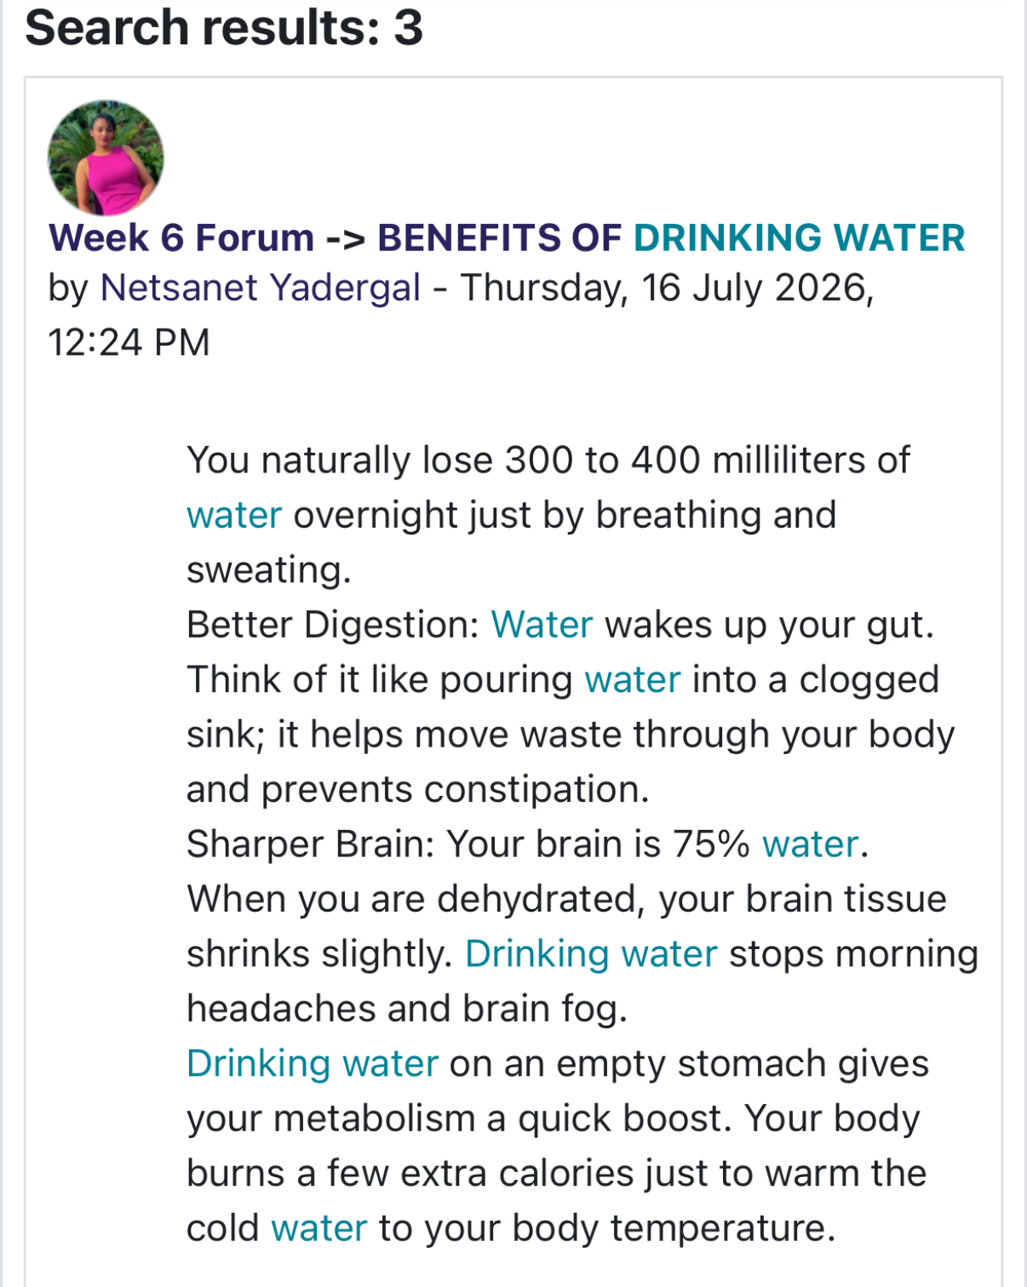
Forem screenshot 10: Opportunities and Benefits

All things considered, Unit 3 allows me with useful tools that I plan to aggressively explore additional chances in early years and health and social care. These tools include reframing perspective, fostering luck, setting stretch objectives, and creating an online professional profile.

Task 4 – Reflection on Unit 4: The Pursuit of Happiness and Conclusion
The psychological underpinnings of personal development were examined in Unit 4 of this module, with particular attention paid to limiting beliefs, determination, resilience, and the function of mentoring and adaptability in a changing profession. My comprehension of how internal narratives influence wellness and professional performance has improved because of this unit.
The topic that resonated most strongly with me was limiting beliefs. Defines these as subconscious convictions, often expressed as “I’m not…” or “I can’t…”, that quietly restrict potential (Nagy and Muehlenkamp, 2024). Reflecting on this in the weekly forum, I recognised that self-doubt and excuse-making, identified common indicators of limiting beliefs, had occasionally shaped my own approach to new challenges.
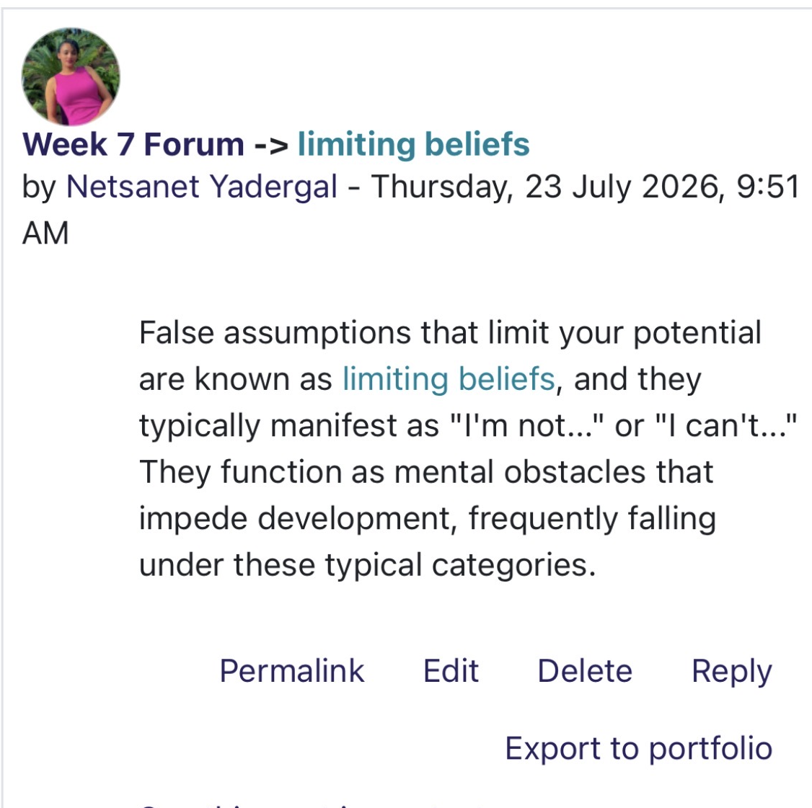
Forem screenshot 11: defining limiting beliefs

I was motivated to reframe negative ideas into affirming words about competence, progress, and resilience by working through the positive self-talk challenge (Figure 2). As a student and in my position as a Professional Early Years care, where children and families frequently rely to practitioners for calm, confident assistance, writing these affirmations helped turn an abstract psychology idea into something I could directly apply.
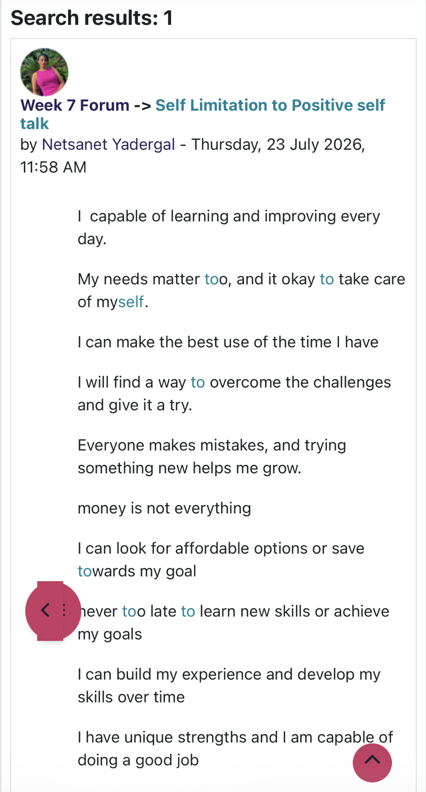

Forem screenshot 12: positive self-talk,

Approach to professional development. The importance of seeing setbacks as feedback rather than judgement was further reinforced by studying resilience and positive reactions to failure. I now intentionally use this concept when juggling the demands of both study and practice.
In order to provide advice and criticism, identify and open opportunities, manage problems and avoid mistakes, and—most importantly—assist in evaluating the various personal and professional factors involved in selecting a career path and a job, mentors share their knowledge, experience, subject-matter expertise, and networks with mentees. expanded this way of thinking to longer-term career planning, emphasising the speed at which confidence and skill growth may be accelerated with help from others (NHS, 2023 & Sanfilippo, 2025).
The value of mentoring in health care education is widely acknowledged. It provides a way to further improve employee engagement and performance, develop learning opportunities, and support collaboration across disciplines (NHS, 2018). Its help to achive what you wants.
Overall, this module has strengthened my self-awareness, resilience, and ability to reframe unhelpful thinking patterns. The combination of theory, forum reflection, and self-talk practice has given me practical tools that I can carry into my career as an early years practitioner, supporting both my own professional confidence and the quality of care I provide to children and families.

Conclusion
Across these four units, one consistent thread has emerged: personal and professional growth depends on intentional action rather than passive waiting. Unit 1 gave me the foundations, autonomy, goal setting, self-awareness, and emotional intelligence, that underpin how I present and understand myself as a practitioner Unit 2 expanded on this, demonstrating that networking is a purposeful, continuous duty that improves safety and care coordination through a variety of weak-tie relationships. By redefining opportunity as something shaped by mindset, stretch objectives, and visibility especially through reflecting practices like blogging instead of being left up to chance, Unit 3 expanded on this. After that, Unit 4 went inside once more, addressing self-doubt and limiting beliefs that might impede progress and emphasising mentoring and resilience as strategies for maintaining confidence in the face of adversity.
Together, these units have demonstrated to me that "Brand You" is an integrated process rather than a single skill: understanding oneself (autonomy, self-awareness), making plans for oneself (goal setting, stretch goals), establishing connections with others (networking, mentoring), and safeguarding one's own mindset (resilience, reframing limiting beliefs). I plan to use these resources into my work as an early childhood educator going forward, utilising them to enhance both my professional growth and the standard of care I offer to kids and families.

Reference
Cobo-Rendón, R. (2024). Perspectives and Strategies of Well-being Across the Lifespan. Springer Nature.
Health and Care Act (2022). health and care act 2022. [online] Legislation.gov.uk. Available at: https://www.legislation.gov.uk/ukpga/2022/31/contents [Accessed 30 July 2026].
Kluwer, E.S., Karremans, J.C., Riedijk, L. and Knee, C.R. (2019). Autonomy in relatedness: How need fulfillment interacts in close relationships. Personality and Social Psychology Bulletin, 46(4), pp.603–616. doi:10.1177/0146167219867964.
Locke, E.A. and Latham, G.P. (2002). Building a practically useful theory of goal setting and task motivation: a 35-year odyssey. American Psychologist, 57(9), pp.705–717. Doi: HTTPs://doi.org/10.1037/0003-066X.57.9.705.
Nagy, L.M. and Muehlenkamp, J.J. (2024). Negative self‐perceptions and severity of NSSI: Testing the benefits and barriers model. Journal of Clinical Psychology, 80(6), pp.1365–1376. doi:10.1002/jclp.23667.
NHS (2018). Mentorship in the Health Professions: A Review. The Clinical Teacher, [online] 15(3), pp.197–202. Available at: https://pubmed.ncbi.nlm.nih.gov/29318730/ [Accessed 31 July 2026].
NHS (2019). Emotional intelligence. Character Lab Playbook. [online] doi:10.53776/playbooks-emotional-intelligence.
NHS (2022). Scope for Growth – Leadership Academy. [online] Leadershipacademy.nhs.uk. Available at: https://leadershipacademy.nhs.uk/scopeforgrowth/ [Accessed 31 July 2026].
NHS (2023). Growth-based Career Planning | NHS England | Workforce, Training and Education. [online] NHS England | Workforce, training and education. Available at: https://www.hee.nhs.uk/our-work/allied-health-professions/enable-workforce/growth-based-career-planning [Accessed 30 July 2026].
NHS (2026). Skills for Care – Social care. [online] Blog.gov.uk. Available at: https://socialcare.blog.gov.uk/tag/skills-for-care/ [Accessed 31 July 2026].
NHS England (2024). Social prescribing. [online] NHS England. NHS England. Available at: https://www.england.nhs.uk/personalisedcare/social-prescribing/ [Accessed 30 July 2026].
NIH (2026). Checking your browser – recaptcha. [online] Nih.gov. Available at: https://pmc.ncbi.nlm.nih.gov/articles/PMC7883354/#sec1_4 [Accessed 30 July 2026].
PositivePsychology (2020). What is self-awareness and why is it important? [+5 ways to increase it]. [online] PositivePsychology.com. Available at: https://positivepsychology.com/self-awareness-matters-how-you-can-be-more-self-aware/ [Accessed 30 July 2026].
Sanfilippo, F. (2025). The importance of mentorship in career development. The American Journal of Pathology. doi:10.1016/j.ajpath.2025.07.002.
Simpson, V. (2026). Talk about luck! On the role of knowledge in communication. Synthese, 207(3). doi:10.1007/s11229-026-05499-9.

