
PROFESSIONAL CAREER DEVELPOMENT REPORT
ABDELLA SHEKEDIN 1712468

June 22, 2018
University of Wales Trinity Saint David

Executive Summary
- A professional development is most important to learn and become a better employee, but many other advantages are possible through participation in development opportunities. These benefits often go unrecognized and can lead to more engaged learning how to do something better

Table of Contents
Executive Summary 1
Terms of Reference 3
Procedure 4
Introduction 5
Findings 6
Conclusion (average of 10% of word count) 7
Recommendations 8
Bibliography 9
Appendices 10
Acknowledgements 11
UPDATE TABLE FREQUENTLY – CHECK IT HAS BEEN UPDATED PRIOR TO SUBMISSION

Terms of Reference

- Pandya, S., 2017. Improving the learning and developmental potential of SWOT analysis: introducing the LISA framework. Strategic Direction, 33(3), pp.12–14

- Beausaert, Simon A. J., Segers, Mien S. R. & Gijselaers, Wim H., 2011. Using a Personal Development Plan for Different Purposes: Its Influence on Undertaking Learning Activities and Job Performance. Vocations and Learning, 4(3), pp.231–25

- Neumann, J. & Kenny, P., 2007. Does Mad Money make the market go mad? Quarterly Review of Economics and Finance, 47(5), pp.602–615.

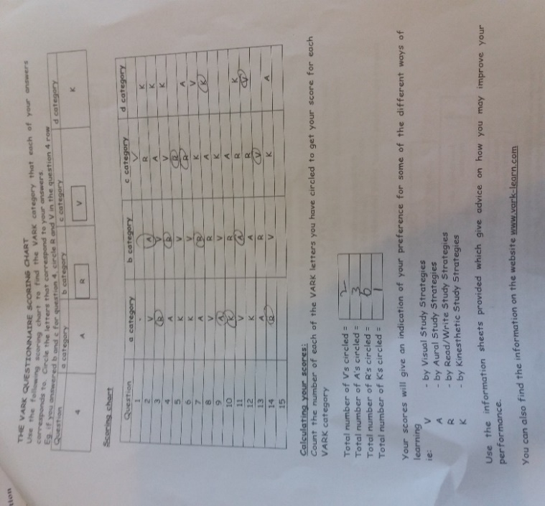

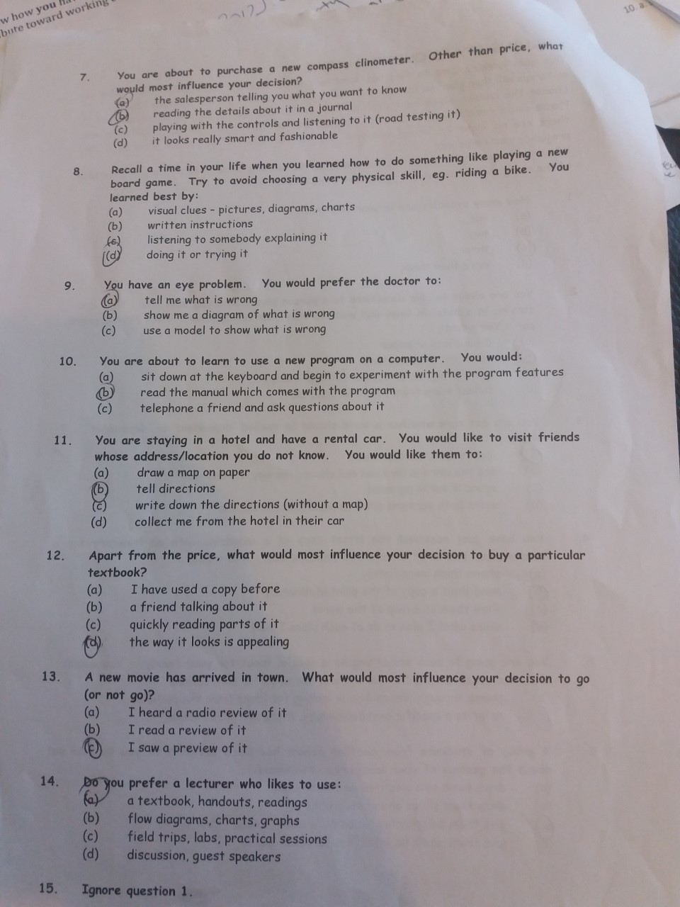

Introduction

- I have to reflect my own professional development career how important for me. The first thing I need to-do is understanding myself, being aware of my own capabilities and limitations and knowing what you truly enjoy and hope to get out of life. Without self-understanding.to find my caplity in class I did swot analysis. therefore, I need to use a SWOT (Strengths, Weaknesses, Opportunities and Threats) analysis on myself.
- I will make a list of my weaknesses like my communication skill I have to improve it . Opportunities would then be listed and will include opportunities for my own self-development professionally in the future, so I have to recognize where my thought and my emotions are leading to me. and I need make any necessary changes.
(beausaert,simon a.j said” Today, most of th organisation they change there system to developing they are employer plans . and although they help the employer to develop to be professional so, they set a plan for them to give them training like accountant and IT computer and this can increase the wage purposes developing them (Smith and Tillema 2001). The study presented here aims at a better understanding of how the purpose of the Personal Development Plan (PDP),the idea with to develop the employer and understanding why it important personal development plan”

finding
- Self awareness enables us to stand apart and examine even the way we “see” ourselves – our self-paradigm, the most fundamental paradigm of effectiveness. It affects not only our own attitudes and behaviours, but also how we see other people
- Go mad is Results Framework and solution focused thinking methodology enable me people to accelerate results and improve productivity
Manager or dirctor

Level 3

Yes,I have to do it.
study class and plan ahead
Friends and working voluntary
Level 2

Study in skill of work placement
To have a degree in MBA
To grow up my skill

Level 1
- Neumann.j,and peppi.k, they siad Empirical studies of numerous popular investment advisory services find statistically significant abnormal returns at the time of their broadcast or published investment recommendations. Our analysis of returns and trading volume around stock recommendations aired on charismatic host Jim Cramer's Mad Money program reveals statistical evidence of response to both his buy and sell opinions, with most of the full-day return following an on-air buy recommendation captured by that day's opening price. Trading strategy analysis suggests that individuals with limited funds should be wary of short-term trading to exploit the show's suggestions, while professional investors may be able to exploit buy picks with a contra strategy.
- (Tony Robbins said in the magic report eye contact is more important. he said style is more important the way you dressing. people like people they like them slave) .

- A professional development is most important to learn and become a better employee, but many other advantages are possible through participation in development opportunities. These benefits often go unrecognized and can lead to more engaged learning how to do something better. By learning some new skills. I start skill of work placement to develop myself and to have Confidence and credibility and Ability to influence and lead becomes less subjective and more about the facts. And, I have to use the learning style I have been learned in class like swot analysis and barriers and go mad and then see personal goals.
- My plan is to have my Owen a taxi company in future. i am coming to take this course to improve my skill I am working as taxi driver at moment with company as employer. so I don’t want to work all my life as employer for someone. I need to grow up. so, I need to open a new business so my plan to use swot analysis Strengths and weaknesses are often internal to your organization, while opportunities and threats generally relate to external factors. For this reason, SWOT is sometimes called Internal-External Analysis..so I have to ask myself What do I need do better than anyone else What do people in your market see as your strengths. I have to Consider my strengths from both an internal perspective, and from the point of view of my customers and people in my market becouse there is computation. Also, if you're having any difficulty identifying strengths, try writing down a list of your organization's characteristics. A useful approach when I am looking at my opportunities so look at my strengths and ask myself whether these open up any opportunities. Alternatively, look at my weaknesses and ask myself whether I could open up opportunities by eliminating them.
(pandya,s(2007) say SWOT analysis and make it more effective. Design/methodology/approach the paper conceptualizes the LISA framework where L, I, S and A correspond to S, W, O and T, respectively, of the traditional SWOT analysis framework. Each linkage is discussed to provide some insights as to how the understanding of the SWOT analysis can be further extended to improve its learning potential and effectiveness)
- I have been learned in this moodle how to understand the skills and knowledge need for working placement and demonstrate readiness foe employability and personal advancement through an understanding of personal strength and areas for further development. I have to understand where did I need to be for the next five years.
- Internal barriers=Something within you that preventing me from reaching my goals. For example Personality, behavioural, attitudinal, psychological, physiological, etc. External barriers = Something in my environment that preventing me from reaching my goals for Examples resources, people, whether, job problem etc.
- Personal development plan achieve I need to use smart goals or good goals like specific and measurable and achievable and realistic and time based.

Goals I can classified into two categories: short-term goals and long-term goals.i will be able to accomplish a short-term goals in approximately six months to three years, while it will usually take me three to five years to reach a them one. Sometimes i can reach a short-term goal in fewer than three months and a long-term one may take for me more time.
For each long-term goal, you must accomplish a series of short-term goals. For example, to become. That is a long-term goal. You must first graduate from college and business school, and then complete a MBA residency. Those are also long-term goals. There are several short-term goals you have to reach before you can start working on them. To get into college and medical school, you will have to excel on entrance exams and complete applications. You can even break your short-term goals down even further. For example, my personal plan development.
Skill | Action  Needed | Resources Needed (including people | Date for Action | Date for Review (i.e. next opportunity to practise and demonstrate skill) | Aspirational Goal (Specific, Measurable, Achievable, Realistic/ Resourced, Time-based | Met?
Skill of work placement | I need constantly come in class and improve my skill | .moodle  . online research  . reading books | Every day I have to spend two hour reading books and moodle | I have to complete my assignment on time by 22nd | I want to get a good mark in assignment 25

- You must earn your place on the market every day. There is a challenge or hyper computation in the market .so, I have to learning from other

Conclusion (average of 10% of word count)

- I finding the most important if you're having any difficulty identifying strengths, try writing down a list of your organization's characteristics. A useful approach when I am looking at my opportunities so look at my strengths and ask myself whether these open up any opportunities.
- I finding as well Self awareness enables us to stand apart and examine even the way we “see” ourselves – our self-paradigm, the most fundamental paradigm of effectiveness. It affects not only our own attitudes and behaviours, but also how we see other people
- Internal barriers=Something within you that preventing me from reaching my goals. For example Personality, behavioural, attitudinal, psychological, physiological, etc. External barriers = Something in my environment that preventing me from reaching my goals for Examples resources, people, whether, job problem etc.
- Personal development plan achieve I need to use smart goals or good goals like specific and measurable and achievable and realistic and time based.

Recommendations

- I am going to achieve my goals by by choosing my goals that inspire me helping from the lecture .
- No more negativity and Be proactive and Track my progress

Bibliography

Appendices

Acknowledgements

