Student Name: Jamie Skinner
P Number: 1900676
Programme of Study: Contextual Practices
Module: Ways of Thinking (ADAD4018)
Lecturer’s name: Martin Bush

Task 1: Observational Writing
Semiotics

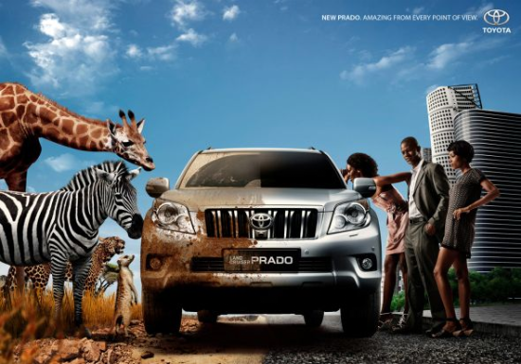
Fig. 1

“Semiotics is the science of signs, a sign being anything that can be used to stand for

something else.” (Berger, 2013, p. 1) By using semiotics, meaning and context become clear

with the aim of heightening our intellectual engagement with a particular piece of visual

communication and art. In this essay I am going to attempt to explain why I have chosen a

certain advert and will deconstruct the advert using semiotic terms. The semiotic terms that

will be used are signifier, encoding, myth and the indexical signs.

The above advert is the 2010 Toyota Prado that was advised in the country of Angola, on the

west coast of Southern Africa. The title of this advert is, ‘Toyota 2 sides.’ The advertising

company is called the Executive Centre, Luanda, Angola. The creative and art director of this

advert was done by António Páscoa and João Martins.

I chose the advert because there is so much to consider, from the animals, the car, the

setting, the city people, the mood, and the written statement. The Toyota Prado

car advertisement clearly shows two dominant sides, there are multiple different types of

animals and purposely chosen people to represent this advert. Thus encompassing two

different environments who are drawn to this particular car

Therefore, this advert has potentially attracted an audience from two entirely different

cultures, as shown there are different types of animals who are drawn to the car, like the

Zebra and the small Meerkat. Looking at the people from the city, their body language and

facial expressions implies that they are amazed by the car! But, this advert has people who

are black, why is that?

The race of the people has been purposely chosen, as shown in my research above, this

advert is targeting the indigenous people from Luanda, Angola.

The wild animals are attracted to the car because the car is running wild and free like them!

This advert uses the signifier and the indexical signs as it brings both human beings and

animals together to continue the myth of this so called “amazing” car.

The advert states, ‘New Prado. Amazing From Every Point Of View.’ This advert is trying to

express how amazing the car is at every angle, which attracts every kind of living thing in the

world to this Toyota Prado car. The term semiotic is encoding when the text is telling us

“how amazing,” this car is, having both an untamed wild side, but also a cultured serious

side for everyday driving. The definition of the word amazing is “Causing great surprise or

wonder; astonishing” (Collins English Dictionary). The advert is using the word “amazing” to

emphasise that the car is “a great surprise and astonishing.”

Without using semiotic terms, I could have quite easily “fallen” for the car myself! Caught

by the prospect of driving something that has both a “wild side and a car for everyday

driving.” However, by using semiotic terms to deconstruct the advert I have discovered the

significance and importance that sign’s and symbols can play in engaging with a particular

identified audience, heightening their connection towards a particular piece of

communication and art, influencing them to accept what is portrayed before them! This is

the power of advertising!

Bibliography

Berger, Arthur Asa & Berger, Arthur Asa, 2014. Semiotics and Society. Society (New Brunswick), 51(1), pp.1.

Dictionary Reference

https://www.jcdecauxafrica.com/advertise-angola#about-angola

https://www.howwemadeitinafrica.com/brand-building-in-angola-a-tricky-business/12328/

https://www.focus2move.com/angola-vehicle-market/

https://www.goodreads.com/author/quotes/13084.Roland_Barthes

https://ceasefiremagazine.co.uk/in-theory-barthes-1/#:~:text=Barthes%20is%20one%20of%20the,but%20sometimes%20as%20a%20poststructuralist.&text=One%20characteristic%20of%20Barthes's%20style,words%20to%20explain%20a%20few.

https://web.b.ebscohost.com/ehost/pdfviewer/pdfviewer?vid=1&sid=66513433-9d68-4797-a037-354348fe3cfd%40pdc-v-sessmgr06

Lists of Figures:

Figure 1. Toyota 2 Sides, Toyota Advertising Campaign, (2010) Accessed from https://www.adsoftheworld.com/media/print/toyota_2_sides [Accessed on 7th February 2010]

Task 2: Manifesto Writing

- Art is a way forward to express ourselves.

- Working hard in school will lead to success.

- No Children has the right to be hungry, right? (The support from Marcus Rashford)

- Every kids dreams can be achieved.

- School meals should be for all kids who need them.

- No Pain, No Gain

- Students are the future

- No is the time to start learning

3 areas of exploration

No Children has the right to be hungry, right? (The support from Marcus Rashford)

Fig 1. Marcus raising a campaign for all kids to receive free school meals over the summer break.
“The thought of 1.3 million children going hungry this summer was unimaginable.” (Sir Keir

Starmer, 2020). This is a powerful message as it is unimaginable because 1.3 million children

in the UK will go hungry. This is where a professional footballer who has experienced hunger

as a child, now doesn’t want children to go hungry like what he went through. There is a

trend where everyone wants to help and provide food those who are going hungry. The

backing of Government, you can the unity as a country as everyone are doing their part to

help one another. Rashford posted, “But in reality, Wembley stadium could be filled more

than twice with children who have had to skip meals during lockdown due to their families

not being able to access food.” (Rashford, 2020). This statement is mind blowing as a

country like UK has such poverty. Therefore, I want to be part of this and making sure that

every child in the UK has food to eat. This campaign that Rashford has done must continue

as it is making a difference, for the Government they must continue with their financial

support in order to keep this going.

Students are the future

Ever year there are more new students carrying on with education. They have the

responsibility to do what is needed to be done. “Education is the passport to the future, for

tomorrow belongs to those who prepare for it today.” (Malcolm X) All students are

procrastinators as they will think they have plenty of time to do the work, in reality they

don’t. “Don’t let what you cannot do interfere with what you can do” (John Wooden). Every

student should have the opportunity to have access to equipment needed for this course.

This will help students who are studying art become more creative within their work. All

students should have help from those who need their health to be cared for. As a student

myself, I am experiencing the workload and this could potentially affect people. Universities
should have more efficient and effective student support. This could be done by talking to

the bosses of the Universities and seek for more student support for those that will need it

most.

Art is a way forward to express ourselves

Fig 2. Art As Expression

This current world has gone further on where human beings are now expressing themselves

even more than before using different techniques. As stated in the Britannica journal, “Art

as a representation of outer existence has been replaced by art as an expression of human’s

life” The Oxford English Dictionary has described the meaning of expression as, “The action

of making known one’s thoughts or feelings.” The way that humans are now expressing

themselves are through doing art, it allows them to release themselves onto their designs.

Again, from the Britannica journal it states, “Idea’s now feel relieved because they have

expressed what they wanted to express.” Art is growing and are being used in many ways,

but the use of expression within the art has become the mastermind of great art pieces.

Bibliography

https://www.theguardian.com/society/2020/nov/08/marcus-rashford-overwhelmed-as-government-pledges-170m-to-help-families

https://www.mirror.co.uk/news/politics/breaking-marcus-rashford-wins-free-22200423

https://www.google.com/search?q=expression+in+art&oq=expression+in+art+&aqs=chrome..69i57j0i457j0l2j0i22i30l4.6702j0j7&sourceid=chrome&ie=UTF-8

https://examples.yourdictionary.com/short-manifesto-examples.html

https://www.cascadeae.com/express-feelings-art/

List of Figures:
Figure 1. Marcus Rashford (2020) Accessed from: https://www.mirror.co.uk/news/politics/breaking-marcus-rashford-wins-free-22200423
[Accessed on 22nd December 2020]
Figure 2. Art As Expression, Accessed from: https://www.britannica.com/topic/philosophy-of-art/Art-as-expression [Accessed on 22nd December 2020]

Task 3: Practiced-based Writing

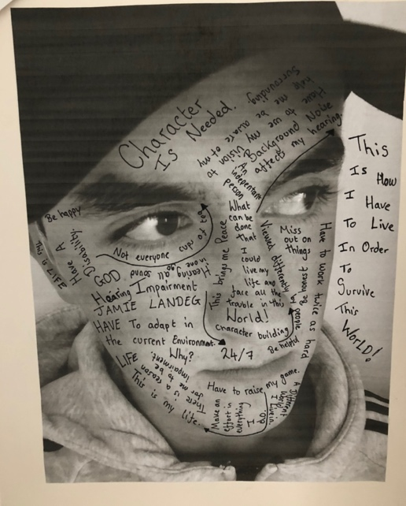

To be a reflective practitioner, I have chosen to reflect on the work I have done recently.

“Reflective practice is a dialogue of thinking and doing through which I become more

skilful.” (Schön) The project was about, ‘In Real Life,’ I wasn’t sure how my end outcome

would look when I first came to think of this project. There was an idea to make my way to

the end outcome, which was to start doing some research. As part of the research, I wrote

down all possible real-life events that happen within the world, that happen in today’s

society. I came to a conclusion where I could talk about disability as a whole, as I am hearing

impaired. The thought process then was to look at disability as a whole. My original idea

was to create a new disability logo.

The first work was to look at the disability logo itself and analyse whether it is a good logo to

use that represents disability, I started to realise that this disability logo doesn’t represent

all disabilities because it is both visible and invisible. The next plan was to try and

experiment whether I could change the logo and create a logo that represents both visible

and invisible disabilities. The end results were unexpected as I wasn’t able to create a logo

because there was a need to have the balance for both disabilities. This shows that my

creative process is not clear cut because then I had to change my plan process to something.

I came to a thought that I could look at myself where I could express myself because of my

hearing difficulties. During the time, I needed to research some artists and I found a guy

named Stefan Sagmeister. I was inspired with his works as he just expressed himself using

his body. Therefore, I wanted to do something similar. As shown in the image, it is a photo

of me with writing on my face that talks about what I go through life in order to survive this

world. This work was a tough one as I needed to reflect back about myself and apply it to

the image. I learnt to use my reflective skills in order to complete this task, as I am doing

now, I am reflecting back at my work. If I was to do this again, I would change a lot of things

because at the time I didn’t know how I would do this project and what the end outcome

would be. I learnt to just trust in the process of my work and allow the research to help

move forward within the work process.

Bibliography

http://www.daneshnamehicsa.ir/userfiles/file/Manabeh/Educating%20the%20reflective%20practitioner.pdf

