Architecture in your home town
Izzie Harris

Both Ogmore Castle (1106) and Ogmore Community Centre (2020) are crucial buildings to the history of Ogmore by sea. Although built in separate centuries, in different styles and for different purposes, both structures attract visitors and contribute to the appeal of the area.

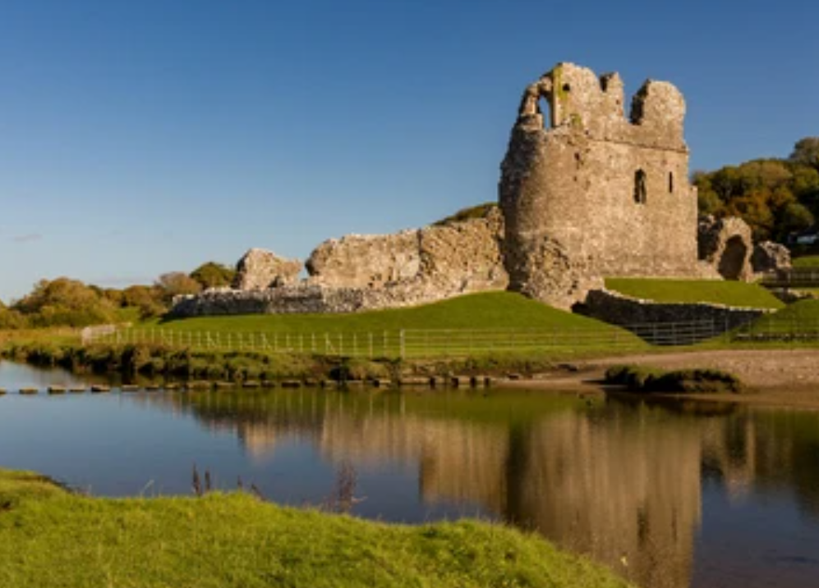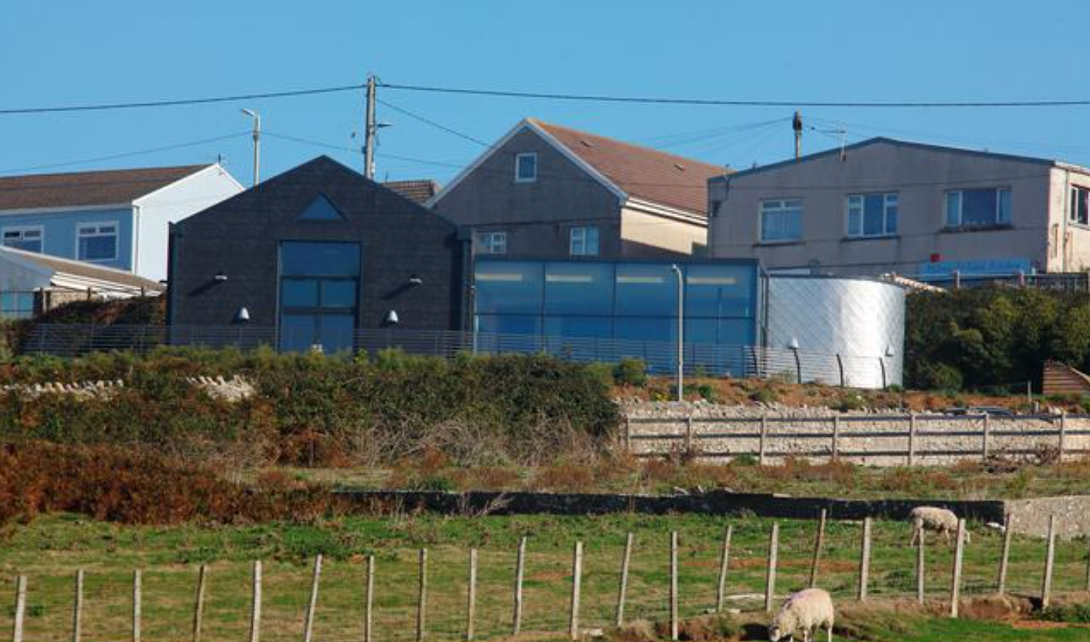
Ogmore Castle Ogmore community centre
(Shutterstock, 2018) (Alamy Limited, 2026)

Context and Historical background :

According to council reports for Ogmore’s community hall, The first approved decision began in 2001, proceeding until 2018 where the final approval for the renovation was agreed (Vale of Glamorgan Council, 2020c pg 3). The site location made use of the land below the main road, consisting of a derelict public toilet block, grassland and brambles with aged play equipment which distracted from the surrounding scenery (Vale of Glamorgan Council, 2020c pg 7). It cost £634,000 to fund the development of the modern style building which was designed by Air architecture, incorporating the indoors with the natural scenery and landscape outside (Vale of Glamorgan Council, 2020).

Ogmore’s motte and bailey castle was built centuries before the community center, founded by the Norman family of de Londres (Duchy of Lancaster, 2025).The construction likely began 1106, being a part of a trio of fortresses built in the early 12th century (Hull, 2006 pg 102). The castle was built upon a bank positioned by the river Ewenny for defense. The grade 1 listed ruin was originally used to guard the area from the Welsh-held west's attacks during conflicts (Visit Bridgend, 2025). However the ruins now act as a local landmark and attraction, including the stepsau teilo stepping stones along to Merythyr Mawr.

Plans and sections :

Ogmore community centre ground floor
(Vale of Glamorgan Council, 2020b)

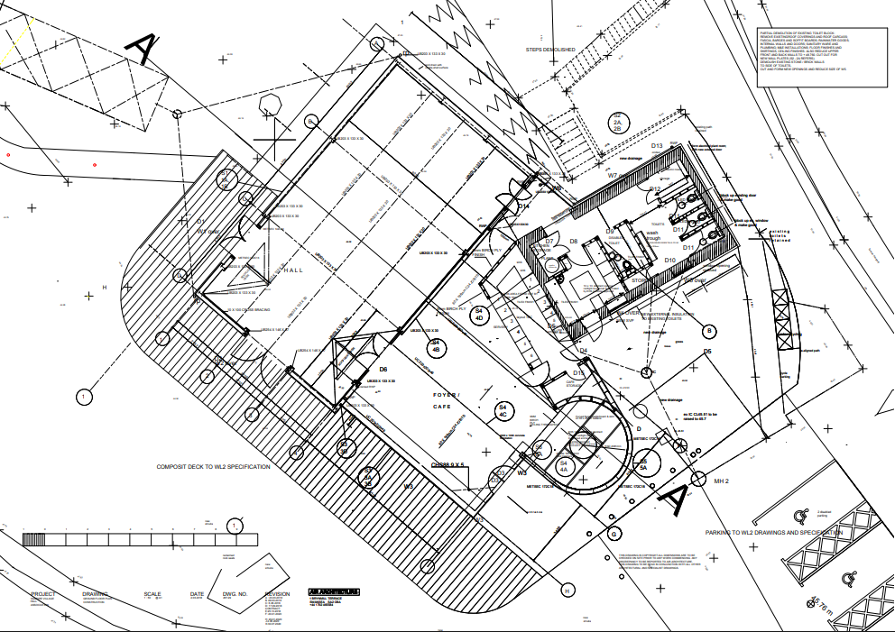

Principle elements :

From the floorplan, the repurposing of the original public toilets is evident with new external insulation added to the existing toilets as a cost saving solution.

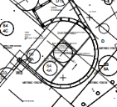

The building also utilises a modern, metallic curvature which contrasts with the angular structure. This acts as a focal point for the coffee shop and could attract visitors.

The building incorporates the outdoors by using a wrap-around deck with seating spanning around the perimeter.

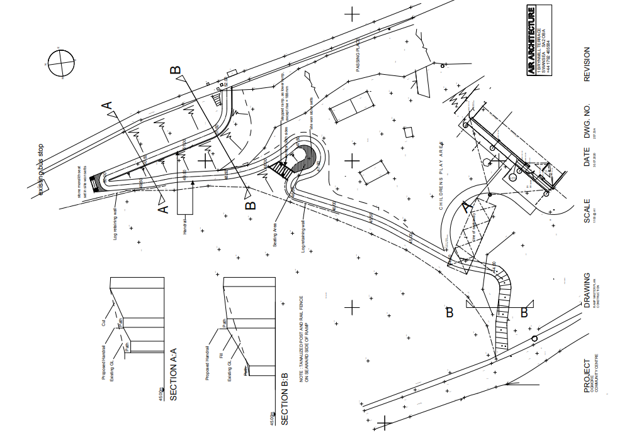

A ramp has also been added for accessibility on site. This could be used to help prams access the playground or for wheelchair access.

Ogmore community centre ocvh ramp master plan
((Vale of Glamorgan Council, 2020a)

Ogmore castle plan
(J. Kenyon et al, 2001)

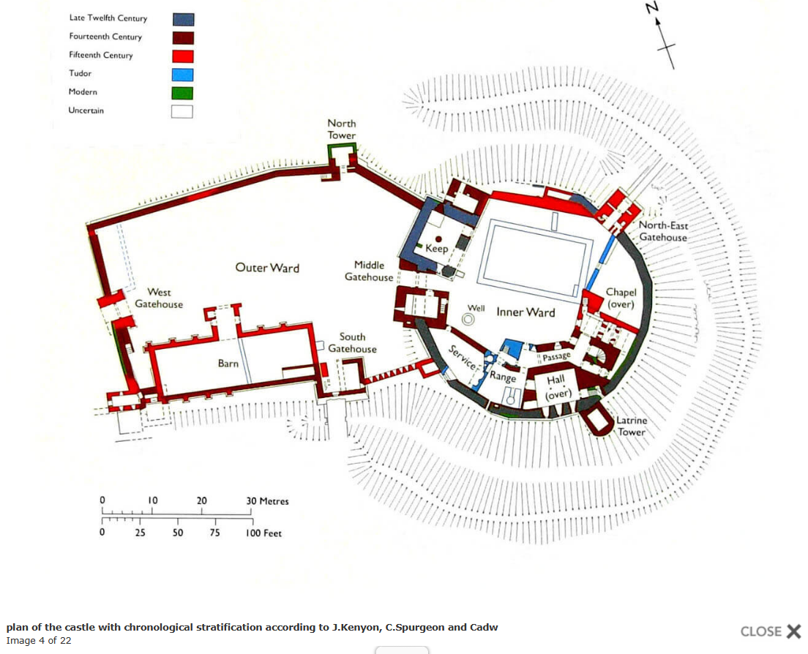

Unlike the community centre, The castle was constructed with a polygonal plan, with the earliest elements dating back to the 12th century until the modern period. The castle adapting over the centuries shows the evolution of materials and styles within architecture. These initial elements consist of the outer and inner ward wall structure which protects the inside enclosure. As well as the North-East gatehouse which controls access to inside the castle (E Morris, 2025). Furthermore for protection, surrounding the castle's bank a defensive moat is visible. This plan therefore functions efficiently due to not only the castle's architecture but landscape acting as a safety and protection mechanism to stop intruders.

Materials and light :

The community center's front of glass allows for a modern design and strong source of natural lighting. Through the development of plans, the building was downsized which benefitted the lighting for buildings around due to minimised shadowing and blocking of light. This was not an issue for the castle due to the lack of surrounding buildings compared to the community centre. The building consists of modern materials such as a steel frame, large glass and a concrete base. Air architecture's first idea took inspiration from agricultural barns with some similarities remaining present (Vale of Glamorgan Council, 2020c pg 7).

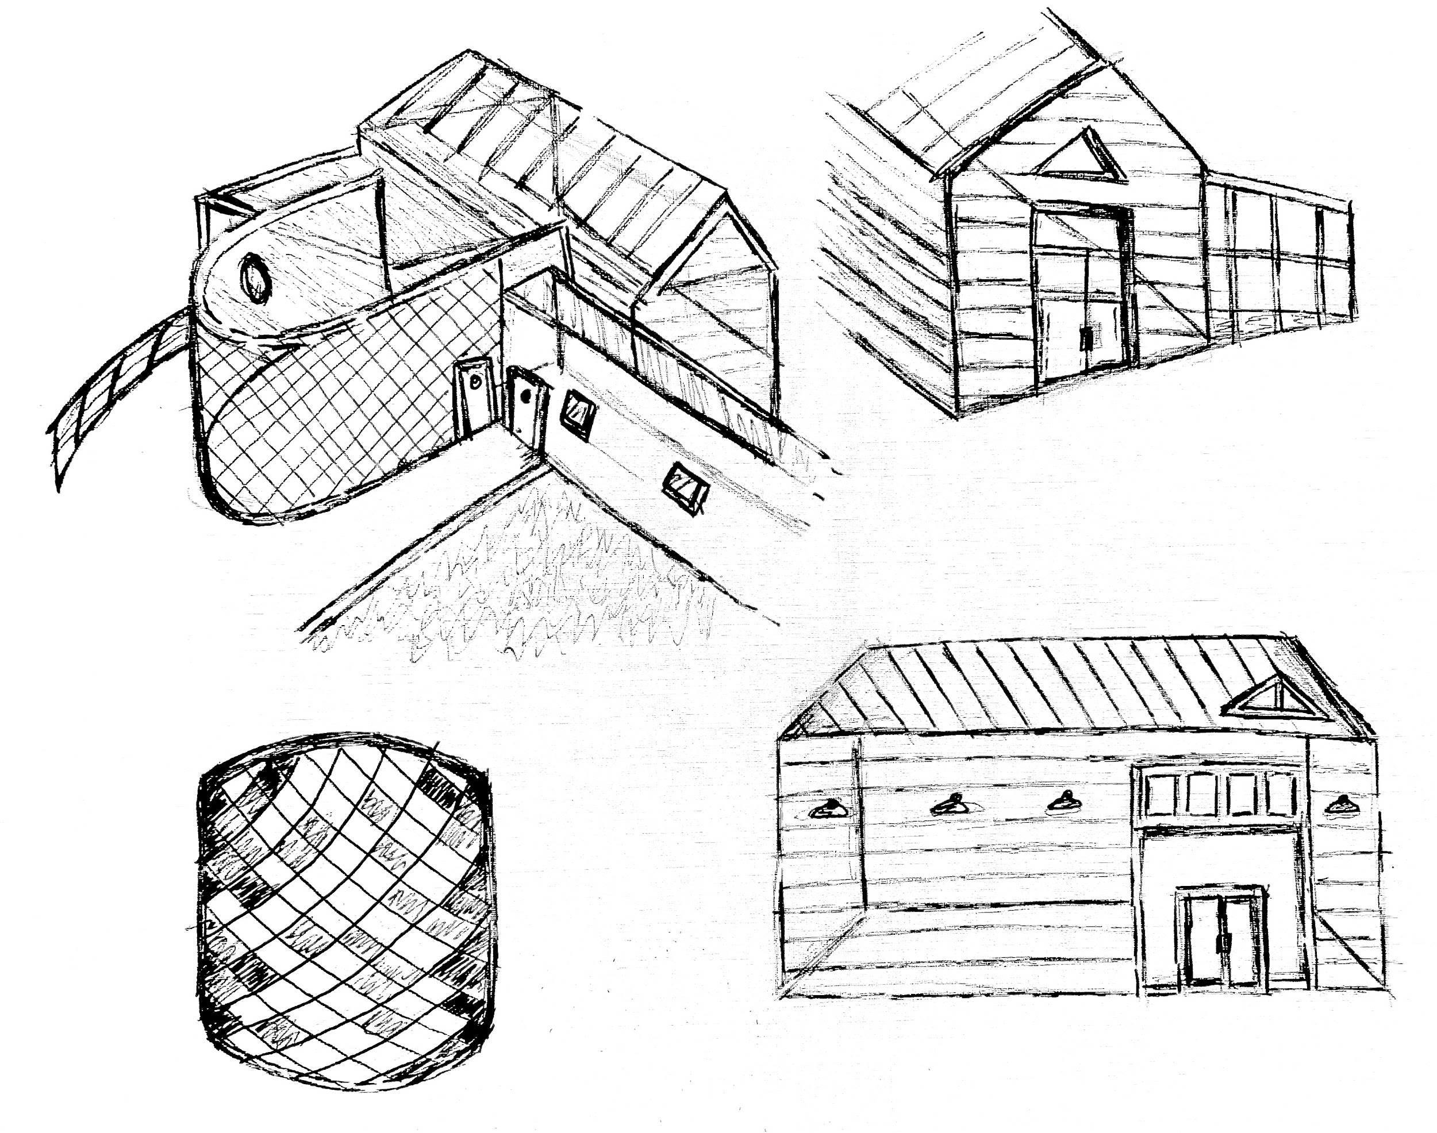
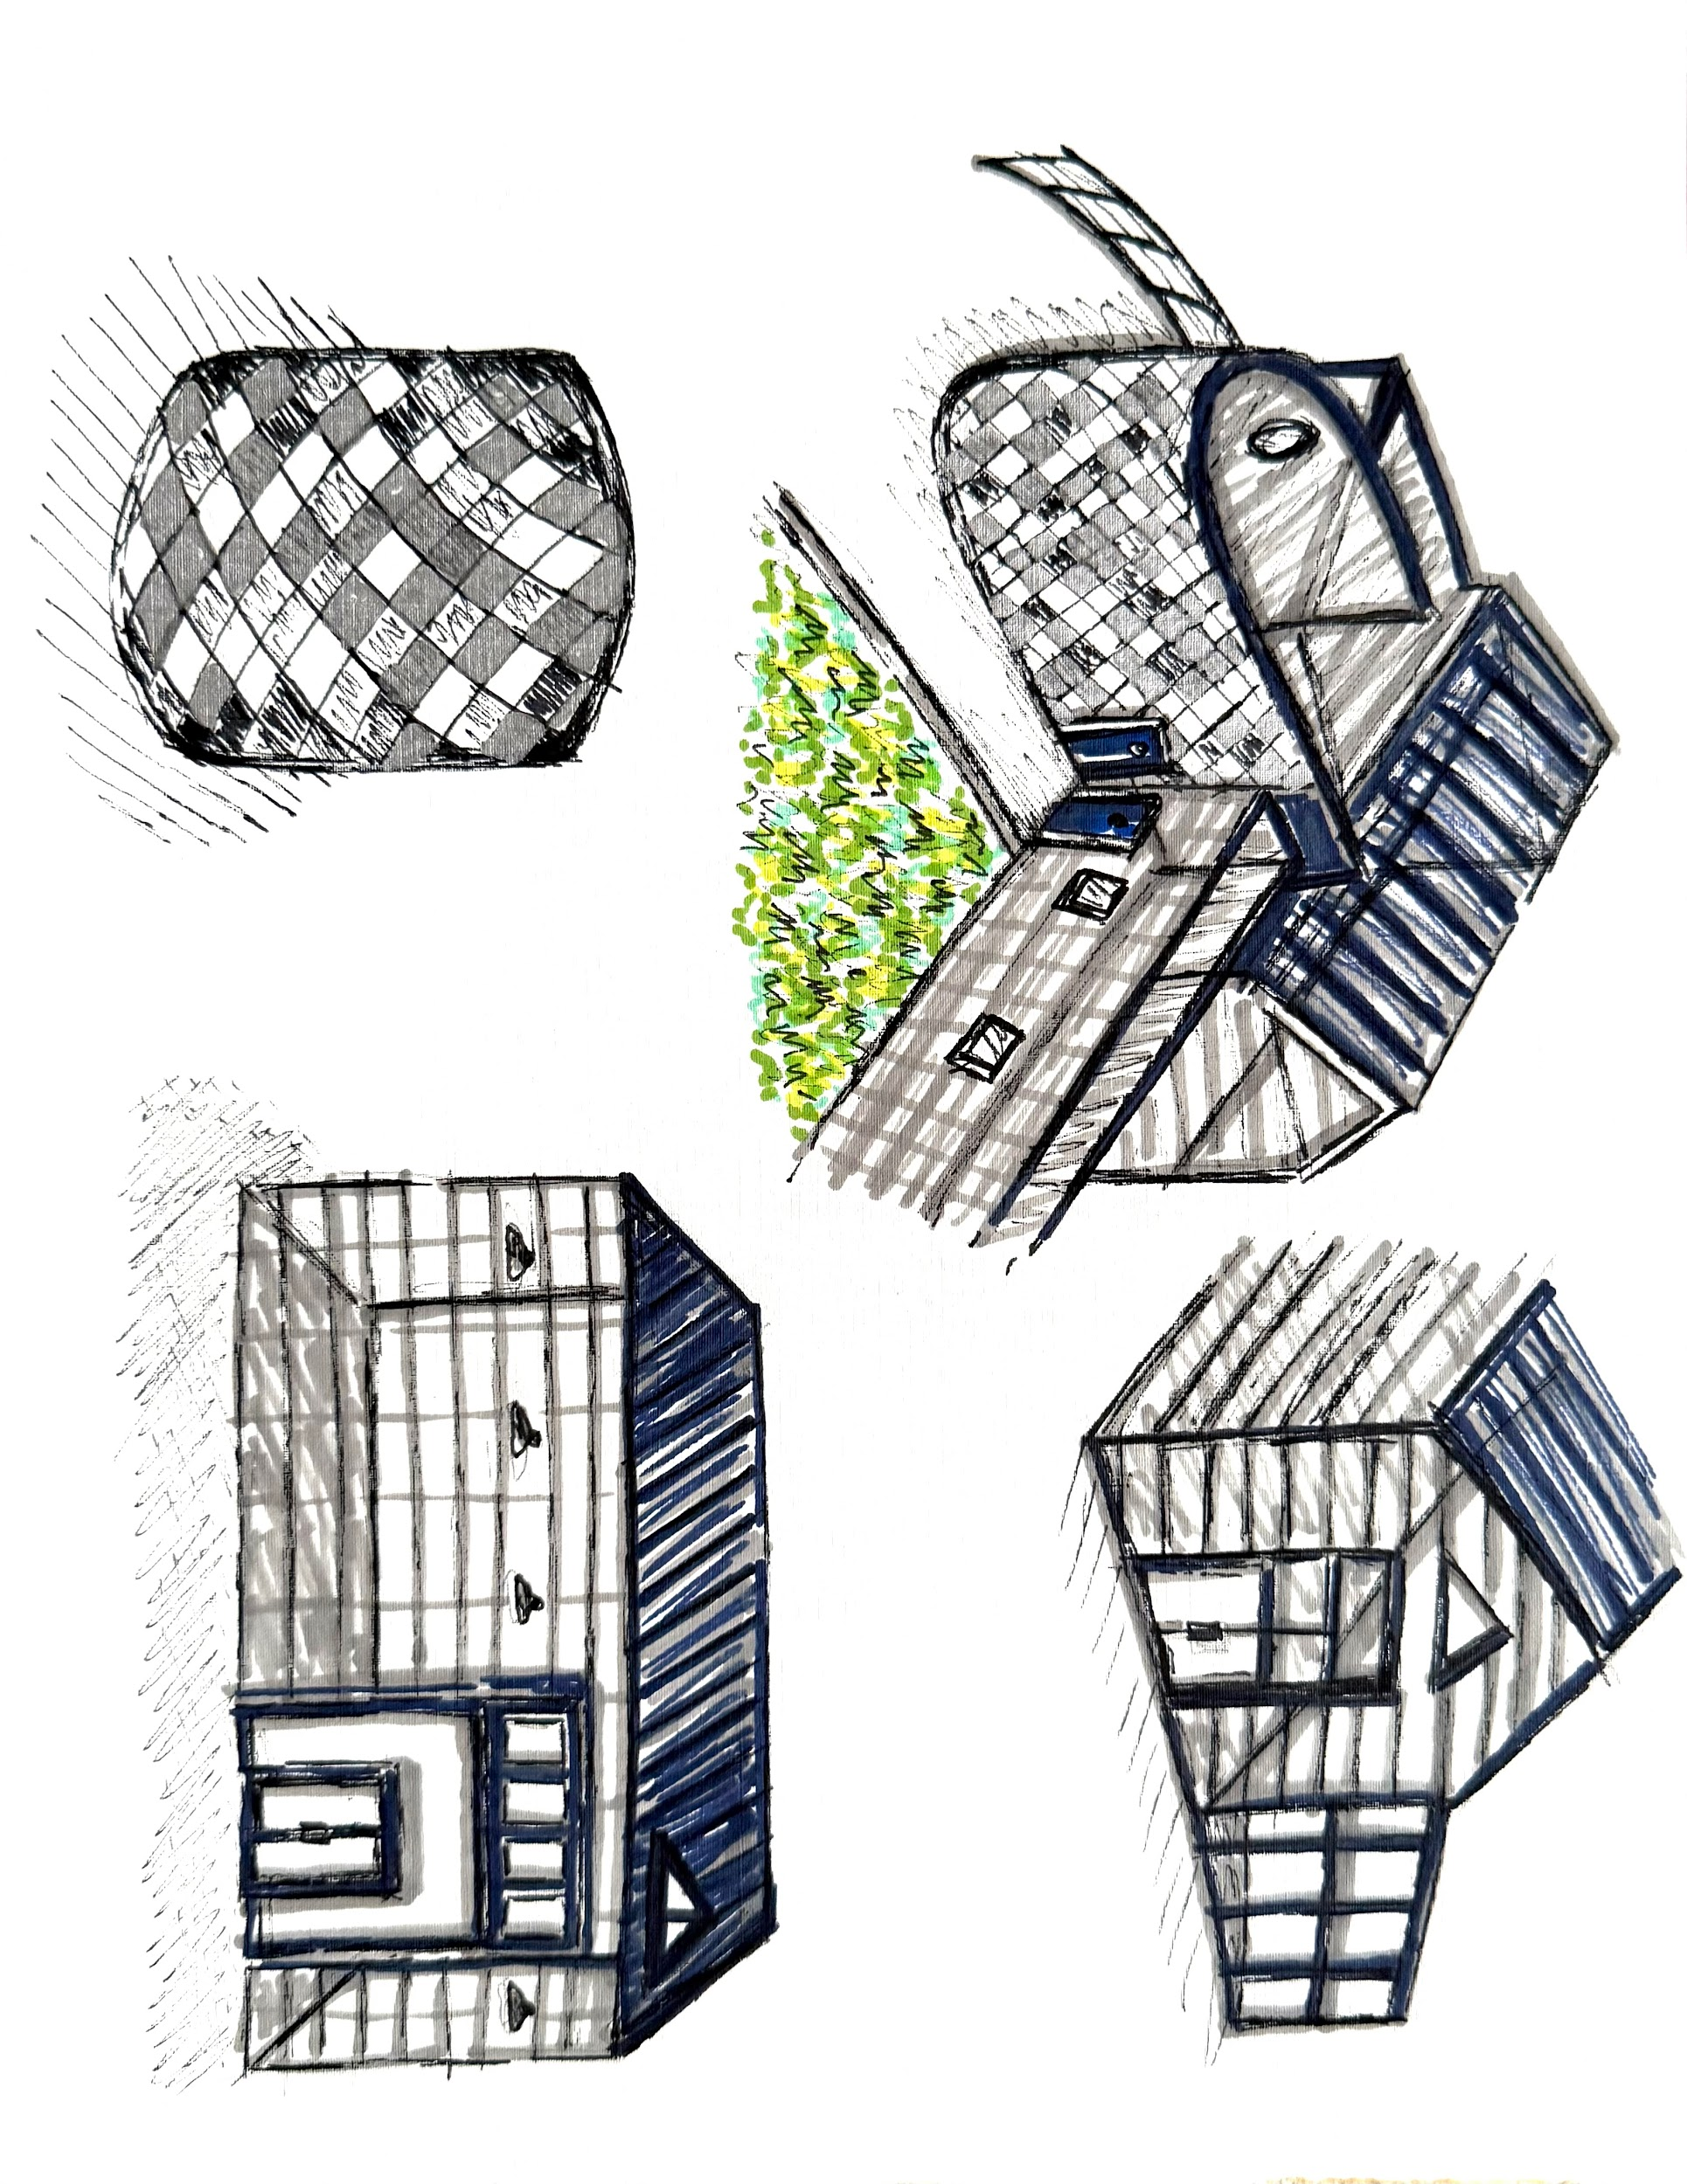

My sketches demonstrate where these materials are used and how they function together as a building.

In the early 12th century, Ogmore castle's structure began made of wood and earth, differing from the community centre's modern steel structure. Before the early 13th century, it was then strengthened with stone and a curtain wall (Visit Bridgend, 2025). Windows and fireplaces were used as a natural lighting source due to the absence of electricity. These are seen in areas such as the 12th century building within the courtyard being brightened by highly stationed small windows in the wall (Ancient and medieval architecture, 2018)

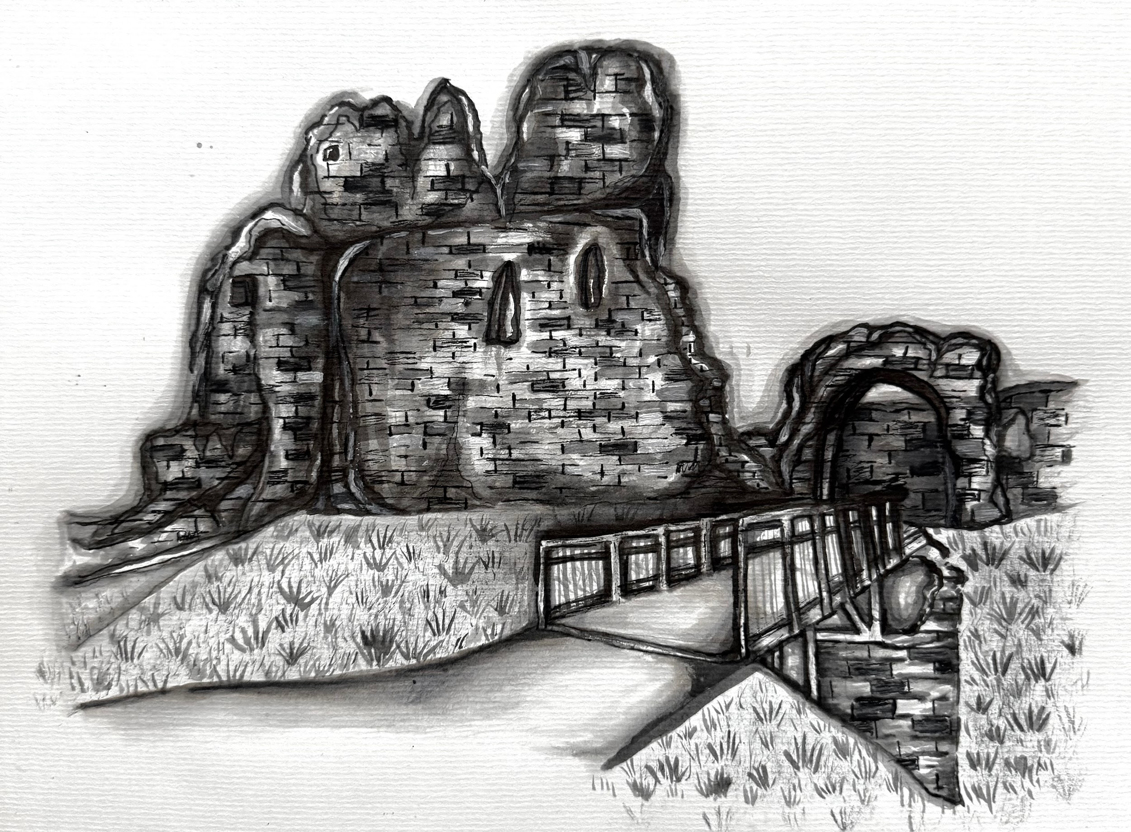

My own study shows a recent section of the castle ruins, with the later added stone structure present.

Use :

The community centre currently hosts the welsh coffee company shop to attract visitors and create jobs. As well as the hall functioning for the local community as a place to gather for funerals, celebrations, weddings or host social, sport or creative events (Vale of Glamorgan Council, 2020). Unless hired, the hall acts as a quiet zone contrasting to the caffe acting as a busier social zone. The layout is functional with direct access from the car park and easy access from the coffee shop to the hall through a shared wall.

Ogmore castle being a key part of Welsh history, now acts as a local landmark and attracts visitors to its remains and stepping stones. Therefore functioning as an attraction rather than a service or shop like the community center. It is also a quieter zone compared to the community centre due to its lack of use and peaceful surroundings. The remaining areas to see include the keeps western wall, the defensive walls remains, fragments of the latrine tower and the foundations of the castle moat (Ancient and medieval architecture, 2018).

Conclusion :

To conclude, Ogmore's architecture is diverse with ancient 12th century structures as well as modern 21st century buildings. The contrast in these two buildings alone highlight the development and progress of architectural styles through the centuries. Due to political shifts and a change of necessities, Castles such as Ogmore that were once essential for authority and defence are no longer in use. Because of this, money is now being invested elsewhere such as locations for leisure and activity like the community center. Architectural styles have also adapted as stone was a dominant material for the castle whereas modern buildings such as the community center are utilising glass and concrete. Timber was also originally being used to support the castle whereas the community centre utilises a steel frame structure instead, showing an advancement in structure as well as material. However, despite the differences, both buildings are essential to Ogmore's history and attraction of visitors.

Word Count : 1064

Reference list
Alamy Limited (2026). Ogmore by sea community centre hi-res stock photography and images - Alamy [online] Alamy. Available at: https://www.alamy.com/stock-photo/ogmore-by-sea-community-centre.html?sortBy=relevant [Accessed 1 Jan. 2026].

Ancient and medieval architecture (2018) Ogmore - castle - Ancient and medieval architecture [online] Available at: https://medievalheritage.eu/en/main-page/heritage/wales/ogmore-castle/ [Accessed 17 Dec. 2025].

Duchy of Lancaster (2024) Ogmore Castle - Wales - Duchy of Lancaster [online] Available at: https://www.duchyoflancaster.co.uk/properties-and-estates/historic-properties/ogmore-castle-wales/ [Accessed 18 Dec. 2025].

E Morris & Exploring castles (2025) Castle Gatehouse: The Strongest Part of any Medieval Castle [online] Exploring Castles Available at: https://www.exploring-castles.com/castle_designs/gatehouse/ [Accessed 16 Dec. 2025].

Hull, L. (2006). ‘Britain’s Medieval Castles’. [online] Available at: http://lisehullcastles.com/books.htm [Accessed 16 Dec. 2025]

J. Kenyon, C Spurgeon and Cadw (2018) Ogmore - castle - Ancient and medieval architecture [online] Ancient and medieval architecture Available at: https://medievalheritage.eu/en/main-page/heritage/wales/ogmore-castle/ [Accessed 18 Dec. 2025].

Planning-register.co.uk (2018a) Application search - Vale of Glamorgan District Council [online] Image available at: https://vogonline.planning-register.co.uk/Document/Download?module=PLA&recordNumber=69258&planId=656832&imageId=41&isPlan=False&fileName=257.33A_OCVH%20RAMP%20MASTER%20PLAN%2030072020.pdf [Accessed 19 Dec. 2025].

Planning-register.co.uk. (2018b) Vale of Glamorgan District Council [online] Image available at: https://vogonline.planning-register.co.uk/Document/Download?module=PLA&recordNumber=69258&planId=656831&imageId=40&isPlan=False&fileName=257.29_REVK_OCVH%20GROUND%20FLOOR%20PLAN%20%2030072020.pdf [Accessed 20 Dec. 2025].
Planning-register.co.uk. (2018c) Vale of Glamorgan District Council [online] Available at: https://vogonline.planning-register.co.uk/Document/Download?module=PLA&recordNumber=69258&planId=742226&imageId=67&isPlan=False&fileName=Final%20%20Report_202000525FUL.pdf. [Accessed 16 Dec. 2025].
Shutterstock. (2018). 2+ Hundred Ogmore Castle Royalty-Free Images, Stock Photos & Pictures | Shutterstock. [online] Available at: https://www.shutterstock.com/search/ogmore-castle?msockid=3b986dfbba4b62003b697b35bbf06334&dd_referrer=https%3A%2F%2Fwww.bing.com%2F [Accessed 2 Jan. 2026].

Valeofglamorgan.gov.uk. (2020) Work starts on Ogmore village hall with help from much-loved local resident [online] Available at: https://www.valeofglamorgan.gov.uk/en/our_council/press_and_communications/latest_news/2020/January/Work-starts-on-Ogmore-village-hall-with-help-from-much-loved-local-resident.aspx [Accessed 21 Dec. 2025].
Visitbridgend.co.uk. (2025). Visit Bridgend | Ogmore Castle (Cadw) [online] Available at: https://www.visitbridgend.co.uk/attractions/OgmoreCastleCadw [Accessed 19 Dec. 2025].

Bibliography
The Ogmore by sea story (2018), Mike and Jenny Hill, True Vine Media

