The video “An intense day on Crib Goch” documents an incident that happened on Crib Goch on the 7^{th of} March 2020 where a group of four individuals encountered difficulties getting off Crib Goch via Bwlch Coch and getting onto the Pyg track of Yr Wyddfa (Snowdon). For the sake of anonymity, I will not be referring to the members of the group by name instead I shall be assigning names to them, the names will be leader (who is a qualified mountain leader), casualty and participant one and two.
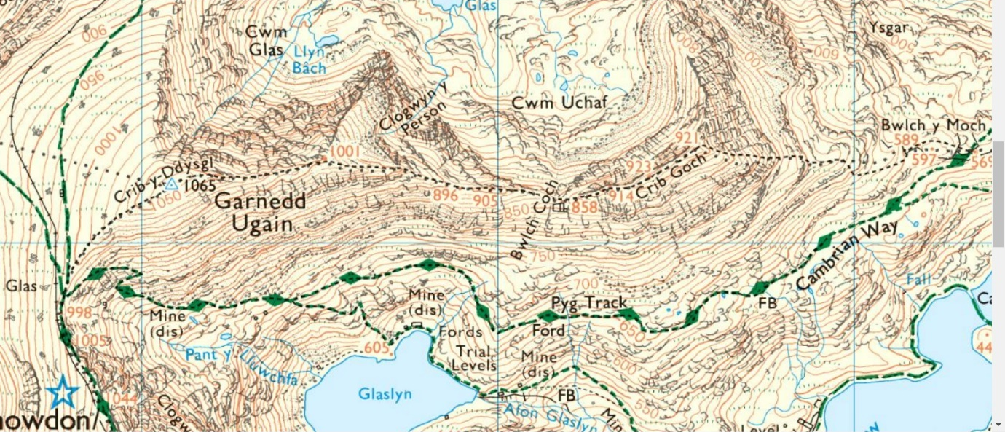
The weather report of the day of the incident is summarized as being “Increasingly windy. Rain and drizzle on and off. Very extensive fog.” (Mountain Weather Information Service, 2020) it is also important to note that the temperature on the day was 3C (at 900m) however could have felt as cold -11C directly in the wind, which was south westerly ranging from 30-55mph. The weather on the day would not have been unmanageable but it wouldn’t have been pleasant and would be difficult conditions for novice climbers to be in with the likelihood of conditions worsening as the day progressed.
Figure 1: Map of Crib Goch
At the time of release of this video there was a lot of controversy on whether or not the groups response was as effective as it could have been, with many questions around the leaders’ response. The aim of this essay is to critically analyse the response from the moment casualty fell as well critically exploring the decisions made, actions taken, and behaviours displayed.

As soon as the incident occurred leader, participants one and two sprang into action immediately to try and find casualty. However, this response should be questioned as it meant they could have become potential casualties themselves, this is evidenced in the video when the initial response is described as “We instinctively started to rush down to try and find him but then we began to slide as well.” (Brave Dave, 2020, 3:39). This response, while understandable, seemed to show a certain disregard for the well-being of the rest of the group in that they were so focused on trying to find casualty, they perhaps didn't give enough thought as to how they would or should, go about finding casualty. White (2019) highlights this to some degree with his factors of risk being “distraction deception and perception” (White, 2019, xiv) at this point of the response to the incident the groups distraction and perception of risk was at an all-time low seeing as they just seen another member of the group slip and fall down the hill they were distracted by trying to help and find them, and in doing so their perception of the risk was lowered not thinking that they might also slip and fall becoming casualties themselves.
After the initial shock of the incident seemed to pass, the group began to make more rational decisions with leader taking on a more commanding role in the group. It is important to note that the leader has a Mountain Leader qualification (Brave Dave, 2022) which means that they have a certain level of competence and skill. It is at this point the group begins to do a more controlled search for the casualty and the leader begins to speak their thought process aloud saying things like “Oh fuck me I think we’re dealing with a dead person” (Brave Dave, 2020, 3:58) and “Oh Christ I’m gonna have to call Mountain Rescue” (Brave Dave, 2020, 4:04) it is at this point we can see how much the incident has affected the leader and his thought process. Even though he has a Mountain Leader qualification, as well as a certain level of skill and knowledge to be able to deal with the situation, aspects of training and process seem to have been forgotten: the leader now is saying everything that is on his mind potentially affecting the morale of other group members and evidencing a degree of shock/panic which could affect the quality of his response to the situation.
This leads to questions being raised about the leader’s response but also the way in which they have been trained as the leaders’ response thus far makes it appear he is way out of his depth and doesn’t seem to manage the situation well despite the situation being dealt with being part Mountain Leaders skill checklist being able to “Manage self and group in a variety of different weather conditions including heat, cold, rain and high wind.” (Mountain Training, N/A). Hickman and Stokes (2016) provide some input about this issue stating “The NGB focus on technical proficiency is in need of reconsideration as to whether it is producing people with the broad range of skills that are currently in demand.” (Hickman and Stokes, 2016, pp. 74) this work potentially highlights a flaw in the way in which mountain leaders are taught and that there is a greater focus on developing and becoming proficient in technical skills over the broader range of skills that in this situation potentially required. This also raises questions about the Mountain Leader training qualification as “Once you have completed a Mountain Leader training course, or in fact any of Mountain Training's award scheme training courses, it is valid forever.” (Mountain Training, N/A) with no assessment to gauge competency or if your still safe to work with however, Mountain Training suggest a mountain leader who regularly uses their skillset will be up to date with good practice, coming from attending workshops or peer-led events. Whilst this may be enough for some mountain leaders but may be not enough for others, like the leader.
After the initial shock of the incident seemingly subsided, the group then went about searching for the casualty: as the search progresses the group begin to call mountain rescue. This action raises some questions in terms of the time it took for the group to finally decide to call mountain rescue even though it would have been better to call when they were higher up to get better signal or indeed in recognition that casualty was in all probability badly hurt and it would have been better to alert help as a matter of priority instead of straight away going to find the casualty. In addition, leaving one of the participants alone to call mountain rescue is a questionable decision because we have no way to assess the participants knowledge and understanding of how to call for mountain rescue as the leader has to explain the process “999 and ask for Mountain Rescue no ask for police and then they get Mountain Rescue.” (Brave Dave, 2020, 5:27) this infers that participant one might not know how to correctly convey to police/ mountain rescue their location, making it more difficult to find the group potentially wasting time to the possible detriment of the casualty. Isolating a group member to call emergency services is questionable as when participant one is calling for help, they will be on their own and at greater risk of hypothermia, but also once help called participant one is at greater risk as they try to get back to the group: they may become a casualty themselves. Sumann et al. (2020) supports this stating that the safety of the rescuers is the first principle of a rescue as well as
“Rescuers must consider potential hazards including transport to and from the scene, access to the scene, clothing and equipment for the rescuers, and reliable communications with other agencies and team members.” (Sumann, et al., 2020, pp. 3)
Although getting to the casualty and providing first aid is crucial, it's also just as crucial not to add to the number of casualties through reckless actions.
After the process of contacting mountain rescue begins the leader and participant two begin searching for the casualty in earnest, at this point in the video the search strategy the leader implements is basically going down the hill in a zig zag line, so that the leader doesn't fall over, and looking by sight as well as calling out to see if they can hear the casualty. Phillips et al. (2014) states “Searching for a missing subject involves a systematic process of investigation, planning, and management of the search.” As far as search strategies go this is about the best the group can do with their limited resources and time due to the nature of the incident, the leader being the only one with a measurable degree of experience, a trained Mountain Leader, participant one calling for help and participant two trying to stay close to the leader. Given the possible injuries that the casualty had potentially sustained, the leaders speed in initiating the management and search for the casualty could have saved the casualties life. Fortunately, the casualty was able to be found due to him remaining conscious and calling for help, despite the severity of the accident. Had the casualty been knocked unconscious the search could have taken longer potentially resulting in either further casualties or for the chances of the casualty surviving being much lower.
Once the leader finally got to the casualty the response to treating casualty is mixed. On the one hand the leader demonstrates an understanding of the need to engage and reassure the casualty. He sees the dangers of hypothermia very clearly and appreciates how falling body temperature may affect survival. His examination of the casualty with regard to bleeding and potential broken bones seems somewhat haphazard: moving a casualty with potential spinal injuries seems unnecessary. However, as Veelen and Maeder (2021) explain the prevention of hypothermia or the attempted reversal of accidental hypothermia in trauma patients is crucial in prehospital and hospital management of the casualty, they also state that there is strong evidence to suggest that hypothermia in trauma patients can lead to in-hospital: higher mortality rates increased length of stay at hospital and a higher need for transfusions. Should the leader’s quick response to administering first aid and steps to prevent hypothermia in the patient could have, in the long run, saved the casualty’s life.
Although the leader clearly recognised the need to speak to and gain responses to the casualty, it must also be noted that the way in which the leader responded and conversed with the casualty could have been more measured, encouraging and supportive: his way of speaking and use of language could have had a negative impact on the casualty encouraging rather that dispelling panic and worry. Buxton Mountain Rescue (2020) state that rescuers should “make a reassuring first impression on the casualty.” (Buxton Mountain Rescue, 2020, 1:35), and by this point as soon as the leader got to the casualty majority of dialogue between them is the leader swearing and seeming a bit frantic which is not very reassuring when this person is trying to help you.
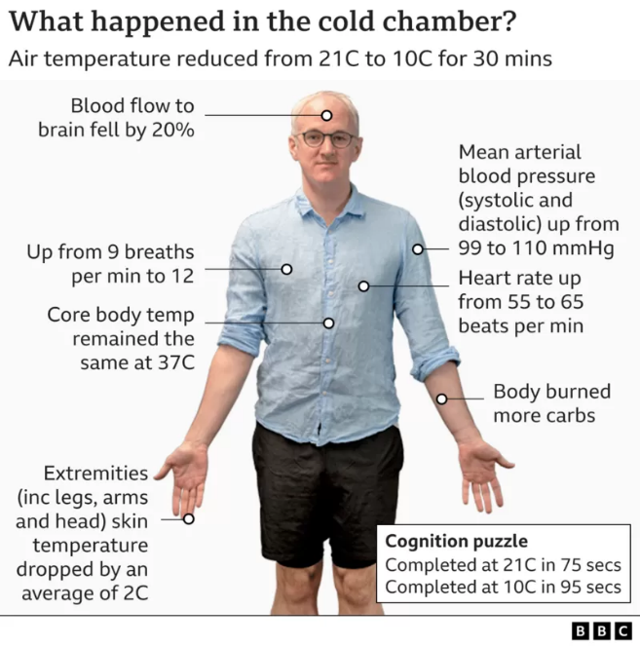
The leader’s reaction can also be explained through the work of Professor Damian Bailey, who did an experiment to see how living an environment of 10C can have on your body. It was found that amongst other outcomes that being in an environment of 10C for as little as thirty minutes can decrease blood flow to the brain by twenty percent which means “there's less oxygen and less glucose [sugar] getting into the brain and the downside of that is it's having a negative impact on your mental gymnastics.” (Gallagher, 2022). Which could explain the way the leader acted in this situation to some degree. The leader is also exhibiting signs of shock and is substituting business and action for thought and consideration.
Figure 2: Effect of being in 10C environment on the body
Also, at this point whilst the leader is doing everything, he can prevent the casualty from getting hypothermia or his condition worsening, the leader tells participant two “empty your bags” (Brave Dave, 2020, 7:49) and “Every warm thing you’ve got.” (Brave Dave, 2020, 8:02) trying to keep the casualty off the ground and warm however decision must also be brought into question as if the entire group gives the casualty all the warm and spare clothing they have what will the other group members wear if they themselves begin to get too cold and potentially get hypothermia themselves: they can't use the group shelter because it has been used it to try and insulate the casualty more and of course they can't wear their clothes now because they've been on the floor and are insulating the casualty. Whilst it is important to check the casualty that is also important to ensure the safety of the rescuers as highlighted by Sumann et al. (2020) and Mountain Training (2022) in that a trained mountain leader should take appropriate action to ensure the group and the casualties well-being in the event of an incident. Thought might have been given to the use of the shelter to mitigate the effect of wind chill.

Once the immediate first aid is given to the casualty the leader then tried to get onto the Pyg track in order to potentially get more help and see if he could find mountain rescue (Brave Dave, 2020, 18:19). The merit of this decision is the group had used the majority of their resources to keep the casualty warm and off the floor to prevent hypothermia, but in doing so the group didn’t have many resources to keep themselves warm so trying to get help from other hikers would help prevent further casualties. However, this decision also has some problems as far as it known the leader is the member of the group that has had any first aid training as such if the casualty’s condition worsens participants one and two may not have the knowledge and understanding help the casualty which could result in the death of the casualty.
It would seem that the leader was frustrated by waiting and inactivity but clearly moving around had further potential for accidents. When the leader tried to get down to the Pyg track he was in such a rush to get down he began slipping and sliding down (Brave Dave, 2020, 19:00) potentially leading to another casualty and, as with my previous point, the leader is the only first aid trained member of the group: if the leader became a casualty it is unlikely the remaining members of the group would be able to/or know how to help to decrease the odds of the leader becoming a fatality.
Once the leader gets to the Pyg track he began running down it to get further help eventually a group of people agreeing to help following the leader to where the casualty was. This was good decision as it mentioned in the video that
“Having the extra people was a massive help. Not only did the guys provide more foil blankets and insulation to put overhead, it was also a real morale boost for Participant one, Participant two and me for the others to help keep Casualty talking.” (Brave Dave, 2020, 19:54).
This was also a really big help to the group at this point as the majority of their resources were being used to keep the casualty warm and now that the second group came with a more diverse range of resource is they were able to not only keep the casualty warmer but also themselves reducing the likelihood of more people getting hypothermia.

In conclusion, although the response to this incident was not perfect and there were certainly some decisions that were questionable, the actions taken helped to save the casualty's life. The leader and participants one and two initiated a great many of the responses that improved the casualty’s chances of survival. The group of people found on the Pyg track assisted with further resources and support so that the Leader, participants and casualty were in much better shape than might have been the case when Llanberis Mountain Rescue arrived. It is likely that the casualty would have certainly been more profoundly affected by hypothermia or even died of exposure within hours of the incident occurring had the various interventions not been used (Brave Dave, 2020, 27:56). It should also be noted again that the leader is a qualified mountain leader and demonstrated a degree of knowledge and understanding in both administering first aid and managing the group, but it is also clear to see that his response is not as effective as it could be. This can be due to skill deterioration, as the mountain leader qualification does not need to be renewed so in theory you can get the qualification and “it is valid forever.” (Mountain Training, N/A) and never need to have your competency assessed again which could lead to bad habits forming. This is further supported by Rhue and VanDerveer (2018) who state, “there is evidence of skill and knowledge deterioration in medical providers at all levels,” (Rhue and VanDerveer, 2018, pp-135). As a result of this even though the leader’s response led to the casualty surviving it may be worth shadowing a Mountain Leader to refresh and develop their skills. In addition, an honest review of responses would be useful (an experiential learning opportunity). The leader may look back at his actions and analyse his strengths and weaknesses: would taking two or three minutes to calm your mind and think through your actions and their best sequence be time wasted. Should a qualified leader have emergency blankets, poles, a pick? Was the chosen escape route the safest or the quickest? Should the group have been closer together as they started their descent to support the least experienced members?
In regard to how the critical analysis of this incident will impact on my personal practise when undertaking adventurous activities, I certainly believe that having a significant focus on the planning will be what I do moving forward: mainly in reading and understanding weather reports as well as route planning. I would make a point to revisit first aid protocols every now and then and research what other, more experienced, practitioners might have to say with regard to particular local hazards and issues (such as the wind funnelling experienced in the video). It would be more practical to become more efficient and experienced in these areas over having all the equipment you may possibly need to mitigate most risk: all the tools in the world will not be helpful unless you are proficient in their use. Being proficient and experienced in these areas I possibly would be to deal with this situation or a similar situation more effectively.
Word count: 3095
Reference List:
Brave Dave (2022) About Brave Dave. Available at: https://www.iambravedave.com/index.php?page=about-brave-dave (Accessed:
Brave Dave, (2020) An Intense Day on Crib Goch (feat. Llanberis Mountain Rescue). Available at: https://www.youtube.com/watch?v=CRf7CnhOzXY&app=desktop (Accessed: 2022)
Buxton Mountain Rescue (2020) DR ABCDEF - Buxton Mountain Rescue Team Primary Survey Training Video (Filmed 2012). Available at: https://www.youtube.com/watch?v=T31GbMZrkdY&t=182s (
Gallagher, J. (2022) ‘Staying warm: What does an unheated room do to your body?’ BBC News, 19th November. Available at: https://www.bbc.co.uk/news/health-63602501 (
Hickman, M. and Stokes, P. (2016) ‘Beyond learning by doing: an exploration of critical incidents in outdoor leadership education’, Journal of adventure education and outdoor learning, 16(1), pp. 63–77. Available at: https://doi.org/10.1080/14729679.2015.1051564.
‌Mountain Training. (n.d.). Mountain Leader skills checklist. [online] Available at: https://www.mountain-training.org/qualifications/walking/mountain-leader.
Mountain Training. (n.d.). Mountain Leader FAQs. [online] Available at: https://www.mountain-training.org/qualifications/walking/mountain-leader/mountain-leader-faqs.
Mountain Training. (n.d.). CANDIDATE HANDBOOK MOUNTAIN LEADER MOUNTAIN TRAINING 2 PREFACE. [online] Available at: https://www.mountain-training.org/Content/Uploaded/Downloads/MLT/ef948181-603b-4997-895a-9753ad8f18b7.pdf.
‌‌Mountain Weather Information Service, (2020) Snowdonia National Park.
Phillips, K. et al. (2014) ‘Wilderness Search Strategy and Tactics’, Wilderness & environmental medicine, 25(2), pp. 166–176. Available at: https://doi.org/10.1016/j.wem.2014.02.006.
Rhue, A.L. and VanDerveer, B. (2018) ‘Wilderness First Responder: Are Skills Soon Forgotten?’, Wilderness & environmental medicine, 29(1), pp. 132–137. Available at: https://doi.org/10.1016/j.wem.2017.11.005.
Sumann, G. et al. (2020) ‘Multiple trauma management in mountain environments - a scoping review : Evidence based guidelines of the International Commission for Mountain Emergency Medicine (ICAR MedCom). Intended for physicians and other advanced life support personnel’, Scandinavian journal of trauma, resuscitation and emergency medicine, 28(1), pp. 117–117. Available at: https://doi.org/10.1186/s13049-020-00790-1.
van Veelen, M.J. and Brodmann Maeder, M. (2021) ‘Hypothermia in Trauma’, International journal of environmental research and public health, 18(16), p. 8719–. Available at: https://doi.org/10.3390/ijerph18168719.
White, J. (2018) Health and safety management: an alternative approach to reducing accidents, injury, and illness at work. Boca Raton: Taylor & Francis, CRC Press.

