  - DESCRIBE THE KEY CONTEMPORARY LABOUR MARKET TRENDS

The concept of ‘labour market’ is crucial when speaking about talent planning, as it involves the potential employees who may be willing to work and the terms in which they are willing to do so (Wilkinson and Taylor, 2016). For this assignment, I will conduct an analysis of the labour market trends for both the United Kingdom and Germany, a European country with a higher population (OECD, 2022e).

According to the OECD (2022f), the active population in Germany is higher than in the United Kingdom by over 10,000 people, where the total population is 67 million, 16 million less than in Germany (OECD, 2022e). The levels of unemployment, however, are slightly lower in Germany (3.1%) than in the United Kingdom (3.9%), as per the OECD (2022g) figures.

When looking at the employment by education level, the OECD (2022b) establishes three different points: below upper secondary, upper secondary non-tertiary, and tertiary. In this aspect, Germany shows higher numbers than the United Kingdom in regards to upper secondary and tertiary employment (82.2% and 88.7% respectively).

Another crucial factor when speaking about employment is the average wages, which are higher in Germany (53,700$) than in the United Kingdom (47,100$), as per the OECD (2022a) data. Whilst speaking about salaries, it is vital to highlight the gender wage gap, with figures (OECD, 2022c) showing a greater percentage in Germany (13.9) than in the United Kingdom (12.3). The income inequality indicates a higher level in the United Kingdom than in Germany (0.37 vs 0.29), according to the OECD (2022d).

In terms of flexible working arrangements, the CIPD (2019) establishes that according to an EU survey from 2018, 80% of the respondents from the United Kingdom said they had access or had used flexible working arrangements, whereas the same study found only 63% of respondents from Germany with the equal conditions. The same study shows a higher rate of part-time employment in Germany (29%) than in the United Kingdom (25%), whereas the United Kingdom showed a share of 20% against Germany (8%) in terms of homeworking.

  - DESCRIBE THE PRINCIPLES OF EFFECTIVE WORKFORCE PLANNING AND TOOLS USED TO CARRY IT OUT

The CIPD (2021e) defines workforce planning as the course of stabilising the skills or labour supply against what is required. In 2018, the CIPD published a Workforce Planning Guide with six steps, as we can see in the picture below.

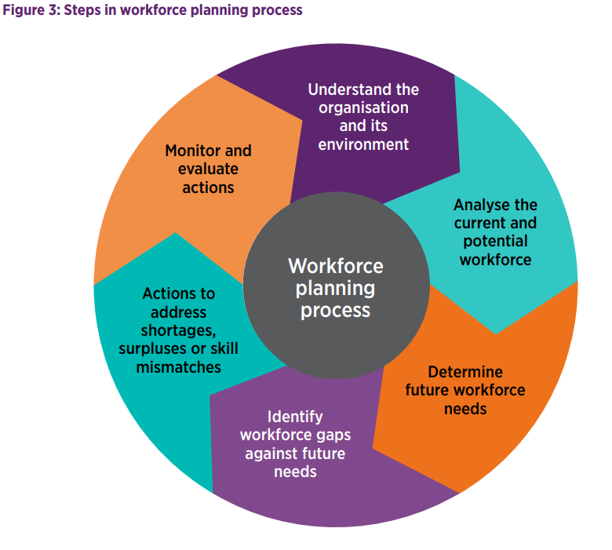
CIPD 2018

First of all, we must understand the organisation and its environment, both now and in the future. For this, the most common tool used is the PESTLE analysis, which looks at six factors: political, economic, sociological, technological, legal, and environmental. It is crucial also to understand the labour markets, both internal and external.

We need to have a knowledge of the organisational strategy for the future too, if there are any plans to be introduced or withdrawn, timeframes, investment in technology or any budget limitations. Moreover, we need to understand the operating model, which combines skills, structures, processes, assets, and technologies for the organisation to provide its services. (CIPD, 2018).

The next step is to analyse the current and potential workforce, their skills, talent profiles, abilities, their views regarding job security, satisfaction, or intention to leave. But also, we must identify the total number of employees, wage cost, age group, length of service, and levels of sickness. This information may be obtained through training records, information from appraisals or consulting person specifications for existing job roles (Wilkinson and Taylor, 2016).

The following step would be to establish the future workforce needs in terms of skills, and calculate the timeframes. One of the tools used is the scenario planning, which shows how people requirements might be affected by different futures and helps to create adaptive plans to achieve upcoming goals (CIPD, 2018).

The fourth step to follow is to identify workforce gaps against future needs, by listing the competencies required for a role and the skill required. This may be done by using an audit form, where the manager would assess the employees’ skills through personal judgement and observation. Subsequently, the results for all the workforce would be summarised to identify the degree to which the skills available match the skills needed for the future (Wilkinson and Taylor, 2016).

To address any gaps, we must develop an action plan, by selecting the most critical areas, identifying potential actions, and prioritising them. Wilkinson and Taylor (2016) determined that the organisation might make use of its own resources, through training, coaching and mentoring, and employee retention, among others. On the other hand, the organisation might use external resources, assessing the local labour market and considering recruiting new employees on a contract basis or through collaborations with universities, for instance. Another option would be outsourcing some activities.

The final step is monitoring and evaluating the actions implemented, which should be done regularly by the managers, not only to check if the actions are taking place, but also to ensure they are still appropriate (CIPD, 2018).

  - EXPLAIN HOW TO DEVELOP BASIC PEOPLE PLANS AND SUCCESSION PLANS

Fuhl (2020) explains different phases when developing people plans in an organisation. Firstly, it is crucial to know the organisation’s goals in the short, medium, and long term, to address any changes in staffing requirements, investment in technology, which might lead to further training, or expanding to other countries.

It is also a priority to work out any operating costs, which should be compatible with the organisational budgets. These costs might be originated from training and development activities or through investment in retaining top talent.

Once understood the business strategy, a draft of the people plan should be made, with a projection of possible recruitment, taking into account the trends in the industry, competitors’ analysis and the type of talent looking to recruit. Some organisations recommend a SWOT analysis to be used as a basis for the company’s present situation and to improve the future.

It is crucial as well to reflect on improvements on engagement activities, such as flexible/hybrid working arrangements, and employee experience, to be considered an employer of choice (Fuhl, 2020).

The plan should explain how it fits within the business strategy and how the achievements will contribute to organisational growth. But before we create the final plan, it would be advantageous to use the insights from the stakeholders, including the employees, IT and Finance, to find out what is important to them.

The following stage is allocating the budget to ensure a return on investment over the estimated timeframe. Devising a roadmap would be useful to understand when key business events will happen, with busy and quiet periods, to then allocate the budget accordingly, with a plan for unexpected situations (Fuhl, 2020).

And finally, measuring success, keeping records of any expenses and how it helped to achieve results, to be able to show how the people plan fits into the business strategy and how it facilitated the revenue and return on investment.

Another topic related to people planning is succession planning, which consists of identifying and developing individuals to fill key roles in the organisation (CIPD, 2020). Succession planning development programmes usually include relevant practical work experience for future roles.

To begin with, the business-critical roles must be identified, either by focusing on individual key positions or by managing them more generically using ‘pools’ of positions where similar skills are needed in emergencies, capable of filling multiple roles.

It is hard to find the right balance between recruiting externally or internally for senior roles. External candidates might bring new ideas and approaches, especially within a failing business to assure its investors. However, by promoting from within, the candidates have the relevant operational experience and know its culture, also helping improve retention rates.

  - ASSESS THE STRENGTHS AND WEAKNESSES OF DIFFERENT APPROACHES TO ATTRACTING TALENT TO THE ORGANISATION

According to Wilkinson and Taylor (2016), when an organisation has to develop a resourcing strategy, it must be based on attracting the right people and distinguishing it from the competitors. They found three fundamental activities: competitor analysis, organisation positioning and employer branding.

The competitors are related to the labour market, not automatically product market competitors. Whilst exploring the differences between them, it is vital to take into account the strengths and weaknesses of the employment agreement presented by each competitor, such as salary, job security, working environment or opportunities for training and development. Once we have analysed the information obtained, we may contemplate if we can make a better offer to ensure that our organisation is more distinct than the rest (Wilkinson and Taylor, 2016).

This SWOT analysis has some advantages, as it enables the knowledge of the strengths and weaknesses of the employment agreement in this case, is flexible, and managers may concentrate on strengths and create opportunities. On the other hand, some of the disadvantages would be, for instance, that the access to quality data might be time consuming and difficult, it does not have a detailed structure and some aspects might be missed, and it would have to be repeated often to be effective (CIPD, 2021d).

Regarding the organisation positioning, Wilkinson and Taylor (2016) cite four different approaches, based on rewards and culture, which are:

- Employer of cash: Might treat employees quite ruthlessly, but recompenses them with good salaries.
- Employer of values: Treats employees very well but cannot offer them high wages. This could be the case of the public and voluntary sectors.
- Employer of churn: Low salaries and tough treatment, which leads to high turnover levels. This is only practical in loose labour markets, where the employees are replaced without difficulty.
- Employer of choice: This is the ideal strategic goal, in tight markets in particular, where employees are treated and paid well.

Employer branding is defined by the CIPD (2021b) as a series of qualities and features, frequently intangible, that offers a particular employee experience, attracts to those who will succeed and perform best and makes an organisation unique. It is essential to link it to the organisation’s values and goals, through the employees’ acting as brand ambassadors, more than ever in these times with the popularity of social media.

According to Taylor (2019), there are different benefits for the organisations, being one of them achieving the ‘employer of choice’ status and differentiation, holding an advantageous view of the company against the competitors. Also, the recruitment costs may be reduced overall, as less would be spent on advertisement as the organisation already holds a positive reputation. It will have a positive influence too in retention and performance.

However, employer branding has a challenge, as it is crucial to evaluate its success and relevance to employees through continuing research (Upadhye, 2017).

  - ASSESS THE STRENGTHS AND WEAKNESSES OF DIFFERENT APPROACHES TO RETAIN TALENT

As I have mentioned above, with a good employer branding we will obtain a better employee retention rate. Wilkinson and Taylor (2016) establish two approaches that can be adopted to boost employee retention: looking at the labour market trends and analysing the internal levels of employee turnover and the reasons for voluntary leave.

The majority of the negative associations of high turnover arise from the costs originated, both direct (HR administration time for leaver, recruitment and new starter; cost of advertising; overtime or temp to cover the vacancy, induction and basic training) and indirect (both leaver and new starter are less productive in their final and first weeks, respectively; loss of productivity in workers if increased overload; possible damage to customer relations and company reputation; lack of return on investment related to training and development given to the employee) (Wilkinson and Taylor, 2016).

Below we can see the advantages and disadvantages of high retention rates:

ADVANTAGES AND DISADVANTAGES OF HIGH RETENTION LEVELS
(Taylor, 2019)
ADVANTAGES | DISADVANTAGES
High productivity | Lack of new employees with new ideas and experiences
Good customer satisfaction levels (more skilled workers) | Weak performers will stay and not to be replaced by more suitable ones
Higher performance and quality | Managers cannot control their wage bills, as there will not be vacancies to cover and will not save any wages by holding back recruitment
Increased financial performance | Will not be able to reduce costs on wages as unable to recruit on a lower salary

It is required to understand the reasons for turnover in order to reduce it, but it is important to know that some of the turnover is unavoidable, such as illness, return to study, or domestic commitments (Wilkinson and Taylor, 2016). However avoidable turnover might be caused by push factors (to do with the current employer, like salary or work-life balance) or pull factors (attraction of a new job), as Taylor (2019) explains.

To find out the reasons of turnover we may use exit interviews, staff attitude surveys and surveys of former employees, among others. Once we have gathered the answers, we can establish which retention strategy we might use. Wilkinson and Taylor (2016) published the following table:

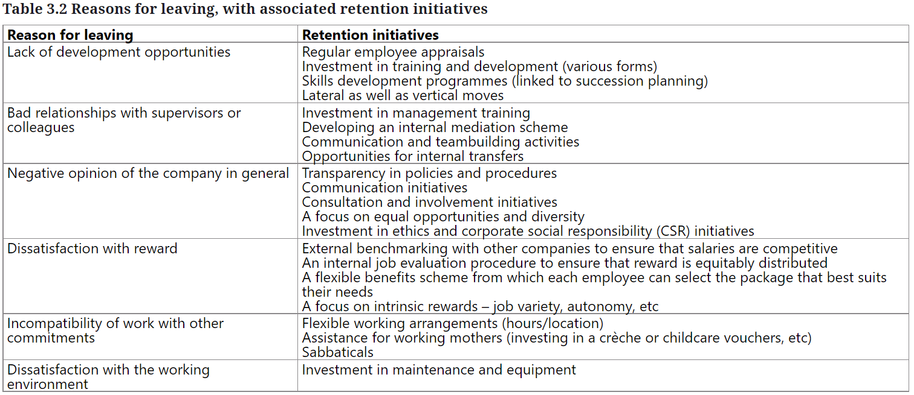

Wilkinson and Taylor, 2016

Thomas (2019) conducted research on the Neath Port Talbot Council social care team, as they were experiencing some turnover issues. Through focus groups and interviews with current employees, it was found that they needed a multi-dimensional support, based on the Four-S Model below.

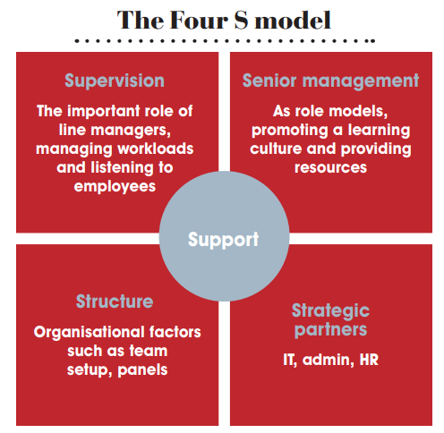Thomas (2019)

Recommendations were made for the implementation of a retention strategy, where the main points were:

- Recruit the right people assigning them to a job where they want to be.
- Formulate a strategy with feedback from both current employees and leavers.
- Provide multi-dimensional support through the Four S model.
- Offer different methods of training and development for all the employees.
- Present career programmes to ensure employees feel they belong in the organisation now and in the future.
- Build strength through training in handling change and in particular for those with emotionally demanding jobs.
- Provide adequate infrastructure and resources, such as technology to adopt working from home practices.

Over a year after these strategies were implemented, the turnover decreased, other departments started adopting some practices in this strategy and they were recruiting several management jobs in which some employees were interested (Thomas and Hatcher, 2019).

  - EXPLAIN KEY ASPECTS OF GOOD PRACTICE IN RELATION TO THE DEVELOPMENT OF JOB DESCRIPTIONS, PERSON SPECIFICATIONS AND COMPETENCY FRAMEWORKS

In the recruitment process, the skills and experiences needed for a role must be determined through a job analysis process, collecting information such as job duties and responsibilities, equipment and materials used, performance expectations, or education/experience requirements (Wilkinson and Taylor, 2016). This information will be derived from the current role-holders, the line manager or other organisation’s stakeholders.

Job analysis is also considered as good practice in recruitment as it ensures that unlawful discrimination does not occur, and the best candidate is selected for the job (Taylor, 2019). Below we can see the Good Practice and Selection Model.

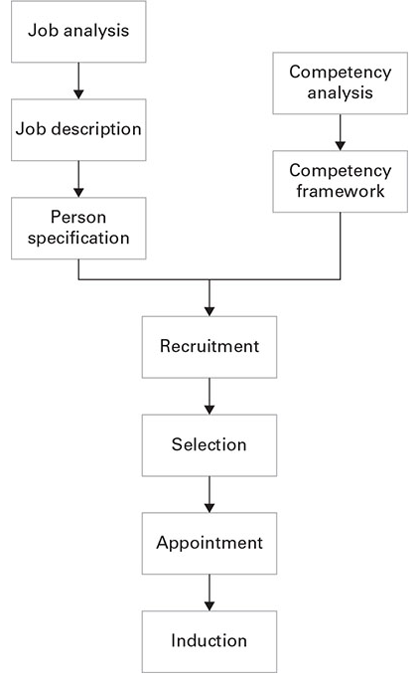Taylor (2019)

After the job analysis is done, the development of a job description and person specification is followed. The job description sums up the tasks that comprise a job, in conjunction with the reporting lines, responsibilities and performance standards. It is used in five particular ways (Taylor, 2019):

- Tool in recruitment
- Tool in selection
- Foundation of employment contract
- Part of the employer’s defence in an unfair discrimination case
- Communication method of expectations, priorities and values to new members of staff

Job descriptions should be updated regularly, usually asking a manager to review them once a year and should concentrate on a general degree of work and skills.

On the other hand, the person specification is based on the qualities required of the candidates in order to fill the role. They can be divided into essential and desirable. When developing person specifications, we must ensure that the aspects included do not discriminate indirectly on any of the protected grounds to avoid legal actions against the organisation (Taylor, 2019).

There is an alternative approach to the job analysis, according to Taylor (2019) which is based on an analysis of the people and their attributes to achieve a superior and effective performance, and it is known as competency frameworks. The CIPD (2021a) defines it as the structure that distinguishes each individual competency needed by people working in an organisation. Research has suggested that frameworks are frequently designed internally and many of the features included are generic headings.

Below we can see the main aspects of job descriptions, person specifications and competency frameworks:

MAIN ASPECTS
JOB DESCRIPTIONS  (Taylor, 2019)  - Job title  - Pay rate/grade  - Location  - Supervisor’s name/position  - Brief description of the purpose of the job  - List of main job responsibilities along with their description  - Reference to other documents that may clarify other on other details  - Date when document was last updated  - Statement specifying that other duties will be carried out by the job holder occasionally  - If included in the employment contract, it is advisable to declare that the content may be reviewed, and it may not be expected to stay the same indefinitely. | PERSON SPECIFICATIONS (Taylor 2019)  - Skills  - Knowledge  - Personality elements  - Education  - Qualifications  - Experience  - Capability and disposition to meet specific working requirements | COMPETENCY FRAMEWORKS  (CIPD, 2021a)  - Core competencies: values and mission  - Common competencies: related to certain jobs (management: leading a team, manage performance)  - Job specific: job function, technical expertise required.  - Leadership competencies  - Meta competencies: related to high-potential individuals recruited to promote and develop.

  - EVALUATE DIFFERENT METHODS OF RECRUITMENT AND SELECTION

Recruitment and selection are different human resources activities which are often contemplated together. Recruitment consists of actively seeking for applicants, selection procedures are applied to choose the best suited candidate to fill the vacancy (Taylor, 2019).

The importance of each stage depends on the labour market. If it is tight, recruitment is more significant, as it is harder to find employees with the right skills. On the contrary, with loose labour markets, there is excess of qualified applicants, making the selection process a priority (Taylor, 2019).

There are different systems of recruitment, such as:

- Internal: Promotion, job rotation, transfers, previous staff.
- External: Job centres, employment agencies, headhunters, professional contacts.
- Media: Job boards, social media, newspapers, professional journals, TV.
- Educational Liaison: Job fairs, careers advisors, college tutors.

Their advantages and disadvantages are shown on the table below:

METHOD OF RECRUITMENT | ADVANTAGES | DISADVANTAGES
INTERNAL  (Taylor, 2019) | - Cost-effective  - Internal labour market  - Maximise return on investment  - Enhance motivation and commitment amid current employees  - Better understanding of the role from employees  - Shorter learning time  - Better knowledge of candidates’ achievements | - Lack of new ways of thinking and working  - Lack of originality  - Usually, the best fit for the job does not work in the organisation  - Inequality  - Turning down internal candidates may be difficult and cause a decrease in trust
EXTERNAL  (Taylor, 2019) | - New ideas and skills  - Larger pool of candidates | - Some methods might generate expenses  - Adverts to be posted through the right method (cannot advertise an engineer job in a medical journal)  - Candidates not known to the organisation  - Longer process than internal
MEDIA (online)  (Taylor, 2019) | - Advertisement cost is low  - Can include much more information | - Does not produce a high number of strong applications as only those seeking for a job will come across the advertisement
MEDIA (printed)  (Taylor, 2019) | - More people can see the adverts | - More expensive
EDUCATIONAL LIAISON (job fairs)  (Creighton, 2018) | - Greater opportunities to acquire more quality candidates  - Networking with other organisations  - Brand awareness increase | - Costs on stand fees (sometimes)  - Costs on equipment to promote the organisation  - Costs on staff wages and travel time  - Time to prepare and attend

Once the recruitment method has been determined, the next step is to decide the process for selecting the candidate. Wilkinson and Taylor (2016) establish five types:

- Application processes: Application form, CV.
- Interviews: Telephone, group, one-to-one.
- Ability and personality tests: IQ, numeracy, literacy, personality.
- Assessment centres: Presentations, samples, role-playing.
- References: Usually from previous employers.

The strengths and weaknesses of each one of them are detailed in the following table:

METHOD OF SELECTION | STRENGTHS | WEAKNESSES
APPLICATION FORM  (Taylor, 2019) | - Best practice to design specific application forms tailored to the job | - Restrictively designed applications may produce applicants being unnoticed
CV (Taylor, 2019) | - Applicants may sell themselves | - Might include irrelevant information to the position advertised  - 'Attractive’ CVs might be chosen from average candidates
INTERVIEW (CIPD, 2021c;  Taylor, 2019) | - Most straightforward  - Least expensive  - Predict future job performance  - Provides information to the candidate about the job  - Encourages suitable applicants to join the organisation | - Predisposed to bias  - Questions intended to confirm initial thoughts regarding candidates  - Assumption that certain attributes represent a specific group  - Interviewers might prefer a candidate who is similar to them, or only because they like them
ABILITY AND PERSONALITY TEST (CIPD, 2021c) | - Benefit the selection process  - Predictor of job performance  - Assess abilities, aptitudes and personality | - Candidates might not have access to what is required to take the test (laptop)  - Potential cost to provide training to those conducting them
ASSESSMENT CENTRES  (Wilkinson and Taylor, 2016) | - Useful to employers to detect the candidate’s competence  - Measures if the candidate is suitable for the role by cross-referencing information from different sources | - Costly for small organisations or for low-skilled employees  - Only sustainable if a large number of candidates needs to be assessed
REFERENCES  (Taylor, 2019) | - Useful in case of internal selection processes in large organisations  - More reliable if writer and recipient are anonymous | - Low validity as predictor of job performance  - Highly subjective  - Tendency to give good ratings, and similar, if asked about different aspects

Recruiters ought to inform the candidates of the expectations of the selection process, including length, technology used and types of assessments. They should also check if the applicant needs any adjustments due to disability (CIPD, 2021c). Nowadays, technology plays a very important role in the processes of recruitment and selection, as it is used to conduct interviews and run online assessments. Any technology method used must be fair and inclusive, strongly tested, and which provides a good applicant experience.

Below we can see the content of a standard application form:

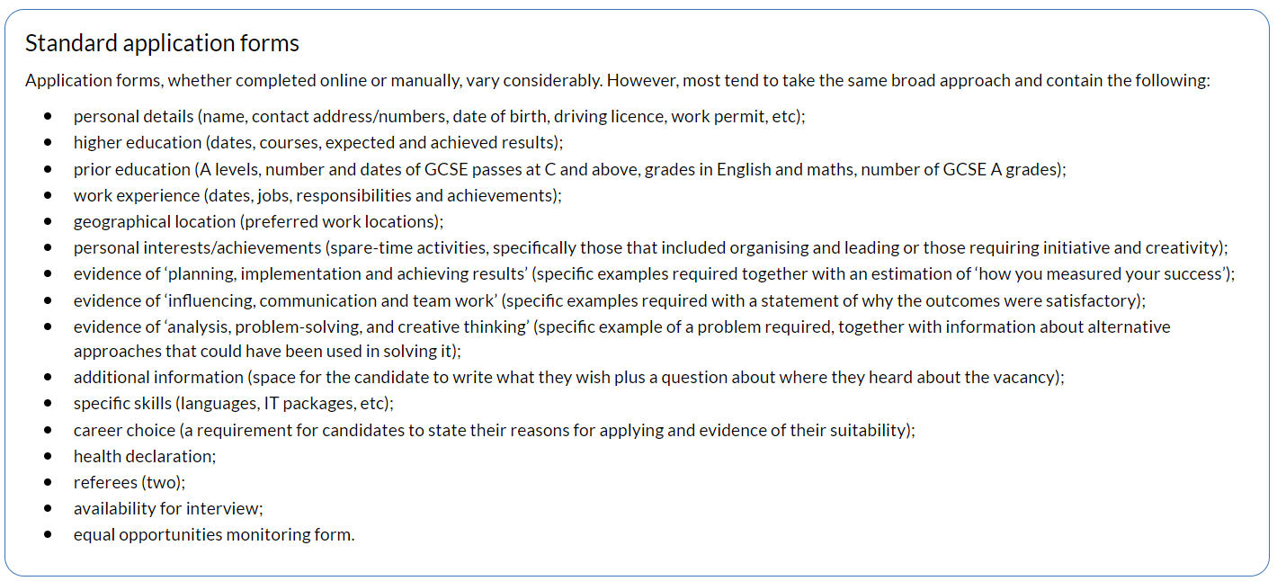
Taylor, 2019

All employers are required to ensure that no unlawful discrimination takes place in the recruitment and selection process on the grounds of ‘protected characteristics’, detailed in the Equality Act 2010 (Wilkinson and Taylor, 2016), whether it is direct, indirect or positive. Other legal requirements for the employers are to check the candidate’s eligibility to work in the United Kingdom and to provide the employee with a contract of employment (Wilkinson and Taylor, 2016).

Employers must ensure that personal factors do not guide the selection decision and that all the individuals have equal opportunities to apply, by advertising jobs through different methods to pursue a diversity, and by analysing how diverse the workforce is, leading a positive action campaign if there is an under-represented group, among other strategies (Wilkinson and Taylor, 2016).

  - EXPLAIN KEY ASPECTS OF GOOD PRACTICE IN RELATION TO DISMISSAL, REDUNDANCY AND RETIREMENT

Retirement is traditionally defined as the employee’s planned departure of a company because the conventional age for exit has been reached. However, it is unlawful for organisations to retire an individual at a certain age, unless there is a genuine reason, such as being unable to perform well due to age. In this case, a performance and capability procedure should be followed (Wilkinson and Taylor, 2016). Retirement is considered as voluntary employee turnover.

To ensure good practice, managers must have ongoing conversations with the employees about their future plans, and a choice of options must be offered when retirement is considered, for instance, reducing working hours, adding extra annual leave, or stepping down to a role with less responsibility.

Taylor (2019) establishes the importance of preparing the employees for retirement, to avoid the shock of not having a job, sense of loss, and lack of purpose. Some of the issues covered are understanding the pension, social security entitlement, leisure activities, re-employment or home safety.

On the other hand, we find two ways of involuntary employee turnover: dismissal and redundancy. Dismissal occurs when the employer terminates the contract of employment, because the employee has not met the requirements of the job (Wilkinson and Taylor, 2016). There must be a valid reason for dismissal, either capability or conduct.

According to Taylor (2019) the following are considered as unfair reasons:

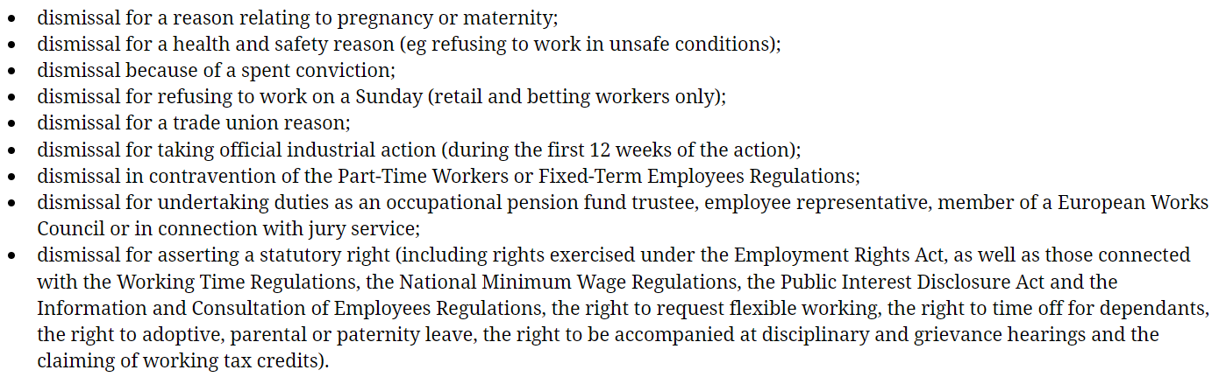
Taylor, 2019

To ensure that the process is fair, the standards expected have been detailed in the ACAS Code of Practice (ACAS, 2022) and are as follows:

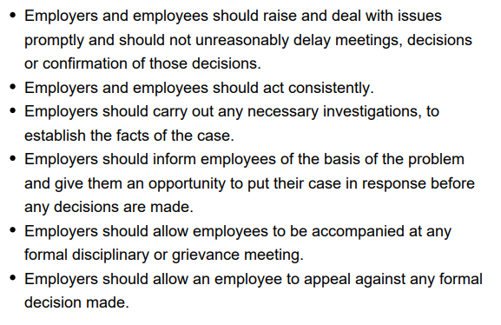ACAS, 2022

Regarding redundancy, Taylor (2019) defines it as the situation in which a job is not needed in the workplace for economic reasons. Selecting employees for redundancy must be a fair and objective process, and some of the reasons classed as unfair are: being, or not, a member of a trade union; pregnancy; as a method of victimising an employee who has claimed genuine statutory rights; or protected characteristics.

A process of consultation and notification must be followed by employers. The law also requires that the employees chosen for redundancy are given reasonable time off work to look for a new post, without determining the exact meaning of reasonable. However, large employers usually offer assistance to these employees and might even provide counselling, or redeployment to a different location (Taylor, 2019).

