Community Engagement Assignment 2 – Reflective Report

Student: Radu-Daniel Catrina 2123271
Lecturer: Zahra Mohammadnazari

Contents
1.INTRODUCTION 1
2.NATURE AND PURPOSE OF REFLECTIVE PRACTICE IN THE CONTEXT OF COMMUNITY ENGAGEMENT USING KOLB’S EXPERIENTIAL LEARNING THEORY. 2
3.PERSONAL REFLECTION ON KNOWLEDGE AND SKILLS GAINED WHILE LEARNING ON THIS MODULE 5
4.REFLECTION ON THE RELATIONSHIP BETWEEN ACADEMIC THEORIES AND MY PERSONAL EXPERIENCE IN MY WORKPLACE USING MASLOW HIERARCHY OF NEEDS THEORY 6
5.CONCLUSION 8
6.REFERENCES 9

1.INTRODUCTION

As a simple yet concise definition, we can regard reflective practice as a process of self-assessment and self-improvement. It derives from observing and analyzing past actions within a certain timeframe with the purpose of understanding or improving ourselves as individuals. It is important to emphasize the fact that reflective practice as a concept is an ongoing and repeating cycle, one of perpetual learning, that can provide us with insight regarding our past activities or endeavors.
According to (Hargraves and Page, 2013), reflection is process used by all professional groups with the purpose of developing and critiquing their own practices. They state that reflection is relative to the profession and as such teachers for example adopt a more cerebral approach of learning to teach others, whilst in social work there is an emphasis on individual reflection on a socio-political level.
In conjunction, (Stedmon and Dallos, 2009) state that reflection is intentionally defined in a broad sense in order to incorporate different aspects involved in the process as emotions experiences and memories. In such, they relate personal reflection to a potential creative activity that transcends knowledge and academic theories.
In order to further understand and elaborate on this concept, I will be discussing and analyzing the nature and purpose of reflective practice in community engagement using Kolb’s experiential learning theory, reflect on my skills and knowledge gained on this module and use Maslow’s hierarchy of needs to reflect on the relationship between academic theories and the personal experience in my workplace.

2.NATURE AND PURPOSE OF REFLECTIVE PRACTICE IN THE CONTEXT OF COMMUNITY ENGAGEMENT USING KOLB’S EXPERIENTIAL LEARNING THEORY.
Before commencing, we must define and understand Kolb’s experiential learning theory in order to facilitate our implementation. This theory refers to a four-step cycle designed to acquire and implement new knowledge (Concrete Experience-Reflective Observation-Abstract Conceptualization-Active Experimentation). It involves transforming experiences in order to create knowledge. As stated by (Kolb, 2015), these four steps are dependent on each other since effective learning involves not only the reflective aspect but others such as experiencing, thinking and acting.
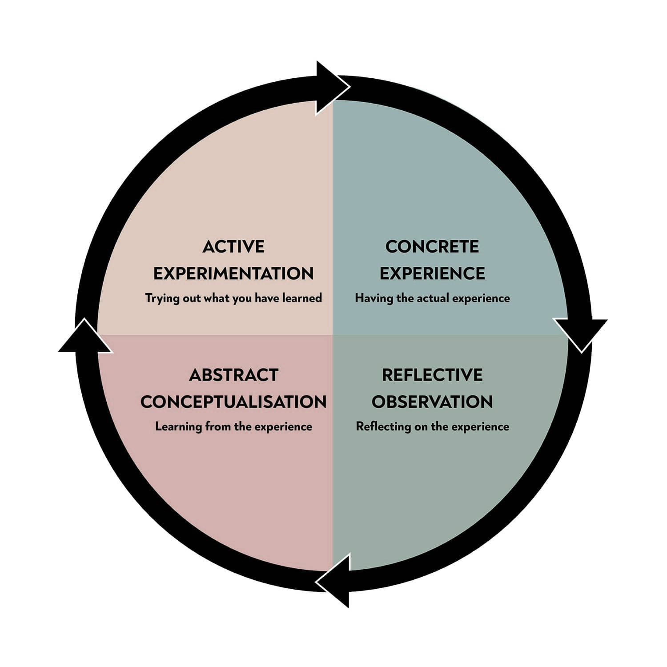

Figure 1. Kolb-learning styles (McLeod, 2017)

According to (Turesky and Gallagher, 2011), this theory is structured in two levels each with two modes correspondingly. The first level is that of learning (concrete experience and abstract conceptualization) and the second is that of transforming (reflective observation and active experimentation).
This cycle process of learning is used in various fields and industries to recognize strengths and weaknesses accordingly.

In order to introduce this process in the context of community engagement, I would like to propose we observe and analyze my own past experience, a community endeavor I took part in with the aim of promoting green spaces within my neighborhood. I will enlist the steps and challenges I’ve faced and relate them using Kolb’s experiential theory in the hopes of underlining the importance of reflective practice.
- Concrete Experience (first stage where learners encounter an experience)
In recent years I’ve observed a continued decrease in green spaces (trees and parks) in my own community. I’ve considered this aspect as a problematic one, and decided a change is necessary.
- Reflective Observation (stepping back and reflecting on the task at hand)
The first step was to determine the reasons behind this decrease in green spaces in order to better understand the phenomenon and shape future behavior. I’ve reached the conclusion that a prime culprit was the rising demand in parking spaces by local communities, especially around residential buildings like a high-rise apartment complex. Due to the large number of occupants and number of cars, former green spaces were sacrificed in order to create parking spaces deemed necessary by the city hall.
In my own experience, I’ve found this to be a flawed and unsustainable practice for the future, a short-sighted solution that will negatively impact myself and the community. In order to get a different perspective than my own, I’ve engaged the local community and received feedback through the form of a meeting with key residents that represent said community.
- Abstract Conceptualization (based on our reflection, we form new ideas and form conclusions)
In order to develop a deep understanding on the issue at hand, I’ve proposed we have a look on the impact this has on our community from a social and ecological perspective. I’ve enlisted a few key aspects to be considered and taken into account:
- The lack of green spaces is visually unappealing and lowers the value of our community.
- The lack of trees and plants will result in significant higher amounts of carbon dioxide in the air and lower amounts of oxygen.
- The lack of parks and green recreational areas lowers community engagement and interaction between its members since there is no adequate spaces to congregate.
- Our children have no means to play in a safe and friendly environment which in turn can have an impact on their psychological growth and happiness.

The local community was responsive and in the light of these new understandings, we have shared potential solutions and paths in order to create a change that will alleviate these concerns.

- Active Experimentation (last stage where we apply our new founded ideas and concepts)
As such, we have implemented a program with key steps and actions we will take, involving not only residents but looking for financial and volunteering support from outside.
- We have petitioned and conferred with the city hall representatives to possibly looking into creating underground parking lots.
- Each member of the community has agreed to actively participate in planting trees or various plants based on an organized plan of action that will be supervised by local leaders.
- We have raised financial support in this endeavor by donations, yard sales and sponsorships from various small companies in our community.
- We have used social media in order to promote these activities and furthermore, through the use of 3D software, constructed a model of how the area could look like in the future and presented this to our city hall representatives.
- Some members took it upon themselves to create flyers promoting green spaces benefits and healthy environments in the hopes of gaining the support of other communities.
We can observe how reflective practice encourages engagement within a community and helps to understand and share different viewpoints and ideas. As stated by Timmins (2015, cited in Moreno et.al, 2019), it is through this sharing of concepts, ideas and viewpoints that members gain awareness and make sense of a situation. This practice enables us to gain self-awareness firstly, then the knowledge necessary to shape better future behavior and decision making.
According to (Kolb, 1984), the aspect of learning is viewed as a process rather than one defined by outcomes, with one cycle closing and another starting. This learning, as the name states, is experimental in nature and a continuous one in which optimal results will be gain by going through all four stages. In this regard, ideas are not fixed but formed and re-formed through experiences. ’Knowledge is continuously derived from and tested out in the experiences of the learner ‘(Kolb, 1984, p.27).

3.Personal reflection on knowledge and skills gained while learning on this module
In attending this module, I’ve managed to change my perception regarding a few key aspects related to myself and furthermore developed a broader understanding of new principles and theories. The first I would like to mention, is community engagement in itself, a process which until recently eluded me and I’ve failed to observe its importance. Starting from the presumption that such a concept has little impact and it’s just another box to tick, I’ve initially failed to understand that community engagement is actually a pivotal step in the process. In the light of new knowledge gained in this module and upon reflection of my former perspective, I’ve managed to grasp a better understanding of abstract concepts and implement them more effectively.
In such, I’ve learned how within every project, a close collaboration between organizations and communities is very important in order to create bonds, generate trust between participants and solidify relationships for a common purpose. One vital aspect is communication and exchanging of ideas which in turn makes member better informed and helps the decision-making process. Furthermore, by collaborating and drawing knowledge from diverse groups of individuals, solutions become more effective and sustainable. Another aspect worth mentioning is the self-empowering of individuals that community engagement can bring by giving various groups the tools they need in order to gain control over their lives and communities.
In terms of interpersonal skills gained, I would like to mention teamwork as one if not the most important aspect that I’ve been disregarding. Having a more individual approach to issues and problems alike, I’ve failed to understand the benefits of such a concept. By learning to work with others you’re not only gaining new insight and perspectives but at the same time you’re developing other skills like communication, listening ablity, empathy towards others and conflict management. We can observe then the various implications of teamwork and the branching elements that we can gain. Teamwork is a core aspect of community engagement as stated in our previous section.
Lastly, understanding self-management has helped me at my workplace and in my personal life. But what exactly is self-management and how do we define it?
As a general definition, self-management could be regarded as our ability to manage behavior, emotions and concepts in a coherent and constructive way.

According to (Bergen, Soper and Gaster, 2002), self-management is the process of enacting control over decision-making aspects and regulating own’s performance by setting specific goals, observing behavior related to those goals and taking proper action. Furthermore, it requires that individuals make a self-assessment of what they perceive to be strengths, weaknesses, skills and values in order to understand what needs are realistic.
In my personal experience, through gaining deeper understanding of such concepts, I’ve managed to implement structure in my thought process, achieve self-awareness by recognizing my abilities accordingly and self-regulating my emotions like anxiety or frustration. These concepts I was able to relate to my workplace, particularly in a teamwork environment where understanding others is impossible unless you first understand yourself.

4.Reflection on the relationship between academic theories and my personal experience in my workplace using Maslow hierarchy of needs theory
Before discussing further, we must initially define and understand Maslow’s hierarchy of needs theory, in order to lay a foundation and grasp the concept. This theory refers to five stages of concrete and abstract needs an individual requires to fulfill and is motivated by. As such, the needs are as follows: physiological, safety, love and belonging, esteem and self-actualization. It is imperative to mention that according to this theory, higher needs can emerge only by fulfilling the previous ones.
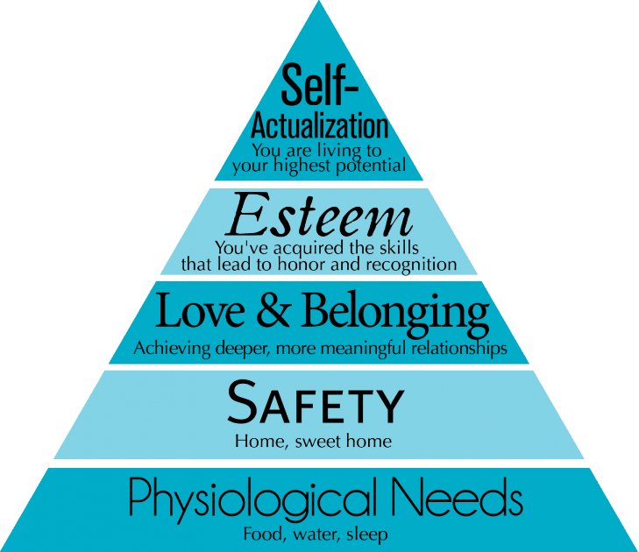

Figure 2. Maslow’s hierarchy of needs (Kurt, 2020)
According to (Jabulani, 2020), in Maslow’s hierarchy of needs, behavior is dictated by needs, hence the importance of some needs varies in accordance with their respective contribution towards the goal or objective. As such, he states the idea that there is often a governing need that takes precedent over others.
In my workplace, the implementation of this theory plays a vital role in individual motivation and understanding different needs employees have. In order for them to perform at their job, firstly, they need to be provided with necessary amenities like canteens, lounge areas, proper shift patterns and breaks or access to toilets and washrooms. Secondly, safety is represented in our case by job security and safe working environment. This is achieved by adhering to strict health and safety regulation and the use of protective equipment. Moving on, belongingness is important in maintaining emotional equilibrium in individuals, implementing a sense of acceptance and creating purpose or meaning. In such, role clarity, emphasis on teamwork, freedom of expressing yourself and trust are vital concepts that my company promotes. Esteem in our case is driven by self-confidence and the need of being valued by others. In this regard, the company financially rewards performance through bonuses and encourage self-empowering by recognizing abilities and traits employees possess. Lastly, after all these needs are meet, self-actualization is represented through achieving one’s purpose. Different for everyone, this stage is the most ambiguous one, since it’s relative to the individual and is not always achieved. It is here where individuals can express creativity in solving problems since all the stages have been met and concepts like emotional stability, self-confidence and self-empowering are attained.
A practical example of creative solutions I use at my workplace, is the utilization of visual aids in order to train new personnel. As opposed to hands-on practice, visual aids like pictures or videos implement a new layer of information easier to assimilate by individuals. This implementation was a personal project of mine which was later adopted as standard by the company. Circling back to our fourth stage (Esteem), we could regard this as a personal recognition of ability which helped me to fulfill this particular need, one that was more important for myself than others.

5.Conclusion
In my work, I’ve defined reflective practice as a concept, explained it’s nature and purpose in community engagement with the aid of Kolb’s experiential learning theory and enlisted the knowledge and skills I’ve gained whilst learning on this module. In addition, I’ve used Maslow’s hierarchy of needs in relation to my workplace activity and presented how the stages of this theory are implemented in a working environment.
Reflective practice is extremely helpful in expanding one's knowledge of others as well as one's own self-awareness, which is an essential element of emotional intelligence. Reflective practice promotes active engagement in working practices and can help to develop creative thinking skills. In such, we can enlist the 5R framework that will guide us through the learning process: Reporting, Responding, Relating, Reasoning, and Reconstructing.
The way communities develop relationships with their partners and members has the potential to change as a result of meaningful community engagement. As such, reflection encourages personal development by increasing individuals' self-awareness, sense of community, value of civic participation, and perception of their own abilities. In the process of learning, reflective activities play an important part in enabling knowledge transformation.

6.References

- Bergen, C.W.V., Soper, B. and Gaster, B., (2002). EFFECTIVE SELF-MANAGEMENT TECHNIQUES. Journal of Business and Entrepreneurship, 14(2), pp. 1-0_11.
- Hargreaves, J. and Page, L. (2013) Reflective practice. 1st ed. Cambridge; Polity Press.
- Jabulani, J. (2016) ‘Making practical use of Maslow’s Hierarchy of Needs theory to motivate employees: a case of Masvingo Polytechnic’, Journal of Management & Administration, 2016(2), pp. 105–117.
- Kolb, D. A. (2015) Experiential Learning: Experience as the Source of Learning and Development. Second edition. Upper Saddle River, New Jersey: Pearson Education.
- Kolb, D.A. (1984). Experimental Learning: Experience as the Source of Learning and Development. London: Prentice-Hall.
- Kurt, S. (2020). Maslow’s hierarchy of needs in education. [online] Education Library. Available at: https://educationlibrary.org/maslows-hierarchy-of-needs-in-education/.
- McLeod, S. A. (2017). Kolb - learning styles. Simply Psychology. www.simplypsychology.org/learning-kolb.html
- Moreno, J.M., Sanyal, K.A., Firoozmand, F., Rutter, P. and Harder, M.K. (2019). Reflective Practices in Community Development: a Grounded Analysis. Systemic Practice and Action Research.
- Stedmon, J. and Dallos, R. (2009) Reflective practice in psychotherapy and counselling. Edited by J. Stedmon and R. Dallos. Maidenhead: Open University Press/McGraw Hill Education.
- Turesky, E. F. and Gallagher, D. (2011) ‘Know thyself: Coaching for leadership using Kolb’s Experiential Learning Theory’, Coaching psychologist, 7(1), pp. 5–14.

