DISSERTATION PROPOSAL

An investigation into the long term sustainability of further intensification of
New Zealand’s dairy industry

Introduction - Research Background
Over recent years, New Zealand’s dairy industry has witnessed a phenomenal increase in global demand for its products. High returns in the sector have become a major incentive for farmers to convert from sheep and beef farming to dairy in an attempt to take advantage of profitable returns from growing demand.
New Zealand’s economy is heavily dependent on international trade and has remained relatively unscathed by the global financial crisis. New Zealand is currently one of the world’s leading dairy exporters, exporting over 95% of its dairy production. Research indicates that dairy commodities account for approximately 30% of the country’s exports and consequently plays a critical role for the success of the current economic climate (RBNZ, 2014).

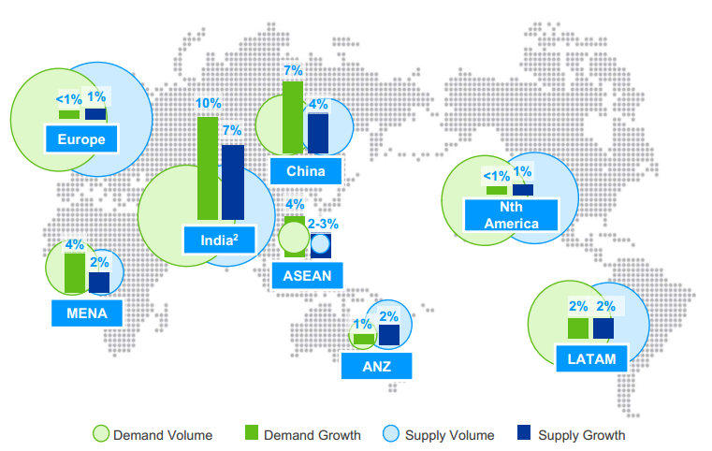
Figure 1- Dairy Demand and Supply Outlook to 2020
(Source: Fonterra 2013)
Fonterra (2013) predict that global demand for dairy products will continue to increase as a result of population growth, rising income, urbanisation and developing countries adopting more westernised diets. China is currently the largest dairy importer, but other countries such as India are also experiencing supply and demand difficulties. Further demand for dairy commodities is anticipated from emergent countries such as Africa, the Middle East and Latin America. (Figure 1).
In New Zealand, farming is classified as a ‘primary industry’ and the country prides itself on its intensive bio-security system which helps to conserve its environment and ensure high standards of agricultural production are maintained (New Zealand Government, 2012). The success of the dairy industry has received a considerable amount of attention which has raised public concern in relation to the intensification of this sector. Long-term consequences of unsustainable practices are under review, along with mounting pressure to impose limits on further farm conversion to dairy. These measures are being implemented to counteract the negative impact on the environment. As a result, the New Zealand Government is faced with the challenge of establishing an equilibrium that is beneficial to both its economy and environment.

Research Rationale
The New Zealand Government has set itself an ambitious goal of raising the current ratio of 30% for exports to gross domestic profit (GDP) to 40% by 2025 (MBIE, 2014). It is evident that the Government is relying on the dairy industry to build on its current position of being one of the world’s leading dairy exporters and therefore a key contributor towards its business growth agenda.
To realise this goal, further intensification of the dairy sector will be necessary. This will mean further investment and possibly extending borrowing facilities at farm level to accommodate herd expansion and land conversion costs entailed with land clearance and irrigation. Although the majority of New Zealand’s dairy farmers appear to be enjoying prosperity, there are mounting concerns as debt for this sector has trebled over the last decade. Further research has highlighted that 10% of dairy farms account for half of this debt and are therefore highly exposed should dairy prices decrease, interest rates rise and/or land prices reduce (Vaughan, 2014). In addition to this, consideration will need to be given to sustainable farming options, the cost of which could impact on profit margins.
The objective of this research is to investigate the sustainability of economic and environmental factors affected by further intensification of the dairy industry in New Zealand. The country’s dairy industry is unique in that its ‘value chain’ operates through a successful cooperative network, from farm level to its domestic and export market. The Ministry Of Primary Industry (2014) state that innovation is “essential to anchoring not only the position of New Zealand dairy, but the whole New Zealand economy.” Porter (1990) suggests that “nations succeed in particular industries because their environment is the most forward-looking, dynamic and challenging.” Therefore, to investigate sustained intensification of this industry, it is intended to establish how the industry ‘creates shared value’ throughout its value chain and enhances its global competitive advantage.
New Zealand’s dairy industry is already experiencing pressures of increased competition from other developed nations desiring to take advantage of this lucrative market. Therefore, this research will also consider if the implementation of sustainable practices will support intensification and strengthen the country’s perception of being ‘clean and green’ (MED, 2011). The purpose of this research is to attempt to answer the following question:
- Can long term sustainability be achieved through further intensification of the dairy industry in New Zealand?
The justification for this research is to investigate current and planned sustainable strategic measures which will support prolonged intensification of the dairy industry which is critical to realising Government targets for this sector. It is essential to understand how the cooperatives work to support the farmers and the role played by strategic partnerships to sustain and enhance the sectors’ performance. Research will entail analysing support networks and strategic management techniques throughout the industry to establish if sustaining intensification is a long or short term goal.
Sustainable agriculture is defined as “agricultural production that is economically viable and does not degrade the environment over the long run,” (OECD, 2013). Therefore, it is vital that the dairy industry in New Zealand maintains growth, profitability and international competitiveness to drive the economy in conjunction with enhancing environmentally friendly farming techniques. “National prosperity is created, not inherited” and is dependent “on the capacity of its industry to innovate and upgrade” (Porter, 1990). The strategic management techniques of the Dairy Industry have brought prosperity to rural areas and a nation which is dependent on the agricultural industry which needs to be safeguarded.

Research Methodology
Collis and Hussey (2009) define research as “a systematic and methodical process of enquiry and investigation with a view to increasing knowledge,” and suggest that effective methods for collecting, analysing and presenting data are essential in addition to applying academic rigour. Saunders et al (2012) recommend the use of their ‘research onion’ as a process for research and stress that every layer is equally important and should not be discarded (Figure 2).
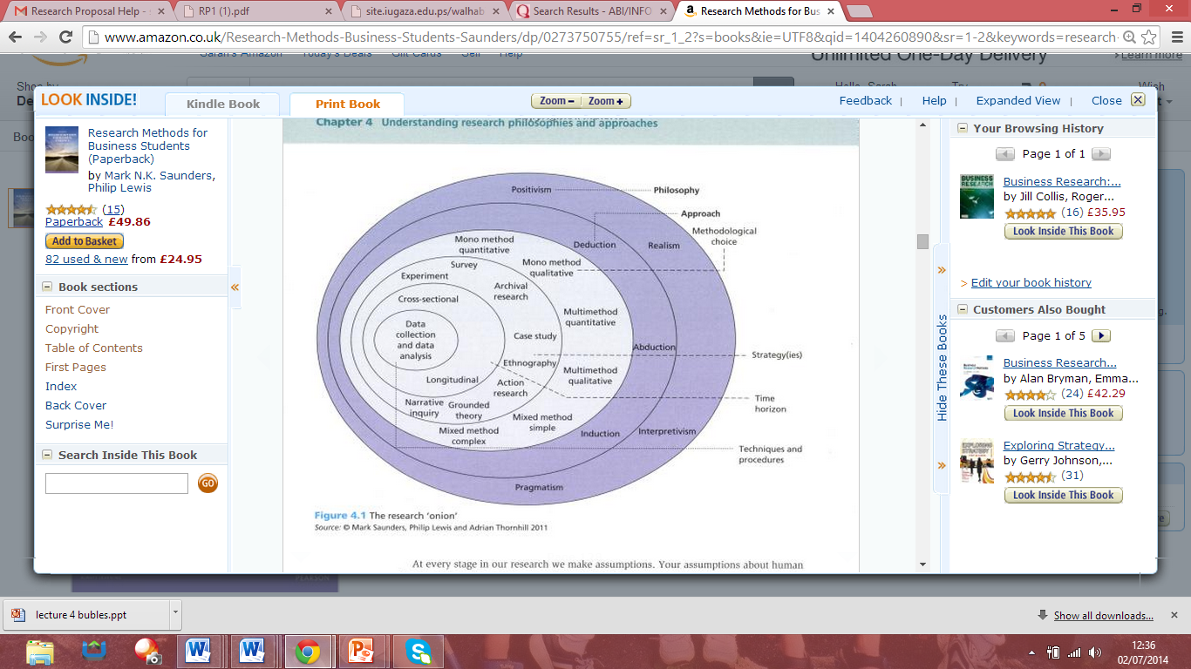
Source: Saunders et al, 2012 – ‘The Research Onion’
For the purpose of this research, it is envisaged that a pragmatism philosophy would be appropriate as it acknowledges various ways of interpreting and undertaking research to obtain a much broader view (Johnson and Onwuegbuzie, 2004). Keleman and Rumens (2008), as cited by Saunders et al (2012), suggest that through mixed method research more reliable, relevant and credible data can be collected to advance the research.
Johnson and Onwuegbuzie (2004) suggested “by utisiling quantitative and qualitative techniques within the same framework, mixed methods research can incorporate the strengths of both methodologies.” However, Yanchar and Phillips (2006), as cited by Onwuegbuzie et al (2011), contend that by using this methodology there is “little regard for challenging issues pertaining to the nature of reality, knowledge, the good, and so on.” Whilst this view has been acknowledged, it is still felt that a combination of qualitative and quantitative research using the triangulation methodology would be more appropriate for this area of research, as it will not rely totally on facts and figures but also consider motives leading to causal effects (Figure 3).
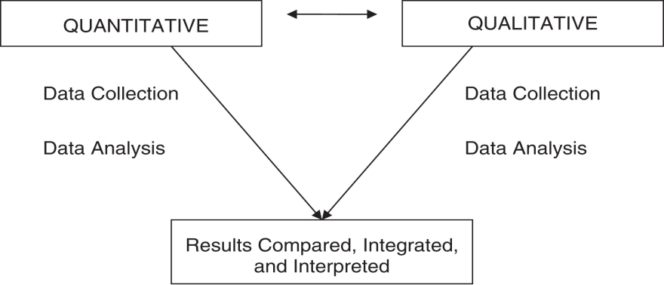
Figure 3 – Triangulation Method
(Source: Bramble et al, 2008)
It is intended to carry out mixed methods research, using both quantitative and qualitative approaches to avoid any bias. Quantitative research will consist of a survey which will be sent to cooperatives in the dairy industry with a view to ascertaining sustainable practices of their members of the value chain. Dairy cooperatives provide strong business support to farmers for ‘on-farm’ management techniques for monitoring purposes. It was decide that these entities would be more accessible for survey purposes rather than trying to contact farmers directly, who may not have the time to participate and would be too large a target market to survey taking into account the time and financial constraints. However, there may be a requirement to devise another surveyor tailored towards farmers if a gap is identified during the research period. It is anticipated that the results from the main survey will provide primary data comprising current and planned sustainable techniques which will support the intensification of the industry.
Although quantitative research will dominate this dissertation, it is felt it would be unwise to exclude qualitative research. Secondary data will be obtained from an extensive literature through accessing relevant academic research, analysing both historical and current statistical data from the New Zealand Government, dairy cooperatives, banks, universities, national and local government and any agencies a vested interest in the sector. This review will help to assess the factors pertinent to the aims and objectives of this research proposal and identify any gaps relating to ‘sustainable intensification’ which require further investigation and will form the basis for the survey questions. Also it is intended to follow up on the sharing of ‘good practice’ by interviewing leaders in the supply chain should this become evident during the research period. Bell (1999) states this will enable “an interviewer to follow up ideas, probe responses and investigate motives and feelings, which a questionnaire can never do.” It is understood that this method of qualitative research is open to interpretation and therefore, further research may be required to substantiate findings.
It is intended to give consideration to sustainability paradigm, however there are those who feel it fails to link farm-system sustainability to food-system sustainability. Welch and Graham (1998) suggested a new paradigm was needed to address the failure of global food systems and its inadequacy to deliver nutritionally healthy food to underprivileged people, especially those in third world countries. The concept of a ‘food systems’ paradigm incorporated a nutritional balance hence extending the ‘sustainability’ paradigm. It would appear, judging from rapid growth in demand for dairy products and the development of dairy farming in third world countries, the global dairy industry over the last few decades has attempted to address these concerns.
Although it could be argued that the sustainability paradigm relates to more agricultural research, there is a need to consider it in a business context for this research in relation to the impact it has in on business strategies within the dairy industry sector.

Reliability and Validity
A variety of research methods will be used to provide a balanced and unbiased view across the study. It is important to consider that qualitative research methods such as interviews are crucial in gaining an in-depth understanding into the subject matter, but can however, be biased due to personal opinion. Therefore, great care will be taken in ensuring that the questions asked will not be leading questions and that there will be a selection of interviewee’s selected.
Attending agricultural meetings would also provide useful research involving live dairy debate may prove beneficial and provide a cross sectional view. However, there could be dilution as people may go off on a tangent and fail to address pressing issues.
Questionnaires are useful in gathering quantitative data and general consensus. The questionnaires will be targeted towards cooperatives within the dairy industry supply chain. It is anticipated that this will enable a core understanding of the current and future sustainability measures needed to support intensification of the industry. However, care must be taken as questionnaires can often be a result of how someone is feeling at a particular point in time. However, one of the issues associated with questionnaires distributed by post is non-response bias (Collis and Hussey, 2009) and therefore, it is intended to primarily use email to contact the target participants.
The validity of the research will be assessed in combination with current academia to draw parallels and understand where the gaps are in this research area.

Resource and Time Management
As time is limited due to work and family commitments, it is essential to ascertain an approximate timeframe to carry out research and analysis. Therefore, an anticipated programme has been devised to monitor progress in relation to time management (Figure 5).

No | Project Name | 2014-2015
No | Project Name | Jun | Jul | Aug | Sep | Oct | Nov | Dec | Jan | Feb | Mar | Apr | May
 | Dissertation
1 | Proposal
 | Define research aims, objectives & methodology
2 | Literature Review
 | Carry out extensive research
 | Compile & send questionnaire
3 | Findings & Analysis
 | Analyse questionnaire results
 | Arrange interviews for gaps in research
 | Collate & analyse feedback
 | Conclusion
4 | Submission Preparation
 | Consultation with Supervisor
 | Proof-read and editing
 | Binding
 | Submission
Figure 5 – Time Management Programme
As a result of recently relocating to New Zealand, it has been recommended to form a link with a local University to gain access to its research facilities. This connection will be in addition to continued access of UWTSD online resources and the internet. An extensive literature review of academic and global research in relation to the dairy industry will be essential. Therefore, it will be necessary to allow for time and a cost element for securing certain documentation. The financial costs of this MBA course have been and will continue to be funded personally. It is intended to interview farmers and experts in the Canterbury area, consequently travel costs are anticipated and a mileage log will be maintained. It is planned to use Survey Monkey however, if email contacts cannot be obtained then surveys may have to be posted to intended participants which will require more time and incur additional costs.

References
Bell, J, (1999), “Doing Your Research Project.” Open University Press, 3rd Edition. Pp.26
Boyes, W and Melvin, M (2012) “Microeconomics” Cengage Publishing 9th Edition. pp.4
Bramble, J.D, Siracuse, M.V., Galt, K.A., Rule, A.M., Clark, B.E., and Paschal, K. A., (2008) "Examining barriers to health information technology adoption", Emerald Vol. Iss: 7, pp.191 - 209
Collis, J. and Hussey, R. (2009) Business Research: a Practical Guide for Undergraduate and Postgraduate Students, Palgrave Macmillan , 3nd Edition, Pp. 1
Dairy Companies Association of New Zealand (DCANZ) (2014), ‘Dairying Today.’ www.dcanz.com. Available at: http://www.dcanz.com/about-nz-dairy-industry/dairying-today - Accessed: 23.06.14
Dynes, R.A., Burggraaf, V.T., Goulter, C. G., & Dalley, D. E., (2010) “Canterbury Farming: Production, Processing and Farming Systems.” www.grassland.org.nz. Available at:
http://www.grassland.org.nz/publications/nzgrassland_publication_5.pdf - Accessed: 20.06.14
Elahi, E., (2013). “Risk Management: the next source of competitive advantage.” Foresight: the Journal of Future Studies, Strategic Thinking and Policy, 15(2), pp. 117-131
Fonterra (2013), “International Dairy Outlook: A Fonterra View.’ www.usda.gov Available at: http://www.usda.gov/oce/forum/past_speeches/2013_Speeches/Rao.pdf - Accessed: 14.06.14
Hussey & Hussey, (1999), “Business Research.” Macmillan Press
Johnson, R. B. and Onwuegbuzie, A J, 2004 Mixed Methods Research: A Research Paradigm Whose Time Has Come.” Educational Researcher, Vol. 33, No. 7, pp.14-26 Available at: http://knowledgeportal.pakteachers.org/sites/knowledgeportal.pakteachers.org/files/resources/American%20Educational%20Research%20Association_0.pdf – Accessed: 22.06.14
McCann, J., 2011. China's Textile and Apparel Industry and the Global Market: Five Competitive Forces. S.A.M.Advanced Management Journal, 76(1), pp. 33-42,54,2.

Ministry of Business , Innovation and Employment (MBIE), (2014), ‘The Business Growth Agenda: Future Direction 2014.’ www.mbie.govt.nz Available at:
www.http://www.mbie.govt.nz/pdf-library/what-we-do/business-growth-agenda/bga-reports/future-direction-2014.pdf - Accessed: 20.06.14
New Zealand Food Technology (2014) Available at: http://www.foodtechnology.co.nz/content/new-zealand-dairy-export-market-%E2%80%93-new-frontiers-new-opportunities – Accessed: 10.06.14
New Zealand Government, (2011,) ‘Ministry for Economic Development - Green Growth – Issues for New Zealand.’ www.med.govt.nz Available at:
http://www.med.govt.nz/sectors-industries/environment/pdf-docs-library/green-growth-disscussion-document-30june.pdf - Accessed: 24.06.14
New Zealand Government, (2012,) ‘Ministry for Primary Industries - Biosecurity in New Zealand.’ www.biosecurity.govt.nz Available at:
http://www.biosecurity.govt.nz/biosec - Accessed: 24.06.14
New Zealand Government, (2014,) ‘Ministry for Primary Industries – Transforming the Dairy Value Chain.’ www.mpi.govt.nz Available at:
http://www.mpi.govt.nz/agriculture/funding-programmes/primary-growth-partnership/transforming-the-dairy-value-chain - Accessed: 24.06.14

Onwuegbuzie, A. J., Johnson, R. B., & Collins, K. M. (2011). ‘Assessing legitimation in mixed research: a new framework.’ Qaulity and Quantity, 45(6), pp. 1253-1271
Porter, M. E., (1990), “The Competitive Advantage of Nations.” Harvard Business Review, Mar-Apr 1990, pp. 75
Reserve Bank of New Zealand (RBNZ,) (2014), ‘The Significance of Dairy to the New Zealand Economy.’ www.rbnz.govt.nz Available at: http://www.rbnz.govt.nz/research_and_publications/speeches/2014/5721595.html - Accessed 10.06.14
Saunders, M.N K, Lewis, P. and Thornhill, A. (2012) Research Methods for Business Students Financial Times/Prentice Hall 6th Edition.
Vaughan, G, (2014), ‘RBNZ sees potential financial stress for dairy farmers with 70% of their debt on floating mortgages in rising rate environment as payouts fall.’ www.interest.co.nz Available at: http://www.interest.co.nz/rural-news/69933/rbnz-sees-potential-financial-stress-dairy-farmers-70-their-debt-floating-mortgages - Accessed: 15.06.14
Woodford, K., Greer, J. & Phillips, A., (2003) “Searching for Productivity and Competitive Advantage on New Zealand Dairy Farms.” Lincoln University, New Zealand.

