1702688
William Rowlands
Analytical Methods and Study Skills

Introduction
In this report I shall be discussing the forces that a connecting rod experiences inside the engine of my choice. Then proceed to look at how forces are impacted by the size of the piston, engine speeds connecting rod length and the cranks radius. I will utilise the spreadsheet provided with the assignment and analyse the output data it provides. The data I shall be inputting to the spreadsheet are the following; Crank radius, Connecting rod length, RPM and the mass of the Piston.
I will be researching different websites in order to collect the right data, so that my results are accurate. From the data I input to the spreadsheet three graphs will be produced based on the RPM I decide to input. From that I shall discuss the changes in the graphs between two separate RPM’s including max RPM and discuss the compressive and tensile forces that the connecting rod will endure.

Research
From my research I have learnt about the critical design features of a connecting rod, the connecting rod joins a piston to a crankshaft and has three main regions; a small end bearing and housing, large end bearing and housing and also a shank.
The small end of the connecting rod reciprocates the large end of the connecting rod causing it to move simultaneously. The movement of the connecting rod going up and down fully makes one revolution of the crankshaft, the connecting rod needs clearance for it to be able to move fully. The high compression caused by the combustion gas causes a high force to the rod shank area and causes stress on this part of the connecting rod, thus in return there are also resisting forces which are away from the crankshaft that apply tension to the other side of the connecting rod. The material used for the large end bearings housing needs to be created from a suitable material that is strong enough to endure the stress it will undergo, and the bearings need to be able to receive lubrication to enable movement. Materials commonly used to create connecting rods are; cast iron, forged steel, forged titanium and aluminium, each material has benefits from cost, manufacturing, weight and durability. Cast iron can be used in light duty gasoline and diesel engines, the advantages of using cast iron are cost and there is less shape variation however, weight grading or adjustment may be needed. Aluminium can be used in light duty petrol engines and is a suitable material for bearing surfaces, this material is usually die cast. Forged titanium is very expensive and difficult to machine, this material needs treatment to prevent wear problems. Forged titanium is most commonly used in sports cars and motor cycles which have high performance and low volume engines. Forged steel is traditionally used in large heavy duty vehicles however, it is adapting and improving with better forging tolerances. Forged steel can be used in premium gasoline engines and also all duty diesel engines. (Manning, 2012)
There are many elements impact the conrod.
- Engine speed
Engine speeds dictate how much stress is on the engine components especially at high RPM. When an engine is at high RPM the Conrod bearings can slip out from their bearing casing due to a lack of lubrication which causes friction and thus can cause for a conrod to throw.

- Mass of a Piston
Depending on the Mass of the piston and design it may cause extra stress against the conrod and may be less efficient if designed poorly, if made too heavy for the conrod issues could arise.
- Length of the connecting rod
The forces can be affected by the length of the connecting rod, a short connecting rod will increase piston speed. High piston speeds not only increase friction and ringwear inside the engine it also increases the pressure on the connecting rods. By using longer rods, with shorter, lighter pistons it can help reduce the pressure on the connecting rods (Larry Carley, 2016). The relationship of the connecting rod length to the stroke of the crankshaft has an impact on its ability to move and can either increase or decrease friction through changes in angularity (Labore, 2016)
- Crank radius
The pistons motion which is connected to a crank via the conrod informs us that the crank radius covers the distance of a stroke.
Testing and Analysing data
For testing I have decided to research into the Honda Manufactured Engine the B18C which came in the 1995 Integra Type R. I have received data from various reliable sources that state max RPM and specification such as the stroke, Connecting rod length and Mass of the piston. After finding all the data required for the testing, I began to look at the various outputs on the graphs and have decided to access the data created at mid RPM and max RPM and comment on any changes.
Found all matching data across three sites being the UK’s Honda forum, wiki motors, and kteller.com. url for sites can be found in reference list.
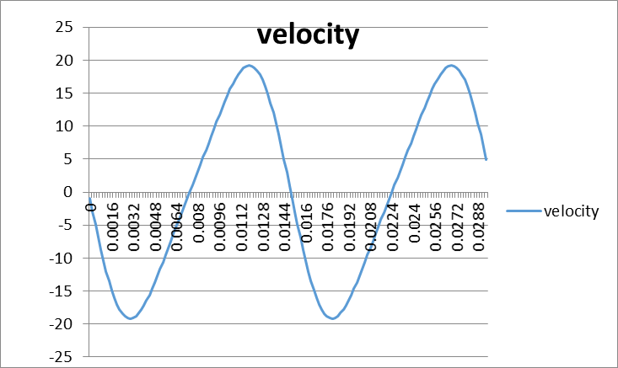
Data found was that the crank radius was 43.6mm conrod length 137.9mm and mass of piston being 0.305 Kg.
Here shows the first amount of data I input to the spreadsheet that was at 4k RPM.
The relationship between the height and velocity are in sync and coincide with each other.
The max tensile force at 4K RPM came out at 3068.01N

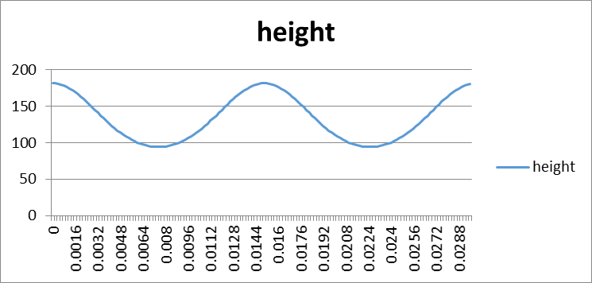
The Height graph seems to stay at a constant wave peaking at 180 and dipping just below 100 however the change in RPM impact the duration between each peak.

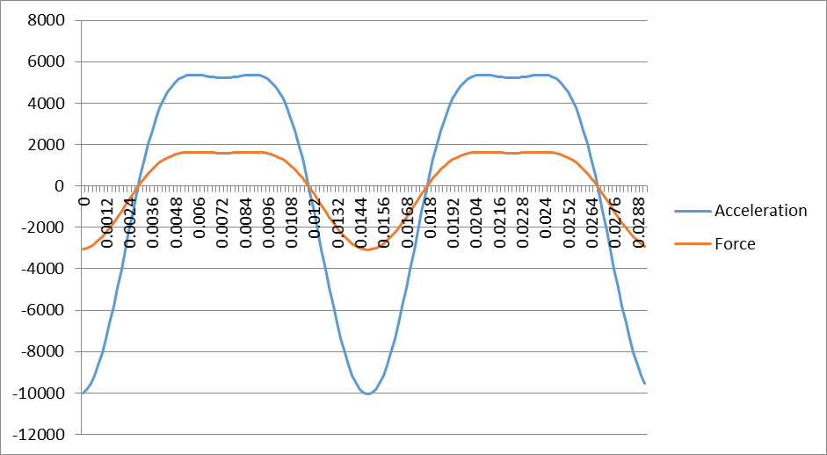

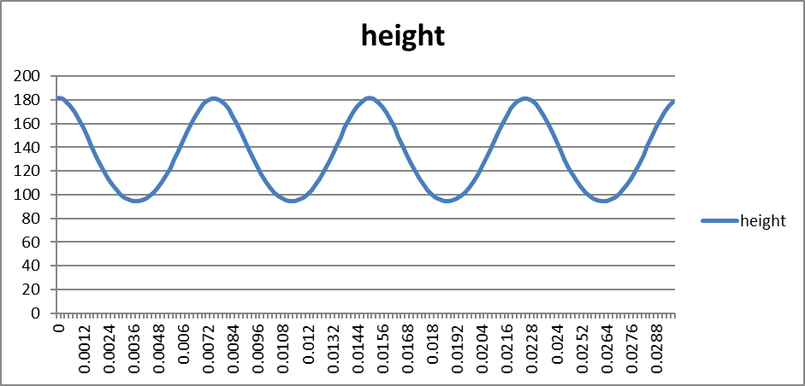
Velocity seems to double with there being double the RPM, as I would expect it to.

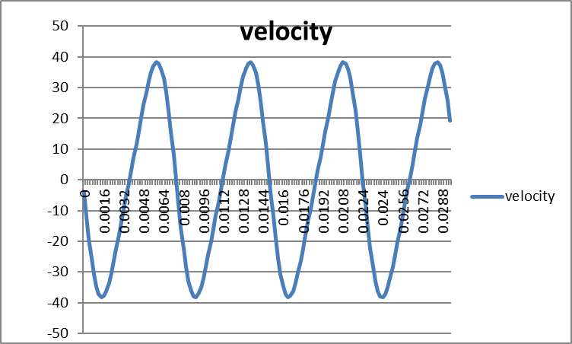

Acceleration also coincides with the force however they both increase drastically with the increase in RPM.

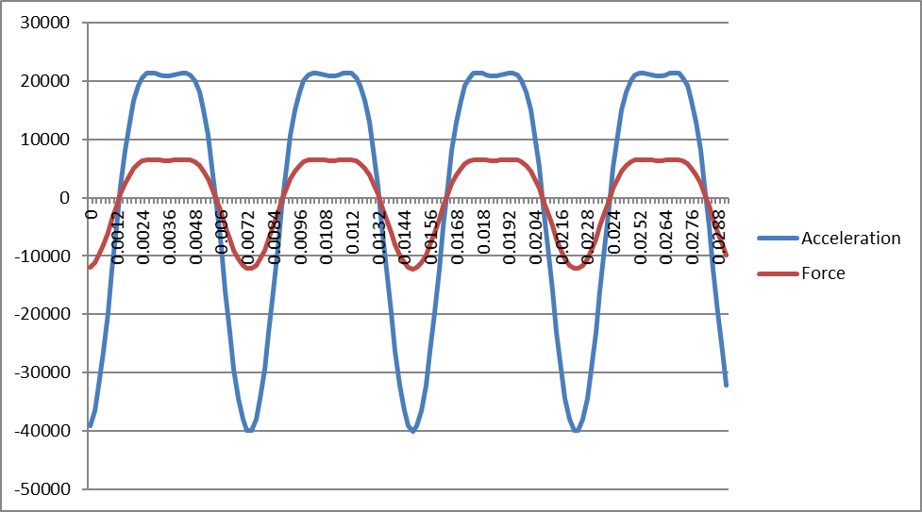

Conclusion
To conclude all the information, I have researched throughout this assignment I have discovered that there is a relation between stroke, piston size and connecting rods and engine life based on my findings. My data showed above expresses that the Max tensile force on the connecting rod at max RPM I chose was 12237N.

Reference List
https://honda-tech.com/forums/tech-misc-15/b16-b18-b20-bores-strokes-517926/
http://mywikimotors.com/honda-b18c-b18b/
https://kteller.com/honda-acura-b-series-piston-tech-guide/
Larry Carley. (2016). Understanding rod ratios. Available: https://www.enginebuildermag.com. Last accessed 05/12/18.
Eric Labore. (2016). Stroker Engines: The Long and Short of Connecting Rod Length. Available: https://www.turnology.com. Last accessed 07/12/18.
Ray T. Bohacz. (2009). How the length of the connecting rod affects horsepower. Available: https://www.hemmings.com. Last accessed 07/12/18.
John Manning. (2012). Chapter 13- Connecting Rod. In: Internal Combustion Engine Design. West Sussex: Ricardo UK Limited. p329-336.

