ESSAY
CHILDREN, YOUNG PEOPLE AND FAMILIES

Student Name: Selina Shafiq
Student Number: 2028762
Module: Children, Young People and Families
Module Code: BMHP5004_BIRM
Assignment: Essay
Lecturer: Dr Crisford Chogugudza

CONTENTS PAGE

- Introduction ………………………………………………………………… Pg 3
- Children Safeguarding ……………………………………………………. Pg 3-4
- The Case of Baby P ………………………………………………………. Pg 4-6
- The Case of Khyra Ishaq ………………………………………………… Pg 7-8
- The Importance of Safeguarding Policies and Procedures ……………Pg 8 -9
- Conclusion ………………………………………………………………… Pg 10
- Bibliography/References ………………………………………………….Pg 11-12

INTRODUCTION
This essay will discuss the importance of children safeguarding policies and procedures in the United Kingdom. There will also be discussions on two high profile safeguarding cases in the last 20 years. The cases that will be talked of are the cases of Baby P and Khyra Ishaq, how they were neglected resulting in their deaths. Both these cases brought a lot of media and public interest, these cases proved how common child abuse has become in society with severe outcomes and how easily these are not recognised. Concerns over families' and children's stress in regards to safeguarding have escalated in recent years. Significant disruptions to children's lives include social isolation, disconnection from social networks, and fewer opportunities for physical activity and outdoor activities.
Children Safeguarding
Safeguarding is the process of advancing children's welfare and defending them from danger. Safeguarding involves protection against child abuse and neglect, ensuring that children's health and development are not compromised, as well as ensuring that they receive care as they grow up in an efficient and safe manner (NSPCC Learning. 2022).
Abuse
Abuse is the term used when someone hurts or makes another person suffer. It could take place at home, in a hospital, at a nursing home, or a public space. A specific relationship is commonly abused by those who abuse others. They could be a member of family, a close friend, a neighbour, or a hired nanny in whose hands we have put our trust. Once someone lacks the knowledge or resources necessary to provide care for an individual, abuse can happen even when it is not deliberate. Although it doesn't change the reality that it had an impact, it does shed light on how it happened. There are four types of abuse: neglect, physical abuse, emotional abuse, and sexual abuse. In many countries, using physical punishment on children is seen as child abuse. Being withdrawn, quiet, and overly submissive may also be signs of abuse, even if it may be difficult to see abuse (Brazier, 2018).
Maltreatment
The National Society for the Prevention of Cruelty to Children defines child maltreatment as "all forms of physical and/or emotional ill-treatment, sexual abuse, neglect or negligent treatment, or commercial or other exploitation, resulting in actual or potential harm to the child's health, survival, or development." (NSPCC) (org.uk. 2019).

Health & Development
The Universal Declaration of Human Rights states that good health enables individuals to achieve their full potential, children to learn more successfully, workers to be more innovative, and parents to give their children the best care possible. An event, new knowledge, or growth are all instances of development. An example of development would be the transformation of a caterpillar into a butterfly (Pallipedia.org. 2022).

THE CASE OF BABY P

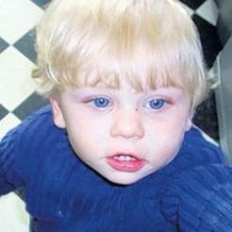

(Young, 2010)
This is the case of Peter Connolly known as Baby P, a baby boy aged 17 months at the time of his death. Baby P died in his crib on the 3rd August 2007, 48 hours after a doctor overlooked the child's serious injuries, which included a broken spine. During eight months of abuse that he suffered with more than 50 injuries he was on the Haringey Council’s Child Protection Register. The child protection register is a secret record of all children in the area who have been identified at a child protection conference as being at substantial risk of harm (Child protection register | Department of Health, 2022). Agency representatives, including social workers from the Council, had seen his family in excess of 60 times. They all overlooked the baby's life-saving warning signs, which were subsequently found to have been covered in chocolate by his crafty caregivers before visits to cover up injuries and bruises. Peter was repeatedly choked and a Rottweiler was encouraged to attack the child as part of the assault. Later, a post-mortem assessment revealed that more than likely he previously experienced rib and back fractures.
Tracey Connelly mother of Baby Peter began dating Steven Barker two months after Peter was born, and it was at Barker's hands that the child would experience horrifying torture. Peter was frequently admitted to the hospital with injuries, and his mother was twice taken into custody. However, the 17-month-old was discovered dead in a blood-stained cot a day after Tracey was informed, she would not be prosecuted. According to a court decision, Baby P was killed by his mother, her lover Barker, and his brother Jason Owen, who had moved into their house. The cause of the death was labelled as homicide.
Tracey Connelly received an indefinite punishment and was informed that she would spend at least five years in prison for the killing of Baby P, Steven Barker was given a minimum penalty of 12 years, while Jason Owen was given a six-year prison term in 2009.

A short and tragic life
2006
1 March Baby Peter born.
13 October Peter taken to GP with bruises. Mother claims he fell down stairs.
11 December Peter placed on child protection register after GP spots a head injury and bruises. Mother arrested.
2007
26 January Peter returned to his mother.
February Nevres Kemal, a former Haringey social worker, writes to the Department of Health with concerns.
22 March Paulette Thomas, a health visitor, reports "no concerns" after check.
7 April Peter admitted to hospital.
1 June Peter to be supervised by friend after unannounced social worker visit.
30 July Last social worker visit. Peter's bruises covered in chocolate.
1 August Peter taken to hospital, but no full examination as he is "cranky".
3 August Baby Peter dies.
2008
11 November Owen and Barker found guilty of causing the death of Peter. Connelly pleads guilty.
(Anthony, 2009)

The Agencies that were involved with Baby Peter and his family are as follows: -
- Haringey’s Children & Young People’s Service (CYPS) (conducting enquiries and subsequently implementing agreed child protection plan)
- Haringey’s Teaching Primary Care Trust (HtPCT) (providing health visiting, general practice, primary care mental health and school nursing services and supporting the child protection plan)
- Whittington Hospital NHS Trust (providing A&E, outpatient, day patient and in patient care and diagnostics including pathology and radiology)
- North Middlesex University Hospital (NMUH) (providing A&E, ante- and post-natal care)
- Great Ormond Street Hospital (GOSH) providing on behalf of HtPCT paediatric medical services in Haringey including the designated and named doctors for child protection and the paediatric A& E and inpatient services at NMUH
- Metropolitan Police Service (MPS) (working with and alongside the CYPS to jointly investigate reported injuries to Peter)
- The Epic Trust and Family Welfare Association (FWA) (via the HARTS service offering specific tenancy and family support using an Individual Support Plan)
- Two Haringey schools
- Haringey’s Legal Services (providing legal advice to CYPS)
- Haringey’s Strategic & Community Housing (organising provision of long term temporary Housing Association accommodation for the family)
(Basw,2009)

In November 2008, two days after Baby P's findings were announced, Children's Minister Ed Balls made a request for an investigation into the involvement of the local government, the NHS trust, and the police into Baby P’s murder. The cabinet member that was responsible for the department and the head of Haringey's Children's Services also resigned. Along with a social worker, three supervisors, and the council's director of children's services, Sharon Shoesmith, were all fired.

THE CASE OF KHYRA ISHAQ
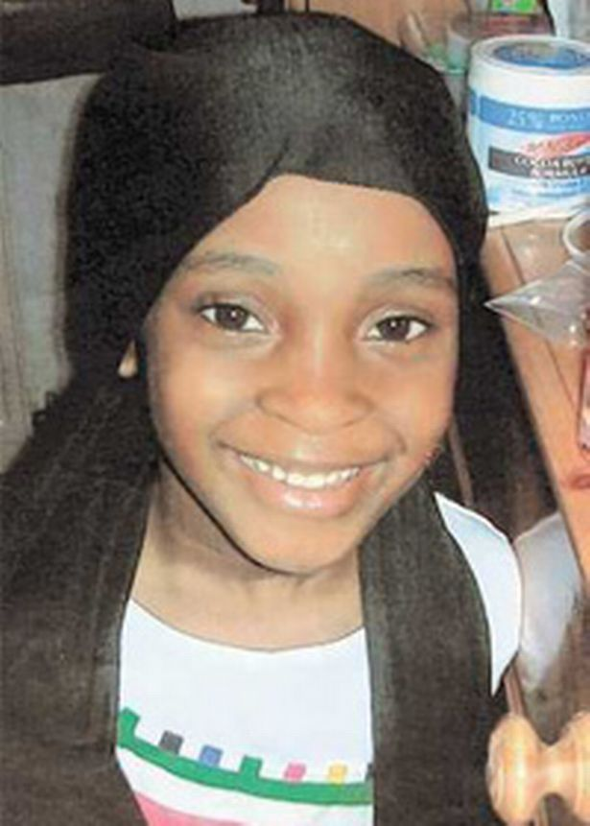

(Carter, 2010)
This is the case of a young girl by the name of Khyra Ishaq, whom was seven years of age at the time of her death. Khyra weighed 16.8kg in May 2008, the month of her passing (2st 9lb). Her body mass index was so low that it was off the bottom of medical charts, and she had lost roughly 40% of her body fat (Carter, 2010). The kitchen of her home was stocked with shelves of goods, tins of candy, and bowls of fresh fruit as the seven-year-old starved to death. To prevent Khyra and the other four kids in the household from accessing the food, a lock had been installed high up on the kitchen doors. If the children were found to have been taking food from the kitchen draws, they would get punished, to an extent where they would have to stand outside in the cold. A vicious regimen that included beatings as punishment, ice baths, and being made to overeat until she became ill resulted in her body's emaciated state with 60 injuries.
From the four children at the home, another two children who cannot be identified for legal reasons, were also discovered to be in a critical condition of malnutrition and in danger of passing away. The children lived at the family home with their mother Angela Gordon, and Gordon's partner, Junaid Abuhamza. Khyra's mother had pulled her out of school.
After teachers raised worry about the wellbeing of a seven-year-old kid living at the house in January 2000, Dr. Suraj Ahmed of Birmingham City Hospital inspected him. As soon as he entered the school, "he began checking in cabinets for food," Ahmed remarked. The school staff were concerned because he would take food from other kids' plates and devour it during lunch. He was underweight for his height. The youngster would repeatedly approach strangers and ask them for food during a brief hospital stay.
There have apparently been screams and "let me out" demands emanating from the house. Before she passed away, Khyra was reportedly seen by a neighbour crying in the backyard while just wearing her panties. The seven-year-old was examined post-mortem by a forensic pathologist who discovered 60 marks, 34 of which might have occurred the week before her death. Eight of these appeared to have been cane-related injuries.
Khyra's body was assessed by Dr. Roger Malcolmson, who reported that he had never seen such a significant fat loss. To really see her for the initial time was shocking. He mentioned how her face was depressed and how her elbow joints were particularly noticeable. Her jawbone was clearly visible, and there was little skin fat.
Khyra's unfortunate death was actually brought on by a severe malnutrition-induced infection, a cause of death you wouldn't anticipate seeing in the West Midlands, let alone Birmingham, in the twenty-first century.
The couple were sentenced for manslaughter, a judge at Birmingham Crown Court informed Angela Gordon, 35, that she would serve at least 15 years before being eligible for parole, and informed Junaid Abuhamza, 31, that he would serve at least seven and a half years (Carter, 2010).
Although there was less controversy around this issue than there was surrounding Baby P, there was still some finger-pointing, with a Birmingham MP calling for the resignation of senior staff members in the children's services department of Birmingham Council, also disciplinary action was taken against the social workers that were involved.
The importance of Safeguarding Policies and Procedures
Acts are often published legal documents having administrative and probative purposes. Acts would not exist if there were no law, hence an Act would come before law. Acts are created to make people aware about specific rules and regulations, whereas laws are written to protect individuals, maintain public order, and prevent unfair behaviour. There are numerous Acts for children and families, including the Children and Family Act 2014. They are placed in place to protect everyone's wellbeing.
Some of the Acts that would have been in place of duty for the above mentioned case are as follows: -

The Children Act 1989
The 1989 Act is based on the principle that, if possible, families should be supported so that children can get the greatest care possible. It highlights the importance of considering the preferences and feelings of the children while making decisions regarding how they should be raised (Elvin et al., 2019).
Some of the policies of The Children Act the local authorities failed in for the above cases are: -
Under Section 1 – The paramount of children’s welfare to conduct the following assessments: multi agency assessment, strategy meeting, single assessment, medical assessment (Child Protection Medical)
Under Section 17 – the duty of local authorities in providing support for families
Under Section 20 - Voluntary Accommodation also linked to Section 47 – they have to have a Court Order to remove a child or use the support of Police. Immediate protection of a child.
Under Section 31 – To place a Care order
Under Section 38 – To place an Interim Care Order
Section 47 - Child protection issues, outlines the procedures as to what has to happen when a child is being harmed

Children Act 2004
The 1989 Act has been improved upon by the Children Act of 2004. It emphasised that all people and organisations that work with kids have a duty to support, protect, and advance kids' welfare (Children Act, 2004).
The Children and Families Act 2014
The Children and Families Act of 2014 upholds the coalition government's commitment to strengthening families and enhancing assistance for at-risk children. It strengthens wider reforms intended to guarantee that every child and adolescent, regardless of situation, has the opportunity to succeed. According to Edward Timpson, Children and Families Minister, “The Children and Families Act is all about reforming services for vulnerable children - reflecting this government’s deep determination to give every child, whatever their start in life, an equal chance to make the best of themselves” (Children and Families Act 2014).
Child and Young People Act 2008
The 2008 Act intends to support young persons in local authority care or who are about to leave care in their educational endeavours and placement stability. There should also be parenting-related activities. (Children and Young Persons Act, 2008)

CONCLUSION

Child abuse/ child neglect can lead to very severe outcomes resulting in death as explained in the above cases. Baby Peter and Khyra Ishaq were two of many children that faced these severe consequences which they did not deserve. However, it is easy to say that these cases have shocked the communities as in regards to Khyra Ishaq, she was very close to home, living in the same city as we do. Normally you would just hear of these matters but not ever think it is happening so close to you. The children could have been saved and prevented from this abuse if the local authorities had followed their duties to best of their abilities, which they failed to do so hence causing the worst outcome for the children. If the policies and procedure were followed by the local authorities, they could have even taken the children into private care where they would have been treated better maybe things would have been different today. Children are vulnerable, they are innocent to the world, they should not have to go through such horrific lifestyles.

BIBLIOGRAPHY AND REFERENCES
Anthony, A,(2009). Baby P: born into a nightmare of abuse, violence and despair, he never stood a chance. [online] the Guardian. Available at: <https://www.theguardian.com/society/2009/aug/16/baby-p-family> [Accessed 16 July 2022].

Basw,(2009).[online]Availableat:<https://www.basw.co.uk/system/files/resources/basw_111257-10_0.pdf> [Accessed 1 August 2022].

BBC News. (2013). Timeline of Baby P case. [online] Available at: <https://www.bbc.co.uk/news/uk-11626806> [Accessed 1 August 2022].

Brazier,Y.,(2018).Childabuse:Types,signs,andreportingpossibleabuse.[online]Medicalnewstoday.com.Availableat&lt;https://www.medicalnewstoday.com/articles/241532&gt; [Accessed 25 July 2022].

Carter, H., (2010). Failures that led to mother starving Khyra Ishaq to death 'beyond belief'. [online] the Guardian. Available at: <https://www.theguardian.com/society/2010/feb/25/khyra-ishaq-starve-social-services> [Accessed 1 August 2022].

Children Act. (2004). [online] Available at: &lt;https://www.legislation.gov.uk/ukpga/2004/31/pdfs/ukpga_20040031_en.pdf&gt; [Accessed 3 August 2022].
Children and Families Act (2014) gains royal assent. [online] Available at:
&lt;https://assets.publishing.service.gov.uk/government/uploads/system/uploads/attachment_data/file/350685/Early_Years_Guide_to_SEND_Code_of_Practice_-_02Sept14.pdf&gt; [Accessed 3 August 2022].

Children and Young Persons Act (2008). [online] Available at: &lt;https://www.legislation.gov.uk/ukpga/2008/23/pdfs/ukpga_20080023_en.pdf&gt; [Accessed 4 August 2022].

Elvin, A., Evans, K., Thoburn, J., Jones, R. and Willow, C., (2019). The Children Act 1989: 30 Years On. [online] CYP Now. Available at: <https://www.cypnow.co.uk/features/article/the-children-act-1989-30-years-on> [Accessed 2 August 2022].

Keogh,K.,(2010). BirminghamMail.[online]Availableat:<https://www.birminghammail.co.uk/news/local-news/khyra-ishaq-a-timeline-of-tragedy-129069> [Accessed 2 August 2022].
Lake, E., Mulshine, M. and Micallef, C., (2022). Baby P the tragic tot who's horrific tale of abuse appalled the nation. [online] The Sun. Available at: <https://www.thesun.co.uk/news/4567187/baby-p-killers-tracey-connelly-steven-barker-jason-owen/> [Accessed 1 August 2022].

NSPCC Learning. (2022). Safeguarding children and child protection | NSPCC Learning.[online] Available at: &lt;https://learning.nspcc.org.uk/safeguarding-child-protection&gt; [Accessed 23 July 2022].

org.uk. (2019). Definition | Background information | Child maltreatment - recognition and management | CKS | NICE. [online] Available at: <https://cks.nice.org.uk/topics/child-maltreatment-recognition-management/background-information/definition/> [Accessed 3 August 2022].

Pallipedia.org. (2022). What is Health development - Meaning and definition - Pallipedia.[online] Available at: & lt; https://pallipedia.org/health-development/&gt; [Accessed 25 July 2022].

