Shafia Bibi | 1711966 | Cohort 1 | Group 2
LECTURER | ERNEST OVIA
DEVELOPING WORKPLACE CRITICAL THINKING
MODULE CODE: BMSK5001_BIRM

Contents
INTRODUCTION 2
BELIEFS, ATTITUDE, VALUES AND WORKPLACE BEHAVIOUR 3
Definition Of Beliefs, Attitudes, Values And Behaviour 3
What Are The Values Of NEXT Retail LTD 3
How Do Beliefs Affect Values 4
How Do Values Affect Attitudes 5
How Beliefs, Values and Attitudes Affect Workplace Behaviour 6
MANAGEMENT THEORY 10
What Is Management Theory 10
How Can Theory Be Applied To Management 10
CONCLUSION 14
REFERENCES 15

INTRODUCTION

This report is based on beliefs, attitudes and values and how they can affect ones behaviour. An analysis will be made on different viewpoints, from employers to employees, including theories. A management theory will be included in this report to assess how effective it can be on different individuals in the same organisation, who may or may not share the same beliefs, attitudes and values. A comparison of the differences will be highlighted to analyse the impacts and how theory can be relevant in todays world.
The report will discuss the beliefs, attitudes and values of individuals employed by NEXT RETAIL LTD. NEXT was first established in 1864 (NEXT PLC, 2019) , now with over 500 stores in the United Kingdom. The estimated employees for the year 2018 was 28,318 (CRAFT, 2019).

BELIEFS, ATTITUDE, VALUES AND WORKPLACE BEHAVIOUR

Definition Of Beliefs, Attitudes, Values And Behaviour

A belief is ones acceptance of something to be true. This may not be evidential, however an individual has their full confidence that it is true.
Attitude refers to ones way of thinking or feeling. Not everyone may share the same thoughts to something.
Values are something that is dear to ones heart. It can be something with upmost importance or usefulness. This again may differ from other people’s values.
Behaviour is how one acts towards another. It consists of a variety of actions or manners. There are different categories of behaviours. This may include: overt behaviour, covert behaviour, conscious, unconscious, rational, irrational, voluntary and involuntary.

What Are The Values Of NEXT Retail LTD

Core values are a persons or an organisations central importance. The core values can help a person or an organisation recognise if they are on the right tracks of their intended goals. Core values can shape behaviour of individuals and teach them from right to wrong. Core values can include: religion, family, honesty and health. Core values can differ from person to person, and organisation to organisation.
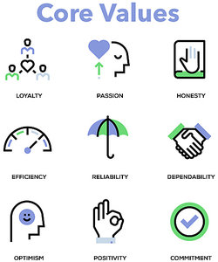

FIG.
NEXT core values and objectives are:
- Provide customers with great product ranges.
- Excellent customer experience.
- Customers at the heart of everything.
- Delivering quality and value for money products.
- Provide an extensive range of clothing and homeware.
- Attract, retain and develop talent at every level.
- A welcoming, respecting and supportive environment.
- Customer needs.
- Efficient and agile product distribution network.
- Management of store.
- Management of financial resources.
(NEXT PLC, 2019)
By having these core values, NEXT are able to monitor and record their outcomes. If needed, this will push them to work harder to achieve what they desire. It is fundamental for every business to have core values to have purpose for their business and watch its growth.

How Do Beliefs Affect Values

Beliefs and values are long term feelings or thoughts and mostly shape / define a person. A belief tends to become a value when the attachment develops and the individual can recognise the importance of it. Types of values can include: loyalty, honesty, commitment, peace, respect and love.
Beliefs and values can help guide individuals in the right path. For example, one of NEXT’s core value is to put customers at the heart of everything. This, for the employer, would be crucial for business growth. Their fight would be to please the customers, no matter what the outcome. There is a saying, “customers are always right”, so even if the customer was wrong, the employer would do their very best to make the customer happy. They will try to resolved any matters quickly and efficiently because they want to put the customer at the heart of everything. They want to promote a positive attitude. This value will also benefit the employees as they will ensure to do right by their customers. Everything will be about the customers. This would also show the customers that they are valued. They are worthy of time and effort.
When a person believes they can achieve something, they will aim for it regardless of any obstacles. The employer believes they can put the customer at the heart of everything, so they will push themselves. For instance, a customer is unhappy about the way they were treated by customer services. They report this to the manager on duty. The manager remembers they are going on annual leave in five days but the problem would require more than a week as she would need to investigate who was assisting the customer. They would need to check the time and date, and how many people were involved. Both views of the incident would need to be recorded. However, the manager believes if she stays behind after work for the next 3 days, she can get this problem sorted before she goes on holiday. The manager values her staff, which is why she would put in more time to put her belief into practice.
Beliefs, on the other hand, can have a negative side effect. A person with low self-esteem and the belief that they are worthless in their job, may not value their job or customers as much as they should. For instance, a sales assistant at NEXT who recently started their job, was constantly being laughed at by their fellow staff. This could lead to a negative behaviour and lose respect for others, efficiency and commitment to their job.
An overconfident person who believes they are better than everyone and believe they can accomplish anything and everything, may not always produce the best. They may lack in some areas, for example communication. Their confidence is so high that they forget how to communicate professionally. They may talk to customers as if they were talking to their friends. Being friendly is one thing, but to talk anyhow is not professional. There should be limits in place. Without limits, they may lose respect too.
Beliefs and values are very much well linked. They are almost always connected to bring an outcome, whether its positive or negative. This then shapes the behaviour and attitude of a person or an organisation.

How Do Values Affect Attitudes

Values have major influence on attitude. It could be both positive and negative. A person that does not value the set rules of an organisation may not produce effective work or work according to their job description. For example, the team leader at NEXT is aware of the rules and regulations set out for everyone. The closing time for weekdays is 8pm. The team leader has noticed the manager is off every Friday. He finds an opportunity here to close the store earlier than stated as he does not value the rule. This leads to poor practice and makes him a bad role model as a leader. Some, on the other hand may admire this as they do not value the rules either. This can lead to others lacking professionalism and a poor attitude. NEXT values the management of their stores. The team leader who does not follow the rules, cannot be on the right path or worthy of their position as they are abusing their power of trust.
One of the pet hates of an employer is to see their staff standing around in the corridors or just chatting amongst each other. A person who values their job will ensure they are not seen hanging around. Even if it means to pretend to be busy by holding a pen and a paper. The employee would fear the loss of their job. This fear would push them to work harder. Sometimes it’s not even fear that would make someone work hard. It could simply be the opportunity of a promotion. This would encourage a positive attitude. This positivity may shine through and pass onto others. It may prompt others to work more efficiently. This could lead to a welcoming, respecting and supportive environment, which is another one of NEXT’s values.
An individual or an organisation that values their work may be motivated to achieve more. An organisation such as NEXT can see their competitor are increasing their sales. This may motivate the staff at NEXT to increase their sales too. This can have a positive impact on the team as they will be working closer together to achieve their shared goal. This can bring out more positive attitudes in people. On the other hand, the pressure to do better than their rival, may create a chaotic environment with peoples attitude towards work or each other failing.

How Beliefs, Values and Attitudes Affect Workplace Behaviour

Beliefs can drastically affect behaviour. This could be a slow or a fast progression. A person that believes they can get away with just about anything may have an overall bad behaviour, if left unnoticed or dealt with for a long period of time. A person who displays good behaviour tends to value their beliefs and understands the important of positive attitudes.
Personal values and workplace values can be related to one another. For example, an employee is in need for higher pay than the national average, as they have a family to support or a mortgage to pay. They value their family, home and money, so that means they would value their job. Their income would be very important to maintain. As mentioned earlier, a chance for a promotion would also encourage good behaviour. The promotion would enable them to afford more, so to seek goodness from their colleagues, managers and customers would also be necessary for them. To value money, it does not necessarily mean a person would value their current job. They could be in that particular job because they have no other choice. Perhaps it is more suitable for its distance or flexibility? When a person’s main priority is money, their behaviour at work may not be so great.
A persons value can be related to their needs but it does not make their needs a value. It is an association. For example, they need money to build a home. Their need is money but their value is a home. The house is also a need in order to create a home.
Where a person values education and career success, if there is a vacancy with additional benefits such as further training, an applicant would believe this job is suitable for them, as it would meet their personal values as well as work values. Work values would be to develop their staff, and personal value would be to develop themselves and their worth. This added benefit would encourage the applicant to apply and sustain that job, as it is their belief they can climb the career ladder through this channel. Their attitude and behaviour may improve with this benefit.

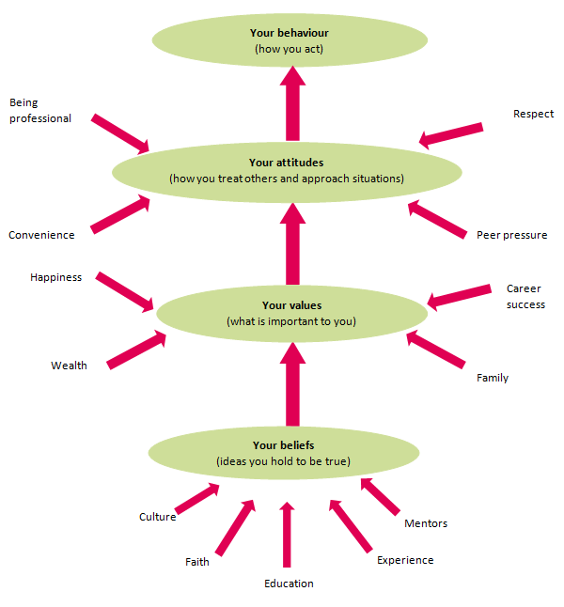

FIG. 2
In this diagram, it can be seen how peoples beliefs are started and how their behaviours are formed. This can be from ones cultural background they are brought up in, taking into account any religion they may learn. Also, peoples learning and experiences can contribute to their beliefs. This belief may or may not progress into a value. A person can believe in religion but may not practise it as they do not value it. If the religion is followed and valued, this may teach them to be polite and respectful of others. This then encourages positive attitudes and behaviour. Beliefs, values, attitudes and behaviour can often influence ones personality, as they are more self-conscious.
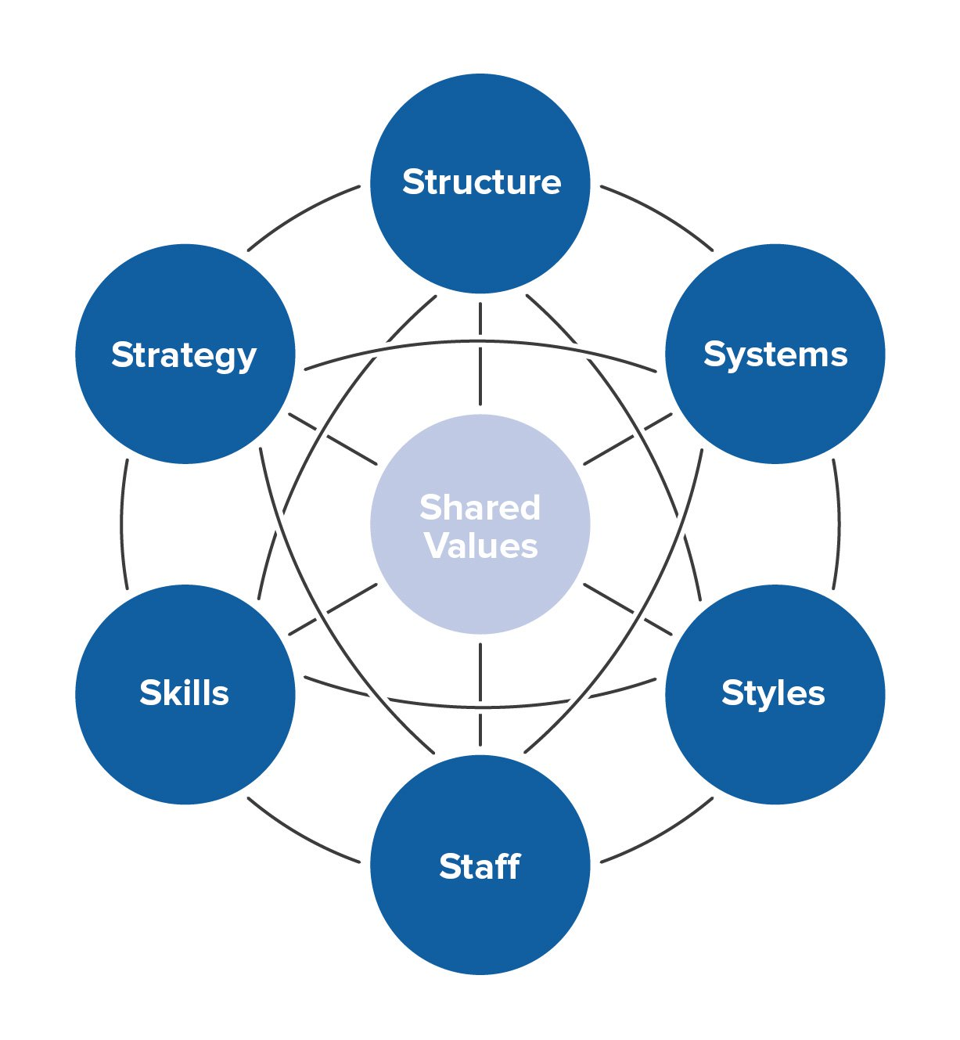
Shared values can be a basis of a relationship. Two people working at NEXT who value their job may value a good working relationship. They will make every effort to progress together. On the other hand, someone who values their job may not value a working relationship. There could be other factors affecting their relationship, such as their personal beliefs. For example, a woman who has never experienced working in a team may belief she can achieve everything by herself. She may not give importance to team work because she has been working alone in an office most of her life. She believes she works better independently and has more initiative than others. This, therefore creates a negative atmosphere and relationships. Others may relay this as bad behaviour, however to herself, she is doing right by the company as it is her belief. It could be said that she does not value a working relationship, however it may be that she does not know how to value a relationship. Perhaps she has never been in any kind of relationship? Maybe she has worked in teams before but they have always ended up disastrously? There could be many reasons as to why she displays herself as not valuing a working relationship.

FIG. 3
This picture shows how values can affect workplace behaviour. According to Mindtools.com (2019), this framework above shows how shared values, when put in central of everything, can affect other areas of work and the organization as a whole. They suggest that the seven elements need to be balanced together for an organisation to succeed.
From an employers perspective, this is everything that can bring success to an organisation. However, from an employee’s point of view, it may be that there is a lot of pressure in that organisation. The employee may not like to follow a structure as they have a more free flow personality. Shared values will not always bring the outcome that is expected. Not every personality will be the same. Some will prefer structure, some may not. Behaviours amongst staff will always be different.

MANAGEMENT THEORY

What Is Management Theory

Management theory is a set of rules and guidance as to how to run an organisation. Management theory is how people on senior levels and above of an organisation deal with their knowledge, goals for improvements and their intended plans for implementing tasks. It also includes how they motivate staff to perform their best. (BusinessDictionary.com, 2019).
There are different types of management theory. This includes: classical, behavioural, quantitative and quality, systematic and contingency management theory. Management theory involves the development of concepts, principles and techniques. The main purpose of management theory is to plan, organise, staff, lead and control within an organisation, according to Olum (2004, P.2). Management can relate to any organisation and to any level. Management is associated with productivity. Without good management, there will be a significant loss of productivity. Olum also states that this implies effectiveness and efficiency. He also adds to this, problem solving is one of the main reasons for management. Management is a necessity in order to overcome barriers to the growth of a company.
Management theory is important in building staff skills and experiences. It is to get the best out of their employees. It also helps analyses the relationship between all members of staff.

How Can Theory Be Applied To Management

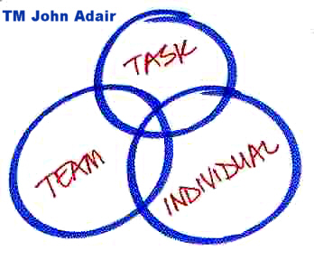
John Adair (1934- ) who has written over 40 books, is the founder of Action Centred Leadership. More than a million managers have used his strategy. Adair believes leadership can be taught and it is not just a trait. Adair’s theory is still used in todays modern world, as it has been proven to work so well. In 1979, John Adair became the worlds first professor in Leadership Studies. (John Adair- Action Centred Leadership, 2015).

(BUSINESSBALLS, 2019).
This Action-Centred Leadership model represents John Adair’s leadership idea. It is his trademark, and that is what businesses use for teaching and training. The three main rules for management are:
- achieve the task,
- manage the team or group,
- manage individuals.
Adair believes, to manage an organisation well, they must identify their aims and vision. This is how they will achieve their task. NEXT Retail have already done this, looking back at their values and objectives, as can be seen at the top of this report. They have a special team of people who monitor their finances, resources and employees.


JAMES (2019, p.5)

Managing the group or team helps establish a relationship, as well as observing performance and behaviour. This helps the manager develop a stronger work force. They can assess and change any necessary plans or ideas. Managing the team also includes training and developing. NEXT already have this in their plans, as a way of developing skills and motivation. Adair’s leadership model also mentions maintaining communication between groups internally and externally. NEXT manages the communication between their staff and stakeholders through visits, feedback systems, forums, conferences, audits, workshops, online messaging, surveys, and much more. Below is a screen snap of how NEXT communicate with their internal and external stakeholders.

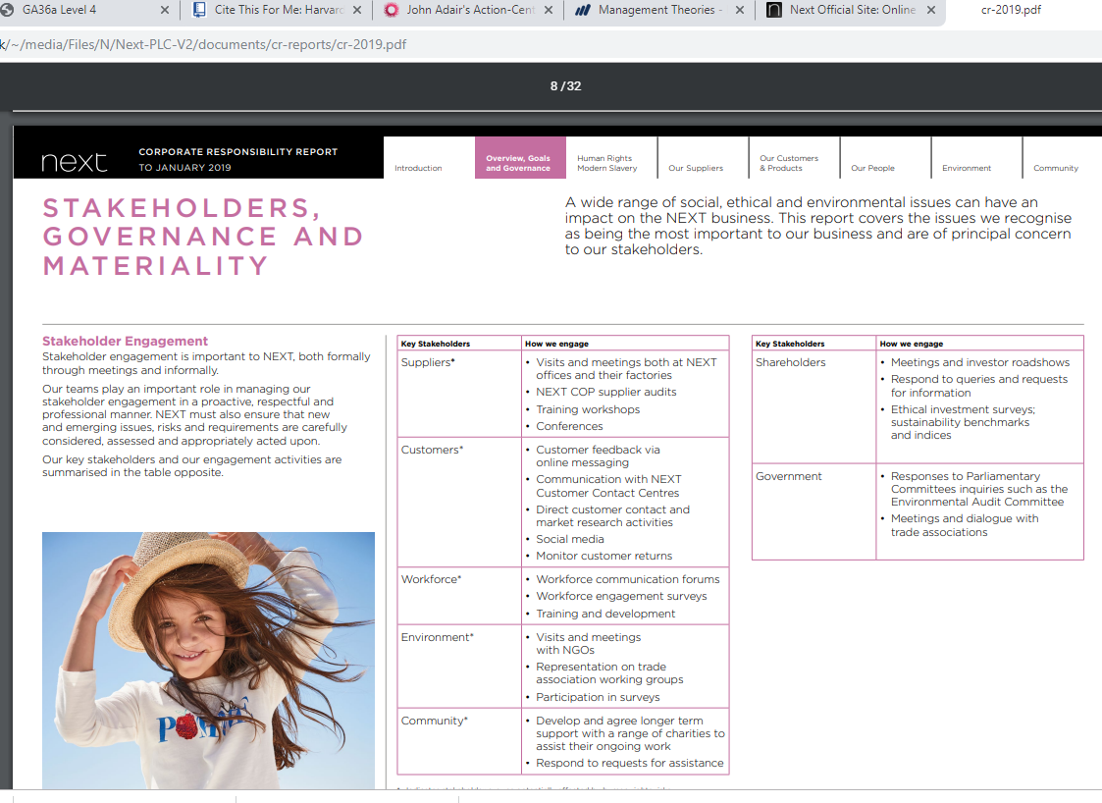

JAMES (2019, p.7)

Adair’s model of management teaches managers to understand people for who they are individually, not just as team members. NEXT has approached this by having reward systems and appraisals in place. They give their staff the opportunity to discuss any issues they may have during an appraisal, and in return the staff are given a feedback by the manager / leader. This enables managers to know more about their staff. They can adapt work for the staffs suitability, for example being able to provide flexible working hours. According to Kakabadse et al. (2018, p.14), “Flexible working is a growing demand to fit jobs into a broader work / life balance.”
Having a reward system in place can also motivate their staff to work harder. NEXT do this by providing the opportunity for “sharesave” and their own workplace nursery for parents with no childcare. Sharesave is an opportunity to save money over a period of 3 to 5 years, to buy a share of NEXT plc at a discounted rate. They also provide mental health awareness training, as they value employee well-being. JAMES (2019, p.22).
“Being able to do all of these things, and keep the right balance, gets results, builds morale, improves quality, develops teams and productivity, and is the mark of a successful manager and leader.” (BUSINESSBALLS, 2019).
It may be safe to say that NEXT are following the model of John Adair’s Action-Centred leadership theory. The theory can be relatable to peoples beliefs, values, attitudes and behaviour. To achieve a task, manage an individual or a team, a manager must believe it is achievable. They must have strength and courage. Only then, they will value their skills and abilities, displaying good attitudes and become a good role model for others. For a manager, it can still get quite tricky to maintain all this. There are many people with different personality / characters, so the manager will need to address all those involved. There are a lot of factors to consider when following Adair’s model. It may look simple, but there are a lot to contemplate. Sometimes, it can become a little of a burden, leaving the manager to miss out some key details in ensuring they are following the points themselves.
For an employee, their belief may be that the rules are there just for the sake of having rules. If they have never obeyed their family, teachers or anyone, ignoring rules can be easy. They may believe they can get away with just about anything without consequences. These individuals may have very little value in life, therefore their behaviour will mirror their attitude.
John Adair’s Leadership model also consists of core functions that make a good management theory. They are as follows: planning, initiating, controlling, supporting, informing and evaluating. If a manager has not got the correct skills to use these core functions, then the organisation will fail to succeed. The organisation requires a manager who has the ability and strength to cover these factors and who can make a difference. If they need training on leadership, then perhaps they are not ready for the role just yet. An effective manager should have already possessed the skills of the core functions. This way their beliefs, values and attitude will shine through and the employees can build their trust in them.
“Employees want empowerment on the job to make work more meaningful and satisfying. They want to contribute their unique talents to organisations that acknowledge their contribution. Their expectations need to be managed by more senior employees, who themselves may have changing aspirations and similar wants and values.” Kakabadse et al. (2018, p.14)

CONCLUSION

At the end of the day, beliefs, values and attitudes will always have impact on workplace behaviour. They will all differ from every individual and organisation. Every person is made up of their own beliefs and values. That defines a persons attitude and behaviour. Beliefs and values can change over a period of time. This will have effect on people’s behaviour in the workplace. As Adair suggested, people need guidance in the right path. This guidance may then become ones belief or value. Looking back at the diagram which shows how beliefs are linked to behaviour, it can be said that guidance is another way people acquire their beliefs, as they gain more knowledge and experience in the process.
In every organisation, there will be people with different attitude and behaviour but the most important thing to remember is, why a person reacts the way they do. Is there more behind their actions or words? Where could it be coming from? It is important to address even the smallest of problems, as there may be bigger problems lying underneath that is causing unwanted attention. Every individual has different learning methods. Each needs should be met to enter the road of success. Just like generations can go way back, peoples beliefs and values can go way back. There are many roads they have taken which have brought them here. If the attitude is negative, perhaps it has been built from many years ago? So it may take quite some time to change a persons negative behaviour to a positive one.

REFERENCES

WEBSITES

BUSINESSBALLS (2019). John Adair's Action-Centred Leadership Model - BusinessBalls.com. [online] Businessballs.com. Available at: https://www.businessballs.com/leadership-models/action-centred-leadership-john-adair/ [Accessed 1 Aug. 2019].

BusinessDictionary.com. (2019). What is management theory? definition and meaning. [online] Available at: http://www.businessdictionary.com/definition/management-theory.html [Accessed 30 Jul. 2019].

CRAFT (2019). NEXT. [online] Available at: https://craft.co/next [Accessed 29 Jul. 2019].

NEXT PLC (2019). Our history. [online] Nextplc.co.uk. Available at: https://www.nextplc.co.uk/about-next/our-history [Accessed 29 Jul. 2019].

FIG. 1. YourDictionary. (2019). Examples of Core Values. [online] Available at: https://examples.yourdictionary.com/examples-of-core-values.html [Accessed 30 Jul. 2019].

FIG. 2. MINISTRY OF BUSINESS, INNOVATION AND EMPLOYMENT (2019). Personal beliefs, values, attitudes and behaviour - Immigration Advisers Authority Your tagline here. [online] Immigration Advisers Authority. Available at: https://www.iaa.govt.nz/for-advisers/adviser-tools/ethics-toolkit/personal-beliefs-values-attitudes-and-behaviour/ [Accessed 30 Jul. 2019].

FIG. 3. Mindtools.com. (2019). The McKinsey 7-S Framework: - Making Every Part of Your Organization Work in Harmony. [online] Available at: https://www.mindtools.com/pages/article/newSTR_91.htm [Accessed 30 Jul. 2019].
ARTICLES

JAMES, A. (2019). NEXT CO R P O R AT E R E S P O N S I B I L I T Y R E P O R T TO JANUARY 2019. [ebook] Leicester: Joanne Poynor, pp.5-8. Available at: https://www.nextplc.co.uk/~/media/Files/N/Next-PLC-V2/documents/cr-reports/cr-2019.pdf [Accessed 1 Aug. 2019].

John Adair- Action Centred Leadership. (2015). [ebook] Corby, Northants: Chartered Management Institute, pp.1-4. Available at: http://www.valuing-your-talent-framework.com/sites/default/files/resources/THK-032%20John%20Adair.pdf [Accessed 30 Jul. 2019].

KAKABADSE, A., BANK, J. and VINNICOMBE, S. (2018). WORKING IN ORGANISATIONS. 2nd ed. [ebook] London and New York: Routledge Taylor and Francis Group, p.14. Available at: http://file:///C:/Users/shafi/Downloads/9780429427992_preview.pdf [Accessed 1 Aug. 2019].

NEXT PLC (2019). BUSINESS MODEL. [ebook] p.2. Available at: https://www.nextplc.co.uk/~/media/Files/N/Next-PLC-V2/documents/2019/business-model.pdf [Accessed 30 Jul. 2019].

Olum, D. (2004). MODERN MANAGEMENT THEORIES AND PRACTICES. KAMPALA: Makerere University, pp.1-7, 22.

