Programme: Certificate of Higher Education in Skills for the Workplace
Student name: Tincuta Bardas
Student ID: 1907524
Module: Digital Skills and Research Methods
Module Code: BMSW4003
Module leader: Paul Ranson
Assignment title: Component 1 Research Methods – Presentation

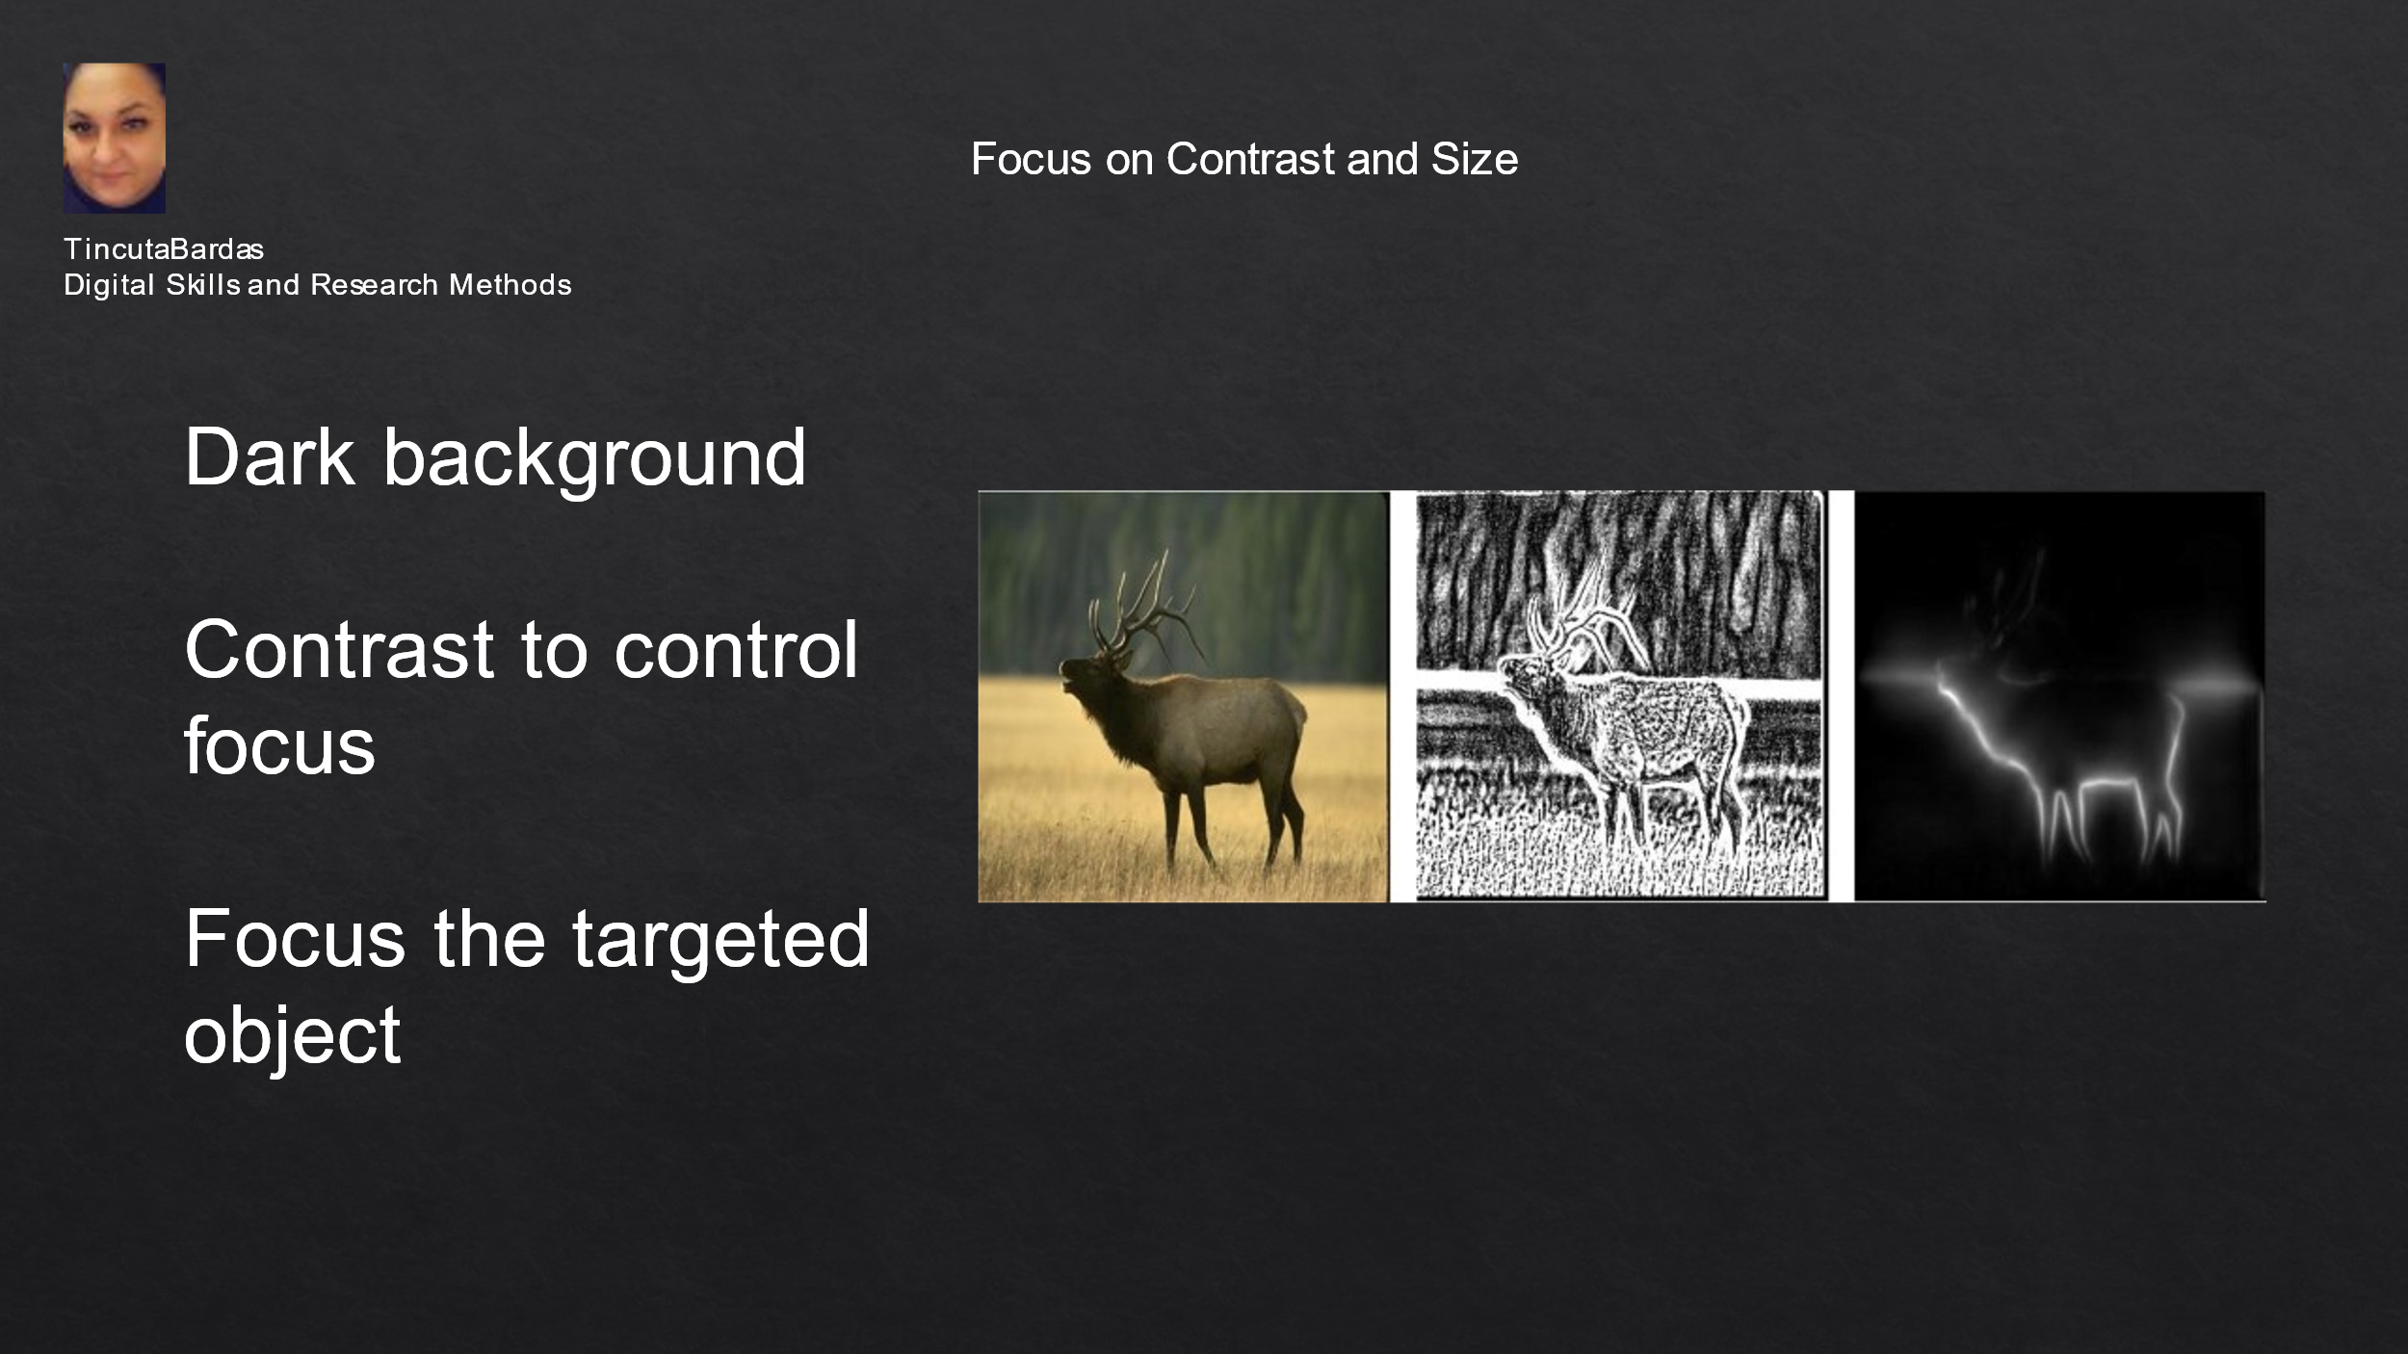

The quality and the flow of the content are as important as the dark background, together with the contrast and size of the text on a slide (Philips, 2021). Dark backgrounds should have light text and bright accent colours for the images. In this way, the audience can see the text and also the graphs or shapes on each slide. Today, most organizations dictate a template with corporate colours, as part of a branding initiative (Chan, 2019). If this is the case, there is not much choice. Still, a high contrast may be used for colours, between the background and the text or visuals. The contrast is useful when used on the size of the font. The headline or title will be smaller and the key information will be larger (Philips, 2021). Thus, the working memory of the audience will be successfully used and the audience’s focus will be controlled, reaching the targeted information (Smith, 2020). The eyes will follow the parts which are presented with a high contrast and thus the key information will be easily retained. The minimum size for the slide’s text is 24, and the contrast could be made with a Bold text, avoiding animation or flickering texts. It is important that the letters on slides are large enough, so most people can see them (Association of Research Libraries, no date). The most important part in the PowerPoint should be the biggest one in the slide. Furthermore, the devices which are used for a presentation, such as screen or TVs, together with the distance to the last row of chairs, are important features in deciding the size of the fonts. If there are used active links, they should resolve to the correct destinations. Overall, the PowerPoint presentations should be made fully accessible to every member of the audience.

