

An investigation into the joint attendance of Police, Fire and Ambulance at terrorist attacks in modern day Britain.

Eleanor Victoria Coster

1815668

BSc (Hons) Professional Policing Practice

Acknowledgements

I would like to thank, Karen Coster and Holly Price for their time, support and encouragement throughout the course of this dissertation.

I would also like to thank my supervisor Lewis Tandy for his guidance, assistance and patience through this process.

Finally, I would like to thank my sister, Shelley Jones. The endless kindness, time and knowledge you provided throughout my University journey is something I will be forever grateful for.

Declarations

- Declaration - This work has not previously been accepted in substance for any degree and is not being concurrently submitted in candidature for any degree. Signed: Date: 25/11/2021

- Statement 1 - This dissertation is being submitted in partial fulfilment of the requirements for the degree of BSc.
Signed: Date: 25/11/2021

- Statement 2 - This dissertation is the result of my own independent work/investigation, except where otherwise stated. Other sources are acknowledged by footnotes giving explicit references. A bibliography is appended.
Signed: Date: 25/11/2021

- Statement 3 - I hereby give consent for my dissertation, if accepted, to be available for photocopying and for interlibrary loan, and for the title and summary to be made available to outside organisations. Signed Date: 25/11/2021

- Statement 4 - I hereby give consent for my dissertation, if accepted, to be available on the university’s IT system to those who have consent to use the system.
Signed: Date: 25/11/2021

Abstract

Joint emergency service response to major incidents such as terrorist attacks has previously been scrutinised for failings in processes. This study aims to focus on joint emergency service communication at major incidents and its current effectiveness. It discusses the confidence of past and present emergency service employees to use JESIP and training provided in order to ensure that the principles of JESIP are utilised at every incident.
To establish the current effectiveness of communication between emergency services, published literature has been analysed, along with a questionnaire distributed across the Police, Fire and Ambulance services in order to achieve a broad range of data collection. The questionnaire achieved a much wider reach than originally expected, receiving responses ranging from initial intake level to senior members of staff. There was a relatively equal split of responses from Police and Ambulance with Fire having slightly fewer participants. Some questions were closed and some were open. The open questions gave respondents the opportunity to expand on thoughts and ideas which were then discussed within the results and conclusion sections.
The results showed that there is a lack of confidence with communications during major incidents, such as terrorist attacks although there is acknowledgement of the JESIP principle. This study has also highlighted a lack of training across all levels and all services. This has been addressed within the recommendations section and some potential improvements around training have been discussed which includes joint training scenarios.

Contents

Table of contents page

Chapter one – Introduction 6

Chapter two - Literature Review 8

Chapter three – Methodology 14

Chapter four - Analysis of results 18

Chapter five – Findings and conclusion 22

Chapter six – Recommendations 27

Chapter seven - Bibliography / Reference 29

Chapter eight – Appendix 35

Introduction

This study has been designed to answer the research question; How effective is communication between Police, Fire and Ambulance at terrorist attacks in modern day Britain. This will be done by analysing the effectiveness of the emergency services mentioned above, as well as the current level of efficiency in relation to communication and understanding of roles by all services. This study includes a wide range of literature that has been evaluated in relation to previous terrorist attacks which have occurred in modern day Britain. This study focuses on two attacks; The London Bombings which occurred in 2005 and the Manchester Area attack which occurred in 2017. These terrorist attacks have been the focus of this study due to the significant impact they had on Britain’s emergency services and the public. Communication in both attacks have been analysed and it is apparent that communication was inefficient.
This topic area is a timely and important area for discussion. On 15th November 2021, the Joint Terrorism Analysis Centre (JTAC) changed the UK national terrorism threat from substantial to severe, meaning a terrorist threat is highly likely. The recent Liverpool Hospital attack which occurred on 14th November 2021 is a stark reminder of the risk of severe terrorist attacks in the UK. There has been an increase in terrorist’s attacks in modern day Britain over the years whereby, terrorists are using more advanced methods of attack therefore creating complex issues for counter terrorism to detect.
The demographic for this study included a wide range of employees of all levels from all three services, as well as a broad range of experience from new recruits to staff members with 15 years plus service. This study has been broken down into themes which allowed for focussed academic research to be conducted on these topic areas.
The aim of this study will undertake the following objectives.
- To analyse the current efficiency in relation to communication during a joint emergency attendance terrorist attack using already published academic literature and data analysis models.
- To evaluate the consensus of communication and training across the three service areas by means of gathering data by survey and analysing results collected.
- Upon analysis, too potentially make recommendations relating to communication and training for new recruits and existing staff.
Therefore, this study aims to research the current situation in relation to communication and training at terrorist attacks in modern day Britain.
This study includes a number of chapters in order to achieve these aims and expand upon these points. Chapter Two will examine the available literature concerning the communication between Police, Fire and Ambulance at terrorist attacks in modern day Britain as well as evaluating the wider implications it has on the emergency response. Chapter Three will identify the appropriate methodology and therefore devise a suitable questionnaire based on points and issued raised from chapter Two.
Chapter Four will provide analysed data collected from the online questionnaires. It includes results collected from both open ended and close ended questions providing participants the chance to offer their own thoughts and opinions on the topic area.
Chapter Five will discuss the findings of results analysed and provide of conclusion in relation to the study.
Chapter Six offers several recommendations for further research topics and potential solutions which could lead to a more effective and efficient response from Police, Fire and Ambulance at terrorist attacks.

Literature Review

Within recent years policy makers, academics and security service have increasingly sought to tackle the evolving threat of terrorism. It became apparent that the events of 9/11, which occurred in America, marked the dawning of a new historical period, therefore, leading to fundamental changes in security across the world. This attack was the first of its kind and introduced a ‘new’ type of terrorist threat. Policy-makers such as Javier Solana, argued that “the terrorist threat could be characterised by the willingness of ‘new’ terrorist movements to ‘use unlimited violence and cause massive casualties’ therefore representing ‘an existential threat’”. (Christopher Baker-Beall, 2013). This field consequently offers rich source of analysis and a plethora of literature regarding both the evolving threat of terrorism in contemporary Britain and crucially within the scope of this discussion, the ways in which emergency services respond to this threat. This literature review is an analysis of the literature in this field. It will identify key arguments, compare and contrast literature already published and provide justification for this study, as well as identify possible gaps that this study will fill.
Terrorisms has captured the attention of policy makers over the years, yet so far, “strong policy solutions have proved elusive”. (Orehek and Vazeou-Nieuwenhuis, 2014). Terrorist attacks have come in waves over the years increasing in the mid 1970’s and declining again during the late 1990s. “However, after 2001, attacks increased again, reaching a series high of 6,660 in 2006”. (Orehek and Vazeou-Nieuwenhuis, 2014). This supports initial thoughts that terrorist attacks are becoming more frequent and therefore, emergency services are increasingly attending calls whereby a joint emergency service attendance is required. Due to this, the subject topic; ‘An investigation into the joint attendance of Police, Fire and Ambulance at terrorist attacks in modern day Britain’ should offer extensive research and study in order to analyse already published work and identify possible gaps in studies concluded to help better response and communication between Police, Fire and Ambulance services and offer ways to improve any areas in need of development. Due to the subject topic having potential to be extremely broad, this study will focus on the two main terrorist attack that have occurred in modern day Britain; the 7th July 2005 London bombings and the 22nd May 2017 Manchester Arena bombings.
Due to the fact that both the 7/7 London Bombings and the Manchester arena attacks were so highly publicised by the media, consideration had to be taken when studying certain published pieces of work. The media can be biased based on information received and what they wish to publish to the public, therefore, filtering the reliable sources from the unreliable sources would be difficult if these type of sources were considered. Having said this, articles such as news reports do offer essential and reliable information which could be extremely beneficial to this study, such as interviews from Police, Fire and Ambulance staff. But, there is still an inherent politicisation of terrorism and therefore academic sources will be relied upon
Having conducted a number of varying research attempts, such as studying journals from academics, internet articles published by news companies and private websites and published books. It is has become apparent that there is limited literature already produced in this topic area. However, from the limited literature available, it is clear that there were a number of issues in relation to communication and understand of each other’s roles between Police Fire and Ambulance. This has been evidence in a report produced by the London Assembly which stated “The difficulties caused by the nature of the incidents were compounded by significant communications problems within the emergency services”. (Greater London Authority, 2006). This document goes onto state that “Managers within the London Ambulance Service, the City of London Police, the Metropolitan Police and the London Fire Brigade relied to varying extents on mobile phones to communicate”. (Greater London Authority, 2006). This supports the initial thoughts that communication lacked efficiency and that further training around this area would help to develop and improve this. It also suggest that face to face communication was limited and technology was relied on in order to communicate. When studying this specific document, it is clear that Police, Fire and Ambulance relied heavily on mobile phone communication as radio signals were effected. The document states “there is no point in having the technology to enable key people to communicate with each other if the relevant authorities do not make sure that the right people are in possession of that technology”. (Greater London Authority, 2006). This is yet another area in which it is clear communication was ineffective and suggests that training the key people in how to use essential technology could improve this over all response and communication between Police, Fire and Ambulance.
A source titled ‘Addressing lessons from the emergency response to the 7 July 2005 London Bombings’ produced by the British Government have published a document with a number of supportive statements in relation to initial thoughts on the lack of effective communication between Police, Fire and Ambulance. One of these being “It has been suggested that failures in the telecommunications equipment used by the emergency services led to a delay in rescuing those caught up in the attacks”. (British Government, 2006). This statement is very similar to that mentioned in the source ‘Greater London Authority’. It supports the need to improve ways in which emergency services communicate and how well they communicate between each other. However, both sources only provide statements of the issues that have arose from lack of communication and nothing in the way of how to improve this. In contrast, this document then goes on to state that “Although there were difficulties, responders were on scene within minutes of receiving 999 calls”. (British Government, 2006). This shows that response and initial communication between Police, Fire and Ambulance in relation to attend scenes was sufficient. Even though this statement suggests that there was no real issue with the initial communication, it does not suggest any information in relation to communication during the incident and how well Police, Fire and Ambulance cooperate with each other. As a whole this source offers great knowledge of the attack as well as a full investigation into the response of police, Fire and Ambulance services and how they conducted themselves at scene and communicating between them.

‘The Coroner’s Inquest into the London Bombings of 7 July 2005’ also offers a vast amount of reliable and useable information in relation to response of Police, Fire and Ambulance at this terrorist attack. This sources supports initial thoughts that issues arose at this attack due to lack of communication and sharing of information between services by stating “The evidence indicated that there was a lack of adequate sharing of information between the emergency services and TFL’s control rooms”. (Coroner’s Inquest, 2011). It suggests that communication could not have been effective nor efficient if services were unable to share vital information between them. This is also supported in the sources already mentioned. This source goes onto state that “At an early stage emergency services were in receipt of information”. (Coroner’s Inquest, 2011). This could be one of a number of reasons as to why the initial response of the Police, Fire and Ambulance services was inadequate due to information sharing as evidenced in this source which stated if information was shared, it “would have enabled London Underground to establish quickly the true cause of the incidents”. (Coroner’s Inquest, 2001). This again heightens the fact that communication played a significant role in this incident and if services were knowable and confident in how to communicate effectively with other services, the response to this attack would have been more efficient. Due to the investigation and publication of this source, Police, Fire and Ambulance have all admitted to their own faults when responding to this attack stating that “each organisation has accepted that there are lessons to be learnt from 7/7 and improvements to be made”. (Coroner’s Inquest, 2011). All services agreed that there were numerous issues which effected the response to this attack which needed to be addressed and “important and detailed recommendations, particularly in respect of communication” (Coroner’s Inquest, 2001) were made.
Overall this published source covers a wide range of information in relation to the 7/7 bombing. It provides a detailed response to the attack by all services and acknowledges that there is need to improve on communication and initial response. Therefore, recognising that there is need for development and lessons to be learnt. The 7/7 bombings occurred in 2005, but more recent terrorist attacks, such as the Manchester arena attack has proven that there is still issues surrounding joint emergency services attendance at incidents such as these. A statement made by a former senior Metropolitan Police detective and counter-terrorism commander, Scott Wilson supports this. Wilson stated that “the vital objectives of JESIP- the Joint Emergency Services Interoperability Principles wo which emergency services should work to in the event of a major incident ‘unfortunately’ didn’t work on the night”. (Wilson, 2021).

The Kerslake Report published on 27th March 2018 provides a large amount of knowledge and information on the Manchester Arena Attack which occurred on 22nd May 2017. This sources offers information on how each organisation manages their own activates at the attack, and how their actions on the day positively or negatively impacted the emergency response. This document breaks down each services response to the attack and outlines “major areas for learning”. (The Kerslake Report, 2018). As a whole, the response to this attack was not effective, communication between Police Fire and Ambulance was poor and procedures between services were weak. In relation to the Greater Manchester Fire and Rescue Service, this report states that there was “no single reason nor individual” (The Kerslake Report, 2018) that caused the failure of response to this attack, rather it was due to “poor communication and procedures”. (The Kerslake Report, 2018). It appears that the Police, Fire and Ambulance services all had information relayed to them which they were not sharing with each other. This was another reason as to why response with hindered and in effective. This is evidenced in The Kerslake Report where by it states that there is an “agreed operation response to a suspected Marauding Terrorist Firearms Attack” (The Kerslake Report, 2018) named ‘Operation PLATO’ which each services should be aware of. However there was no “shared communication across the agencies of the declaration of Operation PLATO” (The Kerslake Report, 2018) and “nor was there a shared understanding of its implications” (The Kerskale Report, 2018). Again, this is more evidence which proves that communication between Police, Fire and Ambulance was ineffective and therefore, leading to a negative impact on the emergency response to this attack.
A further document published in relation to The Kerskale Report, 2018, was the ‘Progress Update on the Kerslake Report’ and this document was produced on April 18th 2019 by the then Mayor of Manchester, Adam Durnham. As stated, initial thoughts in relation to both the London 7/7 bombings and the Manchester Arena Attacks was that communication was poor and therefore, negatively affected the overall response to the attack. It was also evident that further multi-agency training would be one way in which to improve this. This has been supported in the ‘Progress Update on the Kerslake Report as it states that “communication in an environment with multiple information sources is a challenge and therefore regular training and testing will be necessary”. (Durnham, 2019). A further recommendation made in this report is that there needs to be “comprehensive understanding of all terminology used during multi-agency command, control and communication”. (Durnham, 2019). This gain supports the fact that there is a lack of understanding of each services role and this needs to be addressed.
Overall, this published source states a number of issues that potentially hindered the response of the emergency services at the arena. It provides evidential material in relation to what services attended at what times and where, who took control of the incident and what information was shared with who, and when. This demonstrates why this study in necessary, by evidencing key issues in relation to the response of Police, Fire and Ambulance at terrorist tacks like this. As well as commenting on lack of communication and understanding between the three services and the effects it has on the initial response. It also outlines the gaps in knowledge this study is looking to fill by offering potential ways in which to improve and develop communication and understanding which other academic literature is failing to provide.
As well as these published documents. There are a number of news articles that have been published by reporters, reporting on the attacks. One being from BBC News online, which includes a statement from a Chief senior Police officer who admitted “his force failed to work effectively with other emergency services in the Manchester Arena attacks aftermath”. (BBC News, 2021). Again, there is a recurring theme between all sources and published work mentioned in this review, in regards to lack of or ineffective communication skills between Gold commanders from each service. Some information from the BBC News, 2021 source will be highly reliable as it involves statements from senior officers.
To conclude, it is apparent from all source mentioned in this review that there was a clear lack of communication and understanding between Police, Fire and Ambulance at both the 7/7 bombings and the Manchester Arena attacks. The lack of communication between services at the 7/7 London Bombings has also been acknowledged in issue 261 of the NIJ Journal, which states that “The National Institute of Justice (NIJ) is working to help public safety officials communicate seamlessly across agencies and jurisdictions to they can effectively coordinate and respond to emergency situations”. (Strom and Everman, 2008). This evidences that there is need to improve communication and therefore leaves a gap in research which could be filled with suggestions on how to improve this. The research is based on two different terrorist attacks occurring years apart however, there are great similarities between them both. The main similarities being lack of effective and efficient communication between Police, Fire and Ambulance during the initial response and lack of understanding of each other’s roles. All sources mentioned argue very similar points, evidencing that the findings of this research demonstrate the need for further investigation and development within this field of emergency response. It is clear that there has already been a wide range of research conducted on this topic however, there is room for more in depth research as there appears to be significant gaps in suggestions of ways to improve and better communication and responses between services. Acknowledgement has been taking in relation to the JESIP website as this offers possible way in which relations between Police, Fire and Ambulance services can improve joint attendance at Terrorist attacks in modern day Britain. However this organisation was introduced in 2012, and from the response at the Manchester Arena Attack, it is clear more still needs to be done.

Research Methodology

This chapter will seek to outline the ways in which this study aim to answer the research question; how effective is communication between Police, Fire and Ambulance at terrorist attacks in modern day Britain. Previous research conducted through the literature review has already provided evidence that emergency services have the need to improve their response to these types of incidents. One example of this would be a statement made by the Chief Constable of Greater Manchester Police following the Manchester Arena Attacks. He acknowledged that, “his officers failed to carry out basic functions of JESIP” (BBC News 2021) and that it “impacted considerably on joint working’” (BBC News 2021). This methodology will help to outline how data will be collected and why specific research choices were made in order to best answer the research question.
The overall methodological approach will mainly consist of a mixed method approach, allowing a combination of both quantitative and qualitative research to be incorporated. As defined by Harden 2010 a mixed method approach is, “….combining the findings of qualitative and quantitative studies within a single systematic review to address the same overlapping or complementary review questions." (Harden A. 2010) The majority of information gathered will be quantitative research via questionnaires. Questionnaires are “a set of standardised questions often called items” (Sage Research Methods 2008) they allow researchers to “collect individual data about one or more specific topic” (Sage Research Methods 2008). This in turn allows a larger sample size of front line Police officers, Firefighters and Ambulance crew, the opportunity to provide their views and opinions via close ended questions. This will offer a large amount of precise and easily recordable information on the subject topic, allowing results to be collected quickly and efficiently. Quantitative research offers opportunity to analyse attitudes, opinions and behaviours of those emergency service members and generalise results from a large sample population. It is a more structured method of information gathering than qualitative research. This is support by a statement on ‘DJS Research’ “…quantitative data is generally collated from more structured means, such as questionnaires…” (DJS Research, 2021) There are a number of positives reasons for using quantitative research, these are that it is likely more samples will provide responses as questionnaires are easily understood and less time consuming than other forms of information gathering. As well as this, respondents can be based anywhere. From a data collection point of view, they are easy to analyse and draw a conclusion from.
The sample size is typically smaller when using qualitative research. This type of data collection will be incorporated into the questionnaire which will allow opportunities to gather more in-depth data, with a mixture of open ended unstructured and semi structured questions targeting senior Police officers, Firefighters and Ambulance crew. Three questions within the questionnaire will be open ended so will allow the participants to elaborate on their thoughts and feelings on joint service communication. The open ended questions will give participants the freedom to deviate and expand their answers, whereas the closed questions do not allow for this and only give the participants the chance to respond with to the set answers. From this, any considerations not offered within the set answers can be raised and will be discussed within the data analysis and recommendations section as potential reflections for further study. This additional data within the open questions will provide further insight into the problems each service is affected by and will help develop ideas for potential improvements and development.
In order to answer the research question, the majority of research and data used and collected will be secondary. This will allow the study to examine and evaluate any possible errors which occurred, and then suggest ideas to improve. Secondary research uses already existing data which can be “summarised and collated to increase the overall effectiveness of research” (Question Pro 2021). Therefore, providing an in-depth and reliable investigation of the research topic. Having said this, there will be two forms of primary research used when collecting data. The primary research used will be questionnaires, which means “going directly to the source” (Smart Survey 2021) and therefore, “not relying on pre-existing data samples” (Smart Survey 2021). This research will allow data to be obtained first-hand from individuals currently employed by the three main emergency services being focused on. This offers these individuals the opportunity to provide their valued opinions and experiences which will be vital to the subject topic.
Closed questions were developed which were specific and relevant to the research question. Furthermore, these questions will enable the participants to offer responses that can be easily analysed for a reliable evaluation to be conducted. Alchemer states that “Quantitative questions will result in data that is easy to convert into objective, numbers-based analysis.” (Alchemer, 2021). A formal standardised questionnaire will be used when collecting data. This will allow “prescribed wording and order of questions, to ensure that each respondent receives the same stimuli” (Marketing research and information system 1997). A number of problems were encountered when constructing the questions for the questionnaire. This includes potential issues with sensitivity around the topic area and ensuring closed questions provided relevant information to analyse. These problems have been acknowledged and steps have been taken in order to prevent them from occurring and help better the standard of the questionnaire. In relation to these problems, consideration was taken when constructing the questions as it could be a very sensitive topic for participants who have attended terrorist attacks or incidents alike. Science Direct have acknowledge that, “... rescue workers who were deployed to disaster sites might suffer from acute stress disorder (ASD), anxiety and depression, post-traumatic stress disorder (PTSD), and other psychological disorders” (Science Direct 2018). Terrorist attacks are on the increase which has been evidenced by the Statista Research Department who state “In 2019 there were 64 terrorist attacks in the United Kingdom compared with 60 in 2018” (Statista Research Department 2021). They are still fairly uncommon compared to other major incidents. This was a problem encountered when developing the questions as even though a wide range of participants will be answering the questionnaire, a consideration was how many have actually attended a terrorist incident in their career as well as a concern around impact on the detail in the data being obtained. In order to prevent this problem occurring, some questions will be adapted in order for the relevant information to be obtained. For example, questions will be asked around communication at terrorist attacks/major incidents which joint emergency services have attended. This will give participants who have not attended a terrorist incident, the opportunity to answer the questions. However, consideration will be taken in relation to this when evaluating results by asking questions about communication between key services and apply this to a terrorist attack context utilising secondary literature which has been discussed in Chapter Two.
The target will be front line through to senior police officers, firefighters and ambulance crew. Due to the fact that there are a larger amount of front line emergency service personnel compared to that of their senior officers, the majority of data collected will be from questionnaires being completed by front line participants. The sample size for this will be between 50-100 participants and no family or friends will be used as samples in this research. This will be a sufficient and adequate amount of samples allowing enough data to be collected, analysed and evaluated when relaying back to answer the subject topic. Science Buddies states that “If you increase the sample size to 100 people, your margin of error falls to 10%” (Science Buddies, 2021). This supports that the research methods chosen are effective.
Data will be analysed using different methods depending on the type of data collection. The questions from the questionnaires are a form of quantitative data, which comes from closed-ended questions. These can be converted into numerical value, which will best be analysed and shown via graphs. Graphs are “easier to compare results and identify trends” (HubSpot, 2021). A histogram graph will best be suited as it is an “alternative way to display the distribution of a quantitative variable”. (Lumen). Histograms are also “useful for large data sets” (Lumen). There are a number of data methods to choose from. It is vital that the best suited method is used in order to best display the findings.
A different method for analysing data collected from the open questions will be used to that which is used for questionnaires. The most common form of qualitative data analysis when analysing this style of questioning is thematic analysis. Thematic analysis is “a method for identifying, analysing, organizing, describing, and reporting themes found within a data set” (Braun & Clarke, 2006). An advantage of using this type of method is that it’s flexibility which is supported by Braun & Clarke who state that “…thematic analysis provides a highly flexible approach that can be modified for the needs of many studies, providing a rich and detailed, yet complex account of data” (Braun and Clarke, 2006)
As well as considering all the data that will be obtained from the different collection methods, it is important to adhere to ethical principles when dealing with participants who are involved in the questionnaire. This is in order to protect the dignity, rights and welfare of research and data obtained from the participants. Previous research has brought to light concerns of abuse committed whilst research was undertaken, but “there have been considerable efforts made to establish ethical principles and legal guidelines for research”. (Research Ethics and Forensic Patient), which this study will adhere to.

Analysis of results

This section contains the results of a study conducted to answer the research question: ‘How effective is communication between the Police, Fire and Ambulance Services at terrorist attacks in contemporary Britain?’. This section also includes discussion around data collected, and that it is consistent with the literature review and methodology. In addition to this, this section will also include sample demographics, using tables and charts to strengthen the analysis within the section. Google Forms was used to help analyse 249 individual responses in order for specific themes to be drawn out. Google forms was the chosen method of data collection because it allowed a range of standard, multiple choice, check boxes, liner scales and open ended questions to be incorporated into the questionnaire. This method also allowed information to be shared with the participants at the beginning of the questionnaire stating why the study was being conducted and any ethical considerations. Google forms automatically saves answers in the response tab, showing the summary of graphs and lists of answers giving as much detail as necessary. Even though no personal data was collected, Google forms was chosen due to the safety element and responses can only be accessed through a google account log in. This questionnaire consisted of 19 questions, with the majority being closed and was sent out via a web link. This allowed for a wide range of participants to be contacted, quickly and efficiently in order for them to have easy access to the questionnaire. The online questionnaire is primarily quantitative, although there were 3 questions which were open ended which resulted in a small amount of qualitative data collection, therefore allowing participants to provide their own views and opinions on the area of study.
As ‘Demographic, ‘Communication’ and ‘Training’ were identified as key themes throughout both the questionnaire and responses (open and closed), the responses will be discussed in this order and can be viewed in the appropriate appendices.
The first key theme identified when exploring the data was demographics and this was a theme which recurred throughout questions 1, 2, 3 and 4. This allows data to be grouped together in relation to the number of participants there were from each service, how long they have served for, what rank they are and if they have worked for more than one service before. Demographics play a vital role in the analysis of the data as it required a wide range of respondents across all three services, as well as a wide range of experience to increase the validity of the results. This was achieved by sharing the questionnaire across a number of different platforms, which allowed it to be accessed by the appropriate target audience. The platforms used were internal mail boxes, social media (some closed emergency services pages) and sharing the link amongst colleagues on shift. In total 249 responses were received as broken down below. Raw data is given in appendix 1. All three emergency services are represented in the survey with the majority of respondents from the Police and Fire service leaving the fire service less prominent in data collected. Data shows that 97 (39.4%) were Police, 87 (35.4%) Ambulance, 60 (24.4%) Fire and with 2 (0.8) preferring not to say. The total years of experience vary between services and individuals, with the majority of participants having between 0-5 years of experience representing 35.1% (61 participants) and 24.6% of the sample size having 21+ years of experience. This shows a vast range of experience from participants across all three services who have taken the time to complete the questionnaire allowing for more detailed and reliable data to be collected. As well as this, 39 or (15.7%) of participants stated that they have worked for more than one of the emergency service meaning that 207 participants (83.5%) have only ever worked for one service, leaving 0.8% of the participants preferring not to say.
The second key theme which emerged when analysing the data was communication. This links the majority of questions from the questionnaire together creating the main theme of the study. Questions 5, 6 , 7, 8a/b, 9, 10, 13, 14, 15, 16, and 17 all relate to communication, whether that be communication methods, how effective communication is currently between services and if participants feel communication can be improved. The majority of participants who answered question 4 (83.5%) stated that they have not worked for more than one emergency service, where as 15.7% stated they have. This links into question 5 (appendix 2), as 47.6% of participants who answered yes to question 4, stated that this benefited them when communicating with other services at joint incidents. This data supports the consideration that participants feel they communicate better with other services if they have a working understanding of other roles and knowledge of their needs and priorities at calls. JESIP states that “Sharing and understanding information aids the development of shared situational awareness, which underpins the best outcomes of an incident.” (JESIP 2021) Questions 6 and 13 (appendix 3, and appendix 4) provide data in relation to participants communicating with other services at a joint emergency service scenes and how effective this communication was, 98% of participants stated that they have personally communicated with another emergency service with only 2% saying they have not. This shows all levels of service members communicate at major incidents, with 92.9% of communication being face to face. The vast majority of respondents (42.3%) to question 13 (appendix 4) stated that they feel communication was good when they interacted with other services. However, 33.9% of participants felt communication was average and similarly, 14.1% felt that communication was poor or very poor. These percentages appear quite worrying, as although the majority of participants feel communication is good currently between services, a vast amount of respondents feel communication is not as effective as it should be. Gov.uk state that “Flexibility and effectiveness depends on positive engagement and information sharing between all agencies and at all levels.” (Gov.uk 2013)
Question 9 (appendix 5) also supports this data as 39.4% of participants stated that they have been involved in a joint emergency service incident where due to poor communication between services an error/misunderstanding has occurred. This supports the findings of (The Kerslake Report, 2017) as it argues “it was a combination of poor communication and poor procedures” that lead to failures. This has also been supported in the literature review section. Questions 15 and 16 (appendix 6 and appendix 7) relate to multi-agency reviews after incidents and if there were any specific communication concerns brought up between services, of which 88 participants have been involved in a multi-agency review post incident with 44 of these stating that concerns around communication were brought up.
The final theme is around ‘Training’ which is an important element to include within the questionnaire as it is an essential requirement for all staff of all levels. Also, this is an important element to include particularly as an examination of the literature highlighted the complex relationship between communication, training and effective responses to terror attacks in contemporary Britain. Of the 249 responses received, 42.5% had received no training in relation to multi-agency communication. Although the JESSIP principle exists, it appears that many are unaware of it, or how it can benefit day to day communication, which may in turn contribute to the breakdown in communication at any incident. Of those who had received any kind of training on communication within their role there was a large split between the forms of training received with workshop style learning and online learning combined receiving 61.8% of the responses with only 22.9% of participants stating that they had received practical/drill style training on communication. Science Direct states that “Simulation exercises are an important part of emergency preparedness…” (Science Direct, 2020). A few responses in question 11b (appendix 8) stated that they had received ‘all of the above’, but this was only 8 of the participants who had stated that they had received any form of training.
Question 12 and question 19 (appendix 9 and appendix 10) strongly suggests that communication can be improved by means of training, as over 88% of participants stated that additional or more comprehensive training between emergency services is necessary (question 12) and again over 88% of participants stated that they would benefit from joint emergency services training days which would be face to face (question 19) as a method of this training being delivered. Belin suggests that team training can contribute to overall success, “...by understanding your role within a particular team, you can develop your strengths and manage your weaknesses as a team member, and so improve how you contribute to the team” (Belbin, 1969).
From the open question feedback received, the common responses were focused around the need to increase confidence in multi-agency communication, understanding of other emergency services methods of communication as well as industry specific language, awareness, knowledge and appreciation of the varying styles of communication between services. One participant stated that “Understanding the working strategy from other services around specific incidents would benefit my knowledge of how to collaborate more effectively with joint services...”. This also supports the findings of a published document (Crown copyright, 2006) who stated that further steps need to be taken “including commissioning a review of training needs, to promote a better understanding by responders of the roles and responsibilities…”. This also supports the data collected and findings in the literature review.
The overarching research question adopted within this study was developed due to the apparent lack of communication between Police, Fire and Ambulance at terrorist attacks, and as a whole, the findings of this study have supported that communication between these services needs to be improved and that they are unprepared for terror attacks. The literature reviewed allowed opportunity to site what information was already available, as well as highlighting gaps in the research which could be filled with reliable data. In relation to training it has become apparent that having an understanding of what other services do, provides a better understanding of communication. Nearly all those who have worked from another emergency services stated that it benefited them with knowledge, communication and understanding, this has been supported in questions 4 and 5. As the data collection progressed, it became apparent that the majority of participants felt that communication was good between services. This is one area which contradicts the initial study outcome as it indicates that communication is good enough and members of all three services feel happy and content with the standard of communication between them. However, there is still a large number of participants who feel communication was poor, which has been evidenced in question 13. Analysing data from question 8a which confirmed that most people communicated face to face, and data from question 11a which stated that most people received training online or workshop format (as opposed to scenario/drill training) fully support the feedback from question 19 which has suggested that multi-agency, ‘in person’ training days were going to be the most effective way to improve communication training, and therefore communication at incidents, as this is a more realistic way of delivering training.

Findings and Conclusions
Having analysed, in chapter Four, the data collected by way of a mixed method approach, the findings fell into two main themes. These being Communication and training. This chapter discusses the findings and states the conclusion brought from this study, as well as limitations that have occurred. The main findings of this study were that the level of communication and its efficiency between Police, Fire and Ambulance is inadequate at terrorist attacks in modern day Britain. Findings from the literature review supports this, as well as data collected from Police, Fire and Ambulance personnel of all ranks who took part in the questionnaire. Both the literature review and analysed data evidence that there is a lack of effective communication and understanding of each services roles at terrorist attacks alike.

This study was conducted in order to answer the research question; ‘How effective is communication between the Police, Fire and Ambulance Services at terrorist attacks in contemporary Britain?’.
In order to effectively answer the research question a number of objectives were produced and the aims of this study have successfully be achieved.
The aims being:
- To analyse the current efficiency in relation to communication during a joint emergency attendance terrorist attack using already published academic literature and data analysis models
- To evaluate the consensus of communication and training across the three service areas by means of gathering data by survey and analysing results collected.
- Upon analysis, too potentially make recommendations relating to communication and training for new recruits and existing staff.
Failures have been discussed in detail in the relevant sections of this dissertation, as well as potential solutions and recommendations to improve communications in the future with regards to training opportunities and operational duties at all levels. The content of this study was organised in such a way as to clearly establish what the study entails and to offer a detailed overview of literature already produced as well as gaps in literature which could be filled by further research. This conclusion will summarise the whole study and bring together final thoughts on findings from research data collected and previous academic research published.
The main findings of this of this study are that Police, Fire and Ambulance employees have all recognised and acknowledged that there is a lack of understanding and communication in relation to joint attendance at major incidents such as terrorist attacks. When highlighting the main themes from the results collected in the data analysis section it was clear there was a low level of satisfaction by all services when it came to communication at incidents where all services attended. This is supported in a statement made by the North West Ambulance Service (NWAS) who attended the Manchester Arena attacks. They admitted that “inter-agency liaison, communication and decision-making between police, the ambulance service and firefighters was inadequate” (Dearden, 2020). These concerns illustrate that the communication and training around this area is weak and potentially could lead to further issues at major incidents. The implication of this is could be that members of the public are put at further risk, as well as emergency service employees endangering themselves and increasing the threat risk and harm at an incident. A reported posted in 2019 by Castellan supports this by stating “quick and proactive communication could help you avoid additional damages from an incident” (Castellan, 2019). In view of this, Police, Fire and Ambulance need to acknowledge the lack of communication and consider ways to improve this which this study has provided.
This study is unique and explores the perspectives of front line emergency service personnel in relation to attending major incidents such as terrorist attacks. It has identified the issues which are of most concern and areas that need to be addressed in the future. It has also identified the need for such studies to be conducted in the future and possibly expand to include a wider range of concerns and issues that occur at incident jointly attended by Police, Fire and Ambulance.
The literature review offered an insight into previous research conducted and any gaps which could be filled by this study. Conducting the literature review highlighted multiple gaps in previous academic research specifically around communication at major incidents. It offered opportunity to read reports on previous UK terrorist attacks, for example, ‘Coroner’s Inquest into the London Bombings of 7 July 2005’, ‘Addressing lessons from emergency response to the 7July 2005 London Bombings’ and ‘The Kerslake Report’. Even though there was limited content included in these reports specifically around communication at the London bombings and Manchester Arena attack, it was clear enough that inefficient communication played a role in failures which could have contributed to negative outcomes to the emergency response. Based on this study, communication isn’t explicitly reviewed as part of a post major incident process, this could offer an insight into why literature is limited in this field. Due to this, there is little to comment on in relation to communication in reports following major incidents. This study aimed to contribute to filling this research gap by offering an insight into the apparent lack of communication and training for joint emergency services employees. As a result of the lack of previous study material which focused solely on communication, any literature gathered had to be drawn from larger more generic report and even when communication was mentioned it was minimal in relation to the main document, The Kerslake Report. The information gathered from text discussed within the literature review focusses on the findings of professional individuals who investigated the London bombings and Manchester Arena attack allowing for a non-biased and reliable source. This study concentrates on the three main emergency services in the UK; Police, Fire and Ambulance, therefore, aiming to gain a broad knowledge and understanding of each services thoughts and opinions on the two attacks mentioned in this study. It was important to open the study out in order to examine whether these efficiencies were present across the hierarchy of emergency services. As suggested, inefficient communication was a common theme across all ranks who answered the questionnaire. This study attempts to fill a gap with regards to a different approach to reviewing communication at major incidents such as terrorist attacks and therefore answering the research question, ‘How effective is communication between the Police, Fire and Ambulance Services at terrorist attacks in contemporary Britain?’.
The methodology offered opportunity to discuss the effective ways of gathering the most reliable and appropriate data for this topic area. Having assessed the potential methods of data collection it became apparent that a mixed method approach would provide data that would be best suited for this study. By combining both qualitative and quantitative data, it can balance out any limitations from each method as well as providing “stronger evidence and more confidence in your findings” (GOV.UK, 2020). By using both qualitative and quantitative research methods, by way of opened and closed ended questions the finding of this supports the assertions presented within the literature review, which were that there is a lack of understanding and communication between Police, Fire and ambulance at major incidents such as terrorist attacks, in modern day Britain. This approach best suited the research question as it offered both multiple choice structured answers, as well as the opportunity for participants to give their own thoughts and feelings on the study topic. The results of this data collection matched expectations as well as offering ways to improve and develop further understanding of each of the services roles and new effective communication techniques. Even though the sample size is typically smaller when using qualitative research, by incorporating this into the questionnaire, it has allowed a large sample size to have the opportunity to provide their opinions. A total of 249 participants took part in the questionnaire, therefore allowing a possible 249 individual qualitative data responses. Due to the sheer volume size of participants taking part in this questionnaire, and the reliability and strength of the data received, it is apparent that the methodology was more effective than initially planned. There did not appear to be any new insights, the data analysis reflected the literature review conducted and the initial thoughts within the introduction. The main questions that arose from the study were around post incident communication review and actions based on any negative feedback. Questions such as: “should there be a formal review process following and major incident?” “And who should be involved?” The research methodology played a vital role in being able to answer the overarching research question; ‘How effective is communication between the Police, Fire and Ambulance Services at terrorist attacks in contemporary Britain?’, in relation to choosing the most suitable methods of data collection in order to provide the most reliable and detailed results.
The data analysis highlighted the lack of communication and training between Police, Fire and Ambulance at major incidents and provided some potential solutions to issues that were identified. These solutions will be discussed further in the recommendation section to follow. The findings from the data analysis section, supported the assertions presented within the literature review as well as initial discussions that there is a lack of communication and training between the three services. The data was obtained from a total of 249 participants all of which are employees across the three emergency services with a relative split of experience, rank and roles covered. Data collected strongly evidenced that there were concerns from Police, Fire and Ambulance services surrounding the effectiveness of communication and lack of understanding of each other’s roles when attending terrorist attacks in modern day Britain. These results have been evidenced in the appendix. A potential limitation to the data collected was the opportunity to interview individuals who had personally attended recent terrorist attacks in modern day Britain. This would have offered a more thorough understanding of the challenges faced at incident when considering communication. This is one implication when considering the research question as even though there was no opportunity to interview service personnel who have attended such attacks, this area was sufficiently discussed in the literature review.

To conclude, this study has provided opportunity to discuss previous academic research already published around this topic area and due to this, it has helped to identify possible gaps in the research which could be filled with further data collection. Gaps such as personal opinions and experiences from front line services workers, further reports on most recent attacks allowing for lessons to be learnt, mistakes to be analysed and improvements to be made. Further gaps include limited literature on learning opportunities and training potential. The key findings of this study are that communication is not effective between Police, Fire and Ambulance at terrorist attacks in modern day Britain, as well as limited training being offered to emergency services personnel in relation to terrorist attacks or major incidents alike. Therefore, leading to an insufficient emergency response to these types of incident. The key findings from this study have provided an answer to the overarching research questions ‘How effective is communication between the Police, Fire and Ambulance Services at terrorist attacks in contemporary Britain?. This has been accomplished by the research conducted and collection of reliable and relevant data by participants in the questionnaire.
As well as this, recommendations have come about from data obtained from participants. These recommendations are that face to face training will be more effective than any online learning classes and scenario based training days where all three services attend and complete scenarios together. Head space recognises that scenario based leaning is most effective as it states “it gives the learner the chance to practice what they have learnt, using the actual workplace machinery, tools and other resources needed to do the job” (Headspace, 2021). Overall, this study has reinforced the literature discussed in this study in that there is a lack of communication between Police, Fire and Ambulance at major incidents such as terrorist attacks. It is important to note that there is room for further research in this area that can be done to better understand this issue, and arguably Police, Fire and Ambulance would benefit if this were to happen.

Recommendations

The following recommendations are based entirely on the findings made whilst conducting this study via analysis of literature and data collected from questionnaires.
Firstly, communication between the UK’s emergency service; Police, Fire and Ambulance needs improvement. Consistently throughout the study there has been multiple occasions whereby ineffective communication has been mentioned, and therefore leading to failings at incidents such as terrorist attacks. When asked in the questionnaire whether participants felt that communications was effective, many stated that although communication has to occur at such incidents, it is of an average standard and there are issues with the effectiveness of this. Identified issues include:
- Lack of understanding of other services roles at terrorist attacks
- Lack of knowledge of other services roles at terrorist attacks
- Lack of training in effective communication with other services
- Lack of relationship between Police, Fire and Ambulance

The second recommendation, training, identifies the need to improve communication and identify a way in which these issues can be amended. This recommendation includes more detailed and specific training in relation to initial training courses of new recruits across all three emergency services. Information gathered from the open ended questions suggests that this training should include, the understanding of other emergency services roles at incidents alike.
Other specifics on training topics would include priorities of other emergency services at major incidents such as evidence preservation and potential incident escalation. Finally the JESIP principles should have more focus during initial training to instil the importance of its use. At present there appears to be an awareness of JESIP but a lack of understanding of its use.
Another recommendation identify from this study could be online simulation training of terrorist attacks. Offering training on a quarterly basis complementing the face to face scenarios. This reduces the concern of using too many resources for training on a regular basis while also maintaining a good working knowledge of communication.
As well as training content, information was gathered on the current methods of training delivery. Data gathered from the questionnaire evidenced that 92.9% of participant stated that communication at major incidents is face to face. However, only 38% of 249 participants stated they had received workshop/face to face communication training. Which when considering the higher percentage of participants who communicate face to face at incidents, this is not an effective training programme. A strong recommendation would be that it is essential for all communication training to take place in a face to face environment which simulates a real life situation.
Another recommendation based on open question results would be to provide staff of all levels with joint emergency services scenario based training. For new recruits from Fire and Ambulance as well as police probation officers specific practical based scenario training days would be beneficial if incorporated into initial training period and led by experienced and knowledgeable members from all three services.
There is a seemingly large gap in research around ways to improve communication, knowledge and understanding in relation the joint attendance by Police, Fire and Ambulance at terrorist attacks. It is important to note that there is room for further research and awareness of this clear issue which may prove vital when responding to attacks in the future.

Bibliography

Addressing lessons from the emergency response to the 7 July 2005 London bombings, 22 September 2006, What we learned and what we are doing about it, viewed 12th July 2021, <https://www.jesip.org.uk/uploads/media/incident_reports_and_inquiries/Addressing%20Lessons%20from%20London%207th%20July%202005%20Bombings.pdf.>

Areas of Learning, pg.9, 22. viewed 8th November 2021, <https://www.jesip.org.uk/uploads/media/Documents%20Products/Kerslake_Report_Manchester_Are.pdf>

BBC News, 27th April 2021, Manchester Arena Inquiry: Police Chief admits bomb response failings, Viewed 16th July 2021, <https://www.bbc.co.uk/news/uk-england-manchester-56905189>

BBC News, 8th July 2021, Manchester Arena Inquiry: Police chief apologies for response failings, Viewed 10th August 2021, <https://www.bbc.co.uk/news/uk-england-manchester-57768100>

Castellan, why effective communication is the key to emergency response, published June 14th 2019, viewed 29th October 2021 <https://castellanbc.com/blog/why-effective-communication-is-the-key-to-emergency-response/>

Chapter 4: Questionnaire Designs, 1997, Formal standardised questionnaires, Viewed 21st August 2021 <http://www.fao.org/3/w3241e/w3241e05.htm#TopOfPage>

Coroner’s On quest into the London Bombings of 7 July 2005, 6th May 2011, Report under rule 43 of The Coroner’s Rules 1984, viewed 10th July 2021, <https://www.jesip.org.uk/uploads/media/incident_reports_and_inquiries/Coroners%20Inquest%20in%20to%20London%20Bombings.pdf>

Crown Copyright, 2006, Addressing lessons from the emergency response to the 7 July 2005 London bombings, what we learned and what we are doing about it, 22 September 2006, pg.20, viewed 1st October 2021. <https://jesip.org.uk/uploads/media/incident_reports_and_inquiries/Addressing%20Lessons%20from%20London%207th%20July%202005%20Bombings.pdf>

DSJ Research, Qualitative and Quantitative research methods, 2021, viewed 20th November 2021 <https://www.djsresearch.co.uk/glossary/item/Qualitative-and-Quantitative-Research-Methods>

Greater London Authority, Report of 7 July Review Committee, Reliance on mobile telephone, pg.46, 3.4, published June 2006, viewed 2nd November 2022. <https://www.london.gov.uk/sites/default/files/gla_migrate_files_destination/archives/assembly-reports-7july-report.pdf>

GOV.UK, Emergency response and recovery, principles of effective response and recovery, co-operation, published 20th February 2013, viewed 21st November 2021 <https://www.gov.uk/guidance/emergency-response-and-recovery>

Greater London Authority, Report of 7 July Committee, Reliance on mobile telephone, pg.48, 3.11, published June 2006, viewed 2nd November <https://www.london.gov.uk/sites/default/files/gla_migrate_files_destination/archives/assembly-reports-7july-report.pdf>

Headspace, face to face vs online learning, on the job learning, 2021, viewed 28th October 2021 <https://headspace.org.au/young-people/face-to-face-vs-online-learning/>

Hub Spot, August 19 2021, Analyse quantitative data first, written by Swetha Amaresan, Viewed 14th August 2021 <https://blog.hubspot.com/service/survey-results>

International Journal of Quantitative methods, Thematic Analysis: Striving to meet the trustworthiness criteria, (Braun &Clarke, 2006) , Published October 2 2017, viewed 22nd November 2021 <https://journals.sagepub.com/doi/full/10.1177/1609406917733847>

JESIP, March 2016, JESIP fact sheet 1, viewed 18th July 2021, <https://www.jesip.org.uk/uploads/media/pdf/JESIP_Fact_Sheet_1_V7_March_2016.pdf>

JESIP working together- saving lives, lasted updated 2021, JESIP, viewed 2nd July 2021, <https://www.jesip.org.uk/jesip-the-programme>

Lumen, concepts in statistic, Histograms, Viewed 27th August 2021 <https://courses.lumenlearning.com/wmopen-concepts-statistics/chapter/histograms-1-of-4/>

Manchester Evening News, Co-ordinated response to Arena bombing by emergency services ‘didn’t work at all’, expert tells public inquiry, Scott Wilson, published by Paul Britton, published 15th September 2021,viewed 14th November 2021 <https://www.manchestereveningnews.co.uk/news/greater-manchester-news/co-ordinated-response-didnt-work-21573564>

Marie Curie, care and support through terminal illness, poor communication in the NHS wastes public funds and damages patient care, updated 31st March 2016, viewed 21st November 2021 <https://www.mariecurie.org.uk/media/press-releases/poor-communication-in-the-nhs-wastes-public-funds-and-damages-patient-care/103176> >

NIJ Journal, Issue number 261, Interagency Coordination: Lessons Learned From the 2005 London Train Bombings by Kevin J. Strom, Ph.D., and Joe Eyerman, Ph.D., pg., 5, viewed on 16th November 2021 <https://www.ojp.gov/pdffiles1/nij/224088.pdf>

Oxbridge Essays, Last updated 12 May 2021, How to write a dissertation literature review, viewed, 2nd July 2021, <https://www.oxbridgeessays.com/blog/write-dissertation-literature-review-depth-guide/>

Progress Update on the Kerslake Report, Published by Adam Burnham, April 18th 2019, Pg. 19, 2.17, viewed 10th November 2021. <https://www.greatermanchester-ca.gov.uk/media/2031/kerslake-progress-report-1.pdf>

Progress Update on the Kerslake Report, Published by Adam Burnham, April 18th 2019, Pg. 19, 2.19, viewed 10th November 2021. <https://www.greatermanchester-ca.gov.uk/media/2031/kerslake-progress-report-1.pdf>

Question Pro, 2021, Types of interviews in Research Methods, Viewed 13th August 2021, <https://www.questionpro.com/blog/types-of-interviews/>

Sage Research Methods, 2008, Questionnaires, Edited by Paul J Lavrakas, Viewed 15th August 2021, <https://methods.sagepub.com/reference/encyclopedia-of-survey-research-methods/n424.xml>

Science Buddies, Sample size: How many survey participants do I need?, 2021, viewed 22nd November 2021 <https://www.sciencebuddies.org/science-fair-projects/references/sample-size-surveys>

Science Direct, International Journal of Disaster Risk Reduction, Psychological impacts of disaster on rescue workers: A review of the literature, volume 27, Published March 2018, viewed 20th November 2021 <https://www.sciencedirect.com/science/article/abs/pii/S2212420917303187>

Smart Survey, 2021, Primary research methods explained, Viewed 20th August 2021,<https://www.smartsurvey.co.uk/articles/primary-research-methods>

Statista, June 2020, Number of terrorist attacks in the United Kingdom 1970-2019, Viewed 18th August 2020, <https://www.statista.com/statistics/539190/incidences-of-terrorism-united-kingdom/>

The Canadian Journal of Psychiatrym vol 45, 10: pp 892-898, Elements of Ethical Research Practice, December 01 2001, pg 894, Published by: Cheryl Regehr, PhDl, Marlys Edwardh LLB, LLM, LSM2, John Bradford MB, ChB, DPM, FFPsych, FRCPsych, DABPN, FRCPC, DABFp3, Viewed 28th August 2021 <https://journals.sagepub.com/action/doSearch?filterOption=thisJournal&SeriesKey=&SeriesKey=cpab&AllField=ethics>

The evolution of the European Union’s ‘fight against terrorism’ discourse: Constructing the terrorist ‘other’, Christopher Baker-Beall, published July 12th 2013, Introduction, pg.2, viewed 1st November 2022. <https://journals.sagepub.com/doi/pdf/10.1177/0010836713483411>

The Independent, Manchester Arena bombing inquiry: Emergency services admit communication failures and protocol violations, Published by Lizzie Dearden Security Correspondent, Wednesday 30th September 2020, viewed 20th November 2021 <https://www.independent.co.uk/news/uk/home-news/manchester-arena-bombing-attack-emergency-response-failures-communication-b698687.html>

The Kerslake Report, 2018, An independent review into the preparedness fro, and emergency response to, the Manchester Arena attack on 22nd May 2017, viewed 8th July 2021, <https://www.jesip.org.uk/uploads/media/Documents%20Products/Kerslake_Report_Manchester_Are.pdf>

The Kerslake Report, 2018, An independent review into the preparedness fro, and emergency response to, the Manchester Arena attack on 22nd May 2017, The Major Areas of Learning, pg.8, 16. viewed 8th November 2021 2021,<https://www.jesip.org.uk/uploads/media/Documents%20Products/Kerslake_Report_Manchester_Are.pdf>

The Kerslake Report, An independent review into the preparedness for, and emergency response to, the Manchester Arena attack on 22nd May 2017, the major areas of learning, pg.8, viewed on 22nd September 2021. <https://www.jesip.org.uk/uploads/media/Documents%20Products/Kerslake_Report_Manchester_Are.pdf>

Thematic Analysis: Striving to Meet the Trustworthiness Criteria, October 2nd 2017, What is Thematic Analysis? pg., 2, Published by Lorelli S. Nowell, Jill M. Norris, Deborah E. White, Nancy J. Moules, lasted viewed 20th August 2021 <https://journals.sagepub.com/doi/10.1177/1609406917733847>

Understanding the Terrorist Threat: Policy Implications of a Motivational Account of Terrorism, Olenek and Vazeou-Nieuwenhuis, Introduction, pg.2, Published October 1st, 2014, viewed 1st November 2022. <https://journals.sagepub.com/doi/pdf/10.1177/2372732214549747>

University Libraries, Systematic reviews & other review types What is a mixed methods review, last updates October 26 2021, viewed on 18th November 2021 <https://guides.temple.edu/c.php?g=78618&p=4178717>

Appendix

Appendix one
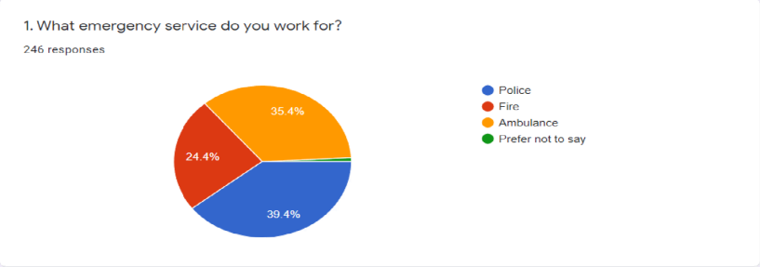
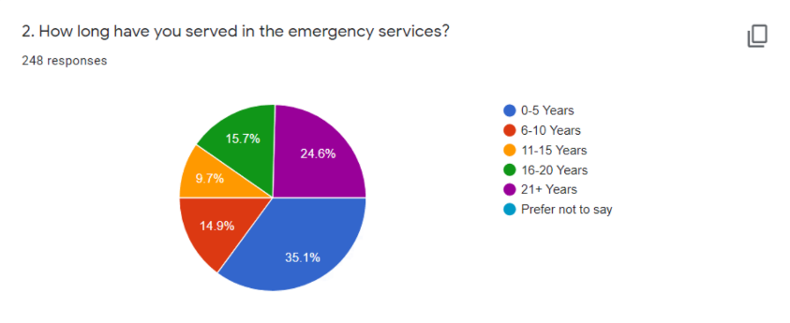
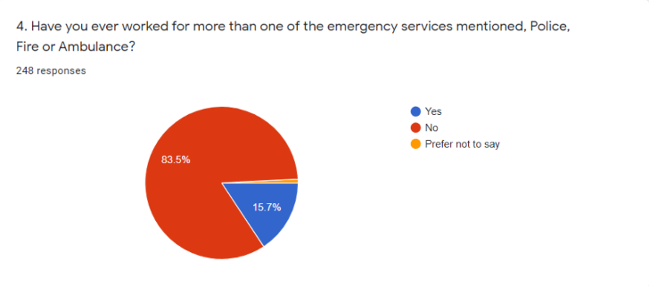

Appendix 2
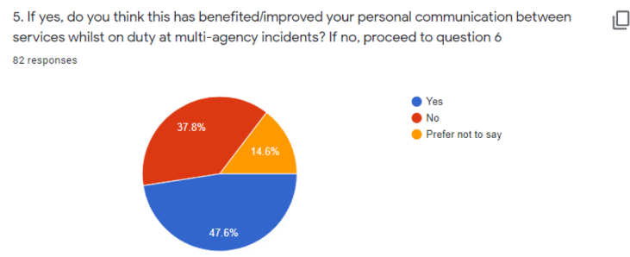

Appendix 3
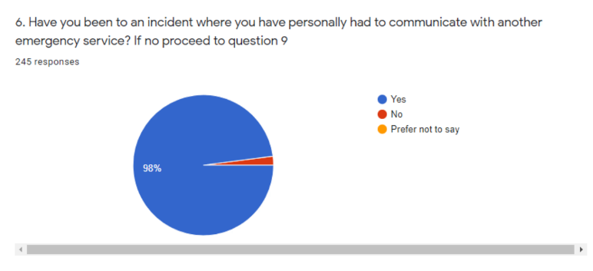

Appendix 4
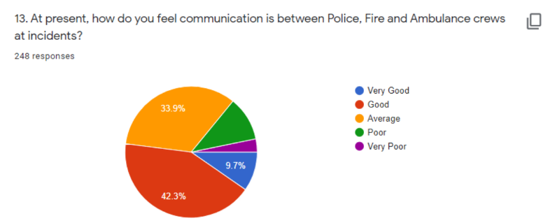

Appendix 5
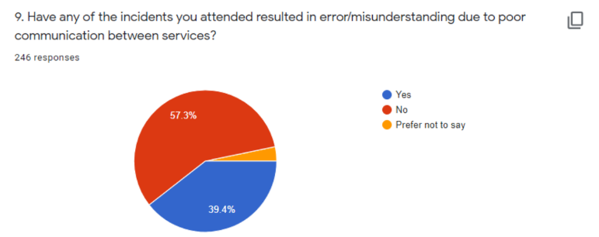

Appendix 6
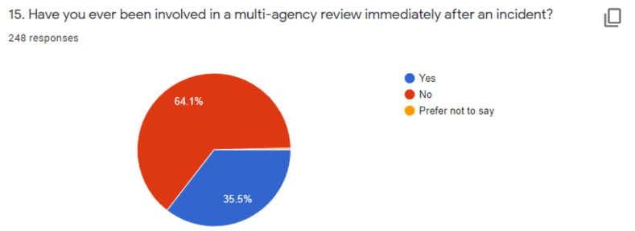

Appendix 7
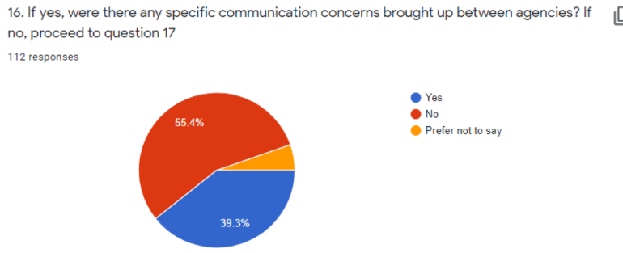
Appendix 8
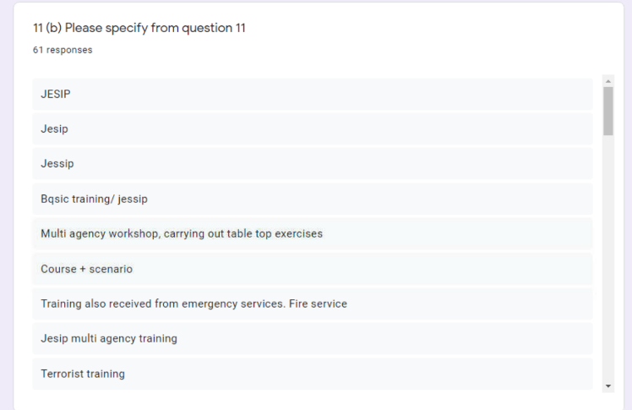
Appendix 9
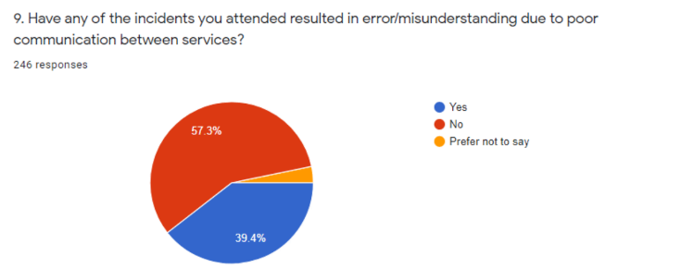

Appendix 10
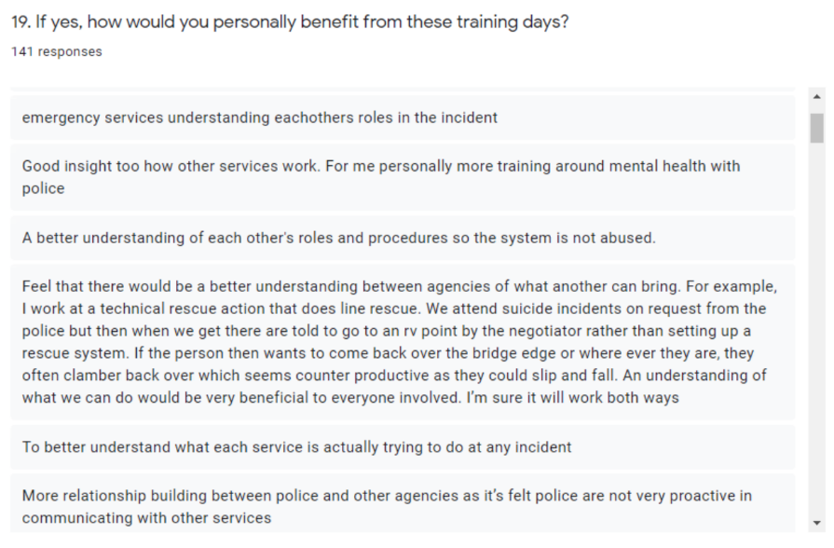

Appendix 11


