

Report title: Component 1: Written Assignment case study report diabetes
Student name: Javaria Irfan Hafiza
Student number:2504716
Module: Introduction to Physiology
Module code BMHP5023
Lecturer: Dr. Robert Nartowski
Word count:2100

Table of Contents
Introduction 3
Section 1: Anatomy & Physiology 3
Section 2: Pathophysiology & Impact: 5
Section 3: Monitoring & Data Use 6
Section 4: Evidence-Based Lifestyle Recommendations 7
Conclusion: 8
Reference: 10

Case study 1 Diabetes

Introduction
Diabetes mellitus is a long-term condition in which the body is unable to produce enough insulin or use insulin effectively, causing glucose (sugar) levels in the blood to become too high. The pancreas produces the hormone insulin, which helps glucose move from the bloodstream into cells, where it can be used as a source of energy. In Type 2 diabetes, the body either does not produce enough insulin, or the insulin does not work effectively, which can result in persistently high blood glucose levels (NHS, 2025a). Poorly controlled blood glucose levels may increase the risk of complications affecting the heart, kidneys, eyes, nervous system and blood vessels.
Key risk factors for Type 2 diabetes include being overweight or living with obesity, physical inactivity, increasing age, having a close family member with diabetes and belonging to certain ethnic groups, including South Asian, Black African and Black Caribbean populations (Diabetes UK, 2025). Some risk factors, such as age, ethnic background and family history, cannot be changed, while others, including physical activity and body weight, can be influenced through lifestyle changes.
The purpose of this report is to provide relevant information to patients attending the GP surgery in the case study who may require a greater understanding of their condition. It will explain how blood glucose is regulated and how cellular metabolism uses oxygen and glucose to produce energy. It will also examine how recording and tracking blood glucose levels can support the safe management of Type 2 diabetes and how lifestyle changes, including diet, exercise and stopping smoking, may improve health outcomes.

Section 1: Anatomy & Physiology
The pancreas, insulin, glucose and cells in the body work together to maintain blood glucose levels within a suitable range. After eating a meal, carbohydrates are broken down into glucose, which enters the bloodstream. The pancreas produces insulin when blood glucose levels rise. Insulin helps move glucose from the blood into the cells so that it can be used for energy. This is important because controlling blood glucose helps the body maintain its normal activities, while cells need glucose to carry out their normal functions. Insulin is an important hormone in regulating glucose metabolism because it helps control the movement and use of glucose in the body (Norton et al., 2022).
(figure 1 Mechanism of action of glucagon)
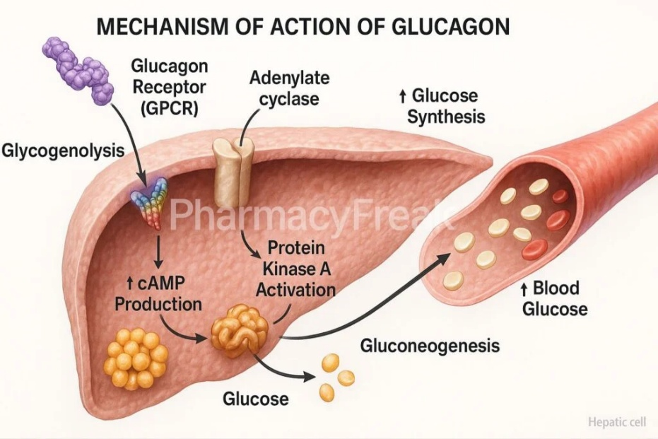(Pharmacy Freak, 2026)

The body can become less responsive to insulin in people with Type 2 diabetes. This is known as insulin resistance. When cells do not respond properly to insulin, glucose cannot move from the blood into the cells as effectively. As a result, more glucose remains in the blood and blood glucose levels can become too high. High blood glucose levels may affect normal body processes and increase the risk of diabetes-related complications if they continue for a long time. Patients visiting the GP surgery should understand this process because it shows why controlling blood glucose is important when managing Type 2 diabetes.
Energy is also necessary for cells to function and carry out important activities such as movement, growth, repair and maintaining normal body functions. Glucose is an important source of this energy. Oxygen helps with the breakdown of glucose during cellular metabolism to release energy. This process happens inside cells and is known as cellular respiration. The energy released is used to produce adenosine triphosphate (ATP), which provides energy for cellular activities. During cellular respiration, glucose is broken down and energy is transferred into ATP, while oxygen is involved in the process and carbon dioxide and water are produced as waste products (Betts et al., 2022).
The connection between insulin, glucose and oxygen shows how different processes in the body work together. Glucose from food enters the bloodstream, insulin helps glucose move into cells, and cells use glucose and oxygen to release energy. In Type 2 diabetes, ineffective insulin action can cause more glucose to remain in the blood instead of moving into the cells effectively. Therefore, maintaining blood glucose at a suitable level is important for normal cell activity and overall health.

Section 2: Pathophysiology & Impact:
Glucose may stay in the bloodstream rather than effectively entering the cells when control of blood glucose is impaired. This can happen because of the body's reduced sensitivity to insulin in Type 2 diabetes. Blood glucose levels may consequently stay high for extended periods of time. This can gradually damage the blood vessels and other organs, increasing the risk of conditions such as kidney disease, heart disease, nerve damage and vision problems. NICE recommends that people with Type 2 diabetes should be supported to manage their blood glucose and make healthy lifestyle changes as part of their diabetes care (NICE, 2026).
Blood glucose levels can be directly influenced by diet. The type and amount of food consumed can affect the amount of glucose that enters the bloodstream because foods containing carbohydrates are broken down into glucose. In addition, a diet high in sugary foods, saturated fats and excess calories may make blood glucose control more difficult and may contribute to weight gain. Being overweight can reduce the body's sensitivity to insulin, making blood glucose management more difficult. On the other hand, a balanced diet that includes vegetables, wholegrains and other foods high in fibre can support better blood glucose control. Dietary advice should consider each person's individual needs, preferences and ability to make changes, supporting people to take an active role in managing their health (The King's Fund, 2026). This is important in the GP surgery because the practice nurse can provide advice that is realistic and suitable for each patient's circumstances.
The body's ability to control glucose is also affected by physical activity. Muscles use glucose as fuel when they are active. Therefore, regular exercise can help the muscles use glucose more effectively and can improve the body's sensitivity to insulin. This can support better blood glucose control and weight management, which may reduce the risk of diabetes-related complications. The UKHSA promotes increased physical activity and a healthy diet as important lifestyle changes for reducing the risks associated with Type 2 diabetes (UKHSA, 2018). For patients in the case study, encouraging regular physical activity can therefore support blood glucose management as well as overall health.
In addition, smoking can be harmful to people who have diabetes. Smoking can affect the blood vessels and increase the risk of cardiovascular problems. This is particularly important because diabetes already increases the risk of damage to the heart and blood vessels. Therefore, stopping smoking can help reduce some of these additional health risks. The practice nurse can help patients understand how their daily choices can affect their condition by discussing healthy eating, physical activity and smoking. This reinforces the case study's goal of educating and encouraging patients to manage their diabetes safely and effectively.

Section 3: Monitoring & Data Use
Health data gathering and recording is essential because it enables patients and healthcare professionals to understand how a condition changes over time. Blood glucose measurements can give individuals with Type 2 diabetes information about their blood glucose levels at a particular time. Patients can identify trends and recognise how factors such as food, exercise and medication can affect their blood glucose levels by keeping a record. Blood glucose meters can store previous results, allowing patients and healthcare professionals to review the information and monitor changes over time. (Department of Health and Social Car ,2019)
Regular monitoring can also support better diabetes management. For example, if a patient regularly monitors their blood glucose levels and finds that the results are frequently higher than their agreed target, they can discuss this with their practice nurse or another healthcare professional. The healthcare team can use this information to assess whether further guidance, support or a review of the treatment plan may be needed. However, not everyone with Type 2 diabetes needs to monitor their blood glucose at home every day. The need for monitoring depends on the patient's treatment and their risk of low blood glucose.
Another significant type of monitoring is HbA1c. An HbA1c test provides an indication of a person's average blood glucose level over the previous two to three months, unlike an individual blood glucose measurement. This gives healthcare professionals a broader view of the person's blood glucose control. Regular HbA1c testing can therefore help healthcare professionals assess diabetes control and identify whether further management or support may be required (Health London, 2025).

Section 4: Evidence-Based Lifestyle Recommendations
People with Type 2 diabetes can control their blood glucose levels and lower their risk of complications by making lifestyle changes. Appropriate adjustments should be made in line with each patient's specific needs, preferences, and ability to make changes. The practice nurse can provide guidance and assistance to patients who visit the GP surgery to help them make small changes that they can maintain over time.

One important lifestyle change is eating a balanced, nutritious diet. Patients can be advised to consume less sugary drinks (glucose-fructose corn syrop), processed foods, and foods high in saturated fats while increasing their consumption of vegetables, wholegrains, and foods that are high in fibre. These changes may support healthy weight management and help regulate the amount of glucose that enters the bloodstream. NICE recommends that dietary advice for people with Type 2 diabetes should be individualised and included as part of a personalised diabetes management plan (NICE, 2026).
Regular exercise is another important recommendation. Patients should start with realistic activities such as walking, cycling, or other activities they enjoy and gradually increase their activity. Muscles use glucose for energy when they are active, which may improve insulin sensitivity and blood glucose control. There is evidence to suggest that various forms and levels of regular physical activity can improve glycaemic control in individuals with Type 2 diabetes, according to a systematic review and meta-analysis. This means that regular activity can have a direct physiological effect on how the body uses glucose (Gallardo-Gómez et al., 2024).
Moreover, smoking cessation should be emphasised. Because people with diabetes already have a higher risk of developing cardiovascular problems, smoking can harm blood vessels and increase cardiovascular risks. (NHS, 2025b). The practice nurse can talk to patients about their smoking habits and offer or recommend suitable support for quitting. Therefore, quitting smoking can help lower further risks to the heart and blood vessels (NHS, 2025b).
Lastly, combining dietary changes with regular exercise may improve the likelihood that lifestyle changes will be successful. Research suggests that combining dietary changes with regular exercise can provide additional health benefits for people with Type 2 diabetes, including improvements in physical fitness and, in some studies, blood glucose control and body weight (Amerkamp et al., 2025).
Therefore, rather than asking patients in the case study to change everything at once, the practice nurse should support achievable changes. This may encourage safer, long-term diabetes management by helping patients understand how their everyday choices influence their bodies.

Conclusion:
To sum up, Type 2 diabetes is a chronic medical condition that interacts with the body's ability to control blood sugar levels. Recognising how insulin, glucose, and cells connect is important because it allows patients to understand the need of maintaining healthy blood glucose levels for regular bodily functions. When the body develops insulin resistance, glucose can stay in the bloodstream, which can raise the risk of complications affecting the heart, kidneys, eyes, nerves and blood vessels.
Checking blood glucose levels along with utilising health data can help patients and medical professionals understand how well diabetes is being managed effectively. Recording blood glucose results and checking HbA1c can provide useful information about blood glucose control over time. Healthcare professionals can use this information to assess whether a patient might need more support or adjustments to their medical care.
The management of Type 2 diabetes also depends significantly on lifestyle decisions. Blood glucose control, good weight maintenance, and cardiovascular health can be promoted by a balanced diet, frequent exercise, and quitting smoking. According to the evidence included in this report, individuals with Type 2 diabetes could benefit even more from a blend of regular exercise and a good diet.
Therefore, the practice nurse's role is crucial in helping patients comprehend their illness and make practical lifestyle adjustments. Providing patients with clear information, encouraging them to monitor their health and giving them individualised support can help them take a more active role in managing their condition. Overall, helping patients understand Type 2 diabetes better can support safer and more effective long-term management and may reduce the risk of future complications.

Reference:

1. Amerkamp, J., Benli, S., Isenmann, E. and Brinkmann, C. (2025) ‘Optimizing the lifestyle of patients with type 2 diabetes mellitus: Systematic review on the effects of combined diet-and-exercise interventions’, *Nutrition, Metabolism and Cardiovascular Diseases*, 35(5), p. 103746. doi: 10.1016/j.numecd.2024.09.016.
(Accessed: 4 October 2026).
2. Betts, J. G., Young, K. A., Wise, J. A., Johnson, E., Poe, B., Kruse, D. H., Korol, O., Johnson, J. E., Womble, M. and DeSaix, P. (2022) *Anatomy and Physiology 2e*. Houston: OpenStax. Available at: https://openstax.org/books/anatomy-and-physiology-2e/pages/1-introduction
(Accessed: 28 September 2026).
3. Diabetes UK (2025) *Type 2 diabetes risk factors*. Available at: https://www.diabetes.org.uk/about-diabetes/type-2-diabetes/diabetes-risk-factors
(Accessed: 27 September 2026).
4. Gallardo-Gómez, D., Salazar-Martínez, E., Alfonso-Rosa, R. M., Ramos-Munell, J., del Pozo-Cruz, J., del Pozo Cruz, B. and Álvarez-Barbosa, F. (2024) ‘Optimal Dose and Type of Physical Activity to Improve Glycemic Control in People Diagnosed With Type 2 Diabetes: A Systematic Review and Meta-analysis’, *Diabetes Care*, 47(2), pp. 295–303. doi: 10.2337/dc23-0800. Available at: https://pubmed.ncbi.nlm.nih.gov/38241499/
(Accessed: 4 October 2026).
5. Department of Health and Social Care (DHSC) (2019) Medical devices: information for patients. Available at: https://www.gov.uk/guidance/medical-devices-information-for-users-and-patients
(Accessed: 28 September 2026).

6. My Health London (2025) *Blood glucose monitoring*. Available at: https://www.myhealthlondon.nhs.uk/resources/internal/blood-glucose-monitoring/
(Accessed: 28 September 2026).

7. National Institute for Health and Care Excellence (NICE) (2026) *Type 2 diabetes in adults: management*. NICE Guideline [NG28]. London: NICE. Available at: https://www.nice.org.uk/guidance/ng28
(Accessed: 4 October 2026).

8.NHS (2025a) Type 2 diabetes. Available at: https://www.nhs.uk/conditions/type-2-diabetes/
(Accessed: 27 September 2026).

9. NHS (2025b) Treatment for type 2 diabetes. Available at: https://www.nhs.uk/conditions/type-2-diabetes/treatment/
(Accessed: 7 October 2026).
10. Norton, L., Shannon, C., Gastaldelli, A. and DeFronzo, R. A. (2022) ‘Insulin: The master regulator of glucose metabolism’, *Metabolism*, 129, p. 155142. doi: 10.1016/j.metabol.2022.155142.

11. Pharmacy Freak (2026) *Mechanism of Action of GLP-1*. Available at: https://pharmacyfreak.com/mechanism-of-action-of-glp-1/
(Accessed: 7 October 2026).
12. Public Health England (2018) *Health matters: preventing Type 2 diabetes*. Available at: https://www.gov.uk/government/publications/health-matters-preventing-type-2-diabetes/health-matters-preventing-type-2-diabetes
(Accessed: 28 September 2026).

12. The King's Fund (2026) *What makes care outstanding? * Available at: https://www.kingsfund.org.uk/insight-and-analysis/reports/what-makes-care-outstanding-cqc
(Accessed: 4 October 2026).

