

A critical analysis of the relationship between teacher subject knowledge and effective learning and teaching in the primary school

Within this assignment the writer will undertake a critical analysis of the relationship between teacher subject knowledge and effective learning and teaching within the primary school. This will be achieved by conducting a literature review on relevant theorists in this area of education. In particular the writer will be reviewing the work undertaken by Lee Shulman’s key aspects for knowledge for teaching, the knowledge quartet and how this relates to the new curriculum being developed by Graham Donaldson; successful futures. Throughout this literature review, this assignment will aim to discover the key points of subject knowledge and how that informs effective teaching and learning. From the findings of this literature review, the writer will aim to relate it to professional experiences from placement and to then help inform future practice.
The writer’s first professional teaching experience (PTE) took place in a two form entry school in the Vale of Glamorgan. This school has recently been built and it is a pioneer school for the new Donaldson curriculum and the digital competency framework. The year group that the practitioner had spent PTE one working with, was year two where each lesson was run in carousel activities. Within the carousel activities there were continuous literacy, numeracy and ICT skills being developed even if those subjects were not the main focus of the lesson. This assignment will reflect on the writer’s own subject knowledge across all of the six areas of learning within the Successful Futures Document.

Literature review
Much of the theory relating to teacher subject knowledge comes from Lee Shulman (1987) who wanted to discover the impacts of teaching and learning as a result of teacher’s subject knowledge. Shulman suggests that there are different contents that form a teacher’s knowledge base; content knowledge; general pedagogical knowledge; curriculum knowledge; knowledge of learners and their characteristics; and knowledge of educational contexts. Shulman then developed the idea that there are four major sources for teaching the knowledge base, the first being scholarship in content disciplines where a teacher must not only understand the content being taught in class, but have a depth of understanding with respect to the subject being taught to be able to respond to discussions in class. Young and Muller (2015) suggest that some teachers lack clear subject knowledge across the curriculum which may be noticeable by the children leading to disengagement and an ineffective learning environment.
The second source of the knowledge base is educational materials and structure. Teacher subject knowledge may be based on school initiatives or schemes of work. If so this may inform teachers subject knowledge as they have a program to follow. Next is the formal educational scholarship which is the understanding of the process of teaching, schooling, teaching and learning. The final source of the knowledge is the wisdom of practice where Schulman talks about what guides the practice of able teachers. Schulman (1987) carried out an observation with an experienced English teacher who talks about what guides her practice; she uses a four step model when teaching children. Firstly she teaches the literal meaning, next she questions the meaning in relation to characters, after that she discusses the different interpretations and what effects they may have, and finally she tries to apply this to real life scenarios and questions where the children may see this in their own society. Berry, Friedrichsen and Loughran (2015) argues that not all teachers have the content knowledge available to be able to provide expansive explanations, this may have a detrimental effect on learning as different pupils learn in different ways.
Schulman does go on to say that the knowledge base for teaching is not fixed and final, how can it be when different schools adopt different methods of teaching and different schemes of work. However, he does suggest that teacher subject knowledge is important and the key for teachers is to first understand the content knowledge and then transform this into pedagogically powerful lessons. Homes Group (1986) and the Carnegie Task Force (1986) support Schulman’s work by arguing that teacher knowledge should frame teacher education and directly inform teaching practice. However, Hattie (2012) suggests that teacher subject knowledge had little effect on the quality of student outcomes. He argues that expert teachers or experienced teachers do differ in how they structure lessons and utilise their subject knowledge and how they can relate lesson content to other subjects in the curriculum. Kleickmann and Anders (2013) do not agree with this and suggest that teacher subject knowledge is vitally important for pupil progress.
A different view towards teacher subject knowledge is the knowledge quartet which was developed by Rowland, Huckstep and Thwaites (2003) who base their work around the findings of Shulman. The research that they carried out focused more on teacher’s mathematical knowledge. However their findings from this research can be applied to all subjects across the curriculum. The knowledge quartet is made up from; foundation, transformation, connection and contingency.
Foundation is the knowledge and beliefs that inform pedagogical choices and strategies, these beliefs regarding maths inform their way of teaching. Transformation is seeing the knowledge of teachers in action through planning to teach and the act of teaching itself. Of particular importance is the teacher’s use of examples presented to pupils which demonstrates how deep a teacher’s subject knowledge is. Connection involves linking different areas of maths to real life scenarios, drawing on prior knowledge. The contingency is the ability for teachers to be able to respond to children’s ideas and their readiness to deviate from an agenda set out when the lesson was prepared. Hattie (2012) supports this theory by suggesting that excellent teachers are able to predict and determine the types of errors that children may and therefore be much more responsive to pupils. Uncertainty about the sufficiently of one’s subject knowledge may include feelings of anxiety. The knowledge quartet may help inform better understanding of maths and develop richer learning experiences for learners.
Many theorists support the importance of teacher subject knowledge. Not only must a teacher understand that something is so, the teacher must further understand why it is so and therefore the emphasis is on a deep understanding of the subject matter taught at school (Krauss et al, 2008). To be an excellent teacher a relationship should exist between a teacher’s subject knowledge of the content they are teaching and the progress made by their pupils. Teachers cannot help children learn new things if the teacher does not understand the content being taught themselves (Ball, 1991). Teacher’s level of understanding of the content they are teaching is related to how effectively children learn it. Hill et al (2005) suggest that the difference in teachers who have a good subject knowledge compared to teachers without equates to more than a month’s additional learning for children in a year.
Most teachers will have high expectations of themselves and their abilities to teach children across all areas of the curriculum. However, Muijs et al (2014) argue that ‘a great teacher may have high expectations’ is of no use to the learners unless they have a strategy for raising their own expectations in the form of subject knowledge. This theory is supported by Coe et al. (2014) who suggest that simply describing or defining new concepts or approaches is not enough to characterise teachers as more or less effective; it matters why the teachers adopt them. If teachers do not make informed choices as to why they teaching in a certain way then it may not be effective. Askey et al (1997) identified beliefs about the nature of mathematics and what it means to understand it, along with teachers’ beliefs and theory about how children learn and about the teacher’s role in promoting learning, as important factors between those who were more and less effective. Askey’s findings suggest that teachers have a duty to understand mathematics and how best to deliver it to a class full of children in a variety of ways. This theory can be related to all subjects across the curriculum.
Another point to consider is some teachers may have specific skills in certain subjects due to the subject of their degrees. Coe et al. (2014) suggest that for teachers who hold a degree in mathematics or science were associated with higher pupil learning, but this was not the case in other subjects. Having good subject knowledge in all areas of the curriculum is important for a primary school teacher, but as soon as children reach comprehensive school they change from having one teacher who is expected to have sound subject knowledge of all subjects to lots of teachers who specialise in one subject.
Within Wales over the coming years there will be a new curriculum that all schools will adopt.Currently there are pioneer schools throughout Wales trialling this curriculum called Successful Futures. Graham Donaldson and his team responsible for this new curriculum had many meetings with head teachers, class teachers, school managers, staff and professionals across nurserys, primary, secondary and special schools across Wales. Donaldson talked to over seven hundred people including 300 children and young people. Donaldson discovered that teachers want more power to be able to make decisions about what and how to teach within the curriculum. The children that Donaldson spoke with wanted to have greater influence in shaping their own learning, which may have implications on teachers as their subject knowledge is vital in being able to meet these needs (Donaldson, 2015). Hattie (2012) suggests that excellent teachers are able to educate children to have deep understanding of the all the subjects they teach and therefore are able to meet the varying needs of each pupil.
Donaldson suggests that the curriculum should have four purposes that mean all children will be; ambitious, capable learners; enterprising, creative contributors; healthy, confident individuals; and ethical, informed citizens. These four purposes should inform all of the six areas of learning and experience. The report suggests these areas of learning should ensure a broad educational experience for all children. For teachers, literacy, numeracy and digital competence should be the main focus of each lesson as they should be developed and strengthened across the whole curriculum. Therefore for the ambitions of this curriculum to be successful, teachers are required to have excellent professional skills and judgement in selecting the right teaching methods. Hattie (2012) supports this theory by suggesting that to achieve excellence, teachers must provide recourses and methods that they believe are best and to be able to go back to it tomorrow and have a chance of doing it again but improve it to make for a better experience for the children. These high expectations will only be realised through effective teaching that engages children’s curiosity and enthusiasm through a variety of teaching and learning opportunities. Haberman, Gillette and Hill (2017) support this theory by suggesting that excellent teachers know their children quite well and are therefore able to provide knowledgeable and engaging lessons.
Another important factor of the new curriculum is the place of the Welsh language in the new curriculum. Donaldson (2015) suggests that teacher’s use of Welsh language needs to be strengthened. The report argues that greater focus on children’s ability to speak Welsh confidently in everyday situations is vital with a greater emphasis on its increasing role in workplace settings. According to the Donaldson report, teacher and school leaders need to extend their abilities not only in Welsh, but in health and wellbeing, digital skills, computer science and curriculum for the new curriculum to be a success. Finally, the successful futures document suggests that curriculum development relies on schools and teachers to be directly involved in shaping this curriculum in ways that meet the needs of the children. For this to be achieved, subject knowledge of teachers is of great importance to be able to teach content that is relevant and help create successful futures for all children.

Analysis of student’s subject knowledge
Following my first professional teaching experience (PTE) I am able to understand the relevance of the subject knowledge of teachers. My first placement was in foundation phase in year two and therefore I feel that I have only had a small insight of the depth of subject knowledge required from a teacher. However from my experiences of planning and delivering lessons, subject knowledge is essential to ensure that children are having valuable learning experiences. On placement I delivered lessons where I felt confident and had a great understanding of what I was teaching and one or two lessons where I did not have the in depth background knowledge of what I was teaching. Having the background knowledge or not, I feel that both situations produced positive learning experiences for the children.
Having good subject knowledge when teaching can support the teacher when delivering a lesson, Shulman (1987) suggested that a teacher must understand what he or she is teaching but should have a wealth of understanding to be able to extend the learning. From my experiences I think that having good knowledge of a subject is linked to good planning, when planning a lesson if I did not have the greatest understanding of the topic being taught then I would collaborate with the class teacher to ensure that the quality of the lesson was acceptable. Dawson and Saad (2018) suggest that to create quality lesson plans, a teacher must understand the content of what they are planning to teach. Not only did Shulman suggest that teacher subject knowledge is important but he argues that this knowledge should be delivered in pedagogically powerful lessons. When I delivered lessons that I did not feel overly confident in my subject knowledge, I found it hard to extend the learning for the higher ability children. I think that being able to challenge the higher ability children will come by gaining more experience which should also help develop my subject knowledge.
Referring to Shulman’s knowledge base, he suggests that a teacher must understand the content being taught in order to develop discussion in class. I feel that my knowledge for the year group that I worked with was at a level where I could scaffold group discussions, and intervene if I felt that the children were going off task. Dreher and Kuntze (2014) suggest that it is essential that teachers have specific knowledge to the topic being taught, this will then help develop children’s understanding and curiosity in different topics. On a couple of occasions during PTE I concluded the discussions and moved on as I lacked the confidence to be able to extend the learning. This is a reoccurring theme during my placement that maybe I did not have the depth of knowledge that Schulman (1987) refers to. However, these situations tended to occur during non-core subjects. I feel that I did not encounter these situations too often during literacy and numeracy lessons.
Another part of Schulman’s knowledge base is that teacher’s knowledge depends on different school initiatives. During PTE the school used The Abacus Maths Scheme when planning all of their maths lessons, this may help teachers who do not have the confidence to teach maths as they have a rigid structure to follow. McCormick and James (2018) support my theory by suggesting that teachers use methods that are convenient as opposed to strategies that are best suited to the problem. However, I am extremely confident in my mathematical abilities and I believe that I can show children different ways to solve problems. An example of this came during a smile addition lesson, I had the confidence to be able to predict when a child was going to make a mistake and help support the learning. Also during this lesson I was able to extend the learning for the higher ability children by providing extra challenges (appendix 1). So I believe for me, the school schemes or initiatives restricted my ability to demonstrate different strategies.
The wisdom of practice forms the final part of Schulman’s knowledge base. He referred to a case study he carried out where a teacher follows four steps when teaching literacy; literal meaning, what this tell us, different interpretations, and real life context. I believe that these steps can be applied across the curriculum and with the new curriculum coming to Wales in the coming years, these cross-curricular skills will be important. Geiger et al (2018) suggest that giving multiple definitions and demonstrating how new concepts work in real life scenarios can develop children’s knowledge and enthusiasm in science, technology and maths. I believe that I tried to apply these four steps during my lessons, especially linking new skills to practical situations. This was evident during one of my observations on placement; one of my highlighted strengths was to be able to link problem solving skills to real life scenarios. However, I could not achieve these four steps during every lesson as I do not have the in depth knowledge of all topics across the curriculum. I believe that I will develop my knowledge across the curriculum subjects through gaining a wide breadth of experiences including teaching throughout the different age groups and by working with different teachers.
A different theory behind teacher subject knowledge is the knowledge quartet developed by Rowland, Huckstep and Thwaites (2003). The first step of the quartet is the foundation which is the beliefs of teachers that inform a way of teaching. During my placement I think sometimes I got into a habit of using the same questioning strategies when teaching, and on reflection I believe that this was due to a lack of depth on my subject knowledge in some areas. I consider maths to be a strength of mine as I previously mentioned, however, when teaching ICT and art I found it difficult to vary my lessons and only had one way of teaching the children the new skills. I had limited opportunities to teach these lessons and therefore have not had too many chances to develop these areas of the curriculum; this is a target that I would like to develop during my next placement. This links to the next step of the knowledge quartet; transformation, which is seeing a teachers knowledge through planning and teaching. My lesson plans regularly involved the questioning technique think, pair, share (appendix 2). Towards the end of placement I began to develop my questioning strategies and utilising different strategies during plenaries too (appendix 3). I believe that this highlights my developing confidence in my knowledge.
The third part of the knowledge quartet is connection which links a new mathematical skill to a previously learnt skill. I think that I did this really well during placement not only during numeracy lessons but throughout all curriculum topics. This aspect of the quartet was one of my highlighted strengths during my observations that I was able to link new learning to prior learning, I was able to use the made up character of ‘Pirate Pete’ throughout all lessons to try to hook the children. Vygotsky (1978) suggests that there is a zone of proximal development where children learn best when they can build on prior knowledge to learn something new. During placement I feel that my confidence in my mathematical ability allowed me to naturally link new skills to old ones and also create links to real life scenarios. Artzt et al (2015) suggest that learning is facilitated when children are encouraged to link new information to their prior knowledge. In other areas of the curriculum this ability did not come so naturally, in literacy lessons I would be able to create exciting engaging lessons but I did not have the same level of confidence that I do in my numeracy abilities.
Finally, the last part of the knowledge quartet is the contingency which is being able to respond to pupils’ ideas and to be able to deviate from the prepared plan. During placement I feel that I had mixed experiences when children voiced differing opinions to the learning that was taking place. For the majority of these experiences I feel that I was able to provide insightful responses and I believe that this was due to the year group that I was working with. From my limited experiences of being the class teacher, I believe that my subject knowledge will need to be more in depth when I move into Key Stage Two. Meyer, Kamens and Benavot (2017) support my theory by suggesting that the depth of a teacher’s subject knowledge must increase the older the year group, especially in non-core subjects such as science and humanities. However, I think that for foundation phase, different subject knowledge is required such as initial sounds, phonics and blending. On placement I found teaching initial sounds and blending words challenging because my knowledge of how to explain it was not strong enough. I do believe that my literacy abilities became stronger towards the end of placement and an example of this is highlighted in my ARC form when I taught the pupils how to use paragraphs (appendix 4). I would have found this lesson challenging to deliver at the beginning of placement, but I felt that I developed my vocabulary and explanations which led to an enriching learning experience for the children. I still need to develop my vocabulary and phonics abilities if I am to teach in the foundation phase in my career.
Looking forward to the new curriculum that will be introduced in Wales in the coming years, teachers will be required to deliver cross curricular lessons which will draw upon a variety of teacher’s knowledge. During placement I was lucky enough to have an opportunity to deliver a range of different subjects. Mainly I taught literacy and numeracy which were imbedded into nearly all lessons, but I taught ICT, geography, history, art, Welsh and music. I feel that my knowledge of these topics was limited and would sometimes be evident in my ability to extend explanations and push the children further in their learning. Donaldson (2015) suggests that teachers have a responsibility to develop literacy, numeracy and digital competence across all areas of the curriculum. I believe that I developed literacy and numeracy skills effectively throughout different subjects, however I found including digital competence skills into lessons more challenging but something that I began to introduce more towards the end of practice (appendix 5). Tomte et al (2015) suggest that ICT skills are vital in our constantly developing digital world and that student teachers should be encouraged to develop their own digital competence abilities in order to effectively teach ICT to children. Personally I agree with this theory, I am competent using IT but I feel that I lack the knowledge to be able to teach it with confidence.
Looking at the other areas of learning in the new curriculum; science and technology; humanities; expressive arts; and health and well-being, I feel that I will need to develop my knowledge in these areas in order to ensure I deliver a variety of lessons. Harlen and Qualter (2018) suggest that skills learnt in certain contexts can be widely applied in other areas of learning promoting cross curricular education. I believe that when planning lessons I will naturally include cross curricular skills such as literacy and numeracy skills, but I will need to be more aware of the other areas of the curriculum. I believe that this ability will become easier for me as I become more experienced and develop my knowledge of these areas of learning.
Conclusion
From Shulman’s research into teacher subject knowledge and being able to use that against my own teaching experiences, I believe that it is important for teacher’s to have good subject knowledge. I think that having a depth of background knowledge to the topic being taught is vital to ensure that all children are to have access to enriching learning experiences. Personally I feel that I have learnt a lot about my own subject knowledge from professional practice, I feel that I have a good wealth of knowledge when teaching the elements that Donaldson suggests should be at the heart of every lesson; literacy and numeracy. However I still need to develop my ability to integrate digital competency skills into all aspects of the curriculum. I will have to be constantly developing and evolving to ensure that I can be an effective teacher. For the other areas of the curriculum I do not feel as confident or strong in planning and delivering these lessons, I will make this a target for my next placement. Finally, I think that a teacher needs a greater depth of subject knowledge when teaching the older the age groups especially when responding to children’s curiosities and extending their learning. For the younger age groups more specific knowledge is required such as the use of phonics when teaching children how to read.

Appendices:
Appendix 1:

Appendix 2:
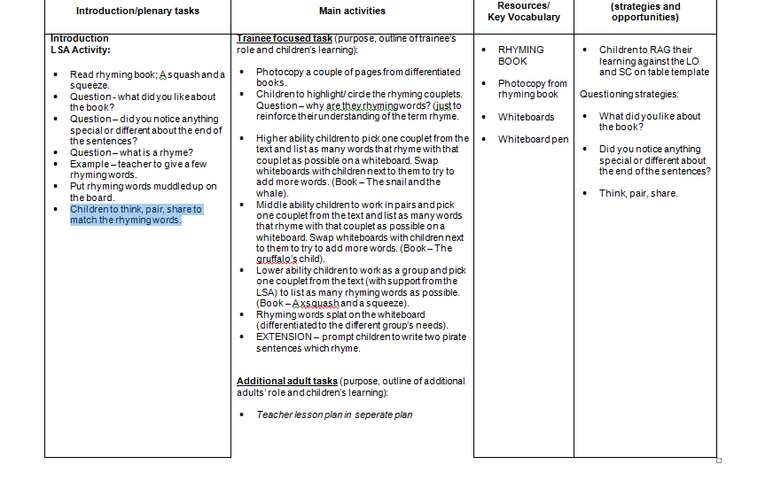

Appendix 3:

Appendix 4:


Appendix 5:
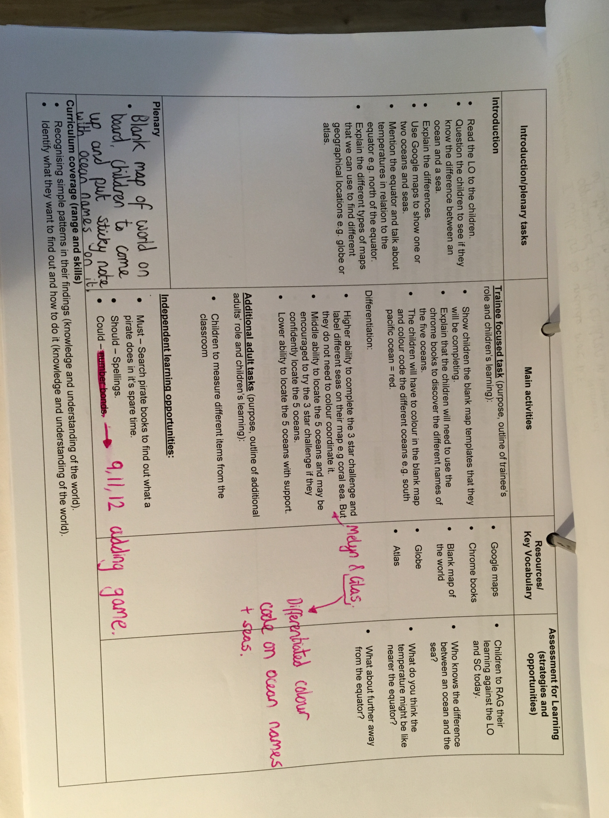

Reference list:

Artzt, A., Armour-Thomas, E., Curcio, F. and Gurl, T. (2015). Becoming a Reflective Mathematics Teacher.. Abingdon, Oxon: Taylor and Francis.

Askew, M., Brown, M., Rhodes, V., Wiliam, D., and Johnson, D. (1997). Effective Teachers of Numeracy: Report of a study carried out for the Teacher Training Agency. London: King's College, University of London.

Ball D.L and Hill H.C. (2009). Measurement issues and assessment for teaching quality. Washington, DC: Sage Publications.

Berry, A., Friedrichsen, P. and Loughran, J. (2015). Re-examining pedagogical content knowledge in science education. London: Routledge.

Carnegie Task Force on Teaching as a Profession (1986) A nation prepared: Teachers for the 21st century. Washington, DC: Carnegie Forum on Education and the Economy.

Coe, R., Aloisi, C., Higgins, S. and Major, L. (2014). Review of the underpinning research. What makes great teaching?, 1(1).

DAWSON, C.W. and SAAD, A., (2018). Requirement elicitaton techniques for an improved case based lesson planning system. Journal of Systems and Information Technology, 20(1), pp. 19-32.

Donaldson, G. (2015). [online] Gov.wales. Available at: https://gov.wales/docs/dcells/publications/150225-successful-futures-en.pdf [Accessed 15 Oct. 2018].

Dreher, A. and Kuntze, S. (2014). Teachers’ professional knowledge and noticing: The case of multiple representations in the mathematics classroom. Educational Studies in Mathematics, 88(1), pp.89-114.

Geiger, V., Mulligan, J., Date-Huxtable, L., Ahlip, R., Jones, D., May, E., Rylands, L. and Wright, I. (2018). An interdisciplinary approach to designing online learning: fostering pre-service mathematics teachers’ capabilities in mathematical modelling. ZDM, 50(1-2), pp.217-232.

Haberman, M., Gillette, M. and Hill, D. (2017). Star teachers of children in poverty. New York: Routledge.

Harlen, W. and Qualter, A. (2018). The teaching of science in primary schools. London: Routledge.

Hattie, J. (2012). Visible learning for teachers. Hoboken: Taylor and Francis, pp.28-37.

Hill, H. C., Rowan, B., and Ball, D. L. (2005). Effects of Teachers' Mathematical Knowledge for Teaching on Student Achievement. American Educational Research Journal, 42(2), 371-406.

Kleickmann, T., and Anders, Y. (2013) Research on teachers’ professional competence: Results from the COACTIV research program. New York, NY: Springer.

Krauss, S., Brunner, M., Kunter, M., Baumert, J., Blum, W., Neubrand, J., and Jordan, A. (2008). Pedagogical content knowledge and content knowledge of secondary mathematics teachers. Journal of Educational Psychology, 100, 716-725.

McCormick, R. and James, M. (2019). Curriculum evaluation in schools. London: Routledge.

Meyer, J., Kamens, D. and Benavot, A. (2018). SCHOOL KNOWLEDGE FOR THE MASSES. [S.l.]: ROUTLEDGE.

Muijs, D, Kyriakides L, van der Werf G, Creemers B, Timperley H & Earl L (2014) State of the art – teacher effectiveness and professional learning, School Effectiveness and School Improvement: An International Journal of Research, Policy and Practice. 25:2, 231-256.

Rowland, T., Huckstep, P. and Thwaites, A. (2003). THE KNOWLEDGE QUARTET. Proceedings of the British Society for Research into Learning Mathematics, 23(3), pp.97-102.

Shulman, L. (1987). Knowledge and Teaching: Foundations of the New Reform. Harvard Educational Review, 57(1), pp.1-23.

The Holmes Group (1986) Tomorrow’s teachers: A report of the Homes Group. East Lansing, MI: Author.
Tømte, C., Enochsson, A., Buskqvist, U. and Kårstein, A. (2015). Educating online student teachers to master professional digital competence: The TPACK-framework goes online. Computers & Education, 84, pp.26-35.
Vygotsky, L. S. (1978). Mind in society: The development of higher psychological processes. Cambridge, MA: Harvard University Press.

YOUNG, M. and MULLER, J. (2015). Three Educational Scenarios for the Future: lessons from the sociology of knowledge. European Journal of Education, 45(1), pp.11-27.

