

Student name: Saskia Green
Student ID: 2416443

Module name: Introduction to Physiology
Module code: BMPH5023
Lecturer name: Shania Hussain

Assessment: written assignment component 1

Table of contents
1. Introduction……………………………….3

2. Structure of the respiratory system……………….4
2.1 The process of mechanical respiration…………….5

3. Gas exchange in lungs……………………………………5
3.1. How increased levels of irritants in the respiratory system led to swelling in the lung tissue, and the impact of this on respiration………………………………………….6

4. Recording and tracking respiratory functions………….7
4.1. Give reasons for the importance of tracking and recording, and if it wasn’t tracked, what would happen…8
5. Recommendations ……………………………………………9
6. Conclusion ………………………………………………9,10
7. References ………………………………………………11

Introduction
Asthma is a chronic respiratory condition characterised by inflammation and narrowing of the airways, leading to symptoms such as wheezing, shortness of breath, chest tightness, and coughing. These symptoms can vary in severity and frequency, often triggered by environmental factors or physical activity. The underlying cause of asthma involves a complex interplay of genetic and environmental factors that lead to airway hyper responsiveness and inflammation (Global Initiative for Asthma, 2023).

Several risk factors are associated with the development and exacerbation of asthma. Genetic predisposition plays a significant role, with a family history of asthma or other allergic conditions increasing the likelihood of developing the disease. Environmental factors, such as exposure to allergens pollen, dust mites, air pollution, and tobacco smoke, can also contribute to asthma risk. Additionally, respiratory infections during early childhood and occupational exposures to irritants are recognised as potential risk factors (Global Initiative for Asthma, 2023).

This case study report will examine the structure of the respiratory system, the mechanics of breathing and how gas exchange occurs in the lungs. It will also consider how irritants affect the lung tissue, leading to inflammation and restricted air flow and explore the risk factors linked to asthma.


Person using asthma pump (Livi, 2022)
-

2. Structure of the respiratory system
The respiratory system is a complex network responsible for gas exchange, primarily oxygen intake and carbon dioxide expulsion. It consists of the upper and lower respiratory tracts. The upper tract includes the nose, nasal cavity, and pharynx, which filter, warm, and humidify incoming air. The lower tract forms the larynx, trachea, bronchi, and lungs. The trachea bifurcates into two bronchi, each leading to a lung where they further divide into smaller bronchioles, culminating in alveoli. These tiny sacs are the site of gas exchange, surrounded by capillaries that ease oxygen and carbon dioxide diffusion (Johnson, 2020). The diaphragm and intercostal muscles aid in ventilation by altering thoracic volume, this creating pressure changes that drive air movement. This intricate system ensures efficient respiratory function, vital for cellular metabolism and homeostasis.
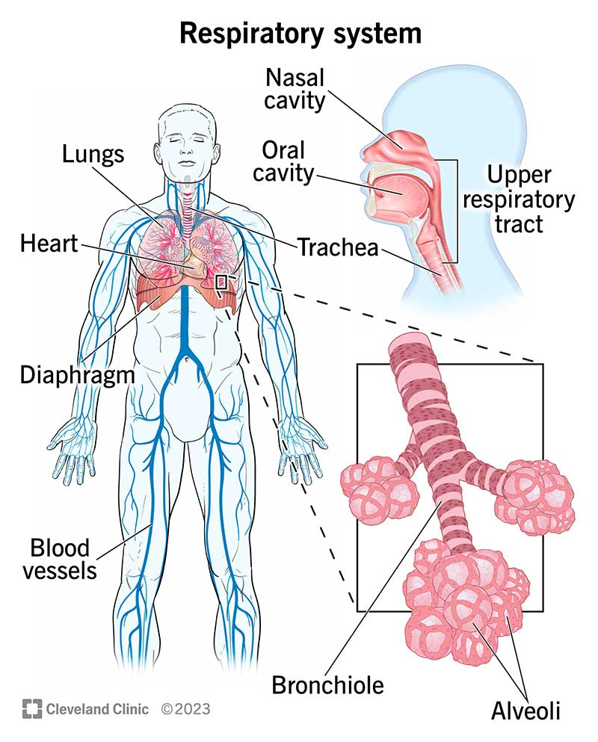
Diagram of respiratory system (Cleveland Clinic, 2026)

2.1 The process of mechanical respiration
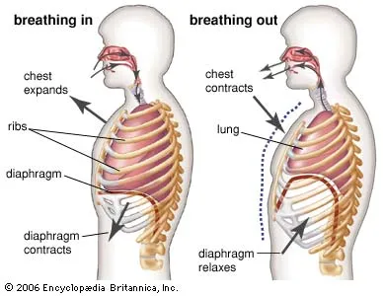
Mechanical respiration is the physical process that moves air into and out of the lungs. It occurs in two main phases, inspiration, and expiration driven by pressure within the nasal cavity. During inspiration, the diaphragm contracts and flattens while the external muscles contract to lift the rib cage upward and outward. This increases the volume of the cavity reducing the pressure inside the lungs compared to atmospheric pressure, allowing air to flow in. In expiration, the diaphragm relaxes and returns to its dome shape, and the rib cage moves downward and inward as the muscles relax. This decreases thoracic volume, increases lung pressure, and forces air out of the lungs. In normal breathing, expiration is mostly passive, although it can become active during exercise (Guyton Hall, 2021)
Labeled picture of mechanical respiration (A. Siebens, 2026)

3. Gas exchange in lungs
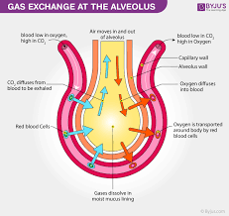
Oxygen absorption and carbon dioxide release in the human respiratory system occur primarily in the alveoli, tiny air sacs in the lungs. When we inhale, oxygen-rich air travels down the trachea, through the bronchi, and into the alveoli. The alveoli are surrounded by a network of capillaries, which are small blood vessels with thin walls that help gas exchange. Oxygen diffuses across the alveolar membrane into the blood in the capillaries due to the concentration gradient, as the oxygen concentration is higher in the alveoli than in the blood. Haemoglobin molecules in red blood cells bind to the oxygen, forming oxyhemoglobin, which is then transported throughout the body to supply tissues and organs. Simultaneously, carbon dioxide, a waste product of cellular metabolism, is transported back to the lungs via the bloodstream. In the capillaries surrounding the alveoli, carbon dioxide diffuses from the blood into the alveoli because its concentration is higher in the blood than in the alveolar air. This process is eased by the enzyme carbonic anhydrase, which helps convert carbon dioxide into bicarbonate ions for easier transport in the blood. Once in the alveoli, carbon dioxide is expelled from the body during exhalation. This efficient exchange of gases is crucial for keeping the body's pH balance and ensuring that tissues receive adequate oxygen for metabolic processes (Jess.S, 2026)

3.1 How increased levels of irritants in the respiratory system led to swelling in the lung tissue, and the impact of this on respiration.
When you breathe in things like smoke, air pollution, dust, and chemical fumes, they can hurt your lungs. The body knows that these things are bad for you and sends out an immune response when they get into the airways. This reaction causes inflammation, which makes the lining of the airways and lung tissue swell and become irritated. Histamine and other chemicals are released by the body during this process. These chemicals make the blood flow to the area faster and make the tissues red and swollen (Tortora, Gerard J. and Derrickson, Bryan H., 2021).
This swelling makes the airways smaller, which makes it harder for air to move in and out of the lungs. The body may also make too much mucus to trap and get rid of the irritants, which can make the airways even more blocked. Because of this, less oxygen can get to the alveoli, where gas exchange happens. At the same time, getting rid of carbon dioxide becomes less effective. This can cause symptoms like wheezing, coughing, and shortness of breath. This makes gas exchange slower and lets less oxygen into the blood. Repeated exposure to irritants can cause long-term damage to lung tissue over time, which can make lung function worse and lead to respiratory problems like asthma or chronic bronchitis (Kumar, Vinay et al., 2020).
Overall, higher levels of irritants interfere with normal breathing by causing inflammation, making the airways smaller, and making gas exchange less efficient, which makes breathing harder.

4. Recording and tracking respiratory functions
For people with asthma, keeping track of and recording their peak flow readings is a key part of keeping an eye on and managing their condition. A small handheld device called a peak flow meter measures how quickly a person can breathe out. This is called peak expiratory flow (PEF). This is a simple and objective way to tell how well the airways are working. People with asthma can have their airways narrowed by inflammation and muscle tightening, which makes it harder for air to flow and lowers peak flow readings.
People can find patterns and early signs of worsening asthma by measuring and recording their peak flow on a regular basis. For instance, readings that go down slowly over a few days may mean that the airways are getting more inflamed, even before symptoms like wheezing or shortness of breath become clear. This lets people act quickly, like changing their medication according to their asthma action plan, which can help stop serious attacks from happening.
People can also figure out their best reading by keeping track of their peak flow readings. This reading is used as a baseline for comparison. A lot of asthma management plans use a traffic light system (green, amber, and red zones) that is based on percentages of this person's best. If you stay in the green zone, it means you have good control. If you drop into the amber or red zones, you need to be careful or get medical help right away. This structured method makes self-management safer and lowers the chance of problems. Also, healthcare professionals can use recorded peak flow data to help them make better decisions about diagnosis and treatment. It gives objective proof of how asthma is changing over time, instead of just relying on symptoms, which can sometimes be missed. In general, regular peak flow readings give people more control over their condition, help them stick to their treatment plan, and lower the risk of severe flare-ups (National Health Service, 2023).
4.1Give reasons for the importance of tracking and recording, and if it wasn’t tracked, what would happen?
Keeping track of and writing down your asthma symptoms is important for keeping the disease under control and avoiding serious problems. Asthma symptoms can change over time, and it can be hard to tell when the condition is getting worse if you do not check on it often. People can find patterns and early warning signs of an asthma attack by keeping track of their symptoms, triggers, medication use, and peak flow readings. This lets them act quickly, like using a reliever inhaler or changing their treatment according to their asthma action plan.

Another important reason to keep track of asthma is that it gives doctors and nurses a clear and accurate record. This information helps nurses and doctors figure out how well the condition is being treated and if any changes need to be made. For instance, consistently low peak flow readings or frequent symptoms may mean that the condition is not well controlled, which would mean that the medication should be looked over. If there is no record of this evidence, treatment choices may be based only on memory, which is not always reliable.

If asthma is not watched, the person's risks go up a lot. People with asthma may not notice the first signs that their condition is getting worse, which can lead to sudden and severe asthma attacks. These attacks can make it hard to breathe, lower oxygen levels, and in some cases, send people to the hospital. If asthma is not well controlled over time, it can permanently damage the airways, a process called airway remodelling, which makes the lungs work less well over time. Also, people may take too much reliever medicine without treating the underlying inflammation, which makes the condition harder to control.

Tracking asthma helps people get help early, makes it easier to talk to doctors, and lowers the risk of having severe or life-threatening episodes. Without it, asthma is much harder to control and more likely to cause problems (National Health Service, 2023).

5. Recommendations
Health promotion is all about making people more aware of things that can make them sick, like smoke, pollen, dust, and air pollution, and teaching them how to avoid or lessen their exposure. Using an inhaler correctly and taking the right preventer and reliever medicines are two important steps that can help control inflammation and lessen symptoms. Regular asthma checkups and personalised asthma action plans help people spot early warning signs and take the right steps to deal with them (National Health Service, 2023).

Making changes to your lifestyle can also help you manage your asthma a lot better. One of the most important things to do is to stop smoking since smoking makes airway inflammation worse and lung function worse. Keeping a healthy weight and getting regular exercise can help you breathe better and get fit overall (Asthma + Lung UK, 2023). Also, making the air inside your home better, like by using air filters and getting rid of mould, can help keep you from coming into contact with allergens.

Social care support, like access to community health services and patient education programs, gives people more power to take care of their own health. These strategies work together to lower the chance of asthma attacks, make life better, and help people with asthma control their condition over the long term (World Health Organisation, 2025).

6. Conclusion
To conclude This report gives an overview of asthma as a long-term breathing problem, focusing on its causes, symptoms, and risk factors. It says that asthma is caused by inflammation and narrowing of the airways, which can cause wheezing, shortness of breath, and coughing. These symptoms are often caused by environmental and genetic factors.

The report also talks about the respiratory system's structure and how it works. It explains how air moves through the upper and lower airways to the alveoli, where gas exchange happens. It talks about how mechanical respiration works, including how air moves in and out of the lungs because of changes in pressure. It also talks about how oxygen gets into the blood and carbon dioxide gets out, which is important for keeping the body working normally.

Additionally, the impact of pollutants like smoke and pollutants on causing inflammation and swelling of the lungs' lining is discussed. This can lead to constriction of the air passage way, mucus secretion, and restricted exchange of gases, resulting in difficulty in breathing. The value of monitoring the condition by conducting peak flow readings is highlighted since it enables the identification of the early warning signs of the onset of symptoms.

Finally, the value of monitoring and controlling asthma and its potential consequences when uncontrolled, such as an attack or permanent damage to the lungs, is highlighted. Recommendations to avoid triggers, take medications properly, make lifestyle modifications, and seek healthcare services for improvement of general wellbeing have been suggested.

References
A, J. (2020) Ch. 1 introduction - anatomy and physiology, OpenStax. Available at: https://openstax.org/books/anatomy-and-physiology/pages/1-introduction
(Accessed: April 2026).
- Siebens, A. (2026) Human respiratory system | description, parts, function, & facts | britannica, Human respiratory system. Available at: https://www.britannica.com/science/human-respiratory-system
- (Accessed: April 2026).
Asthma + Lung UK (2023) Staying a healthy weight, Asthma + Lung UK. Available at: https://www.asthmaandlung.org.uk/living-with/healthy-eating/weight (Accessed: April 2026).
G.J, T. and B.H, D. (2021) Principles of Anatomy & Physiology. Available at: https://www.minams.edu.pk/cPanel/ebooks/a%20and%20p/Principles%20of%20ANATOMY%20&%20PHYSIOL%20-%20Gerard%20J.%20Tortora.pdf
(Accessed: April 2026).
GLOBAL INITIATIVE FOR ASTHMA (2023) Global initiative for asthma - global initiative for asthma, GINA. Available at: https://ginasthma.org/
(Accessed: April 2026).
Hall, G. (2021) Guyton and Hall Textbook of Medical physiology John E. Hall, Phd. Available at: https://librairietabet.com/uploads/livres/106/Ul8ZscQmQN6NqXJuKIH2_16778588370.pdf
(Accessed: April 2026).
Livi (2022) Asthma attack: How to spot the signs and what to do, Livi. Available at: https://www.livi.co.uk/your-health/asthma-attack-what-to-do/
(Accessed: April 2026).
NHS (2023) A guide to living with asthma. Available at: https://www.uhnm.nhs.uk/media/yj5dq1io/160531-asthma-and-me.pdf
(Accessed: April 2026).
NHS (2026) Asthma , NHS choices. Available at: https://www.nhs.uk/conditions/asthma/
(Accessed: April 2026).
professional, C.C. medical (2026) Respiratory system, Cleveland Clinic. Available at: https://my.clevelandclinic.org/health/body/21205-respiratory-system
(Accessed: April 2026).
Speller, J. (2026) Gas exchange - physics - diffusion barrier, TeachMePhysiology. Available at: https://teachmephysiology.com/respiratory-system/gas-exchange/gas-exchange/
(Accessed: April 2026).
V, K., A.K, A. and J.C, A. (2020) I II III robbins and COTRAN pathologic basis of disease seventh edition. Available at: https://scispace.com/pdf/robbins-and-cotran-pathologic-basis-of-disease-6ztan2ja5x.pdf (Accessed: April 2026).
World Health Organization (2025) Chronic respiratory diseases, World Health Organization. Available at: https://www.who.int/health-topics/chronic-respiratory-diseases#tab=tab_3
(Accessed: April 2026).

