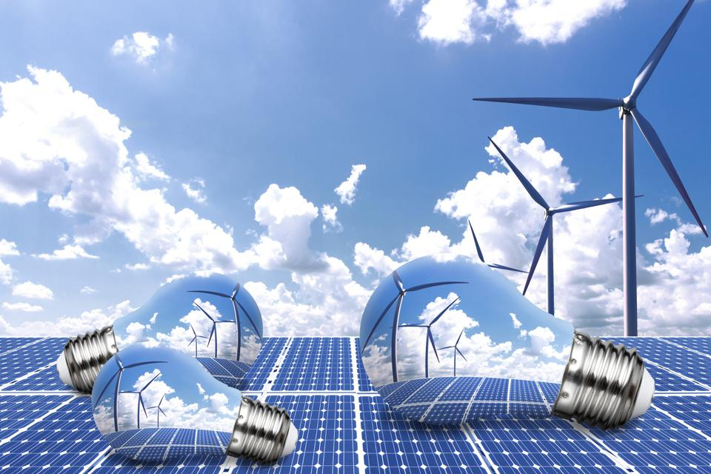
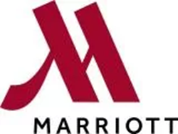
Nelson Da Boa Esperança Capela

Identification Card 1905999

NC Consultancy

Hotel Delta by Marriott Forest of Arden

Date:09/12/2022

Module code: BMIH6005

Energy crise, Present and Future of Hotels.

Executive summary
This report is about the energy management at Delta Marriot Forest of Arden which is part of Marriott International brand.
The report firstly will use online research as a methodology to collect a secondary data to analysis the Micro and Macro business environment the hotel face.
The Micro and Macro market research identified the increase of energy, the increase of interest rate and inflation as the problem hospitality industry face.
Several researchers advocated that the energy price have been increased at prohibited price for the business, especially for the restaurants, bar, cafes and small hotels. They claim that the energy price has increased for example in hundreds of percentages. MarketLine (2022) stated that the price of gas for example increased to 1000% between 2020 and 2022 while Food and Drink Federation (2022), The Caterer (2022) augmented that the price of energy increased between 100% to 500%. As consequences of this, these businesses have to increase the price of their product and service, reduce their opening hours and some had to close down.
In the same way this increase of cost of the products and services impacted business it also impacted people and their shopping habits. If there is a closure of business, people loose their jobs and income which is negative for the economy, for the people and for the society. These businesses are the place, where people meeting to share their ideas, interact and to enjoy themselves, so if these business closedowns it creates a disruption and impact on their lives.
Fortunately, the Micro analyse conclude that this problem caused by economic and political instability could have solution or to be minimised if the business and in particular the Delta Marriot of Arden hotel take the advantages of the tows analysis tool to make the right decision to overcome their weakness and to eliminate their treats.
The analysis of the tows enabled the consultant to provide hotel some strategies such as the training courses to empower the hotel staff with skills in the way they can deal professionally with guest personal data and also for them to assess all the health and safety operational risk. Furthermore, the course will help them in to manage the energy efficiency practices and equipment for the reduction of energy consumption and cost such as LED bulbs, occupancy sensors, lighting and temperature management. The

consultant also demonstrated the if the hotel implements these strategies they can reduce their bill, improve their performance, provide a good and safety public health by reducing their environment pollution and contamination. So, these strategies help them to solve the economic problem, environmental and social since the cost are reduced, there is no reason to close business and to make people redundant.
The consultant provided some recommendations to the hotel such as the renegotiation of the current contract hotels has with its supplier in order to find the best fixed term contract. Energy efficiency equipment such as LED bulbs and occupancy sensor should be purchased and installed as immediate and primary proposal measure and the installation of panel solar as secondary proposal.
The consultant also recommended the hotel to communicate with solar panel suppliers to find the best type and quality of the panel that fit their need. They also were recommended to contact the local authority to know if there are any government grants that could help them to reduce the cost of energy and gas. Likewise, the consultant recommended the hotel to contact all the solar panel to inquiry about the quality, the numbers and the size of the panel that fit hotel needs
Furthermore, the consultant elaborated the action plan with the proposal as a guidance for hotel to implement if they wish to solve or to minimise this problem that challenge the hospitality industry.
Finally, the consultant concludes the report, thanking the hotel for the job opportunity. Likewise, the consultant request if in near future hotel need any collaboration for his side that he looks forward to work with hotel again.

Table of content
Introduction----------------------------------------------------------------------------------------------5
Scope and analysis------------------------------------------------------------------------------------6
PESTEL analysis------------------------------------------------------------------------------7-9
SWOT analysis------------------------------------------------------------------------------10-12
Tows analysis---------------------------------------------------------------------------------13-15
Findings---------------------------------------------------------------------------------------------15-22
The best supplier---------------------------------------------------------------------------------16
Energy efficiency-----------------------------------------------------------------------------16-20
Energy renewable--------------------------------------------------------------------------------20-22
Action plan-----------------------------------------------------------------------------------------22-24
Recommendation------------------------------------------------------------------------------------25
Conclusion---------------------------------------------------------------------------------------------26
Reference------------------------------------------------------------------------------------------27-34
Appendix 1---------------------------------------------------------------------------------------------35
Appendix 2---------------------------------------------------------------------------------------------36
Appendix 3---------------------------------------------------------------------------------------------37

Introduction
This report is about the energy management at Delta Marriot Forest of Arden which is part of Marriott International brand.
The report firstly will use online research as a methodology to collect a Secondary data to analysis the Micro and Macro business environment the hotel face. The Micro analysis of the hotel will be carried by SWOT tools to understand the internal situation of the business in terms of its strengths, weakness, opportunity and treats. In the same way, the PESTEL tool will enable the Consultant to analysis the Macro and the uncontrollable external factors such as Political, Economic, Social, Technological, Environmental and Legal that can have influence in the Hotel operation and performance. The analysis conducted by these tools will empower the management with information to elaborate the strategies and to help them make decision to improve its performance on day-to-day bases (Benzaghta et al., 2021).
Secondly, the consultant will collect and analysis information regarding the energy crise on UK market and its impact on economy, society and people.
Furthermore, the consultant will evaluate the data collected in order to provide proposal for the solutions of the problem and will present them in to the action plan on the way this should be implemented by the hotel in case they approve it.
Finally, the report will be concluded with useful recommendation regarding the best solution for the energy management.

Scope and analysis
Marriott International (2022), Expedia (2022) and TripAdvisor (2022) inform that Forest of Arden Marriott Hotel & Country Club is located within 10,000 acres of ancient woodland in Maxstoke Lane Meriden, Birmingham CV7 7HR West Midlands, England between Birmingham and Coventry.
The hotel has 3 floors, 214 rooms, 18 meeting and events rooms with 1,045 sq. m of total meeting and events. The hotel has a fitness club, tennis court, 18-hole golf courses (e.g., AYLESFORD COURSE and CHAMPIONSHIP ARDEN COURSE), swimming pool, Spa, steam room, Cast Iron Bar & Grill and Zest Restaurant, business centre and golf academy (Marriott International 2022a).
According to Your Golf Travel (2022) and GolfBusiness (2022), the hotel opened in 1992 and is recognised as a one of the most reputed first-class golf resorts and academy in Uk for hosted the European Tour for the British Masters in 1997-1999 and in 2003, and the English Open (Hero open) between 1993-1997, 2000-2002, 2020 and amateur golf’s Brabazon Trophy in 2007.
European Senior Masters (2022) inform that Forest of Arden Marriot Hotel & Country Club was nominated and awarded for six premium such as Golf Sales Team of the Year, Golf Operation Team of the Year, Golf Group of the Year, Food and Beverage Manager of the Yea and Golf Manager of the Year. The restaurant Cast Iron Bar & Grill was also awarded with AA Rosette.
Booking.com (2022) stated that distance between the hotel and Birmingham airport is just 3.6 miles and The East Midlands airport is 29 miles from the hotel. Your Golf Travel (2022) also point out that the hotel is 30 minutes from Birmingham city centre, 10 minutes from NEC venue and Birmingham airport and Birmingham International train station which give hotel easy accessibility by car, train and airplane.
The hotel is surrounding by several hotels, NEC complex and local restaurants which are its direct and indirect competitors.

According to Expedia (2022) the hotel is undergoing renovations from August 2022 to June 2023 with purpose to make the hotel and its facilities to be more designed, excite and attractive. Caswell, (2022) sated that this renovation is part of Marriott strategies to rebrand and to reflag the hotel in to the Delta branch. The transition will not impact on staff term and condition. Likewise, the changes will not impact the benefits of the members of Marriott Bonvoy program.

Johnson et al., (2020) Benzaghta et al. (2021) and Hassanien (2017) suggest the Consultant to use the PESTEL and SWOT analysis tool to analysis the hotel internal and external Business environment in order to perceive if there is any problem that can impact the hotel daily operations
Table 1 (PESTEL analysis)
Political | - Brexit (GOV.UK, 2022c).  - UK political instability  - The Ukraine and Russia conflict (The Caterer, 2022 and MarketLine, 2022).
Economic | - Increase of interest rates and inflation rates (Bank of England, 2022).  - Increase of energy and gas price (Office for National Statistics, 2022a).
Socio-cultural | - Health and Wellbeing (Office for National Statistics, 2022).  - Healthy lifestyle, green products (Johnson et al, 2020).  - New generation and technology (Blythe and Martin, 2019).
Technological | - Renewables energy installation.  - Energy efficiency gadgets.  - Internet.
Environmental | - Reduction of CO2 emission (Ray, 2019; Sky Uk, 2022).  - Climate change, renewable energy and efficiency (CIPD, 2022).
Legal | - Brexit (GOV.UK, 2022b).  - Covid 19. (Lock, 2022).  - Licences and insurance.  - Health and safety Act.  - Data Protection Act 2018 (GOV UK, 2022a).

The Macro market research conducted by PESTEL analysis(table1) could identify the above factors and elements that can have positive and negative impact on hotel daily operations.
Political/Economic
The political instability resulted by election of the new Uk governments and its chancellor created instability and uncertainty in business environment because the fiscal and tax decisions.
The Caterer (2022) states that the excessive demand of the gas and energy in 2021 because the reopening of the business and the economy after the Covid 19 lockdown and the recent Russia invasion to Ukraine and its reduction of gas to Europe as the main cause of the rise of the cost of energy and gas in UK. Likewise, MarketLine (2022) point out that this conflict and the reduction of gas became concern for several Europeans countries because their dependence on Russian gas as an energy source, so the sanction on Russia originated reduction on supply
Social/Economic
Barrett, Farrell and Roantree (2022), Bank of England (2022), stated that the rising of the interest rate, inflation and food price, also have been impacting the life of the people and their ability to pay their bills, to travel and to use hotels accommodation and services. In top of this, the hotel gas and electricity bill will also increase as a consequence of this market instability with further impact on hotel revenue (Office for National Statistics, 2022a).
According to Office for National Statistics (2022) this economic impact also has further consequence on people mental wellbeing.
There is a new shopping preference for new generation regarding to their lifestyle. The sustainability products such as solar panel and CO2 emission are concern of this population age (Blythe and Martin, 2019; Johnson et al, 2020)
Legal
According to GOV.UK (2022a, 2022b) Data Protection Regulation, Health and Safety regulation was identified as a factor and laws that can impact on hotel reputation,

finance and performance. Brexit and Covid 19 are also factors that hotel has to take in to consideration.
It is essential the Human Resources of the hotel to verify the Immigration law and the status of the staff and others they pretend to recruit, to see if they have the right visa for work in the county otherwise, they could pay a huge amount of fee for employing workers without the right visa or work permit (GOV.UK, 2022c).
Future Covid or new pandemic virus restriction are factor for hotel to consider (Lock, 2022).
In the same way it is essential to know about the Health and Safety Regulations, in the way staff can deal with energy efficiency equipment, manual handing and Hazard substances
Environmental.
Sustainability practices, climate change, CO2 pollution and waste management are factors of any business concern.
Hotel produce big amount of waste and CO2 emission that can became an issue in term of environment pollution, infection and contamination if they are not managed well.
Technological
Technological factors refer to the innovations such as the Internet, social media and many more.
CIPD (2022) and Meier (2022) inform that the use of advanced technology help organisation to be more sustainable in terms of climate change as they can use renewable energy and efficiency gadgets to reduce climate change and also through waste management, they can reduce the quantity of their waste. Likewise, Stucki (2019) informed that the production of energy from, sunlight for example is resulted of technology and innovation.

In the same way Consultant used PESTEL to analysis external business environment, Sarsby (2016), Adem, Çolak and Dağdeviren (2018) and Blythe and Martin (2019) suggest the Consultant the use of SWOT tool to analysis the data collected by PESTEL to understand if these external factors can become treat and impact their internal capability of operation or if there is any external factor that can help them to build their strengths, improve their weakness and to eliminate the external treats.
Table 2 (SWOT analysis).
Strength (internal)  - Brand Image and reputation,  - Financial power.  - Market leadership.  - Bonvoy program  - Asset (e.g., 10,000 acres of woodland).  - The Arden and Aylesford golf courses.  - Tennis court.  - Golf academy. | Weaknesses (internal)  - Brand Image and reputation.  - Internet and breakfast are not. free for no member of Bonvoy. program.  - Ineffective Data protection.  - Health and Safety regulation.
Opportunities (external)  - Attract higher personalities from golf and tennis tournament.  - Use of the technology for communication and marketing.  - Grants for solar panel installation  - Technology to improve energy. efficiency.  - Millennian generation. | Threats (external)  - Brexit.  - Covid.  - Health and safety Regulation.  - Direct and indirect competitors.  - Higher Inflation and interest rate.  - Higher price of energy.  - Personal Data breach.

Strength (internal).
According to Marriott International (2022a) the brand has a global presence and market leadership operating in 139 countries with up to 8,000 hotels across. If the revenue from one region declines, the company can rely on the other regions. This is

one strength; however, it also can spread risk for others branches and impact their image and reputation.
Marriott is the largest hotel chain with over 30 brands. The brand has $25.1 billion in assets under its impressive portfolio.
Marriott Bonvoy is the brand loyalty program which enable their members to earn and redeem points. These points enable members to stays at Marriott branches including The Ritz-Carlton, St. Regis, JW Marriott, Sheraton, Westin, Renaissance and others Marriott branches. The program offers members several benefits such as discounted rates, free Wi-Fi, free breakfast, lounge access and more (Marriott International, 2022b).
According to Marriott international (2022c and 2022d) Financial Report, despite the impact of Covid 19 they have a strong financial reserve and cash balance.
Weakness (internal).
MarketLine (2020) and Gressin (2018) published that Marriott International Brand had problem with justice regarding the 2018 Data Protection breach that saw more them 300 million customer personal information such as their bank account, passport address and others personal details stolen by hackers. In July 2019 similar incident happened and the brand was charged £99 million by the UK’s Data Regulator, the Information Commissioner’s Office (ICO). Recently in March this year, the third data protection breach happened and Marriott brand communicated that they have been victim of a second data breach that involved approximately 5.2 million customers.
MarketLine (2020) stated that these incidents happened because the staff did not take the necessary measures and precaution to protect these data and as a consequence the Corporation had to pay these fees.
Data breach represent a great weakness and the inability of staff in to lead with costumers’ personal information but also indicates that they have no respect for Data Protection Act. This weakness can also become Treat because they have to pay a massive fee which impact their profit, brand image and reputation. Despite this incident

did not happen directly at the Forest of Arden branch but their image and reputation can be impacted.
Guest who are not member of Bonvoy program have to pay extra money to have a breakfast and to access the internet. According to Booking, com (2022) this procedure represents a weakness for a hotel because according to the online booking reviews guest are no happy and they think this should be included on the price they pay for a room.

Opportunities (external)
The external market offers opportunity such as technology for hotel to use in their benefits to improve their performance, to develop new product and service. These opportunities help them to make the brand more efficient and positive to deal with treat from external environment such as competitors’ product and services, laws and regulation. They also have opportunity to target personalities who take part on golf academy and all the Millennian generation through social media marketing. Likewise, they can also use for example government grants to implement energy efficiency gadgets and practices or to instal energy renewables (Energy Renewals, 2020)

Treats (external)
Data Protection Act 2018 breach, Health and Safety Regulations, increase of interest rate and inflation, increase of energy price are some treats hotel faces.
Higher price of the energy reflects on the economy and finance of the hotel because the increase of the bill. The revenue of the hotel will also
decrease because higher inflation increases the cost of life, reduce costumers financial power which see their income reduced, increase of price of the product, increase of the householder bills which will also decrease their ability to participate on any events hotel may realise or to travel for leisure and holiday.

Data collected through PESTEL and SWOT analysis demonstrated that there are some treat and weakness that can critically impact the hotel operation, financial profitability and performance.

Gottfried et al., (2018), Kapoor and Kaur (2017), Khalilzadeh, Kebriyaii and Rezaei (2021) and Khatir, and Akbarzadeh (2019) all suggest the hotel the use of Tows analysis tool because this tool will enable the hotel to maximise their strengths and the market external opportunities to make important decisions and strategies regarding to their performance, to improve and overcome their weakness to be in position to eliminate their external treat.
Table 3 (Tows analysis)
Strengths – Opportunity (strategies)  Financial power -Development of technology  Bonvoy program-Market segmentation | Weakness- Opportunity (strategies)  Ineffective Data Protection Act- Good customer service  Health and safety Act- Risk assessment  Chargeable internet – technology development
Strengths -Treats (strategies)  Financial power- energy efficiency and renewable | Weakness-Treats (strategies  Higher price of energy- Personal Data breach

The tows analysis (table 3) identified some combination of the strategies hotel can use to overcome their weakness and to eliminate their treats

Strengths – Opportunity (strategies)
Blythe and Martin (2019) stated that technology empower organisation the opportunity for innovation and higher performance. The hotel can use the strengths to invest on technology and provide online service and payment, mobile application and others trends that may have a massive impact on restaurant performance and operation. Likewise, Johnson et al (2020) stated that with the development of technology and the increase of Millennian generation, hotel can use the social media as its channel to target, marketing and attract all the people who participate at the sports events at their

golf courts and in the academy. The channel also can be used as the way to interact, to communicate, to share information and to receive feedback.

Weakness- Opportunity (strategies)
According to PESTEL and SWOT the hotel staff are lack of skill to deal with guest personal information and possible health and safety procedures regarding to their operation when organise sports and others events. They can take the opportunity through government legislation and guidance to training and empower staff with skill to better deal with guest personal data and also for them to be able to identify and assess all the risks and hazards. Moreover, the training received will help them to manage and control all the procedures regarding to the EE and the reduction of energy consumption.
The external opportunity also offers them social media technology to interact, to communicate and to share online review and comments, to receive feedback for future improvements.
Shahsavari and Akbari (2018) point out that the use of the technology in production of e energy by renewable source such as sun, enable business to solve the problem of the reduction of CO2 and its impact.
Energy Renewals (2020) point out that the business can get up to £100,000 from government grand to help them to upgrade to energy efficiency and renewable

Weakness-Treats (strategies
The hotel has both treats and weakness inter
connected. The weakness they have such as Brexit, Data breach, or charging guest who are not Bonvoy members extra price to use internet can become treats and compromise the hotel operation
Hotel has to create strategies such as price differentiation to include breakfast and free internet on room price for guest who are not member of the loyal program. Internet is a requirement for the 21 century and charging guest extra price is not a good strategy

Strengths -Treats (strategies)
It is clear that the increase of energy and gas price are a real treat for the hotel. To eliminate this treat hotel has to use the potential, the brand financial stability to invest in technology to help them reduce their energy bill. If hotel invest in new sources of energy, they will solve economic problem with the reduction of energy cost and the environmental problem with the reduction of CO2. Alternatively, they can also invest in energy efficiency tools and gadgets such as LED bulbs to reduce their consumption (Kapoor and Kaur, 2017).

According to United Nation (2020) this excessive increase of price of energy and gas and its impact on the 3 pilar of the sustainability, does not reflect on the Sustainability Economic and Development goals agreed between worldwide leaders. The access of energy is not affordable, not reliable, and not sustainable. It has to be innovative to avoid environment contamination and pollution.
The Macro and Micro market research demonstrated that the increase of energy price is a huge problem for the hospitality sector. This problem has to be analysed to understand its scope.
Pardo Martínez and Silveira (2013), Owusu and Sarkodie (2016) and Shahsavari and Akbari (2018) stated that energy is essential for the operation of organisation and its development, however Kannan and Vakeesan (2016), Shahsavari and Akbari (2018) published that the economic development and the increase of global population and rising the living standard and the quality of lives of people have been impacting on energy demand. MarketLine (2022) advocate that this demand is caused by the war between Russia and Ukraine and by the dependence on Russia gas by several country. Furthermore, The Caterer (2022) point out that the excessive demand of gas and energy after the Covid 19 lookdown, is the reason behind the increase of energy price.
Food and Drink Federation (2022) stated that energy prices had increased up 2 times of the price. The survey conducted by The Caterer (2022) concluded that many hospitality operators (restaurants, hotels) lost their profit because their energy price increased between 100% to 400%. Moreover, Skopeliti and Otte (2022) and National

Federation of Self Employed and Small Businesses (2022) publication stated that from 2021 to 2022 the electricity bill increased up to 349% and gas up to 424%. Above all, MarketLine (2022) argument that the price of natural gas increased to 1000% from 2020 to 2022. In addition to that, Food and Drink Federation (2022) stated that several hospitality businesses are facing 400 to 500% rises in their energy bills.
The increase of the energy costs is forcing some hospitality businesses to raise the price of their product, services and to cut trading hours (
According to UK Hospitality (2022), SALVONI and CHAIN (2022), BBC NEWS (2022a, 2022b) and Brock (2022) many hospitalities business (e.g., pubs, restaurant and hotels) had to reduce their service, increased price of product and service and closed down because the increase of their energy and gas bill.
In the same way this increase of cost of the products and services impact business, they also impacted people and their shopping habits. If there is a closure of business, people lose their jobs and income which is negative for the economy, for people and for the society. These businesses are the place where people meeting to share their ideas, interact and enjoy themselves, so this closure create a massive impact people
According to Sky UK (2022) the increase of the price and the demand of gas and electricity in Uk can be solved if the government invest in new sources of energy such as wind and solar energy.
Marriott International (2019) stated that they had implemented sustainability strategies and practices to reduce their environment footprint. The brand plan to use at least 30 % of renewable energy in their brands.
According to Nicholls (2021) there is 3 ways for business to reduce energy cost and improve their economic performance:
- The best supplier
- Energy Efficiency (EE)
- Energy Renewable (RE)

The best supplier
It is important the hotel to contact their energy provider to discuss new contract with new price reduction. In case they refused to renegotiate the hotel should compare who is the market best supplier and change the supplier for better rate. Switching from one supplier to another one could save hotel money and reduce expense by 7% (National hotels, 2022).
Food and Drink Federation (2022) point out that with actual scenario the energy suppliers are refusing to offer fixed term contracts, signing new business customers, further adding to the cost and uncertainty you are facing.
Energy Efficiency
EE is the way to use less energy to perform and to produce better result. With the energy efficiency practices and gadgets homes and infrastructures can use reduced energy to make the appliances and electronics to function effectively. EE is the most efficiency strategy organisations can use to solve climate changes and to decrease the cost of energy (Amjadi, Lundgren and Zhou, 2022).
SEFE Energy (2022) and National hotels (2022) states that commercial business with same characteristics of hotels, the heating represent up to 40% of their energy bills so its fundamental they adopt strategies to reduce this expense if they want to survive. Fig 2 represent how hotel can regulate the heating temperature on each sector. If hotel follow the instructions on temperature control, they can reduce approximately 20% on the cost of temperature control.
Fig 2 (SEFE Energy, 2022)
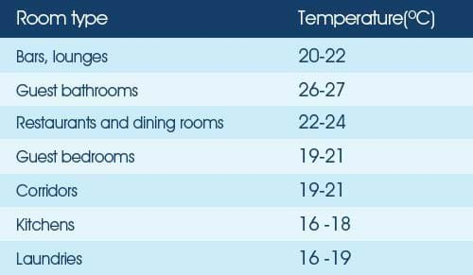

National hotels (2022), Dani, Tiwari and Negi (2021) advocate that changing to energy efficiency equipment can decrease bills approximately in to 50% and are the most cost-effective procedure, however it requires the control of the lighting system in unoccupied areas. Reduced energy gadgets, such as LEDs or CFLs, can produce 75% to 80% reduced energy than normal lightbulbs, and survive longer more than 10 times. The control of light (e.g., On and Off) can be solved with installation of occupancy sensors that work when it is necessary. Sensors enable to save money with the cost of purchase of lights approximately in to 50% which demonstrate that they are the best option on control of the price reduction. The occupancy sensors control the real need on lighting and also on heating, ventilation and air conditioning (CIPD, 2022). Furthermore, SEFE Energy (2022) suggest the installation of smart meter or the installation of automated meter reading device that provide updated cost of the energy to the supplier and to the hotel.
This EE equipment can reduce the energy consumption in hotel for example in 15 to 30% approximately. The LEDs produce approximately 10-15 % of the energy and have 25 times more duration than regular incandescent bulbs
According to CIPD (2022) these strategies and gadgets enables will help to reduce energy bill, and improve efficiency
GOV. UK (2022b) stated that if hotel improve the efficiency of their venue with double glazing, cavity wall and building insulation they can reduce heating bills by around 20% and reduce the energy dependency on suppliers.
Departments and guidance to reduce higher energy consumption in Delta Hotel Forest of Arden according to (SEFE Energy, 2022)
Departments | Orientation
- Kitchen and restaurants  - Rooms, meeting rooms, storage areas, walkways/corridors, exit signs, stairwells, front desk etc. | - Turn off and take off all appliances (e.g., coffee machine, blenders, grills, fryers, etc after used).  - Turn off exhaust fans and lights when they are not in use.  - Regularly defrost fridges and freezers  - Install lighting Emitting Diodes (LEDs)  - Install occupancy sensors for lighting  - Install master key- card the entrance of each room to automatically switched off when guest in not in the room.

Said, Youssef and Waheed (2017) stated that Kitchen, leisure and housekeeping department are the department which use most energy consumption in hotel. Preparing and cooking meals, heating and cooling rooms, the use of hot water, refrigeration of food and beverage represent the mains daily activities that require higher consumption of energy in hotel, so its fundamental to have a control of their cost. It is also essential to keep the maintenance of the appliances, boilers and other equipment.
Environment Protection Agency (2022), Reuter et al., (2020), Said, Youssef and Waheed (2017) point out that if the hotel implement all these procedures with EE the hotel will benefit such as:
Environmental benefits | Social benefits | Economic benefits;
- Decrease the emission of CO2 | - Improvement of the public health as result of less air pollution.  - Increase the public perception that hotel care about society and sustainability goals | - Cost effective in terms of maintenance of equipment and in term of investments.  - Promote innovation and competitiveness.

Renewable energy (RE)
According to Owusu and Asumadu-Sarkodie (2016) and Conrady and Buck (2012) National Grid (2022) RE are energy originated from natural sources such as, sun water and wind.
Liu (2017) stated that energy produced by sun is as one of the most efficient and economic renewable energy because it does not pollute the environment on its production
Meier (2022), Shahsavari and Akbari (2018) inform that the sunlight can produce energy through panel photovoltaic or PV where the electricity is generated via solar energy systems and through Concentrating Solar Power, CSP where it concentrates sunlight using mirrors and then uses the heat to produce steam which will move a turbine to generate electricity.
Sky Uk (2022) stated that the demand and use of renewable energy have been increasing. In 2021 solar energy rose up to 23% and wind 14% which correspond to 10% of global electricity produced by these sources. If the grow still on same level they will meet the sustainability development goal to reduce the global warming by 2030. According to Moore (2022) the transference of the production of energy from fossil fuels to renewable energy can help business to increase their profit. The advance in the technology the price of installation of solar system and battery storage is becoming more affordable for business and for the environment. Bp Energy Outlook (2022) agree with this statement adding that by 2050 the use renewable energy will grow up to 70%.

Advantages /Disadvantages of renewable energy
Advantages | Disadvantages
Reduce climate change Owusu and Asumadu-Sarkodie (2016) and Ray (2019)  Increase business revenue, reduce energy cost, improve business image and reputation which increase the loyalty of costumers and invite new one (Stucki, 2019; Ajayan Prakasam and Mohankumar, 2020). | Higher installation cost and storage.  Weather conditions dependence. If there is no enough sunlight the production the maxim production and efficiency will be compromised  Less capacity of production of electricity in large scale in comparation with fossil fuel sources (Maradin, 2021; Ugli, 2019).  The production of panel solar come from toxic chemicals that can be impacted in to the environment when become waste (Kannan and Vakeesan, 2016).

List of some hotels with solar panel installed
Hotels
- The Marriott Heathrow hotel (Leading Edge Power, 2022)

- Crow Plaza hotel and Accor hotels (Conrady and Buck, 2012)

- Marriott Courtyard -Lancaster (Coastal Solar, 2022)

- Hampton Inn, Bakersfield (Coastal Solar, 2022)

- Wynn Resorts, Las Vegas (Coastal Solar, 2022)

These hotels are example of the hotels that operate with solar panel energy.
Coastal Solar (2022), EnsembleIQ (2018) stated that Courtyard by Marriott Courtyard Lancaster in Pennsylvania for example installed 2700 solar. This installation enabled them to produce more energy than they needed. The project cost them around $1.5 million however they could save 30% of Investment on Tax revenue and received $504,900 from government grant.
The Hampton Inn, Bakersfield reduced their energy bills up to 45%, with solar panel installation. This investment enabled them to save $8800.

Wynn Resorts in la viegas Las Vegas also reduced their energy bill by 75%.
According to Conrady and Buck (2012) Accor hotel have been implemented solar panel in most its hotel since 2004 and by the end of 2008 they had 47 hotels with solar panel installed.
These data shows that several hotels, included some Marriot hotels installed the solar panel as their source of energy. If the Delta Forest of Arden install solar panel as its main source of energy, the hotel also can save on money on energy bill, receive some income if they transport some to the national gride and also will be able to reduce their co2 emission.
Action Plan (table 4)
Number | Problem | Solution | Desired outcome | Time  Scale | Completion  Date | Planned  Budget
1  2  3  4  5 | Primary proposal  Changing supplier  Primary proposal  Energy efficiency training course  Primary proposal  Energy efficiency gadget  Secondary proposal  Renewable energy  (Solar panel)  Consultancy fee | Reduction of energy consumption and price  Empower staff with skill to operate the safety of efficiency control of the gadget and appliances  Reduction of energy consumption  Solution of energy crise and extra income with Solar energy to Nation grade  Payment of consultancy work | Renegotiation of new contract or to find new supplier with lower fixed tariff  Making every one aware about the energy crise and its impact  Purchase of energy efficiency equipment (LED, occupancy sensor  Agreement with suppliers and to choose the best option for the location and price of the installation  Research, identification of problem, scop and analysis, proposal for solution | Immediate and urgent  Urgent  Long term plan  30 days | Less than week  1 week  9/12/22  1-5 years  20 days | £ 00  £00  £739  £859  £16000  £2000  Total; £19598

Table 4 represent the action plan and the Consultant proposals for the conclusion of the job. In the plan there is primary and secondary proposal.
Primary proposal
On this proposal, the Consultant propose the actions hotel should take immediately for the limitation of the gas and energy used. It represents the best strategy hotel have to follow to reduce their energy bill.
On this proposal the Consultant suggest the hotel firstly to compare the price suppliers offers, them communicate with their current supplier to renegotiate the best fixed contract term. Secondly, the hotel has to raise awareness and motivate staff to collaborate in energy efficiency practices. They can do it by training their staff with energy efficiency course. The skill they receive will empower them to manage all the equipment to save energy consumption.
The next step on this proposal is to use the budget to purchase LED bulbs and occupancy sensor. The consultant suggests the hotel to buy 100 LED bulbs for £7.39

each box and 100 occupancy sensors for £8.59(see appendix for the unit price of the LED and occupancy sensor).
Secondary proposal
For secondary proposal, Consultant propose the hotel the use of panel solar as the long-term solution for the problem.
According to GILL (2022) the price of installing commercial panel solar system is between £16,000 and £70,000. GreenMatch (2022) offer the list of their panel solar and installation cost(appendix3). According to Jackman (2022) one of the best installation company hotels should contact is The Eco Roof and Wall Company, however the Consultant suggest the hotel to see others option before make any final decision according to the size, the quality, the amount, the advantages of each panel system and full price of installation cost.
Based on budget provided, the Consultant suggest the hotel to purchase the system that cost the minimum amount of £16000
Finally, the Consult request the fee of £ 2000 for its consultancy report.

Recommendations
- Research for the best energy supplier, compare the prices
- Contact their supplier to renegotiate new fixed term contract
- Provide Energy efficiency training course for all staff in order they learning how to manage energy efficiency gadgets
- Provide Health and safety course to identify and assess all the risks
- Provide Data Protection course to all staff in order to accomplish Data Protection Act
- To contact energy supplier to install smart meter
- Maintenance department to install master key card and energy efficiency equipment
- Maintenance department to choose the best LED bulbs and occupancy sensor
- Contact with local Council to find what is the government support and grand for business regarding energy crise
- Contact solar panel supplier to find the best solar that fit hotel needs

Conclusion
This report concluded the that the Macro market research demonstrated that political instability, the war between Russia and Ukraine and the excessive demand of the gas after the covid 19 lookdown were the cause behind the increase of energy and gas price. This increase also creates market instability with increase of interest rate and inflation with impact on energy price and cost of life. This impact has also reached hospitality business because they have to increase price of their product and service, reduce their opening hours and some had to close down. In the same way this increase of cost, also impacted people and their shopping habits.
In contrast the Micro analyse conclude that these economic and political instability, the external business environment offers opportunity such as technological development for business to overcome their weakness and treats. The business has opportunity to instal EE equipment such as Led bulbs, sensors and effective lighting management and the installation of solar panel can be solution for higher energy bills but also help them to accomplish the sustainability developments goals regarding to climate change and CO2
The current problem of energy increase also can impact Delta Forest of Arden despite the hotel to be part of Marriott international Brand. The consultant presented the hotel the causes of this increase of the energy, the importance it has for hotel, the advantages it has for the finance and the reputation of the brand.
Furthermore, the Consulta presented the hotel recommendation they have to follow to avoid the problem and them the proposal on action plan on how these recommendations should be implemented by hotel
The Consultant would like to take the opportunity to thanks the hotel for this job opportunity and look forward to work again in future with hotel

Reference
Adem, A., Çolak, A., and Dağdeviren, M. (2018) ‘An integrated model using SWOT analysis and Hesitant fuzzy linguistic term set for evaluation occupational safety risks in life cycle of wind turbine’. Safety Science, 106, doi.org/10.1016/j.ssci.2018.02.033
Ajayan, J., Prakasam, P. and Mohankumar, P., (2020) ‘An Overview of Green Energy Management Systems’. Advances in Greener Energy Technologies, pp.601-616.
Amazon (2022) Occupancy Sensor[online]. Available at https://www.amazon.co.uk/Occupancy-Sensor/s?k=Occupancy+Sensor(Accessed 01/12/22).
Amazon UK (2022) LED GU10 Light Bulb Warm White 3000K, 50W Halogen Spotlight Equivalent, 5W 370lm, Non-dimmable, AC 220-240V, 38° Beam Angle - 5pk [Energy Class A+] [online]. Available at: https://www.amazon.co.uk/LED-GU10-Lamp-Warm-White/dp/B06ZZ83JCQ/ref=asc_df_B06ZZ83JCQ/?tag=googshopuk-21&linkCode=df0&hvadid=310060303421&hvpos=&hvnetw=g&hvrand=12752647728013953876&hvpone=&hvptwo=&hvqmt=&hvdev=c&hvdvcmdl=&hvlocint=&hvlocphy=9045468&hvtargid=pla-698743058521&psc=1 (Accessed 15/11/22).
Amjadi, G., Lundgren, T. and Zhou, W., (2022). ‘A dynamic analysis of industrial energy efficiency and the rebound effect: implications for carbon emissions and sustainability’. Energy Efficiency, 15(7), pp.1-19, doi.org/10.1007/s12053-022-10059-4
Bank of England (2022) Monetary Policy Report - November 2022[online]. Available at: https://www.bankofengland.co.uk/monetary-policy-report/2022/november-2022 (Accessed 21/10/22).
Barrett, M., Farrell, N. and Roantree, B., (2022) ‘Energy poverty and deprivation in Ireland’. Economic and Social Research Institute (ESRI) Research Series. Doi.org/10.26504/rs144

BBC NEWS (2022a) York: Pub closed as monthly energy bill almost trebles[online]. Available at: https://www.bbc.co.uk/news/uk-england-york-north-yorkshire-62724135 (Accessed 01/12/22).
BBC NEWS (2022b) Pub numbers fall to lowest on record. When pubs are forced to close it's a huge loss to the local community, people losing their jobs[online]. Available at: https://www.bbc.co.uk/news/business-62031833 (Accessed 01/12/22)
Benzaghta, M. A., Elwalda, A., Mousa, M. M., Erkan, I., and Rahman, M. (2021) ‘SWOT analysis applications: An integrative literature review’. Journal of Global Business Insights, 6(1), 55-73, doi.org/ 10.5038/2640-6489.6.1.1148.
Blythe, J. and Martin, J., (2019). Essentials of marketing 7th ed. Pearson UK.
Brock, A., (2022) Seven recent pub and bar closures as energy crisis takes toll[online]. Available at: https://www.birminghammail.co.uk/whats-on/food-drink-news/seven-recent-pub-bar-closures-24931176 (Accessed 01/12/22).
Booking.com (2022) Delta Hotels by Marriott Forest of Arden Country Club[online]. Available at:https://www.booking.com/hotel/gb/marriott-forest-of-arden-country-club.en-gb.html?hpos=2&sid=a2e8730f9469a683174e832aa07a6d6a&aid=311076&label=arden-house-birmingham-s33qU8cVtclYflqWjKQavQS253708318204%3Apl%3Ata%3Ap1%3Ap2%3Aac%3Aap%3Aneg%3Afi%3Atiaud-146342138710%3Akwd-95066376%3Alp9045468%3Ali%3Adec%3Adm%3Appccp%3DUmFuZG9tSVYkc2RlIyh9YVujEjbMrKBVEQO8hCDrg-c&room1=A%2CA&sb_price_type=total&dist=0&no_rooms=1&req_adults=2&group_adults=2&group_children=0&sr_order=popularity&type=total&hapos=2&dest_type=city&dest_id=-2589864&srpvid=7c2c9ce68ffd0410&req_children=0&srepoch=1666131533&ucfs=1#tab-reviews (Accessed 01/12/22).
Bp Energy Outlook (2022) Energy Outlook 2022 explores the key uncertainties surrounding the energy transition[online]. Available at: https://www.bp.com/content/dam/bp/business-sites/en/global/corporate/pdfs/energy-economics/energy-outlook/bp-energy-outlook-2022.pdf (Accessed 21/10/22).
Caswell, M. (2022) Marriott to reflag 23 UK regional properties under Delta brand[online]. Available at:https://www.businesstraveller.com/business-travel/2022/08/22/marriott-to-reflag-23-uk-regional-properties-under-delta-brand/ (Accessed 14/11/22).

Cingoski, V. and Petrevska, B., (2018) ‘Making hotels more energy efficient: the managerial perception’. Economic research-Ekonomska istraživanja, 31(1), pp.87-101. doi.org/10.1080/1331677X.2017.1421994
CIPD (2022) Sustainable buildings: rethinking workplaces for a healthier future[online]. Available at: https://www.cipd.co.uk/knowledge/work/trends/future-work-insights/future-fit-your-workspace (Accessed 22/10/22).
Constellation Energy (2022) Small Business Energy Savings How Much Energy Do Small Businesses Use? [online blog]. Available at: https://blog.constellation.com/2020/12/14/small-business-energy-consumption/ (Accessed 15/11/22).
Coastal Solar (2022) Do resorts and hotels with solar panels save energy and money? [online]. Available at: https://coastalsolar.com/resorts-hotels-with-solar-panels/ (Accessed 22/11/2022).
Conrady, R. and Buck, M. eds., (2012) Trends and issues in global tourism 2012. Springer Science & Business Media.
Dani, R., Tiwari, K. and Negi, P., (2021) ‘Ecological approach towards sustainability in hotel industry. Materials Today’: Proceedings, 46, pp.10439-10442. Doi.org/10.1016/j.matpr.2020.12.1020
Dawson-Shepherd, A., Kellner, K. and Neumann, J.E., (2013). Developing organisational consultancy. Routledge
Energy Renewals (2020) Apply for a £5K-£100K* Energy Efficiency Grant[online]. Available at: https://energyrenewals.co.uk/01/energy-grant/index.html (Accessed 1/12/22).
EnsembleIQ (2018) First Marriott Property to Be 100% Solar Powered Now Operational[online]. Available at: https://hospitalitytech.com/first-marriott-property-be-100-solar-powered-now-operational (Accessed 01/12/22).
EPA Environment Protection Agency (2022) Local Energy Efficiency Benefits and Opportunities[online]. Available at: https://www.epa.gov/statelocalenergy/local-energy-efficiency-benefits-and-opportunities (Accessed 16/11/22).
European Senior Masters (2018) Forest of Arden nominated for six prestigious golf industry awards[online]. Available at: https://europeanseniormasters.com/news/forest-of-arden-nominated-for-six-prestigious-golf-industry-awards- (Accessed at 21/10/22).
Expedia (2022) Forest of Arden Marriott Hotel & Country Club. About this property[online]. Available at: https://www.expedia.co.uk/Birmingham-Hotels-Forest-Of-Arden-Marriott-Hotel-Country-Club.h28506.Hotel-Information (Accessed 21/10/22).
Food and Drink Federation (2022) Energy costs[online]. Available at: https://www.fdf.org.uk/fdf/what-we-do/environmental-sustainability/energy-costs/ (Accessed 21/10/22).

Gill, T (2022) The Complete Guide to Commercial Solar Panels[online]. Available at: https://www.theecoexperts.co.uk/solar-panels/commercial-solar-panels (Accessed 14/11/22).
Gressin, S. (2018) The Marriott data breach[online]. Available at: https://consumer.ftc.gov/consumer-alerts/2018/12/marriott-data-breach (Accessed 25/10/22).
Golf Business (2022) Forest of Arden in final stages of £5m redevelopment[online]. Available at: https://golfbusinessnews.com/news/corporate/forest-of-arden-in-final-stages-of-GBP5m-redevelopment/ (Accessed 21/10/2022).
Gottfried, O., De Clercq, D., Blair, E., Weng, X. and Wang, C., (2018) ‘SWOT-AHP-TOWS analysis of private investment behavior in the Chinese biogas sector’. Journal of Cleaner Production, 184, pp.632-647.
GOV.UK (2020) Recruiting people from outside the UK [online]. Available at: https://www.gov.uk/guidance/recruiting-people-from-outside-the-uk (Accessed 28/10/22).
GOV.UK (2022a) Data protection[online]. Available at: https://www.gov.uk/data-protection (Accessed 14/11/22).
GOV. UK (2022b) Energy efficiency: what you need to know[online]. Available at: https://www.gov.uk/government/news/energy-efficiency-what-you-need-to-know (Accessed 15/11/22).
GOV.UK (2022c) Penalties for employing illegal workers[online]. Available at: https://www.gov.uk/penalties-for-employing-illegal-workers (Accessed 1/12/22).
GreenMatch (2022) What Is the Cost of Solar Panels in the UK? How Much Do Solar Panels Cost per kW System? [online]. Available at: https://www.greenmatch.co.uk/blog/2014/08/what-is-the-installation-cost-for-solar-panels (Accessed 05/12/22).
Hassanien, M.A., (2017) ‘Strategic planning in higher education, a need for innovative model’. Journal of Education, Society and Behavioural Science, 23(2), pp.1-11.
GreenMatch (2022) All Solar Panel Grants and Schemes in the UK 2022 [online blog]. Available at: https://www.greenmatch.co.uk/blog/2014/08/what-is-the-installation-cost-for-solar-panels (Accessed 01/12/22).
Jack B. Corgel, J. b., (2022) The Energy Price Threats to Hotel Demand[online]. Available at: https://www.hospitalitynet.org/opinion/4109726.html (Accessed 21/10/2022).
Jackman, J (2022) The 11 Best Solar Panel Installers in the UK 2022[online]. Available at: https://www.theecoexperts.co.uk/solar-panels/best-installers (Accessed 25/11/22).
Johnson, G., Whittington, R., Regnér, P., Angwin, D. and Scholes, K., (2020). Exploring strategy. Harlow: Pearson.

Khalilzadeh, M., Kebriyaii, O. and Rezaei, R., (2021)’ Identification and selection of stakeholder engagement strategies: case study of an Iranian oil and gas construction project’. International Journal of Construction Management, pp.1-23. Doi.org/10.1080/15623599.2021.1889749
Kannan, N. and Vakeesan, D., (2016)’ Solar energy for future world: A review’. Renewable and Sustainable Energy Reviews, 62, pp.1092-1105. Doi.org/10.1016/j.rser.2016.05.022
Khatir, M.V. and Akbarzadeh, Z., (2019). ‘Elucidation of structural relationships of SWOT: A mixed method approach based on FMADM for formulating science and technology strategies. Technology in society, 56, pp.44-56. Doi.org/10.1016/j.techsoc.2018.09.004
Kapoor, S. and Kaur, M., (2017)’ Basel III norms: A Swot and tows approach’. Vision, 21(3), pp.250-258.Doi.org/10.1177/0972262917716759
Leading Edge Power (2022) Marriott Heathrow hybrid solar-wind system[online]. Available at: https://www.leadingedgepower.com/case-studies/marriott-heathrow-hybrid-solar-wind-system.html (Accessed 22/11/22).
Liu, Z., (2017) ‘China’s strategy for the development of renewable energies’. Energy Sources, Part B: Economics, Planning, and Policy, 12(11), pp.971-975. Doi.org/10.1080/15567249.2017.1336813
Lock, S, (2022) Year-over-year daily change in seated restaurant diners due to the coronavirus (COVID-19) pandemic in the United Kingdom (UK) from February 24, 2020 to August 1, 2022[online], Available at: https://www.statista.com/topics/3131/restaurant-industry-in-the-united-kingdom-uk/#topicHeader__wrapper(Accessed 01/12/22).
Maradin, D., (2021).’Advantages and disadvantages of renewable energy sources utilization. 670216917’. International Journal of Energy Economics and Policy 11(3), 176-183, doi.org/10.32479/ijeep.11027
MarketLine (2020) Marriott faces fresh data breach woes as London lawsuit launched[online]. Available at: https://advantage-marketline-com.ezproxy.uwtsd.ac.uk/News/marriott-faces-fresh-data-breach-woes-as-london-lawsuit-launched_219615 (Accessed 22/10/2022).
MarketLine (2022) War in Ukraine: Six months on and the conflict is creating a global crisis[online]. Available at: https://advantage-marketline-com.ezproxy.uwtsd.ac.uk/Analysis/ViewasPDF/war-in-ukraine-six-months-on-and-the-conflict-is-creating-a-global-crisis-162097 (Accessed 22/10/2022).
Marriott International (2019a) 2025 Sustainability & Social Impact Goals[online]. Available at: http://serve360.marriott.com/wp-content/uploads/2019/10/Serve-360-goals-page-tabloid_2-updated-20180916-English.pdf (Accessed 20/10/2022).
Marriott International (2019b) Sustain responsible operations[online]. Available at: https://serve360.marriott.com/sustain/ (Accessed 20/10/2022).

Marriott International (2022) Member Benefits[online]. Available at: https://www.marriott.com/loyalty/member-benefits/member.mi (Accessed 10/11/21).
Marriott International (2022b) Marriott Bonvoy Benefits[online]. Available at: https://www.marriott.com/loyalty.mi?scid=48066388-e510-46da-8805-a5fec468e3cc&gclid=EAIaIQobChMI1pb63emu-wIVwoFQBh3hWwPbEAAYASABEgIk9PD_BwE&gclsrc=aw.ds (Accessed 1/12/2022).
Marriott International (2022a) We Are Marriott International[online]. Available at: https://www.marriott.com/marriott/aboutmarriott.mi (Accessed 25/10/22).
Marriot International (2022c) 2021 Annual Report[online]. Available at: https://marriott.gcs-web.com/static-files/b82978a6-9d28-4e38-9855-fc4ae2cebe11 (Accessed 25/11/22).
Marriott International (2022d) Marriott International Reports Outstanding Third Quarter 2022 Results[online]. Available at: https://news.marriott.com/news/2022/11/03/marriott-international-reports-outstanding-third-quarter-2022-results (Accessed 21/11/22).
Meier, P. F., (2022) Renewable solar energy: how does it work and can it meet demand? [online blog]. Available at: https://blog.oup.com/2022/05/renewable-solar-energy-how-does-it-work-and-can-it-meet-demand/?utm_source=TrendMD&utm_medium=cpc&utm_campaign=OUPBlog_TrendMD_1 (Accessed 21/10/22).
Moore, T. (2022) Global shift away from fossil fuels to renewable energy by 2050 would save £10trn, scientists say[online]. Available at: https://news.sky.com/story/global-shift-away-from-fossil-fuels-to-renewable-energy-by-2050-would-save-10trn-scientists-say-12696452
National Federation of Self Employed & Small Businesses FSB (2022) Energy help is needed now, small firms urge, as man y struggle to get through winter[online]. Available at: https://www.fsb.org.uk/resources-page/energy-help-is-needed-now-small-firms-urge-as-many-struggle-to-get-through-winter.html (Accessed 20/10/2022).
National Grid (2022) How does solar power work? [online]. Available at: https://www.nationalgrid.com/stories/energy-explained/how-does-solar-power-work (Accessed 21/10/22).
National hotels (2022) How much electricity do hotels use? [online]. Available at: https://nationalhotels.co.uk/much-electricity-hotels-use/ (Accessed 15/11/2022).
Nicholls, L. (2021) Energy price hikes: What can hospitality business do now? [online]. Available at: https://www.bighospitality.co.uk/Article/2013/11/21/Energy-price-hikes-What-can-hospitality-businesses-do-now (Accessed 21/10/2022).
Owusu, P.A. and Asumadu-Sarkodie, S., (2016) ‘A review of renewable energy sources, sustainability issues and climate change mitigation’. Cogent Engineering, 3(1), p.1167990,doi.org/10.1080/23311916.2016.1167990

Office for National Statistics (2022) Consumer price inflation, UK: September 2022[online]. Available at: https://www.ons.gov.uk/economy/inflationandpriceindices/bulletins/consumerpriceinflation/latest (Accessed 01.12.22).
Office for National Statistics (2022a) Rising business insolvencies and high energy prices[online]. Available at:https://www.ons.gov.uk/businessindustryandtrade/changestobusiness/bankruptcyinsolvency/articles/risingbusinessinsolvenciesandhighenergyprices/2022-10-07 (Accessed 26/10/2022).
Pardo Martínez, C.I. and Silveira, S., (2013) ‘Energy efficiency and CO2 emissions in Swedish manufacturing industries.’ Energy Efficiency, 6(1), pp.117-133.
Ray, P., (2019) ’Renewable energy and sustainability’. Clean Technologies and Environmental Policy, 21(8), pp.1517-1533. Doi.org/10.1007/s10098-019-01739-4
Reuter, M., Patel, M.K., Eichhammer, W., Lapillonne, B. and Pollier, K., (2020) ’A comprehensive indicator set for measuring multiple benefits of energy efficiency’. Energy policy, 139, p.111284, doi.org/10.1016/j.enpol.2020.111284
Said, D., Youssef, K. and Waheed, H., (2017) ‘Energy efficiency opportunities in hotels. Renewable Energy and Sustainable Development, 3(1), pp.99-103, doi.org/10.21622/RESD.2017.03.1.099
Sarsby, A., (2016) SWOT analysis. A guide to SWOT for business studies students. Leadership Library
SALVONI, H. and CHAIN, B., (2022) ‘We risk losing the British pub forever': Venues choose between closing down or 'charging £14 a PINT' to stay afloat with some now shutting for two days a week and cutting menu items amid £80,000 spikes in energy bills[online]. Available at: https://www.dailymail.co.uk/news/article-11164111/Pub-closes-58-000-bill-hike-Energy-bill-crisis-bigger-Covid-businesses.html (Accessed 01/12/22)
Screwfix (2022) LAP SES CANDLE LED LIGHT BULB 470LM 4.2W 4 PACK [online]. Available at:https://www.screwfix.com/p/lap-ses-candle-led-light-bulb-470lm-4-2w-4-pack/842pp (Accessed 15/11/2022).
SEFE Energy (2022) An energy saving guide for hotels [online blog]. Available at:https://www.sefe-energy.co.uk/blog/an-energy-saving-guide-for-hotels/ (Accessed at 15/11/22).
Shahsavari, A. and Akbari, M., (2018)’ Potential of solar energy in developing countries for reducing energy-related emissions. Renewable and Sustainable Energy Reviews, 90, pp.275-291, doi.org/10.1016/j.rser.2018.03.065

Sky Uk (2022) Climate change: Global wind and solar power growth on track to meet climate targets if progress maintained, report says[online]. Available at: https://news.sky.com/story/climate-change-global-wind-and-solar-power-growth-on-track-to-meet-climate-targets-if-progress-maintained-report-says-12577994 (Accessed 20/10/22).
Skopeliti, A.L. Clea and Otte, J. (2022) Small businesses warn they may not survive winter due to UK energy bills[online]. Available at: https://www.theguardian.com/business/2022/aug/25/sleepless-nights-business-owners-energy-bills-quadruple (Accessed 20/10/2022).
Stucki, T. (2019) "Which firms benefit from investments in green energy technologies? –The effect of energy costs." Research Policy 48 (3), 546-555, doi.org/10.1016/j.respol.2018.09.010
The Caterer (2022) Survey results: how are rising energy bills affecting hospitality businesses? [online]. Available at: https://thecaterer.com/business/hospitality-energy-bills-impact-the-caterer-survey-2022 (Accessed 19/10/2022).
TripAdvisor (2022) Forest of Arden Marriott Hotel & Country Club. About[online]. Available at: https://www.tripadvisor.co.uk/Hotel_Review-g186402-d229510-Reviews-Forest_of_Arden_Marriott_Hotel_Country_Club-Birmingham_West_Midlands_England.html (Accessed 21/10/22).
Ugli, T.J.T., (2019) ‘The importance of alternative solar energy sources and the advantages and disadvantages of using solar panels in this process’. International Journal of Engineering and Information Systems (IJEAIS), 3(4). available at: https://philpapers.org/archive/UGLTIO.pdf (Accessed 21/10/22).
UKHospitality (2022) Skyrocketing energy costs force hospitality businesses to raise prices and cut opening hours[online]. Available at: https://www.ukhospitality.org.uk/news/599740/Skyrocketing-energy-costs-force-hospitality-businesses-to-raise-prices-and-cut-opening-hours.htm (Accessed 21/10/2022).
United Nation (2020) The Sustainable Development Goals Report 2020[online]. Available at: https://unstats.un.org/sdgs/report/2020/The-Sustainable-Development-Goals-Report-2020.pdf (Accessed 19/10/2022).
Your Golf Travel (2022) Forest of Arden Marriott Hotel & Country Club[online]. Available at: https://www.yourgolftravel.com/forest-of-arden (Accessed 21/10/2022).
Yüksel, I., (2012) Developing a multi-criteria decision-making model for PESTEL analysis. International Journal of Business and Management, 7(24), p.52. Doi.org/10.5539/ijbm. v7n24p52

Appendix 1
Amazon UK (2022) | Screwfix (2022)
- Price: £7.39 (£1.48 / count)  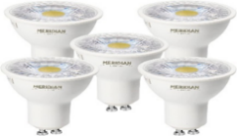 Full face Prismatic Lens - Average life 25000 hours  5W 38° beam angle - Equivalent to 55W  Energy class A+, Up to 80% saving over halogen  IP Rating 20 - Finished in white  - Price: £14.99 (£1.50 / count)  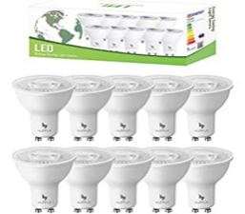 GU10 LED Bulbs, Warm White 3000K GU10 Bulb 6W 350LM, 50W Halogen Equivalent, Non-dimmable Spot Light Bulb, 120° Beam Angle, AC 220-245V LED Bulbs, Pack of 10  - Price: £15.99 (£2.67 / count)  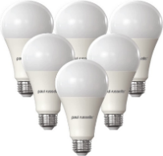 Paul resells 16W LED GLS Light Bulbs Edison Screw ES, Equivalent 120w Bulb, 6500K Day Light, 1901lm Brightness Classic Frosted A70 Standard E27 Globe Lamp | - Price: £7.98 INC VAT Was £12.99  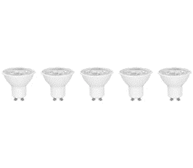 Cool White Dimmable  345lm - Equivalent to 50W  Up to 25,000 Hours Life  4kWh/1000h Life  36° Beam Angle  3 Year Manufacturer's Guarantee  - Price: £7.88INC VAT Was £8.99  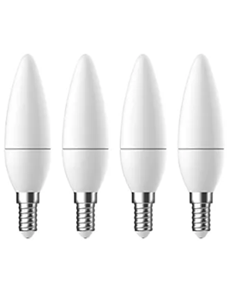470lm - Equivalent to 40W  Up to 25,000 Hours Life  5kWh/1000h Life  3 Year Manufacturer's Guarantee

Appendix 2 (Amazon,2022)
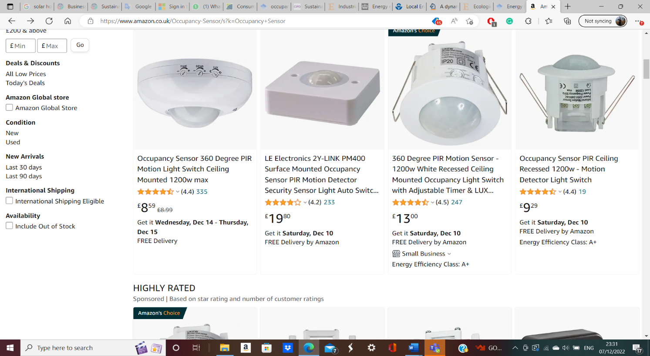
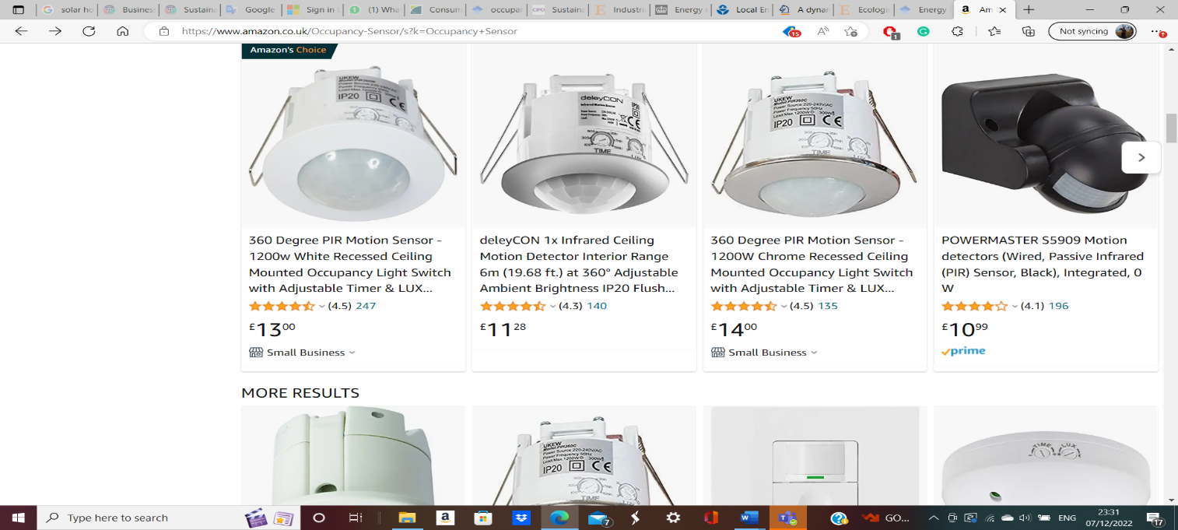

Appendix 3
GreenMatch (2022)
Cost of Solar Panels per kW System in the UK
System Size | Estimated Costs | Number of Panels | Roof Space | Annual Savings on Electricity Bill | Savings after 25 Years (plus profit from SEG)
3kW panel system | £5,000 - £6,000 | 12 | 22 m² | £850 | £21,250
4kW panel system | £6,000 - £8,000 | 16 | 29 m² | £980 | £27,150
5kW panel system | £8,000 - £9,000 | 20 | 32 m² | £1,460 | £39,550
6kW panel system | £9,000 - £11,000 | 24 | 43 m² | £1,460+ | £40,325+

