Marketing Plan
Assessment 1: Report
A case on Hilton hotel

Table of Contents
Introduction 3
Situation Analysis 3
Swot analysis (company) 3
Segmentation and targeting (customers) 3
Perceptual positioning map (Competitors) 4
B2B partnerships (Collaborators) 4
Pestle Analysis (Climate) 4
Objectives 5
Strategy 5
Tactics (Marketing Mix – 4Ps) 6
Action 7
Control 7
Conclusion 8
References 9

Introduction
The success of the organisation comes based on the development of an effective business strategy and implementation of the strategy (Shatokhin et al., 2022). The marketing plan should be designed based on market research and customer needs. The chosen organisation for the marketing plan is Hilton hotel. This report will demonstrate the marketing plan of the Hilton hotel. It will support the marketing team and management to bring success to the hotel (Peevski, 2022). To develop the plan, it needs to analyse the external and internal environment through the use of 5C such as SWOT, Pestle, and Perceptual positioning map. It evaluates the marketing mix of Hilton hotel and designs the objectives for the plan and Gantt chart for marketing activities.

Situation Analysis

Swot analysis (company)
The strengths of Hilton Hotels are high brand value in the global hotel industry, improving customer service, updating service regularly, and employee retention. This is founded over 103 years ago and runs a business from its 584 hotels and 94 more countries (Hilton, 2023). The weaknesses of Hilton Hotels and resorts are limited market share and government policies influencing global operations. The opportunities are high potential to enter emerging markets, use of technology and digitalisation, and innovation of service (Makhlouf, 2022). The threats are high competition, economic recession, political violence etc.

Segmentation and targeting (customers)
Hilton Hotel focuses on different types of segmentation strategy to attract customers especially geographic segmentation as it is running its business globally and focus on a busy area. Hilton hotel, London is available in popular places such as Tower Bridge Trafalgar square (Hilton, 2023). Hilton hotel targets customers based on middle and senior age, income level, luxury, and social class based on demographic strategy. A psychographic strategy is used by Hilton when it considers premium prices for services (Selvalakshmi et al., 2023).
The key target customers of Hilton Hotels are honeymoons, Leisure travellers, extended stay, business class, families etc.

Perceptual positioning map (Competitors)
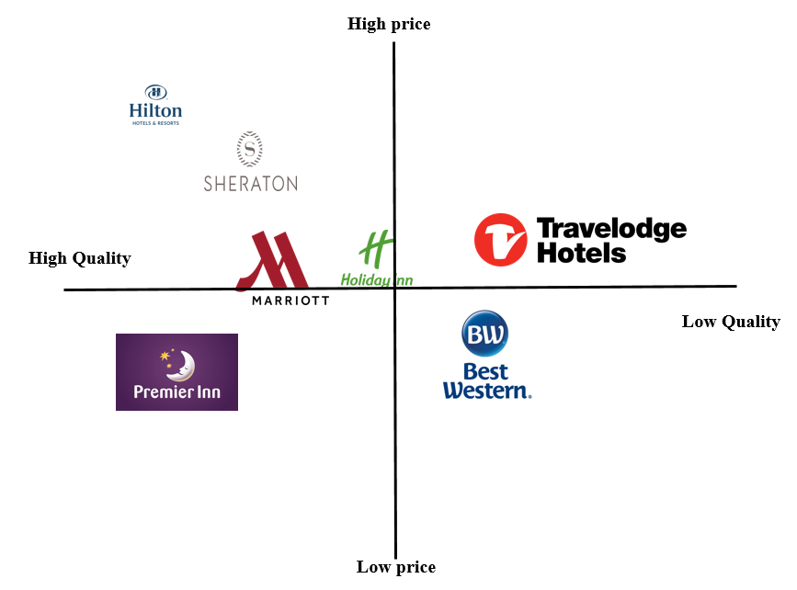
According to the perceptual map, it is seen that Hilton hotel is a luxurious hotel with high price service to the customers (Lilien et al., 2017). The competitors are Marriott, Premier Inn, Sheraton, Travelodge (Hilton, 2023).

B2B partnerships (Collaborators)
Hilton Hotel is running business globally with its 19 different brands. The top brands of Hilton Hotels globally are Waldorf Astoria, Conrad, LXR, Canopy, and Tempo (Hilton, 2023). For the last 13 years, Hilton is the top franchisee hotel running globally.

Pestle Analysis (Climate)
- Political: As the UK left the EU in 2020, it negatively influenced the business of Hilton to decline in the number of visitors and revenue (Benoit, 2022). Lockdown policies by the government of different countries impact the business of Hilton as well.
- Economic: Hilton is a luxurious hotel and needs huge disposable income. during Covid, it faced huge challenges to hold customers. But the government provides loans with a low-interest rate which was positive for the hotel (Hakim Akhorshaideh et al., 2022).
- Social: Changing the lifestyle of the people positively affects the increasing visitors to Hilton hotel.
- Technological: Adopting new technology such as chatbots, online payment, and booking positively affects the efficiency of customer service.
- Legal: Law due to maintaining social distancing during Covid negatively affects the business of Hilton.
- Environmental: Climate change is a threat to Hilton Hotels' running business with the same strategy (Hakim Akhorshaideh et al., 2022).

Objectives
The marketing plan aims to increase the sales and profitability of Hilton hotel for non-room guest revenue by £20 end of Q3.
- Specific: The non-room guest revenue of Hilton hotel will be increased and the number of services will be increased after accommodation.
- Measurable: If the guest revenue for non-room guest revenue increases by £20, it shows the target of this hotel.
- Achievable: The target of Hilton Hotels is attainable by retaining staff, giving incentives to the front desk staff, selling more packages, bundled offers and guest messaging software.
- Relevant: The goal is linked to the Hilton hotel business strategy by improving the profitability per guest.
- Time-bound: the target will be achieved at the end of Q3.

Strategy
The value proposition is the statement which shows why the customer should purchase the product or service from the organisation (Alderton, 2013). this is the most effective method or strategy for attracting customers. Here, the company tells about the reason why the buyers can buy the product. A company may communicate with the buyers through its websites, mobile app, messaging or other advertising methods.
Hilton Hotel takes different value proposition strategies to attract customers from different locations which vary as well. For the current objectives of Hilton hotel, the value proposition can be “Save 20% on the new package”.
This will connect middle-class customers and upscale customers to choose Hilton Hotels when they will come for family packages and business purposes. The targeted customers will be middle class as well (Alderton, 2013).

Tactics (Marketing Mix – 4Ps)
Product: Hilton Hotel is offering services to 94 countries through its 19 brands and more than 7000 properties (Hilton, 2023). There are different types of hotels available for customers such as midscale, luxury and upscale. The key brands of Hilton hotels in different countries are Waldorf Astoria, Conrad, LXR, Canopy, and Tempo (Hilton, 2023). It provides quality room service, a spa, a restaurant, a gymnasium, and a parlour. Every room of the Hilton hotel is facilitated with modern technology and WIFI service which is good for the customers. Guests can take service to organise events from this hotel (Deiss & Henneberry, 2020).
Place (Distribution): The head Office of Hilton Hotel is located in Virginia, United States but it is running its business in many countries especially the UK, UAE, Japan, China, and Singapore. According to Hilton (2023), it is running its services in 94 countries from its 7000 properties. As this is a large hotel chain, the hotel is managed by franchisees. This hotel is located near airports which are easy for travellers to access (Lacobucci, 2014). Franchisee is the most used channel for running this hotel globally.
Price: Hilton hotels provide different types of services based on different prices from midscale to upscale to luxury. This hotel focuses on premium pricing for luxury rooms. On the other hand, the Tru hotel brand of Hilton provides affordable prices for customers which is supportive for mid-class travellers (Hilton, 2023). This hotel follows a price skimming strategy which is helpful for price-sensitive visitors to the hotels as millennials are sensitive towards the price. It provides discounts and new offers to new and existing customers to attract. For example, it reduced prices during Covid-19 to attract customers (Deiss & Henneberry, 2020).
Promotion: Hilton hotel focuses on advertising the products or services through social media platforms, digital marketing, email marketing and so on. for promoting the service, Hilton can use membership opportunities when a new customer arrives at the hotel. Trained to staff and will help to achieve the target of Hilton hotel (Coughlan et al., 2014).

Action
Marketing channel includes people, organisations and function which communicate with customers. The key marketing channels that can be used by Hilton in this goal are social media platforms, influencers and paid ads (Coughlan et al., 2014). Social media platforms will be used which will be less costly and reach more people easily which will be effective for achieving this target (Bhatt & Dani, 2022).
 | Weeks
Activities | 1-4 | 5-8 | 9-12 | 13-16 | 17-20 | 21-24 | 24-27 | 27-30 | 31-36 | 36-40
Identifying problem
Setting goals
Market research
Set audience
Budgeting
Setting Marketing Channels (social media)
Implementation
Measuring success and controlling

Control
The success of the marketing plan will be measured by:
- Revenue per guest: Hilton will measure the per guest revenue on non-room service which will show the success.
- Brand reputation: Increasing the brand value will show success (Sarah Berry, 2023).
- Increasing bundled offer sales: if the sales of packages and bundled offers, it will show success.
- Repetition of customers: If the customers return to the hotel, it will show success.
New customers will get different offers from Hilton Hotels at 20% discount after the first visit. Then, positive behaviour towards service will show success as well (Coughlan et al., 2014).

Conclusion
The key challenges of the marketing plan of Hilton hotel will be getting the desired customers by promoting bundled offers or packages, setting a price, managing market changes and finally implementing the marketing plan. Hilton Hotels can overcome those challenges through effective marketing or promotion. Before going to market the service, Hilton should understand the feasibility test of the plan.

References
Alderton, M. (2013) The value proposition. Newtown Square, PA, Newtown Square, PA: Project Management Institute.
Benoit, R. J. (2022) Consequences of brexit for Europe's Tourist Industry, ETIAS.info. Available at: https://www.etias.info/brexit-impact-europe-tourist-industry/ (Accessed: March 5, 2023).
Bhatt, S. and Dani, R. (2022) “Social Media: Marketing Strategies in hospitality industry,” Research in Tourism and Hospitality Management, pp. 61–67. doi: 10.21467/books.134.8.
Coughlan, A. T. et al. (2014) Marketing channels. Harlow, Essex, Harlow, Essex: Pearson Education.
Deiss, R. and Henneberry, R. (2020) Digital Marketing. Hoboken, NJ, Hoboken, NJ: John Wiley & Sons.
Hakim Akhorshaideh, A. et al. (2022) “The role of Operational Innovation and external environment on the relationship between service quality and marketing performance in the Hotel Business,” Problems and Perspectives in Management, 20(2), pp. 448–458. doi: 10.21511/ppm.20(2).2022.37.
Hilton (2023) Hilton Hotels and resorts - find hotel rooms. Available at: https://www.hilton.com/en/hilton/ (Accessed: March 5, 2023).
Hilton (2023) Hilton London Tower Bridge, Directions to Hilton London Tower Bridge - Hotel and Area Map. Available at: https://www.hilton.com/en/hotels/lontbhi-hilton-london-tower-bridge/hotel-location/ (Accessed: March 5, 2023).
Lilien, G. L., Rangaswamy, A. and Bruyn, D. A. (2017) Principles of Marketing Engineering and Analytics. State College, PA, State College, PA: DecisionPro, Inc.
Lacobucci, D. (2014) Marketing management. Australia, Australia: Cengage Learning.
Makhlouf, A. (2022) “Impact of management information systems on hotel management,” Gostinichnoe delo (Hotel Business), (8), pp. 512–515. doi: 10.33920/igt-2-2208-03.
Peevski, V. (2022) “Hotel Quality Management,” Encyclopedia of Tourism Management and Marketing. doi: 10.4337/9781800377486.hotel.quality.management.
Selvalakshmi, M., Kabila, R. M. and Sivakumar, V. J. (2023) “Reinventing the segmentation, targeting and positioning for resilience,” Teaching Cases in Tourism, Hospitality and Events, pp. 298–310. doi: 10.1079/9781800621022.0027.
Sarah Berry (2023) Measuring marketing performance: 4 steps to success, WebFX. Available at: https://www.webfx.com/blog/marketing/measuring-marketing-performance/ (Accessed: March 5, 2023).
Shatokhin, A. S. and Ushakov, R. N. (2022) “Development of a hotel marketing plan,” Gostinichnoe delo (Hotel Business), (8), pp. 537–547. doi: 10.33920/igt-2-2208-07.

Component 2: Presentation


