

ACADEMIC AND EMPLOYABILITY SKILLS

Module ID: ACCC4000
Submission Date: 13.05.2020
Student ID: 1917474

Table of Contents
1
1. Introduction 2
2. Personal overview 3
2.1. Key points learnt when producing and delivering a successful PowerPoint presentation : 5
3. Goals 5
4. Self-Evaluation 7
4.1. Skills required for Higher Education Learning and Employability 7
4.1.2. Skills required for Higher Education Learning 8
4.1.3. The skills that are required for Employability: 9
4.1.4. Self-Evaluation exercise to discover strengths and weaknesses, personality 9
4.2. Analysis of Self-Evaluation Test Results 10
4.3. Suitable Career Suggestions 13
4.4. Compare the contrast between personal overview and results of self-evaluation 14
5. Personal developing panning 15
5.1. Short-Term Goals 15
5.2. Long-time goals 16
6. Action Plan 17
6. Keeping data secure 17
7. Time management and organization 18
8. Conclusion & Evaluation 19
References 20
Appendices 21
Table of Figures 22
Tables of tables 22

Introduction

“He who conquers himself is the mightiest warrior.” (Confucius)

For a young and ambitious personality, working in Information Technologies is all anyone could desire for. Promising salaries and professional growth are the motivations that keep everyone on their toes. And which of course means coming with an idea is amazing but figuring out how to make it actually work is something completely different. So, this report will show which abilities are required to possess for a well-made and successful person as well as how more useful to plan your time and make all of you plans.

Personal overview

My name is Cristina Nepotu I am presently studying in first year at University of Wales Trinity Saint David in London. After moving from Republic of Moldova in 2016, where I have completed my studies in public finance and worked as an accountant in a Professional School, as an event manager for a big business company and managed to become the project and task manager of a well-known animation company which helped me to understand my true call in life and that was technology sector. I decided to study Information Technology and Cloud Computing as it has become my dream to work in the industry. However, I have no background knowledge in this section and hence it will be difficult in starting from a white sheet of paper.
During the first term in the University, I have been able to collect core knowledge from various modules. It involves studying Internet Protocols and Network Principles along with Information Engineering and many other courses, such as Academic and Employability Skills, which I need to confess it was not easy to integrate in the new life that I have. In this study I am also doing a Self-SWOT and Self-Evaluation tables. These are meant to help me create a suitable plan to fulfil long and short-term goals. I have also collected some information from other experienced individuals. They helped me to start my career and reach my destination. In the time of self-observation, I have been able to find out some problems. The communication skill is required for working as an efficient professional, but few leaks can be found in my communication.
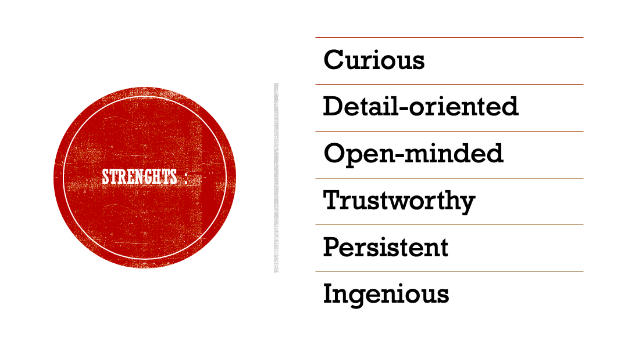
Appendix 1 Strengths
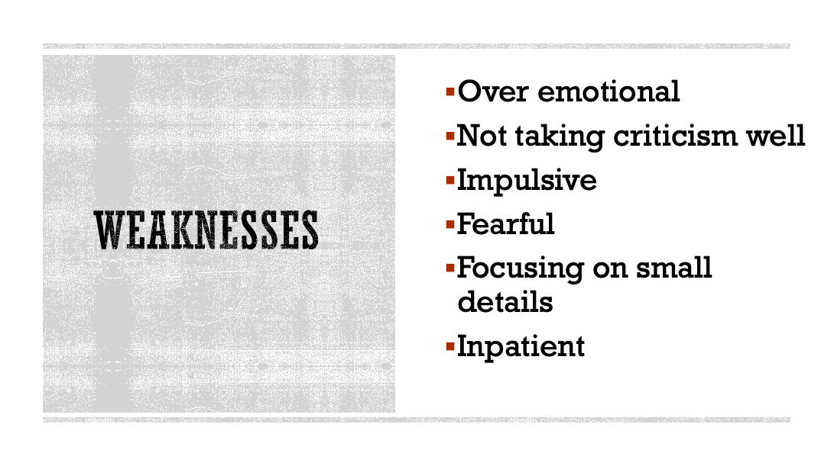
Appendix 2 Weaknesses

2.1. Key points learnt when producing and delivering a successful PowerPoint presentation :

- Show the creativity
- Keep it simple
- Concentrate on the core massage
- Using an interesting design for the audience
- Focus on the contents source

Goals

Prefer to think about myself as an emphatic person. Doing the best I can and try to help thus who need help, either if they ask or not, that why I choose to become a research engineer.
During a day most of the things that we experience are based on research. From food, to health, to safety, and the list is keeps going on.
As a start point, I do believe the abilities that required for a researcher are organisational skills, communication skills, analytical skills and fortunately I do possess them. One skill I don’t master it properly self-confidence. And knowing that this skill is very important because, sometimes you need to have the full control over a situation that you are in, specially when it comes to research, and that is because people are relying on your expertise.
My plan on improving this is by working independently, stop overthinking all the time about a situation. Doing that, just makes it worse and you lose your concentration on what you actually need to work on.
 | Short term time frame | Mid-Term time Frame | Long-Term time Frame
Overall goals that I want to accomplish in this time period. | My short-term goal is to understand first term modules and managing time for individual study and personal life. It is also quite important to be able to use those skills in practice. | To get an internship and be able to collect some professional knowledge in IT. | To perform the knowledge in cloud computing along with creating a personal portfolio. Also be looking forward to accomplish demo projects involving the application of Python and animation as a side hobby.
Table 1 Goals that I plan to accomplish
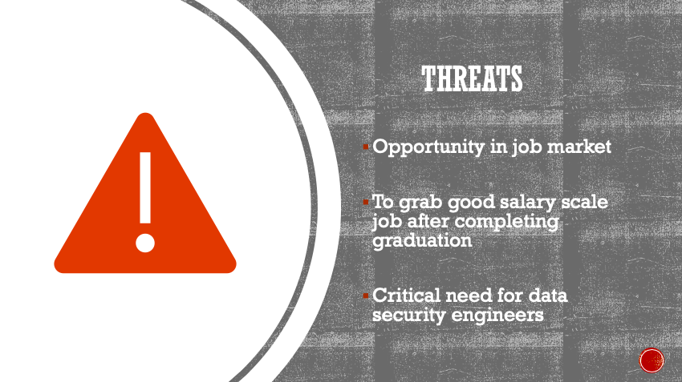
Appendix 3 Threats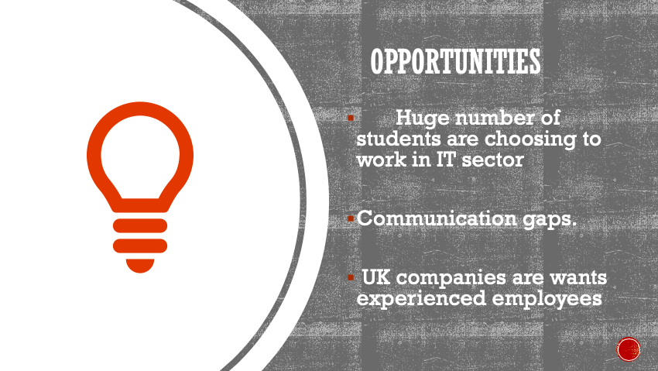
Appendix 4 Opportunities

Self-Evaluation

Skills required for Higher Education Learning and Employability

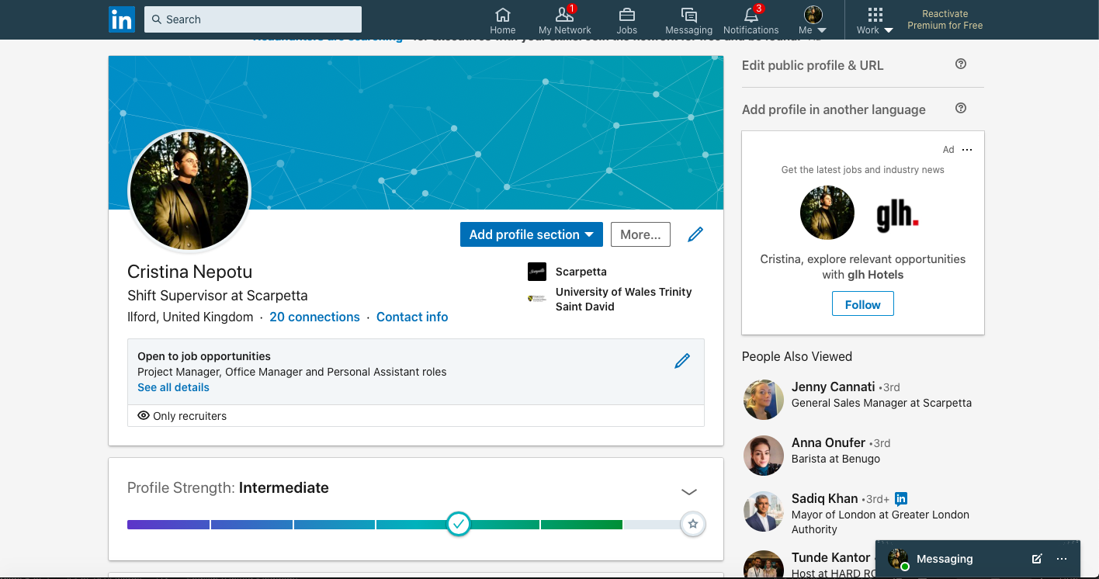
Appendix 5 LinkedIn Profile Screenshot
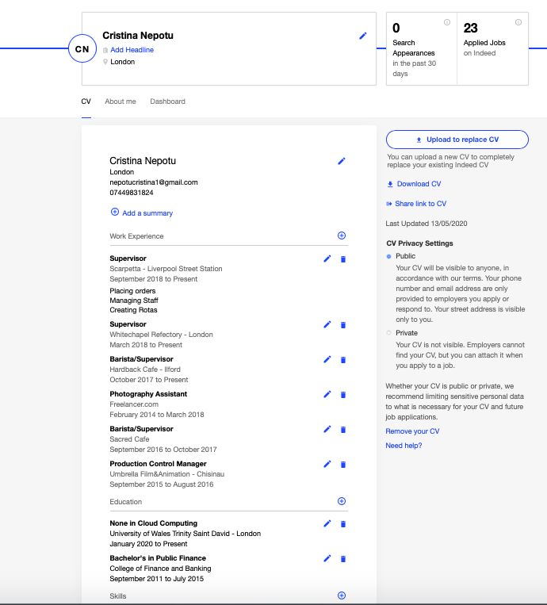
Appendix 6 Indeed Profile Screenshot

4.1.2. Skills required for Higher Education Learning
There are various skills that are required to accomplish the goal of working as an IT professional. This can be stated in the following manner:
To have Python as my Language Coding Skill: In present day’s trend it is important an individual has some knowledge about coding and programming skills. I have been learning Python as it helps in undertake project requiring to code and develop applications (Aiuniv.edu 2020). These are essential software that helps an individual to work with efficiency.
To have an idea of Network and Internet protocols: Every individual should have a basic knowledge about different internet protocols. It helps in developing business projects requiring network configuration (Businessnewsdaily.com 2020).
Information Technology: IT is an important part of every organization and this also helps an organization to get core knowledge about information technology (Businessnewsdaily.com.2020).
Flexibility and Foresight: It is important for every professional to work in any kind of environment (Aiuniv.edu 2020). I am willing to work in the IT and cloud computing environment to gain experience. This will also ensure flexibility in the work experience.

4.1.3. The skills that are required for Employability:
Composition and Documentation: Composition and communication is one of the important skills that can help an individual to learn employability (Economictimes.indiatimes.com 2019). This is the basic criteria of an individual to start his higher education.
Problem-Solving and Critically Thinking: An individual must have a quality to face any kind of problems and work efficiently. In the time of any kind of problem occurring in front of an individual, he or she must think critically and make some plan to solve this problem.
Communication Skills: This is an important skill for employability. If any kinds of problems are faced by a professional he must communicate with the hierarchy to convey them about this problem (Funretro.io 2020). Communication is the only way to overcome any kind of problems that are faced by a professional.
Project Management Skills: Project management skills are required to manage varying job-related projects (Economictimes.indiatimes.com.2019). It helps an individual in a managerial position to execute tasks, allocate them in accordance to skill sets of team members. Having experience in this area is a great bonus in my favour.
Software Proficiency: In present days software is used in every organization, it is important for every individual to have knowledge about various types of software operating.
Academic Qualification: Academic qualification helps an individual to occur knowledge about his profession. Without any academic degree it’s easy to fail working with efficiency.

4.1.4. Self-Evaluation exercise to discover strengths and weaknesses, personality

Self SWOT helped me analysing my strengths and weaknesses that had a deep impact on my professional career (Funretro.io 2020). Which afterwards came as an additional help planning on overcoming some of my fears and moments of anxiety.
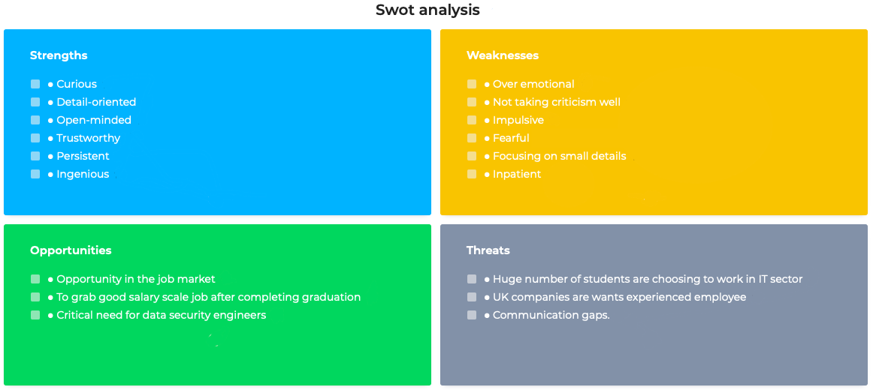

Analysis of Self-Evaluation Test Results
Appendix 7 Source: https://www.swotanalysis.com/20378/Swot-analysis
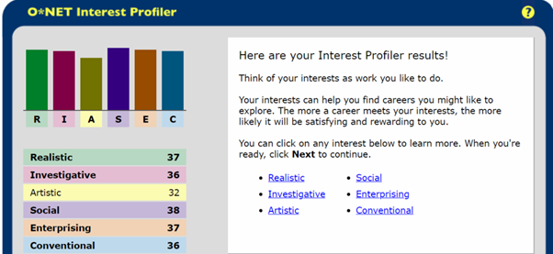
Figure 1 Analysis of Self-Evaluation
Analysis of Self-Evaluation test result helps me to study my personal strength and weakness and this also helps me to improve my professional profile to ensure a bright career. In this analysis I have divided my profile into six important factors and provide a score.
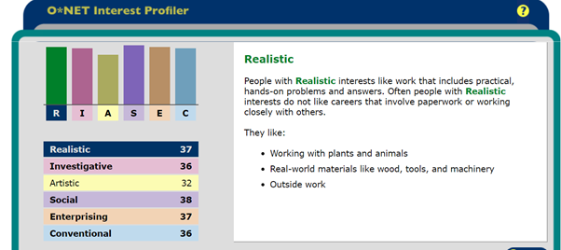
Figure 2 Realistic trait
Realistic: I have observed that in this analysis, I have scored 37 in realistic. Being able to earn a high score in this particular point shows that I have an interest in the real-life problems solving section. It also helps me to make some suitable plans and it also to face any kind of problems. I do believe that working in a team I could use my academic knowledge gained after this course.
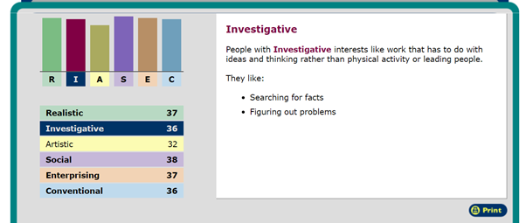
Figure 3 Investigative trait
Investigative: At this particular point, shows my inner abilities of researching. As a different goal of mine is to become a researcher, and this is proving my interest in searching facts and figures routing problems.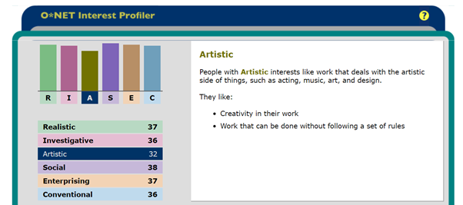
Figure 4 Artistic trait
Artistic: it is an interesting point that I show in this analysis. In this particular factor I was only able to collect 32 scores. The score that I am able to collect in art is less than compared to realistic and investigate points. In this factor my creativity power of work is disclosed and the work that can be done without following a set of rules.
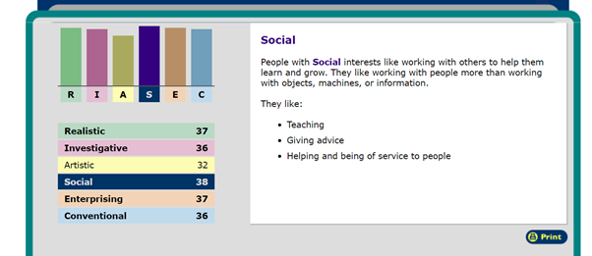
Figure 5 Social trait
Social: this factor has the highest score-38, and this is disclosing that I have a great interest in social activities. It could be interpreted as how to teach my co-employees, giving advice and helping and being of service to people. This score stands in a suitable position. It is also making sure that this is a deep impact in my career path.

Suitable Career Suggestions
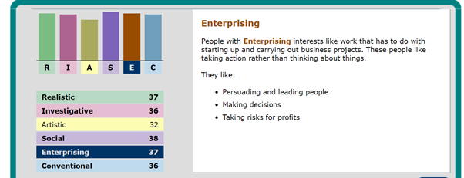
Figure 6 Enterprising trait
Enterprise: at this point show same score as realistic factor. It helps me to work with efficiency and shows the persuading and leading abilities with people that are related to my work.
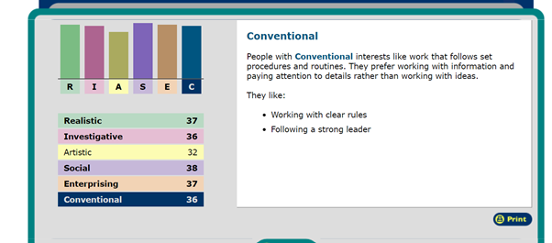
Figure 7 Conventional trait
Conventional: In this point of personal strength and weakness I have been able to achieve a similar score as investigative factor. In my personal profile I am able to work under clear rules without going out of boundaries.

Compare the contrast between personal overview and results of self-evaluation

The suitable career options for me based on the academic qualification and SWOT are: IT professional, Database Manager or Research Scientist of an organization. Even if I believe by the graduation time I might change my prospective.
It is important to be a good observer and have a good communication skill that helps to minimize an organization unnecessary cost (Hashemi, Samani, and Shahbazi, 2017).
The result comes out from the SWOT analysis. In my self-evaluation it is seen that I have a great interest in designing applications and writing codes. Also, that I have core knowledge about leadership and the same result comes out from self-evaluation. According to Self-Evaluation I earn least score in artistic which is quite surprising as in my youth one of hobbies was drawing, and I to believe that was related to my poor abilities of writing reports.

Personal developing panning
5.1. Short-Term Goals | To Achieve | Ways in Achieving Short-Term Goals | Time Frame | Evaluation Process
- To master the integrated use of information technology | It can be generated from joining classes and attending project | Take more projects and develop situational awareness. | 3 weeks | Ability of recognising the fundamental components of information system.
- Student advisor, Dreamweaver | Presenting student advice helps me to have a suitable approach from students. | Being active and joining different groups at the University. | 3 Weeks | Communicating with IT students and professionals.
- Information overview | Reading books with different content helps to find the suitable approach about IT. | Set a suitable time schedule and acquire best marks in the following assessment. | 3 weeks | Information overview helps to get some knowledge about new trend of IT.
- Leadership |  | Take more projects and develop Situational awareness. | 3 Weeks | I have to work with more projects and observe the processes that are followed by other project managers.
- Communication skill |  | Developing listening skill and read some books about how to develop it more efficient | 3 Weeks | Become a good listener and buy some books about communication skill
- Research |  | Set a suitable time schedule and Pose the thesis | 3 weeks | Time schedule helps me to manage time and what actions are taken by me in the right time. Pose thesis paper also helps me find out the main problems that stand in my research.
- Create own project | Starting own short project would help to face real problem and which problems overcome by finding adequate solutions | Understanding the core of IT world | 1 year | It can offer me to work with resourceful and dedicated people.
5.2. Long-time goals | To Achieve | Ways in Achieving Long-Term Goals | Time Frame | Evaluation Process
- Data management and analysis |  | Learn basic classes about data management and data analysis by getting into a course in online platform | 6 months | Completing courses about data management and data analysis. This helps me to work efficiently.
- Computer and Digital Literacy skills |  | Understanding some basic knowledge about Website design | 1 year | Join classes of web designing which also helps to get knowledge about computer and digital literacy
Table 2 Personal development panning

Action Plan
Short-Term and Mid-Term Steps | Long-Term Steps
- I will like to understand the lessons learnt this term. I will be going into online courses of learning cloud computing | - Data management and Analytics and learn Information Technology. I will like to learn the skills of IT and cloud computing
- Communicate with experienced person about how to start my career. And to achieve self-confidence as mid-term goal | - Computer and Digital Literacy
- Staring an internship at a software company called Salesforce
Table 3 Action Plan

Keeping data secure

Is a known fact that data security is about keeping personal information safe. As a Cloud Computing student, I have implemented in my routine few steps to prevent theft of my personal data. The simplest one is always to log of from public or university’s devices. For a person with enough knowledge about cyber security is very easy to access the saved information from the devices.
Second would be using strong passwords that are not easy to guess. And not the least important one is backing up your mobile phone, laptop or iPad. Here is a scenario that could happen to anyone: You have been working on you projects or assignments in a coffee shop. Next to you is passing a person with a cup of tea but he loses balance or gets burned by the heat of the cup and he drops the drink on your laptop. In that case all your information is lost as the NVME or any other type of hard drive gets damaged and there is no way of retuning it back.
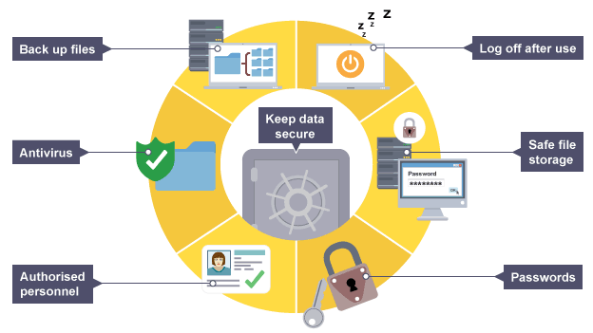
Appendix 8 Data backup strategies Source: https://www.bbc.co.uk/bitesize/guides/zw3cwmn/revision/2

Time management and organization
Time management helps me reduce weaknesses faced by me. I have chosen some books for developing communication skills.

Short-Term Goals | Mid-term Goals | Long-term Goals
- More reading  - Practising learnt material  - Finding a solution for gaps in communication  - Lower outcoming anger | - Taking extra online course related to my moodles at the University  - Starting a personal journal  - Overcoming fear of socialising | - Pursuing a career in Technological Science  - Becoming the best version of myself  - Adopt a dog (all those plans won’t have sense if there is not going to be a dog in my life)
Appendix 9 Time management and organisation skills

Conclusion & Evaluation

To summarise this study, I can say that here was shown several strengths and disadvantages in my professional profile. Such shortcomings are big obstacles to my performance. The key goal is to ensure that I establish effective methods to deal accordingly to problems. Self-evaluation has allowed me to see more clearly what my advantages are, and which are not so much. The six interesting points of the analysis plays an important role in my success path. According to the SWOT table, communication and poor self-esteem are significant shortcomings. It is also making sure that my positive points can help to accomplish the given targets. In the time management part, I am maintaining a suitable time frame that helps me to overcome my weakness. These major factors will help increasing my interest in important factors that will provide quality services.
The SWOT analysis, time management and keeping my data safe helps working efficiently and are included in some suitable plans that are created by myself to ensure the path to success. In the action plan portion, I divided my goals in two: first one is short term and another one is long term.. In short, I have made plans on how to increase my communicative and creativity skills. It is important to concentrate on those points in order to be able to deal with various challenges during the period of performance. In fact, time control and managerial practises are valuable for the effective and significant development of assignments and future growth.

References

Aiuniv.edu (2020). 7 Useful Technical Skills for Managers Available at: https://www.aiuniv.edu/degrees/business/articles/top-technical-skills-for-managers
(Accessed : 22 April 2020).

Businessnewsdaily.com (2020). How to Do a Personal SWOT Analysis Available at: https://www.businessnewsdaily.com/5543-personal-swot-analysis.html
(Accessed : 22 April 2020).

Economictimes.indiatimes.com (2019). Five skills needed to achieve your career goals Available at: https://economictimes.indiatimes.com/wealth/earn/five-skills-needed-to-achieve-your-career-goals/articleshow/51165539.cms?from=mdr (Accessed : 25 April 2020).

Funretro.io (2020). Personal SWOT Analysis Available at : https://funretro.io/personal-swot-analysis (Accessed : 24 April 2020)

Hashemi, S.M., Samani, F.S. and Shahbazi, V. (2017). Strengths, Weaknesses, Opportunities and Threats (SWOT) Analysis and Strategic Planning for Iranian Language Institutions Development. Journal of Applied Linguistics and Language Research, 4(2), pp.139-149.

Monster.ca (2029). Organizational Skills for Your Resume Available at: https://www.monster.ca/career-advice/article/organizational-skills-resume-examples (Accessed: 27 April 2020)
Phadermrod, B., Crowder, R.M. and Wills, G.B.(2019). Importance-performance analysis-based SWOT analysis. International Journal of Information Management, 44, pp.194-203.

Printo, M. and Pascual, R.F. (2017). Exploring LIS students’ beliefs in importance and self-efficacy of core information literacy competencies. College & Research Libraries, 77(6), p.703.
Scharp, K.M., Hall, E.D., Sanders, M. and Colver, M. (2018). The Relationship Between Students' Family Communication, Transition Efficacy, and Communication Skill. Journal of College Orientation, Transition, and Retention, 25(1).

Appendices

Appendix 1 Strengths 4
Appendix 2 Weaknesses 5
Appendix 3 Threats 7
Appendix 4 Opportunities 7
Appendix 5 LinkedIn Profile Screenshot 8
Appendix 6 Indeed Profile Screenshot 9
Appendix 7Source: https://www.swotanalysis.com/20378/Swot-analysis 11
Appendix 8 Data backup strategies Source: https://www.bbc.co.uk/bitesize/guides/zw3cwmn/revision/2 19
Appendix 9 Time management and organisation skills 20

Table of Figures

Figure 1 Analysis of Self-Evaluation 8
Figure 2 Realistic trait 8
Figure 3 Investigative trait 9
Figure 4 Artistic trait 9
Figure 5 Social trait 10
Figure 6 Enterprising trait 10
Figure 7 Conventional trait 11

Tables of tables

Table 1 Goals that I plan to accomplish 5
Table 2 Personal development panning 14
Table 3 Action Plan 14

