

Skills for the Workplace
Assignment Submission

Student Name: | Maryna Krainiuk
Student ID: | 2011437
Module No: | BMSW4005_LON
Module Title: | Professional Career Development
Lecturer: | Gulnar Ali

Table of Contents
Introduction 3
Self-evaluation and readiness for employment 3
Professional Development Plan 4
Explanation of S.M.A.R.T. goals 5
Learning Styles Model 6
Applying the Gibbs’ Reflective Model 7
Analysis of an interview with an employer 8
Conclusion 9
Appendix 1 (SWOT) 10
Appendix 2 (Honey and Mumford Learning Style) 11
Appendix 3 (Interview Questions and Answers) 12
References 14

Introduction

Professional development is an important aspect of human activity in the context of life development. Professional development includes personal development and career development (Career smart, 2020).
Personal development is essential to building a successful career and requires careful planning. Each person needs a thorough assessment of their capabilities, which will track the progress and degree of implementation of the plans.
Effective planning relies on introspection to identify strengths and weaknesses.
In this report, we will discuss my strengths and weaknesses, we will analyse the skills I need to advance as a nurse using SWOT analysis that contribute to my effective personal assessment and follow-up planning. We will determine my readiness for employment by analysing my previous experience.
We will also look at my personal development plan, which defines my short- and long-term goals, including SMART goals.
The reflective Gibbs circle will be used in these reflections.
Overall, this report provides important information to help me better plan my career and understand the work of nurses in health and social care.

Self-evaluation and readiness for employment

Self-evaluation plays a key role in the ongoing improvement process. Through self-assessment, we establish a baseline as a starting point. Then we can make plans for our further self-development actions that will improve the result.
According to Cottrell (2017), self-evaluation is the process of assessing one's own productivity and professional behaviour, identifying new ways to improve. In this process, strengths and weaknesses are found, personal qualities that contribute to future development or that need to be developed.
Medical staff perform different functions in healthcare facilities, so workers must possess a variety of skills and knowledge. Working as a professional nurse requires the knowledge and specific skills of nursing practice. Nurses act as advocates for patients by being close by during illness, helping to restore patients' lives by alleviating pain and suffering.
I have 5 years' experience as a Health Care Assistant and 5 years as a hospital nurse. During the period of my work in these positions, I have acquired the skills of caring for patients. For example, personal hygiene of patients who cannot take care of themselves on their own, prevention of pressure sores. In addition, while working as a doctor's assistant, I mastered the skills of assessing the condition of patients, measuring blood pressure, and taking an electrocardiogram.
Moreover, I have honed my skills in providing emergency care in various situations, including the skills of intravenous, intramuscular, subcutaneous injections, infusions, and blood sampling for tests.
During all this time of interaction with patients and their families, I developed my strengths and learned to communicate and empathize with all patients, improved my nursing practice, knowledge of medical ethics. Plus, has acquired the emotional strength to comply with all the requirements of a professional nursing.
In addition to my strengths, I identified areas in which I need to improve and learn new skills. I need to improve my knowledge of current legislation and policies for nurses, improve communication skills for negotiation, expand the level of knowledge about the drugs used, including side effects and contraindications.
The analytical tool for determining my strengths and weaknesses was the SWOT analysis matrix. In my SWOT analysis (Appendix 1), I identified my strengths, weaknesses, potential threats and opportunities. This approach helped me to build a strategy for my development. Thus, analysing the above in this part of the report, on the one hand, I am ready to continue my career as a nurse. On the other hand, our need to continuously learn and master new skills in order to be a specialist and meet the modern labour market and the requirements of the healthcare sector.

Professional Development Plan

In the professional development of a nurse, an important aspect is a career plan that demonstrates a commitment to nursing as well as job satisfaction. My long-term goal is to become a nurse in a leadership position. Achieving this goal requires a solid foundation of experience, knowledge, and skills. The profession of a nurse provides for continuous training since, to provide quality medical care to patients, medical professionals must be aware of modern healthcare and methods that contribute to improving the physical and mental health of patients.
According to the World Health Organization, health is a state of complete physical, mental and social well-being, and not just the absence of ailments and diseases (WHO, 2021).
An integral part of moving towards my goal is to stay focused on the healthcare sector, be interested in the latest news from this industry, attend training and seminars for nurses, learn new skills and improve the previously acquired ones.
One of the steps in my professional development is studying at the University. Academic experience has enabled me to move forward towards my goals. Working on individual assignments helped me improve my skills in time management, self-management, and analytical and critical analysis. Group assignments and presentations honed my teamwork and communication skills, diplomatic avoidance of conflicts with training colleagues if our points of view did not coincide, problem solving. The curriculum opened new models and techniques for me that I will use in the future if applicable to situations in my work environment.
The next step after graduation from the university, I plan to register with Nurse and Midwifery Council (NMC). According to relevant legislation nurses, midwives and nursing associates practicing in the UK must be registered with the NMC (NMC,2020). Having received registration with the NMC, I safely start working as a nurse in the National Health Service (NHS), thereby honing my practical skills. At the same time, improving their skills and knowledge with the help of additional specialized education in the relevant direction of health care.
I am sure all these actions will lead me to my cherished goal, and, moreover, will have a beneficial effect on my professional development.

Explanation of S.M.A.R.T. goals

SMART is a method of describing a goal, which includes specific, measurability, attainability, realistic and certainty in terms of time. The goal is to understand the result of our actions. Not having a goal is like going on a hike without a map or building a boat without a plan. Setting SMART goals is a guaranteed way to understand what we are going to do and how we are going to do it.
Accordingly, defining my SMART goals will help me develop as a healthcare professional. Below is an example of my Smart Goal 1:

S-Specific | M- Measurable | A-Achievable | R-Relevant | T- Time-bound
Get an Adult Nurse position in NHS England | Registration Number in NMC, Salary | Pass Part 1and Part 2 Test of Competence NMC | Establish contacts with medical facilities where I want to work | Complete within the next 3 month

Learning Styles Model

One way to help achieve our goals is by understanding specific learning styles. The Honey and Mumford Learning Styles Model (1992) exemplifies a suitable model that is suitable for individual learning and is able to cover the horizons of professional development. The learning styles of this model are largely based on Kolb's learning theory (Mobbs, 2010).
Honey and Mumford's model is based on the steps we take to learn new things and consists of the four styles below:
- Theorists are people learners relying on modern theories and models, rational
- Activists are people who learn by doing, fully and impartially participating in the experience
- Pragmatists are experimenters who try new ideas and theories through trial and error
- Reflectors are people learners through observation, evaluating facts and information

Accordingly, understanding that everyone has a different learning style can help us adapt our style of interaction with each other. Because learning is a permanent process, knowing our preferred learning styles and recognizing our strengths and weaknesses allows us to take proactive steps to learn and learn more effectively.
According to the results of the test I took to identify my learning style according to Honey and Mumford (1992), my mentality corresponds to a high level of reflection.
On the test, I passed a total of 80 questions that identified me as a Reflector. This definition implies that the Reflector prefers to be in the background in general discussions (Honey and Mumford, 2000). In addition, I do not rush before making any decisions and do not draw conclusions without listening to the opinions of others. I absolutely agree that I like being a thoughtful listener, as this is an opportunity to get different points of view from different angles. Accordingly, if I am surrounded by Activists, it will be a good motivation for me to act more assertively and increase efficiency in completing the assigned tasks.
However, looking from the other side, my weakness is that I devote a lot of time to accomplishing the assigned tasks. For example, I spent a lot of time searching and studying information before starting this assignment.
While Reflectors have a cautious mindset, I don't quite agree that Reflectors don't like to take risks. In my case, for example, I like to step out of my "comfort zone" to expand my knowledge and experience something that I have not experienced before.

Applying the Gibbs’ Reflective Model
Reflection is one of the key aspects in the process of personal and professional development. By working or learning in a changing environment, reflection helps to deliver quality evidence-based outcomes.
Gibbs Reflective Cycle (1988) shows how critical thinking can be a systematic and deliberate tool for improving and developing skills. The model consists of six steps, which can be divided into two groups. Steps one through three determine what happened and how it affected the situation or the person. Steps four through six help us focus on the situation and find answers to questions.
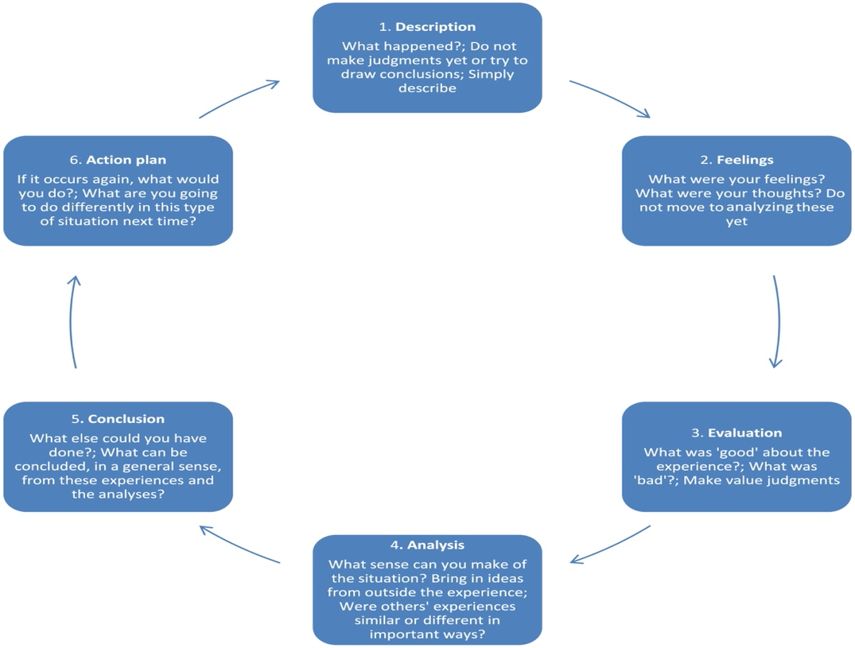

Using a structured form of thinking, I can draw up an action plan that will help me in my personal and professional growth. Reflection in nursing and health care is vital. Reflection provides insight into our actions and behaviour, as well as possible affects. In addition, it influences the final result in the provision of patient care.
The Gibbs model is very useful to achieve the best result, as it helps the reflective practitioner to analyse and evaluate the experience, study his practice and, as a result, formulate an action plan.

Analysis of an interview with an employer
One of the two parts of this semester's final assessment in the Professional Career Development module was an interview with an employer. This assignment meant a fictitious interview with one of my colleagues who was acting as the employer's side and me as a nurse job seeker. My colleague played the role of Human Resource Manager from National Health Services, as my goal is to work in the NHS England team.
The interview consisted of five "open-ended" questions (Appendix 3). To start the conversation, the first two questions were from the category to tell about yourself and your previous experience in the healthcare sector. These questions were intended to reveal more information about my qualifications. Additional information that is not described in the resume and will give the employer more details to make a decision about accepting me for the position of a nurse. Nursing is the day-to-day interaction with doctors, other nurses and departments, laboratories, paramedics, patients and their families. Accordingly, some of the questions consisted of questions defining my skills and readiness for this job.
In general, I can say that the interview was successful in my opinion. I answered questions with confidence and tried to clearly describe my candidacy. This fictitious interview was a good practice for me, as it will give more confidence in my future interview with the employer. In addition, already clearly formulated answers to possible questions are a good bonus.
Also, a significant aspect of the interview was that I was able to be in the role of both the interviewer and the respondent. This gave an understanding of the basic principles of the interview from two sides, both the employee and the employer.
Moreover, I became convinced that the interview is an essential link in the employment process. During the interview, the applicant can confirm the information from the resume and prove that he is really suitable for the proposed vacancy.

Conclusion
In summary, it is critically important for professionals in today's healthcare industry to be competent and knowledgeable for targeted career advancement. Through my training in this module and reflection, I have been able to ensure that I have acquired a set of knowledge that will advance my career. Also, I made sure that by taking some initiatives on my own it is possible to develop effectively.
My academic and professional background has broadened my horizons in the healthcare field. In addition, they gave me the opportunity to identify my strengths and weaknesses, so that I could become a competent specialist. The above experience helped me develop a set of professional knowledge, skills and competencies. Thereby showing that I am ready to move forward in healthcare and build a successful and prosperous career.

Appendix 1 (SWOT)
SWOT-Analysis
STRENGTHS  - Experience in Healthcare  - Self-motivated and highly organised  - Passionate about Nursing  - Good verbal and written communication skills  - Hard-Working  - Empathy  - Enhanced DBS-Check | WEAKNESSES  - Insufficient Knowledge of Legislation  - Low Vocabulary of Professional Medical English
OPPORTUNITIES  - Training  - Communication  - Teamwork  - Diversity in Work Progress  - Materials and Methods  - Achievement of The Goals | THREATS  - Illness  - Stress due to Long Shift  - Professional Competition from Other Nurse  - Lack of Support at Workplace

Appendix 2 (Honey and Mumford Learning Style)

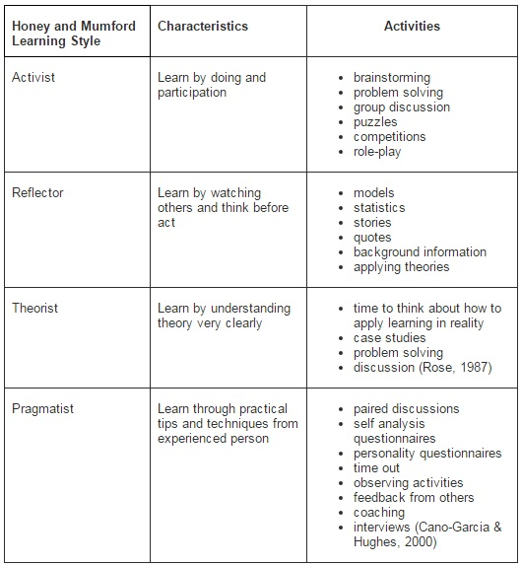

Appendix 3 (Interview Questions and Answers)

INTERVIEW FOR A NURSE JOB

Hello, Anna. My name is Maryna.
Thanks for inviting me to meet with you today.
- “Tell me about yourself.”
To generally describe myself, I would say I’m a hard-working individual that has gained a lot of skills over the course of the 10 years I’ve been working in the Health and Social Care industry.
I truly love helping people, there’s no better feeling in the world.
In my opinion, the nursing profession is one of the most important, because nurses help people cope with illness, treatment, and recovery, depending on the needs of patients.
Also, my profession is extremely promising for self-development.
Now I am looking for a career position that would allow me to continue to grow as a nurse.
- “What is your previous experience in Health and Social Care?”
I started my healthcare career several years ago in Ukraine.
In 2012, I graduated with honours from the Medical College. During my studies, I worked part-time as a Health Care Assistant. This work was good practice for me and taught me how to care for people with different needs.
Also it helped me to become more flexible and manage my time efficiently by combining work and study.
After graduating from Medical College and getting a degree as a nurse, I changed my job. For 5 years I worked as a nurse in the emergency department of a hospital. This hospital consisted of 8 departments such as pulmonology, therapy, gastroenterology, three neurological departments and intensive care.
Accordingly, we admitted patients with different diagnoses and emergencies. This allowed me to develop my skills in teamwork, analytical and critical thinking, attention to detail.
A year ago, I started to study at the University of Wales Trinity Saint David. A course Skills for the workplace in Health and Social Care and now I am looking to take my career to the next level.
- “Tell me about a time when you had to make a decision to prioritise something.”
Working as a nurse, every working day I faced situations in which it was necessary to prioritize. For example, assigning patients depending on their health status in order of urgency and importance (providing medical care from more urgent cases to less). Thereby increasing the patient’s chance of recovery.

- “How do you handle the stress of the job?”
I find the best way to deal with stress at work is through careful organization.
Plus, attention to detail and planning is a good way to avoid unnecessary stress.
By making a plan of action and prioritizing what needs to be done during the day, I have found that tasks that may seem overwhelming at the same time are much easier to complete.
In addition, it allows me to stay calm and focus on what to do in force majeure situations.
- “Are you comfortable working with other doctors and nurse?”
I find myself flexible and I do well in a variety of settings and circumstances.
I really enjoy working in a team, because working with different people allows me to broaden my horizons because different points of view can help me find a solution to a problem that I might not have thought about on my own.
Moreover, I also like self-motivation, and I am equally comfortable working alone

Thank you for making time to interview me for the open role, Anna.
Looking forward to your positive response

References

Career Smart (2020), Fast forward you career. Available at: https://careersmart.org.uk/your-career/career-development/professional-development (Accessed 18 August 2021)

World Health Organization (2021), WHO remains firmly committed to the principles set out in the preamble to the Constitution. Available at: https://www.who.int/about/governance/constitution (Accessed 20 August 2021)

Nursery& Midwife Council (2020), Legal basis of registration. Available at: https://www.nmc.org.uk/registration/your-registration/legal-basis-of-registration/ (Accessed 21 August 2021)

National Career Service (2021), Skills assessment. Available at: https://nationalcareers.service.gov.uk/skills-assessment (Accessed 25 August 2021)

Cottrell, S., (2017). Critical thinking skills: Effective analysis, argument and reflection. Macmillan International Higher Education.

Rosser, M., Mooney G., P., Jasper, M. (2013), Professional development, reflection and decision-making in nursing and healthcare. Wiley-Blackwell, Chichester

Mind Tool (2021), SMART Goals How to Make Your Goals Achievable. Available at : https://www.mindtools.com/pages/article/smart-goals.htm (Accessed 26 August 2021)

Gibbs, G. (1988). Learning by Doing: a guide to teaching and learning methods. London: Further Education Unit.
Honey, P. and Mumford, A. (2000). The learning styles helper’s guide. Maidenhead: Peter Honey Publications Ltd.

MINT Human Resources (2021), Honey and Mumford Learning Style Questionnaire.
Available at: https://www.mint-hr.com/mumford.html (Accessed 28 August 2021)
West, M., Armit, K., Loewenthal, L., Eckert, R., West, T. and Lee, A. (2015) Leadership and Leadership Development in Healthcare: The Evidence Base. London, Faculty of Medical Leadership and Management. Available at:
https://www.kingsfund.org.uk/sites/default/files/field/field_publication_file/leadership-leadership-development-health-care-feb-2015.pdf (Accessed 29 August 2021)

