Emergent Leadership Skills for the Workplace (BMSW6101_BIRM)

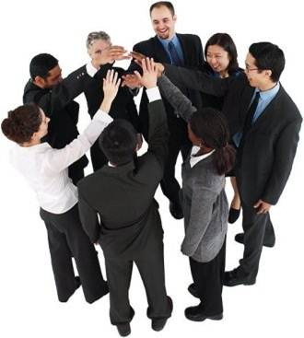

Rasheda Begum
(1814351)
Dr Eric Osei

Table of contents

Contents
Emergent Leadership Skills for the Workplace (BMSW6101_BIRM) 1
Introduction 3
Leadership Philosophies and Leadership Styles 4
Three (3) leadership styles mostly identified with modern leaders in uncertain times 8
Creating a constructive working environment 11
Conclusion 12
Part 2 – Reflective essay 13
References 16

Introduction

Emergent leadership is a formation used by organisations that utilises self-identified leaders, instead of leaders appointed by the company or worked up in the corporate hierarchy.
This is a new management structure, in which many organisations approaching and accepting. As this saves, time and individuals with this trait automatically put themselves forward for tasks that lead others.
This style of leadership has amplified in modern companies as a way to manage large number of employees. Creativity and critical thinking are valued, emergent leaders are individuals who inspire and motivate and are highly respected by their peers.
Many experts to explain exponential change and use this as the theory behind this immense change use Moore’s law of processing power.
The case study analysis will discuss how Chris Banks deals with exponential change during the pandemic and how he has a challenge to accept change and adapt to a different leadership style to be able to confront the problems to keep his job.
The report will highlight the relationship between the leadership styles and their philosophies, and lastly a reflective report on the module I have been taught and how this module has helped me throughout my journey as a student.

Leadership Philosophies and Leadership Styles

An effective leader is someone who can lead to followers, someone who is able to motivate and create an atmosphere where positivity increases productivity it focus on empowerment and influencing people with a plan to work towards achieving the end goal for the company, (CIPD,2021). As human beings, we all have traits of some kind of leadership within or character in our personal and professional lives.
Leaders use emotional intelligence to be able to change their leadership styles by analysing the strengths and weaknesses their followers possess.
There are many styles of leadership and we will discuss a few in this report reflecting how these styles align with the leadership philosophies.
Leadership philosophy and styles are somehow connected, philosophy is a belief of morals whereas style, is somehow learnt or in some people in born characteristic.

Autocratic Leadership Style
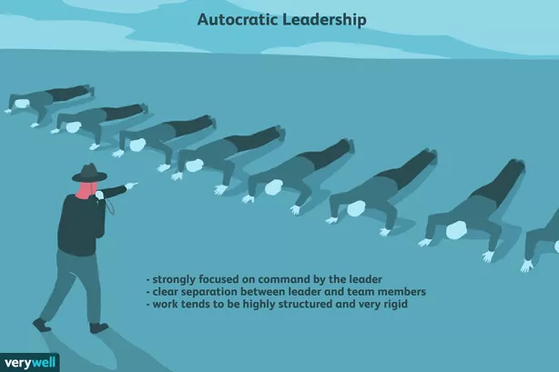

A leader with this style usually takes control over all decisions and takes little input from the team. What they say goes and this can demoralise the team. Autocratic leaders make choices on their judgement and do not like taking advice. The benefits of this style is that it allows for quick decision making, allows for a clear command and works well where strong directive leadership is needed. The drawbacks on this style is that it discourages group input, hurts morale and leads to antagonism (Cherry, K 2020).

Democratic Leadership Style

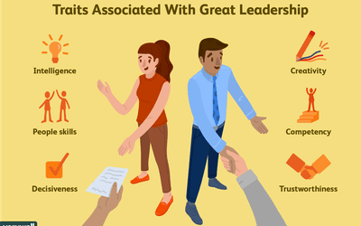

A leader with this style has the final say but includes their team. A democratic leader invites others to participate and encourages involvement, recognition and satisfaction.
The advantages of this style is that everyone feels part of the team, there is motivation and the empowerment to achieve and increase productivity. The disadvantages of this style is that due to the involvement of too many team members making decisions can take longer which may lead to delays in deadlines.

Laissez – Faire Leadership Style.



Leaders with this style have an attitude of trust and reliability towards their employees. They do not get too involved neither do they give many instructions or guidance. This style of leadership allows employees to use their creativity and resources to attain their goals.
The disadvantage of this style is that it is difficult for new comers who need direction and guidance; it can create confusion to who is in charge. It is common in this style that there is a lacking of structure and support and there is no set plan.
In 1960 Douglas Mcgregor’s book, The Human Side of Enterprise had proposed that managers attitudes have an impact on employee motivation. McGregor proposed two theories, Theory X and Theory W.

Theory X
McGregor’s Theory X of management on three assumptions follow that:
- People dislike work
- People like direction and control and like leaders to play a significant role.
- People want security and not responsibility and want leaders to follow.

Based on these assumptions it is required that a Democratic leader must take over to be able to motivate and control. A leader that can guide and give a direction to the team. A leader that can notice where team members need development and training.
This philosophy takes into consideration of Maslow’s hierarchy of needs where McGregor argues that once satisfied with a need that no longer motivates. Companies use monetary rewards such as bonus and pay rises to motivate people. So the more reward the more motivation that leads to success.
Theory Y
McGregor’s assumptions on Theory Y is as follows:
- People like work they do not dislike work – work is like play
- People are self-motivated
- People like the commitment factor
- People seek and accept responsibility
- They like being independent and productive and have the capacity for self –directed activities.

Based on these assumptions, a Laissez – Faire approach is required where the leader works with trust and reliance on their employees. People are already motivated and know what goals they are working towards without the need for direction. These leaders are there to support without the need to guide.

Highlighting the issues in the case study, Chris with an autocratic leadership style is under immense pressure, to adapt his leadership style to be able to cope with the problems raised by the pandemic and COVID-19.
The change in workforce and employee morale has made progression slow and the company is facing losses, employee retention has increased.
Board members are questioning Chris’s leadership style and believe that all successful leaders should be able to confront challenges and deal with changes to exploit new opportunities. Chris would need to change is leadership style and bring in a new philosophy and style to manage the situation and bring it under control. Chris needs to understand what the issue is and how can this be resolved he needs to listen to his colleagues and use his social awareness from his emotional intelligence skills to accommodate the change required.

Three (3) leadership styles mostly identified with modern leaders in uncertain times

In the diverse society today, many organisations throughout the world including counties are facing many problems to name a few, COVID-19, Brexit, and Globalisation.

- Transformational Leader

Jarcinda Ardern became New Zealand’s youngest prime minister and recently her leadership skills tested on two incidents.
In March 2019, terrorists attacked a mosque in Christchurch murdering 51 people during prayer time.
Ardern mourned with the country, she mourned with the community with the families, Ardern reached out to the Muslim community in an empathetic and straightforward manner (Unger, Y, March 2021).
Ardern, consistently praised by her colleagues and the media for her high levels of emotional intelligence of empathy and she has become an effective communicator. Ardern’s leadership is made up of conscientious motivation, strong communication skills and challenging experiences that created an authentic transformational leader’s identity.

- Visionary Leader

Bill Gates made his name as the cofounder of Microsoft where he served as CEO until 2000. He built a net worth $90 billion and more. Gates currently works with his wife Melinda for their charitable organization founded in 2000. Their vision is to issue grants for initiatives and programs across the globe. The couple’s vison is to focus on global health and education and to alleviate poverty.
This type of leadership is increasingly becoming more important, current situations have changed the visons of many organisations, causing them to change and adapt to the way they work especially in the pandemic. COVID-19 caused many companies to implement changes in the way they work to make sure there is not a disturbance in productivity or employee motivation.

- Servant Leadership

Servant leaders do not focus on hierarchy instead drive the company to success. They unite the workplace by empowering and motivating their employees to achieve what the company’s goal. Servant leaders have the eye for teamwork, they value this, and to increase this they invest in growth by teaching and mentoring their team.
Many servant leadership companies strive towards this leadership style:

- FedEX

Founded in 1971, by Fred Smith who still leads the company as CEO. He believes ‘to place people first and they will provide the highest possible service and profits will follow’.
The vision, with this thinking is a distinctive culture, the ‘People- Service – Profit’ this philosophy has helped the company to grow and remain in competitive.

Servant leadership is not only about serving people you lead and trying to help people, but it is also critically about sanctioning everyone to contribute to a higher purpose. It is not what I want you to do but how can I help you to be able to achieve the vision.

Chris was a successful CEO generating significant results over the past 25 years. Chris had an authoritarian style of leadership where he did not need the involvement of his fellow colleagues. In 2020 the COVID-19 pandemic bought increasing disruptions and change to the business.
Chris is struggling with this change with his employees. Employee retention is increasing and demoralisation too. The shareholders are asking Chris to change his leadership style and bring in new philosophies and a new style to be able to solve the raised issues.
Chris needs to change his autocratic leadership style, he needs to increase his emotional intelligence and be more socially aware. Chris could take the democratic approach because his team needs motivation, they need a leader who can guide them rather than direct them. Chris needs to promote effective communication so that he can effectively listen to the problems raised and find an overall solution. Chris needs to adapt from a task orientated leader to a relationship orientated leader, the well-being of his employees are important, this will bring trust and build a strong relationship.

Creating a constructive working environment

Constructive work environment builds trust, innovation, positivity and effective communication. Employees are happier and it creates a happier environment in return a successful company.
To be able to create a constructive working environment, senior team members need to clarify the expectations from the team.

Expectations | A statement that explains clearly what the company’s expectations are and how management will follow this through to it’s team.
Companies representatives | Company structure is mapped out and employees are know the team very well from all managers to team leaders to specialists and HR
Provide companies policies and rules and regulations | Employees made aware what the policies are regarding health, holiday, and discrimination. The procedures required to deal with conflict.

To be able to face the dilemma Chris is in, he must be ready to change and adapt to new ways of leading. Chris will need to initiate a constructive working environment; Chris needs to reinforce his role, the expectations of the company the vision and goals need to be revised with a different approach to attain them. Chris would need to introduce new working environments arrange more flexibility for his employees taking into consideration their well-being.

Conclusion

This report analyses what emergent leadership is, it highlights the different leadership styles and how they relate to the leadership philosophies. We understand that there is no limitations to any of the styles mentioned, not all fit the purpose or environment we work in. However if change is required then as a leader we should be able to adapt to change according to the circumstance to continue providing to lead a successful team.
The report explores the different ways which Chris can improve his leadership style to repair the damage caused by the pandemic. We have learnt that different styles of leadership have their own benefits and downfalls too. This report enhances the choices that Chris can take to develop his team again which includes taking on new styles and increasing his emotional intelligence.

Part 2 – Reflective essay

There are many reflective models, such as the Kolb reflective cycle (1984) or the Driscoll model (1994). I have decided to us the Gibbs reflective cycle (1988) to reflect on my learning. I will reflect on my presentation and on the classroom activities we did in class.

- Description

During this module, I learnt about the different leadership styles and the philosophies. I was not aware of all the styles but I knew I had a democratic style of leadership. Learning about the different philosophies was interesting and made sense when we discussed it. It made sense to say that motivation dies down and employees are always looking for new rewards or incentives at work, this reminded me of our team at work where many times we have mentioned to our line manager that we deserve a bonus. This topic mentioned in a humorous way reminding the seniors how hard our department has worked throughout the pandemic.
Whilst our video presentation I realized how difficult it was to make eye contact yet not to sound as if I was reading off a script, by take 22 I had memorised my script and I felt I had a lot of eye contact and spoke with confidence. In class, we were given a few tasks to complete and some were to paraphrase an article in three sentences.
I found this task quite difficult, because I cannot digest an article straightaway it takes me a couple readings before I fully understand what I am reading. To paraphrase this was a challenge, especially in three sentences. I enjoyed the assignment because I was able to research the different styles and elaborate the findings for the case study.

- Feelings

We started this module back into campus, after studying level 5 online, I was a little apprehensive because I have not met all my colleagues so it would have been the first time meeting them all, however majority of my fellow students were studying online and we had a handful in class.
When we started this module, I was not quite prepared because I was not aware of all the contents or some of the terminology. Our lecturer made it very easy and clear as teaching progressed. After submitting the video presentation, which I thought I had done really well, I was confident that I would receive a high mark. Once I received my marks I was a little disappointed from the feedback, I have used this constructive feedback for my future video presentations.
When given classroom tasks, I felt my confidence drop because paraphrasing is not something that comes easily to me and I found myself under pressure when my fellow students were able to read out what they understood from the articles.

- Evaluation

I felt that I gained knowledge in the areas of leadership styles and their philosophies.
I learnt about task and relationship orientated leadership styles.
During the video presentation, I was able to align my leadership style with Laura, I realised that my leadership style had more characteristics than I thought. I learnt how to upload a video presentation; this is useful for future projects.
I felt going into campus gave me more support as I was more engaged in class and was able to participate more.
I felt that some lessons, rushed such as the lesson on philosophies and I decided to record that lesson so that I can always go back for reference.
The first term of level six has been amazing and I have been able to relate both modules together emotional intelligence with leadership styles, I have learnt that they both go hand in hand.
With the knowledge gained, I have been able to advice Chris on the case study I highlighted all the relevant topics relating to the module.

- Analysis

During this module, we conducted activities to learn about the different leadership styles. We watched videos and one of them was of Laura Brodie which we used for task one. Another video was on the different types of leadership styles. We participated in class activities reading literature on Task orientated and Relationship orientated leadership styles.
This module made me realise that I have two leadership styles; democratic when I am at work at The Works working as a team leader where I motivate team members, work together to create productivity. I also have an autocratic approach when I am the floor manager at my family owned restaurant. I have this approach because my team members rely on my decisions and me.

- Conclusion

This module has taught me the philosophies behind the leadership styles. I have acquired more knowledge that I can use in future projects.
I can use this in my everyday leadership tasks either me home or work and be able to adapt to change.
This module has taught me that there are no limitations and each style cannot fit all scenarios and change is important.

References

https://www.businessinsider.com/top-ten-business-visionaries-creating-value-for-the-world-2016-6?r=US&IR=T#5-bill-and-melinda-gates-6

Chartered Institute of Professional Development (2021). Leadership. [Online].
Available: https://www.cipd.co.uk/knowledge/strategy/leadership#gref. [Last accessed on 14 October 2021].
https://www.forbes.com/sites/katecooper/2018/07/03/who-is-the-servant-leader-really-serving/?sh=1cb9a3bc323c

https://www.linkedin.com/pulse/jacinda-ardern-authentic-transformational-leader-yancy-unger

https://courses.lumenlearning.com/wmintrobusiness/chapter/reading-douglas-mcgregors-theory-x-and-theory-y-2/

https://www.indeed.com/career-advice/career-development/emergent-leadership
https://www.managementstudyguide.com/exponential-change-and-its-implications.htm
https://www.skillpacks.com/servant-leadership-examples-in-business/

https://www.thesuccessfactory.co.uk/blog/advantages-of-democratic-leadership

https://www.verywellmind.com/what-is-autocratic-leadership-2795314

https://www.wgu.edu/blog/what-laissez-faire-leadership2006.html#close

