COMMUNITY ENGAGEMENT: ASSIGNMENT 1

Executive summary
Community engagement is the process to ensure of accessing of members to valuable activities of the society and also able in contributing to those. It has evaluated its mission, vision and values with type of customers and their expectations. It has also evaluated impact of micro and macro-environment on the performance of Idverde. Here, the role and importance of employees for achievement of goals of the company has been discussed with the importance of HR manager in the organization. The required skills and knowledge for the role of HR manager also has been assessed in this report.

Table of content

Introduction 4
Organizational background 4
Discussion 5
Role of employees 5
Training and development and its importance 5
Role and its importance 6
Skills needed for the role 7
SWOT analysis 7
PESTEL analysis 9
Conclusion 12
Reference 13
Appendices 15

Introduction
Community engagement is the process to ensure of accessing of members to valuable activities of the society and also able in contributing to those. This report is aiming in evaluating the role of employees and HR manager of the UK construction company IDVERDE. It will discuss the mission, vision, and impact of macro and microenvironment on its performance.

Organizational background
Idverde is a firm that belongs to the consumer discretionary sector of the UK and it is one of the leading companies of the commercial services industry that used to provide service in ground maintenance and projects of landscape constructions (Idverde, 2019). It has its operations covering the entire UK and Europe with total colleagues of 5000.
The vision of Idverde is to be the supplier of choice to create and maintain the landscapes for the purpose of business as well as communities (Idverde, 2019).
The mission of the company is to create as well as to the maintenance of landscapes for its clients and to employ motivated colleagues in an ambiance which can make feel them valued as well as proud of working (Idverde, 2019).
Ideverde used to value collaboration, integrity, and innovation of its services and respect to employees and responsibility and focus on work (Idverde, 2019).
There are various kinds of customers including local authority, private sectors, and housing associations. These kinds of customers usually expect service of grounds maintenance. For the service of landscape construction, customers included the authority of heritage building and hospital and health sectors.

Discussion

Role of employees
As per the views of Ruck et al. (2017), employees used to play significant role in contributing effectively to the successful operating of a firm. Employees are used to be authentic assets in an organization and their role is to strive effectively in delivering the best effort to achieve targets assigned to them. Employees have a significant function in determining organizational culture. In this context, the employees working in Idverde also are playing an important role in achieving the goals of the company. There are also certain responsibilities of employees that needed to practice by them. Employees have a role in the abiding legal framework of an organization and to maintain the safe environment of the company. They also have the ability in creating innovative and convenient solutions to various problems.
Employee engagement is important to effectively work on the path of achieving the goals of an organization. Management of the Idverede needed to make well equipped to its employees and make them available to their resources for making convenient working. Skilled employees are important as they used to meet the assorted deadlines that enhance sales and create the brand via interactions with customers in a positive manner. These skills are important for the employees of Ideverde as projects of landscaping and ground maintenance needed to be complete in a fixed deadline. The accomplishment of work in time and good communication with clients’ makes customers satisfied which helps in achieving organizational goals.

Training and development and its importance
Training and development is the effort of an organization that is important for boosting the performance of its workers. According to Noe et al. (2017), training and development sessions are important for employees as it has the purpose of serving their motivation that in turn creates an organization in making high skilled employees. Considering this fact, employees and the workforce of Idverde are also provided training sessions regarding ground maintenance, engineering skills and knowledge about updated machinery uses. Knowledge about horticulture and biodiversity and ecology is also provided to the employees for making more efficiency in the working process of Idverde.
As stated by Noe et al. (2017), employee training is important in order to address the weak areas of employee and lacking skills in them. A program for training used to brings an opportunity for inculcating the required skills in them. Similarly, a session for development assists in expanding the base of knowledge about relevant subjects of all employees. Idverde are also able to make an improvement in the performance of their employees by providing training about safe and secure practice and uses of using machines and equipment for their work of construction and maintenance. Training and development also help in fostering the creativity of employees and make them independent during facing any challenge in work.

Role of HR manager and its importance
Human Resource Manager is responsible for making an effective plan and to direct as well as coordinating the functions of the administrative department of an organization. As per the views of Banfield et al. (2018), the HR manager also has the duty in the process of recruitment and interview as well as the hiring of new workforces and to make coordination among top management with employees. There are various kinds of roles and responsibilities of an HR manager in an organization. Planning and making coordination of the workforce in an organization for using talents from the employees is the major duty of the HR manager. In this context, the HR manager of Idverde also performs its duty in hiring and using the best talent from the workforce to improve performance of employees.
The HR manager of the concerned company also has an important role in providing advice to the managers regarding policies of the organization including various rules and regulations. Handling various issues of staff are including conciliating disputes and the process of making directions of disputes. HR managers also have the role of consulting with top management regarding the strategic planning of an organization. As opined by Banfield et al. (2018), they used to identify processes and methods in maximizing the worth of the employees in an organization and also make ensure their utilization with the most possible efficiency. Their responsibilities used to associate in overseeing relations of workforces and regulatory compliance as well as services that are employee-related including payroll and training as well as benefits. The HR manager of Idverde also has a role in supervising the specialists of the department and used in supporting workforces as well as has a role in ensuring that jobs get accomplished in full accuracy and on the allocated time.

Figure 1: Role of HR manager
(Source: Banfield et al. 2018)

Skills needed for the role of HR manager
There are various skills and knowledge necessary for the job role of Human Resource Manager. As mentioned by Navimipour et al. (2015), the first and foremost important ability and skills for HR manager is communication and leadership. It is necessary for an HR manager to be able in communicating effectively in a workplace with every level of organizational structure including employees to top management. Interaction of the HR manager is necessary as they have to communicate with the providers of outsourcing and public officials as well as union leaders.
Analytical and critical thinking is another important skill that is necessary for an HR manager as they have to perform judgment and also make decisions in various areas. The ability in analyzing any situations and perspectives on the implications of determined decisions from a perspective in a critical manner is mainly necessary for HR managers. The HR manager also needs to possess relation-building and leadership skills for making a collaborating and cohesive working environment that helps in achieving organizational goals. Leadership skills are necessary as they have to create strategic planning for the whole workforce.

Figure 2: Skills of HR manager
(Source: Navimipour et al. 2015)

SWOT analysis
Strength | Opportunity
- A broad range of services  - Skilled employees  - Present in the entire UK and Europe  - Community investment fund  - Follow health and safety regulations  - Environment-friendly motive  - Aim to conserve biodiversity | - Has an opportunity to open in new markets  - Opportunity to focus on more technological service  - Able to open service for animal husbandry areas beside horticulture
Weakness | Threat
- Restricted in areas  - Lack of online booking service  - Competitors are present | - M T Grounds Maintenance Ltd, Iris Garden Services Ltd, and E-scapes Landscapes Professional Gardening & Grounds Maintenance Services are the rivalries of Idverde
Table 2: SWOT analysis
(Source: Gürel and Tat, 2017)
Idverde has the strength of leading landscape and ground maintenance companies covering the UK and Europe. It has also a good organizational structure and over 5000 employees that bring the opportunity for opening more branches in other markets of different countries. It has also the strength of focusing and maintenance of laws and regulations and aims at building a sustainable environment and conserving of biodiversities. However, besides these strengths, lacking of the online booking system and limitation in areas are a weakness. Competitors are also present that pose a threat to the sale and performance of Ideverde.
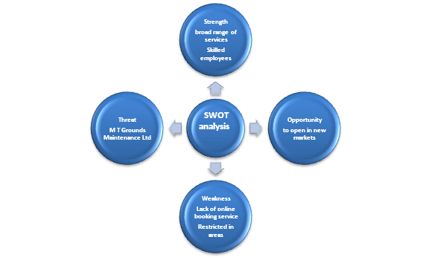
Figure 1: SWOT analysis
(Source: Gürel and Tat, 2017)

PESTEL analysis
Components | Factors | Impact
Political | - A stable form of government  - Brexit has impact  - Trading is open form  - Policy of trade is free | Positive and negative
Economy | - Rate of inflation has decreased to 1.7% (ons.gov.uk, 2019)  - Rate of exchange got hiked to 0.16%  - Rate of annual GDP growth got decreased to 1.4% (statista.com 2019) (Refer to appendix 1)  - Tax rate got enhanced to 41.6% (gov.uk 2019) | Positive and negative
Social | - Rate of unemployment is 3.8(tradingeconomics.com 2019) (Refer to appendix 2)  - Rate of gender inequality decreased to 8.6%(ons.gov.uk 2019)  - The literacy rate is 99%  - Lifestyle is the high status | Positive and negative
Technology | - Infrastructure and technology are advanced  - Government of the UK had invested £1 billion in developing AI(itpro.co.uk 2019)  - UK government had invested £153 million for quantum computing | Positive
Legal | - Consumer rights act 2015 (citizensadvice, 2019)  - Data Protection Act 1998 (legislation.gov.uk, 2019)  - The Competition Act 1998 (legislation.gov.uk, 2019)  - The Enterprise Act 2002 (legislation.gov.uk, 2019) | Positive and negative
Environment | - Policies as well as campaign creating awareness about environmental  - Policies of recycling  - Policies of waste management | Positive and negative
Table 2: PESTEL analysis
(Source: Sammut-Bonnici and Galea, 2015)
There are various external factors that able in affecting the performance of the commercial service industry and Idverde is also subjected to these factors for belonging in this sector. A stable form of government and free and open trade policy of the UK has a positive impact on the Idverde’s performance. However, Government decision on the Brexit has created little negative influence regarding additional tariffs and taxes. The financial condition of the UK is facing little worsen due to the reduction of GDP rate and increased tax rate.
But, the inflation rate has decreased which is positively effecting by increasing the purchasing power of people of the UK. Decreasing the unemployment rate with gender inequality rate and increasing literacy rate facilitates the company in getting skilled female and male employees. The government of the UK has also facilitated the company’s operation and performance by investing in technology and AI development. However, there are few acts and regulations that are needed to be abiding by Idverde for its sustainability in the market.

Conclusion
Thus it can be concluded by the report that Idverde is an UK commercial service company that used in serving landscape and ground maintenance present in UK and Europe. It has evaluated its mission, vision and values with type of customers and their expectations. It has also evaluated impact of micro and macro-environment on the performance of Idverde. Here, the role and importance of employees for achievement of goals of the company has been discussed with the importance of HR manager in the organization. The required skills and knowledge for the role of HR manager also has been assessed in this report.

Reference
Banfield, P., Kay, R. and Royles, D., (2018). Introduction to human resource management. Oxford University Press: Great Clarendon Street.
citizensadvice (2019) The Consumer Rights Act 2015. Available at: https://www.citizensadvice.org.uk/about-us/how-citizens-advice-works/citizens-advice-consumer-work/the-consumer-rights-act-2015/ [accessed on: 1.11.2019]
gov.uk (2019) Income Tax: Personal Allowance and basic rate limit from 2019-20. Available at: https://www.gov.uk/government/publications/income-tax-personal-allowance-and-basic-rate-limit-from-2019-to-2020/income-tax-personal-allowance-and-basic-rate-limit-from-2019-20 [accessed on: 1.11.2019]
Gürel, E. and Tat, M., (2017). SWOT analysis: A theoretical review. Journal of International Social Research, 10(51).pp. 995-1005
Idverde (2019) OUR VISION, MISSION AND VALUES. Available at: https://www.idverde.co.uk/ [accessed on: 1.11.2019]
itpro.co.uk (2019) Government has partnered with industry for the first time to train the next generation of AI talent. Available at:https://www.itpro.co.uk/business-strategy/careers-training/33050/uk-universities-receive-110m-to-fund-ai-masters-and-phd [accessed on: 1.11.2019]
legislation.gov.uk (2019) Competition Act 1998. Available at: http://www.legislation.gov.uk/ukpga/1998/41/contents [accessed on: 1.11.2019]
legislation.gov.uk (2019) Data Protection Act 2018. Available at: http://www.legislation.gov.uk/ukpga/2018/12/contents/enacted [accessed on: 1.11.2019]
Navimipour, N.J., Rahmani, A.M., Navin, A.H. and Hosseinzadeh, M., (2015). Expert Cloud: A Cloud-based framework to share the knowledge and skills of human resources. Computers in Human Behavior, 46, pp.57-74.
Noe, R.A., Hollenbeck, J.R., Gerhart, B. and Wright, P.M., (2017). Human resource management: Gaining a competitive advantage. McGraw-Hill Education: London.
ons.gov.uk (2019) Consumer price inflation, UK: August 2019. Available at: https://www.ons.gov.uk/economy/inflationandpriceindices/bulletins/consumerpriceinflation/august2019 [accessed on: 1.11.2019]
Ruck, K., Welch, M. and Menara, B., 2017. Employee voice: An antecedent to organisational engagement?. Public Relations Review, 43(5), pp.904-914.
Sammut‐Bonnici, T. and Galea, D., (2015). PEST analysis. Wiley Encyclopedia of management, pp.1-1.
statista (2019) United Kingdom GDP growth 2000-2018. Available at: https://www.statista.com/statistics/281734/gdp-growth-in-the-united-kingdom-uk/ [accessed on: 1.11.2019]
tradingeconomics.com (2019) United Kingdom Unemployment Rate. Available at: https://tradingeconomics.com/united-kingdom/unemployment-rate [accessed on: 1.11.2019]

Appendices
Appendix 1: GDP of UK
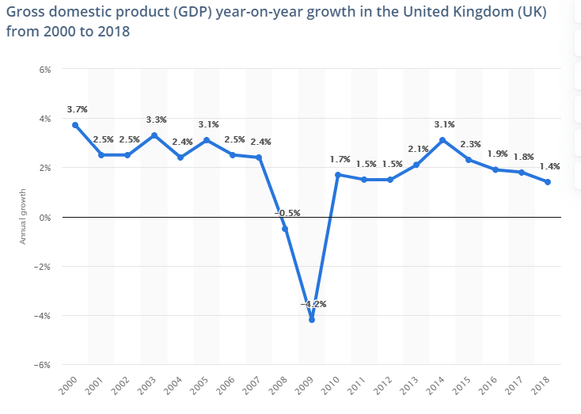
(Source: https://www.statista.com/statistics/281734/gdp-growth-in-the-united-kingdom-uk/)

Appendix 2: Unemployment rate
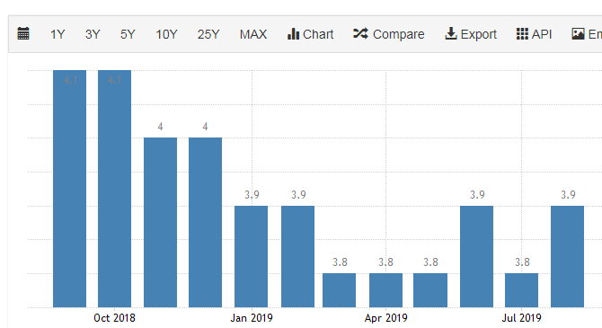
(Source: https://tradingeconomics.com/united-kingdom/unemployment-rate)

