Technical Report of An Internet of Things

John Hughes
1708241
Academic Writing
Semester Two
15th April 2019

Table of Contents

Title Page……………………………………………………………………………………….…1

Table of contents……………………………………………………………………………..2

1 Introduction…………………………………………………………………………….……3

2.1 Characteristics of IoT……………………………………………………….………4-5

2.2 The consumer IoT………………………..……………………….…………….……..6

2.3 The future of IoT……………………………………………………………….……….7

3 Conclusion…………………………………………………………………….………………8

References…………………………………………………………………………….…………9
1 Introduction

The Internet of Things (IoT) has a rather broad meaning and can be difficult to clearly define. As stated by Luigi Atzori in the article from Computer Networks, the term originally derives from a “Things orientated” perspective; the “things” considered being Radio Frequency Identification (RFID)[1]. In short, RFID is a method of electronic tagging that enables automatic identification of objects at distance, without requiring line-of-sight [2]

From there, IoT has evolved into a vast network of technologies. Felix Wortmann and Kristina Fluchter state in their article, entitled “The Internet of Things”, IoT is characterised by the combination of physical and digital components to create new products and enable novel business models [3]. In today’s consumer environment, this would commonly refer to smart devices, ranging from mobile phones and televisions to digital utility meters for water, gas and electricity, which expands into most aspects of everyday life.

2.1 Characteristics of Internet of Things

For something to be considered an IoT, it would need to consist of three main features. Firstly, you would need a thing/device composed of hardware features such as embedded sensors and processors.

The next requirement would be connectivity itself, typically via an antenna of some kind, in order to enable communication between hardware and application software.

The third and final feature would be the IoT cloud, which would often be the more complex of the three features as it would compose of a number of software features to deal with analytics, data, process and communication management.

All three features would be best illustrated in the form of a technology stack. A diagram of which is shown in fig.1, taken from an article in Harvard Business Review by Michael E. Porter and James E. Heppelmann.[3]

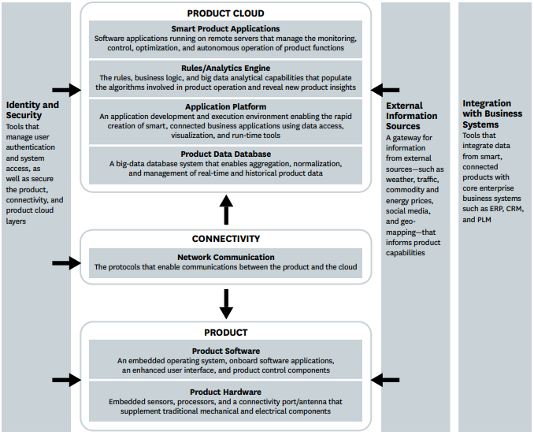
Fig.1 From Porter and Heppelmann 2014 [3]

As shown in the diagram, there are three important components of the technology that bridge over all three main features. The identity and security would require extensive coverage so as not to expose any weaknesses to malicious entities capable of compromising the technology.
External information sources are necessary to supply real-time information, a fundamental requirement for almost all IoT technologies.
Integration with business systems is necessary to expand the reach of technologies across multiple industries, allowing the capacity for systems of systems and in turn having greater influence of IoT based devices and software.[3]
2.2 The Consumer Internet of Things

In the consumer world, IoT is gradually setting the standards in many competitive markets. As stated in Harvard Business Review, authors Porter and Heppelmann describe “The third wave of IT-driven competition”. Sensors, processors and software are being integrated into products to improve functionality and performance. These products are typically known as smart, connected products/devices. [3]
The article goes on to define the term “smart, connected products” in a manner that carries three familiar features in the world of IoT – physical, smart and connectivity components. These features are fast becoming a requirement in many markets. Without such technology, products are becoming too outdated and left behind in the competitive consumer world. [3]
An article from the Journal of Consumer Research, by Donna L. Hoffman and Thomas Novak Predicts that the IoT industry is to be worth $3 trillion by 2025, with 27 billion different kinds of things connected to the internet. [5] This would mean that radio transmitting devices would outnumber humans by at least 3-fold. It goes on to illustrate the idea of a smart home, starting off with a hue hub connected to a mobile phone, an automated coffee machine activated by “Alexa”, through to a pet-bot for their son. The article highlights just how far reaching the IoT is becoming in everyday life. [4]

2.3 The future of IoT

The next stage of IoT seems to head towards A.I technology. This was evident with the development of Google Lens, as described in Mike Elgans article, “Google, AI and the rise of the super-sensor”. [5]
The Google Lens is essentially an application that uses cameras to identify things it’s pointed at with the use of A.I. technology. From there, it can gather information from the pictures and process the data to perform a vast array of functions. According to the author, this represents the future of IoT technology with the rise of the super-sensor.[5]
The idea pointed out by the article is less sensors, but with greater capability. Rather than have many sensors with individual purposes, you can have general purpose super-sensors that relay data to software based “synthetic sensors”. Examples of use for synthetic sensors involve monitoring and identifying specific sounds, motions or personnel and using this data for convenience with other things, such as opening doors for authorised personnel, warning staff of vehicle movement and monitoring required maintenance. [5]

3 Conclusion

IoT technology has swelled considerably since its inception. From its origins of identifying radio transmitting devices, it has reached almost all forms of modern technology so far. And what has not been reached yet, is just a matter of time before it does. In its early days, nobody would have thought you’d need a smart lightbulb or television set but now, it’s a case of why not? In the not too distant future, most things will be incorporated into a cloud controlled network, and those things that aren’t, will likely be in the hands of things that are, i.e robots.
The next evolutionary stage of IoT seemingly concerns the emergence of A.I amongst the things in the network. This dramatically expands the capabilities of IoT technologies to incredible heights. If the technology is allowed by current and future authorities, it could have the potential for near total control over the planets resources, by which point, its influence over the masses will be virtually inescapable.

References

[1] Atzori Luigi; Lera Antonio; Giacomo Morabito, The Internet of Things: A Survey,”Computer Networks”, Vol54, issue15, (28/10/2010), available at https://www-sciencedirect-com.ezproxy.uwtsd.ac.uk/science/article/pii/S1389128610001568 Accessed on 15/4/2019
[2] Wortmann Felix; Fluchter Kristina, Internet of Things, “Business & Information Systems Engineering”, vol54, issue3, pp221-224, (June 2015), Available at https://link-springer-com.ezproxy.uwtsd.ac.uk/article/10.1007/s12599-015-0383-3 Accessed on 15/4/2019
[3] Michael E. Porter; James E. Heppelmann, How Smart, Connected Products Are Transforming Competition, “Harvard Business Review”, (November 2014), available at https://www.gospi.fr/IMG/pdf/porter-2014-hbr_how-smart-connected-products-are-transforming-competitionhbr-2014.pdf Accessed on 17/4/2019
[4] Hoffman Donna L. ; Novak Thomas, Consumer and Object Experience in the Internet of Things: An Assemblage Theory Approach, “Journal of Consumer Reaserch”, vol. 44, issue 6, p1178-1204, (April2018), available at https://web-a-ebscohost-com.ezproxy.uwtsd.ac.uk/ehost/detail/detail?vid=0&sid=7ccfe517-cd4d-4bef-81a1-0f493636bb93%40sdc-v-sessmgr02&bdata=JnNpdGU9ZWhvc3QtbGl2ZQ%3d%3d#db=bth&AN=128637154, Accessed on 18/04/2019
[5] Elgan Mike, Google, AI and the rise of the super-sensor, “Business source complete” CIO (13284045), 2017, available at https://web-b-ebscohost-com.ezproxy.uwtsd.ac.uk/ehost/detail/detail?vid=0&sid=f93fc700-220e-47a2-8a2c-62d088578d6c%40sessionmgr104&bdata=JnNpdGU9ZWhvc3QtbGl2ZQ%3d%3d#db=bth&AN=123177142 accesed on 19/04/2019

