New skills learned or improved in the fourth interim period
Due to the recent outbreak of Covid-19 in the UK and across the world, businesses have been affected. Artisan Flooring has been one of these companies that have been affected due to sites closing down which has decreased the work activity in the company as people are following the governments guidelines.

Despite all this occurring Artisan Flooring is still finding a way to operate as much as possible by working from home. This has helped me improve my IT skills by being involved in a number of video conference calls with other contract managers in the company to discuss how current jobs are going and what is happening with the companies labour. This was the first time I have been involved with a video conference call.

Further to this I’ve been carrying out valuations for ‘The Pines’ job which is the invoice for all the works we have done fundamentally. At this point all flats and houses are complete with only the communal areas to the flats needed to be done which will need to be organised in the future. This is because Morganstone have closed the site down until further notice.

How have you used the new skills learnt in the workplace?
These skills have been used in order to communicate to other managers to discuss activities within the company despite the house isolation going on for all. I also have used these skills to take time to talk with Mark Stevens my senior at work to learn how valuations are done to be able to carry my own one out for the project I am running. The valuation I done to learn this process along with Mark can be seen in Appendix A, this valuation was done for the contractor Speller Metcalfe, the job being a wester power distribution building in Llansamlet. This is another job I have been now running since March 16th.

What was the highlight?
The highlight of these whole procedures and events is that I have managed to drive my skills further forward aiding me in being able to take on further jobs making me currently in charge of a total of three projects, this being from the skills I have learnt which I feel excited about because it is striving me closer towards the independent contract role I am after.

What parts of the tasks were most and least challenging?
Most challenging the tasks carried out during this crisis of Covid-19 is the delays it has caused. This is regarding sites closing down and the major delay is trying to get in touch with people as I am unable to leave the house to go to site to see jobs as it isn’t essential, I am relying on our fitters to relay information back to me which means I’m waiting on calls in between them fitting material. This hasn’t caused a huge impact but more of an inconvenience.
I’m feeling during this time there really hasn’t been a least challenging task or moment due to everyone being hands on with calls, quotes, valuations for work it has been hectic and with the fact of not being able to leave has added to the difficulty.

How are you progressing according to your objectives?
My main objective of gaining skills of practical knowledge and communication skills has come on a long way which has immeasurably supported me in being able to manage more jobs, while still managing the original project. This gives me great confidence in my capabilities in achieving my objectives.

Appendices

Appendix A – My Valuation for WPD, Speller Metcalfe
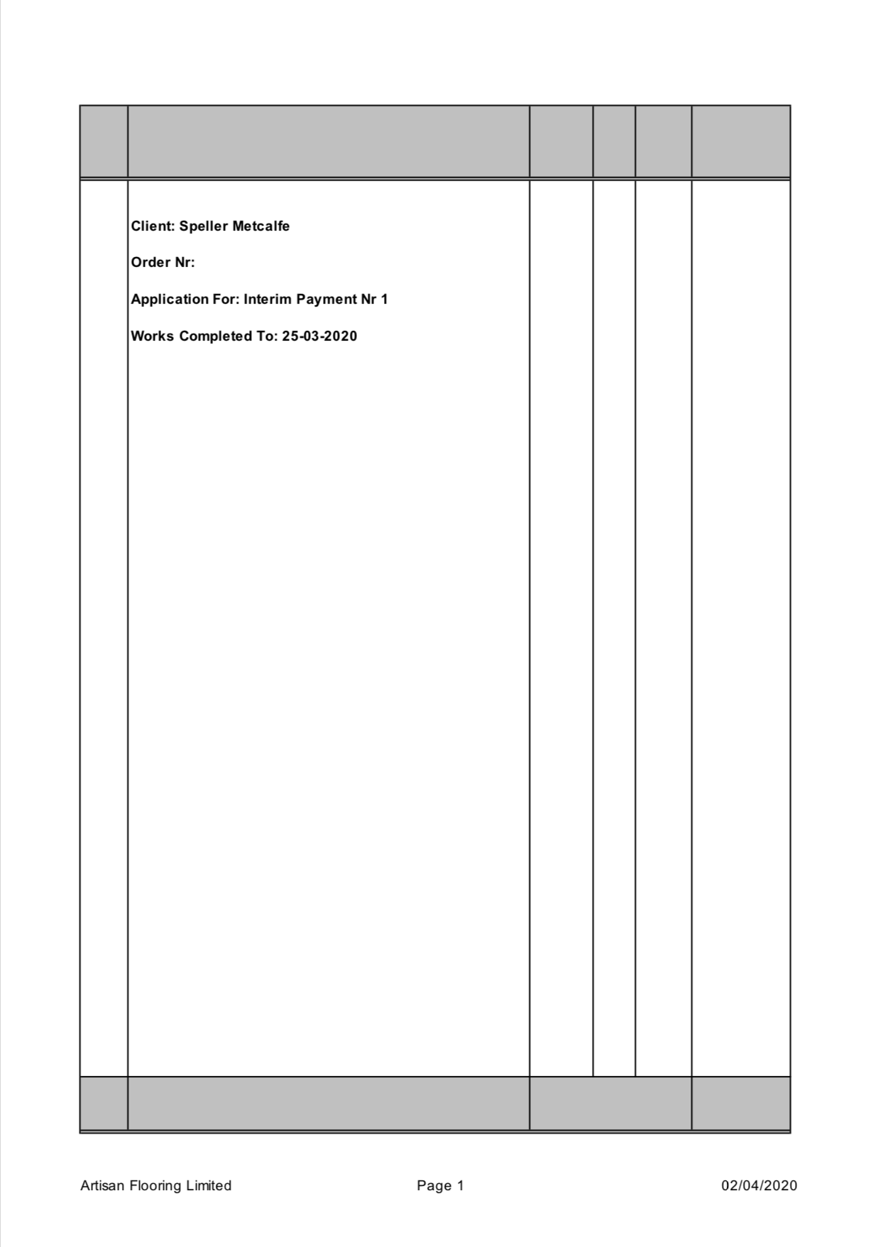

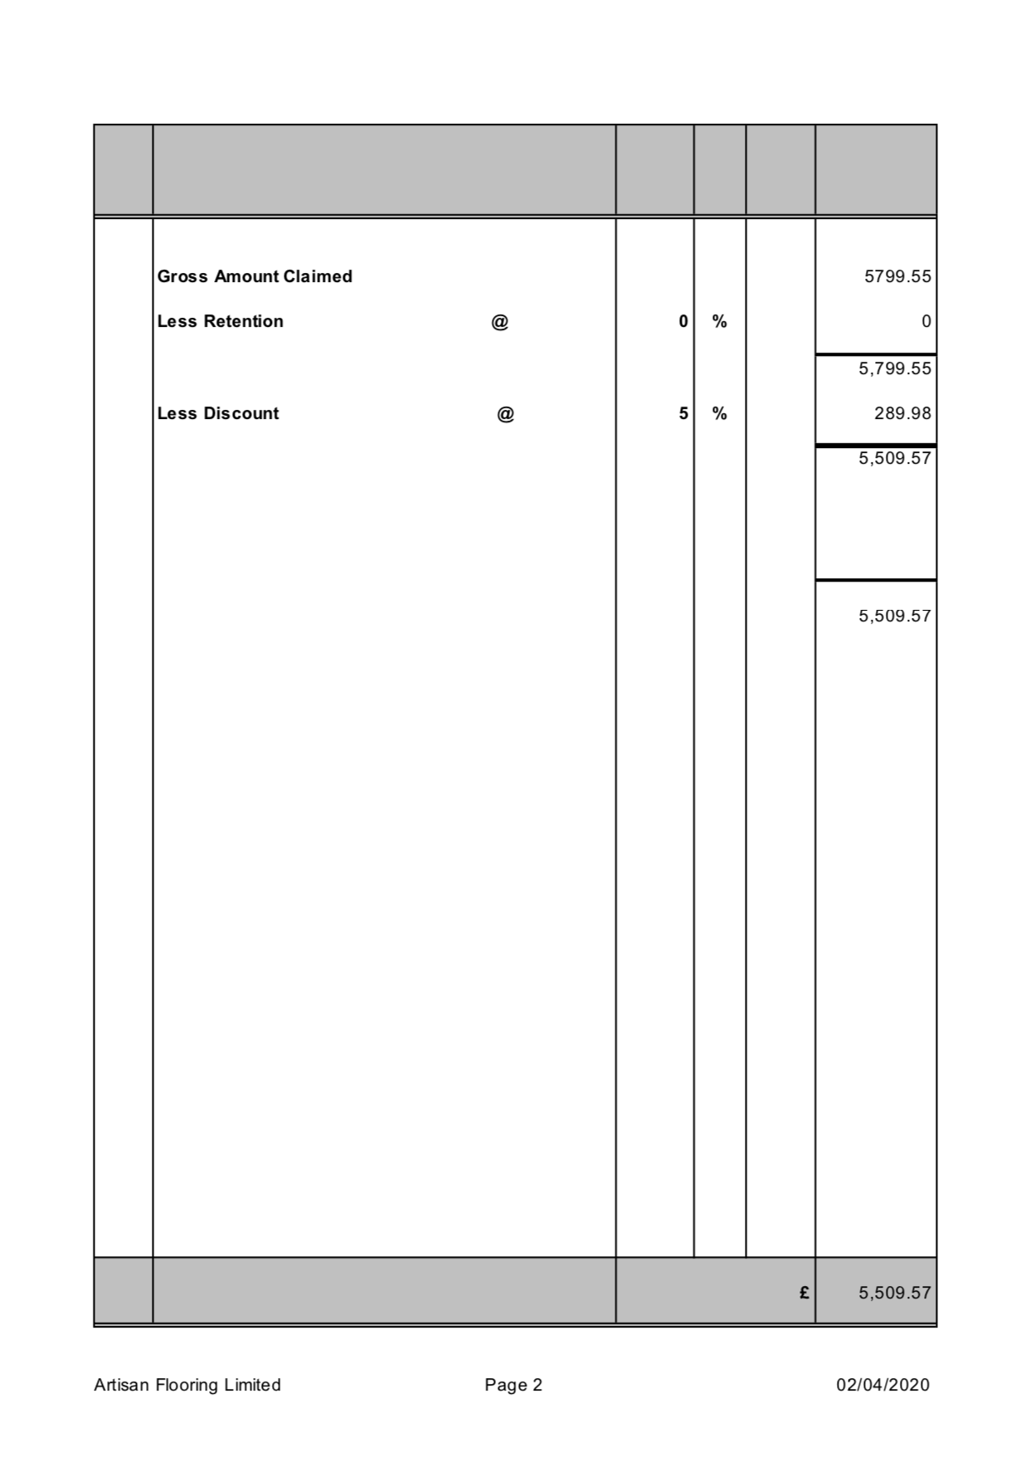
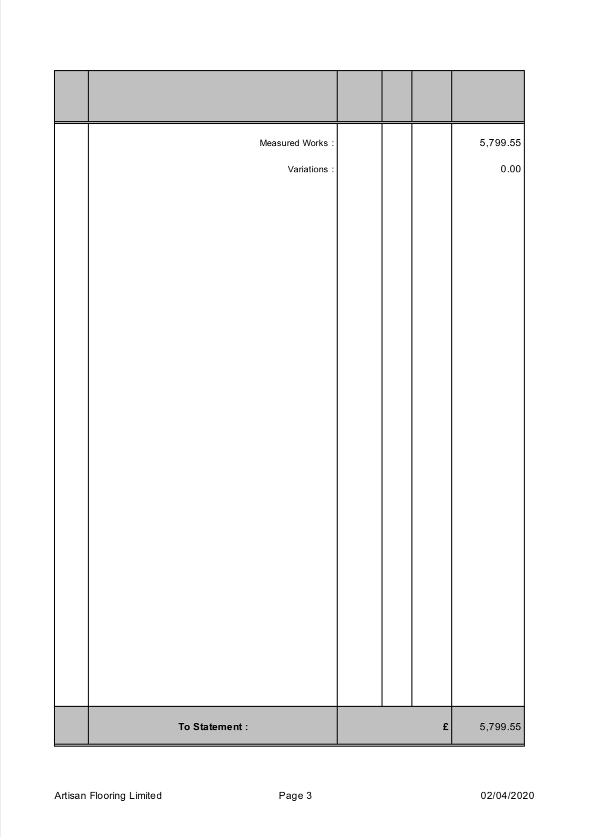

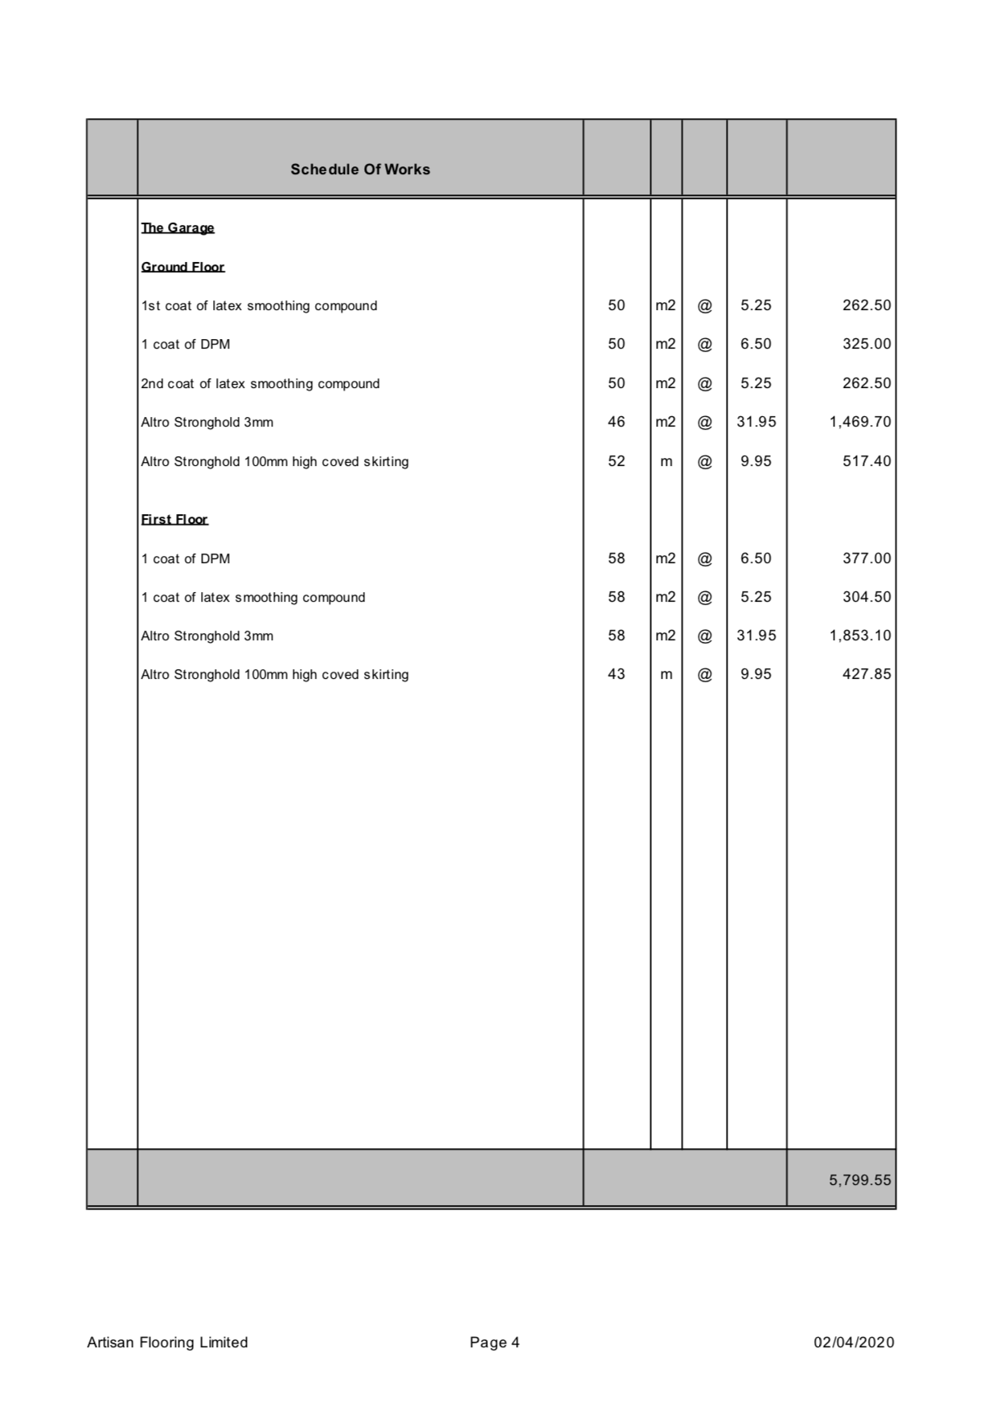
References

Designingbuildings.co.uk. (2020). Site meeting. [online] Available at: https://www.designingbuildings.co.uk/wiki/Site_meeting [Accessed 16 Feb. 2020].

Rics.org. 2020. [online] Available at: <https://www.rics.org/uk/upholding-professional-standards/standards-of-conduct/ethics/> [Accessed 10 March 2020].

