

BA Business Management

LCBB4004

Marketing Fundamentals

Assessment 1- Blogging to communicate

Name: Cristina Caraman
Student ID: 2125666

Lecturer: Afzal Sayed Munna

Submission date: 02/09/2022

Table of Contents
Introduction 4
Blog 1- Segmentation 5
Blog 2- Targeting 5
Blog 3- Positioning 6
Blog 4- Product 7
Blog 5- Price 7
Blog 6- Place 8
Blog 7- Process 8
Blog 8- People 9
Blog 9- Promotion 9
Blog 10- Physical Evidence 10
Conclusion 11
References 12

Introduction
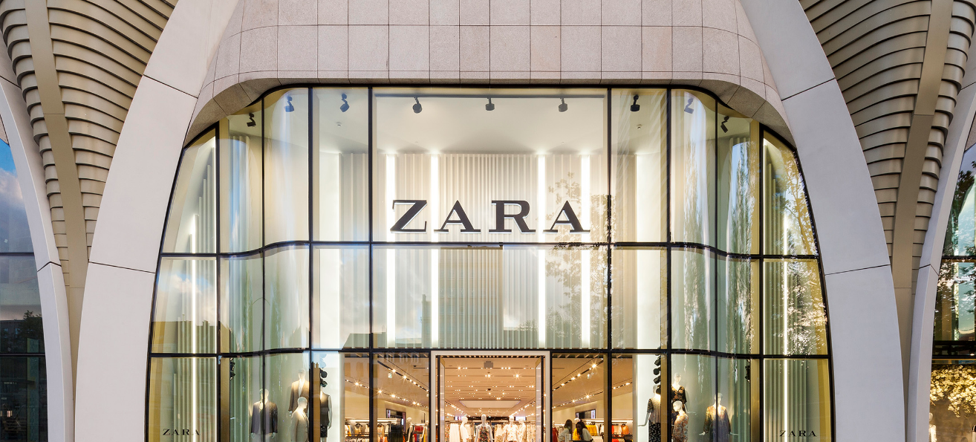
Figure 1: Zara
(Source: Gheorghe and Matefi, 2021)
Zara is one of the renowned fashion companies with global influence. It operates in almost 80 different countries and is mainly famous in Italy, Spain, and France. Zara works exclusively on selling products like shoes, clothing, beauty, perfumes, and swimwear (Gheorghe and Matefi, 2021). The company will be launching new shoes (flat leather slider sandals with high straps) for women which will specifically target customers from the superior class. The blog contains analysis for appropriately targeting, segmenting, and positioning the product with the help of STP. Furthermore, in order to bring clarity, the blog will conduct a marketing mix analysis for the new product which will aid in strengthening the marketing strategies.

Blog 1- Segmentation

Figure 2: Segmentation of Zara for a new shoe product
(Source: López et al., 2021)
Zara being a fashion industry focuses on demographic segmentation. The new product will be sold only to female customers. It has also decided to manufacture for the age group of around 18 to 25 which includes teens as well as adults (López et al., 2021). As Zara sells products that are highly fashionable the new product will be aimed at the unmarried section rather than the aged group. It has divided the customers into two segments:
Segment A is made for teenagers and adults who can afford to buy expensive and luxurious items.
Segment B is for those middle-income groups who prefer good quality in a comparatively medium range.

Blog 2- Targeting

The new product will focus more on the first segment as the customers of segment A are ready to buy the trendy shoes at any price. This level of profitability of this segment is more as the buyers belong to the high class. As the new product focuses on segment A there will be an overall growth as compared to other segments as the product is manufactured for those buyers who are willing to pay for the luxurious product (Chunling, 2020). The population of potential women customers are large which will aid Zara to flourish in the market. With the changing standard of living, consumers prefer to buy good quality products. Women are more into fashion as compared to men and thus the new product also targets women (Varley et al., 2018). This will help Zara to get more revenue from the market. Since Zara is a fashion industry, it does not possess any technological or social barriers which can helpful for the industry to set up its services in the market without any disturbances.

Blog 3- Positioning
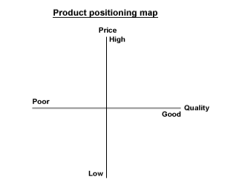
Figure 4: Positioning of Zara’s new shoe product
(Source: Regine, 2022)
The new shoes manufactured will be positioned at a high price and of superior quality. The product will provide comfort to the buyers and thus Zara can compete with other brands like Mango, H&M, and Burberry (Regine, 2022). In order to maintain its superiority in the market, the brand focuses on selling distinguished and unique products. As Zara has recognised the need for high fashion it selects those buyers who want premium quality shoes. Thus the price of the new product is expensive. This will ultimately bring the customers of other brands towards Zara as they offer standard quality shoes. Apart from that Zara has the power to satisfy the needs of the customers it will position them as a famous brand. Moreover, the new shoes for women will be introduced in different online apps and websites which will ultimately capture the market (Morrissey et al., 2019). By hosting campaigns the new product will be spread across the globe and this will benefit the brand to reach more customers.

Blog 4- Product

The new product of Zara is shoes for women in the age group of 18 to 25. The shoes focus on those customers who like to wear fashionable and trendy shoes (Zara, 2022). The new product is manufactured according to the needs of the customers keeping in mind the current fashion. Zara understands the demands of the consumers and responds rapidly to their unstable requirements. The design of the shoe is also attractive and due to this, the product will be in demand. Zara will use excellent quality raw materials to produce the new product. The product undergoes many sections and the product examines thoroughly before it is sent to the stores (Codilla and Mohamed Salad, 2021). The new product can be delivered to a large number of people as Zara has smooth functioning. Apart from those women, and customers like products that look fancy and colourful Zara is well known for creating new eye-catching items.

Blog 5- Price

Zara is an outstanding brand, and the pricing policy is high-end. Zara The company spends an enormous amount of money on basic raw materials and promoting the brand through outdoor advertisement. The company uses pricing strategies like value-based pricing in order to target its potential customers and as well as to increase its customer base (Ferreira, 2019). The brand also ensures that the price of the product is in accordance with quality. Moreover, the strategy used by the brand will be differentiation. This method includes that the services and products are contrasting from the other competitors like Burberry, Mango, and H&M (Vafokulova and Juraev, 2022). Therefore, superior quality products are expensive and can be afforded only by wealthy people. The price of the new product will also be high as the brand delivers high-quality shoes. Thus, with the help of this plan, the quality and price of the new product will differ from the rest of the brands.

Blog 6- Place

The new product is to be introduced in the domestic as well as international market. It will be available in various stores across the globe and the customers can also get it from the big shopping complex (Théot, 2020). The place of the product will be set according to the demand of the customers. The product will be made available in those places like high society, standards and lifestyles where the customers will feel satisfied and can afford to buy. In addition, the new product can be purchased from online websites where the products can be delivered to the customers' desired location with extra charges (Celano, 2021). The location of the stores is modernised and made spacious with huge mirrors and attractive lighting. This is done to create a satisfactory shopping experience for the customers of Zara.

Blog 7- Process

The process followed by Zara in dispatching the products is simple. The new product will be delivered to the customers through various channels. It will be made available in stores which will be looked at by the manager. Self-checkouts for customers will also be made available to deliver an easy and high shopping experience to the customers (Tudor, 2018). The new product can also provide delivery services from the stores to the customers. It will also be sold online as Zara has its official website. The customer can choose any option for the purchase of the product. However, the new product of Zara ensures that the quality will remain constant in national as well as international markets. This will draw the attention of the customers who will be willing to pay any amount for a premium quality shoe. This will eventually optimise the company’s time and enhance overall productivity. The company’s shopping apps and website will facilitate customers to make online purchases and logistics partners Clippers Logistics PLC will ensure the safe and timely delivery of orders to the addresses of customers respectively (Phillips et al., 2022).

Blog 8- People
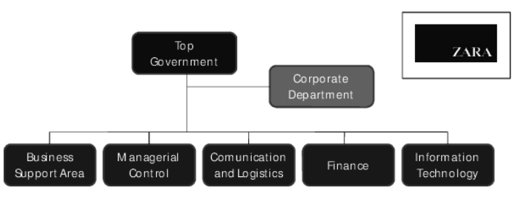
Figure 9: Departments of Zara involved in introducing a new product
(Source: Zhang et al., 2021)
Zara has more than 2900 stores across the globe and there are numerous people working for the brand Zara (Zhang et al., 2021). The company has many individuals who are in charge of manufacturing the product. They play a vital role in the success of Zara and thus Zara spends a massive amount of money on the training and advancement of the employees. The people involved in making the product are suppliers, employees and consumers. Suppliers are responsible for providing the basic materials and without the aid of suppliers the company will not be able to initiate the manufacturing process (Comm and Mathaisel, 2018). The employees are those who complete the task and assist in attaining the success of the company. Lastly, the consumers are the most crucial part of any business because if the consumers do not purchase the new product in the market then the company will face immense loss. Moreover, it leads to a waste of resources and also time.

Blog 9- Promotion

Zara is a well-known fashion brand and promotion is an important part of any business. Thus, Zara also takes the initiative to promote its products (Su, 2020). The new product of Zara will be highlighted through an outdoor promotion like magazines and banners. The new product will be promoted by Zara on many platforms like Facebook, Instagram and through its own website (Chunling, 2020). By showing the product on social networks Zara will be able to generate an immense amount of revenue. As the new product is on the high end it can initially give a certain amount of discount to advertise the item. The new product can be promoted through celebrities, fashion models, and online influencers who have significant influence over people.

Blog 10- Physical Evidence

The place where the new products of Zara will be supplied is the stores and shopping malls. The new products can be found on the official website of Zara as well. The stores include shoes, clothes, perfumes, swimwear, and handbags (Silva et al., 2019). Apart from that it also has outstanding interior decoration and is fully furnished. The packaging of the new product will include a cardboard box with the logo of Zara. They have embraced eco-friendly packing methods to minimise waste. The bags for the customers are purely made from paper so that it doesn't harm the environment. With better brand quality which amplifies the brand image as well as the brand loyalty of the product (Sitaro, 2020). The new product will be classified properly which will not be complicated for the customers to find the product. In addition to that, the official website of Zara can be located easily and can be operated effortlessly. Furthermore, the slogan of the company printed on each package with “love your curves” will assist customers in easily distinguishing Zara from other brands.

Conclusion
The blog has assisted in determining the method of segmenting, targeting and processing which is necessary for breaking down the market of the new product according to the segment. The new product will aim at using a demographic strategy and it will be manufactured only for the female group. The main target area will be on the basis of the age of buyers which includes adults and teenagers. Positioning of the new product will be superior quality and high price. Moreover, the new product has assisted in discovering the importance of the marketing mix . Zara understands the needs of the customers and manufactures according to their requirements. The pricing method used for the new product is differentiation. The new product will be available across the globe and even the product will be distributed through various channels. The brand also makes effective use of social media and outdoor advertisements. This method will help the company to enhance its productivity and by implementing the same strategy the new product can accomplish its goal.

References
Celano, S., 2021. Eco-canvas and circular economy: a proposal for a sustainable fashion business model.
Chunling, L., 2020. Analysis on the Marketing Strategy of Fast Fashion Brand Zara Based on 4c Theory. In 4th International Conference on Economics, Management Engineering and Education Technology (ICEMEET 2020) (pp. 3-5).
Codilla, D. and Mohamed Salad, A., 2021. Building a Modest Fashion Brand.
Comm, C.L. and Mathaisel, D.F., 2018. The use of analytics to market the sustainability of “Unique” products. Journal of Marketing Analytics, 6(4), pp.150-156.
Ferreira, A.M., 2019, June. Sustainable Collaborative Design Practices: Circular Economy and the New Context for a Fashion Designer. In Advances in Social and Occupational Ergonomics: Proceedings of the AHFE 2019 International Conference on Social and Occupational Ergonomics, July 24-28, 2019, Washington DC, USA (Vol. 970, p. 90). Springer.
Gheorghe, C.A. and Matefi, R., 2021. Sustainability and Transparency—Necessary Conditions for the Transition from Fast to Slow Fashion: Zara Join Life Collection’s Analysis. Sustainability, 13(19), p.11013.
López, T., Riedler, T., Köhnen, H. and Fütterer, M., 2021. Digital value chain restructuring and labour process transformations in the fast‐fashion sector: Evidence from the value chains of Zara & H&M. Global Networks.
Morrissey, L., Franceschi, R.B. and Ferreira, A.M., 2019, July. Sustainable collaborative design practices: Circular economy and the new context for a fashion designer. In International Conference on Applied Human Factors and Ergonomics (pp. 90-101). Springer, Cham.
Phillips, C., Tai, S. and Berry, K., 2022. Experiences of acute mental health inpatient care in the UK: from admission to readmission. Psychosis, 14(1), pp.22-33.
Regine, K., 2022. Sosandar: Focusing on Convenience and the Consumer. In SAGE Business Cases. SAGE Publications: SAGE Business Cases Originals.
Silva, E.S., Hassani, H. and Madsen, D.Ø., 2019. Big Data in fashion: transforming the retail sector. Journal of Business Strategy.
Sitaro, T.D., 2020. Fast Fashion and Sustainability-The Case of Inditex-Zara.
Su, Y.Z., 2020. The Internationalization Strategies of Fast Fashion Clothing Retailer Brands: A Cases Study of ZARA, H&M, UNIQLO, and Gap.
Théot, K., 2020. How Changing Consumer Attitudes Toward Climate Change are Creating New Opportunities in the Fashion Industry.
Tudor, L., 2018. Change in textile and clothing industry. Industria Textila, 69(1), pp.37-43.
Vafokulova, M. and Juraev, U., 2022. Marketing strategy and failure of Forever 21.(What is the reason behind Forever 21’s failure?). Eurasian Research Bulletin, 4, pp.67-75.
Varley, R., Roncha, A., Radclyffe-Thomas, N. and Gee, L., 2018. Fashion management: A strategic approach. Bloomsbury Publishing.
Zara, 2022. Women Shoes. [online] https://www.zara.com/uk/en/. Available at: <https://www.zara.com/uk/en/woman-shoes-l1251.html> [Accessed 8 August 2022].
Zhang, B., Zhang, Y. and Zhou, P., 2021. Consumer attitude towards sustainability of fast fashion products in the UK. Sustainability, 13(4), p.1646.

