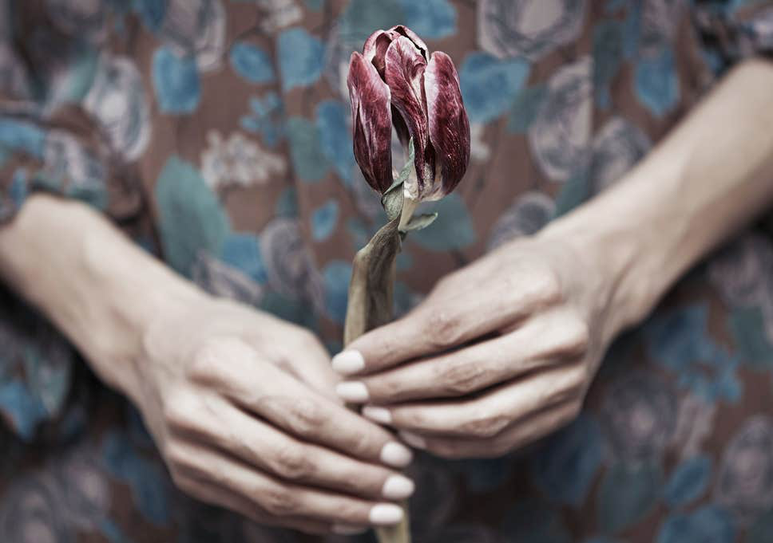
Life After Loss

A help guide for those learning to cope with life after the loss of a partner
A tool for health professionals to support the bereaved in old age.
March 2020.

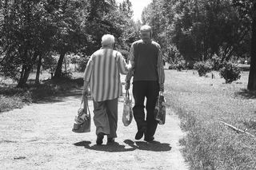
Contents
Section 1
Executive summary

Section 2
Introduction

Section 3
Coping with life after loss

Section 4
Conclusion

Section 1: Executive Summary
Over the years, bereavement and grief has undergone dramatic changes that have been instrumental to understanding how, as humans, we experience the loss of a loved one in old age (Hall, 2014). The loss of a loved one in old age may cause changes to daily life for the bereaved where tasks may become difficult to manage (Bratt et al., 2016). During development in later life, the loss of a loved one partnered with social and physical decline leaves a high chance for negative grief results (Spahni et al., 2014). Negative physical, psychological, social, economic and practical changes can be associated with the death of a long-term spouse (Spahni et al., 2014). Compared to fellow peers in marriage, individuals whom are bereaved display symptoms of depression, raised loneliness rates, decreased satisfaction of life, more negative emotions and increases stress (Bennett & Souldshy, 2012).

This help guide aims to provide the understanding of how bereavement and grief can be processed, while offering methods for coping with life after loss. Over the years, there has been a rise research-based evidence on how loss and grief is experienced by those bereaved and how this has led to an ever-expanding amount of knowledge into the traditional ideas of grief (Hall, 2014).
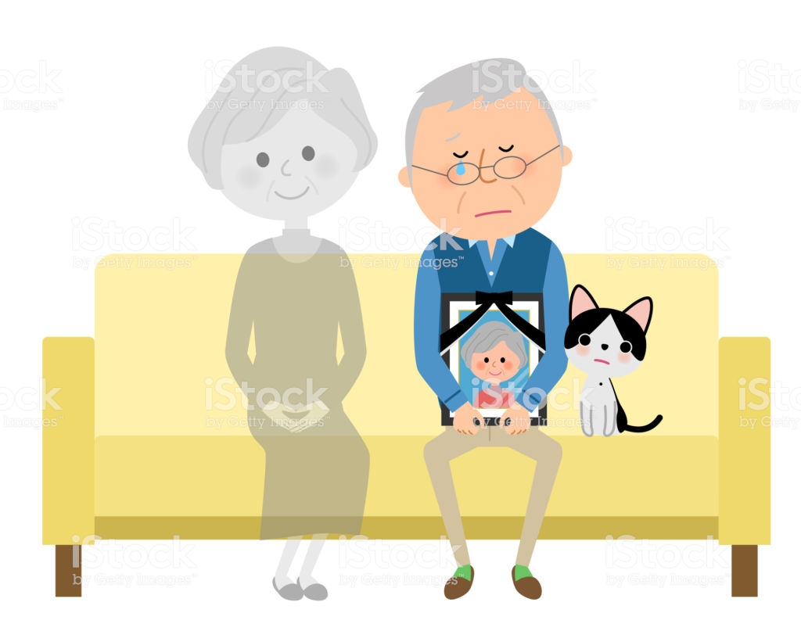
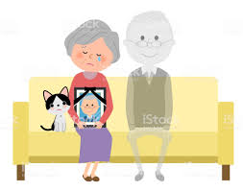

Section 2: Introduction
What is bereavement?
Strobe et al (1993) defines bereavement as a period of loss that can trigger a reaction of grief that in time will manifest into a set of behaviours also known as stages of morning.

Losing someone through death is said to be a painful challenge where families adapt to the death of a loved one from a child, spouse, grandparent, parent or any other family member. In both Wales and England, it was reported that 46,133 people died between January and October 2019 (ONS, 2019). It was suggested by Kleinman (2012) that to date there is no evidence scientific or otherwise to indicate the average period in which one should grieve the loss of a loved one. Throughout the world, many cultures have differing views on the period of time allowed to grieve this loss – from a year to a lifetime (Kleinman, 2012).

There have been many attempts over the years to define the stages of grief, from the initial feeling of being numb that follows loss to depression, recognition and recovery (Zisook & Shear, 2009). However, studies have shown that the intensity and length of grieving can be different for each person. The question of whether grief is a disease or not has been raised by Engel (1961) and has explained how both a physical disease and grief carry many of the same characteristics. For a disease, healing takes place over time but may not always be completed fully; for those whom already have a disease grieve and bereavement may carry an effect on that person’s health that can be detrimental – this can lead to a grieving process that is complicated, leading to potential psychological complications (Zisook & Shear, 2009).

What is spousal bereavement?
Defined as a biological, normative transition through old age – spousal bereavement can be seen as a stressful even in life that comes with considerable consequences on well-being and tasks carried out daily (Spahni et al., 2014). With various reactions to the loss of a long-term spouse that in turn comes with different outcomes on the well-being on those bereaved, a generalised assumption of the ramifications of spousal loss during old age would not be appropriate (Spahni et al., 2014). Neimeyer and Holland (2015) suggest that by the age of 65 around 10% of males and one half of females will have had to deal with the loss of their spouse, with figures reaching 40% for males and 80% for females by the age of 85. Lund et al (1993) undertook longitudinal research in the United States of America on spousal bereavement among the older generation. Beginning in the 80’s, Lund et al (1993) used a sample of 192 bereaved individuals and 104 control individuals over the age of 50 and married. The results of this study were used in a secondary study examining the effectiveness of self-help groups regarding adjusting to loss and bereavement.
Section 3: Coping with life after loss
Throughout the field of psychology, clinicians and researchers have carried out studies into the many naturals ways to process grief using foundation theories such as the Stage Model by Kubler-Ross, the Dual Process Model by Strobe, the Grief Phases by Freud, the Attachment Theory by Bowlby and Parkes and Active Tasks by Worden (Hall, 2014).

Pervious research has been used to examine how individuals deal with grief and bereavement, work on grief began with Sigmund Freud (1917) who’s paper on grief work became a foundation for others such as Bowlby (Strobe & Schut, 1999). It was suggested by Freud (1961) that grief as a process is solitary and follows the loss of a loved one. Freud believed that an individual would first become withdrawn, where they would detach themselves from the deceased loved one gradually (Buglass, 2010). In his work titled ‘Mourning and Melancholia’, Freud (1917) suggested that there is a general crossover between mourning and deep sadness (melancholia). Mourning is said to be an individual’s natural reaction to losing a loved one and that there are distinctive elements to melancholia; a loss of interest in what is going on in the outside world, a deep depression and an inability to love (Freud, 1957). However, Freud has come under criticism for the assumption of subjectivity which is based purely on individualisations. Freud (1917) also suggests that the mourning of a loved one will cease once the emotional attachment between the individual and deceased loved one has come through an end after bereavement.


Following Freud, Kubler-Ross (1969) Five Stages of Grief Model; which implies that failing to complete one or more of the stages may result in complications – these stages are denial, anger, bargaining, depression and acceptance. Although this model does not come without its limitations – in reality, during bereavement overlapping may occur. It was suggested by Corr (1993) that the Five Stage Model of Grief set out by Kubler-Ross was one based upon clinical workings and not empirical research, this means that the application of the Five Stage Model of Grief can be difficult to apply to a bereaved individual (Buglass, 2010).

Another theory of bereavement is that of Bowlby (1973) and the Attachment Theory, which examines the human bonds and attachments formed very early. Similarly, to Kubler-Ross and Freud, it is also suggested by Bowlby that an individual will grief in stages that can be flexible and overlap – the four stages of Bowlby’s Attachment theory are shock/numbness, yearning/searching, despair/disorganisation and reorganisation/recovery (Buglass, 2010).
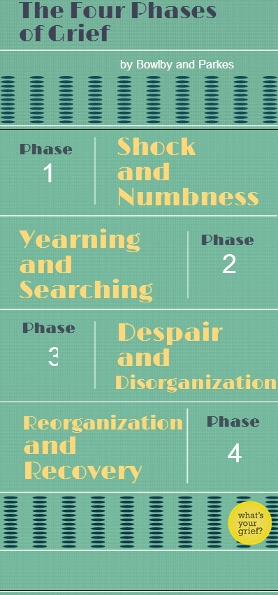
Bowlby’s Attachment Theory provides an explanation for the human need to form a bond with another human and what might happen should this bond be broken. The use of experiences through childhood is key to explaining bereavement and how these can influence an individual to grief in adulthood (Bowlby, 1973). A similar study was carried out by Parkes (1998) which also suggests four phases of grief. Parkes (1998) proposes that there is a transition during grief where the individual goes from distress at the loss of a loved one to a resolution. There are limitations to the theories presented by both Bowlby (1973) and Parkes (1998) where each suggests that individuals are made to confront their grief as a means to cope with the loss of a loved one to not cause detrimental consequences to one’s health (Buglass, 2010).

There has been an array of research into the mortality rates of those bereaved and the implications to health which could be linked to Bowlby’s Attachment Theory. Over the years, bereavement has been linked to a mortality rate increase after a loved one has been lost (Bowlby, 2008). Kraus and Lilienfeild suggested in the 50s that married individuals showed lower mortality rates over a number of age ranges than single, divorced or widowed individuals. This was followed by Young et al (1963) who aimed to examine mortality and widowhood duration effects, finding that rates of mortality increased by 40% once a loved one had died (Rees & Lutkins, 1967).

Section 4: Conclusion
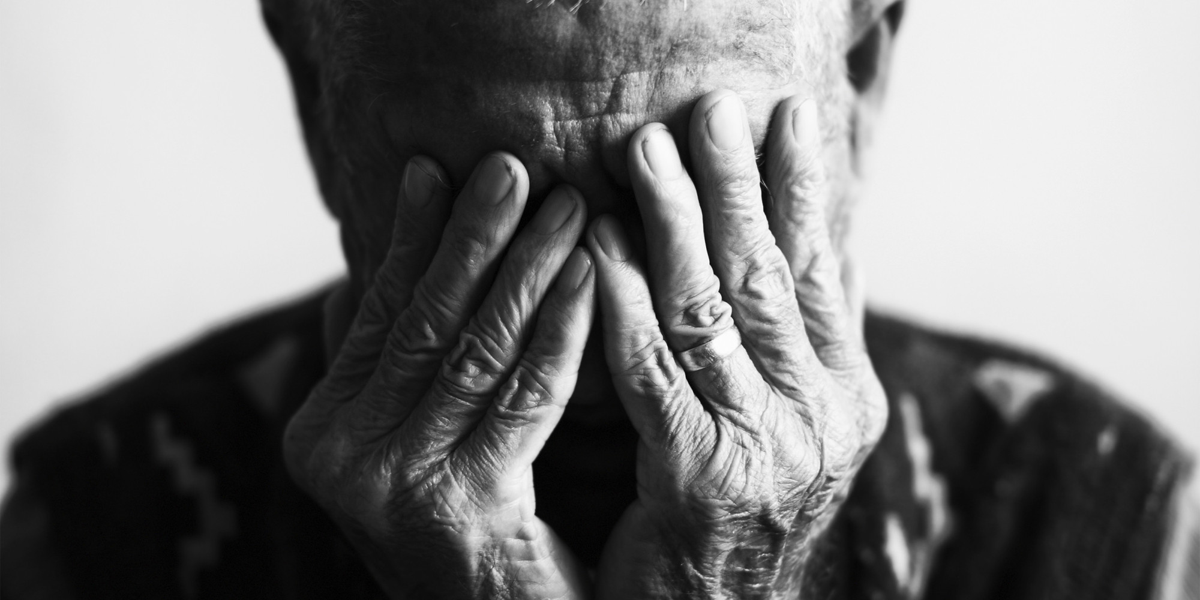
While expanding clinical research has furthered that understanding of bereavement and grief symptoms and processes, there is no model that can be generalised (Hall, 2014). With the many positives that come with bereavement and grief theories, there are also a number of limitations – the misapplication of these theories by individuals can lead to one believing that the way that they are grieving is wrong. On examining these theories of grief and bereavement it is clear that all individuals will grieve in a different way depending on culture and their relationship with the loved one they have lost.

Reference List
Bowlby, E. J. M. (2008). Loss-Sadness and Depression: Attachment and Loss (Vol. 3). Random House.
Buglass, E. (2010). Grief and bereavement theories. Nursing Standard (through 2013), 24(41),44.
Freud, S. (1957). Mourning and melancholia. In The Standard Edition of the Complete Psychological Works of Sigmund Freud, Volume XIV (1914-1916): On the History of the Psycho-Analytic Movement, Papers on Metapsychology and Other Works (pp. 237-258).
Hall, C. (2014). Bereavement theory: recent developments in our understanding of grief and bereavement. Bereavement Care, 33(1), 7-12.
Kleinman, A. (2012). Culture, bereavement, and psychiatry. The Lancet, 379(9816), 608-609.
Kübler-Ross, E. (1969). On death and dying. New York: Macmillan.
Lund, D. A., Caserta, M. S., & Dimond, M. F. (1993). The course of spousal bereavement in later life. Handbook of bereavement: Theory, research, and intervention, 240-254.
Neimeyer, R. A., & Holland, J. M. (2015). Bereavement in later life: Theory, assessment, and intervention. In APA handbook of clinical geropsychology, Vol. 2: Assessment, treatment, and issues of later life. (pp. 645-666). American Psychological Association.
Office of National Statistics (2019, November 26) Deaths registered monthly in England and Wales. Retrieved from: https://www.ons.gov.uk/peoplepopulationandcommunity/birthsdeathsandmarriages/deaths/datasets/monthlyfiguresondeathsregisteredbyareaofusualresidence
Rees, W. D., & Lutkins, S. G. (1967). Mortality of bereavement. British Medical Journal, 4(5570), 13.
Stroebe, M. S., Schut, H. A. W., & Stroebe, W. (2007). Health consequences of bereavement: A review. The Lancet Infectious Diseases, 370(9603), 1960-1973.
Stroebe, M. S., Stroebe, W., & Hansson, R. O. (Eds.). (1993). Handbook of bereavement: Theory, research, and intervention. Cambridge University Press.
Stroebe, M.S,. Schut, H. (1999). The dual process model of coping with bereavement: rationale and description. Death Studies 23(3) 197-224.
Zisook, S., & Shear, K. (2009). Grief and bereavement: what psychiatrists need to know. World Psychiatry, 8(2), 67-74.
With ample research and evidence showing that interventions are not seen as effective for those grieving generally but can be effective for those that might be of high risk or experiencing confusion during the grieving process (Hall, 2014).
This leaflet aims to offer informational support on a number of interventions aiming to help cope with life after loss -
- Medication
- Counselling
- Support groups

Life After Loss

An informational support guide for interventions for coping with life after loss
support groups to cope with life after the loss of a loved one (Vlasto, 2010).
Gallagher et al (2005) explored the effects of grief and bereavement counselling on former clients who had been offered counselling through an organisation offering bereavement care within the voluntary sector. A total of 89 participants completed a questionnaire that found the former clients reported a positive experience during their counselling session and found that the help given in the session allowed them to cope well with the loss of a loved one (Gallagher et al., 2005).
Voluntary sector counsellors can be seen to be one of many providers of counselling and are vital to grief and bereavement counselling (Vlasto, 2010).
Counselling – What is it?
A specific means in which an individual can access support for a number of different problems; counselling comes in many different forms, which all aim for the same outcome. Counselling aims to understand how an individual might deal with certain situations as a means to assist the individual with the ways and means to deal and cope with these problems in the healthiest and safest way possible (Fallowfield, 1988).
Throughout the United Kingdom, the counselling of grief and bereavement is one of the most accessed forms within the sector. Grief and bereavement counselling aims to support the individual by means of one-to-one support, support over the phone and

bereavement counselling as a practice is both helpful and effective in enabling the individual to cope with life after the loss of a loved one (Simonsen & Cooper, 2015).

The use of medication
The use of antidepressant medication is seen to do very little to reduce and address core complications, while the use of grief and bereavement counselling is valued and highly supported provides the health

Historically, an individual has said to prefer talking a problem through with a counsellor both during or post the loss of a loved one, as grief and bereavement counsellors are most likely to –
- Be trustworthy
- Offer reassurance
- Show empathy
- Not judge
- Be genuine
Simonsen & Cooper (2015) explored how grief and bereavement counselling was able to support seven different participants with a way to cope with life after the loss of a loved one. Through the use of interviews and interpretive phenomenological analysis the results showed that as with previous research, grief and

Grief and bereavement support groups can also be a means to reduce psychological issues that may arise both during and after grieving for a loved one (Cain et al., 1986).
Diamond et al (1987) explored the social support during in support groups, the satisfaction of life, the individual’s health and how they are coping with the loss of a loved one on 192 participants, all aged between 50-93 years of age. All participants were dealing with the loss of a spouse and given a questionnaire to fill out at different times over a six-month period. Diamond et al (1987) reported that the social support received in support groups play a key role in the way one grieves during the first two years following the loss of a loved one.
professionals carefully assess and tailor the counselling to the patient (Hall, 2014).
How can support groups help?
Support groups for grief and bereavement have been developed as a means to support individuals that are coping with the loss of a loved one by providing an environment that is welcoming, warm and safe (Picton et al., 2001).
Across the United Kingdom there are a number of support groups all aiming to offer support to individuals at different stages of their grief. It has been reported by individuals whom have accessed these support groups that the groups are both helpful and inviting (Steiner, 2006).

Conclusion
From the intervention research provided in this leaflet, it is clear to see that grief and bereavement counselling, support groups and medication can help those to deal with the loss of a loved one.
For the future, it is hoped that the individual will be able to grieve the loss of a loved one in a healthy manner; while receiving the support available to assist with coping in daily life.
Research in the future could benefit from examining the individuals who access grief and bereavement counselling and support groups as a means to cope with the loss of a loved one and the effect that accessing these interventions have on the grieving individual.
Lund & Caserta (1992) also explored support group research, specifically examining 134 grieving spouses’ participation in 26 support groups (8 meetings a week). Lund & Caserta (1992) reported a statistical difference in the number of attended meetings and the values perceived in the support group.


Reference List

A Gallagher, M., Tracey, A., & Millar, R. (2005). Ex‐clients' evaluation of bereavement counselling in a voluntary sector agency. Psychology and Psychotherapy: Theory, Research and Practice, 78(1), 59-76.

Cain, E. N., Kohorn, E. I., Quinlan, D. M., Latimer, K., & Schwartz, P. E. (1986). Psychosocial benefits of a cancer support group. Cancer, 57(1), 183-189.

Diamond, M., Lund, D. A., & Caserta, M. S. (1987). The role of social support in the first two years of bereavement in an elderly sample. The Gerontologist, 27(5), 599-604.

Fallowfield, L. J. (1988). Counselling for patients with cancer. BMJ: British Medical Journal, 297(6650), 727.
Hall, C. (2014). Bereavement theory: recent developments in our understanding of grief and bereavement. Bereavement Care, 33(1), 7-12.

Picton, C., Cooper, B. K., Close, D., & Tobin, J. (2001). Bereavement support groups: Timing of participation and reasons for joining. OMEGA-Journal of Death and Dying, 43(3), 247-258.

Simonsen, G., & Cooper, M. (2015). Helpful aspects of bereavement counselling: An interpretative phenomenological analysis. Counselling and Psychotherapy Research, 15(2), 119-127.

Steiner, C. S. (2006). Grief Support Groups Used by Few— Are Bereavement Needs Being Met?. Journal of social work in end-of-life & palliative care, 2(1), 29-53.

Vlasto, C. (2010). Therapists' views of the relative benefits and pitfalls of group work and one-to-one counselling for bereavement. Counselling and Psychotherapy research, 10(1), 60-66.

