BMPF7008

Anne Crozier
2246692

A Qualitative Exploration of Peer Influence and Participation in Middle School Choir

Word Count: 7202

Table of Contents
Table of Contents 2
Project Proposal How can peer influence impact individual participation and overall valuation of choral singing among students in grades 7-8? 4
Literature Review 7
Trends in Secondary Choral Enrollment 7
Role of Peer Influence in Adolescent Engagement with Singing 8
Creating Supportive Environments to Mitigate Negative Peer Influence 9
Methodology 10
Procedure 12
Interview Question Development 13
Scheduling and Conducting Interviews 13
Conducting Focus Groups 13
Data Analysis 14
Phase 1: Data Familiarization and Writing Familiarization Notes 14
Phase 2: Systematic Data Coding 14
Phase 3: Generating Initial Themes from Coded and Collated Data 14
Phase 4: Developing and Reviewing Themes 14
Phase 5: Refining, Defining, and Naming Themes 15
Phase 6: Writing the Report 15
Ethical Considerations 15
Findings 16
1) Fear of Mistakes and Negative Peer Evaluation in Choir 16
1a) Stigmatization and Othering of Choir Participants 17
2a) Perceptions of Peer Effort in Choir 19
3) Support Systems Fostering Resilience in Choral Participation 20
Limitations and Recommendations for Future Research 21
Conclusion 22
Reference List: 24
Appendix A: Gantt Chart 34
Appendix B: Ethics Form 35
Appendix C: Informational Flyer 51
Appendix D: Participant Interest Form 52
Appendix E: Consent Forms 54
Appendix F: Six Phases of Reflexive Thematic Analysis 59
Appendix G Semi-Structured Questions 60
Appendix H: Focus Group Questions 62
Appendix I: Student A Interview Transcription, Audio File and Initial Codes 64
Appendix J: Student B Interview Transcription, Audio File and Initial Codes 71
Appendix K: Student C Interview Transcription, Audio File and Initial Codes 78
Appendix L: Student D Interview Transcription, Audio File and Initial Codes 87
Appendix M: Student E Interview Transcription, Audio File and Initial Codes 94
Appendix N: Student F Interview Transcription, Audio File and Initial Codes 100
Appendix O: Focus Group 1 Transcription, Audio File and Initial Codes 109
Appendix P: Focus Group 2 Transcription, Audio File and Initial Codes 118
Appendix Q: Reflexive Journal Sample 132
Appendix R: Theme 1 and 1a Supplemental Table 133
Appendix S: Theme 2 and 2a Supplemental Table 135
Appendix T: Theme 3 Supplemental Table 137
Appendix U: Organize Codes (Phase 2) Example 139
Appendix V: Generating Initial Themes (Phase 3) in a Spreadsheet Example 140

Project Proposal
How can peer influence impact individual participation and overall valuation of choral singing among students in grades 7-8?
Context
Participation in elective music programs, including middle school choir, has posed an ongoing challenge for music educators (Demorest et al., 2017). Recent research has indicated a negative trend in enrollment in these programs (Elpus and Abril, 2011), especially since COVID-19 (Grebosz-Haring et al., 2022). Cronenberg (2022) pinpointed a drop in enrolment in middle school choir between grades 7 and 8 in the United States (U.S.). For clarification, when this report utilizes U.S. grade levels, this refers to students aged 12-13 for 7th grade and 13-14 for 8th grade (Colorado Department of Education, 2023). Peer influence has been identified as a key factor affecting adolescents' engagement in and valuation of music (Boer and Abubakar, 2014; Clements, 2002; Laursen and Veenstra, 2021; Sichivitsa, 2007; Williamson, 2000). Building upon this research, the present study aims to investigate how peer influence among students in grades 7-8 impacts individual participation and overall valuation of choral singing within the context of the [NAME] school district.
Justification and Intended Impact
The study on peer influence in middle school choir participation is situated within the broader context of adolescent peer dynamics. Research examining secondary choral programs has suggested that peer influence may affect student participation (Barresi, 2000; Williamson, 2000). While previous research often focuses on the negative aspects of peer pressure (Allen et al., 2006; Goldstein et al., 2020; Laursen and Veenstra, 2021), recent studies suggest its potential for positive outcomes, such as increased focus and inspiration (Meshram, 2016; Tejaswini and Romate, 2015). By examining both the positive and negative aspects of peer influence, this study aims to provide a comprehensive understanding of how peer dynamics affect 7th-8th grade student participation and valuation of singing in choir. Gaining clarity on the role of peer dynamics in the choral classroom may offer insights into enhancing enrollment across the secondary school choir programs within the [NAME] school district (Barresi, 2000). This knowledge may contribute to the academic literature and benefit the community by informing strategies to foster a supportive and motivating environment, thereby enhancing student participation and retention in choir programs. Additionally, these insights could inform my professional practice by helping me implement more effective peer engagement strategies within my own classroom as a secondary choral music teacher. Furthermore, should retention improve starting at grade 7, then there may be an increase and continuation in the high school program, grades 9-12.
Outlined Intention
This study will incorporate qualitative research methods and a constructivist theoretical framework. A visual chart representing the timeline of this project is located in Appendix A.
- In late April 2024, participants from [NAME] Middle School will be identified through purposive sampling. They will include:
  - Two 7th-grade choir members (one female, one male)
  - Two 7th-grade students who opted out of choir (one female, one male)
  - Two 8th-grade choir members (one female, one male)
  - Two 8th-grade students who opted out of choir (one female, one male)
- Participants will sign consent forms and receive an email containing the research design.
- Semi-structured interviews will be conducted (early May 2024) with eight students in 7th and 8th grade. These interviews will precede the focus group to gather data on students' personal perceptions, experiences, and the role of social influences in shaping their attitudes toward choral singing. Video or audio recording may be employed to capture the interactions. The interviews will be semi-structured to allow for adaptability based on the participants' responses, fostering an interaction conducive to students' comfort (Brinkmann, 2023). The dialogue will be transcribed, verbatim, following each interview.
- A single focus group will be conducted (mid-May 2024) with the same eight students from the interviews to capture the influence of peers on individual attitudes toward choral singing, as the composition of the focus group may influence student responses (Brinkmann, 2023). Peer interactions and changes in body language, particularly when discussing valuation and attitudes toward choral singing in a social setting compared to individual interviews will be observed and documented in a field journal diary.
- Reflexive Thematic Analysis (Braun and Clarke, 2006), with a deductive, latent and constructionist lens, will guide a report to identify key themes and insights from the transcriptions to examine how social factors shape individuals' narratives and identities (Roulston, 2014). Subsequent presentation (mid-July 2024) and will be shared with participants.
Ethics and Insider Research
The project involves potential emotional impact on middle school participants due to discussing personal experiences with choral singing and vulnerability in sharing their opinions in front of and with their peers (Liu et al., 2021). Confidentiality concerns regarding the sharing of sensitive information will be addressed through careful data management, such as anonymizing student and school names and storing information in password protected files to protect participants' privacy (Memory Madondo, 2021; Roulston, 2014). Furthermore, the research received approval from the University of Wales Trinity Saint David Ethics Committee (see appendix B) and will adhere to the ethical guidelines set forth by the American Educational Research Association (2011) throughout the research process.
Being an insider researcher in this project may impact the study in several ways. As a member of the school district, I may have pre-existing relationships with participants, which could influence their willingness to participate or their responses during interviews and focus groups. Additionally, my insider perspective may provide valuable insights into the context and dynamics of the middle school choral program, but it could also introduce bias which needs to be mitigated throughout the research process through use of bracketing, process of documenting personal feelings about the data to try to mitigate researcher bias when analyzing data (Memory Madondo, 2021).
Personal Learning Outcomes
During this course, I aim to improve proficiency in qualitative research methods and data analysis techniques, specifically transcribing and coding using reflexive thematic analysis. This involves accurately capturing participants' responses and systematically identifying themes to understand underlying patterns. Reflexive thematic analysis will help me reflect on my role as a researcher and ensure the integrity of my data interpretation. Additionally, I am learning to use existing literature as a model to validate and justify my research methods. By examining peer-reviewed studies, I can refine my approach to designing interview questions and conducting focus groups, ensuring my methods are robust and credible. This course bridges theoretical knowledge with practical application, enhancing my understanding of peer influence in middle school choir participation.
Introduction
Participation in elective music programs, including middle school choir, has posed an ongoing challenge for music educators (Demorest et al., 2017; Legette, 1998). Recent research has indicated a negative trend in enrollment in these programs (Elpus and Abril, 2011), especially since COVID-19 (Grebosz-Haring et al., 2022). Siebenaler (2006) pinpointed a significant change in attitudes towards singing during middle school in the United States (U.S.). Positive attitudes towards school music classes tend to decline as students get older (Siebenaler,2006; Mizener, 1993) and female-identifying students tend to hold more favorable opinions towards music than male-identifying students (McPherson et al., 2015; Mizener, 1993). Understanding why middle school students participate in choir is a complex issue to study (Legg, 2013; Pendergast, 2023). Commonly researched aspects of this subject tend to include an examination of choral teacher qualities (Clements, 2002; Pendergast, 2023), student motivations (Freer and Evans, 2019), gender identities and stereotypes (Freer, 2009; Legg, 2013; McBride and Palkki, 2020), musical self-concept (Demorest et al., 2017; Siebenhaler, 2006) and communal, peer, and familial supports (Dabback, 2018; Pendergast, 2023; Siebenaler, 2006). However, peer influence has been consistently cited as one of the more significant presences found in adolescent engagement and valuation of music (Boer and Abubakar, 2014; Clements, 2002; Laursen and Veenstra, 2021; Sichivitsa, 2007; Williamson, 2000). Building upon this research, the present study aims to investigate how peer influence among students in grades 7-8 impacts individual participation and overall valuation of choral singing within the context of the [NAME] school district.

Literature Review
This literature review analyzes secondary choral enrollment trends and the impact of adolescent peer interactions on singing participation. Ideas surrounding what constitutes a positive singing environment in the middle school choir classroom to encourage student participation is also explored.

Trends in Secondary Choral Enrollment
For today's adolescents, 'music’ represents a convergence of community, culture, and technology (Wallerstedt and Lindgren, 2016), and holds a significant part in identity construction during this developmental stage (Evans and McPherson, 2017; Lamont et al., 2003). Yet, enrollment trends in secondary music ensembles across the U.S. do not reflect this sentiment (Evans and Freer, 2019; Williams, 2011). Secondary music ensembles in the U.S. are typically elective courses (Elpus and Abril, 2019) and are valued less by students in comparison to other academic classes (Casals et al., 2011; Evans and Freer, 2019; McPherson and Hendricks, 2010; McPherson and O’Neill, 2010; McPherson et. al, 2015; Williams, 2011). While research validates that the COVID-19 pandemic greatly lowered choral participation in schools across the United States (Grebosz-Haring et al., 2022), secondary choral enrollment has been an ongoing challenge prior to the pandemic (Elpus and Abril, 2011; Scheib, 2003). In 2013, of the 24% of high school seniors who reported taking a music elective in their secondary education, approximately 13% of students reported being enrolled in at least one year of choir (Abril and Elpus, 2019). In comparison to data dating as far back to 1985, these percentages of secondary music ensemble participation reflect student engagement at an all-time low across many regions in the U.S. (Williams, 2011). It is also notable that school choral ensembles have struggled nationwide with underrepresentation of male students at a 2:1 ratio for over thirty years (Elpus, 2015). These national discrepancies highlight a need to explore what is contributing to this low valuation of ensemble singing in secondary schools.

Role of Peer Influence in Adolescent Engagement with Singing
Peer pressure is the influence exerted by peers or members of one's peer group to conform to certain behaviors, attitudes, or actions to fit in or gain acceptance within the group (Johal and Mehta, 2015). Research suggests that adolescents, due to their extensive time spent in fixed social settings, are susceptible to conforming values, behaviors, and participation in school and social activities around peer acceptance (Allen et al., 2006; Goldstein et al., 2020; Bandura, 1986; Laursen and Veenstra, 2021; Meshram, 2016; Tejaswini and Romate, 2015; You, 2011). Social identity and peer influence play a pivotal role in shaping adolescent engagement with singing as well (Barresi, 2000; Pendergast, 2020; Williamson, 2000).
Recent studies highlight the pivotal role of peer networks in promoting students' engagement and enjoyment of music electives (Clements, 2002; Demorest et al., 2017; Pendergast, 2020). Research underscores the importance of students feeling socially connected to foster a sense of belonging and sustain active involvement in school music programs (Adderly et al., 2003; Pendergast, 2023). Singing in a choir exemplifies communalism, where the collective goals supersede individual interests (Einarsdottir and Gudmundsdottir, 2016). Consequently, choir members must conform to group norms and collaborate towards a shared objective (Dabback, 2016). Some middle school choral directors observe instances where students exhibit a lack of appreciation for group cohesion, manifesting behaviors that undermine collective efforts, including ridicule and fostering a hostile learning atmosphere (Elpus and Carter, 2016). Furthermore, this negative peer influence or fear of not fitting in can hinder adolescents' engagement with singing and contribute to disinterest or avoidance of musical activities (Elpus and Carter, 2016; Hawkinson, 2015). Peers may also reinforce gender stereotypes, such as singing being a feminine activity, which have been shown to affect some student's willingness to sing based on perceived social expectations of their peers (McBride and Palkki, 2020). Abril (2007) examined singing anxiety only seemed to arise within a social context, when participants perceived that they would be personally evaluated by others. Recognizing and addressing these peer influences is essential for fostering a supportive environment that encourages active and sustained participation in choral singing (Elpus and Carter, 2016).

Creating Supportive Environments to Mitigate Negative Peer Influence
The role of peer influence in adolescent engagement with singing underscores the importance of creating inclusive and supportive environments within choral programs and peer groups. Research indicates that while peer influence can have a powerful impact, fostering a positive and supportive environment can mitigate the negative effects and promote resilience among students. The presence of strong familial and community support systems, along with a nurturing school environment, is crucial in helping students withstand negative peer pressure (Clements, 2002; Demorest et al., 2017; Siebenaler, 2006). In middle school, students are particularly susceptible to peer influence due to their developmental stage and the desire for social acceptance (Allen et al., 2006; Laursen and Veenstra, 2021). However, when students feel supported and valued by their family, friends, and educators, they are more likely to engage positively in choir and other school activities. Creating a safe and supportive classroom atmosphere where students feel encouraged to express themselves musically without fear of judgment is essential (Barresi, 2000; Lucas, 2011).
Additionally, allowing students some degree of choice and autonomy, such as selecting songs that reflect their interests, can increase their investment in the program and enhance their motivation to participate (Renwick and McPherson, 2002). Celebrating individuality while balancing the collective nature of choir can help students feel a sense of belonging and ownership over their musical experience. By harnessing the positive aspects of peer influence and providing a robust support system, music educators can create an environment where all students feel empowered to participate in singing activities. This holistic approach not only fosters resilience but also promotes a culture of acceptance, encouragement, and mutual respect, ultimately enhancing the overall choral experience for students (Barresi, 2000; Williamson, 2000). Insights from this research can equip choir leaders with strategies to build a positive peer culture, encourage student participation, and improve retention rates in choral programs by creating supportive and inclusive environments (Siebenaler, 2006).
In summary, while music seems to hold substantial cultural significance for adolescents, enrollment in secondary music ensembles, especially choir, remains comparatively low. Research underscores the impact of peer networks on students' decisions to enroll and persist in music programs, highlighting the importance of fostering positive peer dynamics within choral settings. However, gaps exist in understanding the specific mechanisms through which peer influence operates and how it shapes individual participation. Building on these insights, the following methodology section outlines the research approach used to investigate how peer influence among students in grades 7-8 impacts individual participation and the overall valuation of choral singing within the [NAME] school district.

Methodology
The study embraced the notion that each participant’s experience is distinct, thus prioritizing depth and richness over traditional validity concerns (Yardley, 2000). The researcher’s desire to explore the unique, subjective experiences of students called for a qualitative and constructivist approach to answer the research question, "How can peer influence impact individual participation and valuation of singing in middle school choir?" This theoretical lens allowed the researcher to investigate how student perceptions of peer influence shape individual engagement and valuation of singing within the social context of middle school choir. The data, analyzed using reflexive thematic analysis (Braun and Clarke, 2006), was approached deductively and framed within a constructivist lens. This perspective emphasizes the co-construction of knowledge, where meanings and understandings are developed collaboratively between the researcher and participants (Roulston, 2014). It acknowledges the uniqueness of everyone’s perception and the subjectivity and insider status of the researcher (Berger, 2015).
Methods:
Qualitative data gathered for this study included interviews and focus groups. The researcher also maintained a reflexive thematic analysis journal to engage with the coding and thematic development as suggested by Braun and Clarke (2022). Six interviews were conducted using a semi-structured approach from [SCHOOL] between May 16, 20204 to May 17, 2024. The average length of interview was 19 minutes and 41 seconds, and the total combined time of recording was one hour 58 minutes and 9 seconds. Two focus groups were conducted using a semi-structured approach from [SCHOOL] between May 23, 20204 to May 29, 2024. The average length of interview was 23 minutes and 4 seconds, and the total combined time of recording was 46 minutes and 8 seconds.
Participants
Purposive sampling was used to ensure that participants had relevant experiences and perspectives, which is crucial for qualitative research aiming to explore specific phenomena in depth (Patton, 2015). An informational flyer, located in Appendix C was distributed to the choir teachers at [SCHOOL] to give clear information to participants about the study, aiding informed consent (Cohen et al., 2018). Students interested in participating filled out an interest form, which can be reviewed in Appendix D. This method allowed for the identification of students who met the study’s criteria and were willing to share their experiences (Robinson, 2014). The researcher then received a list of names of students who fit the criteria and followed up by emailing and calling families to obtain consent. This multi-step recruitment process ensured that informed consent was properly obtained, respecting ethical guidelines and ensuring transparency (BSA, 2017). Redacted consent forms can be viewed in Appendix E.

The sample study included:

Two current 7th-grade choir members (two female identifying students)

Two 7th-grade students who opted out of choir (two male identifying students)

Three current 8th-grade choir members (two female identifying students, one male identifying student)
A group of seven participants engaged in the study through this selection process, leading to seven students who consented to participate. Considerations for student inclusion criteria and sampling selection are outlined below.
- Participant Considerations
Because peer influence is a “pervasive force” in adolescent behavior (Laursen and Veenstra, 2021, p.889), the researcher used purposive sampling to intentionally select a sample that would represent differing ranges of student engagement with singing in middle school choir. This included female and male identifying students, 7th and 8th grade students, students who enjoy singing in choir, students who dropped choir as an elective class, students who exhibit strong influence (both positively and negatively), and students who are not active participants. This diverse sampling was essential for the focus groups to explore if students felt the same way about their opinions when surrounded by peers with differing viewpoints, enhancing the richness of the data (RAND, 2009).
- Sampling
Qualitative researchers often disagree on exact sample sizes needed for qualitative studies (Marshall et al., 2013) however a small sample size was utilized, consistent with qualitative research norms, where depth of understanding is prioritized over breadth (Mason, 2010). This is particularly appropriate within a constructivist framework, which emphasizes the co-construction of meaning and the unique perspectives of individual participants (Creswell, 2013). A discussion of the eligibility criteria was held with the music teachers to ensure that the selection process was thorough and targeted the desired student characteristics. This step was critical to ensure that the sample accurately reflected the range of peer influence dynamics within the school (Creswell, 2013). Students were approached by their current school music teacher to gauge their interest in participating. This approach leveraged the existing trust and rapport between teachers and students, facilitating a more willing and open participant pool (Cohen et al., 2018).
Procedure
Figure 1 provides a visual to accompany the procedural methods followed in the study as outlined below.
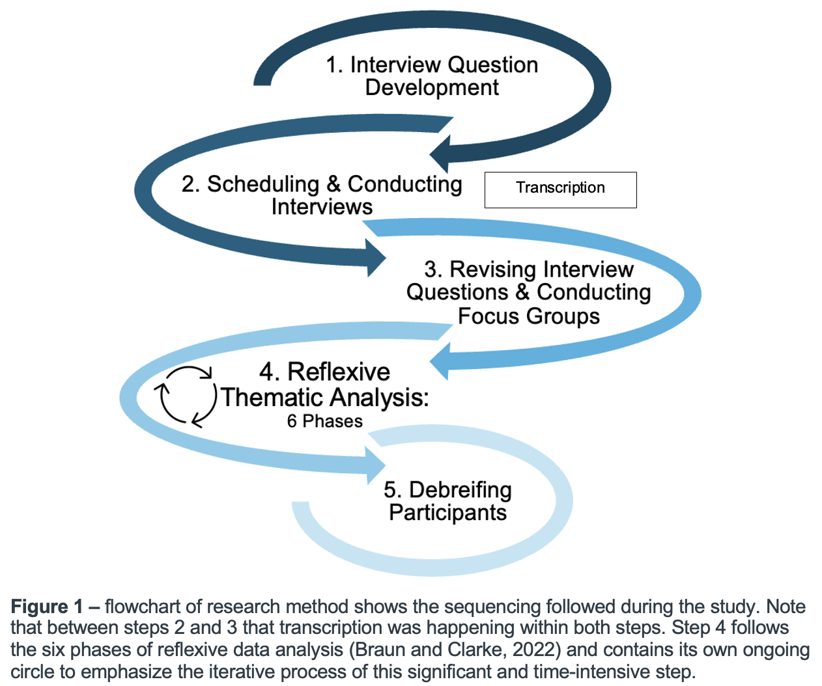

Interview Question Development
Interview questions were adapted from a questionnaire developed by the Clements (2002) study on factors that influence 7-8th grade choral engagement and then edited using a qualitative interview questions guidebook developed for novice researchers (Roberts, 2020). Interviews were purposefully structured to last 15-20 minutes to allow enough time for students to open up, yet be short enough to not overwhelm the children (O’Reilly, and Dogra, 2017). This allowed for eight questions with three extra questions, if needed (see appendix G). Themes of the questions included student background in singing, attitudes towards singing alone versus singing in school, influencers versus followers, perceptions of peer participation in choir, peer pressure, sense of belonging in class, and stereotypes surrounding students who participate or do not participate in choir. All questions were predetermined and then depending on the student response, follow up questions were asked for clarification. To help the researcher understand the context of both student-perceived realities and the ideal singing environments that they envisioned, some questions utilized techniques derived from story completion (Gravett, 2019). In this method, students were given the beginning of a story and were asked to finish the prompt either by telling a story from their life or by drawing upon their perceptions and feelings surrounding middle school choir.

Scheduling and Conducting Interviews
All interviews were completed prior to the focus groups to ensure that personal views were recorded without the influence of group dynamics, which can shape individual responses and potentially suppress dissenting opinions (Gill et al., 2008; RAND, 2009). This method aligns with qualitative research practices that emphasize the depth and authenticity of individual experiences (Kitzinger, 1995). Interviews were audio-recorded and transcribed verbatim. An initial analysis through the transcripts guided the focus group question development. Five main questions were prepared, each containing a potential follow up question. Two extra questions with accompanying follow up questions were prepared in case the other topics were exhausted (see appendix H). This allowed for enough open-ended responses while preparing for more direct questions in case students had shorter responses (Bryman, 2016; Turner, 2010).

Conducting Focus Groups
Four out of the seven students did not show up to the first focus group, so a secondary focus group was held and three of the four students who were unable to attend the first focus group were in attendance for the secondary focus group. Chairs for both sessions were arranged in a circle to promote equality among participants and encourage an open dialogue (Morgan, 1997). Both audio and visual recordings were made to help the researcher discern the student voices and ensure responses were transcribed accurately (Brinkmann, 2023; Creswell, 2013).

Data Analysis
The six phases of Braun and Clarke’s (2006; 2020) reflexive thematic analysis, as seen in Appendix F, were used through an iterative process to analyze the interviews and focus groups. Engagement with each of these steps is outlined below:

Phase 1: Data Familiarization and Writing Familiarization Notes
After the six interviews with students A-F were completed and initially transcribed, which can be viewed in appendices I, J, K, L, M, N, O, and P, the researcher looked for common themes and questions to use for the focus groups. Basic data familiarization (Braun and Clarke, 2022) was conducted across the six interviews. Interviews were listened to and corrected to reflect as close to the spoken original as possible. Each interview was listened to and read at least five times, until the interviewer felt very familiar with the overall subject of each conversation. As in alignment with the Braun and Clarke (2022) reflexive thematic analysis process, a field journal was kept to throughout the entire research project solely to be used as a tool to engage with to reflect on research positioning, record ideas and initial reactions to the interviews, and develop themes. An example of how the researcher engaged with this is demonstrated in appendix Q.

Phase 2: Systematic Data Coding
Next, the entire dataset was examined, and codes were assigned to specific segments of the data that appeared relevant to the research question. Each code was a label that described the content and meaning of the data excerpts. Each code was then transferred into a table in Excel (see appendix U). This methodical approach ensured comprehensive coverage of the data (Saldana, 2015).

Phase 3: Generating Initial Themes from Coded and Collated Data
An online and adapted version of a thematic map (Braun and Clarke, 2006) organized all the coded data extracts into a single, collated spreadsheet file for pattern identification (see appendix V). From there, codes were grouped into potential themes, which involved sorting different codes into overarching themes that reflected significant patterns in the data and meaningful categories.

Phase 4: Developing and Reviewing Themes
Themes were compared to the coded extracts and across the entire dataset. This iterative process ensured that the themes were coherent and accurately represented the data (Braun and Clarke, 2022). To visually process the frequency and significance of each theme throughout the dataset, each candidate theme was assigned a color (see table 1.0). The entire dataset was then analyzed and any codes that aligned with the themes became highlighted with the corresponding theme color.

Phase 5: Refining, Defining, and Naming Themes

A detailed analysis of each theme was conducted by sorting the online spreadsheet file by color: yellow for theme one, green for theme two, and purple for theme three. From this step, each theme was further refined based on the overall story the data told. Each theme was then defined and named clearly to try to capture the essence of what each theme represented. This clarified the key findings of the study (Braun and Clarke, 2013).

Phase 6: Writing the Report
The final phase involved weaving together the analytic narrative and data extracts to tell a compelling story about the data. This included contextualizing the findings within existing literature and providing a thorough account of the analysis process. This phase intended to ensured that the study's conclusions were well-supported and communicated effectively (Silverman, 2016).
Debriefing
Debriefing took place over email between June 24 - July 1, 2024. This provided participants with closure and addressed any lingering questions (Bloor et al., 2001; Brinkmann, 2023).

Ethical Considerations
The research received approval from the University of Wales Trinity Saint David Ethics Committee and adhered to the ethical guidelines set forth by the National Commission for the Protection of Human Subjects of Biomedical and Behavioral Research throughout the research process (1979). The design was mindful of potential ethical concerns, particularly the power dynamics between teachers and students and protecting vulnerable populations, such as children (O’Reilly and Dogra, 2017). To mitigate these imbalances, all meetings were conducted during the school day in familiar and comfortable settings for the students, to encourage a feeling of ease throughout the process (Mertens, 2014). Recording devices were made visible during the interviews to maintain transparency, and interviews were conducted with utmost respect for participants' privacy. Data were anonymized to protect participant identities, with files password-protected to ensure confidentiality (BSA, 2017). By addressing these ethical considerations, the research aimed to foster an environment of trust and respect, ensuring participants felt safe and valued throughout the study (Hammersley & Traianou, 2012).

Findings
The analysis revealed three primary themes and two subthemes as shown in table 1.0:
Table 1.0 – Themes and Subthemes Generated in A Qualitative Exploration of Peer Influence and Participation in Middle School Choir
Theme 1: Fear of Mistakes and Negative Peer Evaluation in Choir
Subtheme 1a: Stigmatization and Othering of Choir Participants
Theme 2: Social Dominance in Choral Ensemble Participation
Subtheme 2a: Perceptions of Peer Effort
Theme 3: Support Systems Fostering Resilience in Choral Participation

These themes provide insight into how peer influence may impact individual participation and valuation of singing in middle school choir settings. Following Braun and Clarke’s (2022) reflexive thematic analysis approach, each theme discussed in the text also contains an accompanying table explaining the central organizing concept, boundaries of the themes, and a comprehensive list of quotations found in appendices R, S and T. The following themes and subthemes are discussed to highlight their significance, supported by participant quotations from both the interviews (INT) and focus groups (FG).

Fear of Mistakes and Negative Peer Evaluation in Choir
A significant fear negative peer evaluation affecting students' willingness to participate in choir activities was identified as a primary theme across the dataset. Accompanying the general anxiety of peer judgement was a subtheme of stigmas and negative perceptions of different types of students in the choral program. One student shares,
"it's funny if it happens to somebody else and then if it happens to you, it's not funny…if I get called out, I feel like embarrassed or mad...maybe even sad, but like with somebody else, like, I'll be, like, snickering, like holding in my laughter" (Student C, FG2).
This response encapsulates the tension between empathy and self-preservation in the choral setting. Similarly, another student shared feelings of scrutiny and the weight of potential errors: "because everybody's watching you...if you- you mess up, you know, then you got that on your shoulders" (Student E, FG).
This metaphorical burden underscores the lasting impact of public mistakes on a student's self-esteem and social status. Another student agrees, “kids like worry about their reputation in chorus and if people are gonna laugh at them or something" (Student D, INT). This perceived omnipresent judgment deters some students from participating in choir. Some students feel obligated to modify their behaviors and “tone it down a little” (Student A, FG) in an effort to protect their reputation.
These testimonies are consistent with literature on social anxiety and peer influence, which suggests that fear of negative evaluation can lead to reduced participation in classroom activities (Ryan, 2000; Wentzel, 1998). Furthermore, witnessing peers reacting negatively to mistakes, can reinforce the fear of judgment and reluctance to engage fully in choir activities (Adderley et al., 2003).

1a) Stigmatization and Othering of Choir Participants
Othering occurs when a dominant group defines and marginalizes other groups by emphasizing and demeaning their differences (Brons, 2015). The perception of singing as a non-heteronormative-male activity (Kennedy, 2002; Sweet, 2010; Watson et al., 2017) was interpreted across the dataset. Quotes like, "people could think it's almost like a soft thing rather than playing an instrument…" (Student E, INT) and "some people would think that like, if you like singing like and your male, like you'd be gay" (Student C, INT). These quotes are interpreted assumptions about sexual orientation and singing, reflecting heteronormative biases that equate non-masculine behaviors with homosexuality (Koza, 1993; Green, 1997). Such assumptions create an environment where some students may avoid choir to prevent being labeled in a way that diverges from the heteronormative standard (Ashley, 2006; Harrison, 2007; McBride and Palkki, 2020).
Beyond gender stereotypes, general social out-casting of choir participants was interpreted across the student responses as well. Students in choir were described as"…really shy kids. Awkward kids" (Student F, INT) or “just like geeky in kind of like their own way. Not really into sports…" (Student D, INT). These statements underscore the persistent stereotypes and social perceptions that can deter students from joining or participating in choir, fearing they will be marginalized or ridiculed (Adderley et al., 2003). Interestingly, active choir participants also engaged in othering, expressing negative views towards non-participants. Some choir members described their non-participant classmates as lazy or as "a waste of space," (Student C, INT) highlighting internal conflicts within the choir community itself.
These lingering stigmas and accounts of othering highlight the frequent social risks that many participants face in choir. These struggles shared by the participants is in alignment with research on how fear of judgment may be a barrier to student engagement in choral activities (Adderley et al., 2003; Freer, 2010; Kennedy, 2002).
2) Social Dominance in Choral Ensemble Participation
Peer influence in adolescent development, particularly in educational settings, is well documented (Berndt, 1999; Eccles and Roeser, 2011; Allen et al., 2006; Durlak et al., 2011; Sweet, 2016; You, 2011). In conversation with all of the participants, shared stories about how just a few strong behaviors in their classes tend to dominate the social space of a learning environment and influence their peers to abide to the mainstream behaviors. Several students even noted the significant impact of peer behavior on their own participation. One student highlighted this influence by stating, “If one person actually puts in the effort to be good at choir, a lot of people will put in the effort. But if one person skips, then a lot of people would skip” (Student F, INT). The contagious nature of both positive and negative behaviors within the choir may affect overall class engagement (Allen et al., 2006; Durlak et al., 2011; Goldstein, 2020; Sweet, 2016; You, 2011).
Students B, C, F and G generally shared that the most dominant type of behavior in their choir classes were negative:
“If one is like gossiping they start gossiping too. If one laughs, they all laugh. One snacks, they all snack. They're like they have a chain reaction on each other like. Like they're one but not one...” (Student C, FG).
This observation underscores the collective influence peers have on one another, demonstrating how behaviors can quickly become mirrored throughout the ensemble, especially within friend groups (Pendergast, 2020).
In contrast, Students A, D and E typically reported the dominant behaviors in their choir classes as overall positive. Student A observed, “Surprisingly, all the other sopranos followed her because they actually wanted to put in the effort and get, you know, the song done” (Student A, INT). This indicates that when a peer takes the initiative and demonstrates commitment, others are likely to follow suit, fostering a more productive and engaged learning environment. Another student recalled: “there's this one kid in the Alto group which is [STUDENT], and like she was singing out...I guess that kind of like, inspired everyone just to really like focus right now and just sing out” (Student D, INT). In these examples, the proactive behavior of a single student can serve as a catalyst for increased focus and participation among peers (Meshram, 2016; Tejaswini and Romate, 2015), highlighting the importance of role models within music ensembles (McPherson and Hendricks, 2010)
Furthermore, the importance of positive peer influence in motivating students aligns with research on peer group dynamics and academic motivation (Ryan, 2000). This work highlights that supportive peer relationships can enhance student engagement and foster a more inclusive and productive learning atmosphere. In the context of choral participation, where collaborative effort is essential, these findings are particularly relevant (Dabback, 2016; Sweet, 2010).

2a) Perceptions of Peer Effort in Choir
Social dominance in choral engagement naturally coincided with a subtheme of individual effort as a calculated and fluid phenomenon dependent on perceived peer effort and the dominant social behavior (Sweet, 2010). The shared perceptions of peer effort and engagement from the interviews suggest that many student decisions regarding participation in choir were reliant on how they were perceiving their peer’s amount of effort and type of attitude maintained in class. While there were certainly many different degrees of commitment and enthusiasm observed among peers in choir, the most common perception shared was that a vast number of students do not typically engage in choir class.
Student C shared, “my class they sing but they don't really try. Like they look bored. They look tired. They don't- they don't want to be here” (Student C, INT). This quote is interpreted to reflect a critical view of peer engagement, indicating that students are merely going through the motions without genuine effort or enthusiasm. The perceived lack of effort and visible signs of boredom suggest a disconnect between the students and the activity, demotivating more passionate members and creating a less vibrant and effective choir environment. This affects student C, because she shares, “I don't want to be the only one singing…because I'm gonna seem weird” (Student C, INT). Another participant also believes the collective population to be disinterested in singing: “in my class, a lot of people like zoned out, like, didn't sing or just like. You like didn't sing that much” (Student G, FG).
Students shared that they know others who calculate their level of effort in choir to maintain control over their social standing and use their positioning to criticize or make fun of those who do participate:
“It's almost like the kids who don't sing...they won't know. Like, ‘oh, they voice cracked. How did they voice crack while they’re singing?’ But if they were singing, they would have the chance of voice cracking, so I feel like the people who don't sing have more room to make fun of the people who do sing" (Student E, FG).
Student E encapsulated this theme of calculated participation to avoid risking a chance to be made fun of. When asked how other students in her class normally participate in choir, another student commented, “[they’re] just like...lazy and like they don't really like to sing as much as I do” (Student B, INT). This statement also underscores a negative perception of the general choral population in grades 7 and 8. This perception can be detrimental to the overall class dynamic, leading to frustration and a sense of isolation for those who are more dedicated, and perpetuate othering sentiments which can diminish the class’s ability to work together (Adderley et al., 2003)
In great contrast to her peers, student A expressed, “My choir is quite nice and everyone's really engaged in it” (Student A, INT). This representation of a positive perception of peer engagement, where the student appreciates the collective effort and enthusiasm of her choir class is not in alignment with the other participants. However, while this is an outlier to the other student examples, what they all have in common is the fact that the dominant behavior is in alignment with her individual effort output.
Students are more likely to engage in activities when they see their peers doing the same (Wentzel, 1998; Eccles and Roeser, 2011). This dynamic can create a positive feedback loop where increased participation by some students encourages others to join in, enhancing overall engagement (Ryan, 2000; Bandura, 1986). Conversely, when students perceive their peers as disengaged, they may also reduce their own effort, leading to a decline in overall participation (Sweet, 2016).
3) Support Systems Fostering Resilience in Choral Participation
Positive familial attitudes towards music can help counteract potential negative influences from peers (Creech, 2010). Many students pointed out that their enjoyment and commitment to choir were influenced by support systems outside the classroom. For instance, one participant expressed:
"Because like if I'm in the car with like my family like there's always music going and [BROTHER] is always singing. And then he's always so happy about it. And then if it's like a good song, I like a genre I like, and I'm singing too, it's just like a fun time" (Student D, INT).

This underscores the importance of a supportive home environment where family members actively engage in musical activities, creating a positive and enjoyable context for the student. Student A also mentioned having family support of her singing: "my parents signed me up for like another, um... music class outside of school" (Student A, INT). This illustrates how parental involvement in enrolling their children in additional music classes can bolster their confidence, contributing to their resilience and sustained participation in choir activities (Creech, 2010).
Additionally, the desire to impress and gain approval from parents was another significant factor in fostering resilience and commitment among students. Student F shared,
"…There's also like a lot of kids who like you, just want to impress their parents trying to like you know, I just want to, like, have something that they know, like I'm good at this. I can do this" (Student F, INT).
This may indicate that the aspiration to make parents proud can drive students to persevere and excel in choir, reinforcing their engagement and dedication. These findings align with existing literature on how the presence of a positive support system, especially from family, can provide the encouragement and confidence needed for students to participate actively in choir, despite the fear of judgment or negative peer evaluation (Crosnoe, 2000; Eccles and Roeser, 2011; Hamm and Faircloth, 2005; Ryan, 2000). This theme underscores the critical role of supportive relationships in promoting resilience and sustaining engagement in choral activities.
Limitations and Recommendations for Future Research
Despite the data providing a rich picture of participants’ experiences, the researcher acknowledges that the understanding developed is partial and does not fully capture the phenomenon under scrutiny (Braun and Clarke, 2006). Students who enjoyed choir readily signed up and attended all sessions, whereas securing participation from those who disliked choir was challenging. Consequently, two students dropped out before their interview, necessitating a secondary focus group due to no-shows from students who disliked choir. This suggests that students with avoidant behaviors may be underrepresented, potentially skewing results (Bartholomew et al., 2021; Saunders et al., 2018). While much is known about the impact of peer influence on student participation, less is understood about the specific mechanisms through which peer dynamics operate in different educational settings, such as choir (Legg, 2013; Pendergast, 2023). Additionally, further research is needed to explore the role of support systems in mitigating negative peer influences and promoting resilience. The analysis primarily considered students who were resilient due to familial support for singing. However, the research did not explore additional factors recognized in the literature as possible contributors to student engagement, such as Self-Determination Theory (Deci and Ryan, 2000; Freer and Evans, 2019). Moreover, the study focused mainly on U.S. students in grades 7 and 8, limiting generalizability to other age groups or educational settings. Lastly, the reliance on self-reported data may introduce bias, as participants might have been influenced by social desirability or recall biases (Fischer and Katz, 2000). Addressing these gaps in future studies could provide a more comprehensive understanding of the factors that influence student participation and engagement in educational activities.
Conclusion
In conclusion, this study illuminates the complex social dynamics that shape student participation in choral ensembles. Through the analysis of six interviews and two focus groups, three main themes emerged: fear of mistakes and negative peer evaluation, social dominance in choral ensemble participation, and support systems fostering resilience. These themes, along with the subthemes of stigmatization and othering of choir participants and perceptions of peer effort, provide a nuanced understanding of the social landscape within choral classrooms.
The fear of mistakes and negative peer evaluation emerged as a significant barrier to student engagement, exacerbated by persistent stigmas and stereotypes associated with choir participation. This anxiety, particularly pronounced among male students, reflects broader societal norms and gender expectations that continue to influence adolescent behavior in educational settings. Concurrently, the study revealed the powerful influence of social dominance within choral ensembles, where both supportive and disruptive behaviors can significantly shape class engagement and individual participation. Importantly, the research underscores the critical role of support systems and personal resilience in enhancing student participation. These findings not only corroborate existing literature on social anxiety and peer influence in educational contexts but also extend the understanding of these dynamics within the specific realm of choral education. The study highlights the delicate balance educators must strike between mitigating negative peer judgments and fostering positive interactions to create an inclusive and supportive learning environment.
Moving forward, these insights offer valuable directions for both practice and future research. Educators may benefit from implementing strategies that address social anxieties, challenge stereotypes, and promote positive peer interactions within choral settings. Future studies could explore targeted interventions to enhance resilience and support systems for students facing social challenges in choir, potentially leading to more inclusive and engaging choral experiences for all students. Ultimately, this research contributes to a growing body of knowledge on the social aspects of music education, emphasizing the need for a holistic approach that considers not only musical skill development but also the complex social dynamics that shape student engagement and participation in choral ensembles.

Reference List:
Abril, C.R. (2007) ‘I have a voice but I just can't sing: a narrative investigation of singing and social anxiety’, Music Education Research, 9(1), pp. 1-15.
Adderley, C., Kennedy, M. and Berz, W. (2003) 'A home away from home: The world of the high school music classroom', Journal of Research in Music Education, 51(3), pp. 190-205. DOI: 10.2307/3345373.
Allen, J.P., Porter, M.R. and McFarland, F.C. (2006) 'Leaders and followers in adolescent close friendships: Susceptibility to peer influence as a predictor of risky behavior, friendship instability, and depression', Development and Psychopathology, 18(1), pp. 155-172.
Ashley, M. (2006) 'You sing like a girl? An exploration of 'boyness' through the treble voice', Sex Education, 6(2), pp. 193-205.
Austin, J., Renwick, J. and McPherson, G.E., 2006. Developing motivation. In: G. McPherson, ed., The Child as Musician: A Handbook of Musical Development. 1st ed. Oxford: Oxford Academic. Available at: https://doi.org/10.1093/acprof:oso/9780198530329.003.0011 [Accessed 10 June 2024].
Bandura, A. (1986) Social Foundations of Thought and Action: A Social Cognitive Theory. Prentice-Hall.
Barresi, A.L. (2000) ‘The successful middle school choral teacher’, Music Educators Journal, 86(4), pp. 23-28.
Barrett, M.S. and Zhukov, K. (2023) 'Choral Flourishing: Parent and child perspectives on the benefits of participation in an excellent youth choir', Research Studies in Music Education, 45(3), pp. 525-538.
Bartholomew, T.T., Joy, E.E., Kang, E. and Brown, J. (2021) 'A choir or cacophony? Sample sizes and quality of conveying participants’ voices in phenomenological research', Methodological Innovations, 14(2).
Berger, R. (2015) 'Now I see it now I don’t: Researcher’s position and reflexivity in qualitative research', Qualitative Research, 15(2), pp. 219-234.
Berndt, T.J. (1999) 'Friends' influence on students' adjustment to school', Educational Psychologist, 34(1), pp. 15-28.
Bloor, M., Frankland, J., Thomas, M. and Robson, K. (2001) Focus Groups in Social Research. Sage.
Boer, D. and Abubakar, A. (2014) ‘Music listening in families and peer groups: benefits for young people's social cohesion and emotional well-being across four cultures’, Frontiers in Psychology, 5, pp. 1-15.
Braun, V. and Clarke, V. (2006) 'Using thematic analysis in psychology', Qualitative Research in Psychology, 3(2), pp. 77-101.
Braun, V. and Clarke, V. (2013) Successful Qualitative Research: A Practical Guide for Beginners. Sage.
Braun, V. and Clarke, V. (2020) 'Reflecting on reflexive thematic analysis', Qualitative Research in Sport, Exercise and Health, 11(4), pp. 589-597.
Braun, V. and Clarke, V. (2022) Thematic Analysis: A Practical Guide. Sage.
Brinkmann, S. (2023) 'Conducting and Analyzing Qualitative Interviews', in Qualitative Interviewing: Conversational Knowledge Through Research Interviews. 2nd edn. New York: Oxford Academic, accessed 10 May 2024.
British Sociological Association (BSA) (2017) Statement of Ethical Practice. Durham: BSA.
Brons, L. (2015) 'Othering, an analysis', Transcience, a Journal of Global Studies, 6(1), pp. 69-90.
Brown, B.B. and Larson, J. (2009) 'Peer relationships in adolescence', in Lerner, R.M. and Steinberg, L. (Eds.) Handbook of Adolescent Psychology. 3rd edn. Vol. 2, pp. 74-103. Wiley.
Bryman, A. (2016) Social Research Methods. Oxford University Press.
Casals, A., Vilar, M. and Ayats, J. (2011) ‘I’m not sure if I can... but I want to sing!’ Research on singing as a soloist through the art of improvising verses', British Journal of Music Education, 28(3), pp. 247-261. doi:10.1017/S0265051711000192.
Clements, A.C. (2002) The importance of selected variables in predicting student participation in junior high choir (Doctoral dissertation). Available from ProQuest Dissertations and Theses database. (UMI No. 3062930).
Cohen, L., Manion, L. and Morrison, K. (2018) Research Methods in Education. 8th edn. London: Routledge.
Colorado Department of Education (2023) Grade Level / Age Chart. Available at: (Accessed: 29 June 2024).
Creech, A. (2010) 'Learning a musical instrument: The case for parental support', Music Education Research, 12(1), pp. 13-32.
Creswell, J.W., 2013. Qualitative Inquiry and Research Design: Choosing Among Five Approaches. 3rd ed. Thousand Oaks, CA: SAGE Publications.
Cronenberg, S. and Williams, K.E. (2022) Standing in the Gap: Understanding the Persistence of Black and Latinx Music Educators. Available at: https://nafme.org/wp-content/uploads/2023/02/2020-2022-FINAL-GRANT-RESEARCH-REPORT-Cronenberg_Williams_Standing-in-the-Gap-Report.pdf (Accessed: 12 May 2024).
Crosnoe, R. (2000) 'Friendships in Childhood and Adolescence: The Life Course and New Directions', Journal of Social and Personal Relationships, 17(1), pp. 1-28.
Dabback, W. (2016) ‘A community of singing: motivation, identity, and communitas in a Mennonite School choir programme’, Music Education Research, 20(2), pp. 242–251. doi: 10.1080/14613808.2016.1257593.
Deci, E.L. and Ryan, R.M. (2000) ‘The “What” and “Why” of Goal Pursuits: Human Needs and the Self-Determination of Behavior’, Psychological Inquiry, 11(4), pp. 227–268. doi: 10.1207/S15327965PLI1104_01.
Demorest, S.M., Kelley, J. and Pfordresher, P.Q. (2017) ‘Singing Ability, Musical Self-Concept, and Future Music Participation’, Journal of Research in Music Education, 64(4), pp. 405-420.
Durlak, J.A., Weissberg, R.P., Dymnicki, A.B., Taylor, R.D. and Schellinger, K.B. (2011) 'The impact of enhancing students’ social and emotional learning: A meta-analysis of school-based universal interventions', Child Development, 82(1), pp. 405-432.
Eccles, J.S. and Roeser, R.W. (2011) 'Schools as developmental contexts during adolescence', Journal of Research on Adolescence, 21(1), pp. 225-241.
Einarsdottir, S. L. and Gudmundsdottir, H. R. (2015) ‘The role of choral singing in the lives of amateur choral singers in Iceland’, Music Education Research, 18(1), pp. 39–56. doi: 10.1080/14613808.2015.1049258.
Elpus, K. (2015) 'National estimates of male and female enrolment in American high school choirs, bands, and orchestras', Music Education Research, 17(1), pp. 88-102. doi: 10.1080/14613808.2014.972923.
Elpus, K. and Abril, C.R. (2011) ‘High School Music Ensemble Students in the United States’, Journal of Research in Music Education, 59(2), pp. 128-145.
Elpus, K. and Carter, B.A., 2016. Bullying victimization among music ensemble and theatre students in the United States. Journal of Research in Music Education, 64(3), pp.322-343. Available at: https://doi.org/10.1177/0022429416658642 [Accessed 1 July 2024].
Elpus, K. and Abril, C.R., 2019. Who enrolls in high school music? A national profile of U.S. students, 2009–2013. Journal of Research in Music Education, 67(3), pp.323-338. Available at: https://doi.org/10.1177/0022429419862837 [Accessed 5 May 2024].
Evans, P. and McPherson, G.E. (2017) 'Processes of musical identity consolidation during adolescence', in Hargreaves, D.J., MacDonald, R.M.R. and Miell, D. (Eds.) Oxford Handbook of Musical Identities. pp. 213–232. Oxford UK: Oxford University Press.
Fisher, R.J. and Katz, J.E. (2000) 'Social-desirability bias and the validity of self-reported values', Psychology & Marketing, 17(2), pp. 105-120.
Freer, E. and Evans, P. (2019) 'Choosing to study music in high school: Teacher support, psychological needs satisfaction, and elective music intentions', Psychology of Music, 47(6), pp. 781-799.
Freer, P.K. (2008) 'Boys' changing voices in the first century of MENC journals', Music Educators Journal, 95(1), pp. 41-47. Retrieved from
Freer, P.K. (2010) 'Two decades of research on possible selves and the 'missing males' problem in choral music', International Journal of Music Education, 28(1), pp. 17-30.
Fisher, R. J., & Katz, J. E. (2000). Social-desirability bias and the validity of self-reported values. Psychology & Marketing, 17(2), 105-120.
Gill, P., Stewart, K., Treasure, E. and Chadwick, B. (2008) 'Methods of data collection in qualitative research: Interviews and focus groups', British Dental Journal, 204(6), pp. 291-295.
Goldstein, S.E., Lee, C.S., Gunn, J.F., Bradley, S., Lummer, S. and Boxer, P. (2020) ‘Susceptibility to peer influence during middle school: Links with social support, peer harassment, and gender’, Psychology in the Schools, 57(1), pp. 91-110.
Gravett, K. (2019) 'Story Completion: Storying as a Method of Meaning-Making and Discursive Discovery', International Journal of Qualitative Methods, 18.
Grebosz-Haring, K., Schuchter-Wiegand, A.K., Feneberg, A.C., Skoluda, N., Nater, U.M., Schütz, S. and Thun-Hohenstein, L. (2022) ‘The Psychological and Biological Impact of "In-Person" vs. "Virtual" Choir Singing in Children and Adolescents: A Pilot Study Before and After the Acute Phase of the COVID-19 Outbreak in Austria’, Frontiers in Psychology, 12, pp. 1-21.
Green, L. (1997) Music, Gender, Education. Cambridge University Press.
Hall, C. (2005) 'Gender and boys' singing in early childhood', British Journal of Music Education, 22(1), pp. 5-20. doi: 10.1017/S0265051704005960.
Hallam, S. (2010) 'The Power of Music: Its Impact on the Intellectual, Social and Personal Development of Children and Young People', International Journal of Music Education, 28(3), pp. 269-289.
Hawkins, D.L., Pepler, D.J. and Craig, W.M., 2001. Naturalistic observations of peer interventions in bullying. Social Development, 10, pp.512-527. Available at: https://doi.org/10.1111/1467-9507.00178 [Accessed 25 June 2024].
Hamm, J.V. and Faircloth, B.S. (2005) 'Peer Contexts in Middle and High School: The Linkages between Peer Experiences and School Engagement', New Directions for Student Leadership, 107, pp. 33-43.
Hammersley, M. and Traianou, A., 2012. Ethics in Qualitative Research: Controversies and Contexts. London: SAGE Publications.
Harrison, S.D. (2004) 'Engaging boys overcoming stereotypes: Another look at the missing males in vocal programs', The Choral Journal, 45(2), pp. 24-29.
Harrison, S.D. (2007) 'A perennial problem in gendered participation in music: What's happening to the boys?', British Journal of Music Education, 24(3), pp. 267-280. doi: 10.1017/S0265051707007577.
Johal, D.S. and Mehta, R., 2015. Behavioral problems in relation to peer pressure among adolescents. Indian Journal of Health and Wellbeing, 6, pp.156-160.
Kennedy, M.A. (2002) 'It's cool because we like to sing:' Junior high school boys' experience of choral music as an elective', Research Studies in Music Education, 18, pp. 26-37. doi: 10.1177/1321103X020180010401.
Kitzinger, J. (1995) 'Qualitative research: Introducing focus groups', BMJ, 311(7000), pp. 299-302.
Koza, J.E. (1993) 'The "Missing Males" and Other Gender Issues in Music Education: Evidence from the Music Supervisors' Journal 1914-1924', Journal of Research in Music Education, 41(3), pp. 212-232.
Lamont, A., Hargreaves, D.J., Marshall, N.A. and Tarrant, M. (2003) 'Young people's music in and out of school', British Journal of Music Education, 20(3), pp. 229–241.
Laursen, B. and Veenstra, R. (2021) 'Toward understanding the functions of peer influence: A summary and synthesis of recent empirical research’, Journal of Research on Adolescence, 31(4), pp. 889-907.
Legette, R.M., 1993. Causal attributions of music majors and nonmusic majors regarding success and failure in music: A study of motivation and achievement. Research Perspective in Music Education, 4, pp.3-6.
Legg, R. (2013) 'Reviewing the situation: a narrative exploration of singing and gender in secondary schools', Music Education Research, 15(2), pp. 168–179.
Liu, L., Wang, X., Chen, X., Tang, S. and Zheng, Z. (2021) ‘Modeling Confirmation Bias and Peer Pressure in Opinion Dynamics’, Frontiers in Physics, 9.
Lucas, M. (2011) 'Adolescent Male Attitudes About Singing in Choir', UPDATE: Applications of Research in Music Education, 30(1), pp. 46–53. doi:10.1177/8755123311418623.
Mason, M. (2010) 'Sample size and saturation in PhD studies using qualitative interviews', Forum: Qualitative Social Research, 11(3), Art. 8.
Marshall, B., Cardon, P., Poddar, A. and Fontenot, R. (2013) 'Does sample size matter in qualitative research?: A review of qualitative interviews in IS research', Journal of Computer Information Systems, 54(1), pp. 11-22.
McBride, N.R. and Palkki, J. (2020) 'Big boys don’t cry (or sing) … still?: a modern exploration of gender, misogyny, and homophobia in college choral methods texts', Music Education Research, 22(4), pp. 408–420. doi: 10.1080/14613808.2020.1784862.
McPherson, G.E., Osborne, M.S., Barrett, M.S., Davidson, J.W. and Faulkner, R. (2015) 'Motivation to study music in Australian schools: The impact of music learning, gender and socio-economic status', Research Studies in Music Education, 37(2), pp. 141–160.
McPherson, G.E. and Hendricks, K.S. (2010) 'Students’ motivation to study music: The United States of America', Research Studies in Music Education, 32(2), pp. 201-213.
Madondo, S. (2021) "Ethics in Qualitative Research" in Data Analysis and Methods of Qualitative Research: Emerging Research and Opportunities. Hershey PA: IGI Global, pp. 1-32.
Mertens, D.M., 2014. Research and Evaluation in Education and Psychology: Integrating Diversity With Quantitative, Qualitative, and Mixed Methods. 4th ed. Thousand Oaks, CA: SAGE Publications.
Meshram, R.G. (2016) "The upside of peer pressure on adolescent behavior", Indian Journal of Health and Wellbeing, 7(8), pp. 845.
Mizener, C.P. (1993) 'Attitudes of children toward singing and choir participation and assessed singing skill', Journal of Research in Music Education, 41(3), pp. 233-245. doi: 10.2307/3345327.
Morgan, D.L., 1997. Focus Groups as Qualitative Research. 2nd ed. Thousand Oaks, CA: SAGE Publications.
The National Commission for the Protection of Human Subjects of Biomedical and Behavioral Research, 1979. The Belmont Report: Ethical Principles and Guidelines for the Protection of Human Subjects of Research. Washington, DC: Department of Health, Education, and Welfare. Available at: https://www.hhs.gov/ohrp/sites/default/files/the-belmont-report-508c_FINAL.pdf [Accessed 14 March 2024].
O’Reilly, M. and Dogra, N. (2017) Interviewing children and young people for research. London: SAGE Publications Ltd.
Orton, A. and Pitts, S.E. (2019) 'Adolescent perceptions of singing: exploring gendered differences in musical confidence, identity and ambition', Music Education Research, 21(1), pp. 40–51. doi: 10.1080/14613808.2018.1507019.
Patton, M.Q. (2015) Qualitative Research & Evaluation Methods. 4th edn. Thousand Oaks, CA: SAGE Publications.
Papageorgi, I., Hallam, S. and Welch, G.F. (2007) 'A Conceptual Framework for Understanding Musical Performance Anxiety', Research Studies in Music Education, 28(1), pp. 83-107.
Pendergast, S., 2023. Research-to-Resource: Two motivation frameworks for encouraging school choral participation. Applications of Research in Music Education, 41(2), pp.5-14. Available at: https://doi.org/10.1177/87551233221082507 [Accessed 23 April 2024].
RAND (2009) Data Collection Methods: Semi-Structured Interviews and Focus Groups. RAND Corporation.
Robinson, O.C. (2014) 'Sampling in Interview-Based Qualitative Research: A Theoretical and Practical Guide', Qualitative Research in Psychology, 11(1), pp. 25-41.
Roberts, R.E. (2020) 'Qualitative Interview Questions: Guidance for Novice Researchers', The Qualitative Report, 25(9), pp. 3185-3203.
Roulston, K. (2014) 'Analysing Interviews', in The SAGE Handbook of Qualitative Data Analysis. 55 City Road, London: SAGE Publications Inc., pp. 297-312. Available at: https://doi.org/10.4135/9781446282243 (Accessed 10 Apr 2024).
Ryan, A.M. (2000) 'Peer Groups as a Context for the Socialization of Adolescents’ Motivation, Engagement, and Achievement in School', Educational Psychologist, 35(2), pp. 101-111.
Saunders, B., Sim, J., Kingstone, T., Baker, S., Waterfield, J., Bartlam, B., Burroughs, H. and Jinks, C. (2018) 'Saturation in qualitative research: exploring its conceptualization and operationalization', Quality & Quantity, 52(4), pp. 1893-1907.
Scheib, J.W., 2003. Role stress in the professional life of the school music teacher: A collective case study. Journal of Research in Music Education, 51(2), pp.124-136. Available at: https://doi.org/10.2307/3345846 [Accessed 13 Apr 2024].
Siebenaler, D.J., 2006. Factors that predict participation in choral music for high-school students. Research & Issues in Music Education, 4(1), Article 5. Available at: https://commons.lib.jmu.edu/rime/vol4/iss1/5 [Accessed 15 May 2024].
Silverman, D., 2016. Doing Qualitative Research. 4th ed. London: SAGE Publications. ​
Shuler, S.C. (2011) 'Music Education for Life: Building Inclusive Effective Twenty-First-Century Music Programs', Music Educators Journal, 98(1), pp. 8-13.
Sichivitsa, V.O. (2007) "The influences of parents, teachers, peers and other factors on students' motivation in music", Research Studies in Music Education, 29(1), pp. 55-68.
Sweet, B. (2016) Growing Musicians: Teaching Music in Middle School and Beyond. Oxford University Press.
Sweet, B. (2010) 'A case study: Middle school boys' perceptions of singing and participation in choir', Update: Applications of Research in Music Education, 28(2), pp. 5-12. doi: 10.1177/8755123310361770.
Szabo, M. (1999) 'Why don't boys sing?', General Music Today, 12, pp. 11-14. doi: 10.1177/104837139901200204.
Turner, D.W. (2010) 'Qualitative interview design: A practical guide for novice investigators', The Qualitative Report, 15(3), pp. 754-760.
Veenstra, R., Lindenberg, S., Munniksma, A. and Dijkstra, J.K. (2010) 'The Complex Nature of Peer Relations and Bullying: An Application of Goal-Framing Theory', in Jimerson, S.R., Swearer, S.M. and Espelage, D.L. (Eds.) Handbook of Bullying in Schools: An International Perspective. pp. 87-99. Routledge.
Wallerstedt, C. and Lindgren, M. (2016) ‘Crossing the boundary from music outside to inside of school: Contemporary pedagogical challenges’, British Journal of Music Education, 33(2), pp. 191–203. doi:10.1017/S0265051716000164.
Warzecha, M. (2013) 'Boys' perceptions of singing: A review of the literature', Update: Applications of Research in Music Education.
Watson, P., Rubie-Davies, C.M. and Hattie, J.A. (2017) 'Stereotype Threat, Gender-Role Conformity and New Zealand Adolescent Males in Choirs', Research Studies in Music Education, 39(2), pp. 226-246.
Wentzel, K.R. (1998) 'Social Relationships and Motivation in Middle School: The Role of Parents, Teachers and Peers', Journal of Educational Psychology, 90(2), pp. 202-209.
Williams, D.A. (2011) 'The Elephant in the Room', Music Educators Journal, 98(1), pp. 51-57.
Williamson, S. (2000) "Positively Adolescent!", Music Educators Journal, 86(4), pp. 29-32.
Woody, R.H. (2021) 'Music education students’ intrinsic and extrinsic motivation: A quantsitative analysis of personal narratives', Psychology of Music, 49(5), pp. 1321-1343.
Yardley, L. (2000) ‘Dilemmas in qualitative health research’, Psychology & Health, 15(2), pp. 215–228. doi: 10.1080/08870440008400302.
You, S. (2011) 'Peer influence and adolescents’ school engagement', Procedia - Social and Behavioral Sciences, 29, pp. 829-835.

Appendix A: Gantt Chart
This GANTT chart depicts a timeline for the research project, spanning April 2024 – July 2024.

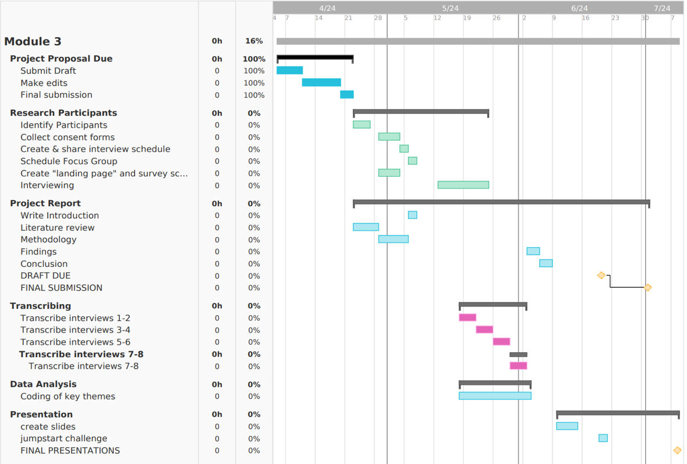

Appendix B: Ethics Form
As in compliance with the University of Wales Trinity Saint David policy for the Module BMPF7008, the following is evidence of completion and approval of the ethics form. Please note, sensitive information has been redacted to protect researcher privacy.
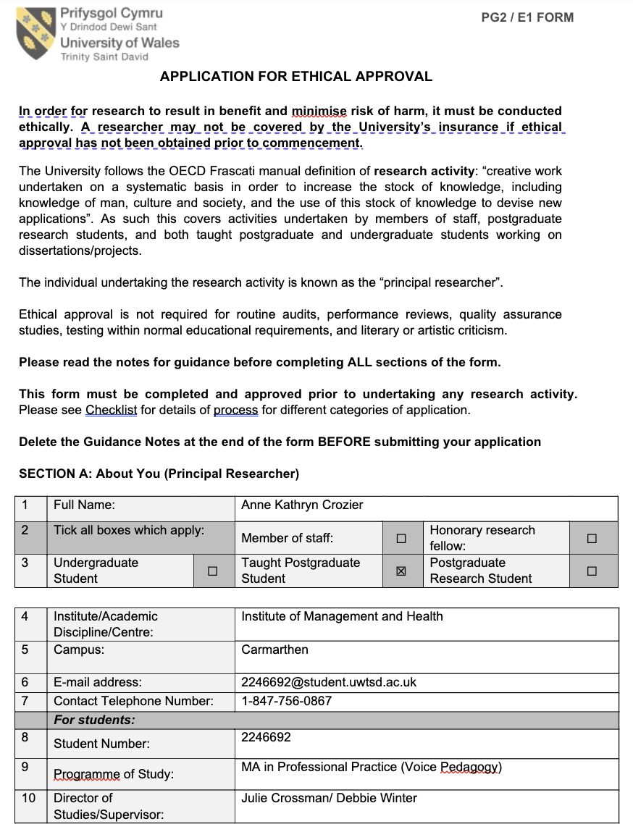

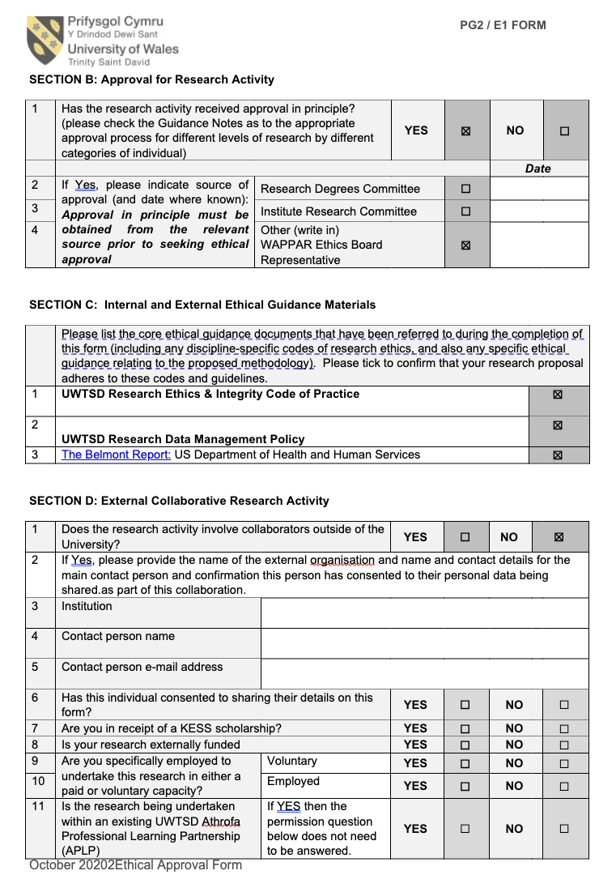

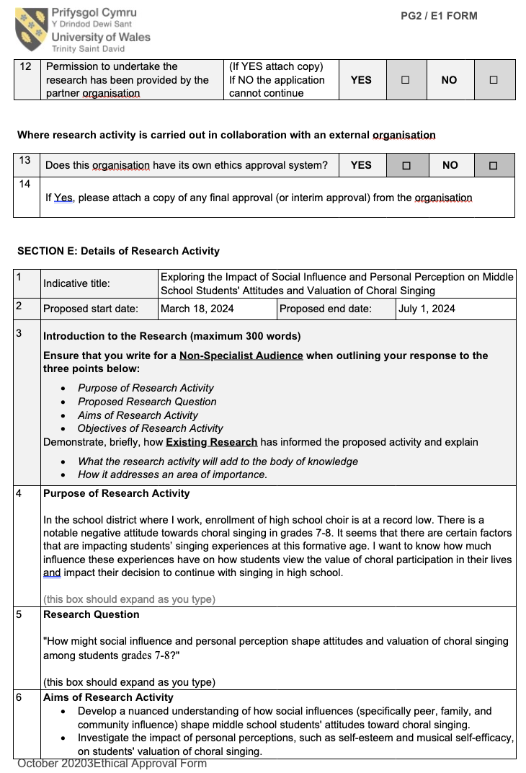
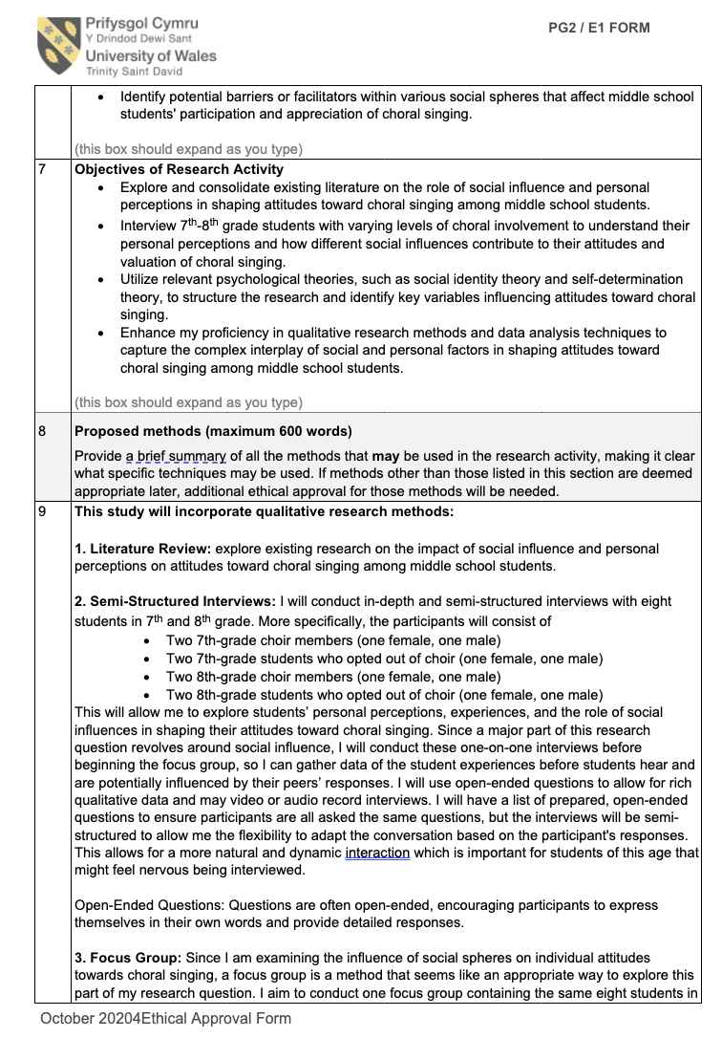
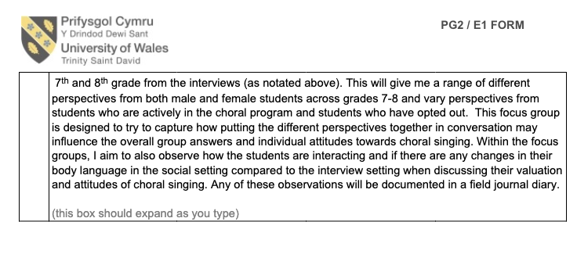
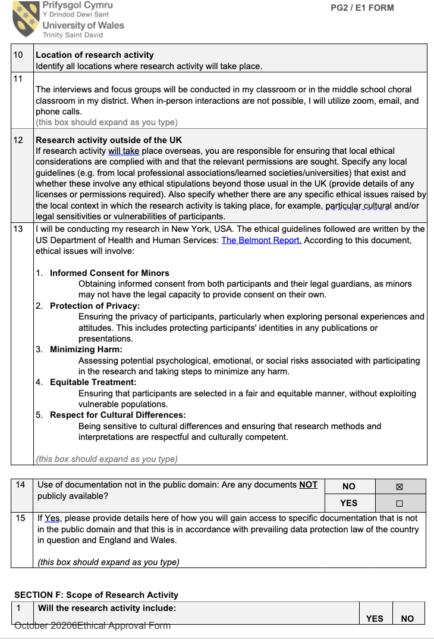
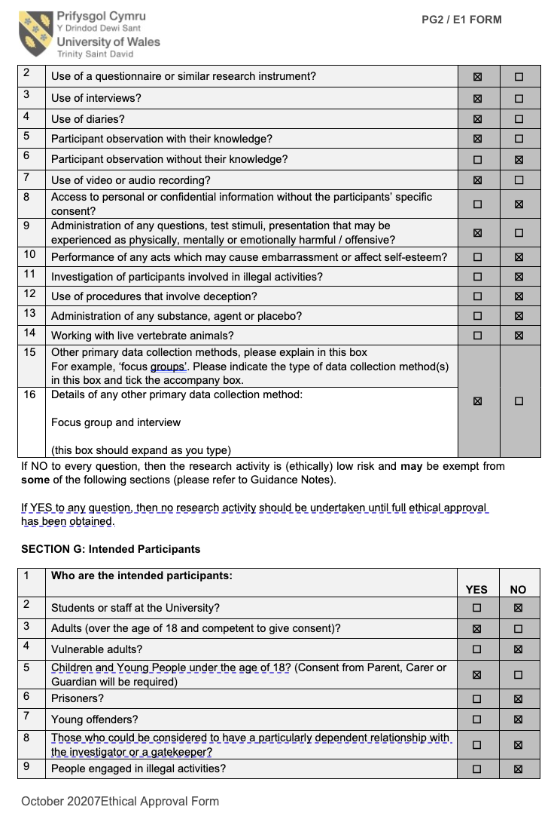

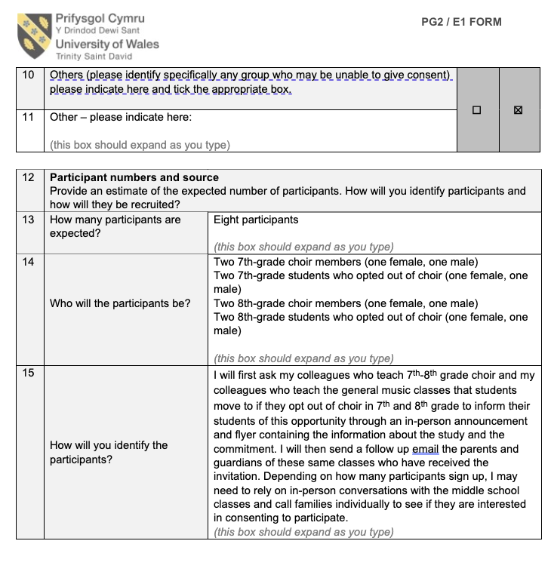

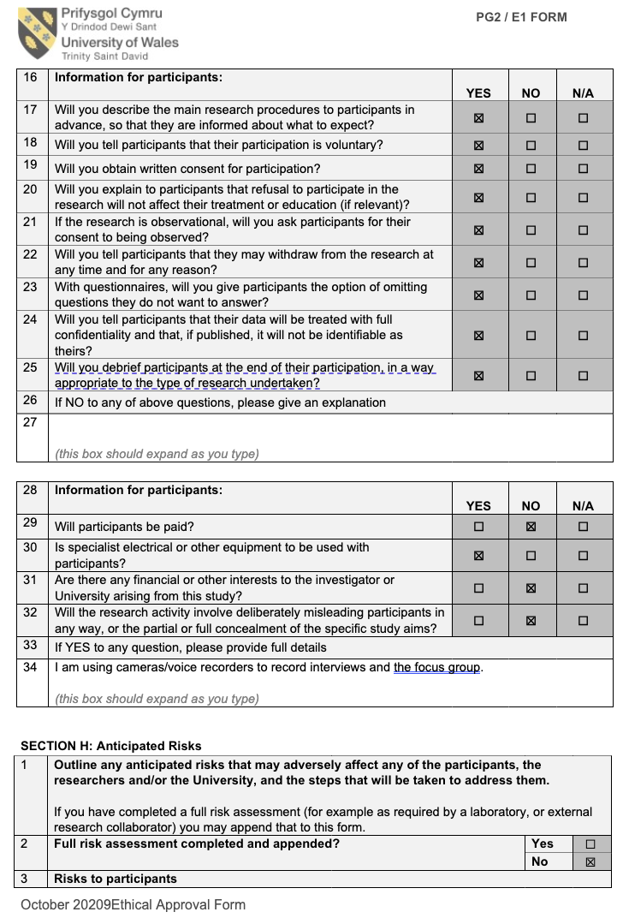

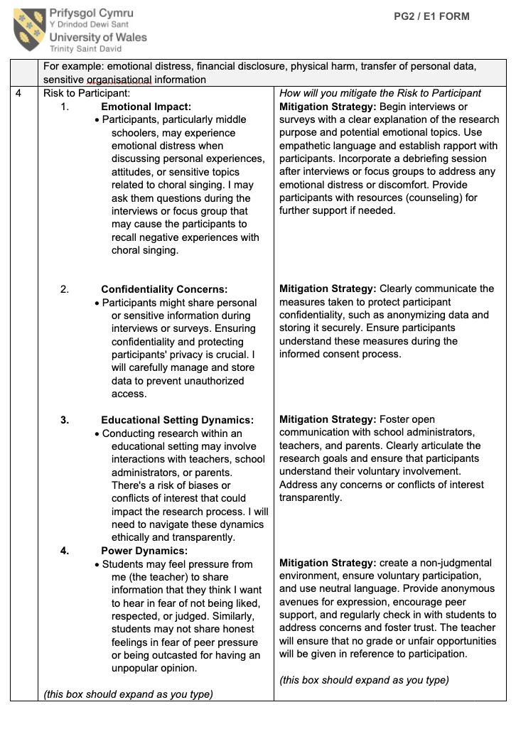
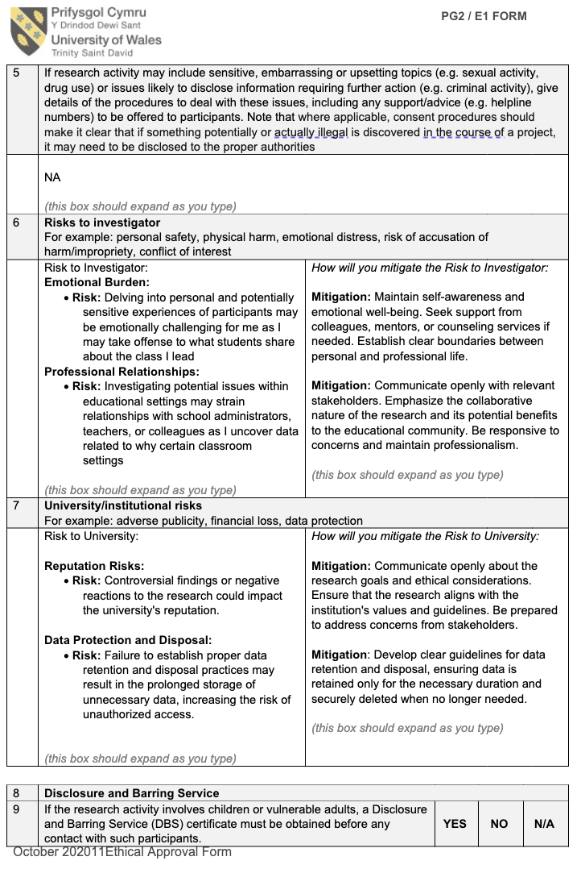

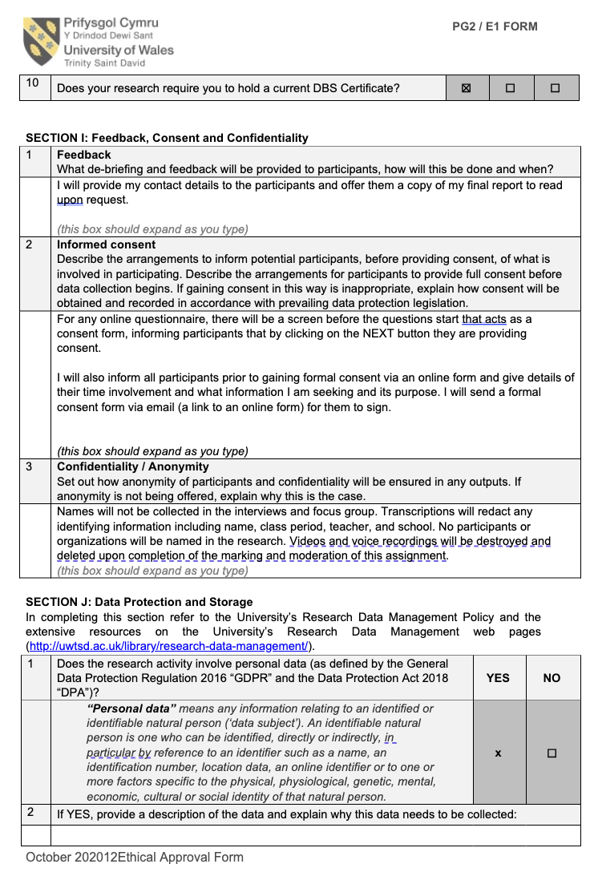

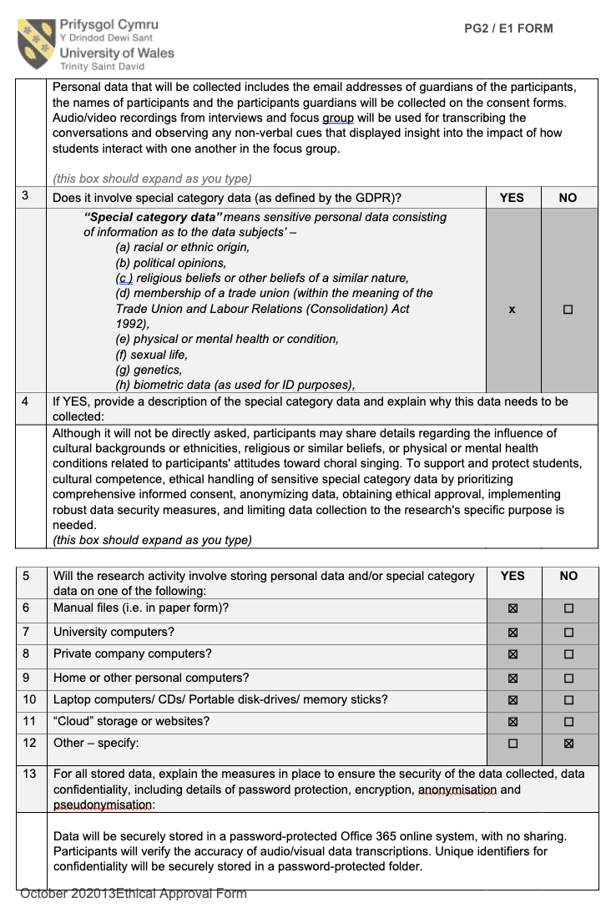
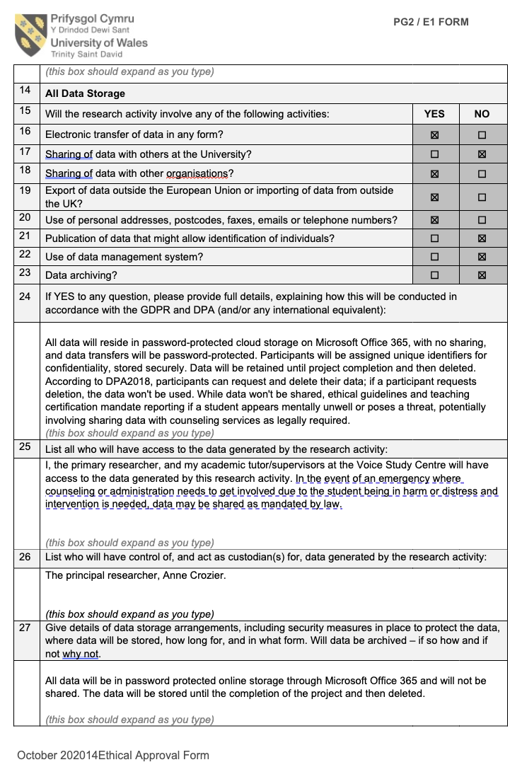
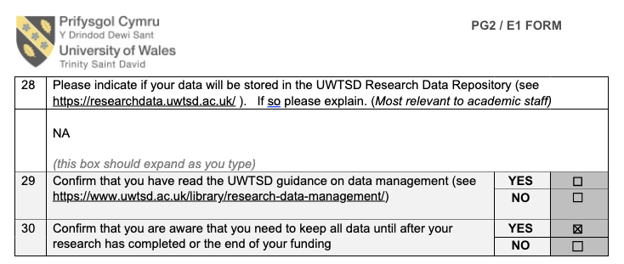
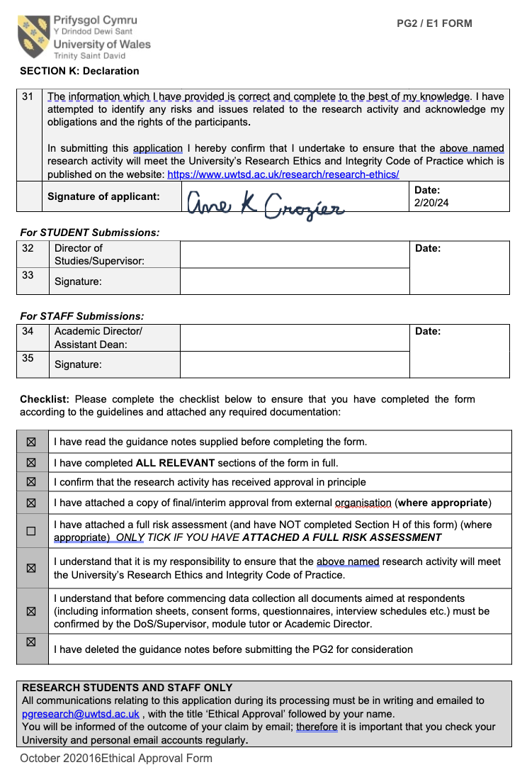

Appendix C: Informational Flyer
Teachers at the [SCHOOL] were provided digital copies of this informational flyer to help inform students of the study’s focus and eligibility critera.
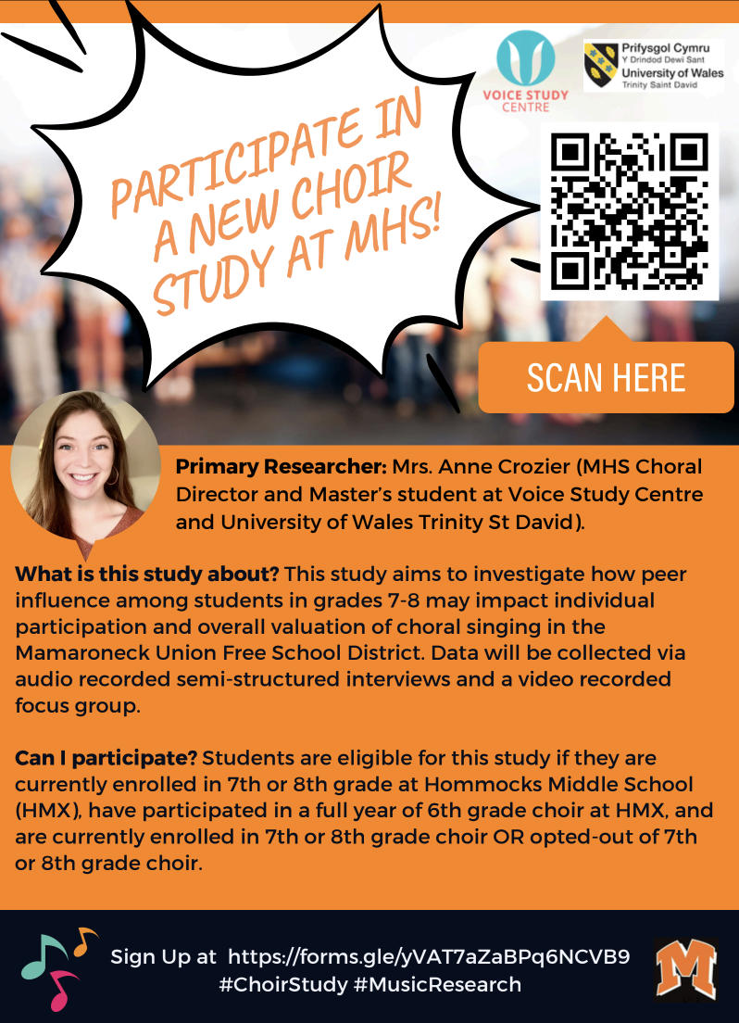

Appendix D: Participant Interest Form
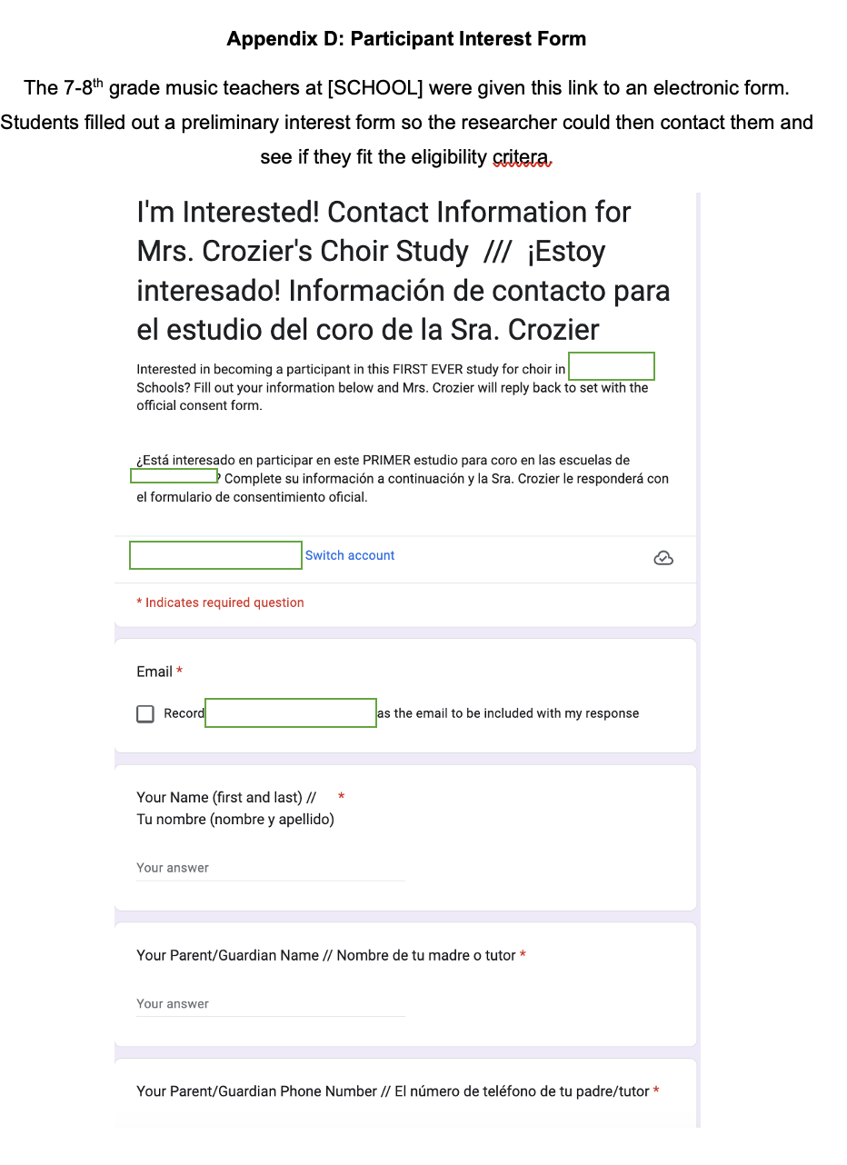
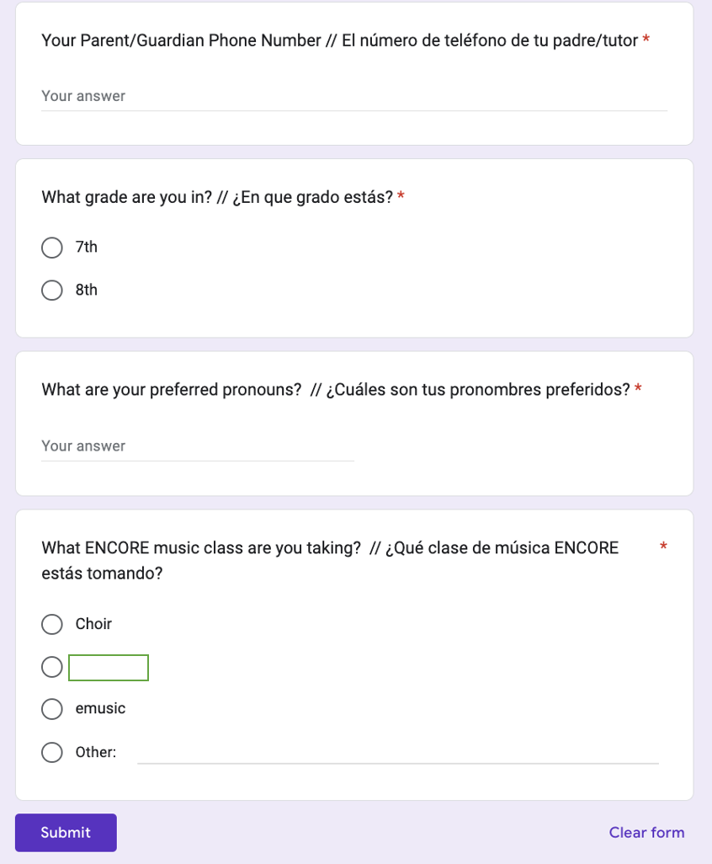

Appendix E: Consent Forms
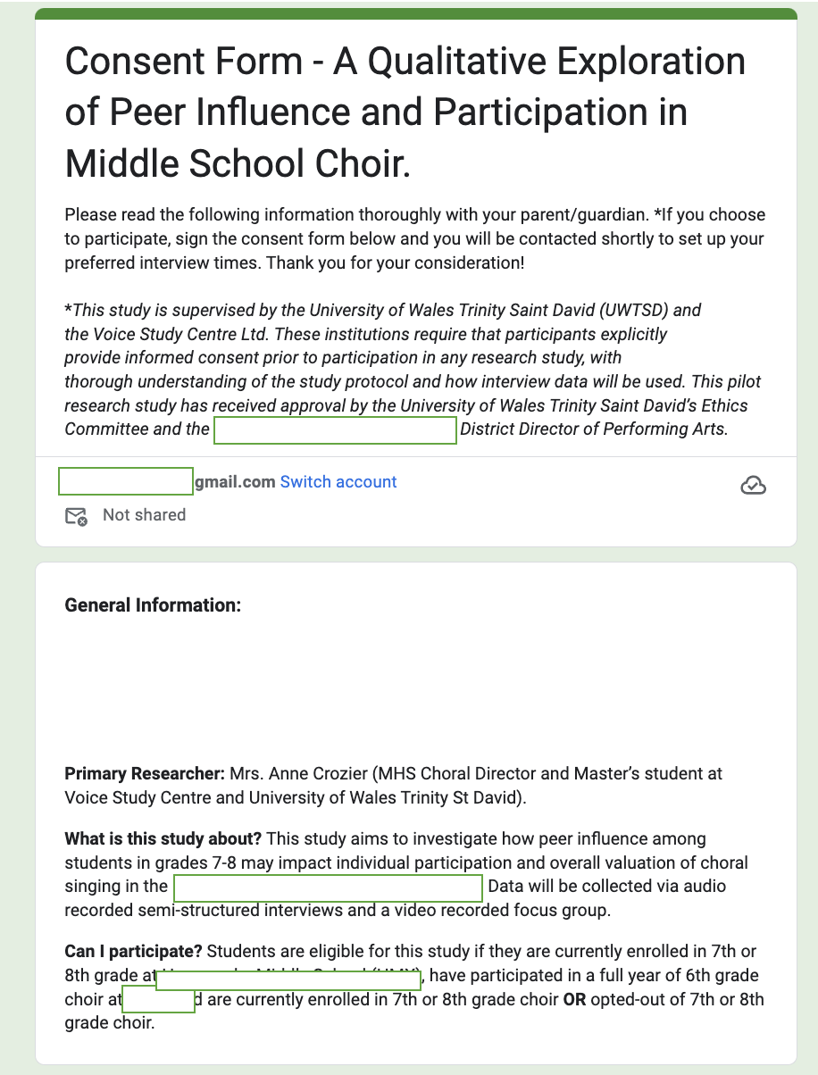
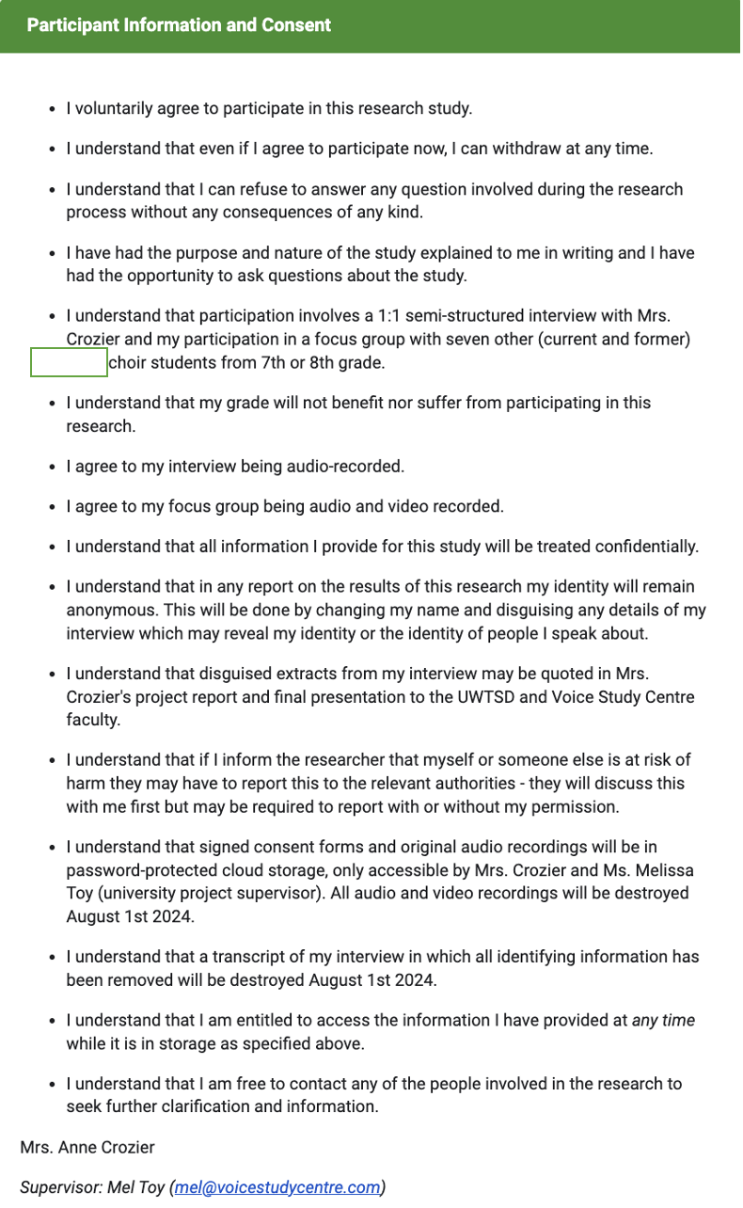
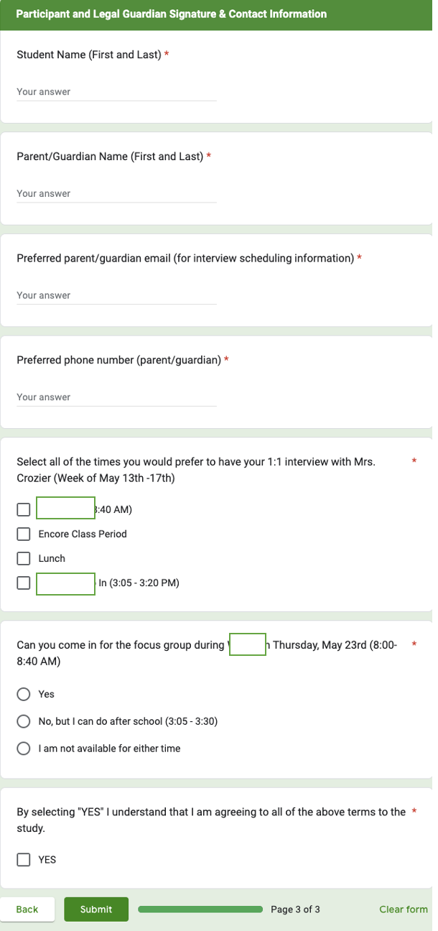

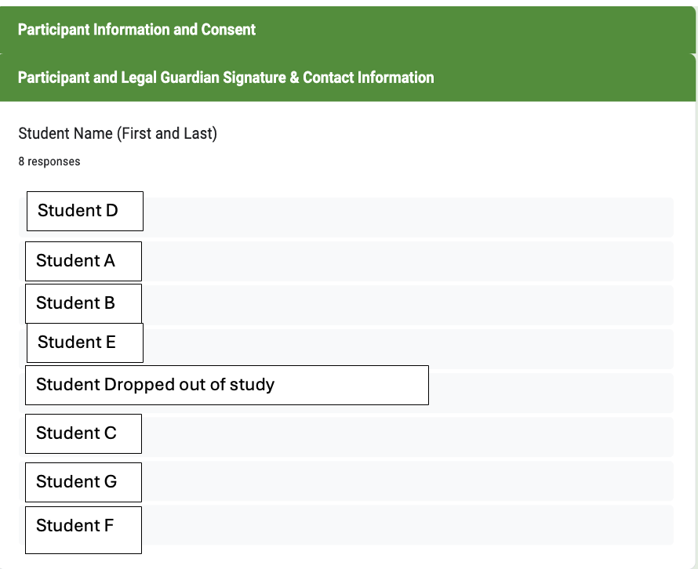
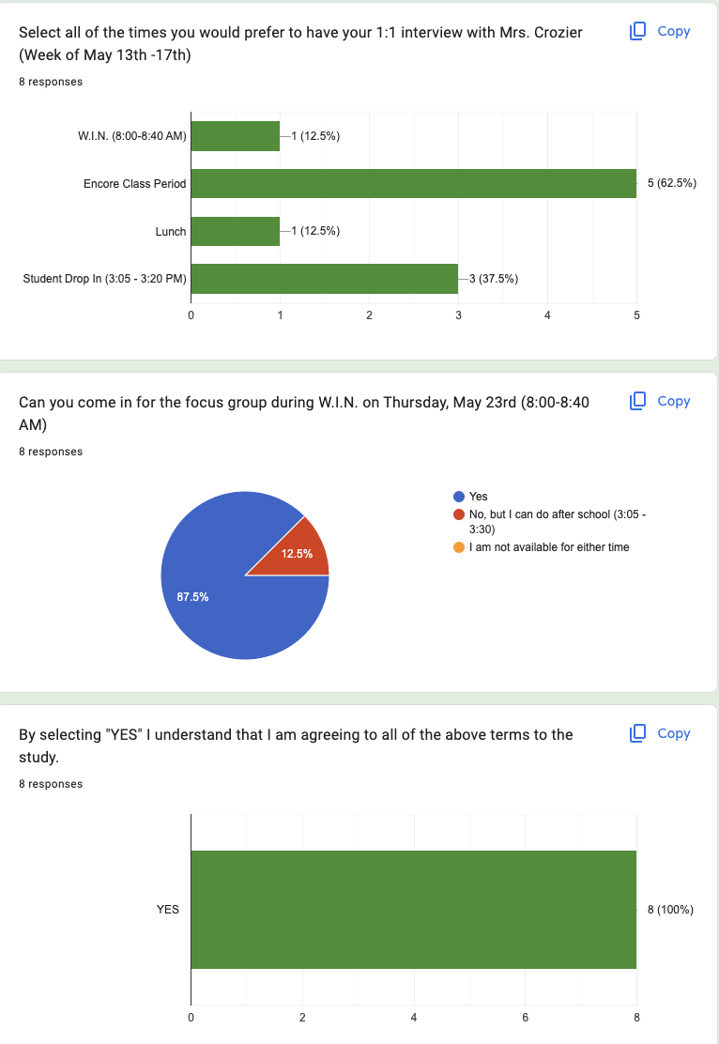

Appendix F: Six Phases of Reflexive Thematic Analysis
This is a helpful guide explaining the six recursive steps that occur during reflexive thematic analysis, according to Braun and Clarke (2006).
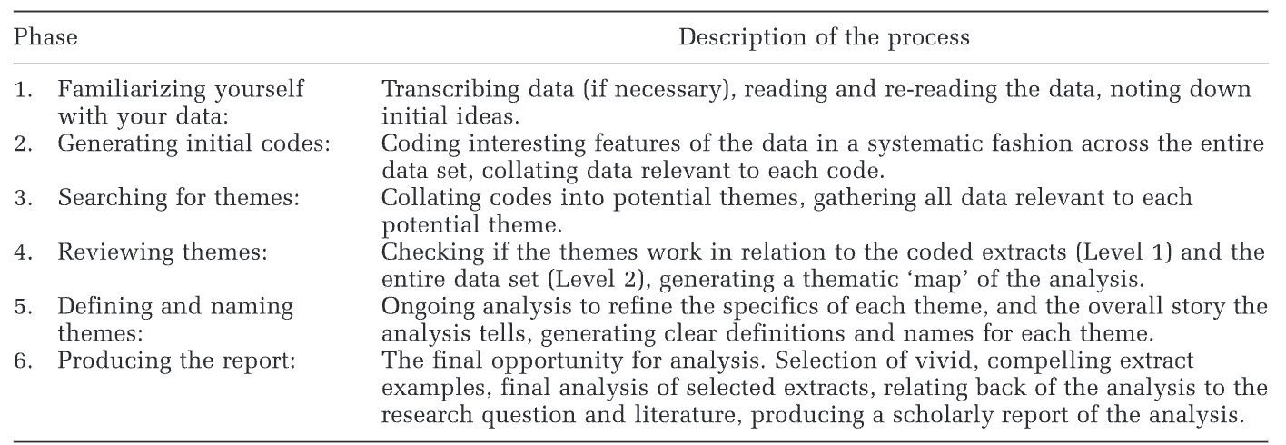

Appendix G Semi-Structured Questions
Below is the order in which questions were asked. This sheet served as a guide to help the research stay on track with timing and content during the interviewing.
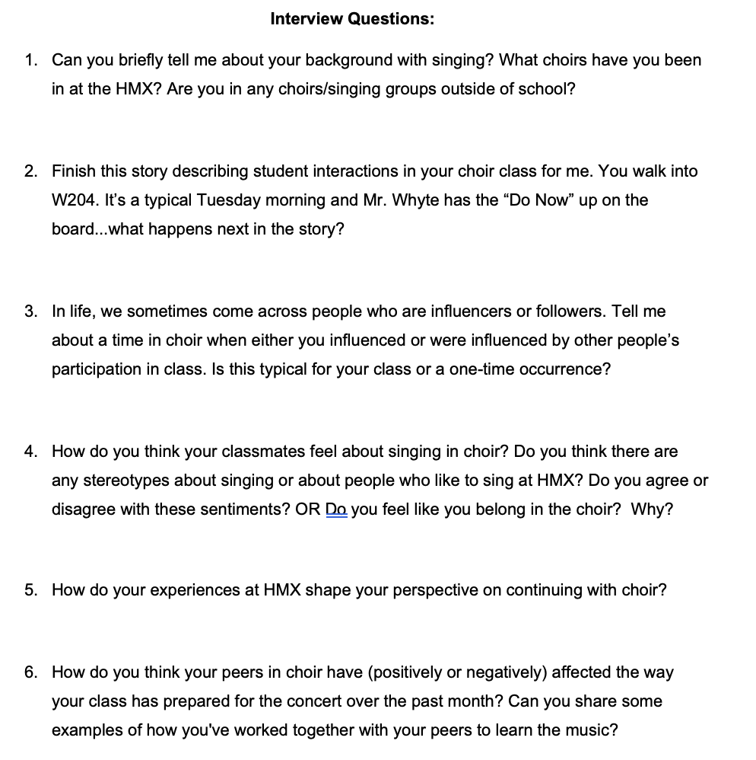

Appendix G: Semi-Structured Interview Questions (Cont.)
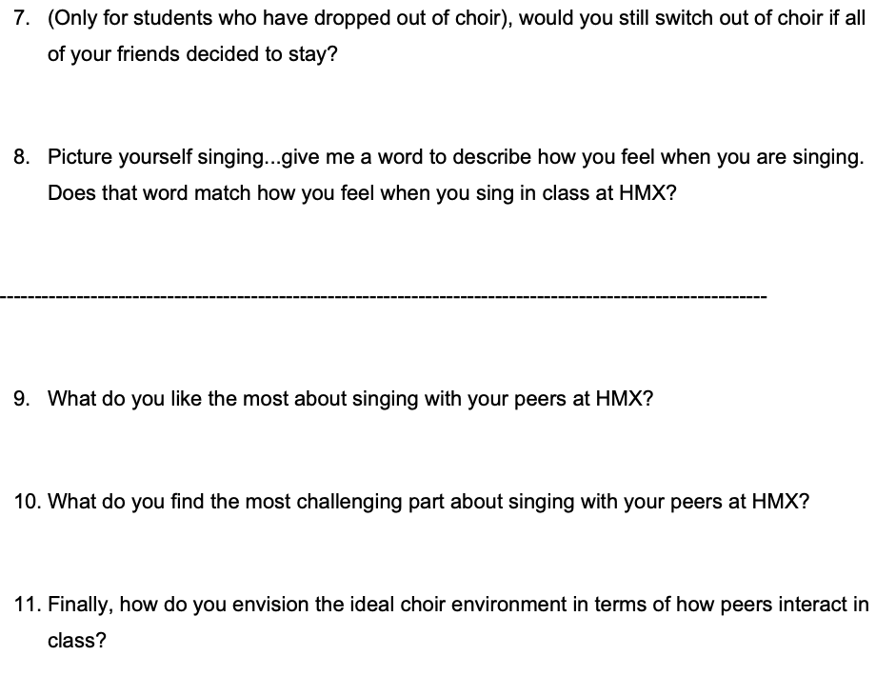

Appendix H: Focus Group Questions
Focus Group Structure
Preparation
Setting the Scene: Arrange the seating in a circle to foster open dialogue and eye contact.
Introduction (3 minutes): Briefly remind the students of the purpose of the focus group. Emphasize the importance of respecting each other’s opinions and assure them that there are no right or wrong answers.
Icebreaker (2 minutes): “If you could master any skill, what would it be?”
Focus Group Questions
Exploring Peer Influence and Participation in Singing (10 minutes)
Different Types of Students in Choir:
- Question: "We've noticed that there are different types of students in choir: those who try and sing out, those who follow the majority, and those who are opposed to singing. How do you think these different types of students affect the overall atmosphere in choir?"
- Follow-Up: "Can you give examples of how these different attitudes have influenced your own singing or the class dynamic?"
Comfort Levels with Singing:
- Question: "Some of you mentioned that singing itself is enjoyable, but singing in front of others can be challenging. Can you talk more about why singing in front of your peers feels different?"
- Follow-Up: "What could be done to make singing in front of others feel more comfortable for everyone?"
Exploring Peer Influence and Valuation of Choir (10 minutes)
Feelings About Singing in Choir:
- Question: "When you described singing individually, you used words like 'free,' 'liberating,' and 'happy.' How do these feelings change when you sing in choir at school?"
- Follow-Up: "Why do you think there's a difference in how you feel about singing alone versus singing in choir?"
Peer Influence on Choir Participation:

- Question: "How do your peers’ attitudes toward choir affect your decision to stay in choir or participate actively? Do you feel more encouraged or discouraged by them?"
- Follow-Up: "Have you ever felt pressured by your peers to either participate more or less in choir? Can you share a specific instance?"
Closing (3 minutes)
Summary and Reflection:
- Question: "Based on everything we've talked about today, what do you think is the most important factor that influences how you and your peers feel about choir?"
- Follow-Up: "Is there anything else anyone would like to add before we finish?"

Additional Focus Group Questions
Impact of Peer Dynamics on Performance:
- Question: "Think about the upcoming concert. How do you think the different attitudes of your peers (those who sing out, those who follow, and those who don't care) will impact the performance?"
- Follow-Up: "What could we do to get everyone more engaged and enthusiastic about the performance?"
Creating a Supportive Environment:
- Question: "What are some ways we can create a more supportive environment in choir that makes everyone feel comfortable singing out?"
- Follow-Up: "Do you think having small group performances or other activities could help with this?"

Appendix I: Student A Interview Transcription, Audio File and Initial Codes
Audio file
Student A
Transcript
Interviewer: So like give me the inside scoop from- pretend like I don't know what [SCHOOL] is. I don't know what [SCHOOL]s choir is, and I want you to give me as much detail as you can so that I can understand from your point of view how you feel about things. OK?
Student A: Yeah.
Interviewer: OK, great. Awesome. So let's get started. So...can you briefly tell me about your background with singing and what choirs have you been in at the [SCHOOL]? Are you in any other singing groups outside the school?
Student A: Sure. Um I've always been really interested in singing ever since I was like little. I used to like listen to a lot of Disney songs and I know it sounds kind of cliche, but like I really do love singing. And when I came to [SCHOOL], um, I was put into choir and I really liked it. Like we sang a lot of songs and it was very interesting. We also learned how to do harmonies and I really found that interesting because it sounded beautiful. And then I realized that I really liked music. So then my parents signed me up for like another, um... music class outside of school, but like in their language, so we speak Hindi at home. So we, um, I do Hindi singing classes and they've been going for like 3 years now.
Interviewer: Wow, I didn't know that. That's really neat. Very cool.
Student A: [overlaps] Thank you.
Interviewer: Yeah, getting involved. That's amazing. OK, so now that I have an understanding of your background a little bit, I want you to finish this story for me. OK? I'm making up the story- [overlaps] made-up story.
Student A: [overlaps] Alright.
Interviewer: Let's set the scene you walk into [CLASSROOM]. Right? It's a typical Tuesday morning. [TEACHER] has the ‘do now’ on the board, OK?...What happens next? What are you doing? What are your peers doing? What happens?
Student A: Alright. So as soon as you walk into the choir room, you sh- you should, um... You should usually go get your binder, cause [TEACHER] always insists you must have your binder on you. We do a lot of um, spell-, uh, not spelling, we do a lot of like fine work with the music. So that's why. And then as you put your stuff down, sit in your seat and you look up at the board and the do now then you do the ‘do-now’. Now, sometimes it's like sight reading or opening up your computer and completing something and then after that he usually um makes a couple of announcements, warms us up and then we go right into like um singing and music practice and we do like, we do pretty good. My choir is quite nice and everyone's really engaged in it. [TEACHER] tells us that we are his best choir class of this year.
Interviewer: Wow, what do you think...So I want to know a little bit more about that. That's awesome. What do you think attributes to that like being the best choir class? What makes that- you said ‘everyone's engaged.’ What does that look like?
Student A: Well, we all sing...mostly. The baritones? I don't know about them. And...no- we usually do all sing and like if some people aren't singing, some of us will like um...raise our voice like louder to like, fill in for those missing people. So we all really like, um want to make sure our music is like as good as possible. And we also do um, a lot of sight reading. We drop our jaw, we um project our voice and we have good diction! Yeah.
Interviewer: That's great. I love that. Thank you. Yeah. Now, you said something in there that I want to circle back to. You said ‘our class,’ right, is maybe ‘the most engaged class or best class.’ So what about the other classes? How? How do you know that you guys are the. Best class what do you-
Student A: [interrupts] Well, [TEACHER], always kinds of tells us that. That we um focus a lot more than the other classes have and it tells us like how far we've gone compared to other classes. And I have some friends in the other classes. They tell me like, ‘oh, we're like singing...this song.’ And I'm like ‘oh, we already covered that.’ They're like. ‘What?’ And then they also say sometimes that ‘[TEACHER] tells us that your period is um the best.’ So yeah, that's kind of how we know.
Interviewer: Well, thanks for sharing. OK. So I want to explain the concept to you...In life sometimes we have or come across people who are influencers or followers. Are you familiar with this?
Student A: Yeah.
Interviewer: Right-
Student A: [overlaps] Yep.
Interviewer: OK. So tell me about a time in choir- again, like you just did- telling me a story when you influenced someone or were influenced by other people's participation in class.
Student A: So this one time we were doing a sight-reading challenge and [TEACHER] chose um...was going to choose three people to like um...sight read because he does it for a grade. So then um two other people stepped up. I was really tired that day, so I didn't know if I wanted to, but they were like really good people and I was like ‘you know what? today I'm going to do, I'm going to be like them and I'm going to actually put some effort in today.’ It was a...Wednesday.
Interviewer: [laughter]
Student A: Then so then I like um stood up and I also did the sight reading challenge and it was really good, yeah.
Interviewer: So is that an instance where you said other people inspired you to do-
Student A: [interrupts] Yeah.
Interviewer: Ah okay, now, that's nice. Thank you. Do you think that you could tell me maybe an opposite time?
Student A: Okay, um...so this one time (4.0) Wait a minute. Sorry-
Interviewer: [interrupts] and it doesn't have to be about you too, it could be about something you observed from...other people in your class.
Student A: Mhm.OH! I remember. So I'm in the Alto section, right? And in soprano section, some of the kids, like, they don't really want...to do...singing. So um there's this really nice girl, in that section, her name is [NAME]. So one day I was just watching the sopranos like usual. And then I see that [TEACHER] tells them to do, like an activity, like form a circle and practice. So [NAME], like, really took charge, and she was like, ‘Okay guys, we're going to practice this, and we're going to make sure this is great’ and surprisingly, all the other sopranos followed her because they actually wanted to put in the effort and get, you know, the song done. And that was really nice. And I was like, wow, [NAME]. It's a great example.
Interviewer: So do you think this is typical for your class or like a one time or two time occurrence you noticed?
Student A: I mean like it's sort of in the middle. Like occasionally we'll all be like, ‘oh, we're so tired.’
Interviewer: [laughter]
Student A: But then sometimes it's one of those days where we're like, we're going to get this done. We're going to make it as beautiful as possible.
Interviewer: Thank you. Okay, so changing gears a little bit, how do you think your classmates feel about singing in choir?
Student A: Hm. So it's like a 50/50 split. So some kids who like really sing out and like are really participating. They really like choir...and some other kids that um DO participate, but not as much...they- they think choir as like not as a great class. Like if I'm being completely honest.
Interviewer: Please do, yes.
Student A: Mhm. And sometimes they'll complain. But like in class they'll be like engaged and they won't complain. It's nice.
Interviewer: Thank you. So following up with that, do you ever hear of any stereotypes about singing or about people who like to sing like in your class? Or maybe outside of class?
Student A: I don't really hear any stereotypes about that. It's usually like um...everyone kind of wants to sing and some- if some people don't then that's fine. But like, there are other people there to sing too.
Interviewer: Do you feel like you fit in the choir?
Student A: Yeah, I feel like I really fit in cause like, I= feel like I support the alto section and I feel like I= really belong to the Altos, you know.
Interviewer: That's lovely [chuckles]. And uh let's see, that's really helpful. I want to skip back to another time where you're talking about other people's opinions and how people feel in class. So can you think about time whe=re your peers opinio=ns on singing or actions, participating or not participating, maybe has impacted your decision to want to continue on with music like in the following year? Like think about when you were 6th grader. Was anything happening in class impacting your decision to want to stay with it or maybe= try something else?
Student A: Honestly, there is sometimes a lot of negativity around choir cause like people don't want to sing at like 8:00 in the morning. So then um, I didn't really let that impact me because I felt like singing was one of my true passions and I really wanted to make that happen, no matter what anyone said about it.
Interviewer: Thank you for sharing. Um, do you think that other people might have a challenge with this? Like you were pretty resilient there, but do you think other people maybe like to sing, but the influence of other people kind of gets in the way or makes them change their mind?
Student A: Perhaps, yeah. I have a couple of friends who like singing but like, their um their friends...maybe not so much. So then I feel like they've slowly, like, um...not liked singing? So yeah...I won't name any names!
Interviewer: [chuckles] Oh that's okay! You don't need to. Thank you. Okay. So do you think your peers in choir have either positively or negatively affected the way your class is prepared for the concert over the month?
Student A: [interrupts] Definitely, positively for the Spring concert, definitely. For the winter?...Not really. We were like, still learning, but like for the spring concert, we have been like on it and we've been practicing. And we're really um far ahead of the other classes, like I said, and we're really doing good, you know?
Interviewer: Nice. So can you share an example of how you work together with your peers in class to learn your music?
Student A: So this one time, [TEACHER] told us to circle up again and start practicing. It was like some choreography for one of our songs. So then we didn't really want to do it. We didn't want to dance in the morning. But like we were like, you know what, let's just get it over with. So then we started, like, trying to come up with dance moves and some of us were demotivated. But then [TEACHER] kind of encouraged us and like we did it, in the end...eventually.
Interviewer: Nice. Okay. So for students who may be switched out a choir, what do you think the main reasons for their decision were to leave?
Student A: Probably they don't like singing or they think they're bad at? But I feel like that's not a reason to leave choir. If you're like- if you like singing or listening to singing, then definitely choir is the option to go. Like you don't necessarily have to be a great singer yourself to enjoy choir, you know? And you can really try. In practice makes....(pause) Improvement (chuckles) so yeah!
Interviewer: I like that (chuckles) thank you, [STUDENT A]. Um, so following up with that, think about from your perspective and where you are, if maybe all your friends, let's - I'm being dramatic here - but let's say all your friends were to decide to move to [MUSIC CLASS] or [MUSIC CLASS] and it's just you and not- some other kids that also like to sing, but maybe they're not your closest friends. Would that kind of impact how you feel about class?
Student A: Most of my friends are already in um orchestra, E-music or band. And yeah, we like to tease each other about it and yeah, it's good like... I really don't care if all of my friends move to another music group. I really like singing and that's not going to change anything for me. And I usually make up new friends pretty quickly, especially if they like singing, so yeah. That's what happened with [CHOIR]. Kind of like I met a lot more people who love to sing, and I made really good friends with them. Yeah.
Interviewer: Hmm, cool. Now I have kind of a- this is kind of a deeper question here. We got to think about this, but if you were to give one word to describe how you feel when you sing...what would that be?
Student A: (3.0) "Liberating."
Interviewer: Liberating.
Student A: Yeah, like I have an urge to sing. So like, it kind of frees, you know, that urge and like I don't know, I really like singing.
Interviewer: Do you think if you were to come up with a word to describe how you feel singing in...choir- what period do you have? [CLASS PERIOD]?
Student A: [CLASS PERIOD].
Interviewer: What word would you use to describe how you feel singing [CLASS PERIOD]?
Student A: Hm. Like it really depends. Sometimes I'll be ready to sing because like, I had [CHOIR] that morning. But then other times I want to go back to bed.
Interviewer: [chuckles]
Student A: So then. But usually I really like- I really want to sing. So I guess um choir [CLASS PERIOD] would be... Hm. I don't really have a word to describe it now.
Interviewer: That’s okay-
Student A: [interrupts] It's...Enjoyable.
Interviewer: Okay good. That’s a great word. Thank you. Okay, so we're kind of going to wrap things up here a little bit so okay...if you could envision the ideal choir program at [SCHOOL] in terms of peer-interactions and support, what would you change or what do you picture?
Student A: Hm. I guess.... Like the choir program here is already very good, but like there is some negativity about choir...so that I feel like maybe there should be like more...um activities to like um introduce people to choir like maybe like a one day thing and this could be- this could be with any of the other like music groups like we could like um switch things up for a day, especially with the 6th graders, because, like, you know, they don't know which one to really choose. So we could- at the end of the year we could give them like one day to see what it's like to be in choir, one day to see um what it's like to be an orchestra, and like, that'll really integrate them into, you know, the community. And it's great. Yeah. Maybe some more advertising too, for like the other music groups like [CHOIR] and um [CHOIR]. I know there are a lot of posters around, but maybe if like there was a um QR code and a video to see like what really is [CHOIR] that would be great.
Interviewer: Thank you. Those are good ideas.
Student A: Thank you.
Interviewer: OK, last couple of questions and then we're done here. So what do you like the most about singing with people at [SCHOOL]?
Student A: I really like how we work together and we um all collaborate to make a beautiful piece like, especially with harmonies like it's beautiful, you know, like, um making one part right and then combining it with the other music parts, it's great.
Interviewer: What do people have to do to make those harmonies?
Student A: So they first have to know the notes and then we do a lot of sight reading for that. And then they also have to get the rhythm, right. So [TEACHER] goes through that a lot and then finally they have to combine that with the words. And then you have a ‘part’ [gestures].
Interviewer: [chuckles] I like the hand gesture. Very good. I'll make sure I put that in the interview. Ah okay. Last question, what do you find the most challenging part about singing with your peers at [SCHOOL]?
Student A: The most challenging part? Sometimes people don't want to participate in. I'm like, ‘why are you here if you don't want to participate?’ Like I get it if it's, you know, a one time thing or like, sometimes you're tired. But like if you don't want to participate every day what are you doing here? So I really think that people should make um good choices when it comes to choosing their music group like if you don't want to put in the effort, then why are you here?
Interviewer: That's a good point. And what do you think is that- would you say the same for other people in your class? Do you think they would find that or agree with you with what they think is the most challenging part of being in [SCHOOL] choir?
Student A: Uh, yeah, probably. And some people also find it challenging to, like, have proper diction and open their mouth. And you know. sing 'do re mi fa sol’ etcetera, etcetera. And yeah, I get that. But if you put in enough effort, then you'll eventually get it.
Interviewer: Awesome. Well, thank you, [STUDENT A]. I think I got all my questions for you. So I'm all good. Do you have any questions for me?
Student A
Well, like, what are you doing? I'm just asking what was like the purpose of this interview.
Interviewer
Mm-hmm. Absolutely. So I'm interviewing you, and there are six other students. Some. Who are in 7th grade? Some in 8th grade. Some in choir, some who used to be in choir and I'm just trying to gather perspectives. So from your point of view, what do you think um when I say the topic and peer influence or peer pressure in the choir for middle school? I want to see if there is a. Any effect or correlation between these two? Um And because I think about at the high school, right, do these?
Student A
Yes.
Interviewer
experiences you have inform how you want to continue or does it um change the way you feel about singing right? And some students you know might have different perspectives depending on how they feel and every day. So I'm just trying to kind of figure out what you think and what other people think. And then maybe together we can figure out.
Student A
Yeah.
Interviewer
How to move forward or make improvements if if needed right? So it's kind of you're you're doing a really cool thing, you're part of a really new new.
Speaker
Thank you. Nice.
Interviewer
And hopefully you know, it'll help make a positive change in our program because I love to sing, right. And I love the program and I and I want you guys to have a positive experience. So just trying to help do that, right. Cool. OK, so I'll stop my interview.

CODES:
"I've always been really interested in singing ever since I was like little." | Interest in Singing | Semantic
I was put into choir | getting put into choir
"My parents signed me up for like another, um... music class outside of school, but like in their language, so we speak Hindi at home. So we, um, I do Hindi singing classes and they've been going for like 3 years now." | External Musical Activities  Familial Support for singing | Semantic
"My choir is quite nice and everyone's really engaged in it. [TEACHER] tells us that we are his best choir class of this year." | Class Engagement | Semantic
"We usually do all sing and like if some people aren't singing, some of us will like um...raise our voice like louder to like, fill in for those missing people." | Peer Influence on Participation | Latent
"Well, [TEACHER], always kinds of tells us that. That we um focus a lot more than the other classes have and it tells us like how far we've gone compared to other classes." | Teacher Influence | Latent
"So this one time we were doing a sight-reading challenge and [TEACHER] chose um...was going to choose three people to like um...sight read because he does it for a grade. So then um two other people stepped up. I was really tired that day, so I didn't know if I wanted to, but they were like really good people and I was like ‘you know what? today I'm going to do, I'm going to be like them and I'm going to actually put some effort in today.'" | Motivation from Peers | Latent
"So [NAME], like, really took charge, and she was like, ‘Okay guys, we're going to practice this, and we're going to make sure this is great’ and surprisingly, all the other sopranos followed her because they actually wanted to put in the effort and get, you know, the song done." | Positive Peer Leadership | Latent
"So it's like a 50/50 split. So some kids who like really sing out and like are really participating. They really like choir...and some other kids that um DO participate, but not as much...they- they think choir as like not as a great class." | Peer Engagement Variation | Latent
"Honestly, there is sometimes a lot of negativity around choir cause like people don't want to sing at like 8:00 in the morning." | Negativity in Choir | Latent
"Perhaps, yeah. I have a couple of friends who like singing but like, their um their friends...maybe not so much. So then I feel like they've slowly, like, um...not liked singing?" | Impact of Peers on Commitment | Latent
"Definitely, positively for the Spring concert, definitely. For the winter?...Not really. We were like, still learning, but like for the spring concert, we have been like on it and we've been practicing." | Positive Influence on Concert Prep | Latent
"So this one time, [TEACHER] told us to circle up again and start practicing. It was like some choreography for one of our songs. So then we didn't really want to do it. We didn't want to dance in the morning. But like we were like, you know what, let's just get it over with. So then we started, like, trying to come up with dance moves and some of us were demotivated. But then [TEACHER] kind of encouraged us and like we did it, in the end...eventually." | Collaborative Learning | Latent
"Most of my friends are already in um orchestra, E-music or band. And yeah, we like to tease each other about it and yeah, it's good like... I really don't care if all of my friends move to another music group. I really like singing and that's not going to change anything for me." | Friends in Other Music Classes | Latent
"I usually make up new friends pretty quickly, especially if they like singing, so yeah. That's what happened with [CHOIR]. Kind of like I met a lot more people who love to sing, and I made really good friends with them." | Making New Friends in Choir | Latent
"I felt like singing was one of my true passions and I really wanted to make that happen, no matter what anyone said about it." | Individual Passion for Singing | Latent
"I really like how we work together and we um all collaborate to make a beautiful piece like, especially with harmonies like it's beautiful, you know, like, um making one part right and then combining it with the other music parts, it's great." | Peer Support and Collaboration | Latent
"The most challenging part? Sometimes people don't want to participate in. I'm like, ‘why are you here if you don't want to participate?’" | Challenges with Peer Participation | Latent
"Sometimes people don't want to participate and I'm like, ‘why are you here if you don't want to participate?’ Like I get it if it's, you know, a one time thing or like, sometimes you're tired. But like if you don't want to participate every day what are you doing here?" | Peer Influence on Enjoyment | Latent

Appendix J: Student B Interview Transcription, Audio File and Initial Codes
Audio file
Student B
Transcript
Interviewer: OK, awesome. So, [STUDENT B], thank you so much. Uh, I have a couple of questions for you. But before we begin, I just want to hear from you- can you briefly tell me a little bit about your background singing, um whether that be at [SCHOOL] or singing in general?
Student B: I've - 've been singing in like early ensembles like [SCHOOL] singers and [CHOIR]. And...and um...and singing has been really...fun for me and like- embracing and coming together and singing.
Interviewer: Lovely. Thank you so much.
Student B: [nervous laughter]
Interviewer: So um I'm going to have you finish my story. I'm going to start off a sentence and I want you to kind of finish the story and tell me in great detail. OK?
Student B: Mhm.
Interviewer: Imagine, like, I've never heard of [SCHOOL] choir before and I want you to give me such a vivid detail that it's almost like I'm there in your choir with you. OK so...imagine it's a Tuesday morning- regular day at [SCHOOL] and you walk down the hallway to [ROOM]. You walk in, you see the ‘do now’ is on the board. How do you and your peers finish the rest of class? What happens? Tell me, in detail.
Student B: We- we try to do it and when I don't figure it out so like I ask my neighbor if we need help and they just help me...and yeah.
Interviewer: Okay. What about beyond the ‘do now’ what? What happens usually next? How do kids interact? You said if you don't know someone helps you-but what else? What else goes on?
Student B: [overlaps] Kids-
Interviewer: [overlaps] but what else? What else goes on?
Student B: Kids sometimes like talk while we're doing the ‘do now’ then [TEACHER] is like "come on, do it now!" and I'm like "okay!" And then yeah, and then we start singing...that's it. Mhm.
Interviewer: Mhm. What else? Like if you had to tell me about your warm ups, like when you're singing or starting to sing, tell me about. What you're doing compared to what other kids are doing?
Student B: Hm. I'm just following [TEACHER] and other kids don't really. And like I have to get them to like...get up and like...do what [TEACHER] is doing because I'm like the leader.
Interviewer: [overlaps] Oh, you- you do? Oh, you're the leader. Tell me- tell me more about that.
Student B: Because I (2.0) because I like um...like I listen to [TEACHER] whenever he says "come on, up" [gestures hands to stand up] And then I go up and everyone's like sitting down and he has to say, repeat it “again, UP” like that, I'm like [shrugs] “okay.” Yeah.
Interviewer: Can it be: difficult for you if you feel like you said you're the leader? Are there other leaders in your class, or do you kind of feel like It's just you?
Student B: Hm. ° some ° There's some...leaders.
Interviewer: Yeah...yeah. What do you think makes it difficult for people to follow the instructions or want to sing?
Student B: Probably because it's just too hard for them and like they just have to learn...that...there's some hard things that you have to do so you just have to deal with it.
Interviewer: Mm...mhm. Do you think if you were to describe those kids who maybe don't participate, uh how would you describe them like their personality or how much they try?
Student B: They're like- they're just like...lazy and like they don't really like to sing as much as I do?
Interviewer: And...do you think that...-think about, like you said, they don't like to sing as much as you, but do you think that's more so in choir class or just you think they just don't like to sing?
Student B: I can see it in their facial expressions. I-I can see it in their facial expressions to like just like them, like...[makes disinterested face] like that. And then like probably that- probably that makes them like not want to sing anymore. But I have a happy attitude.
Interviewer: [laughs] Do you think you're happy attitude inspires other kids to be happy as well?
Student B: Mhm! Yep!
Interviewer: That's good. And what do you think- the opposite? Do you think that other kids- like you have an impact with happy attitudes? Do you think there are other kids that have an impact with their...- you said ‘lazy’ or 'not wanting to try attitude?’
Student B: ° I don’t know ° like some, I think?
Interviewer: Okay, some. Okay. But a mix you'd say?
Student B: Yeah.
Interviewer: OK, cool. Thank you. So let's keep talking about that. Um there are sometimes in life, there are people who are [influencers] and there are some people who are [followers, right?] Would you agree with that?
Student B: [mhm]. [mhm]. Yes.
Interviewer: How do you see that happening in choir? Can you tell me about a time where you noticed? People were influencers or people were clearly followers.
Student B: Like some people, actually try their best and they show their best effort.
Interviewer: Mhm.
Student B: And yeah.
Interviewer: Yeah. And can you tell me about a time like can you think of an activity, something like- I know [TEACHER] sometimes has you guys go up to the board, right and do sight singing? [Yeah.]
Student B: [Oh yeah.] That's sad. I don't like it. [laughs]
Interviewer: Tell- but tell me about uh...how people- like you said you have a good attitude, you can influence people...Or do you see the opposite happening? Do you see people who maybe say, 'oo, I don't want to do this’ and other people say, ‘yeah, I don't want to do that either’ and it kind of has a trickle effect.
Student B: Yeah, that happens in my chorus class because like um like...some...-some people don't really like sight reading. That's like, me too. I don't really like it, but I have to do it and... [bell rings] Yep [laughter].
Interviewer: And Yep [laughter]. Okay, thank you, [STUDENT B]. So I'm going to ask you a new [question now]. OK. So how do you think your classmates feel about singing and choir at [SCHOOL]? How do you think not just people in your class but students and [SCHOOL], how do they feel about [singing?]
Student: B [Okay]. [Like everyone?]
Interviewer: Everyone. What do you think the general student feels like?
Student B: Some students have positive energy and some students have negative...So I don't really know (2.0) about it?
Interviewer: That's OK. So let's just think from your perspective, right? So when you think about students who's saying do you think of anything that comes to your mind? Like, are there any stereotypes about kids who sing in choir? Have you ever heard anyone say like ‘oh, those kids are like all like this.’ Or do you have any that you think of or?
Student B: I don't...really know...how to answer that.
Interviewer: That's Okay. Do you want me to restate the [question or?] OK, so do you think that you feel that kids who are either in choir in your class or outside of class, do you think that they think, ‘oh, choir kids are like,’ [fill in the blank] or ‘choir kids always do’ this? Or is there a type of attitude about kids who sing in choir?
Student B: [Yeah] [laughs] I think choir is like...Choir can be hard because like you have to like...you have to sight read and like, read the notes and then like sing it- like aloud with like [TEACHER] and then it becomes hard because when he says ‘come together’, it's like we all mess it up and like-
Interviewer: Hm.
Student B: And they don't like doing the same things over and over again because it's annoying and it takes up time.
Interviewer: Do you think anyone has a positive view of choir?
Student B: Yes.
Interviewer: And who are those kids?
Student B: Me and [STUDENT] and [STUDENT], they're like, very good at singing. Plus, we're going to do the solo togeth- together like, yeah, so. Yeah.
Interviewer: Hm. Good for you. Can it be hard...being in the leader group or do you not really care too much what other people think?
Student B: I don't really care as much? I just want to be the best student that I can be.
Interviewer: That's great. Do you think other kids...feel a little self-conscious about singing and choir?
Student B: Hm...I think so?
Interviewer: You think so? [Yeah]. I have another question for you, okay? So can you tell me about...how your experience has been- So you've been in choir you said last year and this year, right? Has your experience made you want to continue singing next year and at the high school?
Student B: [Yeah.] Um...Yes, I -yes, because I really want to do ensembles and like regular choir, because it's just fun singing together as a group.
Interviewer: Mhm. And do you think that there is...any impact of what kids do in class? It’s like- cause you said you care and you've got friends who care, but for the kids who maybe don't put as much effort as you, does that change your experience? Does that ever make the class less fun?
Student B: Hm. No? I - I don't think so, because they're just trying what they can be and I'm not pressuring them like, ‘hey guys, copy me.' I don't want to do that. I'm just being cool and like singing.
Interviewer: You're doing your own thing, not worried about what other people think.
Student B: Yeah.
Interviewer: Good for you, Anya.
Student B: Thank you.
Interviewer: Now I have another question for you. So imagine you said you have a lot of friends in [choir, right?] Would it be hard for you to stay in choir if you felt like all your friends did [MUSIC CLASS]? (3.0) What do you think? (3.0) What do you think, [STUDENT B]?
Student B: [Mhm] Um...(3.0) Wait I'm sorry could you repeat that?
Interviewer: I could- yeah, sure. The question was, if- I said you have a lot of friends in choir, you think right? Would it be hard for you, you think to stay in choir if all your friends did [MUSIC CLASS] or [MUSIC CLASS]?
Student B: Um. I would just like...deal with...singing because singing is like...just fun and like singing, and like dancing through the words or something...singing it out. Yeah.
Interviewer: Yeah. So regardless, if your friends were in or not, wouldn't- [wouldn't change things for you]. Okay, cool. Now, [STUDENT B], I want you to tell me if you're picturing yourself singing right now. Okay? I want you to give me a word to describe how you feel when you are singing?
Student B: [Yeah]. Mm...(3.0) [Beautiful]...wonderful and like I feel calm- like when I have a solo.
Interviewer: [° Beautiful °] Hm. Nice. Do you feel that same way when you're singing at home versus when you feel like singing at [SCHOOL]?
Student B: [Yes. Yeah.]
Interviewer: [you feel the same?] I love it. Thank you so much. Okay, now the last two questions for you, actually 3 questions. But you can handle it [laughter]
Student B: Aw okay [laughter]
Interviewer: What do you like singing the most with other people at [SCHOOL]?
Student B: Singing the most?
Interviewer: What do you like the most about singing with other kids at [SCHOOL]?
Student B: It’s- Is that we like- singing together and like and like not one person is alone. It's like a group and like a team working together. And that's what I like.
Interviewer: And what do you find- like on the opposite...what do you find most challenging about singing with other kids here?
Student B: It's...probably like hitting the notes, because that's like a struggle for me.
Interviewer: And what about- so that's for you personally [ clears throat] - what do you feel is challenging the most singing with other kids?
Student B: Uh...Probably like coming in harmony together...because like the baritones are so low and like I can't hear them...I can't hear my- my own voice. So it's like [sings unsure 'oo’].
Interviewer: [Laughter] So sometimes when they're singing something different from you- it could be hard to focus. Now my last question for you, okay?
Student B: Mhm?
Interviewer: If you had the picture, the ideal choir environment like the ideal environment, how would you describe how kids interact and treat each other? How do they behave in class? Like, what's the ideal choir class for behavior- kids' behavior?
Student B: Um...It's like a little quiet? But some kids are like, loud. And like (2.0) hm...(3.0) And like they are, like, focused on the ‘do now’ and they're like doing the do now without being asked so many times. So yeah.
Interviewer: So how- What would you change? To make it better. So what- what do you wish other kids would do?
Student B: I wish that other kids can like actually, like listen to [TEACHER] when it's the first time, not like repeating himself. It's really annoying, yeah.
Interviewer: And (2.0) talk about- you- you said earlier- I'm circling back to this. You said how you kind of are a leader, right? And- and you kind of do your thing no matter what.
Student B: Yeah?
Interviewer: Do you think that that's how all kids should be in class?
Student B: Mm (3.0)...Mm? (3.0)...I think- I think they should give it a try first before they actually like- before they like give up like ‘oh man, I can't do that’ and I'm like ‘come on guys. Yeah, you can do that.’
Interviewer: Why do you think kids don't try?
Student B: Because some kids, like, there's this girl. Her name is [STUDENT]. She's my best friend and she doesn't really sing as much as me. So I'm just trying to get her like ‘[STUDENT] come on let’s just sing together.’
Interviewer: Like, what does she tell you? Wh- What did she say? ‘[STUDENT B]. No, I can't?’ Why? Wh- What makes it hard for her to try? What do you think?
Student B: Because probably like she doesn't like the posture and like the stands. And like the...Yeah, that's really hard for her...to stand and stand up and then. And she's like, ‘no I'm like this’ [gestures to sitting slouched].
Interviewer: Hm...so does [STUDENT] feel like maybe nervous about what other people think? [You think so?]
Student B: [I think so]...yeah.
Interviewer: And so maybe she doesn't want to stand out?
Student B: Mhm.
Interviewer: Ah okay. Do you see that like for other kids, not just [STUDENT]?
Student B: Um...
Interviewer: Do you think that's why they don't try or?
Student B: Yeah, some kids just sit down. Instead of standing up when- when everybody's standing up they just sit down. It's like weird.
Interviewer: Huh. Yeah. Do you have any idea what that's all about? Because you said they don't want to, but maybe...maybe they just need to try it like you said, but if something's getting in the way? Huh. What other ideas do you have? What else do you think?
Student B: Hm...Because [TEACHER] tells [STUDENT] to like, actually, like, ‘get up’. I'm like, and she's like, ‘ugh, fine. I don't want to do it.’ She's like, making like-
Interviewer: Hm...
Student B: -A scene in front of the whole class.
Interviewer: Hmm. But she's getting attention for it, right?
Student B: Yeah.
Interviewer: Do you think she wants attention for it?
Student B: I don’t know.
Interviewer: Do you think other kids like the attention? Or do they not want to be noticed?
Student B: Looks like they don't want to be noticed.
Interviewer: Interesting. Well, thank you for sharing your thoughts. I really appreciate your time. This is really helpful and I will see you next week, right?
Student B: Yeah. Of course. Oh yeah, the focus group.
----
Interviewer
Yeah, in the morning. And what do you have any dietary restrictions to eat? Bagels. Doughnuts.
Student B
UM.
Interviewer
Apple juice.
Student B
Well, I used to be allergic to milk, but I'm well, I yeah.
Interviewer
OK, now OK, cool. So I'll see. You next week, OK.

CODES:
Quote | Code | Type
"And singing has been really...fun for me and like- embracing and coming together and singing." | Enjoyment and communal aspect of singing | Semantic
"We try to do it and when I don't figure it out so like I ask my neighbor if we need help and they just help me...and yeah." | Peer support in learning | Semantic
"Kids sometimes like talk while we're doing the ‘do now’ then [TEACHER] is like 'come on, do it now!'" | Disruptive behavior among peers | Semantic
"I'm just following [TEACHER] and other kids don't really. And like I have to get them to like...get up and like...do what [TEACHER] is doing because I'm like the leader." | Leading by example and motivating peers | Latent
"Because I...listen to [TEACHER] whenever he says 'come on, up'...I'm like ‘okay.’ Yeah." | Compliance with teacher instructions | Latent
"Probably because it's just too hard for them and like they just have to learn...that...there's some hard things that you have to do so you just have to deal with it." | Perception of task difficulty among peers | Latent
"They're like- they're just like...lazy and like they don't really like to sing as much as I do?" | Perception of peers' lack of effort | Semantic
"I can see it in their facial expressions to like just like them, like...[makes disinterested face] like that. And then like probably that- probably that makes them like not want to sing anymore. But I have a happy attitude." | Influence of facial expressions and attitudes on participation | Latent
"Do you think you're happy attitude inspires other kids to be happy as well? Mhm! Yep!" | Positive peer influence through attitude | Semantic
"Yeah, that happens in my chorus class because like um like...some...-some people don't really like sight reading. That's like, me too. I don't really like it, but I have to do it and... [bell rings]" | Peer influence in expressing dislike for activities | Latent
"Some students have positive energy and some students have negative...So I don't really know (2.0) about it?" | Mixed attitudes towards choir among peers | Semantic
"I think choir is like...Choir can be hard because like you have to like...you have to sight read and like, read the notes and then like sing it- like aloud with like [TEACHER] and then it becomes hard because when he says ‘come together’, it's like we all mess it up and like-" | Challenges in group cohesion | Latent
"Me and [STUDENT] and [STUDENT], they're like, very good at singing. Plus, we're going to do the solo togeth- together like, yeah, so. Yeah." | Positive peer relationships and collaboration | Semantic
"I just want to be the best student that I can be." | Personal motivation regardless of peers | Semantic
"I think so? Yeah. You think so? [Yeah]." | Awareness of peer self-consciousness | Latent
"Yes, because I really want to do ensembles and like regular choir, because it's just fun singing together as a group." | Enjoyment of group singing | Semantic
"They're just trying what they can be and I'm not pressuring them like, 'hey guys, copy me.' I don't want to do that. I'm just being cool and like singing." | Non-pressure approach to peer influence | Latent
"It's- Is that we like- singing together and like and like not one person is alone. It's like a group and like a team working together. And that's what I like." | Valuation of teamwork in choir | Semantic
"It's...probably like hitting the notes, because that's like a struggle for me." | Personal challenges in singing | Semantic
"Probably like coming in harmony together...because like the baritones are so low and like I can't hear them...I can't hear my- my own voice." | Difficulty in achieving group harmony | Latent
"I wish that other kids can like actually, like listen to [TEACHER] when it's the first time, not like repeating himself. It's really annoying, yeah." | Frustration with peers not listening to the teacher | Latent
"I think they should give it a try first before they actually like- before they like give up like 'oh man, I can't do that' and I'm like 'come on guys. Yeah, you can do that.'" | Encouragement for peers to try | Latent
"Because some kids, like, there's this girl. Her name is [STUDENT]. She's my best friend and she doesn't really sing as much as me. So I'm just trying to get her like '[STUDENT] come on let’s just sing together.'" | Influence on best friend's participation | Semantic
"Because [TEACHER] tells [STUDENT] to like, actually, like, 'get up'. I'm like, and she's like, 'ugh, fine. I don't want to do it.' She's like, making like- A scene in front of the whole class." | Peer resistance and attention-seeking behavior | Latent

Appendix K: Student C Interview Transcription, Audio File and Initial Codes
Audio file
Student C
Transcript
Interviewer: Shall we have a conversation?
Student C: Yeah!
Interviewer: OK. So [STUDENT C], can you briefly tell me about your singing background? So whether that be at [SCHOOL] or we're outside of [SCHOOL]? Tell me about your singing experience.
Student C: It's pretty much at [SCHOOL]. I remember when I was like...in I think maybe second grade or third grade? Probably 3rd grade or 4th grade because...I remember it was like around the pandemic...and I remember that I would like write songs and one time in 6th grade I wrote one and I had to sing it in class and I was so nervous, but I still got it over with.
Interviewer: Wow. And what do you think about do you still feel that way sometimes? When you perform?
Student C: Yeah. And I'm auditioning for the solo in [SONG], so...I'm definitely gonna be nervous then, but I'm still gonna have to sing because I know I'm going to have family there because my I know my mom will be there. My dad will probably be there. My grandma, my cousins are always at all my plays and concerts and stuff so I know they're always going to be there.
Interviewer: You sound pretty brave. That's awesome. Good for you.
Student C: [Laughs] Thank you.
Interviewer: Sounds like you love to sing, too. [Yeah, that's great.]
Student C: [Thank you I do, it's fun]
Interviewer: I love that. So, [STUDENT C], tell me a little bit- I'm going to...-we're going to do this little exercise where I'm going to start a sentence and then I want you to finish-
Student C: [Gasps] We get to finish each other's sentences? Ya!
Interviewer: [Laughter] -exactly! So I'm going to tell you a story. And I want you to finish the story. It could be a real story. It could be a made-up story based on what you think about, but it's all about kids and how they act in your choir instead-
Student C: [interrupts] Should I say the first thing that pops into my head?
Interviewer: Whatever you think of- whatever you think of when I talk about the [SCHOOL] choir, okay? So let me start it and you take over. Be as detailed as you can. Okay so I go first, so. It's a typical Tuesday morning. You walk down the hallway into [CLASSROOM], you see- oh, [TEACHER] has the ‘do now’ on the board and it's time for you and the other kids to sing. What happens next?
Student C: Some kids sing, other kids just sit there and do absolutely nothing. Just stare into space, pick their noses, talk with each other, but not doing the ‘do-now.’ Just...staring at nothing, laughing.... Existing. Taking up all the oxygen in the room [holding in laugher].
Interviewer: And- and what do you do?
Student C: Usually I do the ‘do now’, sometimes I don't, but that's only because I don't know how to do it...like I have trouble seeing what pitches are just from um looking at the notes because I don't know how to read notes even though school is almost over...but I do have some of my friends help me out because they know how to read it. I don't understand how to do it though.
Interviewer: Well that's okay. [spoken as if aside] ° You could ask [TEACHER]. ° [laughter] But you said you had friends in class that help you. Do these- do these friends sit next to you or by you?
Student C: Yeah. One of them is a soprano and I'm an Alto. So we're like, across the room. So we only usually only to do that when, like [TEACHER] is out. But I have one of them who knows how to read it. And she sits right next to me.
Interviewer: Okay That's good. Now tell me about the other kids. You said they just sit there. They're not paying attention or whatever-
Student C: [interrupts] Some kids just sit there and do absolutely nothing, and then other kids just stare into space and then some kids are like talking to each other and whispering and laughing and eating SNACKS.
Interviewer: What do you think that's about? Why do they do that?
Student C: I don't know, [TEACHER] says that one of the one of them, who's probably the most [spins in chair to gesture to the choir risers] destructive kid in the entire class, loves chorus, but I don't really see that (anymore).
Interviewer: Hm. Interesting-
Student C: Because when he sings, like I barely hear him...Like if he did a solo, you'd need like THREE MICROPHONES [laughing while speaking].
Interviewer: Well, tell me more. What do you notice about this kid? What else does the student do in class?
Student C: Like he's always trying to go to his friends in the baritone section, even though he's an Alto, like he's always distracted. He's- he gets in trouble sometimes for, like, not doing what he's supposed to and he doesn't really do the ‘do now’s.’ He just stares at the board and does nothing.
Interviewer: Do you think he: tries to follow what other people do or does he often lead and distract other kids to doing what he does?
Student C: He doesn't really distract people, he like keeps to himself. But he always just seems distracted.
Interviewer: Hm. Interesting. Now tell me about the other kids. So you said that was one kid who just does his own thing. Tell me about, like, the rest of choir class. When [TEACHER] asks you to sing, okay...[what happens]
Student C: [There’s] always like- when we're sitting down, there's always like these three girls in the back [points] over there who are always like just talking and sometimes snacking like the WHOLE ROW, like they’re all friends. Wh- and then they're always singing the soprano pitch so I always mess up because when [TEACHER] doesn't say it, I hear them singing soprano pitch and I get, like, all mixed up.
Interviewer: Are they Altos?
Student C: Yeah. And I know the song -the pitches - for [SONG], but they keep singing the soprano pitch and I don't want to be the only one singing the alto pitch while they sing the soprano pitch because I'm gonna seem weird.
Interviewer: Huh. If you're doing the only thing, even if it's the right thing?
Student C: ° Yeah °
Interviewer: You feel like you stick out in a bad way, huh? Do you think-
Student C: [interrupts] ‘cause there's these- there's this girl who's in my class...who - my friend - who talks about like kids behind her back. Like this one girl was doing the solo, and she was, like, kind of silent with it- and then she was, like, laughing. And then this is one girl who was, like, trying to say, like, what pitch to do? And- and I remember she had made fun of her and she started crying...but I wasn't there that day. But my friends told me that happened. And then my friend said that she's always talking about me and her behind our backs.
Interviewer: Hm and she's in your same section?
Student C: Yeah, we- she sits like right behind me. We’ve told [TEACHER] about it, though, but I don't know if he's talked to her about it yet.
Interviewer: Do you think that this is a problem that is unique to choir or do you notice in your other classes too?
Student C: Probably my other classes because I remember in my [SUBJECT] class, there's like this part of the board where like people work like people are writing their birthdays and like, how far away it is. I write mine and my- our social studies future doesn't really touch it, so he leaves it alone...and mine keeps getting erased. And I asked him, ‘who do you have in your classes?’ And he says he has her and it's probably her because she's just like that.
Interviewer: Hm. Aw I'm sorry to hear that, but do you think that may:be in this class- you said a lot of the students who don't try are all friends, do you think- what would happen if one of them started trying?
Student C: Maybe the others would try, too like...I've seen that sometimes, like when one's not singing SOME are singing, but most of them aren't really doing anything. And then when they all sing, they all sing. Like when one sings, they all sing...pretty much, at least.
Interviewer: But if one doesn't sing?
Student C: They pretty much, just don't try it. ° They don't do anything. °
Interviewer: Hm. What do you think is going on with that? Do you think they care about what their friends think more? Do they care what you think?
Student C: I think they care what their friends think. They don't, really care about choir.
Interviewer: Hm and...you said you don't think they care about choir, but do you think, that maybe...their friends, if they were not in the class...Let's say it was just one of those students in the other class. Would they act differently if their friends weren't there?
Student C: Mm- maybe? I don't really know, because like they're always just together and talking and laughing. And...maybe, like, maybe they'd be different, but maybe they'd still stay the same. I don't know for sure.
Interviewer: Hm. Okay. That brings me to my next question actually. So in life, sometimes we've got influencers, [right?] and sometimes we've got followers, right, influencers and followers. [They exist everywhere.]
Student C: [uh-oh] [Their followers.]
Interviewer: You think they're followers.
Student C: Yeah.
Interviewer: Tell me more about that.
Student C: 'Cause they like follow up thing that one does- like if one is like gossiping they start gossiping too. If one laughs, they all laugh. One snacks, they all snack. They're like like they have a chain reaction on each other like. Like they're one but not one...
Interviewer: Hm. Do you see it go both sides? Like do they do- you said- you listed things that are probably usually not ideal in class, right? Bad behaviors, right or negative behaviors. But do you see it ever- the opposite? D- does it ever- do they ever have a positive version of following? You see them have with each other?
Student C: Mm. Not...really. No
Interviewer: Not as much. OK. What about for you? Do you feel like you have an influence?
Student C: No. [laughs] Not at all.
Interviewer: No? Why?
Student C: I don't know, like if I'm singing the right pitch in choir, everybody just stares at me like I'm crazy. Like if they're singing the wrong one, they just stare at me like I'm crazy. They don't really join in- well, except for my friend, but that's about it.
Interviewer: Mhm. And what - for you like, what helps you just keep doing your thing regardless? Or is it hard to do your thing? Is it hard to lead correctly and do what [TEACHER] asks you?
Student C: Well yeah. Because like I said, because they're always singing the wrong pitch and I hear them and [TEACHER] singing with another group, so I always mess up my pitch.
Interviewer: Do you- do you care so much about, like you- I remember you just said earlier, like you could be the only one doing the right thing and then people look at you like you did the wrong thing. Do you- does that ever make you nervous or?
Student C: Yes.
Interviewer: Yeah. [Tell me more]
Student C: [During the solo] I was like- like we would do- we were singing earlier, ‘cause I had chorus today and I was like, whisper singing because I was nervous. But that might have been because it was just a bunch of random 5th graders coming in and I didn't know who they were while they were there. Stressful situation. You see random people come in, you don't know why they're coming in and how long they’re gonna be there?
Interviewer: So talk to me- you said random people you don't know, but you know most of the kids in your class, right? Do you feel like it's easier or harder to sing with people you know or know you, or people you don't know?
Student C: I think easier with people I do know because...I'm a really a social person, but the weird thing about me is that like if I'm in a place and I don't know a single person there, I get social anxiety. And it's not like the severe severe social anxiety where like you throw up and like, you get terrified and have weird- is-is hallucinations the word? I think that's the word. And like you panic, but it's kind of bad- like, I remember ther- I was chaperoning with my mom at the high school, I think sophomore dance once. And she was like in another room with teachers and there was a high schooler that I had just met. But he had left. So there's nobody I knew there. So I curled up into a corner of the room. For about 30 minutes until a bunch of high school girls found me and we became friends. After that I was like, fine, I'll dance the night away!
Interviewer: [laughter] Wow, because once you felt like you had friends and people who knew you. You felt- things felt better, yeah.
Student C: Yeah. More calm.
Interviewer: Yeah.
Student C: Like, I feel like if I was doing the solo and I didn't have anybody in my family that was there, I probably choke. But...I know that my mom's going to be there. My cousin, my dad, my grandma. So I know I'm going to have some people there. So all I have to do is just look at them- then I won't panic.
Interviewer: Hm. And that's- why you think?
Student C: (3.0)I don't know actually, because this has only happened lately like this year, maybe last year. B- but before that I was perfectly fine- like being places where I didn't know people.
Interviewer: That's okay. But when you know people or you feel like people that care about you, right? It's less stressful and you can focus on doing your best?
Student C: Yeah.
Interviewer: You'd Agree? Cool. Thanks, [STUDENT C]. Okay, so let's chat a little bit- I have another question for you, okay? So...if you think about your classmates, but also just the general school- students at [SCHOOL], how do you think people typically feel about singing at? [SCHOOL].
Student C: They don't like it...to be honest.
Interviewer: And tell me why-[or what do you think?]
Student C: [Every time I look] around my class, there's always a like quite a few people who aren't singing, look bored, unenthusiastic...like [TEACHER]'s always making comments about like how like the way we're singing- he, like we were singing something about like um...‘joining the dance,’ and he said, ‘the way you guys were singing, I would not want to join in this dance.’ He makes like- he makes comments like that ‘cause like we always- well, not me- but like most of the class pretty much always looks depressed or bored or unenthusiastic. Like they're waiting for the bell to ring every second that they stand there.
Interviewer: Hm.That's interesting. And do you think that's more ‘they don't like to sing’ or ‘they don't like to sing in front of others or with other people?’
Student C: I don't know honestly, because I don't know them personally enough to answer that, but there are like a handful of people, including me, who are enthusiastic about singing yeah, but not like too many.
Interviewer: but not enough [to change the culture] is what you're saying. Yeah. Okay.
Student C: [Yeah, not enough.] Yeah. Well, like if you were to gather some from like each course class, you'd probably have like the size of a normal chorus like- full chorus class.
Interviewer: Mhm.
Student C: Just one class is still pretty small out of like all the classes he has because he is 8th grade and 7th grade class- well I don't know about 8th grade actually because 8th grade during the concert. They definitely sang better than us. They look more happy, more energetic, they sang louder. So I think 8th grade probably has more people who like to sing in it.
Interviewer: Hm. Interesting. Okay. So tell me about this. So do you think in your opinion, do you think or feel like there are stereotypes about kids who like to sing? At [SCHOOL], let's say.
Student C: I don't know?... But there would probably be stereotypes of boys who like to sing.
Interviewer: Tell me more
Student C: Because boys are just like that- like they're- they tease a lot. And a lot of them are homophobic or RACIST. Generally crazy. So I feel like some people would think that like, if you like singing like and your male, like you'd be gay.
Interviewer: Mm. And you feel like people-
Student C: -I've never personally seen this, but like based on like what I've seen in general, I feel like that's how they be perceived.
Interviewer: Mhm. So you haven't necessarily heard this, but that's how you feel based on how people do or do not participate in your class.
Student C: Yeah.
Interviewer: Okay. But you've never heard people say that necessarily.
Student C: No.
Interviewer: Okay. Well, thank you for sharing that, yeah.
Student C: You’re welcome.
Interviewer: So another question for you, [STUDENT C]. When you think about. Your experiences at [SCHOOL] for singing do you feel like you belong in the choir?
Student C: I feel like- if I was a chorus teacher, I'd just get all the people who don't sing, take them out of the class, help the people who like to sing, sing, and then talk to people who don't like to sing because...I honestly find it like really annoying when like people aren't singing because like I like singing and they just ruin it for me and the baritones in my class BUTCHER CHORUS for me because they don't sing. They literally just speak...in deep voices, and I don't know if [TEACHER] doesn't know, or if he's just deliberately just going with it because he knows he doesn't have a choice because he's not going to get them. He knows he's not going to be able to get them to sing.
Interviewer: Hm. Interesting.
Student C: But either way he works with what he has and I gotta give him props for that, because if I was, the chorus teacher I'd just kick them out, 'no more baritones in this chorus class.’
Interviewer: But do you feel like you belong in choir and you like, feel comfortable with choir? I mean, you said you don't love how other people act, but do you feel comfortable?
Student C: Yeah like, I feel like chorus is like fun. I remember when we were singing one of our songs, I was like on the risers just dancing.
Interviewer: [laughter] I love it. That's great. Okay, another question for you. You're doing great. So thinking about your time here at [SCHOOL], has your experience in choir,6th grade/ 7th grade, had an impact on your choice to continue singing? Like, do you want to continue singing next year and at the high school?
Student C: I've only been here this year because this is my first year, but from what I've experienced so far, probably. But if other people don't sing, I'm still going to be upset. But I feel like based on what I've seen in high school and middle school, I think it'll be better in high school than it will in middle school. Because I remember for this year during Halloween only like a few out of like the thousands of kids in school probably only like 100 or 200 kids dressed up. Not really that really kids dressed up for Halloween. Meanwhile, my mom told me that in the high school, almost everybody like dressed up like you said that there was this kid who was the president and then he had Secret Service. But like, barely anybody did anything like that here. Like everybody just wore regular clothes
Interviewer: Oh- do you think? Why- why do you think that is?
Student C: These kids have no spirit. Like I remember for school spirit week. I- I and my friends were pretty much the only people participating in it. Like even pajama day. I mean, sure, there were quite a few people, but like, still not even like people are- like people wear pajama pants every other day. And then the one day where they’re actually allowed to wear pajamas. they wear regular pants and shorts.
Interviewer: Do you think people think it's maybe cool...to not care? Or cool to not participate?
Student C: Probably. Probably I find it annoying. Really really annoying. Teachers probably find it annoying too. You have this one teacher because my- our old teacher left so that she could go to, like, go to the school that's closer to like her home. And our new teacher, he started out really nice and he's still really nice. But like we had this teacher and not teachers, sorry, like student who, like, right after our teacher left, he started acting like a toddler and he always got all the teachers upset. So now our teacher like yells a lot and he gets mad pretty easily and he's always like he- he actually gave the detention this week I think. Because these kids kept pouring color pencils on their heads and dropping it all over the floor. Then picking it up and doing it again, picking it up, doing it again. And when he (the teacher) started out, he was like so, like, kind and nice, like, and calm. He, like, he seemed the type of person who would never hurt a fly. And now he seems like he'd SWAT all the flies [laughs].
Interviewer: Oh man. Well OK, I want to wrap it up here because I know your mom's going to pick you up soon. Um so two last questions for you, okay?
Student C: I think I still have
Interviewer: A little time? A minute? Okay. So think about the concert. Right. You've got a concert coming up. That's exciting. How do you think that your students like yourself? Your, your- your other peers in class have either contributed or impacted the quality or what you guys can do on the concert?
Student C: I think a lot of our people in this choir do absolutely nothing. They're just there for free oxygen. Like they all they do is stand there and convert carbon diox- wait- is it carbon dioxide? No, wait, convert oxygen to carbon dioxide...like they're a waste of space. I mean, no- I mean, no offense, but like, it's true. They don't sing. They just stand there and laugh and scratch their noses and stare and just wobble around.
Interviewer: Do you think it's impacting other people though? Do you think that those kids who are doing nothing, do you think it's getting in the way of other kids from doing something?
Student C: Probably and people who do sing like they sing louder because, like, they're trying to like make up for the people who aren't really doing anything. And [TEACHER] talked about that a few times, like when people aren't singing that loud, other people have to sing louder to make up for the people that aren't singing loud. And that's basically the definition of our choir class.
Interviewer: Yeah. And for the kids that you think don't sing, do you think they feel nervous to sing. Do you think they want to be heard? Not be heard?
Student C: They've said some pretty outrageous things, and are just genuinely mean, so I and- they seem like they clearly have a lot of confidence to be that mean to people, to their faces. So they for a fact are not nervous.
Interviewer: Hm.
Student C: They pretty- they just seem like bored with the class, like they don't really enjoy the class.
Interviewer: Huh. Well, you said outrageous things. You mean to other students in your class?
Student C: Yes.
Interviewer: About singing?
Student C: Not really about singing, but like just "stuff"...like. I have- we have a kid who I'm like, 99% sure is racist.
Interviewer: And- and because of things that he said?
Student C: Yeah.
Interviewer: And said to you? To- to who?
Student C: Sometimes to me, sometimes to other kids, but like he jokes about it. But all his jokes are pretty much racist jokes.
Interviewer: Wow, I'm sorry to hear that. And-
Student C: It’s fine.
Interviewer: -and he does he say this in front of other students?
Student C: Yes, like he does. He doesn't really do it in chorus or anything, but like he does it a lot in my art class. Like he's said some pretty crazy things in that class. I don't think he even knows I'm a citizen.
Interviewer: [sighs] Oh boy.
Student C: [sighs] yeah...oh boy, indeed.
Interviewer: Well, [STUDENT C], I th-thank you so much for sharing all of this. I know y-you didn't have to come and sit down and take the time. So thank you for your time and for your honesty. Right. And for your willingness to tell me what it feels like to- to be singing here. I just want to close with something positive here with. How do you envision the ideal choir [SCHOOL] program? How would people act? What would they do? How do they interact with each other? What is your like the dream vision?
Student C: Everybody's happy, everybody always sings the perfect volume. They don't deliberately mess everybody up. They're nice to each other. They're nice to [TEACHER]. They're... Like... Able to make jokes that are actually funny and are not harmful in any way, like they're kind. They're outgoing, they sing out, they sing with the crowd. They help each other out. Basically what any teacher would want their class to do.
Interviewer: Mhm. Cool. Thank you, [STUDENT C]. Well, I think that's- that's uh- oh! If you want to answer one more question, you want to answer one more question?
Student C: sure!
Interviewer: Okay so if you had just describe how you feel...singing anywhere at home in the car, how do you feel if you're to give me one word to describe how you feel singing?
Student C: There's...way too [many words]like it's hard to choose just one...like I'd say happy like-
Interviewer: [overlaps] That's okay, you can give me a couple.
Student C: Warm, fuzzy inside...like joyful...maybe. Like...[laughs] beautiful. Um like happy. Like maybe singing is like my happy place. Like- like music, just like I really like listening to music and singing along. Like it's my way to calm down.
Interviewer: Would you say that those words match how you feel singing in this room?
Student C: When people sing, yes, when people don't sing, no...I feel mad when people don't sing and disappointed. Like, not, like- disappointed in them for not singing, because they’re supposed to be singing. I'm honestly surprised half this class is not failing chorus.
Interviewer: Well, [STUDENT C], thank you so much. You did like 3 bonus questions for me [laughter]. I'll pause it there because I know-

CODES:
Quote |  | Code
"I remember that I would like write songs and one time in 6th grade I wrote one and I had to sing it in class and I was so nervous, but I still got it over with." |  | Anxiety in performance; Personal determination
"I'm auditioning for the solo in [SONG], so...I'm definitely gonna be nervous then, but I'm still gonna have to sing because I know I'm going to have family there because my I know my mom will be there. My dad will probably be there. My grandma, my cousins are always at all my plays and concerts and stuff so I know they're always going to be there." |  | Family support and expectations; Performance motivation
"Some kids sing, other kids just sit there and do absolutely nothing. Just stare into space, pick their noses, talk with each other, but not doing the ‘do-now.’ Just...staring at nothing, laughing.... Existing." |  | Lack of engagement; Peer distraction
"Usually I do the ‘do now’, sometimes I don't, but that's only because I don't know how to do it...like I have trouble seeing what pitches are just from um looking at the notes because I don't know how to read notes even though school is almost over...but I do have some of my friends help me out because they know how to read it." |  | Peer assistance; Lack of musical literacy
"But I have one of them who knows how to read it. And she sits right next to me." |  | Proximity to supportive peers
"Some kids just sit there and do absolutely nothing, and then other kids just stare into space and then some kids are like talking to each other and whispering and laughing and eating SNACKS." |  | Peer distraction; Social behavior over participation
"Because when he sings, like I barely hear him...Like if he did a solo, you'd need like THREE MICROPHONES [laughing while speaking]." |  | Lack of confidence in peers; Minimal peer effort
"Like he's always trying to go to his friends in the baritone section, even though he's an Alto, like he's always distracted. He's- he gets in trouble sometimes for, like, not doing what he's supposed to and he doesn't really do the ‘do now’s.’ He just stares at the board and does nothing." |  | Misalignment of peer roles; Distracted behavior
"There's always like these three girls in the back [points] over there who are always like just talking and sometimes snacking like the WHOLE ROW, like they’re all friends." |  | Peer group dynamics; Disruptive behavior
"And I know the song -the pitches - for [SONG], but they keep singing the soprano pitch and I don't want to be the only one singing the alto pitch while they sing the soprano pitch because I'm gonna seem weird." |  | Fear of standing out; Peer conformity pressure
"My friend said that she's always talking about me and her behind our backs." |  | Peer gossip; Social dynamics
"Maybe the others would try, too like...I've seen that sometimes, like when one's not singing SOME are singing, but most of them aren't really doing anything. And then when they all sing, they all sing. Like when one sings, they all sing...pretty much, at least." |  | Peer influence on participation; Group dynamics
"They pretty much, just don't try it. ° They don't do anything. °" |  | Lack of peer effort
"I think they care what their friends think. They don't, really care about choir." |  | Valuation of peer opinion; Lack of intrinsic motivation
"If one is like gossiping they start gossiping too. If one laughs, they all laugh. One snacks, they all snack. They're like like they have a chain reaction on each other like. Like they're one but not one..." |  | Chain reaction of peer behavior; Group identity
"Not...really. No" (in response to whether peer following can be positive) |  | Lack of positive peer influence
"I don't know, like if I'm singing the right pitch in choir, everybody just stares at me like I'm crazy. Like if they're singing the wrong one, they just stare at me like I'm crazy. They don't really join in- well, except for my friend, but that's about it." |  | Isolation in correct behavior; Lack of peer support
Quote | Code |  | Type
"Because like I said, because they're always singing the wrong pitch and I hear them and [TEACHER] singing with another group, so I always mess up my pitch." | Influence of others' performance on individual performance |  | Latent
"I was like, whisper singing because I was nervous. But that might have been because it was just a bunch of random 5th graders coming in and I didn't know who they were while they were there." | Anxiety about singing in front of unfamiliar peers |  | Semantic
"I think easier with people I do know because...I'm a really a social person, but the weird thing about me is that like if I'm in a place and I don't know a single person there, I get social anxiety." | Comfort in familiar social settings |  | Semantic
"Like, I feel like if I was doing the solo and I didn't have anybody in my family that was there, I probably choke." | Support from known individuals reducing anxiety |  | Latent
"They don't like it...to be honest." | Perception of peers' attitude towards singing |  | Semantic
"But like most of the class pretty much always looks depressed or bored or unenthusiastic. Like they're waiting for the bell to ring every second that they stand there." | Lack of enthusiasm among peers |  | Semantic
"I feel like chorus is like fun. I remember when we were singing one of our songs, I was like on the risers just dancing." | Personal enjoyment of singing |  | Semantic
"I think a lot of our people in this choir do absolutely nothing. They're just there for free oxygen." | Frustration with inactive peers |  | Semantic
"People who do sing like they sing louder because, like, they're trying to like make up for the people who aren't really doing anything." | Compensation for inactive peers by active participants |  | Latent
"They've said some pretty outrageous things, and are just genuinely mean, so I and- they seem like they clearly have a lot of confidence to be that mean to people, to their faces. So they for a fact are not nervous." | Confident but disruptive peers |  | Semantic
"Everybody's happy, everybody always sings the perfect volume. They don't deliberately mess everybody up. They're nice to each other. They're nice to [TEACHER]." | Ideal vision of a supportive choir environment |  | Latent
"Warm, fuzzy inside...like joyful...maybe. Like...[laughs] beautiful. Um like happy. Like maybe singing is like my happy place." | Emotional benefits of singing |  | Semantic
"When people sing, yes, when people don't sing, no...I feel mad when people don't sing and disappointed." | Emotional response to peers' participation |  | Latent

Appendix L: Student D Interview Transcription, Audio File and Initial Codes
Audio file
Student D
Transcript
Interviewer: Okay. All right [STUDENT D] so good morning. Um, let's start with just kind of a broad question here. So my first question for you is, can you briefly tell me about your background with singing at [SCHOOL] and just in general?
Student D: Um. 6th Grade...I took singing. And then when you got to pick like if you want to do E music or chorus, I stuck with chorus just ‘cause like the teachers and it was just like fun to do. And then this year it's been fun and it's kind of a nice way to end 8th grade.
Interviewer: Nice. Good. Thank you. So just the choirs you are in, we're 6th grade 7th and now eighth.
Student D: [Yes]
Interviewer: OK, but no extra groups?
Student D: No.
Interviewer: OK, cool. Thank you. Um okay, so we're going to do a little exercise where I'm going to start a story, and you're going to finish it. So it could be a real story. It could be a made-up story.
Student D: Okay.
Interviewer: Just based off of what you remember or how you remember kids and yourself acting together in, let's say [TEACHER]'s class. Okay?
Student D: Okay.
Interviewer: So let's say it's a typical Tuesday walking down the hall, you see [CLASSROOM]. You walk in, you grab your binder and you see the 'do-now.' What happens next? What are you doing? What are kids typically doing? Finish the story.
Student D: Um. We'll go there and then he’ll walk over and then we'll warm up by doing lip trills and then like the ‘ooh’ and the ‘ah.’ And then if we have like a concert like that we're preparing for, then we'll start to like go over the pieces and then we add to add like choreography. Then we'll start doing that and we really just do that the whole time.
Interviewer: Nice. Now tell me. So that's like the good- like, what you 'do' in class- that's great. I have a good understanding of that- Now- how do kids respond to it? Are kids engaged? How do kids react when [TEACHER] says "Okay we're doing lip trills!"
Student D: Um well some kids are definitely more happy than others, and some kids are definitely more into it. And like everyone just kind of like does what they have to do, I guess.
Interviewer: Mhm. And you said some kids are more happy to do it. Um, if you were to say what the majority feeling was, was it majority happy? What do you - what do you think?
Student D: Definitely majority happy. That might bust be my class, but definitely majority happy.
Interviewer: And what class do you have? Uh, [CLASS PERIOD]. So that's the [TIME] class? Yeah. Okay, cool. Um Okay, good. Thank you. Now, um is there anything else like at the end of class uh things that you could think of or stories of particular kids that you don't have to necessarily say names, but um can you think of any instances where people were maybe not doing what they were supposed to be doing or is that - does that not happen?
Student D: Um? It's probably happened a few times this year where kids just aren't feeling their best and like they just kind of go sit on like the other the circle table. Just kind of like sit there for a few minutes, just winding down for the day.
Interviewer: Mhm. But you would generally say people are normally active and willing?
Student D: Yeah. Act. Yeah, definitely.
Interviewer: Cool. Good. Thank you. Okay. So my next question for you: in life, we sometimes have people who are influencers - right you know this word? - influencers or followers?
Student D: Yeah.
Interviewer: So thinking on this concept and how it applies in [SCHOOL] choir, do you think there are more influencers or followers? What do you think about that?
Student D: Definitely more followers because there's a few kids in their class that like will sing out, and if kids are singing out then it definitely makes you feel like more confident to sing out, which like helps you.
Interviewer: And from your perspective, which category do you feel like you lean more towards?
Student D: [interrupts] definitely a follower.
Interviewer: And tell me more about that. What do you think about -
Student D: I don't know. I just have, like, friends in my class. Like, I don't want them to like, laugh or like, think of like me as like a chor-, like into chorus and stuff.
Interviewer: Mhm, 'cause- are your friends...- do they not like to sing or are they into singing or what would you say?
Student D: Probably not like singing I guess they're more like the athlete kids.
Interviewer: Mhm. But you like to sing?
Student D: Yeah, yeah.
Interviewer: Do you find it ever hard to sing out and try your best when they're not there?
Student D: yeah.
Interviewer: or when they're there?
Student D: when they’re there.
Interviewer: but when they're not there, how do you feel?
Student D: Probably more confident.
Interviewer: Okay. Interesting. And you said they're more athlete kids?
Student D: Yeah.
Interviewer: Yeah. Do you feel like? That's general for other students who you said identify more as athletes or just maybe more your friend group?
Student D: Uh. Maybe more my friend group, because the other kids in the class, I think they really love singing.
Interviewer: Hm. Thank you. Um so we're going to chat a little bit about if you can think of a time...where -so we're talking more about influencers and followers- can you tell me more of a specific instance when maybe you noticed other people -so you just told me about yourself- That's-that's great. Have you ever noticed when other people's participation have changed based on if someone was really leading in either way? Because you can be a leader in a positive way, you could be a leader in a negative way. Right?
Student D: Yeah.
Interviewer: But can you tell me of a time where you noticed the class as a whole was led by something?
Student D: Well, I think it was when [TEACHER] gave us, like a big talk before and it was just like, just like ‘sing out.’ And then there's this one kid in the Alto group which is [STUDENT], and like she was singing out. And then like, he, like, stopped just to talk to us again. And like, I guess that kind of like, inspired everyone just to really like focus right now and just sing out.
Interviewer: Thank you. That's very helpful. Okay, so if you were to think about the general students at [SCHOOL], so in choir, in orchestra, E-music. Everyone, right. How do you think people generally feel about singing?
Student D: Probably awkward. Yeah.
Interviewer: Yeah? Tell me more about that. Wh-what do you what do you mean by ‘awkward?’
Student D: I don't know, maybe just because like it's like maybe people think that singing they think about like theater and like, kids up on stage singing and maybe people like don't want to do that, but like that's not really what chorus here is.
Interviewer: So do you think that maybe people feel differently about singing in general versus singing here at [SCHOOL]?
Student D: Yeah, yeah.
Interviewer: What do you think- how do you think they feel differently about those two?
Student D: Maybe just like their confidence and like what they can do cause here, like in a class and like you just do the concert but like, you're always with groups.
Interviewer: Mhm.
Student D: But maybe like at somewhere else the people think they'll be like alone and like in front of people.
Interviewer: Hm. And then what do you think about so- and it may or may not be true...so it's okay if you don't have any, but do you think there are any stereotypes about people who like to sing at [SCHOOL], whether that's from yourself or things that you think other people think?
Student D: Maybe just like geeky in kind of like their own way? Not really into sports, they're just, like, really into singing?
Interviewer: Do you agree with these or disagree?
Student D: I mean, not really. I mean, people can do both and enjoy their lives, so.
Interviewer: So [STUDENT D], do you feel like in the choir in your period class or just in general here at the [SCHOOL] do you feel like you belong in the choir?
Student D: Yeah! Definitely.
Interviewer: Yeah. Tell me more about that.
Student D: I think that also depends on like the teacher, because if you have a teacher that's really like supporting you and it's like helping you be confident then that also really helps and which is what, [TEACHER] does and what you did.
Interviewer: Nice. Okay, so based on your experiences, I know we were chatting a little bit about you're going to be at the high school next year. [So exciting]. And you're excited to take [CLASS]. Um, do you think that your experiences in [SCHOOL] choir has shaped your- your decision to want to take [CLASS] versus- let's say taking [CLASS] and choir? Or something like that or how has that had an impact on your choice for your electives coming up?
Student D: [yeah]
Student D: Well, maybe I will do choir eventually, but um I just want to do [CLASS] to get into the design. It didn't really have like anything to do with chorus. Like I don't have anything against chorus.
Interviewer: Okay, that's helpful. So you you're saying ‘no, it didn't impact your [decision.]
Student D: [Yeah. Yeah.]
Interviewer: You just wanted to make sure you got into something else.
Student D: Yeah.
Interviewer: Okay, cool. So how do you think your peers in choir have either positively -so contributed -or negatively impacted how you guys are prepared for the concert next week?
Student D: Well, when people just like, sit there and don't really like have emotion and don't sing like, I mean, then we have to keep stopping and like, it's not helping us like move forward with the piece. But then like when kids are like happy and like into it and it's like a piece that people are interested in like it helps you move forward faster with the piece.
Interviewer: Are you feeling excited about the concept next week?
Student D: Yeah, it's my last concert here.
Interviewer: Nice. And how do you think based off of what you just said, how people are uh contributing to the rehearsal process? Do you guys think that like you are at the- you've reached your potential of ‘this is how good 8th grade choir can sound on the concert?’
Student D: [laughs] Uh well, our first dress rehearsal is on Monday, so that's when the first like when everyone's gonna be together. So really we've just been like-like [CLASS PERIOD] or your period. But I think [CLASS PERIOD] has been doing pretty well.
Interviewer: So have you gotten to work with other class periods yet?
Student D: Uh, last concert we did, but not this concert yet.
Interviewer: Okay. Do you notice the difference between- ‘cause you said your class is pretty unique-
Student D: Yeah.
Interviewer: Everyone seems pretty motivated, happy to be there for the most part.
Student D: Yeah.
Interviewer: So would you say you notice the difference between your class and maybe the other period sections?
Student D: Yeah. Definitely.
Interviewer: Oh yeah?
Student D: It probably just depends on the kids that are in there.
Interviewer: Mhm. And so when you come together for the big choir, what do you notice- what attitude generally is the most popular attitude during rehearsal?
Student D: Um. Probably a good mixture of both, honestly. Like some kids are just doing it because like they have to do it. And there's also like a lot. Of kids that are doing it because like they chose to do it. Yeah.
Interviewer: Mhm. And do you think that any of those attitudes from the kids who you said they ‘have to do it,’ do they maybe impact the rehearsal process or they just-
Student D: -yeah.
Interviewer: Okay tell me more.
Student D: probably because like [TEACHER] would have to keep stopping and then telling them to, like, ‘just sing out,’ and then they won't do it, so it's just like a repeat of everything.
Interviewer: Do you think that there are kids that are in between? Like you said, you feel pretty confident in what you do for the most part, if you're surrounded by the right kids, um do you think there other kids that feel like you? Because I know you said there are some kids that just will do it no matter what. They're determined. Some kids that won't do it no matter what because they're stuck in their ways. But then do you think there are other kids that? You know, really um Resonate with wha- how you feel when you can try and do well with the right people around you-
Student D: Defintely yeah -
Interviewer: but also maybe feeling influenced. Yeah?
Student D: Yeah
Interviewer: Tell me more about that.
Student D: Maybe like...like also kids like worry about their reputation in chorus and if people are gonna laugh at them or something. So like I like-I got- I don't sit with my friends anymore, I got moved and like that definitely helped me feel like more like I don't feel like they're like..like hearing me sing or whatever.
Interviewer: Mhm. Do you feel that way in other classes like in gym or any other classes where you have to show a skill?
Student D: Probably math.
Interviewer: Math?
Student D: When you get called on and then you have to like...read the answer out loud. That's also an awkward situation.
Interviewer: Mhm. Do people want generally to do well in math and say the right answer or-
Student D: Yeah.
Interviewer: Yeah? Okay, so you don't necessarily see kids who are purposely saying the wrong thing.
Student D: [laughs] Yeah.
Interviewer: Okay. But- but you're saying people also feel kind of nervous about being on the spot-
Student D: Yeah.
Interviewer: In front of other people? Yeah. Cool. Thank you. Okay, so- couple more questions I think...yeah, we're doing well here. Okay, so if you thought about- so you're still in choir and you've been in choir 6^{th,} 7th, 8th grade. Have any of your friends switched out of choir?
Student D: Um a lot of my friends last year from six into seventh took e music
Interviewer: Took e music? Did you wish that you switched out, or-
Student D: [Not really, I've had fun]
Interviewer: [overlaps] [-are you happy with where-] Okay, good. Now thinking about if your friends- because you said you do -you do have friends right now in your 8th- in your 8th grade class or [CLASS PERIOD] 8th grade class. [Laughter] If they were to switch out into E music with that or [CLASS], whatever the class is, would it affect your decision to stay in the group you think or?
Student D: I would probably stay in chorus, yeah.
Speaker: Mhm. Cool.
Interviewer: Cool. Thank you. Um now the last we're kind of wrapping up here. I- I want you to picture yourself singing at home somewhere else, just singing in general, okay? And I want you to give me a word to describe how you feel when you are singing.
Student D: Um. Probably like happy. Because like if I'm in the car with like my family like there's always music going and [BROTHER] is always singing. And then he's always so happy about it. And then if it's like a good song, I like a genre I like, and I'm singing too, it's just like a fun time.
Interviewer: Nice. Do you think that that word matches how you feel when you sing in [SCHOOL]?
Student D: Um maybe it just depends on the day.
Interviewer: Yeah. What other words do you think of that you potentially could feel?
Student D: Confident. Like, not judged...um.
Interviewer: Mhm. And then you said okay, ‘depending on the day.’ So those sound like good days. Yeah?
Student D: Yeah.
Interviewer: Now tell me the opposite ones. How do you feel? What's a word to describe?
Student D: Just like annoyed and just don't really feel like- like dealing with singing at that day.
Interviewer: And do you think that's more from yourself or because of who you're around?
Student D: Probably from myself and just how I feel that day.
Interviewer: Mm. Thank you, [STUDENT D]. Okay so the last couple questions. What do you most like about singing with your peers at [SCHOOL]? What's the best part about singing with other people here?
Student D: Probably when it all comes together and it sounds like really nice.
Interviewer: Mhm. Now on the opposite side, what do you find the most challenging part about having to sing with kids at [SCHOOL]?
Student D: Getting everyone to sing [Laughter]
Interviewer: [Chuckles] and just getting people to do the thing.
Student D: Yes [Laughs]
Interviewer: So it's both the best part and the worst part?
Student D: Yeah
[Laughter]
Interviewer: That's cool. All right, now lastly, if you were to picture- envision your ideal choir environment, okay? So it's like the perfect program, according to [STUDENT D]. How do you envision people interacting in class and with each other?
Student D: Maybe just like a positive attitude and like everyone into choir and everyone's not doing it because they have to. They're doing it because they chose to.
Interviewer: Mhm. Yeah. Good. So that's that's kind of it, you, you reached the end good for you. Do you have any questions for me? You go back to this. OK, I'll pause the interview here.

CODES:
Quote | Code | Type
"I stuck with chorus just ‘cause like the teachers and it was just like fun to do." | Positive Teacher Influence | Semantic
"Some kids are definitely more happy than others, and some kids are definitely more into it." | Varying Levels of Engagement | Semantic
"Definitely majority happy." | Overall Positive Engagement | Semantic
"It's probably happened a few times this year where kids just aren't feeling their best and like they just kind of go sit on like the other the circle table." | Temporary Disengagement | Semantic
"Definitely more followers because there's a few kids in their class that like will sing out, and if kids are singing out then it definitely makes you feel like more confident to sing out, which like helps you." | Influence of Confident Peers | Semantic
"I don't know. I just have, like, friends in my class. Like, I don't want them to like, laugh or like, think of like me as like a chor-, like into chorus and stuff." | Peer Judgment Anxiety | Latent
"Probably not like singing I guess they're more like the athlete kids." | Peer Group Interests | Latent
"Probably more confident." | Increased Confidence When Alone | Semantic
"And then there's this one kid in the Alto group which is [STUDENT], and like she was singing out. And then like, he, like, stopped just to talk to us again. And like, I guess that kind of like, inspired everyone just to really like focus." | Peer Inspiration | Semantic
"Probably awkward." | Perception of Singing | Latent
"Maybe just like their confidence and like what they can do cause here, like in a class and like you just do the concert but like, you're always with groups." | Group Singing Confidence | Semantic
"Maybe just like geeky in kind of like their own way? Not really into sports, they're just, like, really into singing?" | Stereotypes of Singers | Latent
"I mean, not really. I mean, people can do both and enjoy their lives, so." | Disagreement with Stereotypes | Latent
"I think that also depends on like the teacher, because if you have a teacher that's really like supporting you and it's like helping you be confident then that also really helps and which is what, [TEACHER] does and what you did." | Teacher Support | Semantic
"Well, when people just like, sit there and don't really like have emotion and don't sing like, I mean, then we have to keep stopping and like, it's not helping us like move forward with the piece." | Negative Peer Impact | Semantic
"But then like when kids are like happy and like into it and it's like a piece that people are interested in like it helps you move forward faster with the piece." | Positive Peer Impact | Semantic
"It probably just depends on the kids that are in there." | Peer Composition | Semantic
"Probably a good mixture of both, honestly. Like some kids are just doing it because like they have to do it. And there's also like a lot. Of kids that are doing it because like they chose to do it." | Mixed Engagement Levels | Semantic
"Probably because like [TEACHER] would have to keep stopping and then telling them to, like, ‘just sing out,’ and then they won't do it, so it's just like a repeat of everything." | Disruptive Influence | Semantic
"Maybe like...like also kids like worry about their reputation in chorus and if people are gonna laugh at them or something." | Concern Over Reputation | Latent
"So like I like-I got- I don't sit with my friends anymore, I got moved and like that definitely helped me feel like more like I don't feel like they're like..like hearing me sing or whatever." | Positive Impact of Seating Change | Semantic
"Probably math. When you get called on and then you have to like...read the answer out loud. That's also an awkward situation." | General Anxiety in Performance | Latent
"A lot of my friends last year from six into seventh took e music." | Peer Switching | Semantic
"But I would probably stay in chorus, yeah." | Commitment to Choir | Semantic
"Probably like happy. Because like if I'm in the car with like my family like there's always music going and [BROTHER] is always singing. And then he's always so happy about it. And then if it's like a good song, I like a genre I like, and I'm singing too, it's just like a fun time." | Enjoyment of Singing with Family | Semantic
"Confident. Like, not judged...um." | Positive Feelings About Singing | Latent
"Just like annoyed and just don't really feel like- like dealing with singing at that day." | Negative Feelings About Singing | Latent
"Getting everyone to sing [Laughter]" | Participation Challenge | Semantic
"Maybe just like a positive attitude and like everyone into choir and everyone's not doing it because they have to. They're doing it because they chose to." | Ideal Choir Environment | Latent

Appendix M: Student E Interview Transcription, Audio File and Initial Codes
Audio file
Student E
Transcript
Interviewer: I just want to know a general background with your singing experience. So tell me what choirs have you been in at the [SCHOOL]? Do you sing outside school? Tell me a little about yourself
Student E: I've just been in the normal choir for every year and I haven't really sang outside of school, but in my experience I realized that in a lot of the- a big part of the choir doesn't sing, so it makes it really hard to sing because everybody hears you and not everyone else combined.
Interviewer: Hmm. Thank you. So don't worry, we're going to keep going with that, that question, that idea of who sings, who doesn't sing. But first I want you to finish my story. Okay. So I'm going to make up a story and you can finish it with real details or made-up details based on your experience, but be as descriptive as you can. So like if I were to read this back, I would know woah, okay, I know exactly what happens in [CLASSROOM]. OK, so. It's typical Tuesday. Morning. You're walking down. The hallway you see [CLASSROOM]. You walk in, grab your binder. ‘Do now’ is on the board. Okay. What are you doing? What are other kids doing? Tell me the story.
Student E: Uh so I normally do my ‘do-now,’ but everyone else around me is talking with each other and then [TEACHER] has to like remind everyone to do the ‘do-now’ because sometimes it's graded. So then people actually care about it, but not many people do it.
Interviewer: And what goes on after that? So you do the ‘do-now.’ What happens next?
Student E: Um then we do warm ups and then we get to the pieces that we've been working on for until that concert.
Interviewer: Go back to warm ups for a second. How do people respond when [TEACHER] says ‘stand up?’
Student E: (3.0) Dreadfully [laughs].
Interviewer: Dreadfully? [laughs] Yourself, included?
Student E: Mhm.
Interviewer: Oh, yeah? And why do you feel that that way?
Student E: Because when he tells us to stand and normally last for a while, like even though it's for something good, because if we sit, we don't get as big of a voice. When we stand up, our legs could get tired because he makes us stand for a while.
Interviewer: Mhm. So people more just like, ‘oh, here it comes again!’
Student E: Yeah.
Interviewer: [Laughter] Gotcha. Now what about the actual singing part? So that's just standing. What about singing? How do people respond to the ‘making a sound'?
Student E: Uh? I mean some songs people really enjoy, but then some songs that he picks, people could find either boring or just not fun to sing.
Interviewer: Yeah. And when [TEACHER] wants people to engage and sing, how do people respond to it? Do they go along with it? Do they give him push-back? What happens?
Student E: Yeah. And most of the time they go along with it because he will take. A-a whole section, just a section, and he'll work with them. So they kind of have to sing or else it's very quiet.
Interviewer: Mhm. Mhm. Now tell me from your perspective, do you want generally want the people to go along with it and sing out?
Student E: Absolutely.
Interviewer: Yeah. Yeah. And how do you feel from your perspective? Like, do you, do you have a hard time following the um when [TEACHER] says, hey, sing out or are you usually singing out?
Student E: I'm normally singing out, yeah.
Interviewer: Nice and talk to me about ‘in between.’ You said he sometimes will work with sections at a time. What do kids do when they're not being worked with? Or maybe they aren't participating. What do they do? Do they just sit?
Student E: Yeah, they kind of just sit.
Interviewer: Yeah? They don't even talk to each other?
Student E: Sometimes they'll talk to each other and he has to tell them to stop talking so you could hear them. And other times they just sit.
Interviewer: Mhm. So talk to me about the kind of group dynamic. Do you feel like you normally have um students in there that you're friends with in choir and out of choir?
Student E: Yeah, like, um I mean some of my friends aren't in choir, but I make friends in choir and I'll talk to them. Like outside of choir, like during recess or something.
Interviewer: Nice. Okay, so let's talk a little bit about the term influencers and followers. Are you maybe familiar with these two words? Okay. So I want you to think about that. In terms of your choir program, right? Or your class, let's just start with your class. Do you feel like there are particular influencers and followers in your class?
Student E: Um? Do I have to name...people? [Oh-well] I think there is influencers like at least two in a section. There is followers, but then there's some kids that are just not influenced at all and they're just there.
Interviewer: [No] Okay so kind of a mix. Who do you think controls the overall vibe of the classroom more? The Influencers or the followers?
Student E: The influencers, definitely.
Interviewer: In a positive way?
Student E: In a positive way yeah.
Interviewer: Okay. Are there influencers that influence in a negative way?
Student E: No.
Interviewer: No, not your class?
Student E: Yeah no.
Interviewer: Okay. Do you see that at all, though? Uh in the choir program? Maybe not your class, not in 8th grade?
Student E: No, not at all.
Interviewer: OK, cool. Thank you. So chat a little bit about- now we talked about there are people who are kind of leading here and people who are following. Do you think there are people who are followers, depending on who is around them and are influencers depending on who's around them?
Student E: Um...no, I don't think so. I mean, I think followers will follow the influencers if the influencers have a HUGE voice, but they won't really if the influencer is not really...trying to.
Interviewer: Mhm. Now talk to me about a specific time where you saw something this happened, whether like it was you said, someone singing out and it made an impact, or someone doing - a lot of kids doing the do now and it made everyone want to join. Can you think of a specific example you could give me? And you saw that in your class?
Student E: Um. I mean, [STUDENT}. He is telling our section to sing out, and we actually do it because he sings really out, so it almost forces us to.
Interviewer: Mhm. And you would call that a positive experience. Cool. Does anyone give push-back to that? They're like, ‘I don't want to do it.’
Student E: Um yeah...some people in the section.
Interviewer: But they still go along with it?
Student E: Yeah.
Interviewer: Okay, cool. Thank you. Um okay, so let's chat. I have another question for you. Okay, so. In general, right? I know we don't know everyone in the school. It's a big school, but how do you think people generally feel about singing at [SCHOOL]?
Student E: Um. You've got the people that are really...what’s the word. They're really trying to get into it, like into the high school and trying to go all the way to college, but they got some people are kind of just doing it because they don't do band or orchestra. And you got some people who just want to do it but don't plan on doing it later on.
Interviewer: Mhm. So how do you how do you think people feel about kids who sing?
Student E: I think they feel really good because it takes up a lot of the voice in the class and so it's not very quiet.
Interviewer: Mhm. And do you think- in your opinion, or maybe things you've heard about- do people ever describe or have maybe- maybe stereotypes about choir kids at [SCHOOL] or kids who sing out? Are there any- do you ever hear people talk about that or from yourself? You're like, ‘oh, yeah, those kids are like...’ fill in the blank.
Student E: No, not really. I haven’t seen it.
Interviewer: No not really? And then another question following up. (to self: lost my notes) Oh, here we go. Do you feel like you belong in the choir?
Student E: Yeah, I feel like I do.
Interviewer: Tell me what makes you feel that way.
Student E: Um. Because nobody is trying to hurt each other in any sort of way, not mentally or physically, and so I feel like everyone should feel welcomed...in the choir group, because everyone's trying to make others feel welcomed.
Interviewer: Mhm. Do you think for the kids that maybe don't like to sing? Do they maybe, like, what's your impression? Do you feel like they feel like they belong there? Even if they don't sing or-
Student E: Um. I don't think so, because they hardly participate. So when I look over around the classroom, there's some kids that are just sitting there with, like, a frown on and so I don't know, maybe they don't feel.
Interviewer: That's helpful, [STUDENT E]. Thank you. OK. So based on your experiences from 6th grade to 8th with singing, do you think your music experiences here have shaped your desire to want to continue music?
Student E: Yeah, because in 6th grade it was almost like ‘oh I can't believe I'm doing this. I shouldn't have done it.’ But then as I got more towards 8th grade I felt more into it.
Interviewer: Do you think you're going to continue on at the high school with singing?
Student E: I don't think so.
Interviewer: That's OK, but tell me why.
Student E: Um I feel like- I was trying- I was- I'm trying to pick electives that will help me towards- I'm not saying that chorus won't help me, but like I feel like the others will very deeply impact me on my way towards college.
Interviewer: OK, so more from a career perspective of what you want to do. What classes are you hoping to take? For electives?
Student E: For electives? Steam, photo, and culinary.
Interviewer: Mhm. Nice. Cool thank you. If you were able to take one of those classes and choir would you? If it had no impact on your schedule.
Student E: Yeah, sure.
Interviewer: Yeah. You wouldn't- you wouldn't mind. You would like to continue-
Student E: Yeah, as long as I keep a free period, then sure [laughs]
Interviewer: OK, awesome [STUDENT E]. A couple more questions here. You doing okay? Okay great. So I want you to think about the kids in your class and whether people's actions positively have supported and con- contributed or more impacted and attracted from your upcoming. Concert it's next week, right? Do you think more kids have been coming together to make this thing happen? Or is there a group of people maybe slowing down the progress?
Student E: No, I think that people are really starting to come together because of it because it's a big part of their grade and they want it to sound nice because there's going to be families there, you know, your friend- it's the last course concert of middle school, so people really want to show good musician- musicianship.
Interviewer: Mm-hmm. Exactly. Yeah. You got it. Um now, can you think of a time and some examples where you saw this happen, whether that be in a dress rehearsal or in your regular class? How are people generally working together to make this happen?
Student E: Um in dress rehearsals I feel like people- since there's a lot more people, I feel like there's more people talking, but there's also more people trying to come together with the neighbors around them to make a big voice.
Interviewer: And what period do you have?
Student E: I have it, uh [PERIOD] on [DAY].
Interviewer: [PERIOD]. OK. So do you feel like your class generally tries? Yeah.
Student E: Absolutely. He even calls us the model class, so.
Interviewer: Yeah. You’re the model class? Now tell me about when your class combines with everyone. Do you notice a difference between you're like, ‘well, our class generally gets stuff done.’ Do you feel like when you you're combined with the other classes for dress rehearsal that you notice the difference in people's attitudes and yeah-
Student E: Yeah because there's a lot of more kids getting distracted from other classes during, like, dress rehearsals.
Interviewer: Mhm.
Student E: They're getting distracted by their friends. Because sometimes they're put next to their friends, or they'll just move themselves. So it's- it makes it a lot harder.
Interviewer: Yeah. Thank you. Now, if you thought about the people in your class...Let's say not even your class, just in general, if your friends were to switch out a choir, would you- would that impact your decision with being in choir you think?
Student E: No, because I'm- I don't really- none of my friends are really in choir, so it wouldn't have an impact on me because I do choir because I find it enjoyable, so I wouldn't leave it if my friends left it.
Interviewer: What if the- the opposite happened? What if your friends who aren't in choir decided to join choir- to your class period. Do you think- how would that change your experience?
Student E: Yeah, that would impact me on- like mostly if they got put near me, I feel like...(3.0) I don't- I actually don't know, because it would almost influence me to talk with- with them so I don't know if that would impact me, greatly or negatively.
Interviewer: How about singing? Would you feel like you sing out the same way you do now if [you’re best buddies are right there]?
Student E: [If they were?]
Student E: If they were to sing out, then yeah, I would be more uh, excited to sing, honestly.
Interviewer: Mm-hmm. Do you think your friends like to sing?
Student E: ...No.
Interviewer: No. OK, cool. Thanks, Mason, uh last question here and then I'll let you go. So I want you to pic- uh picture yourself singing, like in general, it doesn't have to be here. Um think of a word to describe how you feel when you sing.
Student E: Um...(5.0) Together. Because everyone is bringing all the sections, all the voices together, and it makes it sound you can hear every section. And I think that ‘together’ is a good word to express it.
Interviewer: Is that how you feel when you sing here in class?
Student E: Yeah.
Interviewer: You feel like generally together?
Student E: Mm-hmm.
Interviewer: Thank you [STUDENT E] now, because we're actually doing great on time. Can I ask you a? Couple of bonus questions?
Student E: Yeah, sure.
Interviewer: Great. Last couple. Give me what you love the most about singing with kids at [SCHOOL], what’s the best part of it?
Student E: Um. Getting to do the songs we enjoy and the songs we already know that we can sing in front of our families who may know them too.
Interviewer: Now give me the opposite. What's the most challenging part about singing with kids here?
Student E: The kids who don't sing at all, the kids who are just there to be there, it really slows us down.
Interviewer: Mhm. Do you think um it affects how other people feel about singing? You said you feel- you're like, ah, I do it regardless.Yeah, it's annoying, but I'm fine.’ Do you think for the kids that are kind of on the fence that that makes an impact on how they feel about singing?
Student E: Yeah. Because there could be someone singing out and then arou- on both sides of them there could be people not singing at all and you could really hear them and not everyone combined.
Interviewer: Awesome. Now the last question, if you were to describe to me or envision the perfect, ideal choir program, according to [STUDENT E], in terms of how kids interact, how they behave, how people work together, how would you desc-describe that choir program?
Student E: Um. Questions that could impact the whole class. Um no negativity, no sarcasm for anything bad. Um everyone sings out. You can hear every section. Everyone sings the right part. Everybody's singing and not kids who are just talking the whole time.
Interviewer: So that's like your rulebook? [STUDENT E]’s guide to success for choir [laughter]. Love it. Thank you. Well, that's all I've got for today. I'm all good. Do you have any? Questions for me? No. OK, I'll stop for recording here.

Quote | Code | Type
"...a big part of the choir doesn't sing, so it makes it really hard to sing because everybody hears you and not everyone else combined." | Lack of Participation | Semantic
"...they kind of have to sing or else it's very quiet." | Forced Participation | Semantic
"I'm normally singing out, yeah." | Active Participation | Semantic
"...some of my friends aren't in choir, but I make friends in choir and I'll talk to them. Like outside of choir, like during recess or something." | Making Friends in Choir | Semantic
"I think there is influencers like at least two in a section. There is followers, but then there's some kids that are just not influenced at all and they're just there." | Presence of Influencers and Followers | Semantic
"The influencers, definitely." | Influencers Control Class Dynamics | Semantic
"...[STUDENT]. He is telling our section to sing out, and we actually do it because he sings really out, so it almost forces us to." | Peer Influence on Participation | Semantic
"...people really want to show good musicianship." | Desire to Perform Well | Semantic
"...when you you're combined with the other classes for dress rehearsal that you notice the difference in people's attitudes..." | Differences in Class Attitudes | Latent
"...they're getting distracted by their friends. Because sometimes they're put next to their friends, or they'll just move themselves. So it's- it makes it a lot harder." | Peer Distraction | Semantic
"...I don't really- none of my friends are really in choir, so it wouldn't have an impact on me because I do choir because I find it enjoyable..." | Individual Motivation | Latent
"...if [my friends] were to sing out, then yeah, I would be more uh, excited to sing, honestly." | Friends' Influence on Excitement | Semantic
"Um no negativity, no sarcasm for anything bad. Um everyone sings out. You can hear every section. Everyone sings the right part. Everybody's singing and not kids who are just talking the whole time." | Ideal Choir Environment | Latent

Appendix N: Student F Interview Transcription, Audio File and Initial Codes
Audio file
Student F - Part 1
Transcript
Interviewer: Okay. All right. So [STUDENT F], can you briefly tell me about your background with singing and um what choirs were you in at [SCHOOL]like for how long? Just briefly.
Student F: I mean. The first time I was in choir was last year, last two months of 6th grade. I was here for last two months because that's when I moved to America. So yeah, so that's when I started and I did that for the last two months and we basically just learned like...um. how to like pitch our voices high to low, and we like rehearsed for concerts. Uh I couldn't do that. I couldn't participate in the concerts because, you know, I just got there. And then when my choir and when I got there, I mean, I didn't really like dislike choir. I just. I was. I was fine with. I didn't care if I. Did it or if I didn’t.
Speaker: Mhm. Mhm.
Student F: So I did that and then beginning of 7th grade, I thought about it and I said I don't- I don't think choir is for me. But I still did it for like maybe like a month I'm pretty sure. And then I switched to [CLASS].
Interviewer: Cool.
Interviewer: With [TEACHER].
Student F: Yeah, exactly.
Interviewer: Nice. Thank you. Very thorough. Yeah. Great job. OK. So my next question, this is kind of like a made-up thing. Or it could be based off of something real that happened but I want you to finish the story. So I'm going to set the scene and then you finish it based off of your experiences, thinking about how you remember kids used to used to interact in your class or how you used to act in your class. Set the scene for me. OK, so let's pretend you just walked in through that door [CLASSROOM] choir last year. It's a regular Tuesday. You see the ‘do now’ is up on the board from [TEACHER], right. And you're ready to sing. What happens next? What can you remember? What's like a typical rehearsal? What did it feel like?
Student F: Typical rehearsal? We would um – she would give out these packets with, you know, the music notes on it. And she’d tell us, like all this, stand up and then we like rehearse, you know, we'd sing for the concert. And that's how it was in 6th grade, [TEACHER] and then 7th grade, when [TEACHER], when I first started it was he used to call like 3 of us up to like and he would stand right there and he would like, tell us to like, you know, like sing for him. And like, you know, test us how like where he should put us based on like if your voice is low or high and like he told us like, OK, like hit this like hit this, you know this. What's it called this? [Yeah, exactly.] Pitch, pitch. Pitch. Yeah.
Interviewer: [Pitch]
Student F: And yeah, that's about it.
Speaker: Oh.
Interviewer: Okay, cool. And so you just said [TEACHER] used to call you up. How did you or other kids feel in that like-
Student F: I mean it was. (Sh-) I mean, from a kids perspective, it was, you know, it was pretty awkward to like, you know like. Start like randomly. High pitched you know. Pretty funny actually.
Interviewer: Pretty funny, actually. Yeah. Awkward but funny. OK, and do you think other people felt the same way as you?
Student F: Hm. I mean there was some really shy kids. Awkward kids. but I understand that. I mean. It's- it's not like that easy to just like you know. Do that. In front of the class, especially if it's like your first time in choir, you don't know what you're doing and you don't know what to do and you're expected, you know. So uh I get that.
Interviewer: Do you think the way that people felt like you said ‘awkward’ or or maybe ‘shy’ impacted maybe how much they participated in the class or?
Student F: Yeah. I think so. Um I mean, especially choir. I I know a lot of people who skip choir to, like, go to do something else or just skip the class completely. Because of the fact that they're like shy or they like, don't want to, they're just not in the mood this thing and get that too. I mean, sometimes not everybody's always in the mood for singing.
Interviewer: That's really helpful. And comparing that to 6th grade, so that was more 7th grade, you'd say?
Student F: Mhm. Yeah.
Interviewer: Was it similar in 6th grade or how would you describe that differently?
Student F: Basically...
Interviewer: Like how people felt, how you felt.
Student F: I was actually just pretty, you know, like OK with it. I mean, I didn't really mind at all. Uh I would like I wouldn't go to the concert but I would still recite with everyone. You know, I would sing with them. I was just trying to um show [TEACHER] that I was-
Interviewer: [PHONE RINGS] Oh no, it's Okay. Here I'll pause this for a sec-

Audio file
Student F part 2
Transcript
Interviewer: OK. Where we left off?
Student F: Yeah. So um like I said there were like a lot of kids skipping because, you know, they don't, they don't feel like doing it and whatnot. And um I used to, I just wanted to show [TEACHER] that was participating. You know, I wanted to do something.
Interviewer: Hmm.
Student F: I I felt I felt kind of like, awkward, just standing there, like sitting, just not doing anything. So, you know, I wanted to participate.
Interviewer: MHM. Do you think you noticed a difference because you did 6th grade to 7th grade for a little bit? Did you notice the difference in people's um ability to pay attention to other kids, like were other kids um maybe influenced by other students more in 6th grade versus 7th grade? Or is it about the same? What do you remember?
Student F: I mean, um I guess in like 6 or 8 and especially I knew some kids who like um after class like talked good about their like classmates. Like ‘Oh my God, she sang so good or he sang so good.’ And I guess they kind of looked up to that. And there are some kids who looked up to that and wondering, you know, and said, ‘you know what, I want to be like him or her. I'm going to sing more. I'm gonna put in the work.’ Um and then there were also the kids who said ‘I don't think this is for me. This is kind of awkward and I don't think I wanna do this.’ It's, it's fine with both.
Interviewer: Mhm. With both, yeah, but both grades it was pretty consistent you'd say?
Student F: Yeah.
Interviewer: OK. Cool. Thanks. That's great. OK, so another question for you. It’s similar to what we were just talking about. So in life, we sometimes have people, you know, that are influencers or followers uh... do you think that or maybe you could tell me about a time where you really noticed that in a particular choir class? Do you see more influencers or followers? Or is that something that you even notice in choir?
Student F: I mean in- in 7th grade choir I could tell, there were like a lot of kids who like looked up to [TEACHER], you know? Had jokes with him. They- they, I mean, [TEACHER] is a pretty funny guy, you know. Pretty good teacher. And um yeah, I think there were just some kids who, like, actually felt comfortable, you know, singing with him like. He- he- he gave off like a really nice, like influencer, you know. Like, yeah, just a really nice vibe.
Interviewer: Cool. So that's from [TEACHER]. But what about you think between, like you or the kids you remember in your class? Do you think there were certain kids that were influencers to other kids?
Student F: Yeah, I think so. They were like, like I said, there were like some people who actually, like, did really good in singing, could, like, really hit the high notes and vocals and I think they were like there were some kids who I said they were like you know...were jealous. Or some kids- I think that was in 6th grade though - in 7th grade I think nobody really cared that much....so.
Interviewer: And when you gave an example of influencers, it sounds more like positive things that are happening do. Did you ever see or remember times where people were maybe negatively influencing their class or classmates?
Student F: Yeah, I think that happened more than like other times, sometimes like some kids before the class like after class like on my way to choir in 6th grade. I'd overhear some kids say like ‘yo, let's just skip this. Like let's let's just not do this choir. It's stupid. Like I'm not really in the mood.’ And then like, three other kids behind them would agree. And they would just like go [voice crack] sorry.
Interviewer: Hmm. Yeah, cool. Thank you. That's very helpful. OK. So and you said you feel like that was pretty typical, not just like a one time thing.
Student F: Mhm. No, it was it was pretty typical.
Interviewer: Was pretty typical. Cool. Uh OK, so tell me about this. How do you think, general students at [SCHOOL], whether they're in choir or not feel about choir at [SCHOOL] here or singing. Singing in choir. Yeah. How do you think people feel about it here?
Student F: To be honest, I think not that many people really enjoy it. Like, just like the um because, like, a lot of people have stage, fright? What I don't know what it's called. What's it called? Yeah, stage exactly.
Interviewer: Yeah, stage fright is real. Performance anxiety. Yeah, sure.
Student F: Exactly. I mean, I have that too, so. Um but yeah, I think that's one of the main reasons why people don't really- why choir isn't really people's first option, but then there's also like a lot of kids who like you, just want to impress their parents trying to like you know, I just want to, like, have something that they know, like ‘I'm good at this. I can do this.’ You know?
Interviewer: Hmm. OK, cool. So you said you generally you feel like people don't love to sing here. So do you know, or do you have in your mind or you hear of other people? Do you think there any stereotypes associated with the singing program or people who sing here?
Student F: Like groups?
Interviewer: You think? Yeah. Groups or just like about singing. What do you think?
Student F: I mean I'm not really sure because I'm like I I didn't go like, while I was in choir, I didn't really go that far like, you know like.
Interviewer: MHM.
Student F: But I don't think there was ever any like groups that would sing or like practice after school. You know that, like really committed, like a lot to choir. Maybe there were some kids who like, who really wanted want, like, really, really wanted to get good at it. But that's like from their perspective, so I can't really say. I don’t know much.
Interviewer: Hmm. No, that's OK. So maybe I'll rephrase it because I know it's kind of a weird question. But thinking about it, so when you think of your- it doesn't matter if you're in choir or not, right? You're not in choir now, but when you think of choir kids, right, students in the choir program, is there anything that you think of like a type of kid or any stereotypes or like, no, it's all kind of a mix?
Student F: I mean. Yeah, there's like, there's, like, the kids will skip. There’s the kids who um are like shy and awkward and don't want to, there's the kids who like just...they're OK with it. Like it's it is what it is. Right? Then there's the kids who are really committed to it, and I think that's like with every single like. Like things that's like math, uh, English. They're like, they get to skip the ones who committed the ones you know.
Interviewer: Hmm.
Student F: Know. I think there's like, especially at [SCHOOL], like you can tell. There's like a lot of groups amongst, like, popularity, school, you know, school things homework or whatever.
Interviewer: And you notice that not just in choir or. Music class OK.
Student F: No, just like in the whole school. You like, you can tell there's, like, certain like groups. Like especially like friend groups who are like really... Like we'll, we'll only let you like, be part of our friends if you do this or something.
Interviewer: Hm. And do you think people so like, if you're in one of those groups, let's say whatever the class is, I'll just stick with music because we're talking about music. Do you think people act differently in a class depending, like, if their friends are there or not? Like, do you think that affects? Oh, yeah?
Student F: Yeah, 100 percent.
Interviewer: Tell me more. Hmm.
Student F: Um Especially if it's eight period, or if their like friends are there. I think me personally from like my experience I I can focus more on any on like (voice crack) sorry.
Interviewer: no, it's OK.
Student F: On on any class if I if like none of my friends are there because then I can like really concentrate. But if my friends are there like I can't most of the time I'll just be like goofing off.
Interviewer: Hmm. Hmm.
Student F: Just like...yeah.
Interviewer: And you said eighth period. Is that because it's an encore class? Is that what you mean by that just end of the day?
Student F: Like if you're because like, yeah, it's the end of the day. It's that. Especially then it doesn't matter what period. Like kids get, like, really they they don't, they don't seem to care at the end of the day
Interviewer: Gotcha. Nice. Thank you. Uh OK, so another question for you. Did you feel like you belonged in the choir?
Student F: Umm. I mean the sixth grade choir, well, when I was in the choir, I would I would just like do - you know - I would do what she asked me to I would always be like a part of everything you know. You know, I I would try to do as much as I can, but then 7th grade choir when I like, started getting like ‘I- I don't want to do this anymore’ I stopped doing like that much, you know, like when when [TEACHER] asked me up to sing, when I I would like always something I gotta go use the bathroom or something. Just some way to kill time so.
Interviewer: But you felt like overall if you felt like you belonged or in the group?
Student F: No, not really.
Interviewer: OK, cool. Thank you. That's this is all great. [STUDENT F], another question for ya.. So how have because you, you're now 7th grade, you're end of the year, so you've got a couple of years under your belt here at [SCHOOL], right? So how do you think your experiences in the music classes or just in [SCHOOL] in general have shaped your thoughts? About singing or viewing yourself as a singer.
Student F: I mean before, like we, we have these assemblies. Like maybe like a month back. Like being like in the middle of 7th grade where these assemblies where the high school came like the high school choir and like orchestra. And I really enjoyed the music that I did and the singing. It was really, really nice. I mean, I really enjoyed it, especially like the Jazz. Like the singing that they made. I I respect that a lot. So I mean, I can't...I can't see myself like doing that and that that's just like something about me, but I have like, I really like, I have a lot of respect for everybody that does, I mean if at the end of the day, they're, like, enjoying what they're doing it. It's fine, you know, you know.
Interviewer: Hmm. Yeah, cool. But do you think, like, based off of your experience with choir and [CLASS], do you think that's affecting what you would want to take, let's say, at the high school or even next year? Do you think that's affecting how you feel about music or wanting to continue music just based off of your classroom- regular experiences?
Student F: [CLASS] or choir?
Interviewer: Both. Yeah. How do you think it affects the way you feel about like wanting to do music?
Student F: I mean, when I switched to [CLASS] I could see like a big difference that we didn't we didn't like do as much as I thought we would be doing. Like as we did in choir, in choir we really got into music. But in [CLASS] most of the time it's we bang the drums, we play on the...um what’s it called?
Interviewer: Ukeleles?
Student F: Yeah ukuleles and then we just do some like soundtrap on the computer.
Interviewer: Yeah. And do you like it more? Less?
Student F: I mean yeah It's it's, it's a lot more relaxed. I'm not like. I'm a I'm a I'm a like I I'm a sometimes like a lazy person so sometimes I just like to- I think it's like easier and more fun to just to do it on the computer like make beats or just like just banging drums and at the end of the day, you know.
Interviewer: So from this year and from last year, let's say. Let's skip a year. Let's say you're going to the high school. Do you think based off your experiences here, would it positively, negatively, no impact your decision to stick with music if you had a choice?
Student F: If I had a choice?
Interviewer: Like if you could do any elective including a music class, would you want to take a music class?
Student F: I mean, I've never really been into music that much. I've tried it out like I've tried out like electric guitar, piano, but it wasn't- it was never really something that stuck to me like that ‘I want to do this like a long time.’ Never something like that.
Interviewer: Mhm.
Student F: So yeah, if I had the option, I don't think I would go to any music.
Interviewer: Thank you. OK, so another one. OK, I know you're not in choir now, but you did get to prepare for a concert, right? So you have that experience. So I want you to think back to that, remember what it felt like to be in that class. And this could be positive or negative. But think about your peers, your classmates. Do you think that there were ways that students, either helped the progress working towards a concert or maybe got in the way of the progress or what you could accomplish for the concert? Do you remember that?
Student F: Yeah. I mean, I think when she announced it, that we would be having a concert I think there was, there were like a lot of pressure on students, especially when she said if any, if the parent, if anybody doesn't show up, it's going to end up as a zero in your grade. And then I think that put even more pressure. Especially the kids that skip like on a daily so. I don't know if it pushed people to work harder in choir or it pushed them to like- like ‘I don't want to do this anymore’ I like I'm- you know. So there was definitely a lot of pressure. Like especially because when I found out I thought I wasn't going to be in the concert, so I don't. I don't have any experiences like that this except like 6th grade that was the first time I've ever been in choir. "I don't have any experience with this. What do you mean concert?" And then she told me I'm not going, because I didn't have any experience. I was happy.
Interviewer: Now that was just pressure from [TEACHER], or of the concert pressure. What about you think between students? Did- did people- it could be because of the concert or whatever, but their actions, their behaviors. Do you think people had an influence over whether you guys got stuff done? Or didn't get stuff done.
Student F: I mean. After the concert, was like announced, I heard about like um a group chat about kids in the 6th grade making like a group chat and ‘let's like all meet up and like rehearse together for the concert.’ So yeah, I'm pretty sure there was like a group chat about it like. That about like, maybe like 6-5 kids that really like, ‘let's rehearse for this. I really want to get good in this. I really want to get a good grade.’ And then there was also, like the kids who like just said ‘I don't care if I got zero. I'm not doing I'm. Not doing that.’
Student F: Yeah, it's mixed.
Interviewer: So both both and how? How do those kids exist in class?
Interviewer: Who? Who? Who wins in the class? Is it more of the ‘yeah, we're not going to do this’ or ‘come on, guys let's- let's try?’
Student F: I think there were more of ‘I’m not going to do this’ because the kids will actually like rehearsed and whatnot, they were like kind of shy and awkward and I don't think or like- I'm- I don't think they were in, like, the mindset. I'm-I'm-I don't you know, I don't think they wanted to step up in front of the class and say, ‘come on, guys. Let's do this’ or whatnot. So I guess more and more people like decided ‘yeah, I don't think I want to do this’ so.
Interviewer: Do you think those kids who said ‘I don't want to do this’ had more influence on in the class, or maybe on other kids?
Student F: I think they have more.
Interviewer: MHM. And what about? I'm going back to you. Remember. You talked about friend groups a little bit. Did you see any, like, similar types of friend groups that felt one way or another about that about trying or? Or wanting to try depending on like ‘who's next to me.’
Student F: I mean. And I think like there were like some friend groups who, like, wanted to. Like. Really put in, you know, like to do everything they could to, like, make their parents proud and like [TEACHER] proud, you know, just, you know, just have fun while singing. And um but the (of course) my friend group who didn't really mind that much? There were definitely kids who didn't like who just didn't care. I mean, it was-it is what it is for them.
Interviewer: MHM.
Student F: So they didn't really have, like a thought process about it. They didn't like really care if they do it or if they don’t
Interviewer: So you think those kids who had that ‘this is what I'm doing. I don't care.’ Do you think other people tried to follow what they did?
Student F: Mhm. 100 percent. I think it was like the um the default option. You know it's like. So I feel like the awkward kids like you don't attract much attention to your- to yourself. So, but and then you also because like, especially like school, if you like. If you try too hard in school, you'll get called like a ‘teacher's pet’, or you know, they don't want to get that negative attention on them. So it was like a default option- ‘I don't skip and I don't get bad grades and I also don't like you know cause too much drama.’
Interviewer: So people just kind of like blend in. Yeah.
Student F: Yeah, exactly. I mean.
Interviewer: Do you think you fit into any of those groups?
Student F: I mean [exhale] (3.0)
Interviewer: It's a hard question, I know, I know.
Student F: I don't really think so. I just, I just think I like my whole thought process. Just do that always. ‘You know what? If I'm here, you know? That's two months of 6th grade. I just got here. I mean might as well make something out of it. I'm gonna show [TEACHER] that I'm. I'm not just going to sit around. I want to be helpful. You know, I want to be. You know. I want to do something.’
Interviewer: Thanks, [STUDENT F]. Cool. All right, so this this question, OK may be easier to answer because now we're going to. Talk. About, OK, not about choir and [CLASS] right. So here's a hypothetical question for you. Let's say your best friends or good friends all decided to stay in choir. Would you still have switched out?
Student F: Switched out? No, I think. I think I would have stayed in my [CLASS].
Interviewer: Or sorry, vice versa, if your friends stayed in. Oh, wait, is that what you're saying? I'm sorry, did I cut you off? If your friends, let's say your friends that you have said, [STUDENT F], we're all doing choir, what would you do?
Student F: Uh I would probably try to stay in [CLASS].
Interviewer: Stay and [CLASS] OK. And you'd be like, ‘good for you guys.’
Student F: [laughs] yeah.
Interviwer: Cool, cool. OK. Do you have friends that you feel like most of your friends that are in [CLASS] or choir?
Student F: [CLASS].
Interviewer: [CLASS] most your friends or E music/[CLASS]? Yeah, cool. OK. Um. Last little bit, we're at the final home stretch here. Thanks. So I want you to picture yourself making music or singing here. If you were to give me one word to describe how you feel when you sing, let's start with just how you feel singing in general - could be at home, in the car, just the act of singing. Give me one word that describes how you feel singing.
Student F: I think like (3.0) um singing at like home, like remembering like a song that goes through like your mind. Like a good song- you like singing that like a happy tone, you know, like it's it's what I also like sing songs in my house, you know, like a happy. You know, like when I like, I wake up, I got this song in my head and I just started singing it, you know, just having a good day, like a nice time. And then I think when you when you like, when you sing in front of people, I think that like confidence, like stoops down. So I don't think that confidence is like really there. I think people like express themselves a lot more when they're like alone or when they're like people that they can trust [voice crack].
Interviewer: No, it's totally OK. It's all good. Nice.
Student F: My voice cracks are so annoying.
Interviewer: Mine does too. It's OK. It's because it's at the end of the day. And you know why? As I make you talk so much, that's the natural thing. It's all good. That's really insightful, Eric. Thank you.
Student F: Yeah of course.
Interviewer: Really good stuff. So if you were to envision like, let's say, we want to make the choir program better for more kids, right? How would you envision like, what's the ideal environment for students? Like, what do you think kids need to do to support each other or to interact like, what needs to happen to make it better for everyone or for you, or for kids who maybe end up dropping.
Student F: Something that I've seen is what they did in orchestra for the 8th grade. Because we're going to Disneyland and I think that motivated a lot of people to go to orchestra. They –they- they probably thought like if I can just go for like the last month- get a free trip to Disneyland. Then I’ll get to go to Disneyland, I think if we did something like that for choir like ‘Come sing and in choir and we'll - then we're going to have a big field trip and we're going to go to like a diner or like this water park.’ I think a lot of lot of more people will go. I think that- that's- that's actually a pretty good strategy of mine.
Interviewer: Would you want anything to change though? Like let's say we do that. We go to a water park. But would you want anything to change between the students? Like let's say you had control- I know we don't have control over it, but let's say the way people acted was different. How would it be different if people like how would people act differently? How would it be better if people behaved a certain way?
Student F: It depends on like how they behave. Like if they're taking the advice of the um the kids will skip on the daily, I think they would like nobody would just show up the choir anymore, that the the mindset would just be like ‘I'm not showing up to this, this stupid. I'm not gonna do this anymore.’ But then I think like choir is probably, from my experience, like some really nice kids, most like almost never, negative things are said. It's just it's um pretty positive place, you know. I think like all the kids in choir, I mean I don't know anymore because- I think all of them are, you know, just pretty nice, pretty friendly so. I think for anybody like starting or joining in it, it wouldn't. It wouldn't be like that bad because you know- and I think the people that are in choir are like willing to help each other out because they help me out because I didn't know anything they like showed me ‘ah okay. So just do this and then do that.’ And then I learned from them. So I think it's like it's a pretty good environment and like it depends on the people. That affect the the whole classroom.
Interviewer
Good stuff. Thank you so much. I think I got everything.

CODES:
Quote |  | Code | Type
"...I didn't really like dislike choir. I just. I was. I was fine with. I didn't care if I. Did it or if I didn’t." |  | Indifference Towards Choir | Latent
"...I thought about it and I said I don't- I don't think choir is for me. But I still did it for like maybe like a month I'm pretty sure. And then I switched to [CLASS]." |  | Uncertain Commitment | Latent
"...he used to call like 3 of us up to like and he would stand right there and he would like, tell us to like, you know, like sing for him." |  | Teacher-Led Participation | Semantic
"...it was pretty awkward to like, you know like. Start like randomly. High pitched you know. Pretty funny actually." |  | Awkwardness in Public Singing | Semantic
"...there was some really shy kids. Awkward kids. but I understand that. I mean. It's- it's not like that easy to just like you know. Do that." |  | Shyness Among Peers | Semantic
"...a lot of people who skip choir to, like, go to do something else or just skip the class completely. Because of the fact that they're like shy or they like, don't want to, they're just not in the mood this thing..." |  | Avoidance Due to Shyness | Latent
"...sometimes not everybody's always in the mood for singing." |  | Mood-Dependent Participation | Latent
"...I was actually just pretty, you know, like OK with it. I mean, I didn't really mind at all." |  | Personal Comfort | Latent
"...I would like I wouldn't go to the concert but I would still recite with everyone. You know, I would sing with them." |  | Selective Participation | Semantic
Quote | Code |  |  | Type
"There were like a lot of kids skipping because, you know, they don't feel like doing it and whatnot." | Skipping class due to lack of interest |  |  | Semantic
"I just wanted to show [TEACHER] that was participating. You know, I wanted to do something." | Desire to impress teacher |  |  | Latent
"I felt kind of like, awkward, just standing there, like sitting, just not doing anything. So, you know, I wanted to participate." | Awkwardness leading to participation |  |  | Latent
"There are some kids who looked up to that and wondering, you know, and said, ‘you know what, I want to be like him or her. I'm going to sing more. I'm gonna put in the work.’" | Positive peer influence motivating participation |  |  | Semantic
"There were also the kids who said ‘I don't think this is for me. This is kind of awkward and I don't think I wanna do this.’" | Peer influence leading to disengagement |  |  | Semantic
"I could tell, there were like a lot of kids who like looked up to [TEACHER], you know?" | Teacher as a role model |  |  | Latent
"There were like some people who actually, like, did really good in singing, could, like, really hit the high notes and vocals and I think they were like... were jealous." | Peer admiration and jealousy |  |  | Latent
"Some kids...say like ‘yo, let's just skip this. Like let's let's just not do this choir. It's stupid.’" | Negative peer influence encouraging skipping |  |  | Semantic
"A lot of people have stage fright...that's one of the main reasons why people don't really- why choir isn't really people's first option." | Performance anxiety discouraging participation |  |  | Semantic
"There were definitely kids who didn't like who just didn't care." | Indifference among peers |  |  | Semantic
"If you try too hard in school, you'll get called like a ‘teacher's pet.’" | Fear of negative labeling for effort |  |  | Latent
"If my friends are there like I can't most of the time I'll just be like goofing off." | Peer presence leading to distraction |  |  | Semantic
"I think I would have stayed in my [CLASS]." | Preference for non-choir class despite peer choice |  |  | Latent
"I think there were more of ‘I’m not going to do this’ because the kids who actually like rehearsed...were kind of shy and awkward." | Dominance of negative peer influence |  |  | Latent
"I respect that a lot...I have a lot of respect for everybody that does, I mean if at the end of the day, they're, like, enjoying what they're doing it." | Respect for peers' commitment |  |  | Latent
"If we did something like that for choir like ‘Come sing and in choir and we'll...have a big field trip.’ I think a lot of lot of more people will go." | Extrinsic motivation through rewards |  |  | Semantic
"I think like choir is probably, from my experience, like some really nice kids, most like almost never, negative things are said." | Positive social environment in choir |  |  | Latent
"The people that are in choir are like willing to help each other out." | Peer support within choir |  |  | Semantic

Appendix O: Focus Group 1 Interview Transcription, Audio File and Initial Codes
Audio file
Focus Group 1.m4a
Transcript
Interviewer: Okay, so like I was saying, we um had our conversations last week and I went through and listened back and I kind of sorted through to find common themes or maybe follow up questions that I want to ask you as a group. So together, we're going to have a conversation about similar topics that I asked you last week. Okay? But before we begin, I told you about the recording, right? It's just for this purpose for me to understand and remember our conversation, not to be shared with anyone. And then, of course, for you to know the purpose of the focus group is to give me your perspectives, right? It's not for grade and you can share whatever you like. So no pressure. Whatever you feel comfortable with. And of course- not going to be an issue, but we're always respectful of what people say and mindful of the group dynamic. Okay? Any questions before we begin? OK. Cool. So fun. Ice breaker question. I love a good ice breaker. OK, if you could master any skill. Of any kind. What would it be?
[Students A, B & E laugh]
Student A: That’s a hard one.
Interviewer: Mm-hmm.
Student E: I don't know...um.
Student B: Uh, what’s a master?
Interviewer: ‘Master’ like if you became the best at any skill.
Student B: Oh.
Student A: OH, theoretical physics, obviously [laughs].
Interviewer: Okay.
Student A: I mean, like then you'd- you'd become like Albert Einstein, practically...Practically-
Student E: Self-defense...
Interviewer: Self-defense? Interesting.
Student B: Probably like music.
Interviewer: Music?
Student A: No wait...seeing the future of now. That would lead to complications. Um I don't know. Just (3.0). This one's hard...um...science in general, I guess, because like it explains so much about like who we are, the world around us.
Interviewer: Cool. Anyone else have?
Student A: [coughs] sorry.
Interviewer: It's Okay. It's Okay if not too. This was just an ice breaker.
Student E: I mean, if we're getting that deep into it maybe like curing sickness?
Interviewer: Oo. Nice.
Student B: Yeah.
Student A: Maybe preventing preventing death- no wait. Preventing death would be good though.
Interviewer: That would be quite the skill.
Student A: But then, like, that's kind of [STUDENT E]’s thing. So I'm like, I guess I'll go with, you know...science
Interviewer: Well, very good. Now that we've kind of warmed up our brains early in the morning, let's dive into some questions, shall we? Okay. So my first topic, I want to talk about the different types of students in choir that you told me about in your interview, not specific students, just "types." So from our conversations. We've noticed that there are different types of students in choir. 1)Those who try and sing out. Right 2) those who follow the majority just kind of go with whatever everyone's doing and then 3) those who are definitely opposed to singing, OK, got those in your hand. OK?
Students A and B: Yeah.
Interviewer: So how do you think these three different types of students affect the overall atmosphere in choir?
Student A: It depends on who's leading, like um if like more people are singing out than usual, like more people are taking the lead of people actually sing out than like it's gonna be a good atmosphere, you know, you got people singing and people.
Student B: (agreeing) Um people singing. Yeah.
Student E: I feel like the people who are not singing almost bring the atmosphere like down because it leaves more open space to be quiet and it makes other people feel more shy to sing out.
Interviewer: Can you give examples of how the different attitudes that we just mentioned have influenced your own singing? You could also say no, right? How has it impacted you individually in your contributions to class?
Student A: I mean, it really has not, I guess.
Student E: I mean it almost want makes me want to sing out more-
Student A: Yeah.
Student E: Because you want it to sound good, so like [TEACHER] doesn't say anything about, like, ‘stand up, do it again.’ So you kind of want to sing out so nothing bad happens.
Student A: Because, like, we worked so hard for this. Like why not do it good, you know?
Interviewer: Mhm. And what about the overall class dynamic? Would you say the same thing like how does it impact or influence other people -these kind of different categories of students? What do you notice? What is the overall most influential type of choir kid.
Student E: Um the one who sings out
Student A: Yeah. Usually that. But then sometimes it like reverses and like it's the people who don't talk-sing - so then um they kind of just, you know, sit there and like other people follow their lead and then eventually [TEACHER]'s, like, ‘what's gotten into you guys today?’
Student B: Yeah.
Interviewer: Okay. Thank you. So another question, we're going to talk about like comfort levels, different comfort levels with singing. So some of you had mentioned in your interviews with me that singing itself is enjoyable. You like to sing, but singing in front of others may be challenging. Can you talk more about why singing in front of your peers feels different than just singing.
Student E: Because everybody's watching you. Everybody just hears you instead of- you know, everybody's kind of distracted because they got to sing on their own, but when you're the only one singing, people are all paying attention to you if you. You mess up, you know.
Student B: Mhm.
Student E: Then you got that on your shoulders.
Interviewer: Hm.
Student A: Yeah, you know, like the humiliation, I guess? Like if you mess up you're like, ‘I did not mean to do that.’ And like kind of sticks with you the entire day...so.
Interviewer: What about you, [STUDENT B]?
Student B: Um, I agree with [STUDENT A].
Interviewer: Mhm. So what could be done to make singing in front of peers more comfortable?
Student E: A supportive group.
Interviewer: Tell me more what that means.
Student E: Um they won't say anything bad they won't like. They'll point out your mistakes in a good way, but not like pointing out like, ‘wow, how the heck did you do that?’ Like they'll point out in a good way and, like, make you work on that.
Student A: Yeah, and um- and that's kind of sometimes the trouble to get here in HMX, but like, you know. We still have a good group of people like you're- you usually have friends to support you in your classes, but like people who don't I like kind of feel bad for them.
Interviewer: Hmm. Is there anything else you think that would change people's comfort level with singing out in class beyond just like you said, people being supportive? Do you think there's anything else that would help?
Student A: I mean. Like if I'm going to be honest, it's usually like the same people who always volunteer and like [TEACHER] then has to, like, choose people at random and like, that's kind of why they don't like to sing in like front of people. I don't know, maybe it's like- Like for graded assignments? I guess he should [TEACHER], or like whoever the course teachers should be like. ‘If you guys don't sing, you know it's for grade like I give you the giving you the option to sing now or later.’
Interviewer: Anything else come to mind about what you would like to see, maybe differently, or what you think would be an interesting...change to the classroom to make it easier for people to sing or...maybe not as scary or awkward to sing in front of people? Mainly just the people is what I'm hearing, right? Yeah. How people act and contribute. That [will change dramatically]
Student E: [interrupts] Yeah and also like a joyful song...
Interviewer: okay
Students A and B: Yeah.
Student D: Like song that people want to sing, like, not that they don't want to sing and they're almost like forced to do.
Student A: Yeah, it's kind of the reason we did so well on [SONG] because like everyone really liked that song.
Interviewer: Hmm.
Student B: Yeah.
Interviewer: Interesting. Thank you. Okay, so another question for you all. You're doing great. Thank you. Uh, when you describe singing individually, do you remember how I asked you a question to tell me if you could tell me one word to describe how you feel? Right. So some of the words I'll share with you some of the words you told me were "free" right or "liberating" "happy, beautiful," right? Some- these are some of the words that were shared. How do these feelings or these words change when you sing at choir- in choir here versus at home or...in your free time?
Student A: Like like if I'm gonna be honest, I sing a lot [cough] sorry.
Interviewer: That’s okay
Student A: -at home. So then like, it kind of does change when I go into choir because I'm like everyone's kind of, you know, judging you, I guess,? Like in school this is kind of true as well, like everyone's watching you, everyone's judging you so like you- you kind of tone it down a little sometimes.
Interviewer: Mm-hmm.
Student A: Like, usually I don't let that get to me.
Student E: Yeah, if- I don't sing outside of school really but if I were to, I feel like I'd feel better in my free time because I'm by myself, I get to listen to myself rather than someone right next to me, hearing everything I do.
Interviewer: Hmm. And what about for you, [STUDENT B]?
Student B: Um I think I - I sometimes sing in the shower and- and like in school too and it just makes me happy.
Student A: Yeah.
Interviewer: Do you feel different singing at home versus in choir?
Student B: No. I just like it.
Interviewer: No. Okay. So you're- across the board- it doesn't affect you. Okay. Interesting. Thank you. So follow up question. Why do you think there's a difference for some? Right, not everyone. But for some people, why do you think there's a difference in how you feel about singing alone versus singing and choir.
Student E: Um because the people who are at school stay with you for a long time. So when you're at home your family, if they hear you singing, you know, they'll forget about it maybe like a day later but everybody in school -that story could get passed around everyone, and that goes up to high school all the way until college.
Student A: Yeah. Oh my God.
Student B: Totally.
Student A: Yeah, that always- that like almost always happens. Like you gotta be really careful with what you do kind of like. For example, if you like- this is not singing related but like if you screw up or on something like it kind of does stick with you and people do remember it. So like I don't know, I guess it's like a reputation almost.
Interviewer: Would you say that people tend to hold on to the negative things more than positive things?
Student E: Yeah.
Student A: Definitely.
Interviewer: Hm. And you notice that not just for singing class, but like gym class, let's say, or math. If you're to, I don't know, trip and fall or say a wrong answer.
Student A: Yeah.
Student B: Yeah.
Interviewer: You think that other kids hang on to that?
Student E: Definitely.
Interviewer: Huh. What do people tend to do when someone makes a mistake? Like what's the- what have you seen? How do people react?
Student E: Laugh.
Interviewer: People laugh?
Student A, B and E: Yeah, yeah.
Interviewer: Sometimes it's a little worse. Like it gets passed throughout the entire school and at the end of day, everyone's whispering about it like. You know...it's not cool
Student E: The things I've seen, it's either two completely different things. It's either people help-
Interviewer: Mhm.
Student E: Or people stay behind and laugh at it [or just yeah.]
Student A: [overlaps] Bystanders.
Interviewer: Do you think there- there's a similarity between the people who sing out in class, the people who don't actively participate and then following up with that similar kids who will help versus kids who will just kind of blend in and laugh?
Student A: I mean yeah, because like, they're both like, both groups who, like, willing to help they're, like, actually doing something right. Meanwhile the kids who don't do those things well... they're not good, you know it's not- it's not cool.
Student E: Yeah It's almost like the kids who don't sing...they don't- since they don't sing, they won't know. Like, ‘oh, they voice cracked. How did they voice crack while they’re singing?’ But if they were singing, they would have the chance of voice cracking, so I feel like the people who don't sing have more room to make fun of the people who do sing.
Interviewer: Hmm.
Student A: It’s also sometimes people who are like insecure about their singing I guess but like not usually.
Interviewer: Do you see this in 7th grade, more 8th grade? You've all been in choir for 6th, 7th, and 8th grade, right? What do you notice? A difference in grade 6, 7, or 8?
Student A: Eighth-
Student E: My-
Student A: Sorry, go ahead.
Student E: Um I feel like in the lower grades it's a bit more pressure and in the higher grades it's less pressure because you've been with the same kids for much longer.
Student A: I mean, I kind of feel the opposite because like in 6th or 7th grade, you're like a tiny kid you know no one really you know, cares... about whether you mess up or not, but like 8th grade like you're grown up now like you have to live up to like you know expectations. So there's more eyes on you and...
Interviewer: Hm. Okay. Thank you. So I have just a couple more questions. You guys are doing great. OK, so moving on. How do your peers' attitudes towards choir affect your choice to either stay, in choir, or actively participate in class in the day to day?
Student A: What?
Interviewer: Your- so your classmates, how do you notice their attitudes and how it affects your choice to either continue, in choir? Right? To want to pursue it next year or just in general and participate on the regular day-to-day?
Student A: Usually I just sing out like, um not to brag, but I kind of do support the alto section in my class [laughter] but like I just want to sing out because, you know, I actually want this to be a good song. I want this to like succeed. And even though there are always people judging like, I really don't care, I'm going to do choir in high school too.
Student E: Um I feel like if the kids who you are- I feel like the kids who don't sing are not doing it in high school, but if they carry on until high school, I feel like you would feel even more pressure because...it’s- since it's high school, it's more advanced songs so I feel like if they stay in the choir it may- it almost discourages you to stay in it.
Interviewer: Hm. Thank you. I have a- one more follow-up question and then we'll switch to another topic. Have you ever felt pressured by your- uh students in your class to participate less in choir?
Student A: I mean that there was that one time when, like, I don't know, I can't really remember it that well- like no one was really participating. So I was like, ‘you know what? I'm going to give myself a break today.’ And like I didn't participate either. I kind of felt bad because, like I didn't do the right thing but like...I was taking a break.
Interviewer: Mhm. Okay. Thank you. So in summary of everything we've talked about today, what do you think is the most important factor that influence- influences how you and your peers feel about choir. What do you think if there is to summarize one thing that you notice as being the most influencing thing to get people- to affect how they feel about choir? What is it you think?
Student A: I mean, I think it's really just the people like, it's also kind of the lifestyle too, like not the lifestyle. The general like...I don't know. It's the people maybe because, like, I feel like people don't really appreciate talent here. Like, I'll be completely honest. Like the people in, like orchestra, like jazz band and etcetera like they all um like some people, some kids here find it weird that they do that thing so some people, really...
Interviewer: Hm. Would you guys agree with that or? What do you think?
Student B: Yeah.
Student E: Um yeah, I feel like it's what choir almost has a reputation of like people singing, you know. People could think it's almost like a soft thing rather than playing an instrument, which they could think takes more skill so.
Interviewer: Hm. Hm. Okay. Is there anything else that you guys would like to add before we finish any less insights that you'd say, oh, you know, as far as your we didn't get to talk about blah or I really feel this way about singing or something. You think we got kind of covered?
Student A: No.
Interviewer: Okay awesome. Thank you so much. So we'll stop here.

CODES:
Quote | Code | Type
"It depends on who's leading, like um if like more people are singing out than usual, like more people are taking the lead of people actually sing out than like it's gonna be a good atmosphere, you know, you got people singing and people." | Influence of lead singers on atmosphere  people gravitate to the most dominant behavior | Latent
"I feel like the people who are not singing almost bring the atmosphere like down because it leaves more open space to be quiet and it makes other people feel more shy to sing out." | Non-participation lowering morale  Feeling exposed discourages participation | Semantic
“I mean, it really has not, I guess.”  “I mean it almost want makes me want to sing out more-“ | leaders have resilience to withstand group dynamic
"Because you want it to sound good, so like [TEACHER] doesn't say anything about, like, ‘stand up, do it again.’ So you kind of want to sing out so nothing bad happens." | Avoidance of negative feedback from teacher  just do the right thing and everything will be easier  positive leaders care about quality and trying your best | Latent
Yeah. Usually that. But then sometimes it like reverses and like it's the people who don't talk-sing - so then um they kind of just, you know, sit there and like other people follow their lead and then eventually [TEACHER]'s, like, ‘what's gotten into you guys today?’ | strong personalities dictate class environment
Because everybody's watching you. Everybody just hears you instead of- you know, everybody's kind of distracted because they got to sing on their own, but when you're the only one singing, people are all paying attention to you if you. You mess up, you know. | Everybody's watching you  hyper awareness of how other people see you
Then you got that on your shoulders. | Fear of embarrassment
Yeah, you know, like the humiliation, I guess? Like if you mess up you're like, ‘I did not mean to do that.’ And like kind of sticks with you the entire day...so. | fear of social rejection from peers  Feeling like mistakes define you  fear of public humiliation  reputations at stake
"A supportive group...they won't say anything bad they won't like. They'll point out your mistakes in a good way, but not like pointing out like, ‘wow, how the heck did you do that?’ Like they'll point out in a good way and, like, make you work on that." | Need for constructive feedback  trust and support crucial for successful choir class | Semantic
Like if I'm going to be honest, it's usually like the same people who always volunteer and like [TEACHER] then has to, like, choose people at random and like, that's kind of why they don't like to sing in like front of people. | Fear of singing in front of others
"A joyful song...like song that people want to sing, like, not that they don't want to sing and they're almost like forced to do." | Song selection affecting participation  songs that students resonate with makes them want to engage  kids more likely to sing if they like the song  students struggle with forced participation | Latent
Yeah, it's kind of the reason we did so well on [SONG] because like everyone really liked that song. | when students like what they are doing they will try harder
" So then like, it kind of does change when I go into choir because I'm like everyone's kind of, you know, judging you, I guess? Like in school this is kind of true as well, like everyone's watching you, everyone's judging you so like you- you kind of tone it down a little sometimes." | Self-consciousness in front of peers  feeling judged at school  everyone is watching you, judging you | Latent
Like, usually I don't let that get to me. | resilience in leaders
I don't sing outside of school really but if I were to, I feel like I'd feel better in my free time because I'm by myself, I get to listen to myself rather than someone right next to me, hearing everything I do. | fear of judgement and rejection
"When you're at home your family, if they hear you singing, you know, they'll forget about it maybe like a day later but everybody in school -that story could get passed around everyone, and that goes up to high school all the way until college." | Long-term impact of peer judgment  fear that anything you do in middle school will forever be a part of your reputation | Semantic
Like you gotta be really careful with what you do kind of like. For example, if you like- this is not singing related but like if you screw up or on something like it kind of does stick with you and people do remember it. So like I don't know, I guess it's like a reputation almost. | lots of energy spent on avoiding mistakes  students have to calculate when its safe to take risks
Interviewer: What do people tend to do when someone makes a mistake? Like what's the- what have you seen? How do people react?  Student E: Laugh. | Laughing at other's mistakes
Sometimes it's a little worse. Like it gets passed throughout the entire school and at the end of day, everyone's whispering about it like. You know...it's not cool | gossip and being made fun of
Student E: The things I've seen, it's either two completely different things. It's either people help-  Interviewer: Mhm.  Student E: Or people stay behind and laugh at it [or just yeah.]  Student A: [overlaps] Bystanders. | Those who help versus those who capitalize on others mistakes for social promotion  capitalizing on other people's mistakes for self/social promotion
"I feel like the people who don't sing have more room to make fun of the people who do sing." | Non-participants criticizing participants | Latent
"I mean that there was that one time when, like, I don't know, I can't really remember it that well- like no one was really participating. So I was like, ‘you know what? I'm going to give myself a break today.’ And like I didn't participate either." | Peer influence leading to decreased participation | Latent
I mean yeah, because like, they're both like, both groups who, like, willing to help they're, like, actually doing something right. Meanwhile the kids who don't do those things well... they're not good, you know it's not- it's not cool. | kids who help have confidence to act in a positive manner even without peer acceptance
"I feel like the kids who don't sing have more room to make fun of the people who do sing." | Non-participants criticizing participants | Latent
"It's almost like the kids who don't sing...they won't know. Like, ‘oh, they voice cracked. How did they voice crack while they’re singing?’ But if they were singing, they would have the chance of voice cracking, so I feel like the people who don't sing have more room to make fun of the people who do sing." | Mocking participants due to lack of experience  The people who don't sing have more room to make fun of the people who do sing | Latent
It’s also sometimes people who are like insecure about their singing I guess but like not usually. | insecurity as a possible reason for disengagement with singing
Um I feel like in the lower grades it's a bit more pressure and in the higher grades it's less pressure because you've been with the same kids for much longer. | It gets easier to sing when you establish trust
I mean, I kind of feel the opposite because like in 6th or 7th grade, you're like a tiny kid you know no one really you know, cares... about whether you mess up or not, but like 8th grade like you're grown up now like you have to live up to like you know expectations. So there's more eyes on you and... | expectations increase as you get older
Usually I just sing out like, um not to brag, but I kind of do support the alto section in my class [laughter] but like I just want to sing out because, you know, I actually want this to be a good song. I want this to like succeed. And even though there are always people judging like, I really don't care, I'm going to do choir in high school too. | students with a sense of belonging have more resilience to judgement  Students with a sense of belonging and purpose for participation
I mean that there was that one time when, like, I don't know, I can't really remember it that well- like no one was really participating. So I was like, ‘you know what? I'm going to give myself a break today.’ And like I didn't participate either. I kind of felt bad because, like I didn't do the right thing but like...I was taking a break. | It's hard to go against the mainstream, even for leaders
"I mean, I think it's really just the people like, it's also kind of the lifestyle too, like not the lifestyle. The general like...I don't know. It's the people maybe because, like, I feel like people don't really appreciate talent here... like some people, some kids here find it weird that they do that thing...” | Perception of talent undervaluation  stereotypes about music not being cool | Latent
I feel like it's what choir almost has a reputation of like people singing, you know. People could think it's almost like a soft thing rather than playing an instrument, which they could think takes more skill so. | Singing is a 'soft" activity  perception that you don't have to work hard at singing  Choir's perceived lower status

Appendix P: Focus Group 2 Interview Transcription, Audio File and Initial Codes
Audio file
Focus group 2.m4a
Transcript
Interviewer: And recording here. Okay, my focus Group 2. So welcome back. Welcome [STUDENT G]. So my first question to kind of open things up a little bit of ice breaker question. If you can master any skill like be the best anything in the world, what would it be?
Student G: Stocks.
Interviewer: Tell me more why?
Student G: So I can make more money.
Student C: Stock trading cool could become the next.
Interviewer: Billionaire millionaire. Yeah, trillionaire. It's OK what would you? Like to do, [STUDENT F], if you can master any skill? Any skill.
Student F: I'm not sure.
Interviewer: If you could be the best at anything, doesn't matter.
Student F: The best at anything? Probably like martial arts like this.
Interviewer
Cool. Do you have a reason?
Student C: (unintelligible)
Student F: I think I don't know. I think it would be like pretty cool knowing like if you (unintelligble) martial arts, right, you know. Being able to do all of that.
Interviewer: Yeah.
Student F: Maybe you could teach other people.
Interviewer: Cool. [STUDENT C], what about you?
Student C: I'd say either playing the drums or being sneaky.
Interviewer: Cool. Any reason why?
Student C: The drums would be because I desperately want to play the drums, yet I have no idea how real drums work [laughter].
Interviewer: That's OK. That's why this is an icebreaker question, right?
Student C: And sneaking, would probably be because I was little. I used to sneak around my house like a ninja [laughter]. (To students F and G) Stop making me laugh! And I just want to get better at that
Interviewer: Love it. We're off to a great start, guys love it. Exactly what we're doing, right? It's all good. Just here to break the ice. OK. So I took a listen to all of the interviews I did with you guys over the past few weeks and I took some of the questions and the answers and kind of boiled down the most common phrases and topics that we discussed and then created a secondary set of questions I'm going to ask you. There's no right or wrong answer you can share as much as you'd like. We're just going to kind of try to see if we can figure this out together, okay. And if you giggle, that's totally fine. This is not a grade for anything.
Student G: Yeah I gotta lock in.
Interviewer: You can lock in
Student C: I laugh really easily, so if they laugh I will too.
Interviewer: [Students laughing] It's all good, [STUDENT G]. Yeah, that there is an effect with that, right? It's like the domino. Effect of laughter.
Student C: Yeah, laughter is really contagious.
Interviewer: Super. Shall we?
Student C: Yeah.
Interviewer: OK. So my first question, so we've noticed that there are different types of students in choir and remember, [STUDENT F] and [STUDENT G] I'm talking about in general like those think on your past experiences. So we talked about 1) kids who try, kids who sing out, 2)kids who just kind of follow the majority, go with the flow, and then 3) those who are definitely opposed to singing all in one class, right. Would you agree with that so far?
Student C: Everybody in my whole class.
Interviewer: Right. So how do you think these different types of students affect the overall atmosphere in choir.
Student C: Domino effect. What one- for the most part in my class what one student does another student does so like- like I told you, those bunch of- that girl ‘colt’ in the back of my chorus class...what one does they all do? If one's eating snacks, [laughing] they all start eating snacks. If one's singing the wrong pitch. They all sing the wrong pitch. One of them was actually moved to the soprano pitch. Um not the soprano pitch - the soprano place because they all kept singing the soprano pitch...um like every song we did. And we're all Altos. So they tried to figure out who was singing the soprano pitch the most and they figure out who it was. So [TEACHER] moved her and they still do it...but they do it less.
Interviewer: Okay thank you. What about- what do you guys think? So- yep.
Student F: Yeah. So basically like what she said, if like one person does one thing, I think like a lot of people will follow. Like if one person actually like puts in the effort to be good, at choir a lot of people will put in the effort. But if one person likes skips then-
[Student G laughs]
Student F: A lot of people, would skip.
Student G: In- in my chorus class last year like even if like five people were actu-
Student F: [interrupts] you were in chorus?
Student G: [laughs] - Like were actually singing, it just wouldn't even do anything because of one kid. He would- he's so funny. He would- he would just make everybody laugh and then the teacher was- get- would get mad.
Student C: We kind of how do you have kids like that in my class? I don't know if you guys know who he is... [STUDENT NAME]? He’s -
Student G: Oh [STUDENT]’s brother....Jesus [laughter]
Student C: Yeah. But like, he's always fooling around. And I remember we were doing concert rehearsals. Like he kept doing things that [TEACHER] didn't ask him to leave, but he said, like he was doing stuff that would get him asked to leave like he was saying, I don't know, something with like numbers that were like up to one or nine or something like that. And [then he just burst in] and said 10.
Student G: [interrupts] prime numbers...it's pretty sigma.
Student F: That's pretty...uh....yeah
Interviewer: So you guys all gave me great examples of from what you remember from your own classes. Can you think about how it's affected you personally and your own efforts or abilities to focus or participate?
Student G: It it taught me how to zone out.
Interviewer: Tell me more. What do you mean by that?
Student G: So I didn't have to listen to the teacher [laughter]
Interviewer: No, but I'm saying- what- what caused you to do that?
Student G: Well, oh I didn't have to listen to the teacher?
Interviewer: By- by listening to anyone else, any of your other peers? Is that what you mean?
Student G: No, but just like not participating.
Interviewer: Just not participating. Yeah, yeah. But what I'm saying is because of other students or just your own choice?
Student G: Probably both. Yeah.
Interviewer: Do you remember having like, a group of kids that you generally were friends with in your class?
Student G: Eh-yeah.
Interviewer: Okay, so you guys kind of just did a group thing together. Were you in the same class? You too? No, you weren't. OK.
Student F: I was in Mr...uh
Interviewer: That's OK was. It.
Student G: [TEACHER]?
Interviewer: [TEACHER]’s class, yeah.
Student C: I was supposed to have [TEACHER] in like on the schedule thing and get at the beginning of the year. If you asked for them and said [TEACHER] but. I had [TEACHER].
[Students F and G laughing throughout]
Interviewer: Yeah. They teach different levels. That's fine. Okay, so I think we- we can move on to the next question so. Some of you mentioned in your interviews that singing itself can be an enjoyable activity individually or just the idea of singing.
Student G: Mhm.
Student F: Yeah.
Interviewer: But singing in front of others can be challenging. So can you talk about why singing in front of peers feels different than just singing alone, humming a tune to yourself?
Student G: Like, I wouldn't say it difficult in front of other people. But like I'm singing ‘3 little birds...’ And if I'm singing ‘white girl music’-
[All students burst into laughter]
[Teacher walks in to get Student F to assistant principal’s office]
[Student F leaves room]
Interviewer: Ope sorry, that's Okay. So [STUDENT G] keep- keep talking. What are you saying? I'll ask-
Student G: Yeah but like Just like depends on the music.
Interviewer: Depends on the music? Well, I'm talking about more about singing with people or in front of people.
Student G: Yeah but I feel like it’s easier if it’s a song you like because -
Interviewer: Oh, Okay. Gotcha. So for you, it's more about if you like the music or not?
Student G: Well, I guess you could say that that. I just kind of don't like chorus in general. I don't think it's a good class.
Student C: I like chorus, to be honest. But I don't like the kids like I genuinely despise at least like half my class. Half for not singing like I don't mean like half the class thing like half like 'that's the reason why’ half of them for not singing and the other half is just because a lot of them are just really mean- like one of this- one of the girls...She's always talking about me and my other friends in the class were on her back. I mean, like, behind our backs. And she actually made one- one of my friends, cr-, cry at least twice. So for me, I feel like singing in front of like a class isn't that difficult, but like maybe I'm- what I did when I tried to follow for [SONG] like I was sang really soft and I was like laughing a lot because I was kind of nervous. But right now I've gotten better at that but I feel like I rather sing in front of my class in front of my family.
Interviewer: Hmm. You would rather sing in front of your class than your family?
Student C: Yeah, like if I'm in the shower- I sing a lot in the shower. So like if the door is like- the bathroom door is open I don't sing- maybe I'll hum, but I rarely ever even do that and then if the door is closed I’ll just sing out.
Interviewer: So you mentioned earlier that you kind of laugh when you get nervous. Yeah. Do you notice that? [STUDENT G], does that happen to you too? Like, if something gets uncomfortable or like, it's hard to stay in it, like, do you break out into laughs, do you notice?
Student G: Uh, if it's like awkward yeah but if it's just like hard to stay in it...I'm just not gonna participate.
Interviewer: You just stop? Yeah. If it's too hard?
Student C: Me genuinely, I just laugh real easy. I have class cl- class clowns in almost every one of my classes and sometimes I laugh with them even when I don't want to laugh at them because my brain's first instinct just to laugh on them. Like I laugh without thinking. But I don't want to laugh at them, but I still do.
Interviewer: Mhm. So um on the opposite side then we were just talking about if singing feels more comfortable or not comfortable in front of others, now I want to ask you if you think you could suggest anything to make it feel more comfortable? What would you suggest?
Student C: I'd kick somebody out of that class...at least two people.
Interviewer: So you think is it more of an atmosphere for you, like supportive atmosphere, is that you're saying? Can you be more specific, [STUDENT C]?
Student C: Yes. There's these kids that laugh at literally everyone and there’s- I told you the mean girl [chuckles] and then that kid I told you about last time who makes those..."jokes."
Interviewer: Mhm.
Student C: All of them are pretty insane and they make fun of each other a lot, so I usually just get them out because that would make me feel a little bit more comfortable knowing that I'm probably not gonna have anyone's that’s gonna laugh at me.
Interviewer: What about you, [STUDENT G], I know you're not singing now and you say you don't enjoy to sing, but if you could do something to recommend, to feel more comfortable. What would you think?
Student G; Um like... I don't really know anybody that likes to sing maybe like one...or two... people. And, but I would say like to get more of a class thing, probably get rid of class clowns and that.
Interviewer: Oh okay, so you agree with [STUDENT C], actually?
Student G: I guess yeah 'cause then there's less distraction then it might -it might make it like- if, like there's no class cl- clowns and there's no distractions it can get more boring.
Interviewer: Mhm.
Student G: And then like, there'll be less participation, right? It kind of depends.
Interviewer: Okay.
Student C: In my class for the most part people shut up when somebody's doing a solo but there's still that one group of girls that's always whispering and stuff, unless they're doing the solo. And they don't really pay attention that much, which is why when we were doing a rehearsal once- basically, half like almost the whole class started singing the solo.
Interviewer: Um [STUDENT G], I want to go back to something what you said earlier, you said you usually try more when you like the song or you like the thing.
Student G: Yeah.
Interviewer: Do you think that would change how people feel more comfortable or do you think even if they liked it, they would maybe feel nervous or do you think it actually makes a difference if you like the song or not?
Student G: I think it probably does because. I don't- I don't remember that much in chorus from last year because I didn't really pay attention. But I do remember, like when we got like a new like song from the concerts, we would go to like each part a lot and then each part a lot again. So it would kind of get like...repetitive and boring so.
Student C: Yeah.
Student G: if like we already knew the song and knew most of the lyrics, it would be easier or even if you just knew like some of the lyrics.
Interviewer: Hm. Okay.
Student C: Like usually when we sing, like when we request the concert song- the first time, we didn't sing the song that was voted on the most, which kind of upset me. But like this time it did and I didn't know the song, so I didn't really like hearing it over and over and over again. And it got really annoying to me. I didn't want to pay attention too much - I did 'cause I like singing, but I didn't want to. But then eventually when I had warmed up to the song, I started like getting more excited about singing it and I enjoyed it more and I think I cried happy tears once or twice because it was- it was overall a pretty beautiful song.
Interviewer: Hm. Okay I'm going to change gears a little bit to a new topic here. So this general topic is about feelings about singing in choir. So when I asked a question last week to some of you to give me one word how you feel when you when you sing and some of the words that people said were words like ‘free, liberated, happy,’ etcetera. So how do these feelings change when you sing individually or like, let's say in the car or just along with your friends versus at [SCHOOL]?
Student C: When I'm alone or like I'm with my friends and I'm singing like -when I'm alone, I feel like more calm...and... like carefree and when I'm with my friends, I get really excited- because I remember during lunch, me and my friend just started "chanting peanut butter and Jelly time" I started jumping up and down [laughter]. But then when I'm singing, um like in the shower, I have to be careful because I get excited too, so I almost slipped once. It was worth it. But like when I'm at [SCHOOL] it it depends like if the class is actually singing and the song sounds good like it cheers me up a little bit, but like if people are singing really bad and on purpose, or they're deliberately trying to mess each other up, it gets pretty annoying and makes me kind of upset.
Interviewer: So, [STUDENT G], I'm going to change the question a little bit for you not just to singing, but like music making in general because you're [CLASS], right? So that's a music class. So I would say- do you do you listen to music outside of school?
Student G: Mhm.
Interviewer: Yeah? Okay so let's go with this example. When you're listening to music, you generally enjoy it. You would say, right? Because you're choosing to listen to it. However, when you go into [CLASS] a music class here, how do your feelings change towards music or about music?
Student G: I think [TEACHER] is a good, like teacher when it comes to that because the last like project we did was like Kanye West and then he gave us the vocals for it and we had to make the song kinda around that.
Interviewer: Ah.
Student G: And it was like a song I have listened to before and I know it.
Interviewer: Hmm. OK, so you said you would feel more positive about it actually. OK, so. Not engaging with music in a choir setting, but rather in a more informal [CLASS] or E music setting is working for you that's good for you. Okay, cool. So then I will ask you the choir question. How did it- compare that- how you enjoy making music in that way to when you sang in an ensemble with choir, how would you describe how you felt? Singing in choir. Give me some words.
Student G: I think I'd all the songs in chorus are pretty weird, like one of them was in like an African language and that just like didn't make sense to me.
Student C: Do you have anything against that? Just genuinely asking.
Student G: No, but I don't. I don't think anybody in the school spoke Zulu.
Student C: I know like one person, but that's basically it. I know-
Student G: -exactly. One person out of the student body of 500 plus. And not- there's not even 500 people who are in chorus.
Student C: The songs do pretty much sound good though. Maybe you don't like- um at the concert we had just now last Wednesday I think it was last Wednesday, um I was in it so I should know this. But um like when the 8th grade was singing they were singing a song that was also an African, which I think was called Singabahambayo? I don’t remember. Like I it sounded familiar and I didn't understand it, but it still sounded pretty nice. Like even if you can't understand the songs, they still sound good - most.
Interviewer: Thanks [STUDENT C] ah, keep going.
Student G: I get that but listening to it, versus singing it is different. Like you could say the same thing about any song in the different language listening to it like it could be about anything- I don't really know. I think if you're singing it – like it should like- because the two most spoken languages here is English and then like a like a Spanish variant, so it should be like one of those I would say but probably English because most people here speak English. I think I know like one person who doesn't.
Speaker: Mhm.
Interviewer: So going back to my original question, we kind of went, as side route for a second, that's okay though. Can you just give me a word or to describe how you felt singing in 6th grade choir?
Student G: Um..Probably broadly like ‘repetitive.’
Interviewer: Mhm. Cool. Thank you. That's- that's what I wanted to see, which is a contrast to how you feel now making music-or just listening. And would you say you find music fun otherwise, though?
Student G: Like listening? Yeah
Interviewer: Just not in choir. Yeah, you enjoy that. Ok cool.
Student C: Where did the other kid go?
Interviewer: Say that again, [STUDENT C]?
Student C: Where did the other kid go?
Student G: He went to the AP's.
Interviewer: Oh he had to leave. That's Okay. We'll continue our conversation. So another question for you guys. You're doing great. Thank you. So based on how other people feel, in choir how you feel in choir, did it affect your decision to stay in choir for this year, 7th grade? Based off your experience in 6th grade.
Student G: Um I think if I'd stuck with choir again it would probably be like - there be more people like actually trying, so probably be like less-
Student C: It depends on what class you're in.
Student G: -More annoying to uh deal with since like- because I didn't like it so it would be harder for me to like zone out
Interviewer: Mhm.
Student G: Because in my class. A lot of people like zoned out, like, didn't sing or just like. You like didn't sing that much. So it would be like harder to somehow probably like. - I don't like- more... Probably would get like more my nerves to - to like do it for a whole year again.
Interviewer: Mhm. It'd be harder for you to blend in, probably at this point right?
Student G: Yeah.
Student C: It depends on what class your in. My class they sing, but they don't really try. Like they look bored. They look tired. They don't- they don't want to be here. I saw some kids staring out the window for 5 minutes straight as if he was going to run and jump out the window.
Interviewer: Mm-hmm.
Student C: I feel like based on what I've done in chorus it sound- like it might sound like I genuinely don't want to be in chorus-
[Student F enters room]
Student C: Honestly, if I had to choose between band and chorus maybe I'd do chorus like I feel like I like Chorus and I like staying in it, but whatever happens in 8th grade, that's going to determine whether I do in high school. Because I like singing, but so far this has proved to me that the kids I'm with don't like singing as much and um like I'm- but I'm gonna give it one more chance. So like going to see if next year they're gonna have changed or still-still the same. But I do know that in high school, they're like more laid back and not as judgy because this year, during Halloween, almost nobody wore costumes. But then um, in the high school, there were. A bunch of kids that were wearing high-, not high schools, they were wearing costumes. So like maybe people would be more outgoing there.
Student G: The high school is weird, though in my opinion. They're pretty weird.
Student F: Like how?
Student G: My sister's weird. Your brother's really weird [laughter]
Student C: It's only some kids.
Student G: Your brother's 17 in 9th grade, dating 9th graders.
Student F: 9What do you mean by that?)
[laughter]
Student C: Like every subject?
Student G: He's about to become an adult. So he's going to be dating 16 year old 10th graders.
Interviewer: Question, [STUDENT G] or in general to anyone can answer this question just to because I want to be mindful of time, I want to send you guys back to class with time. Uh a couple more questions. I want you to think about based off of what you guys were just talking about the general dynamic. How much or how little do you think other kids in your class affected your involvement? And could be in [CLASS] too doesn't have to be choir- in music class.
Student C: you’re in choir?
Interviewer: Former - former, now and [CLASS]. Yeah. So how do what you notice other people like [STUDENT G], you said a lot of people zoned out right in 6th grade. Do you think regardless of people were zoning out or participating, would that affect what you do?
Student G: Uh...It depends.
[Laughter]
Interviewer: Tell me more and then I'm gonna ask you the same thing.
Student F: sorry.
Student G: If I'm the only one, if I'm the only one zoning out out. I'll probably like Lip sync or something? I probably wouldn't sing. But even if it was in [CLASS] (unintelligible laughter) I probably wouldn't do it either, but in in [CLASS]. It doesn't even matter what I'm going to [laughter], cause somebody's always going to do worse.
Student C
If you were, you were in chorus and you were lip syncing, [TEACHER] would definitely know. And [TEACHER] I think maybe he teaches either lower or higher level then [TEACHER] probably lower? So if [TEACHER] knows your lip- singing, [TEACHER] is BOUND to realize the moment you open your mouth.
Student G: I don't care.
[Laughter]
Interviewer: So, [STUDENT F], I'm gonna ask you the same thing. It's okay. No, it doesn't matter. I'm getting your all- all your opinions so. [STUDENT F] for you -
Student F: (to Student G) my guy.
Interviewer: I think actually you might have already answered this question for me last week, but I'm still going to ask-
Student F: okay
Interviewer: so from what you can remember individually. Did you feel like if there was a group of people that were not participating- let's say like most of the kids were not singing- Would it- would you want to not sing as well or vice versa?
Student F: I don't think I would sing. Yeah, I think I I would, I-I would just do me.
Interviewer: So let's do the opposite example. Then what if everyone's singing except you? Would you try to lip sync like [STUDENT G]? Or would you just sit there? Or would you sing?
Student F: Yeah, I would- I would probably lip sing. Because if I sit there, I would probably like he would tell me to get up and start singing, so I would-
Student G: yeah. You’d probably got like called out-
Interviewer: try to go with it?
Student G: Because that's what happened in my science class.
Student C: He would make you, he, [TEACHER], would make you stand up.
Interviewer: How do you feel when you get called out? Let's talk about like any class like you said in science class. How does it make you feel when you get called out?
Student F: Bazinga.
Student G: In my science class, it's not really me, but when it- what happens to my friends is all- (Eric keeps interrupting with "Bazinga")
Interviewer: It's what?
Student G: It's really funny...[laughter]
Interviewer: oh it's funny?
Student G: because he (the teacher) makes like jokes about it would be like, ‘is it seven or nine’ when it has nothing to do with it? And then you say the wrong answer, he tells you to get out.
Student C: Yeah. Like, like, it's funny if it happened to some like...um... Quoting a lyric from a song from a musical....umm... "It would be funny if it didn't suck if it wasn't me." So like, it's funny if it happens to somebody else but-
Student G: [interrupts] What musical is that? That' s pretty sigma
Student C: 13 the musical. But it's on Netflix.
Student G: That' s pretty sigma.
Student C: But like, it's funny if it happens to somebody else and then if it happens to you, it's not funny. Like for example like if I get called out, I feel like embarrassed or mad.
[Students F and G laughing]
Student C: And And depending on what it is, maybe even sad, but like with somebody else, like, I'll be, like, snickering, like holding in my laughter - like there was this one kid. Who um he's always on his laptop and someone come on his laptop and our science teacher told him to close the laptop and he said it's not fair.
Student G: is it [STUDENT]?
Student C: Why does - no it's not [STUDENT]...[NAME]. And um.
Student F: Oh it's, [STUDENT]?
Student G: (unintelligible laughter and comment)
Student C: -and he said it's not fair. Why does all the students name get to have his laptop open and the science teacher said ‘because I'm biased and I don't care.’
Interviewer: so guys, thanks for your time. I want to just kind of wrap it up with one more question and then we'll we'll head back to class, Okay? So. I'm just wondering if, like we talked about, if there are some changes that you can make to make music class all the same music in general, not just choir, more enjoyable for people to participate. What would you think would be like the biggest or most impactful change? And I just want one thing from each of you, okay? So whoever has an idea first? Sure, [STUDENT F], go ahead.
Student F: Like Disneyland like-
[Students C and G laughing]
Interviewer: Yeah. Well, we're. Actually doing that at the high school. Yeah, go ahead, continue. That's okay continue.
Student F: Yeah exactly! Yeah, Disneyland. Like if you-
Student G: if you what, if you what.
Interviewer: Let him finish, please, [STUDENT G]. Thank you.
Student F: Yeah, If you if you put up like- like- like some. If you put up like, okay, ‘if you if you all like to work hard, we we can go to this’ and then they something like go Legoland.
Student G: (laughing and unintelligible comment)
Student C: Oh. Like music in the parks like they're doing like HMX.
Student F: Yeah, or all go to like a city then I think more people would you know? Yeah.
Interviewer: Okay, so an external reward.
Student C: It could be faking it though, just to behave.
Interviewer: [STUDENT G], what about you? What's one thing you think? That would help.
Student G: Let me think about this. Hold on.
Interviewer: Mhm. And [STUDENT C], you'll be next. So think of your answer.
Student G: Low key um... I think.
(student F and G laughing)
Interviewer: It’s okay, take your time.
Student G: [STUDENT F], please hop off like ohh my-.
Student F: I'm glazin’ [laughing]
Student G: I think in 8th grade like you have like 90s plus and like 6th and 7th grade your music classes. You you should be allowed to like opt out
Interviewer: entirely?
Student G: Yeah. And either like, just have a free. Period or like. Study hall -
Student C: You are able to not have any music.
Interviewer: It's okay, let him finish please.
Student G: Probably like, yeah, like a study hall or a free period. Or like- kind of like how- how we have advisory here like another advisory period. (To student F) Can you stop moaning?
Student F: I'm not - bro what?
Interviewer: Okay. So just like a different a different option, right, so not a non music option.
Student G: I'm done.
Student C: Yeah, that. That does exist, kind of like what? Like somebody when my classes. He has no music and then one of my friends she has no music either. And she has like this reading class instead.
Interviewer: So, [STUDENT C], do you have any other suggestions? And we'll wrap it up here, guys.
Student C: They gave me ideas when I already had was just like – KICK out all the class clowns. Like BAN the clowns [laughs]. But it could also be like- he said you could reward them or you could punish them for not behaving like I would say like what [TEACHER] does really like if you don't sing or drop your jaw or something you have to do solo. But for me that makes me want to deliberately drop my jaw just to get it, not drop my jaw, just to get a solo. I don't do that though, but.
Student G: What does that mean? Drop your jaw.
Student C: Like.
Interviewer: Just to-to properly sing better. Yeah.
Student C: Open your mouth.
Interviewer: Yeah. Like it's like if you're in baseball is like, lift up your elbow. It's just like that-
Student G: [interrupts] I don't play baseball.
Interviewer: That's okay. Just a better way to understand. Okay, so [STUDENT C], you're saying more a behavioral thing, [STUDENT F], you're saying more like external rewards and you're saying just having the option having? Choice. Yeah. Yeah.
Student C: Or kick or kick people out.
Interviewer: So thanks guys. I think I have everything I need. Do you have any questions for me? Before I wrap. Things up. No, no. OK, thanks so much. And like I said, I'll stop my recording here.

Quote | Code | Type
I laugh really easily, so if they laugh I will too. | social cues and behaviors mirrored by peers  Laughter and social bonding affect focus | Latent
"If one does they all do? If one's eating snacks, they all start eating snacks. If one's singing the wrong pitch. They all sing the wrong pitch." | Peer influence leads to mimicking behavior  Group think mentality | Latent
"If one person actually puts in the effort to be good, at choir a lot of people will put in the effort. But if one person likes skips then a lot of people, would skip." | Effort and disengagement are contagious  the boldest behavior dominates the classroom environment and determines how likely people are to try to participate in class | Latent
you were in chorus? | negative judgement and stereotypes about kids who are in choir | latent
Like were actually singing, it just wouldn't even do anything because of one kid. He would- he's so funny. He would- he would just make everybody laugh and then the teacher was- get- would get mad. | Class clowns disrupt engagement and participation  boldest behaviors control class dynamic
he's always fooling around...like he was doing stuff that would get him asked to leave like he was saying, I don't know, something with like numbers that were like up to one or nine or something like that. And [then he just burst in] and said 10. | students purposely mess up to be seen as funny
It taught me how to zone out... So I didn't have to listen to the teacher [laughter] | extreme negative view of choir
I wouldn't say it difficult in front of other people. But like I'm singing ‘3 little birds...’ And if I'm singing ‘white girl music’- | negative view of singing  singing viewed as soft
I just kind of don't like chorus in general. I don't think it's a good class. | choir not seen as a valuable class  Negative peer influence leading to class aversion | latent
I like chorus, to be honest. But I don't like the kids like I genuinely despise at least like half my class. Half for not singing like I don't mean like half the class thing like half like 'that's the reason why’ half of them for not singing and the other half is just because a lot of them are just really mean- | Frustration that other kids ruin choir  some kids threaten the safe space environment  Negative peer dynamics discourage participation
She's always talking about me and my other friends in the class were on her back. I mean, like, behind our backs. And she actually made one- one of my friends, cr-, cry at least twice. So for me, I feel like singing in front of like a class isn't that difficult, but like maybe I'm- what I did when I tried to follow for [SONG] like I was sang really soft and I was like laughing a lot because I was kind of nervous. But right now I've gotten better at that but I feel like I rather sing in front of my class in front of my family. | nervous to sing in front of others you don't trust  Bullying and gossip affect willingness to participate  Nervousness due to fear of judgment from peers
Uh, if it's like awkward yeah but if it's just like hard to stay in it...I'm just not gonna participate. | awkwardness and laughter tend to go together
Me genuinely, I just laugh real easy. I have class cl- class clowns in almost every one of my classes and sometimes I laugh with them even when I don't want to laugh at them because my brain's first instinct just to laugh on them. Like I laugh without thinking. But I don't want to laugh at them, but I still do. | Natural impulse to match social cues
I'd kick somebody out of that class...at least two people. | Students who like choir only want to sing with kids who try  Don't be in choir if you are not going to positively contribute
Yes. There's these kids that laugh at literally everyone and there’s- I told you the mean girl [chuckles] and then that kid I told you about last time who makes those..."jokes." | kids who make fun of others make it hard to sing  Peer judgment and teasing create uncomfortable atmosphere
All of them are pretty insane and they make fun of each other a lot, so I usually just get them out because that would make me feel a little bit more comfortable knowing that I'm probably not gonna have anyone's that’s gonna laugh at me. | fear of the students who make fun of others and threaten the trust of the class dynamic
I would say like to get more of a class thing, probably get rid of class clowns and that. | class clowns seen as negative  class clowns control the dynamic  Desire for a more focused and respectful class environment
In my class for the most part people shut up when somebody's doing a solo but there's still that one group of girls that's always whispering and stuff, unless they're doing the solo. | cliques are selective about who they support  Inconsistent peer respect affects performance comfort
But I do remember, like when we got like a new like song from the concerts, we would go to like each part a lot and then each part a lot again. So it would kind of get like...repetitive and boring so. | Class is boring when you have people slowing down the progress
if like we already knew the song and knew most of the lyrics, it would be easier or even if you just knew like some of the lyrics. | Familiarity with class content helps engagement
Like usually when we sing, like when we request the concert song- the first time, we didn't sing the song that was voted on the most, which kind of upset me. But like this time it did and I didn't know the song, so I didn't really like hearing it over and over and over again. And it got really annoying to me. I didn't want to pay attention too much - I did 'cause I like singing, but I didn't want to. But then eventually when I had warmed up to the song, I started like getting more excited about singing it and I enjoyed it more and I think I cried happy tears once or twice because it was- it was overall a pretty beautiful song. | Effort and persistence can lead to positive results.
When I'm alone or like I'm with my friends and I'm singing like -when I'm alone, I feel like more calm...and... like carefree and when I'm with my friends, I get really excited- ...But like when I'm at [SCHOOL] it it depends like if the class is actually singing and the song sounds good like it cheers me up a little bit, but like if people are singing really bad and on purpose, or they're deliberately trying to mess each other up, it gets pretty annoying and makes me kind of upset. | Having support and feeling not judged makes singing enjoyable  there is a divide between kids who try and kids who don't try  overall class effort and behavior impacts individual feelings toward singing
I think I'd all the songs in chorus are pretty weird, like one of them was in like an African language and that just like didn't make sense to me. | some students don't feel the choir curriculum aligns with what they value and see as cool  Song selection and cultural relevance affect peer and personal engagement
broadly like ‘repetitive.’ | it's only repetitive because you don't participate
"If the class is actually singing and the song sounds good like it cheers me up a little bit, but like if people are singing really bad and on purpose, or they're deliberately trying to mess each other up, it gets pretty annoying and makes me kind of upset." | Quality of peer engagement affects personal enjoyment and mood | Latent
"I think if I'd stuck with choir again it would probably be like - there be more people like actually trying, so probably be like less- more annoying to deal with since like- because I didn't like it so it would be harder for me to like zone out." | Peer effort and participation influence individual persistence and coping strategies | Latent
"I saw some kids staring out the window for 5 minutes straight as if he was going to run and jump out the window." | Visible peer disengagement can demoralize others  unengaged and lazy attitudes | Latent
"I feel like I like Chorus and I like staying in it, but whatever happens in 8th grade, that's going to determine whether I do in high school. Because I like singing, but so far this has proved to me that the kids I'm with don't like singing as much and um like I'm- but I'm gonna give it one more chance. So like going to see if next year they're gonna have changed or still-still the same. But I do know that in high school, they're like more laid back and not as judgy... So like maybe people would be more outgoing there. | Future participation depends on peer dynamics and class environment  Positive view of high school as.a place where you can find your safe spaces and not feel judged  if the general singing atmosphere continues to be negative, more kids will drop out  Desire to be around people who try | Latent
"My class they sing, but they don't really try. Like they look bored. They look tired. They don't- they don't want to be here." | Lack of peer enthusiasm reduces overall class morale | Latent
"The high school is weird, though in my opinion. They're pretty weird." | Perceptions of older peers affect future engagement decisions  Trying is weird | Latent
"I think [TEACHER] is a good, like teacher when it comes to that because the last like project we did was like Kanye West and then he gave us the vocals for it and we had to make the song kinda around that." | Positive peer influence in music projects can enhance engagement | Semantic
It doesn't even matter what I'm going to [laughter], cause somebody's always going to do worse. | jaded view that choir is a joke and bad behaviors always win
I don't care. | elitist attitudes by some students who think singing is beneath them
Yeah. Like, like, it's funny if it happened to some like...um... Quoting a lyric from a song from a musical....umm... "It would be funny if it didn't suck if it wasn't me." So like, it's funny if it happens to somebody else but...like, it's funny if it happens to somebody else and then if it happens to you, it's not funny. Like for example like if I get called out, I feel like embarrassed or mad... And depending on what it is, maybe even sad, but like with somebody else, like, I'll be, like, snickering, like holding in my laughter | It's funny when it happens to somebody else  embarrassed when called out
It could be faking it though, just to behave. | way to fix behaviors has to be bigger than external rewards (empathy, respect, shared values)
Student G: [STUDEN F], please hop off like oh my-  Student F: I'm glazin’ [laughing] | kids struggle to focus with friends who want to goof off
You you should be allowed to like opt out | resentment towards being forced to take music
“KICK out all the class clowns. Like BAN the clowns [laughs]. But it could also be like- he said you could reward them or you could punish them for not behaving.” | bold action is wanted to change the culture surrounding singing and general respect at the middle school  Kids who like choir have intense negative feelings towards class clowns

Appendix Q: Reflexive Journal Sample
Below is an example of how the researcher engaged with the reflexive process during phase one, as per the Braun and Clark (2022) recommendation.

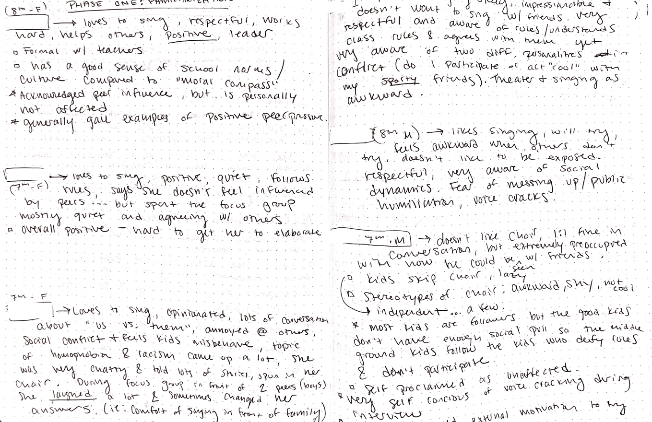

Appendix R: Theme 1 and 1a Supplemental Table
Below is an example providing supplemental quotes for theme 1 and subtheme 1a.

Table 1.1 – Theme 1: Fear of Mistakes and Negative Peer Evaluation in Choir
Central Organizing Concept: | - fear of being judged negatively by peers impacts students' willingness to participate in choir activities  - Stigmas and stereotypes about students in choir.
Boundary of the Theme: | - encompasses feelings of anxiety, nervousness, and reluctance to sing or perform due to potential peer evaluation  - subtopic limited to discussion of gender stereotypes and social out-casting in choir.

Table 1.1 – Supplemental Examples of “Fear of Judgment and Negative Peer Evaluation in Choir”
Code | Quote | Source
Students find it hard to sing/do the right thing for fear of sticking out and seeming "weird" | "And I know the song -the pitches - for [SONG], but they keep singing the soprano pitch and I don't want to be the only one singing the alto pitch while they sing the soprano pitch because I'm gonna seem weird." | Student C
Fear of reputation being jeopardized | "Also kids like worry about their reputation in chorus and if people are gonna laugh at them or something." | Student D
Fear of being singled out | "A big part of the choir doesn't sing, so it makes it really hard to sing because everybody hears you and not everyone else combined." | Student E
Avoidance behaviors increase when class has a component for performance in front of peers | "... When [TEACHER] asked me up to sing, when I- I would like always something I gotta go use the bathroom or something. Just some way to kill time so." | Student F
Fear of failure greater than consequences of a bad grade | "And then there was also, like the kids who like just said ‘I don't care if I got zero. I'm not doing I'm. Not doing that.’" | Student F

Appendix R: Theme 1 and 1a Supplemental Table (Cont.)

Table 1.2 – Supplemental Examples of “Stigmatization and Stereotyping of Choir Participants”
Code | Quote | Source
Elitist attitudes by some students who think singing is beneath them | "I wouldn't say it’s difficult in front of other people…if I'm singing ‘white girl music’- " | Student G, FG
Boy uncomfortable with using their high voices. Singing is funny | "It was pretty awkward to like, you know like. Start like randomly. High pitched you know. Pretty funny actually." | Student F, INT
Students who like to sing perpetuating a stereotype that boys can’t sing | "They just ruin it for me and the baritones in my class BUTCHER CHORUS for me because they don't sing. They literally just speak..." | Student C, INT
fear of being made fun of | If you try too hard in school, you'll get called like a ‘teacher's pet’, or you know, they don't want to get that negative attention on them. | Student F, INT

Appendix S: Theme 2 and 2a Supplemental Table
Below is an example providing supplemental quotes for theme 2 and subtheme 2a.

Table 2.0 – Theme 2: Social Dominance in Choral Ensemble Participation
Central Organizing Concept | This theme explores how dominant peer behaviors and attitudes influence the overall participation and engagement in choir.
Boundary of the Theme | It includes both positive and negative influences from both dominant behaviors in the classroom.
Supporting Quotes:
“If one person actually puts in the effort to be good at choir, a lot of people will put in the effort. But if one person skips, then a lot of people would skip.”
“If one is like gossiping they start gossiping too. If one laughs, they all laugh. One snacks, they all snack. They're like they have a chain reaction on each other like. Like they're one but not one...”
“Surprisingly, all the other sopranos followed her because they actually wanted to put in the effort and get, you know, the song done.”
“then there's this one kid in the Alto group which is [STUDENT], and like she was singing out...I guess that kind of like, inspired everyone just to really like focus right now and just sing out.”
“I mean, [STUDENT]. He is telling our section to sing out, and we actually do it because he sings really out, so it almost forces us to.”

Appendix S: Theme 2 and 2a Supplemental Table (Cont.)

Table 2.2 – Supplemental Examples of Social Dynamics and Dominance
Code | Quote | Source
Friend groups influence valuation towards singing in school | “I have a couple of friends who like singing but like, their um their friends...maybe not so much. So then I feel like they've slowly, like, um...not liked singing…” | Student A
Peer influence is strong and tends to be more obvious when negative behaviors occur | “If one is like gossiping they start gossiping too. If one laughs, they all laugh. One snacks, they all snack. They're like they have a chain reaction on each other like. Like they're one but not one...” | Student C
Friends could have a positive impact | “If they were to sing out, then yeah, I would be more uh, excited to sing, honestly.” | Student E

Table 2.3 – Supplemental Examples of “Perceptions of Peer Effort in Choir”
Code | Quote | Source
high engagement makes it easier to enjoy a singing class | My choir is quite nice and everyone's really engaged in it | Student A
perceiving other's expression as unpleasant | So when I look over around the classroom, there's some kids that are just sitting there with, like, a frown on and so I don't know, maybe they don't feel. | Student E
Observations of peer effort and engagement | “My class they sing but they don't really try. Like they look bored. They look tired. They don't- they don't want to be here.” | Student C

Appendix T: Theme 3 Supplemental Table
Below is an example providing supplemental quotes for theme 3.

Table 3.0 – Theme 3: Support Systems and Resilience in the Choral Classroom
Central Organizing Concept | This theme explores how positive support systems and personal resilience impact individual participation in choir.
Boundary of the Theme | It includes the role of familial support, positive peer networks, and personal determination in fostering engagement and overcoming challenges.
Supporting Quotes:
“Usually I just sing out like, um not to brag, but I kind of do support the alto section in my class [laughter] but like I just want to sing out because, you know, I actually want this to be a good song. I want this to like succeed. And even though there are always people judging like, I really don't care, I'm going to do choir in high school too.”
“I don't really care as much? I just want to be the best student that I can be.”
" I had to sing it in class and I was so nervous, but I still got it over with.
Probably like happy. Because like if I'm in the car with like my family like there's always music going and [BROTHER] is always singing. And then he's always so happy about it. And then if it's like a good song, I like a genre I like, and I'm singing too, it's just like a fun time.

Appendix T: Theme 3 Supplemental Table (Cont.)

Table 3.1 – Supplemental Examples of “Support Systems and Resilience in the Choral Classroom”
Code | Quote | Source
Positive peer influence | “If they were to sing out, then yeah, I would be more uh, excited to sing, honestly.” | Student E
Familial support for choir and singing | Probably like happy. Because like if I'm in the car with like my family like there's always music going and [BROTHER] is always singing. And then he's always so happy about it. And then if it's like a good song, I like a genre I like, and I'm singing too, it's just like a fun time. | Student D
Parental support for singing | my parents signed me up for like another, um... music class outside of school | Student A
leaders are more resilient sticking to values without friend support | I really don't care if all of my friends move to another music group. I really like singing and that's not going to change anything for me. | Student A
Fight or flight in performance anxiety  Family expectations of trying your best | …There's also like a lot of kids who like you, just want to impress their parents trying to like you know, I just want to, like, have something that they know, like ‘I'm good at this. I can do this.’ | Student F

Appendix U: Organize Codes (Phase 2) Example
After transcribing and assigned initial codes to interview and focus group, codes were loaded into an online spreadsheet to begin sorting the codes.
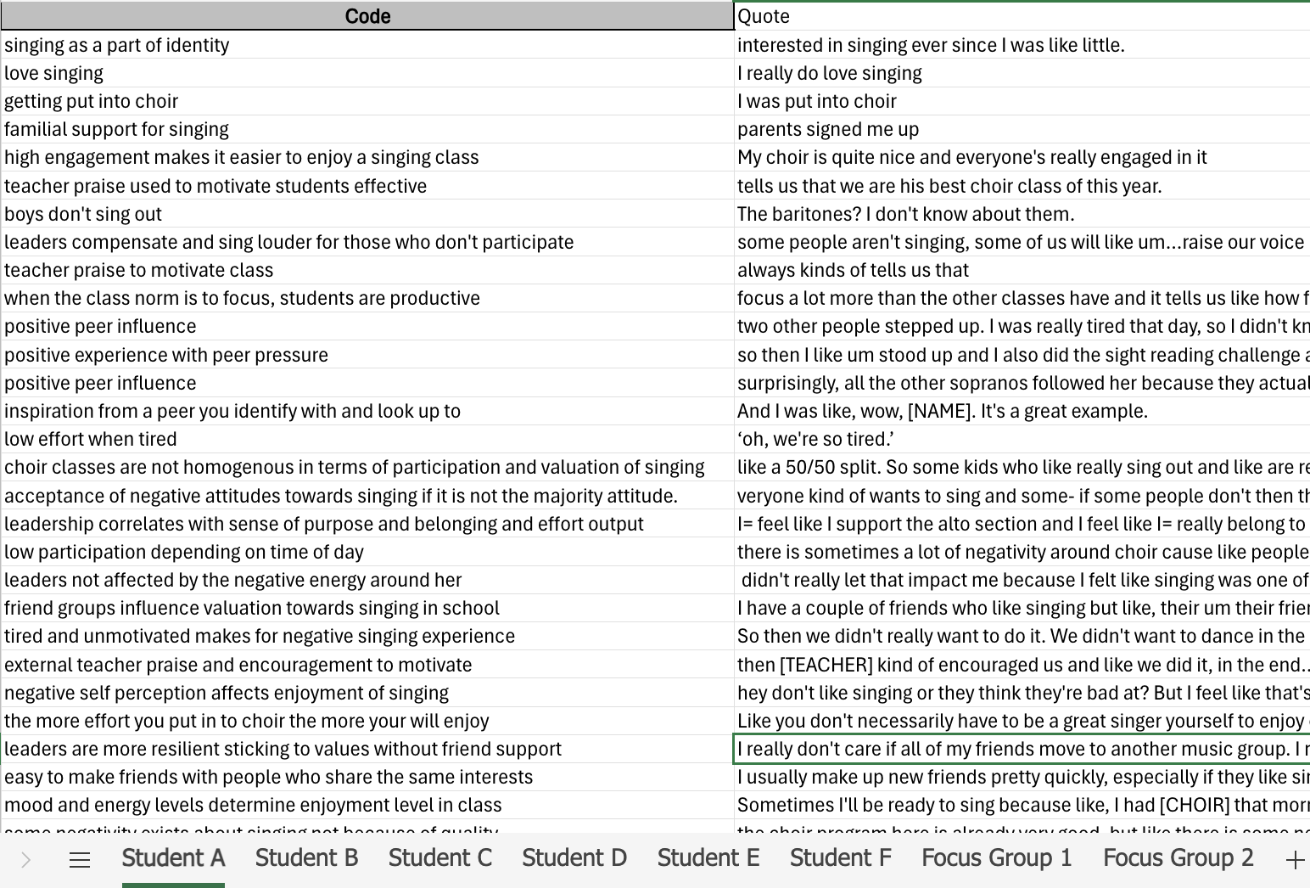

Appendix V: Generating Initial Themes (Phase 3) in a Spreadsheet Example

Typically, reflexive thematic analysis involves developing a sort of thematic map. The process of handwriting was too messy and large for the researcher’s preference, so an online adaptation was made to fit the needs of the researcher. At this point all the coded data extracts were sorted into a single, collated spreadsheet file for pattern identification. It is not possible to include the whole image of the spreadsheet, so this is a portion that showcases different candidate themes.



