BA (Hons) Business Management
Strategic Management and Sustainability
Module Code: LCBB 6015


Sustaining Competitive Advantage in the Transition to Electrified and Software-Defined Mobility

Report on
Strategy Formulation for Toyota Motor Corporation

Lecturer: Mr. Nadeem Mirza

Student Name: Razvan Vasile
Student ID:2439123

Submission Date: 17 August 2026

Executive Summary
Toyota Motor Corporation remains a strong carmaker, but it's a fast-changing market. The value of an EV is changing, shifting from hardware alone toward batteries, software and digital services, while China has become a major centre of EV production and sales. The total sales of EVs in the world reached 20 million in 2025, representing one quarter of all new car sales, and China accounted for 60% of global sales of electric cars. Toyota continues to enjoy scale, hybrid leadership, the Toyota Production System and a supplier network. However, if EV and software-based services grow faster, then these benefits could diminish. The analysis indicates that Toyota can invest, but with profit pressure and a less competitive BEV position, strategic risks exist. It has a multi-pathway approach that mitigates the risk of demand across regions, but may spread investment too thin across too many technologies. The report suggests a Regional Accelerated Electric and Software Mobility Strategy. Toyota needs to accelerate BEV growth in growth markets, increase battery production capacity and enhance software and AI. Hybrids need to continue to be a significant part of the mix where charging, affordability and customer demand allow. This approach is a compromise which safeguards cash and develops the skills required for competition.

Contents
Executive Summary 2
Introduction to Strategy 4
Background of Toyota 5
Strategic Intent 6
Current Performance 7
Strategy Analysis 8
External Environmental Audit 8
PESTEL Analysis 8
Porter's Five Forces 8
Internal Environmental Audit 9
VRIO Analysis 9
Value Chain and BCG Analysis 9
SWOT Synthesis 9
Strategy Formulation 11
Conclusion and Recommendations 12
Conclusion 12
Recommendations 12
References 13

Introduction to Strategy
Strategic management links a firm's long-term choices with changes outside the business and the resources inside it. It is relevant because shifting technology, policy or customer needs can impact an organisation's position (Whittington et al., 2023). This risk is evident in the car business. Products and cost structures are evolving with electrification, software-defined vehicles, AI and tightened carbon. They also alter the skills that give an advantage. Toyota can't just stick with its current strengths - lean production, hybrid leadership. But are those strengths still relevant to the next round of competition? This report evaluates Toyota Motor Corp. and formulates a growth strategy. It first examines the firm's history, vision and performance. It then evaluates external pressure through PESTEL, and internal strengths and gaps through VRIO, Value Chain, BCG and SWOT. The value of Porter's framework is that it considers competition not only from direct competition but also from suppliers, buyers, substitutes and entrants (Porter, 2008). A key question is whether Toyota's multi-pathway strategy can sustain advantage in the face of strategic value shifts toward batteries and software in BEVs.

Background of Toyota
Toyota Motor Corporation is headquartered in Toyota City, Aichi, Japan and is present in the global vehicle markets (Toyota Motor Corporation, 2026a). It has an automotive division including passenger and commercial vehicles, and a vehicle portfolio that includes internal-combustion, hybrid-electric, plug-in hybrid, battery-electric and fuel-cell vehicles. Toyota is also rolling out connected and mobility services. A wide portfolio that would decrease reliance on any single technology, but also complicate capital allocation due to the need for multiple systems to be built simultaneously. Efficient manufacturing, quality, scale and supplier coordination are Toyota's forte. The importance of the Toyota Production System is that it is a process of routine that connects the reduction of waste, problem-solving, and continuous improvement together. Toyota has also developed a solid base in hybrid technology, providing a practical path to reducing fuel consumption prior to the widespread availability of BEVs (Toyota Motor Corporation, 2025). However, the basis of competition is moving. More of the value of the vehicle is now determined by its batteries, software, data, and digital services. Toyota's manufacturing strength remains valuable, but it must also be applied to batteries and software rather than treated as a sufficient advantage on its own.
.

Strategic Intent
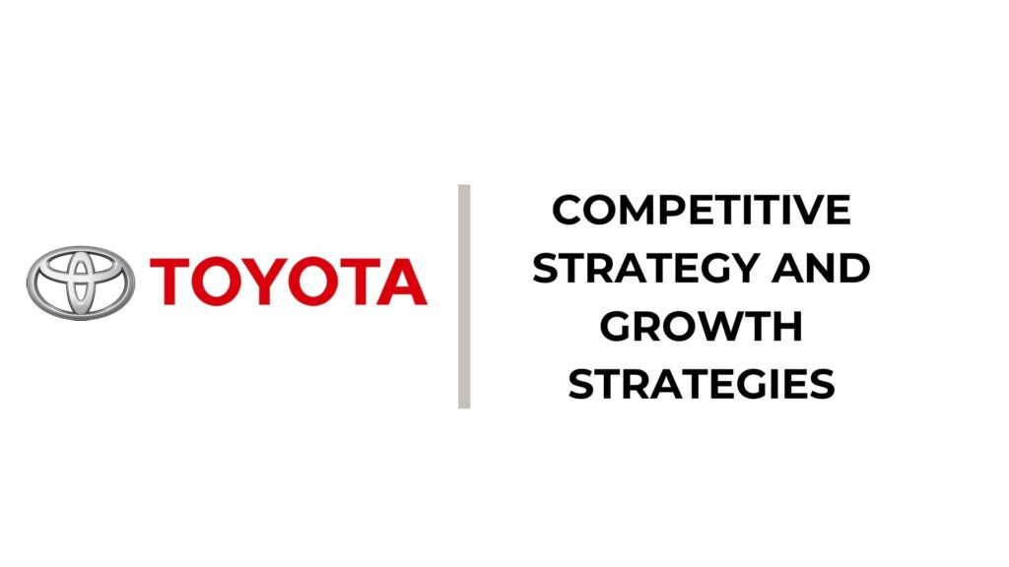
Figure 1: Toyota’s Strategic Intent (Toyota Motor Corporation, 2025).
Toyota's intent is broader than selling cars. It has a mission of “Producing Happiness for All” and a vision of “Creating Mobility for All”, contributing to its transformation from a “car company” to a “mobility company” (Toyota Motor Corporation, 2025). It is a direction that adapts to changing trends in connected, automated, shared and electrified mobility. It provides Toyota with space for meeting markets' needs. However, it is a broad vision. While a broad purpose can help to inspire innovation, there is a danger that a broad purpose can be diluted by managers funding a lot of technologies without a regional focus. Its goals include becoming carbon neutral, safer mobility, electrification, battery development, and battery and software capabilities (Toyota Motor Corporation, 2026c). These goals are achieved through Toyota's multi-pathway strategy, which provides HEVs, PHEVs, BEVs and fuel-cell vehicles for local conditions. This makes sense in situations with limited charging infrastructure or financial issues. This, however, comes with a catch. As EV demand increases, the distribution of resources might dampen BEV and software growth relative to that of other players that are advancing more rapidly (IEA, 2026). Toyota's plans are believable, but it will have to make decisions about location and rate of expansion for each pathway.

Current Performance
Toyota entered FY2027 with strong revenue but weaker operating profit. The sales revenue for the FY2027 first quarter was ¥13.53 trillion, up 10.4% year-on-year, and operating income was ¥1.06 trillion, a decrease of 8.8% (Toyota Motor Corporation, 2026b). Automotive revenue increased by 8.8% to ¥12.01 trillion, while automotive operating income fell by 21.0% to ¥719.9 billion. This gap matters. With its higher costs, the company is not enjoying as much profit as it used to, based on its sales revenue. Toyota has financial scale, but gains in efficiency are falling short in terms of margins.
Figure 2: Toyota Q1 FY2027 Year-on-Year Change (IEA, 2026).
There is another concern: the wider market. In 2025, sales of electric cars passed the 20 million mark, accounting for 25% of new car sales (IEA, 2026). China accounted for almost 75% of electric car production, and Chinese manufacturers account for 60% of global sales of electric cars. Toyota's sales strength is quite evident in hybrids, and in general on a global scale, but less pronounced in BEVs The difference is strategic. In the future, software and batteries may account for a larger share of vehicle value, and Toyota could lose ground in these areas if its capabilities develop too slowly, while retaining high sales if industry growth and learning go towards BEVs
Toyota is investing to fill that shortfall. In 2025, its battery plant in North Carolina started to supply batteries, contributing to the growth of battery supply from the region and reducing the dependence on external batteries, which will enable HEV, PHEV and BEV production (Toyota Motor Corporation, 2026a). Toyota and Woven by Toyota are developing software, AI and connected mobility functionality. Toyota's actions indicate that it has the means to change. But the current performance doesn't guarantee a complete transition. The question is whether the investment is quick and targeted enough to be in line with market changes over the years.

Strategy Analysis

External Environmental Audit

PESTEL Analysis
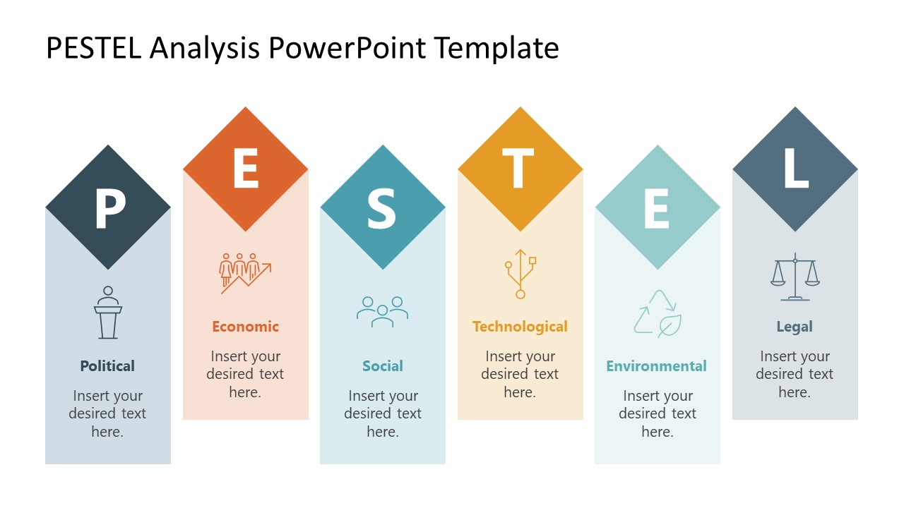
Figure 3: PESTEL Analysis (Jeong et al., 2024).
PESTEL shows that Toyota faces uneven pressure across regions. Governments are tightening CO2 standards or providing incentives for battery production to encourage EV adoption, and these policies are accelerating adoption. In this regard, Jeong et al. (2024) demonstrate that competition is influenced by government decisions in industrial policy in the context of EV transition. Toyota can't fit one combination of powertrains all over. Economically speaking, the demand for BEVs is price-sensitive, and charging access and battery cost are sensitive, which means that Toyota's multi-pathway strategy in slower markets makes sense. But technology is advancing rapidly. Beyond powertrains, the business model in the automotive industry is changing as a result of digital systems, connected services and software (Llopis-Albert et al., 2021). Another area of environmental impact is on vehicles, factories and supply chains (Lukin et al., 2022). Toyota is gaining flexibility through the technologies, but Toyota risks falling behind if its BEV investment does not keep pace as BEVs become more common.

Porter's Five Forces
Porter's Five Forces suggests rivalry is the most serious external threat. The competition features big auto manufacturers, as well as the likes of Tesla, BYD and Chinese electric vehicle startups. Toyota faces stronger competitive pressure from Chinese firms as they accounted for 60% of global electric car sales in 2025 (IEA, 2026). Supplier power is significant in batteries, semiconductors and critical materials, due to the concentration of inputs. As the number of EV options increases, so does the power of the buyer. There are high entry barriers in production, but EV platforms and digital services have opened the value chain to new companies. Toyota's size helps, but it can't stop pressure on margins from competitors on battery price, software and speed.

Internal Environmental Audit

VRIO Analysis

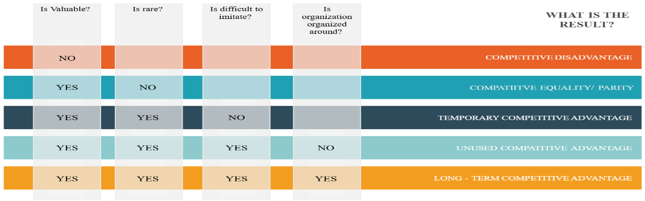
Figure 4: VRIO Analysis (Barney, 1991).
VRIO highlights where Toyota can defend an advantage. Toyota Production System's value is that it facilitates quality, waste control and problem solving. Copying is difficult as routines, supply connections and learning take time. According to the resource-based view, resources which are valuable, rare and difficult to imitate and for which the organisation can make use generate sustained advantage (Barney, 1991). Toyota's value adds are its brand, production network and knowledge of hybrid technology. But the hybrid capability may become more common as competitors start to catch up, whereas the software capability is not as well developed. Toyota should be using its strengths to renew, not to use as an advantage.

Value Chain and BCG Analysis
The Value Chain shows that value is shifting towards batteries, semiconductors and then towards software, data and services. The roles of the supply chain members are evolving in EVs, and the role of battery manufacturers and technology partners is growing increasingly significant (Jagani et al., 2024). Toyota's battery investment helps mitigate supply risk and increase control, but it also entails capital commitments. The argument for the use of cash generated from hybrid and mature lines of business for funding BEVs and software is based on BCG logic. Toyota's BEV business can be treated as a Question Mark because the market is growing fast while Toyota's relative BEV position is still weaker, and hybrids continue to be cash-generating in numerous markets. This is only if Toyota can reallocate resources before it gets too expensive to enter.

SWOT Synthesis
A SWOT synthesis makes the strategic gap clear. Toyota's assets include its scale, brand trust, manufacturing discipline, hybrid depth and supplier coordination. The challenges are a less mature BEV position, software maturity and funding multiple powertrains. Growth opportunities in EVs, battery systems, AI, connected services and region-specific products. The threats are Chinese price competition and regulation, technology changes and supply shortages. Electrification is also reshaping value chains and increasing competition between plants and suppliers (Rísquez Ramos and Ruiz-Gálvez, 2024). The real question is: does Toyota have resources? It does. The key question is whether Toyota is redirecting those resources quickly enough toward areas where future value and learning are growing.

Strategy Formulation
Figure 5: Global EV Market Context, 2025(IEA, 2026).
Toyota has three strategic choices. It could still follow the multi-pathway format but make minor adjustments. This will help support demand in markets, but will also decrease the rate of learning for BEVs and software. Second, Toyota may be ready to adopt a BEV-first strategy globally. That would satisfy the primary technology trend, but not consider charging, income, and customer needs differences. The uptake of EVs is robust but unevenly distributed between regions (IEA, 2026). A regional approach is the more suitable option that will ensure flexibility and allocate more capital and management resources to markets where BEVs and digital services are expanding most quickly.
The Regional Accelerated Electric and Software Mobility Strategy has three pillars. Firstly, Toyota has to accelerate its BEV development in China, Europe and high-growth EV markets by leveraging local design and shorter product cycles. Second, it should develop battery ecosystems by expanding its own battery production capacity, partnerships with suppliers, and diversifying its material sources. Overall, EV supply chains are reshaping the roles of traditional suppliers and establishing new power dynamics in batteries (Jagani et al., 2024). Third, Toyota should regard software as a fundamental product functionality. According to research on digital mobility, Toyota already has a focus on autonomous and connected services, but the value of these services in the future lies in the ability to offer them to customers in a scalable manner (Pérez-Moure et al., 2023). Direct connections between Arene, AI, OTA updates and connected services and BEV platforms should be made.
This is a better option than extremes. Changing all of them to BEV will be a waste of capital when hybrids still make sense, and a limited shift will make Toyota look like it's behind the curve when it comes to the cost of BEV scale shapes. To make decisions on plant production, it is not only products that matter, but also plant production choices, as this will alter plant competition and the structure of suppliers (Rísquez Ramos and Ruiz-Gálvez, 2024). Toyota must implement manufacturing discipline and hybrid cash to fund the transition, but also establish targets for BEV penetration and battery cost, as well as software income. It transforms multi-pathway thinking into a portfolio approach.

Conclusion and Recommendations

Conclusion
Toyota remains strong, but where the advantage in cars is coming from is shifting. Its size, its brand, its manufacturing system, its hybrid leadership and its supplier network generate value. Change is possible if Toyota can finance it. In spite of the increase in revenue, however, operating profit is decreasing, which is a warning sign that size does not eliminate margin pressure (Toyota Motor Corporation, 2026b). The more serious problem is structural. The traditional model of advantage is being outpaced by BEVs, batteries, software and Chinese competition. Toyota's multi-pathway approach is useful because market conditions differ across regions; however, it requires regional priorities. The Regional Accelerated Electric and Software Mobility Strategy provides that balance.

Recommendations
Three actions should follow.
- First, Toyota needs to establish region-specific BEV goals and speed up development times in China, Europe and fast-growth markets.
- Second, it should increase the extent of battery localisation and supplier diversification as resilient supply demands capacity and reduced reliance on a single source (Chauhan and Rani, 2026).
- Third, Toyota should commercialise software and AI as a main business, setting goals for over-the-air, use of connected services and software revenue.
These actions secure strengths as they shift capital and learning towards value. It is not the intent to eliminate hybrids, but to prevent flexibility from becoming delay.

References
Barney, J.B. (1991) ‘Firm resources and sustained competitive advantage’, Journal of Management, 17(1), pp. 99–120. https://doi.org/10.1177/014920639101700108
Chauhan, A. and Rani, M.V. (2026) ‘Resilient supply chains in the automotive industry: a risk prioritization framework for electric and traditional vehicles in Industry 4.0’, International Journal of Productivity and Performance Management, 75(2), pp. 353–374. https://doi.org/10.1108/IJPPM-03-2025-0181
International Energy Agency (IEA) (2026) Global EV Outlook 2026. Paris: International Energy Agency. Available at: https://www.iea.org/reports/global-ev-outlook-2026 (Accessed: 11 August 2026).
Jagani, S., Marsillac, E. and Hong, P. (2024) ‘The electric vehicle supply chain ecosystem: changing roles of automotive suppliers’, Sustainability, 16(4), 1570. https://doi.org/10.3390/su16041570
Jeong, J.H., Kim, C. and Jo, H.J. (2024) ‘Three major challenges in the shift to electric vehicles: industrial organization, industrial policy, and a just transition’, Sociology Compass, 18(5), e13218. https://doi.org/10.1111/soc4.13218
Llopis-Albert, C., Rubio, F. and Valero, F. (2021) ‘Impact of digital transformation on the automotive industry’, Technological Forecasting and Social Change, 162, 120343. https://doi.org/10.1016/j.techfore.2020.120343
Lukin, E., Krajnović, A. and Bosna, J. (2022) ‘Sustainability strategies and achieving SDGs: a comparative analysis of leading companies in the automotive industry’, Sustainability, 14(7), 4000. https://doi.org/10.3390/su14074000
Pérez-Moure, H., Lampón, J.F., Velando-Rodriguez, M.E. and Rodríguez-Comesaña, L. (2023) ‘Revolutionizing the road: how sustainable, autonomous, and connected vehicles are changing digital mobility business models’, European Research on Management and Business Economics, 29(3), 100230. https://doi.org/10.1016/j.iedeen.2023.100230
Porter, M.E. (2008) ‘The five competitive forces that shape strategy’, Harvard Business Review, 86(1), pp. 78–93. Available at: https://hbr.org/2008/01/the-five-competitive-forces-that-shape-strategy (Accessed: 11 August 2026).
Rísquez Ramos, M. and Ruiz-Gálvez, M.E. (2024) ‘The transformation of the automotive industry toward electrification and its impact on global value chains: inter-plant competition, employment, and supply chains’, European Research on Management and Business Economics, 30(1), 100242. https://doi.org/10.1016/j.iedeen.2024.100242
Toyota Motor Corporation (2025) Integrated Report 2025. Toyota City: Toyota Motor Corporation. Available at: https://global.toyota/en/ir/library/annual/ (Accessed: 11 August 2026).
Toyota Motor Corporation (2026a) Annual Report on Form 20-F for the fiscal year ended 31 March 2026. Toyota City: Toyota Motor Corporation. Available at: https://global.toyota/pages/global_toyota/ir/library/sec/20-F_202603_final.pdf (Accessed: 11 August 2026).
Toyota Motor Corporation (2026b) Financial Summary FY2027 First Quarter. Toyota City: Toyota Motor Corporation. Available at: https://global.toyota/pages/global_toyota/ir/financial-results/2027_1q_summary_en.pdf (Accessed: 11 August 2026).
Toyota Motor Corporation (2026c) Sustainability Data Book. Updated 29 June 2026. Toyota City: Toyota Motor Corporation. Available at: https://global.toyota/en/sustainability/report/sdb/ (Accessed: 11 August 2026).
Whittington, R., Regnér, P., Angwin, D., Johnson, G. and Scholes, K. (2023) Exploring Strategy: Text and Cases. 13th edn. Harlow: Pearson.

