
Guide to the Archives Hub EAD Editor

Contents:

General information 3
Saving a Basic Description 4
Completing the mandatory fields 5
Incorrect Markup 5
Identity and Repository 6
Core Information 8
Level of Description 8
Other Level 9
Title 9
Dates 9
Language 10
Physical Description 11
Header Note 11
About the Creator 12
Name of Creator 12
Lookup in VIAF 12
Personal Names 14
Corporate Names 15
Family Name 17
Administrative or Biographical History 17
Content and Structure 18
Scope and Content 18
System of Arrangement 18
Appraisal 18
Accruals 18
Other Descriptive Data 18
Archivist’s Note 18
Context 19
Custodial History 19
Source of Acquisition 19
Digital Images or Digital Content 20
Thumbnail Images 20
Content 21
Thumbnail and Content 21
Other Materials 22
Existence/Location of Originals 22
Existence/Location of Copies 22
Separated Material 22
Related Material 22
Use of the Content 23
Conditions Governing Access 23
Conditions Governing Reproduction 23
Physical Characteristics 23
Other Finding Aids 23
Preferred Citation 23
Publications 23
Access Points 24
Subjects 24
Source 24
Library of Congress Subject Headings (LCSH) 24
Personal Corporate and Family Names 25
Place Names 26
Geographical Feature 27
Events 27
Publications 28
Genre Forms 28
Functions 28
Formatting and Links 29
Title 29
Font 29
Lists 30
Break 31
Web Link 31
Email Link 32
Archival Reference 33
Multi-Level Descriptions 34
Changing the reference 34
Deleting descriptions 35
Administration 35
Uploading Descriptions 36
Editing Uploaded or Migrated Descriptions 36

General Information

Log into the EAD Editor using the username and password provided to you. You will be prompted to change this if it is the first time you have logged in.

The EAD Editor provides a number of sections for you to fill in to create your description.
You can expand each section individually. If you have one section open, clicking on another section will close the current one and open the selected one.

Where a field has an ‘Add’ button, you must click on it to ensure the information you provide is added to the description. If there is no ‘add’ button, then clicking outside of the active text box will add the text to your description.

These blue ‘add’ buttons must be used to confirm that you wish to add your data to the description.

The Editor has preview boxes. Clicking ‘add’, or clicking outside of the active text box, will put your text into the preview box so that you can see what it looks like and review it.

Red crosses beside the data allow you to delete it, e.g. dates and languages.

You can create up to 100 descriptions and store them within the Editor. If you need this limit to be increased, please email us.

Saving a Basic Description

We recommend saving your description frequently.
Your session will expire after 60 minutes of inactivity and you may lose work if you have not saved it.

Save using the button at the top or bottom of the screen.
NB: In Firefox the save button at the top of the screen is within the editing page. In other browsers it is in the top menu bar.

‘Save’ is provided at the top and bottom of the screen. Make sure you save frequently.
The Editor give warnings prompting you to save.

The Archives Hub has a number of mandatory fields that must be completed (see below).

You need to put content into all of the mandatory fields in order to save your description. If you have not filled in all the mandatory fields and you press ‘save’, the Editor will take you to the next mandatory field as a prompt.

If you have filled in all of the mandatory fields, the description will save and you will see an indication of this on the left-hand side of the screen, with metadata about the creator and date of creation.

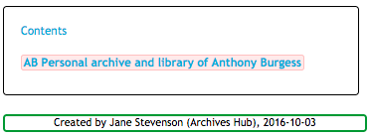
This description has been created, with content in all mandatory fields.

There is also a green information field:
Once you have saved a basic valid record, you can continue to edit, or log out and re-load the description later, from the ‘edit description’ list of your records.

Completing the Mandatory Fields

The Editor is based upon the principle of completing the mandatory fields as a priority, and it will prompt you to do this so that you can save a basic valid EAD record.

The mandatory fields are:
- Repository (you should not need to add this, as your login is recognised)
- Reference (country code, repository code, reference)
- Title
- Level of description (‘collection’ by default)
- Date(s) of material
- Language(s) of material
- Extent
- Scope and content
- Access

You can add placeholder text in a mandatory field, and come back to it to complete it later.

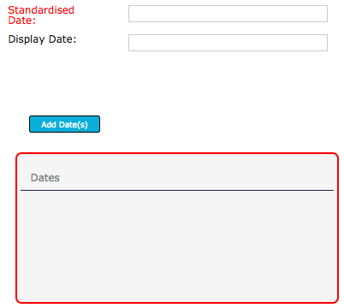
When a display box is outlined in red, you are being asked to complete this field, as it is one of the Hub mandatory fields.

Incorrect Markup
Note that if the markup is incorrect, the box border will turn red, and the preview will disappear. If you correct the markup and click outside of the input box the preview will re-appear.

See our section on Formatting and Links for more information.

Identity and Repository

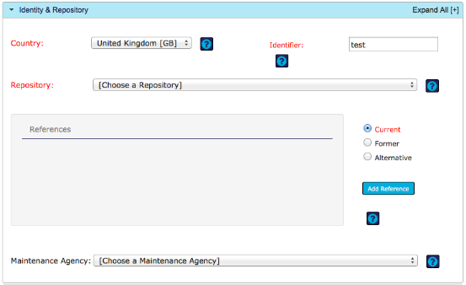
Identity and Repository section

Country
The ISO code for the country where the materials are held

- GB is provided by default so you do not have to add this.
- IM is provided as an option for Isle of Man.

Repository
The institution responsible for providing access to the materials. It is commonly the same institution that creates the description of the materials, but it is possible for descriptions to be created by other agencies.

- You will see your own repository by default.
- You will be able to choose from more than one repository if you have permission to do so.

Maintenance Agency
The institution responsible for providing the description of the materials. It is commonly the same institution that provides access, but it may be that the description was created by an external agency, such as a cataloguing unit.

- You will see your own repository (agency) by default.
- You will be able to choose from more than one repository (agency) if you have permission to do so.

References
The Archives Hub requires a globally unique identifier. The identifier consists of:
a) the country code
b) the repository code
c) the reference for the materials

- The country code and the repository have already been confirmed
- Put the reference for the materials into the ‘Identifier’ box

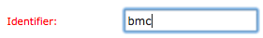
Identifier for the archive collection

- References can be described as current, former or alternative. Ensure that you have the right radio button selected. For the main reference use ‘current’
- Click ‘Add Reference’, and the reference will be displayed, with the country code and repository code.
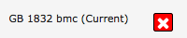
Reference added to a description

- Use the red cross to delete the entry if you wish to replace or remove it.
- Only add a ‘Former’ or ‘Alternative’ reference if you wish to do so. You can only add one of each of these references within the Hub Editor.
Remember, you must use the ‘Add Reference’ button to actively commit the reference to the description.

Why do we provide the option to add current, former and alternative references?

The current reference is the one that researchers should be using to access the materials. Some repositories prefer to show a former reference, as researchers may have used this reference in the past. It can also be useful for administrative purposes to see older references.
The alternative reference allows for e.g. automatically generated references from archival management software to be displayed as a secondary reference if this is preferred.

Core Information

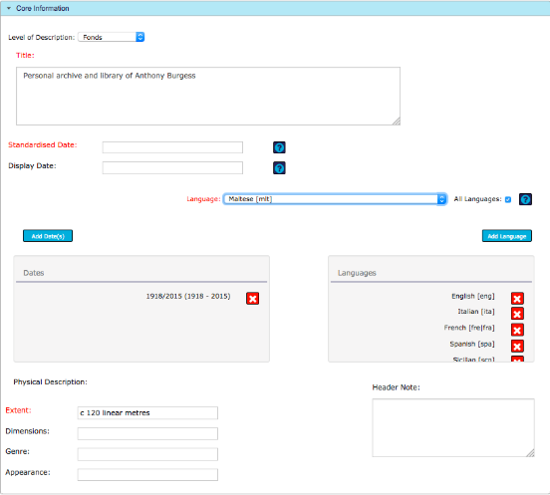
Core Information section

Level of Description

The level of description is the level of the hierarchy that you are describing. By default it is set to ‘Collection’. For a top level description you may wish to use ‘Fonds’ instead if you have a collection with a common provenance.

The levels provided are:
Fonds
Collection
Class
Record Group
Series
Sub Fonds
Sub Group
Sub Series
File
Item
The Archives Hub does not require a collection/fonds description at the top level of your hierarchy. You can, for example, create a series description and then, if you wish, create subseries and item descriptions within the hierarchy. Series can be separated out and described separately and then linked using archival links (see our information about archive links).

Other Level
Only use ‘other level’ if the value that you need is not in the core set of values.
If you do not see the value that you need in ‘other level’ you can request a new value.

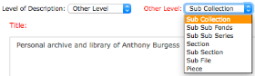
If the core set of level values do not suffice, ‘OtherLevel’ is a value that allows you to select from a further set of values, such as ‘section’ and ‘piece’.

Title
A formal or supplied title for the unit of description.

- Titles should uniquely identify the material and preferably consist of a name element, a term indicating the nature of the unit being described and optionally a topical segment
- Ensure that titles make sense within the context of an online service
- Think about users undertaking title searches or browsing a list of titles
- Try to avoid very general titles such as 'Miscellaneous Papers' or titles that are too brief such as 'Cooper Collection' (a common surname - maybe add forename or initials to help identify the collection)
- Don’t use only the creator name for the title - this makes the title into a name in terms of machine processing
- We recommend putting the dates into the date field rather than the title, as this makes it clearer to users what the dates signify
- We recommend titles should be more than a single word and not more than 500 characters.

Dates

Standardised Date(s)

The standardised date or dates must be entered in the correct ISO format:

yyyy/yyyy
yyyy-mm-dd
yyyy-mm-dd/yyyy-mm
Any other formatting will cause an error, with the box outlined in red, and you will not be able to proceed.


Date incorrectly entered – this should be 1910-06

Display Date(s)

The date(s) that the end users will see. These dates can be in any format. We may provide a suggestion, but this can be overwritten. Display dates may include square brackets, question marks or ‘c’ for circa

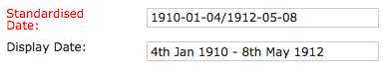
Here the standard date is yyyy-mm-dd/yyyy-mm-dd The display dates are entered automatically but can be changed.

Adding more than one date range
You can add up to three date ranges by simply following the same procedure as above and clicking to ‘add dates’ so that you can view them in the display area.
Once you have added dates, they will be moved from the input boxes and appear in the display area.

You must click to ‘add date(s)’ in order to add your dates to the description.

Language

It is mandatory to add the language of the material. You can add as many languages as you need to by picking them from the drop-down list.

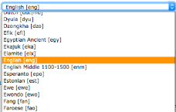
We provide the most common languages in the main drop-down list. Click ‘All languages’ to get a fully comprehensive list of languages.

English is selected by default, but you must still click on the ‘Add’ button to ensure the language is added to your description.

Physical Description

The Editor provides four sections for you to add information about the physical description of your materials. Extent is mandatory at the top level. The other fields can be used as and when you wish.

Extent
Provide quantity and unit. Separate entries with a comma or brackets.
e.g.:
24 boxes (3 cubic metres)
3 boxes (includes 1 oversize box)
5 volumes

Dimensions
More typically used for individual items, so may be more appropriate for lower level descriptions. May, for example, provide the measurement for an individual book, letter or photograph.
e.g.:
10cm x 24cm

Genre
Includes both genre (style) and form (function). May refer to the type of material, style or technique of their intellectual content.
e.g.:
architectural drawings
sound recordings
account books
diaries

Appearance
Used to describe aspects of the appearance of the described materials, such as their color, style, marks, substances, materials, or techniques and methods of creation. It is used especially to note aspects of appearance that affect or limit use of the materials. It may more typically be used at item level.
e.g.:
Bound in 19th century red leather

Header Note

An optional field within the EAD header (so not displayed on the Hub) that contains any descriptive information you wish to add about the EAD finding aid itself. Similar to the "general notes" in traditional bibliographic descriptions.

About the Creator

Name of Creator
At the top level of a description, this refers to the individual(s) or organisation(s) responsible for the creation/accumulation of the materials. They are not necessarily the author of any of the content.
At lower levels, some archives choose to use this field to identify authors, e.g. when describing a set of correspondence.

TNA’s Discovery (Personal) – takes you to TNA’s record creators browse. It does not provide a dynamic lookup: you need to add the name to the Editor manually. If you use this lookup, the ‘source’ is tna (lower case).

Other recognised sources can be used. Please add the source in lower case without gaps, e.g. tna, aim25.

Lookup in VIAF

The VIAF lookup allows you to populate the Editor with a name from VIAF.
VIAF is the Virtual International Authority File. It is a global aggregation of ‘authority data’. By linking disparate names for the same person or organization, VIAF provides a convenient means for a wider community of libraries and other agencies to repurpose data.

Tips for using the VIAF lookup
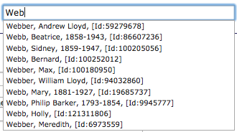

VIAF shows you various options that match your search. If you see the right name you can click to select it.

The steps for using VIAF:
1. start to type in the VIAF box and browse the list of names that you get
2. click the name that you want to select
3. click outside of the VIAF box to populate the Archives Hub name form
4. Check that the name is correct and all of the parts of the name are in the right place
5. click ‘Add Creator’ to confirm that you want to include this creator name

VIAF is reliant on the data that it ingests, so you will find duplicate names. Select the name you think is the best match.

Always pick an entry that includes dates if possible.
You can always check the name directly on VIAF if you wish

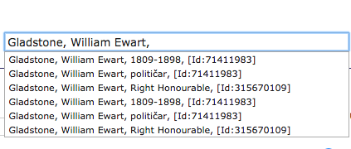
Four entries for Gladstone have the same ID, but the identifier is the same, so the name variations are less important. Sometimes a name will have more than one identifier, especially if life dates are not provided.

It is very important to check that the name is entered into the Editor correctly. The complexity of personal and organisational names means that mistakes can occur. The VIAF entry will not always load correctly. You can modify the name, e.g. by moving elements of the name or by adding a title or epithet, but do not change it to a different person/organisation, as it includes the VIAF ID.
A name may benefit from additions.
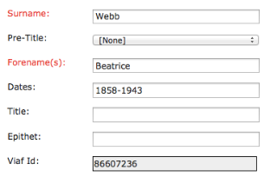

In this example the name may more fully be given as

Martha Beatrice Webb, 1858-1943, Baroness Passfield, social reformer and historian

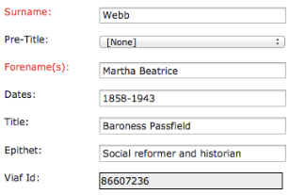
Where information has been added, but the essential elements have come from VIAF, you should keep the VIAF entry and the VIAF ID.

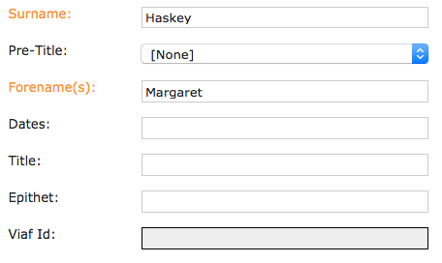
You may wish to or need to add names manually. VIAF tends to include only well-known or published names. Add dates (or a birth date) if you can in order to help identify the individual.

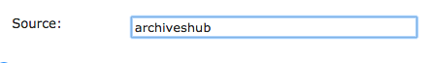
Use the ‘Source’ to identify the source of the name.

- Be careful to select the right name, and check the dates. VIAF is not necessarily always right! It is only as good as the data that it takes in from other data sources.
- VIAF never includes epithets, so these may be added within the Editor.
- The crucial advantages of using VIAF are that names are more consistent and they can potentially be linked across datasets through the VIAF ID.
- If you edit the name to the point that it may not be identifying the same entity as VIAF, then you should not use the VIAF lookup, but just enter the name manually.

Personal Names

There are two formats for personal names.

Format 1
This is the name structured with the forename/surname convention. It is preferable to use this format for names that have this kind of structure.
In Western culture nearly all individuals possess at least one given name (also known as a personal name, first name, forename, or Christian name), together with a surname (also known as a family name or last name)

Format 2
This is the name structured without the forename/surname convention. Use this format if you are not clear how the name is structured, or if it is a mononymous name. East Asian names, for example, may have been converted to the conventional western order, or they may not, and it is not always easy to identify the given name/family name division.

If you look a name up in VIAF and it does not have a surname, forename type structure, then ensure that you are on ‘format 2’ when entering the name.

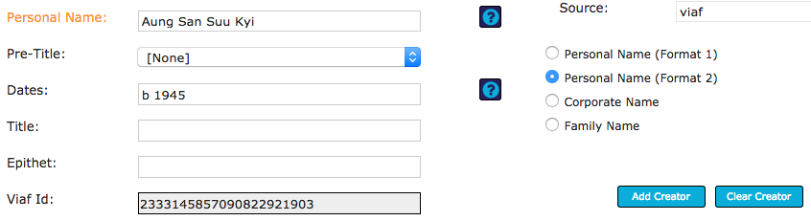
Personal name form showing format 2 for Personal Name with a name entry for Aung San Suu Kyi.

Name Sub-Divisions

Pre-title: A controlled list of pre titles is provided: Dame, Hon., Lady, Lord, Sir,

Dates: Life dates should be provided if possible. Please see the contextual help for date formats. The Editor will not accept other formats.
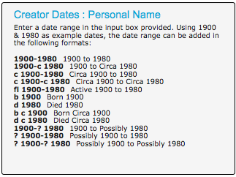
The Editor provides a box showing the formats permissible for life dates

Title: A peerage title, such as ‘Earl of Shaftesbury’ or ‘Duchess of York’

Epithet: May describe a person's status, position, occupation, characteristics, nationality, place of birth, residence or activity, alternative or previous or subsequent names, relationships, etc. You may find it helpful to look a name up in the Archives Hub to find epithets.

Corporate Names

The format allows for a number of sub-divisions:

Jurisdiction: Used for governmental bodies, i.e. the government as the corporate body
e.g. Great Britain and Ireland

Corporate Body: The name of the organisation
e.g. Commonwealth War Graves Commission, Barclays Bank, University of Bristol

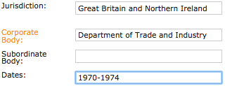
Correct entry - A government department would be entered as a body within the government.

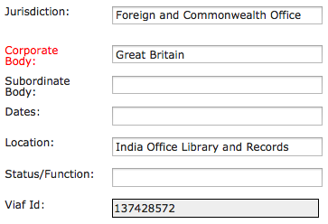
Incorrect entry – the Jurisdiction should be ‘Great Britain’ and the Corporate Body should be ‘Foreign and Commonwealth Office’. Make the correction and then add the entry, with the VIAF ID.

Subordinate Body: A subdivision within the main body
e.g. Royal Academy of Arts > Summer Exhibition

Dates: Used in particular to distinguish bodies of the same or similar name or where there has been a name change,
e.g. Royal Manchester College of Music, 1893-1973.

Location: Used where the location helps to identify the body
e.g. Royal Free Hospital > London

Status/Function: Used to distinguish between bodies by their status or function
e.g. Chester Friary > Carmelite
Chester Friary > Franciscan

There are links to TNA’s Discovery, to help you source names, and you can use VIAF for corporate names.

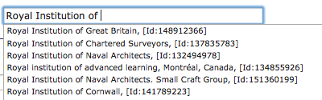
VIAF provides a lookup for corporate names as well as personal names.

Remember, please check your entries carefully, as sometimes data will be added to incorrect boxes, due to the variations within VIAF, and you will need to manually correct it.

You may find it useful to search VIAF directly, as it will give you more information about the name (e.g. https://viaf.org/viaf/137428572/).
VIAF also links to International Standard Name Identifiers (ISNIs), so this is another good reason to use ‘hub’ services like VIAF, to bring data sources together (i.e. http://www.isni.org/isni/0000000121663565)

Family Name

A family name can be sourced from TNA’s Discovery, or you can enter it manually. The epithet is already provided, so please leave this as it is.
You have the option to provide additional information in line with NCA Rules (http://archiveshub.ac.uk/ncarules/rules2.html - Family):

Occupation: Used if a family is strongly associated with a trade or occupation
E.g. Macmillan family, publishers

Location: If a family owns a landed estate or is distinguished from other families bearing the same name by association with a particular place, include this information
e.g. Lever family, Bolton, Lancashire

Title: It is standard to apply the last or highest title as the qualifier
e.g. Stewart family, Earls of Galloway

Administrative or Biographical History

Information about the creator(s) of the material, to place it within context.

The biographical history can provide a useful way to add ‘keywords’ that researchers might use to find your description. It is a good idea to think about people, organisations, places and events relating to the person/family/organisation you are describing. These entities should also be added as index term if the collection is significantly about them.

There are a number of formatting options for this field (as for other text fields). See the section of this guide on Formatting and Links.

Content and Structure

Scope and Content

Used to describe the collection or materials. Include significant people, organisations, places, subjects and events where possible. You may wish to use a bulleted list to give an overview of the content, or this may more appropriately be put into ‘Arrangement’ if the overview reflects the arrangement of the materials.

Please see the Formatting and Links section for more information on other options.

System of Arrangement

Provides information on the physical or logical ordering of the archival material.

It may be useful to use the ‘list’ option here – see Formatting and Links for more information.

Appraisal

Use this field to provide information about how the archival materials were assessed by the archivist, how long they will be retained by the repository, and whether any of the material has been removed, or is scheduled to be removed.

Accruals

Used to indicate if further materials will be added to the archive. Can be used to state quantity and frequency of additions.

Other Descriptive Data

Used for descriptive information that does not fit into other fields. Use other more specific fields where possible.

Archivist’s Note

Information about accessioning, arranging, describing, preserving, storing, or otherwise preparing the description for research use.

Context

Custodial History

Information about the creator(s) of the unit of description to place the materials in context. Include significant information about the life and work of an individual or family, or the origin, administrative history and processes of a corporate body. Custodial history helps to provide authenticity, integrity and interpretation.

Source of Acquisition

Identifies where the repository acquired the materials from and in what circumstances. Date of acquisition can also be added.

Information about the creator(s) of the unit of description helps to place the materials in context. Include significant information about the life and work of an individual or family, or the origin, administrative history and processes of a corporate body

Digital Images or Digital Content

This section is for giving users access to digital content.

You can:
- Embed images to display them within the Archives Hub
- Link straight to digital representations of the materials being described

Remember, this means that the images/digital content will be integrated within the EAD, which is of great benefit in order to create an integrated description that is interoperable and sustainable.
A substantial number of URLs that have been provided in the past are now no longer working, so the researcher just gets an error page. You need to be sure the location of your digital content will not change, or if it does, implement redirects or update your description.

Thumbnail Images

This is for the display of an image within your Archives Hub description.

- Thumbnail link: Add the URL for the thumbnail
- Thumbnail description: Optional description of the image

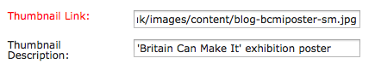

Press ‘Add Link’ to ensure that the image is saved within your description.

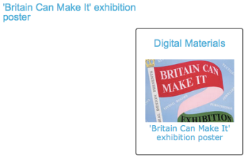

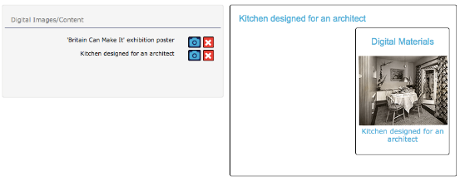
You can add more than one thumbnail image.

Content

Use this option to provide a link to content held elsewhere, which may be a full resolution image, a PDF or Word document, or any other digital content.

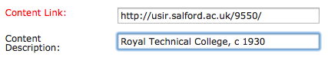

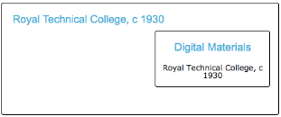

The preview will show the optional label and the link.

Thumbnail and Content

This option provides for a displayed thumbnail image with a link to a full resolution image, or to another URL.

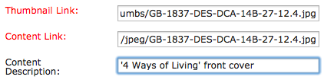
Add the thumbnail URL and the content link that the user will go to when they click on the image.

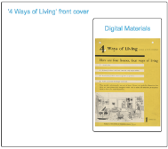
Preview of thumbnail and content option. Clicking on the thumbnail takes the user to a full resolution image.

Other Materials

Existence/Location of Originals

Where the archive materials consist of or include copies of original materials, indicate the existence and location of originals.

Existence/Location of Copies

To indicate if there are copies of the materials being catalogued, where they are, and in what format.

Separated Material

Information about materials which are linked to the collection by provenance, but which may have been removed, destroyed, or physically separated, and therefore not described in the finding aid. Use ‘Related Material’ for a more general associated between materials, where the relation is not due to provenance or accumulation. If adding a link, you will be asked to put the full URL (using ‘http’ or ‘https’).

Related Material

Information about materials which are not part of the collection, but which may be of interest to researchers because they are on the same topic, cover the same event, or have some other kind of association. Include here details of relevant material held in the same repository or by other repositories. If adding a link, you will be asked to put the full URL (using ‘http’ or ‘https’).

Use of the Content

Conditions Governing Access

Provides information about conditions that affect the availability of the materials being described. If there are no restrictions and materials are fully open, you could simply add ‘Open for Consultation’.

May include information about whether an appointment or written permission is needed to access the archive. May include details of restrictions on access imposed by the donor or the repository, or legal restrictions.

Conditions Governing Reproduction

Information on restrictions on copying, quoting or publishing material from within the collection.

Physical Characteristics

Important physical conditions or characteristics that affect the storage, preservation, or use of the materials described. This includes details of their physical composition or the need for particular hardware or software to preserve or access the materials.

Other Finding Aids

Indicates whether any other finding aids exist and whether they are available to the user. You may wish to add a link to your own catalogue. See ‘Formatting and Links’ for adding Web links.

Preferred Citation

Information about citing the materials in bibliographies or other references.

Publications

Publications which are based on, or written about, material in the collection, or may be of value to researchers using the collection. You may wish to add a link to your own catalogue or a catalogue such as Copac. See Formatting and Links for adding Web links.

Access Points

Subjects

Significant topics represented in the described materials.

Source
We ask for source to be included, as using controlled vocabulary provides many advantages in terms of searching and grouping by subject and potentially linking out to other data sources.

Links are provided to take you to the three main thesauri that are used to provide subject entries: Unesco, LCSH and UKAT, as well as the specialist Mesh thesaurus. These links will open in separate tabs.

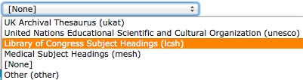
Use the drop-down list to provide the source used for your subject entry.

‘Other’ is provided for if you are using your own local terms. However, bear in mind that this does not offer the advantages of controlled vocabulary.

‘None’ is provided where you are not adding terms from any controlled source. This is not advisable – we would recommend trying to find your term within a thesaurus so that you can add it as a controlled term.

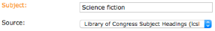
Select the source, type in the term and click ‘Add Subject’ to confirm.

Library of Congress Subject Headings (LCSH)

The LCSH are detailed, so they are good for very specific terms. You can simply use a top level subject entry from LCSH and add it the same as you would for e.g. the UNESCO thesaurus. However, LCSH does also allow for sub-divisions to be added to subject entries – location, dates and other - so your subject terms can be quite complex and very specific. Use the LCSH Authorities interface to search for terms.

Only LCSH provides sub-divisions, so if you use UKAT or Unesco, you should not add sub-divisions.
UNESCO thesaurus: New towns
UKAT thesaurus: New towns
LCSH: New towns
The thesauri often offer the same terms.

With LCSH you can include sub-divisions to enable specificity
New towns--England--History--20th century

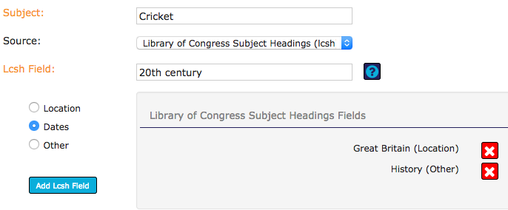

Subject term ‘cricket’ with two sub-divisions already added (Great Britain, History) and dates being added (20th century). Click ‘Add subject’ to ensure that the term is then added to your description.

To add an LCSH term with sub-divisions:
1. Enter the main subject and ensure you have selected ‘LCSH’ as the source.
2. Select the sub-division radio button and enter the required text, click ‘Add lcsh field’
3. Enter additional sub-divisions in the same way using the radio button, typing the term and clicking ‘add lcsh’ field to build your term.
4. When happy with your term, click ‘Add Subject’.

Terms will appear on the Hub with the sub-divisions included:
Cricket--Great Britain--History--20th century

LCSH has some complicated rules governing sub-divisions and we cannot provide full guidance on using them. It is best to take terms from LCSH authorities: http://authorities.loc.gov or other sources that use LCSH.

Personal Corporate and Family Names

See the instructions under ‘Creator Name’ for more information.

Similar to the input area for Name of Creator, this section enables you to look up a name in TNA’s Discovery (source=”tna”). It also provides a lookup on VIAF (the Virtual International Authority File) for personal and corporate names.

You will already have the creator names displayed in the preview box, as they are automatically added as index terms. If you click to edit a creator name, you will be taken back to the Creator section of the Editor, where you can edit or delete the name.


Remember to use the ‘Add’ button. Use ‘Clear Name’ to reset the form.

Place Names

There are links to the Getty Thesaurus of Geographic Names and Vision of Britain (VoB), if you wish to use these as sources for place names. These links are not dynamic, but simply open the service in a new tab.

Source is given in lower case without spaces. e.g. source=”tgn” (for Getty), source=”vob” (for Vision of Britain)

You have a number of sections within place names:

Address This enables you to index by a specific building. Add the number and street or name. e.g. 10 Downing Street (London, England), 84 Plymouth Grove (Manchester, England), Palace of Holyroodhouse (Edinburgh, Scotland).

Locality An area within a town or city. e.g. Bishopthorpe (York, England), Westminster (London, England), Partick (Glasgow, Scotland).

Town or City A village, town or city that the materials are significantly about. You may wish to index just by village/town/city and country. e.g. Cardiff, Wales

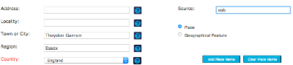
An entry showing the use of VoB as a source for Theydon Garnon, Essex, England.

Region A larger geographic region than a town or city, such as a county or metropolitan area. e.g. Denbighshire (Wales).

Country Country should always be included for place names unless you are indexing a world region or a geographical feature where country is not appropriate. We provide a drop-down list of countries for you to select from.

World Region Used for a continent or area such as Europe, the Middle East or the Sahara.

Add your place name within the EAD Editor, check that it is correct, and click Add Place Name.

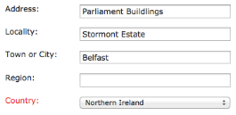
The Editor allows for the use of England, Scotland, Wales, Northern Ireland. These are usually used in preference to United Kingdom.

Geographical Feature

Click the radio button to switch to ‘Geographical feature’ and you have different input boxes:

Feature name The name of a geographical feature, such as a mountain, river, forest or bridge.

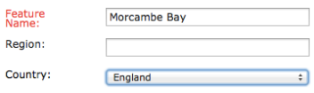

Events

Significant events reflected in the described materials.

We provide a source box for you to select from a thesaurus, or select ‘local’ if you cannot find an event within a recognised thesaurus. We also provide ‘none’ if there is no source available.

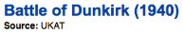
It is best to use a recognised thesaurus such as UKAT to search for events. In this example, we would recommend adding the country, as it provides additional useful information.

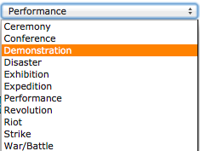
Event type

Pick from the controlled list for your event type, or email us if you require an additional category.

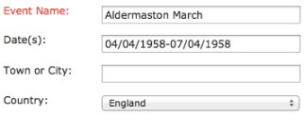
Enter your event into the input box, and press Add Event to add it to your description.
The date can be entered however you wish it to be displayed.

Publications

The formal name of a work, such as a monograph, serial, or painting, listed in a finding aid.

We provide the option to search Copac for a title (source=”copac”). You may also add a publication date if appropriate.

Genre Forms

Terms that identify the style of material(s) being described.

We provide links to the Getty Art and Architecture Thesaurus (source=”aat”) and to the Library of Congress Thesaurus of Graphic Materials (source=”tgm”).

Use the thesauri to source terms,
e.g. AAT: black-and-white prints (photographs)

Functions

Functions is provided as an option, is in line with the ICA International Standard for Archival Functions (ISAF) - http://www.ica.org/en/isdf-international-standard-describing-functions. Functions may be used in preference to administrative structures, as they are generally more stable.

There are few recognised sources for functions, but we provide a link to the Australian Governments' Interactive Functions Thesaurus (AGIFT) and the Art and Architecture Thesaurus (AAT) which has basic functions such as ‘Finance’ and ‘Administration’.

Functions are most frequently used by universities or large institutions as a means to enhance access to archives.

Formatting and Links

You can format your content using the formatting bar.

NB: We provide instructions here on adding markup using the formatting bar. You can also simply type the tags yourself if you are confident that they are correct, and the resulting content will be valid.

Title
Used for a publication title.
Make sure you have ‘Title’ highlighted in the formatting bar. Either use the ‘Add’ button and then enter your title between the <title></title> tags, or highlight your text and click ‘Add’.

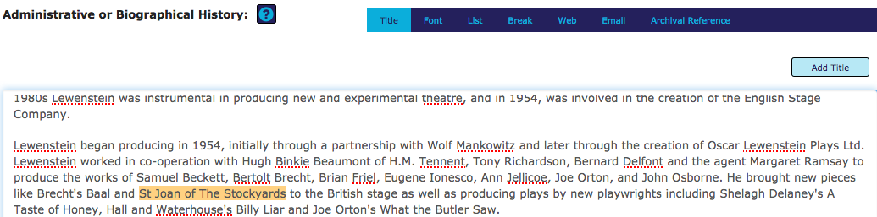

In the above example, the text to be rendered as a title is highlighted. Click the ‘Add Title’ button to apply the markup.
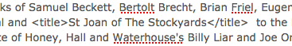
The ‘title’ tag applied to the name of a production.

Font

You can select from bold, italic, quoted and underline. We would not recommend underline for most things, as this is used specifically for hyperlinks.

Select the font, highlight the text and click to add the formatting (e.g. in the example below, click ‘Quoted’ to render the text in quotes).

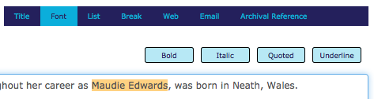

Alternatively, click the style you want and add the text between the tags.
e.g. <emph render="italic"></emph> - add the text between these tags to display it in italics.

All your text will appear in the preview box, so you can see how it will look when live.

Lists

Lists are particularly useful for the Scope and Content or Arrangement of the description, enabling you to provide a summary of the series within the collection.

You can enter the text into the Editor without the markup
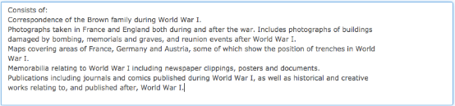

and then highlight the entire list and click ‘Add list’.
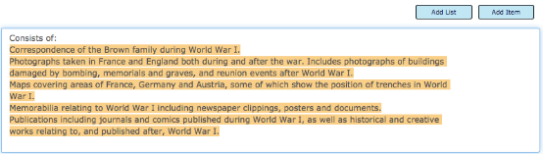

This will add a <list> and closing </list> tag to the whole contents. You then need to highlight each item individually to add item tags, to create bulleted entries:
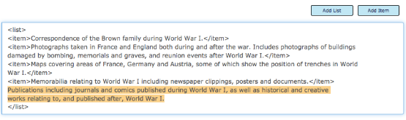

Example of a marked up list
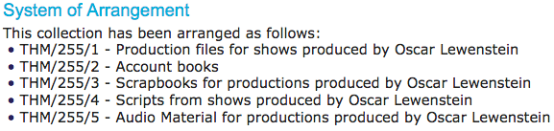
Rendered in the preview box

You can also add empty <list> and <item> tags and then enter the text in the correct places between the tags.

If your list does not show in the preview box, it probably has incorrect markup.

Break

This adds markup for a single line break wherever you have the cursor positioned. But remember that if you have divided your text into paragraphs (i.e. the display shows a number of paragraphs), then they will be carried over to the live display on the Hub. A line break is just a single break, so the following text is on the next line, with no space in-between the two lines.

Web Link

You can add http or https links to your text using the ‘Web’ option.

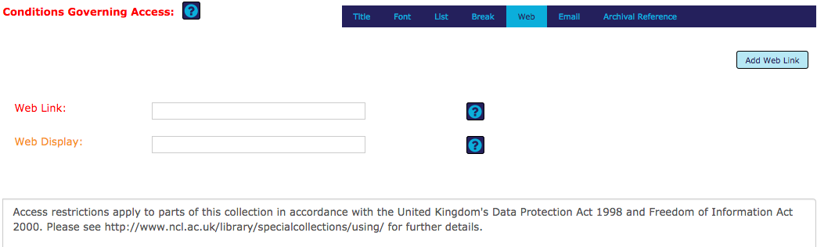
Text with a URL that needs to be marked up as a link. The ‘Web’ option in the formatting bar has been selected.

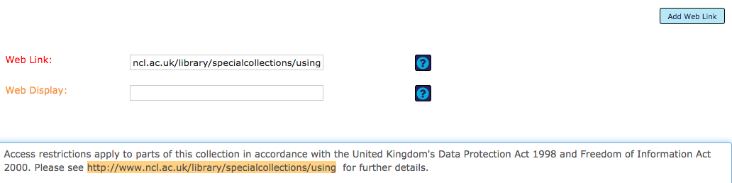
Highlight and copy the URL into the ‘Web Link’.
As the link is being used within the display you do not need to add anything in the ‘Web Display’ box. Simply click ‘Add Web Link’.

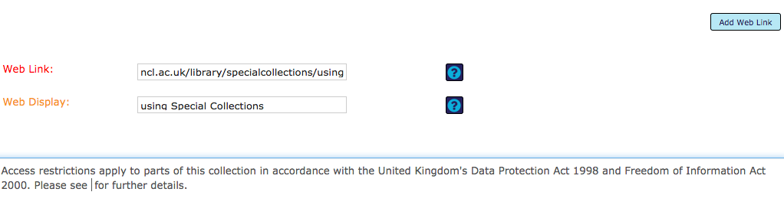

If you want to provide link text that is different to the http URL, then you need to remove the URL from the text and add your text to the ‘Web Display’ box instead. Ensure the cursor is positioned where you want the link text inserted. Make sure you click ‘Add Web Link’.

Email Link

The Email link works in the same way as the Web link.

If you wish to add text for display, instead of displaying the mail link itself, enter text in the Email Recipient box, ensure your cursor is in the right place, and click ‘Add Link’.

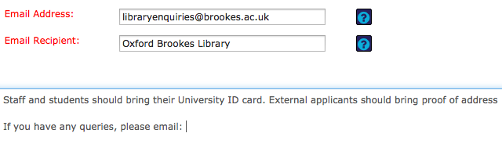
Here the email link will use the text, ‘Oxford Brookes Library’.

Archival Reference

This is used to provide links internally or to other descriptions within the Archives Hub.

A large archive may be split into several series:

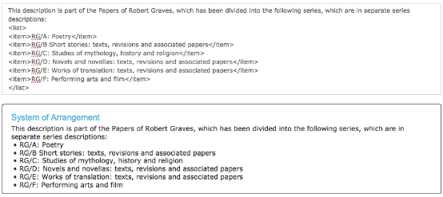
The Robert Graves Archive is split into series and uses the <archref> tag to link to them.

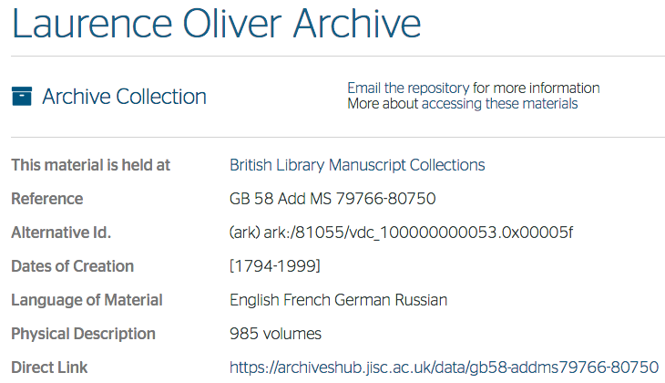
Use the ‘direct link’ that is provided within every Archives Hub description for your ‘archref’ link.

To add the arch ref link, highlight the display text, or add the tags and type in the display text afterwards.

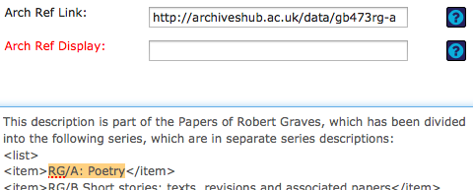
Provide the ‘Arch Ref Link’ in the box (use the Archives Hub ‘direct link’). Highlight the text you want to apply the link to, or put the text into the ‘Arch Ref Display’ box.

Once you Add Arch Ref Link you will see the markup change to add a new link around the text:

<item><archref href="http://archiveshub.ac.uk/data/gb473rg-a">RG/A: Poetry</archref> </item>

Multi-Level Descriptions

If you wish to add levels (components) to your description, use the ‘Add Component’ button to create a ‘child level’, below the level you are currently on.

Add Component provides you with a new level

You will see that the Identity and Repository information is displayed, with a reference provided, that you can change if you wish to.

Changing the reference

To change the default suggested reference you must do the following:

1. remove the suggested reference from the preview box
2. edit the reference in the input box
3. ‘Add Reference’ to put your preferred reference into the preview box

In order to ensure that your component record saves:

1. Check and modify the reference if you wish to (as above)
2. Add a title
3. Click Save

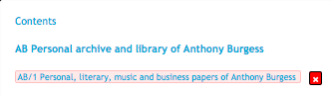
When you have added a component with a reference and title, the Editor will show this in the hierarchy.

You can then continue to create your description, using all of the fields in exactly the same way as with the top level description.

We suggest:

- Add dates that are specific to the component that you are describing, e.g. the series or item
- Add an extent and, for a single item, you may wish to add dimensions if this is important
- Add a language if the language is different from the top level (e.g. the top level describes English and Latin, and this component is in Latin)
- Add a Scope and Content specific to this level of description
- Add images or links to digital content if appropriate at this level
- Add information on Access Conditions if this material is not fully open
- Add index terms if they make sense at this level of description, e.g. personal names where you have a series of correspondence

Deleting descriptions

In Edit mode, you can select an individual description or a component within a description and use the Delete button. You will get a warning asking if you are sure you want to delete. The content will not be recoverable.

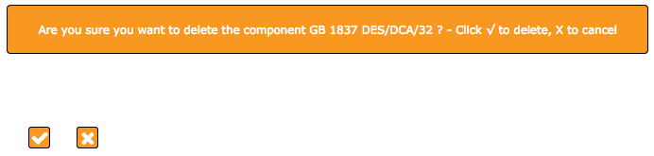
The confirmation message for deletion (you may need to scroll down slightly to see it). You can confirm or cancel.

Administration

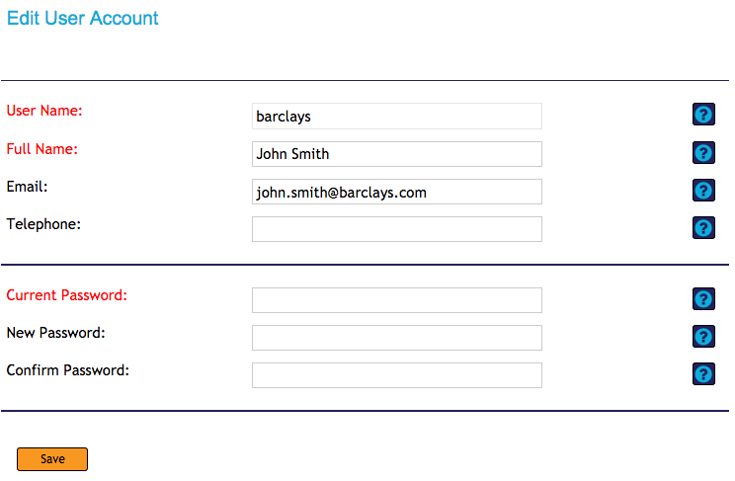
You can change your password within the Admin area. You cannot change your username, as this is set within the system.

You can request additional basic user accounts or admin user accounts for your institution by using the request button or simply emailing us.

A basic user account gives rights to view and edit the descriptions created under that login.
An admin user account gives rights to view all descriptions. But descriptions can only be edited under the account they were created with.

Uploading Descriptions

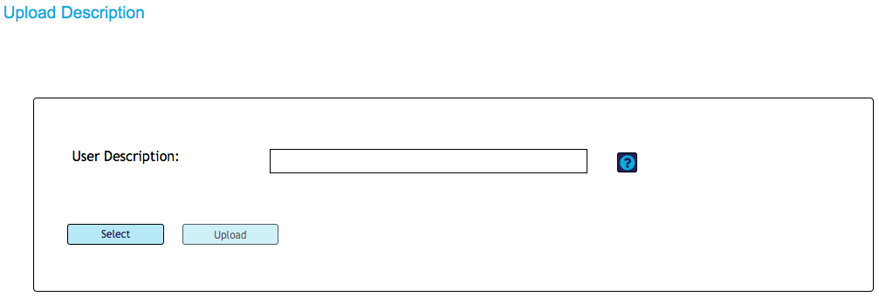
We provide an upload option, for EAD descriptions to be uploaded into the Editor

We have implemented a block on uploads from Calm exports. This is because the EAD created from a Calm export needs more processing to make it Hub valid EAD. If it is uploaded directly, we have found that the variations in the markup create problems.

We can take direct exports from Calm, or, if you want to use the Editor, we need to process the descriptions and then make them available in the Editor. Please email us to discuss the best option for you.

Editing Uploaded or Migrated Descriptions

Please be aware that the new Editor implements more rigorous controls to ensure valid EAD than the old Editor. Therefore, if you upload or open EAD descriptions created elsewhere (including in the old Hub Editor) that are not valid, you will be prompted to make changes. There may be substantial changes if the description has many validation errors.
Many descriptions have been migrated from the old Editor to the new Editor. The new Editor has more validation and field checks, so you may find that you have to make revisions in order to save the description as a Hub EAD description.

When you save a description that has been uploaded to the Editor, you may get prompts about corrections that you need to make. This is because when you click on save, the process of checking the content is initiated.

The tree will show where there are errors in your description.

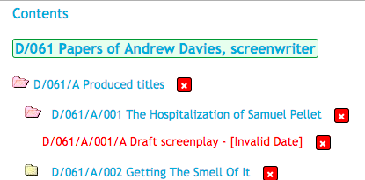
A hierarchy showing where there is an invalid date that needs to be corrected. The folder is also coloured pink to indicate that corrections are needed.

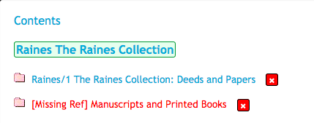
An example showing where there is a missing reference that needs to be added before the description is valid.

Fields will be highlighted in red that need to be completed. If there are corrections to be made within the level you are at (e.g. you are at collection level and there are errors at collection level) then you will be taken directly to the field that needs correcting.

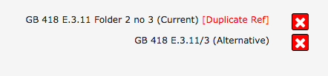
A duplicate reference – one of these needs to be changed to make it unique.

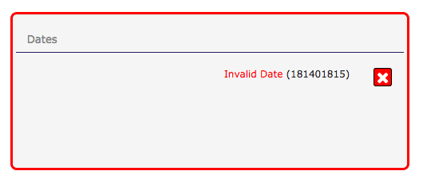
An invalid date that is not ISO compliant. You need to delete the date and re-enter it.

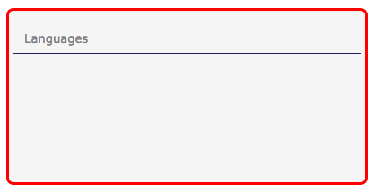
No language is provided at the top level. Add one or more languages.

Once you have made a correction, you will need to save the record. The Editor will then need to re-calculate the errors in the description, so the Table of Contents will take you back to the top, although your folder will still be open.

With index terms, if you select any individual terms to edit, the Editor will check them at that point. It will require you to edit them if they are not valid before you can save the description.

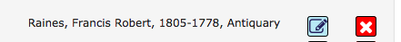
A name with incorrect dates

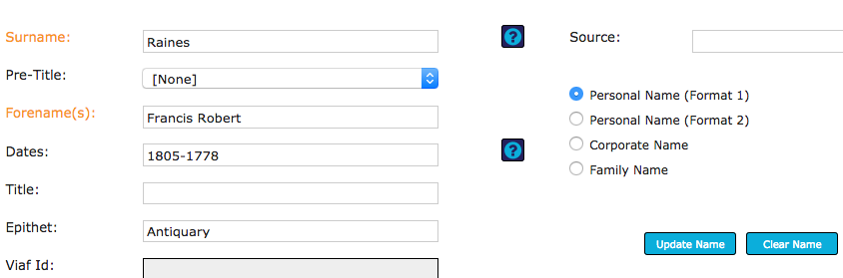
If you click to edit the date, the editor will then check whether it is valid.

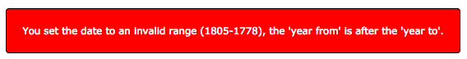

Error: invalid date

We have tried to ensure that the EAD Editor can handle a range of EAD descriptions created elsewhere, including on our old Editor. But the huge amount of variation in description means that you may encounter problems with externally created EAD descriptions. Please email us if you have any problems.

