

Student Name: GOWRI PAMARTHI
Student Number: 2206771
Module Name:
Research Methods and Professional Development (ACFA7004)
Assignment Title:
Customer Sentiment Analysis on airlines using NLP Techniques

Table of content

Table of content 2
List of Figure 4
1 Introduction 5
1 Background of Study 5
1.1 Purpose of Study 5
1.2 Aim and Objective 5
1 Aim 5
1.1 Objective 6
1.3 Research Question 6
2 Literature Review 7
2.1 Existing Research 7
1 Traditional Methods 7
1.1 Modern Methods 7
2.2 Identification Gaps 8
2.3 Role of Customer Sentiment Analysis on Airlines using NLP 10
2.4 Related Work 11
3 Methodology 13
3.1 Overview 13
3.2 Natural processing language 13
3.3 Ensemble Techniques 14
1 Random Forest Techniques 15
1.1 Gradient Boosting and Extreme Boosting Techniques 16
1.2 ADA Boosting Techniques 16
1.3 Decision Tree 17
3.4 Summary 17
4 Result and Analysis 18
4.1 Data Collection 18
4.2 Extract basic and statistical information 18
4.3 Pre-process the text data 19
4.4 Data Cleaning 19
4.5 Data Analysis with graphical ways 19
4.6 Data Splitting and Standardization 20
4.7 Creating Model 20
4.8 Final result 20
5 Evaluation 21
5.1 Conclusion 21
5.2 Recommendation 21
5.3 Future Scope 21
6 Reference 22

List of Figure
Figure 1.1 Ensemble Algorithm Structure 8
Figure 3.2 Natural processing language 14
Figure 3.3 Ensemble Algorithm Structure 15
Fig 1 Random Forest Algorithm 16
Fig 1.3 Decision Tree Algorithm 17

Introduction

[1] Background of Study
“Customer sentiment” the word itself represents the emotions of customers which means the emotion of the customers toward any business, supermarket, or any organizations [2]. Here emotions mean whether the customer is satisfied with the provided services of the organizations or not. The customer is considered the god of any business because if the customer is not satisfied with providing services, then that customers never come back to buy anything next time onwards. In this work study the author considered or selected the sentiment analysis of Airlines using ML techniques. Because here the author wants to know whether all customers who are taking services from this organization whether they are satisfied or not with provided services.
The airline is one of the biggest and busiest industries nowadays because everyone uses these services to reach their destinations within a shorter period and is safer also [6]. But there are various airline services or organizations available in the market. Although multiple organizations availability but many people are not satisfied with the service quality and especially ticket prices of any organization. That’s why in this work study the author tries to identify which airline services most people are not satisfied with and what are the reasons behind that through sentiment analysis. Because analysis of this problem is very important otherwise many organizations are providing low-quality service and at one point the company may vanish due to the lack of customer demand. Because nowadays many organizations are available in the market to provide the same facility within the best budget that’s why is not maintain well the services then they are lost their business scope.

[1.1] Purpose of Study
Here the main motive of doing or selecting this study work is because recently it is observed many people are not satisfied with the provided services and especially the price of tickets. The organizations suddenly increase the price of the tickets and they are not providing that quality also. That’s why the author wants to identify the organizations that are not providing satisfaction-level services to customers.

[1.2] Aim and Objective

[1] Aim
To assess airline customer experiences via the utilization of machine learning and natural language processing.

[1.1] Objective
- The first objective is to find the best suitable for this work-study.
- After that find the platform to implement this work-study code.
- Choosing the best plots and graphs to represent the hidden information.
- Choosing the optimal techniques to create suitable models for this problem statement.
- After that used model evaluation techniques to finalize the best model for that.

[1.3] Research Question
Research question plays an important role in any project because with that it is understood what the author trying to find in this research study. Some of the research questions are given below related to this work study,
- What are the factors that the authority can’t provide quality services?
- How to find the organizations that are not able to provide quality services and for that facing losses.
- From where the particular organization is facing low-quality service issues, and find them.
- How NLP techniques are going to be best-suited approach to finding the customer sentiment analysis?

2. Literature Review

[2.1] Existing Research
The author is describing the existing research on airline customer satisfaction through sentiment analysis. The results of the airline analysis based on the satisfaction of the customers have been divided into two categories such as traditional approaches, it is discussing the earlier stages of the flight customer analysis, and another one is modern approaches, for the sentiment analysis of the customer online site reviews for the estimation of the tested data for the customers or airline passengers.

[1] Traditional Methods
In the traditional methods, the author has been used for the sentiment analysis for the commercial passengers for the airlines and they can relate with their satisfaction of the online reviews. The social media platforms are using textual data and analyse the responses of the tweets, and collect their research proposals and it is based on the lexicons and emotion lexicons (Higgins, 2022). The author has used the firstly NLP method for the detection of the analysis of the customer’s texted data and then used the various ML methods to predict the sentiment of customer analysis, the importance of the airline services is monitored in the approach and the methods are analysed and they have improved the offers for the services and the author has got 71% percentage of the naïve Bayes classification technique for the analysing the online reviews of the satisfaction of the passengers. The author has used the NLP method to predict the consumer satisfaction level for analysing the online reviews of the covid -19 pandemic before and after the analysis of the data. They have used the word embedding system and visual analysis for the level of the rating in the airlines finding the outcomes from the analysis (Gupta and Bhargav, 2022). The data can be predicted using the ML methods for the unrated aspects of the ratings and the existing data has been complemented and there to understand in an easier way to approach them for the airline industry.

[1.1] Modern Methods
In today’s generation, modern methods are used for the prediction of the analysis of customer reviews for their satisfaction level to be more focused on them and their spending a lot of money in the markets. The author has implemented the analysis of customer sentiment analysis for machine learning and NLP techniques are used (Tusar and Islam, 2021). The sentiment analysis of the services and products is finding the outputs for the online available data. They have used the SVM, logistic method, Naïve Bayes, etc, for the prediction of airline sentiment customer analysis. The data has been used in the research and has been considered to be the misbalancing and multi-classification data, it has got a 77% percentage of accuracy in the SVM and logistic regression of words methods. The author has used digitally texted data for the reviews of online site analysis. The researchers are increased based on the applications in the future, they analysed the fundamental relationships with their methods. In the marketing analysis, there are so far in the integrations. The neural networks methods are based on the ML methods, the author has pre-trained the data for the diagnosis and prediction to selective methods to be procured and reviewed the textual data to liked and analysed for the objective in the diagnosis versus the prediction of future (Alantari et al., 2022).
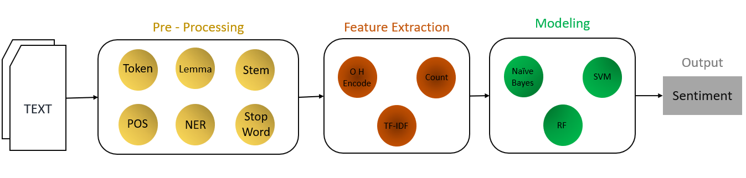
Figure 1.1 Ensemble Algorithm Structure
Source: Own Image.

[2.2] Identification Gapss
SI. No | Title And Author | Technique Used | Result | Gaps
1 | Sentiment Analysis of Customer Feedback and Reviews for Airline Services Using Language Representation Model  (Patel et al., 2023) | Machine Learning Method (ML)  It is used as a classification method for this dataset. | The random forest method compared to the BERT model was the best performed in the ML methods. | There is the text and data were supplied to the sentimental analysis of the airlines for the attitudes and emotions of the consumers.
2 | Predicting aspect-based sentiment using deep learning and information visualization: The impact of COVID-19 on the airline industry  (Chang et al., 2022) | The author has used machine learning (ML), Natural Language Processing (NLP), and deep learning techniques (DL). | The data has been outperformed using the ML method for the prediction of the unrating aspects of customer reviews. | They have 9identify the research gap of the unrating level of the customer reviews sentiment analysis
3 | Sentiment Analysis of Twitter Data for Better  Services of Airlines Using Classifier-Model  Algorithms, AI, and NLP Techniques  (Ahmed et al, 2022) | In the dataset, the author has used machine learning and natural language processing, deep learning techniques for customer sentiment analysis. | The author has described that outperforms the classification methods using various ML methods | The gap is identifying the untextual data in these research papers
4 | Sentiment analysis on Twitter data integrating TextBlob and deep learning models: The case of the US airline industry  (Aljedaani et al., 2022) | The author has used various Machine learning techniques and deep learning methods in the analysis of the airline sentiment analysis of the customer’s online reviews. | The results have got an optimum solution for the 92% of the support vector machine and extra tree classification method. | Here the author does not mention the sentiment analysis of the airline industry.
5 | Opinion Mining on US Airline Twitter Data Using Machine Learning Techniques  (Saad, 2020) | In the dataset, the author has used various methods in machine learning techniques, and Natural language processing (NLP). | The results of the dataset have a got 6the training 70% and 30% for the testing and at last, the SVM method has got the 83% of the highest accuracy in the classification of the ML. | The author does not mention the gaps in the opinions of the sentiment analysis of the airline’s reviews of the passengers.

[2.3] Role of Customer Sentiment Analysis on Airlines Using NLP
In the role of customer analysis of the sentiment analysis on airlines has opinions on the natural language processing and they can use the Machine learning techniques and it is automatically an emotion for the communication in the online sites. In the analysis, the customers traveling in the airlines are given a review in the online websites for the analysis of the implementation of the analysing data for the accuracy models and they are to be predicted and depended on the methods. It has various methods for customer analysis to get manually crafted rules automatically. The Rule-based method is a human-crafted rule for the analysis of the polarity, subjectivity, and opinions of the user to analyse the customer reviews online for the airline industry. It has some rules such as stemming, tokenization, and parts of speech tagging and parsing, another rule is based on the lexicons as it is a word and in the form of expressions. It has some polarized words and positive, and negative words for their appearances and also for neutral sentiment. The advanced level of techniques they are using the new expressions and vocabularies are added the new rules, some of them are affected in the analysis of customer reviews for their regular investments of the approaches. After, that the ML method will automatically rely on their systems for analysis, and the hybrid system is also approaching automatically in the future for the analysis of the customer sentiment on the airlines.

[2.4] Related Work
Various researchers are working on this project in their distinct ways. The main Aim of the project is to predict the customer sentiment Analysis on airlines using the NLP techniques. As a result, some researchers choose the ML technique while others use the DL technique. Yet, both tactics have the same purpose because, in the end, both techniques produce the best output of this model as well as the total result. In this part, the authors discuss all related work to this project. However, in this study, the author only used proposition-based ML techniques. To gain more relevant information, the author would also want to see others do a related study on this topic. Such knowledge contributes to the development of more accurate values.
The author Prabhakar et al., (2019), the main thing going on nowadays, the internet is the main role in the play and makes decisions throughout the overall world. The sentiment analysis of the customers is handling the problems, the US airlines will make in helping to the customer’s online reviews of various sites. Twitter will provide the best level of customer sentiment analysis of the airlines. The author has used in that machine learning techniques for performing analysis of the various algorithms and in this paper the author has used the ADA boost method for the identification of employed. Ashi et al., (2019), the author has been used Advance technology to solve the problem of customer sentiment analysis is the NLP method. The ABSA problem was found the author is predicting the classification of the sentiment analysis of the customer’s reviews of airlines on the websites. They are about their models and detecting the sentiment analysis they have used the support vector machine and the author has got the optimum solution of the fast text Wikipedia word embedded system was better than travel web for the reviews of customers on the websites.
The research paper on a social network service using the Twitter site to produce their products and various services based on their opinions for customer sentiment analysis arises, and it automatically updated the data for analysis. The detection of the polarity of sentiment analysis due to some of the services like positive, negative, and neutral for various airlines in the US. The author has used the word embedding methods for the prediction and they also used deep learning techniques for the long-term prediction and exploratory data analysis of the customer analysis. The accuracy has been trained for the 80% and training has got the 20% of future prediction (Monika et al., 2019). The analysis of the text is performing the airline services by giving reviews for future prediction. The author has used the importance-performance analysis (IPA) the experiencing the various things to get reviewed on the online site. They have analysed the statistical data for the evaluation and correlation between them, TAIPA calculations, and benchmarks in the airport transportation industry for the customer satisfaction of data that has been analysed (Nam and Lee, 2019). Another research paper on social networking platforms is permitted to users, items, messages, etc., and many more throughout the world. The author has been used for the detection of customer sentiment analysis on airlines using machine learning methods to solve the problems of airline transportation and reviews of online sites. The author has used various methods such as SVM, naïve Bayes, and RF then the analysis of sentiments of the customers are analysed. The dataset has been doing not performed well (Kaur and Malik, 2022). The customer’s opinions are mostly receiving their products and services by the company wise. Customers are using social networks, and messengers, are receiving data from the tools. The author has described the strengths and weaknesses of the airlines and the customers to be analysed for the management of the solutions for the problems and for improving the marketing strategies of the business to attract the customers for their satisfaction reviews in the airlines (Farzadnia and Vanani, 2022).

3. Methodology

[3.1] Overview
This methodology part describes the scope of the project and offers solutions to the issues. Design, research approach, problem-solving planning, data gathering, and how the author will provide research question answers are covered in this part. In addition to these, this chapter goes into great detail about the present study's limitations. A model that must be trained to anticipate patterns is known as a machine learning model. Here, the author chooses which groups, such as regression and classification, to place the issue. Here, this data set, which also contains NLP, confirms that the issue is one of classification. This dataset includes a text column as well as a column of object-type data that is divided into three classes: neutral, positive, and negative kinds. NLP is explained in 3.1. According to the literature study, the ensemble techniques are explained in Section 3.2 along with which is best for this. Section 3.3 explains how standard machine learning methods affect this project. The main challenge of this project is answering the research question. According to [1] Since most of these connected issues fall under the category of visualization, the author must include a meaningful visualization in this section so that readers can quickly grasp the scope of the issue and the nature of the research process. The viewers are more satisfied with this type of response.

[3.2] Natural processing language
Making natural human language understandable to computer programs is the focus of the subject of natural language processing. The two primary methods for using natural language processing in this technique are syntax and semantic analysis. The word placement in a phrase that ensures proper grammar is called syntax. NLP employs syntax to evaluate a language's meaning based on grammatical principles (Kedia, and Rasu, 2020). NLP is essential to this project because the author has already discussed it in the dataset's text and airline sentiment columns. For this reason, the author should use NLP for the preprocessing steps of tokenization, stemming, lemmatization, part-of-speech tagging, named entity recognition, and chunking (Srivastav et al., 2020). Tokenization is the process of breaking down text into discrete characters. The finest words are being created through stemming and lemmatization. Choosing the best part of the body to use for speaking and tokens is a component of speech. Chunking is the process of assembling smaller pieces of material into larger ones.
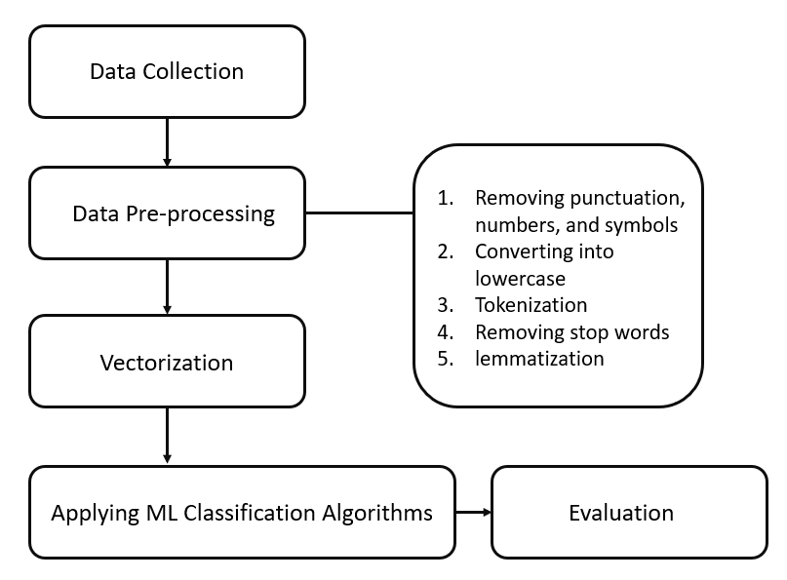
Figure 3.2 Natural processing language
Source: Own Image.

[3.3] Ensemble Techniques
A computer is taught to provide a history of data through the process of machine learning, and the computer then utilizes what it has learned from the history of data to make a forecast. Four different kinds of artificial intelligence exist. supervised, unsupervised, semi-supervised, and reinforcement learning are all types of machine learning methods. Regression and unstructured (classification) learning are two subsets of supervised machine learning, which includes this dataset. A method known as ensemble learning is used in this supervised machine learning scenario. Algorithms for ensemble learning blend the forecasts from multiple models. Bagging, stacking, and boosting are the three major classes of ensemble learning methods, and it is crucial to comprehend each method in-depth and take it into account in this predictive modeling project (Sahoo, et al., 2022). Ensemble techniques are useful in this endeavor because they typically yield more accurate results than a single model would.
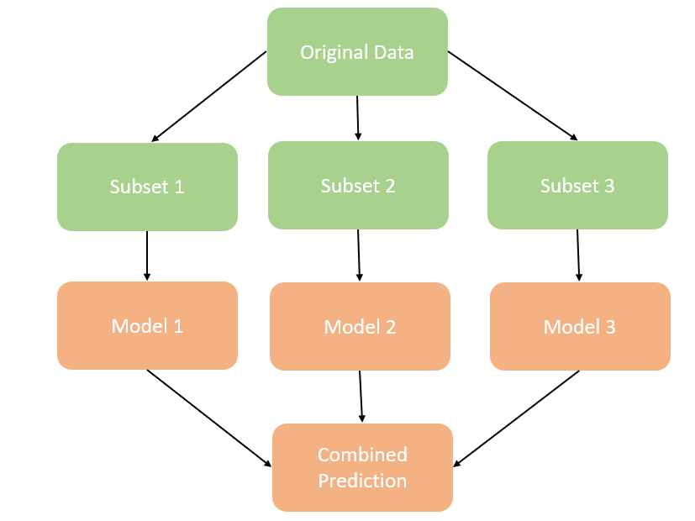
Figure 3.3 Ensemble Algorithm Structure
Source: Own Image.

[1] Random Forest Techniques
Random forest is one of the most popular machine-learning techniques. It belongs to the bagging model and performs well in both regression and categorization. The random forest uses all of the decision trees to make predictions rather than just one, and it chooses the result based on which predictions got the most support. Because each decision tree is perfectly trained for a particular collection of data, multiple decision trees are used to create the final product as opposed to just one. Each decision tree has a significant variance, but when they are merged at the same time, the variance seems to have a detrimental effect on accuracy [8]. Large databases can be built up with ease as well. This strategy is the most effective one for this study.
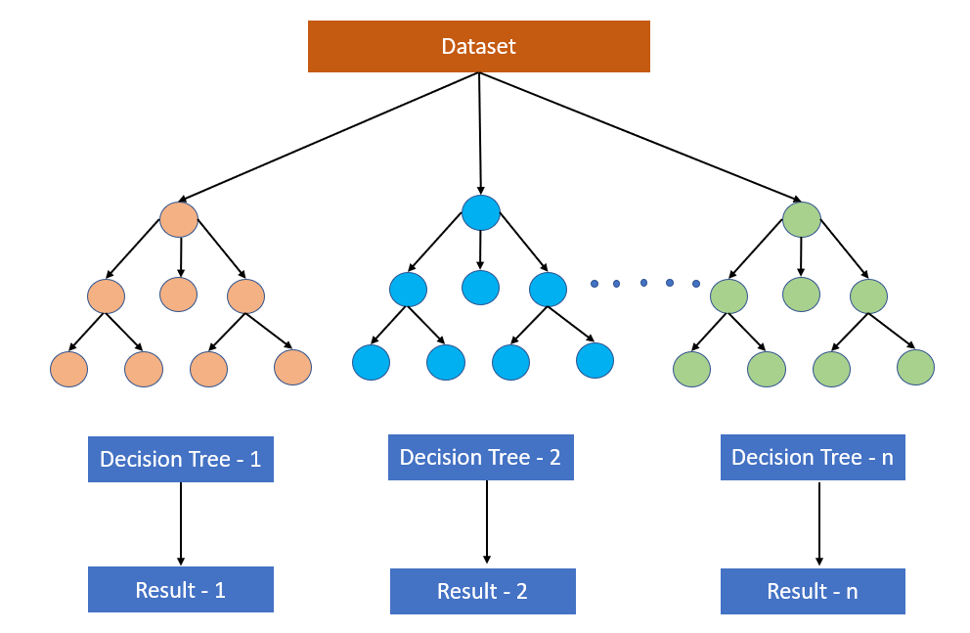
Figure 1 Random Forest Algorithm
Source: Own Image.

[1.1] Gradient Boosting and Extreme Boosting Techniques
Gradient boosting methods can produce predictive models for many difficult regression and categorization problems. The gradient boosting generator is one of the most effective boosting techniques. Both Gradient Boosting and XG Boosting are processors that work similarly and bring new models to fix flaws in older models. As per the view of Lartey et al. (2021), one tree makes an erroneous prediction about the variable's weight in this model, and another tree uses XG and gradient boosting to feed it to make the decision tree. To completely randomize the selection process, the technique makes use of sampling with replacements. These kinds of techniques are best for this project.

[1.2] ADA Boosting Techniques
Ada, which stands for adaptive boosting, is effective for classifying data because it turns several weak classifiers into a single powerful classifier. The AdaBoost does is that it creates a model, gives all the data points equal weights, and then gives incorrectly classified points greater weights (Ramakrishna, et al., 2023). Because of this, ADA Boosting is appropriate for both binary and multiclass categorization.

[1.3] Decision Tree
One of the most well-known machine learning methods that can be applied to categorization and regression issues is the decision tree. It is a tree-structured classifier, where internal nodes stand in for a dataset's features, branches for the decision-making process, and each child node for the classification result (Nistor, and Zadobrischi, 2022). It has two nodes, the Leaf Node, and the Decision Node. This approach to NLP was recommended by the majority of researchers, so it was taken into account for this undertaking.
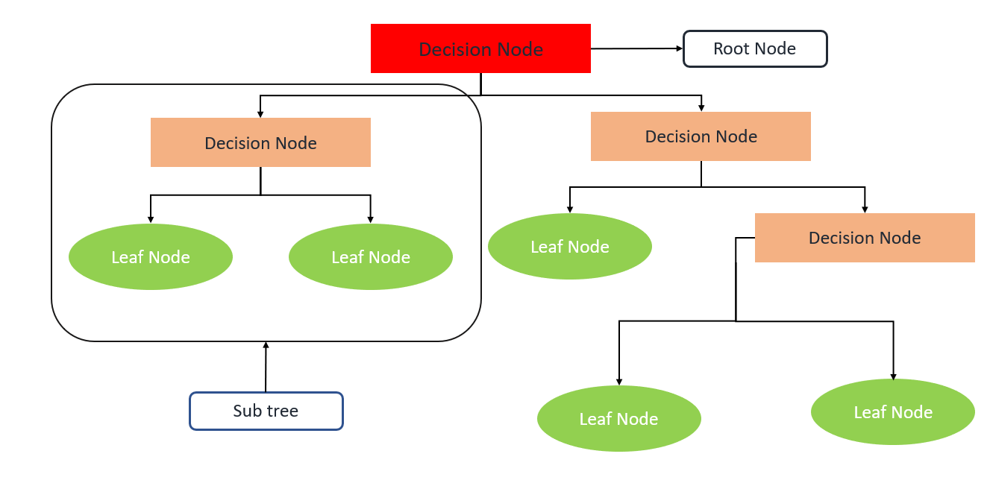
Figure 1.3 Decision Tree Algorithm
Source: Own Image.

[3.4] Summary
The opinions expressed on flight websites can be analyzed using a variety of techniques. To evaluate the sequential patterns of the prediction methods and investigate the process of the predictive modeled dataset for effective outcomes, a variety of machine learning algorithms are used. Real-time applications employ every machine learning technique to potentially produce the intended results. Using the decision tree and XGB classifier for result validation, the regression and classifier models are applied to the trained dataset to assist in identifying the dataset's errors. These methods and techniques can be used to handle complex issues and produce reliable results.

4. Result and Analysis
Here the author describes the complete technique for evaluating the model. According to the target variables of the dataset, it is a multiclass classification technique as well as supervised learning. For this reason, all classification techniques are used here. So many techniques are used to get results. In this section, the author describes all the techniques that help in generating good-quality data. Here the author wants to use some statistical methods and some visualization techniques to get more secret information. After completing all the pre-processing tasks, the author used some selective ML models to predict this model. Here the author selects some classification models because it is a multi-class problem based on the target variable. Also, the author uses NLP techniques to manage all the textual information. Because as per the title, the main goal is to analyse the customer sentiment means that the customer wants to summarize the reviews then based on the customer reviews the writer identifies the sentiment through NLP.

[4.1] Data Collection
Data collection is an important step in every data science project. Another important point is to find the right data because if there is no good information in the dataset, the whole model will fail. So, it is important to find the right information before starting any action. For finding data, there are two popular websites one is Kaggle and the other is UCI. Both sites have a lot of data. Because of this, the author finds this content on Kaggle, and the author is also able to get good-quality data based on the content.
After collecting the data, the author loads the data with the help of Pandas Libraries. In Pandas library there are many functions are present. Based on the data extension, all the functions are working. For example, if the data extension is CSV, then the read-csv function is used for loading purposes.

[4.2] Extract basic and statistical information
Because of this, some libraries are required so the author imports all libraries. The author prefers Pandas and NumPy because the Pandas library helps to manipulate data and NumPy helps to handle all mathematical calculations. Many Python functions and methods help extract basic information. For example, the dtype function helps to find the type of all attributes. Then the Isnull function helps to check if any missing values ​​are present. To check for duplicates, the duplicate’s function is present which returns duplicate values ​​if present. To check the total number of rows and columns, the shape method helps. All basic functions help to get more information about the data. For this reason, the author intends to use all the methods mentioned in this project. Similarly, describe a function capable of displaying complete statistical information about the data. By using this function one can easily know information about numeric columns as well as the hierarchical column. For this reason, the author prefers to use this method as well.

[4.3] Pre-process the text data
According to the dataset, here the author wants to analyse the sentiment data. Here customer reviews need to be processed and data is divided into categories based on the reviews. If a customer gives a good review, then it comes under a positive review and if a customer gives a negative review about the airline, then it comes under a negative review. Similarly, some people give good reviews as well as bad reviews while such reviews fall under the neutral category. For this reason, the author wants to use NLP techniques to manage textual data. Some libraries are required to implement NLP techniques. The author imports all required libraries.

[4.4] Data Cleaning
After extracting the basic and statistical data, it is very easy to delete all the unwanted data. This is a very important step in every ML project. It also helps to increase the accuracy of the model. For this reason, the author uses this technique here. For example, suppose the total number of unique columns is 1 then this column is useless at this time so one can easily remove this entire column with a drop function. Similarly, many times the column name does not represent a unique name, in which case, it is important to replace the name with a unique name. If a duplicate is found, all duplicates are easily removed from the data using the drop-duplicate function. In this project, the author used all the functions to get the data in a pure format.

[4.5] Data Analysis with graphical ways
Here the author analyses the data to get more information as well as helps to explore all the hidden information. Here the author uses univariate, bivariate, and multivariate analysis used for analysing data graphically. Univariate analysis helps to obtain information about a single feature. For this reason, the author used this analysis to get more information. This is because models are often under-predicted due to useless features. At the same time, the author also used bivariate analysis because it always compares one characteristic with another characteristic. It helps to get information about the comparison between the target column and other columns.

[4.6] Data Splitting and Standardization
After getting good-quality data, then one of the most important steps is to segment the data. For this reason, the authors split the dataset into X and y. All independent columns are stored in the X variable and dependent columns are stored in the y variable. Next, the author again splits this X and y into train and test data. Because every machine learning technique wants to train the model before testing it. Training helps teach the model to prove a good prediction. From the complete data, the author stores 70% data for training purposes and the remaining 30% data is stored for testing purposes.
Next, another important point is to standardize both training and test data. Because the machine doesn't know which values ​​0 and 1 take. Therefore, all features must be converted to a standard format before using any algorithm. For this purpose, the author divided both train and test data based on categorical and numerical forms. For categorical data purposes, the author uses label encoding and when necessary, the author uses one hot encoding. Similarly, for numerical data purposes, the author used a standard scalar. Add categorical and numeric data and test data to train after transforming.

[4.7] Creating model
It is a multiclass classification technique for this reason the author used all the algorithm which is capable to handle multiclass problems. Because many algorithms are not capable to handle multiclass classification. Before starting the model execution, the author imports some libraries to evaluate the project outcomes of all the selective models. The ensemble model always performed well in the multiclass problem. For this reason, the author used all the ensemble models. In the ensemble model, the author used only bagging and boosting techniques. For bagging the author use a Decision tree and for boosting the author used Random Forest, AdaBoost, Gradient Boosting, and XGBoost. All the algorithms always used weak learners and create strong learning for this reason every time accuracy should be increased.

[4.8] Final result
After using all the models, the author selects a model based on evaluation techniques. In evaluation techniques, there are different methods. It is a multiclass classification technique based on target variables. So, precision, recall, f1-score, and precision all come under the classification report. Based on any strategy, anyone can choose their model. But the author prefers to use precision because it is compatible with all techniques.

5. Evaluation

[5.1] Conclusion
After applying different techniques of the ML classification problem, the author got different results from multiple algorithms but the author can’t finalize all of the models for this proposed work study. The author has to choose the best suitable model and what is the reason behind that problem to choose that particular model or other words it can be said that gives the justification for this choosing model. After that, the author concludes this work study in this chapter. It is observed that the author applies different techniques of pre-processing and cleaning to provide clean data in the model so that model learns well. After these so many struggles finally the author completed this work-study now it’s time to apply these techniques to different airline organizations so that they can optimize their mistakes and correct all of them to maintain their reputation in the market and increase the revenue of the organizations.

[5.2] Recommendation
Generally, the recommendation id is given to improve the performance of the model as well as the procedure by which some other people complete this work within a short time with high prediction power. But here the work is going on, it’s not completed so for that the recommendation is to collect the quality of data and apply the standard data format as well as proper visualization techniques to show all the hidden information of the data. Here the author uses the ML techniques but it is well known that compare to ML Deep Learning (DL) is more accurately performed, so it is also recommended to use DL techniques to get more accurate results.

[5.3] Future Scope
After completion of this project work, it is possible to recommendation of different airline organizations to use these models or techniques to identify the problems and find the factors why the customers are not satisfied with their services and many more. If the organization is able to find the mistake, then they can easily rectify them and improve their facility to attract customers as well as increase the revenue of the organization.

6. Reference

[1] Alharbi, M. and Laramee, R.S., 2019. Sos text is: An extended survey of surveys on text visualization. Computers, 8(1), p.17.
[2] Dwivedi, Y.K., Ismagilova, E., Hughes, D.L., Carlson, J., Filieri, R., Jacobson, J., Jain, V., Karjaluoto, H., Kefi, H., Krishen, A.S. and Kumar, V., 2021. Setting the future of digital and social media marketing research: Perspectives and research propositions. International Journal of Information Management, 59, p.102168.
[3] Janjua, F., Masood, A., Abbas, H., Rashid, I. and Khan, M.M.Z.M., 2021. Textual analysis of traitor-based dataset through semi-supervised machine learning. Future Generation Computer Systems, 125, pp.652-660.
[4] Kedia, A. and Rasu, M., 2020. Hands-on Python natural language processing: explore tools and techniques to analyze and process text with a view to building real-world NLP applications. Packt Publishing Ltd.
[5] Lartey, B., Homaifar, A., Girma, A., Karimoddini, A. and Opoku, D., 2021, October. XGBoost: a tree-based approach for traffic volume prediction. In 2021 IEEE International Conference on Systems, Man, and Cybernetics (SMC) (pp. 1280-1286). IEEE.
[6] Morrison, A.M., 2022. Hospitality and travel marketing. Taylor & Francis.
[7] Nistor, A. and Zadobrischi, E., 2022. The influence of fake news on social media: analysis and verification of web content during the COVID-19 pandemic by advanced machine learning methods and natural language processing. Sustainability, 14(17), p.10466.
[8] Patange, A.D. and Jegadeeshwaran, R., 2021. A machine learning approach for vibration-based multipoint tool insert health prediction on vertical machining centre (VMC). Measurement, 173, p.108649.
[9] Ramakrishna, M.T., Venkatesan, V.K., Izonin, I., Havryliuk, M. and Bhat, C.R., 2023. Homogeneous Adaboost Ensemble Machine Learning Algorithms with Reduced Entropy on Balanced Data. Entropy, 25(2), p.245.
[10] Sahoo, R., Pasayat, A.K., Bhowmick, B., Fernandes, K. and Tiwari, M.K., 2022. A hybrid ensemble learning-based prediction model to minimize delay in air cargo transport using bagging and stacking. International Journal of Production Research, 60(2), pp.644-660.
[11] Srivastav, A., Khan, H. and Mishra, A.K., 2020. Advances in Computational Linguistics and Text Processing Frameworks. In Handbook of Research on Engineering Innovations and Technology Management in Organizations (pp. 217-244). IGI Global.

