
Contemporary issue in performance management


[Date]

20/04/2026

Student name: Protick L Gomes
Student Id: 2506443

Executive Summary
The report also takes into account two case studies because they can be used to assess the efficacy of the present performance management in improving strategic control, decision-making, and long-term value creation. The first case, Mitchum Fabrication Plc, concerns the performance measurement at the level of a division, transfer pricing, and the Information systems role. The analysis reveals that, in comparison to the performance of divisions, Return on Investment (ROI) is too insignificant to apply as the primary measure since it can only mislead the managerial response and degrade the goal congruence. The report further concludes that a cost-plus transfer pricing strategy would be more suitable than a market-based one, but the proposed executive information system would help in improving the coordination, reporting, and strategic control. In the second case of Indorex Footwear Limited, the company looks at how the growth crisis is affecting its performance based on the Balanced Scorecard and the necessity of business process reengineering. The results indicate that external shocks, sourcing cost increment, and sourcing cost loss deal with Indorex, as well as weak structures. Although the customer satisfaction, efficiency of the process, internal development, and development of employees have improved, the financial performance has dropped drastically. The report concludes that the need to have business process reengineering to optimize Planning, sourcing, responsiveness, and coordination. In general, both instances demonstrate that successful performance management should be a blend of good financial practices, non-financial metrics, behavioral consciousness, and alignment of strategies.

Table of Contents
Executive Summary ii
Introduction 0
Main Findings 1
Part 1: Mitchum Fabrication Plc 1
Evaluation of divisional performance and proposed measures 1
Transfer pricing evaluation 3
Executive Information System and Performance Management 5
Part 2: Indorex Footwear Brand 8
The Growth Crisis Facing Indorex 8
Quantitative and Qualitative Performance Using the Balanced Scorecard 11
The Need for Business Process Reengineering (BPR) 14
Conclusion 19
Bibliography 20
Appendix 21

Introduction
The report contains two case studies within the framework of modern performance management and the way organisations could utilise performance information even more effectively to contribute to the process of decision-making, control, and successful development in the long term. The first case study is an analysis of Mitchum Fabrication Plc, a divisionalised manufacturing company experiencing issues with regard to how the performance of the different divisions is being evaluated. In this part of the report, the evaluation of the performance metrics of each of the divisions, especially the ROI, RI, and EVA, in design, and the implications of the transfer pricing among the different divisions, is discussed.
Another case study illustrates the case of Indorex Footwear Limited, which was a medium-sized fashion firm that was going through a strategic and operational tussle. This focuses on the crisis of company growth, evaluation of its quantitative and qualitative performance using the Balanced Scorecard approach, and an overview of reasons why business process reengineering is needed to support the competitiveness and growth of the business in the future. Overall, the report highlights the importance of aligning the performance measurement systems and the organisational strategy with effective control mechanisms and the broader objective of value-creation in the long run.

Main Findings
This process of designing, managing, and improving the contribution of people, teams, and the organisation is referred to as performance management (Lewandowski and Cirella, 2022). The purpose is to improve productivity, create performance targets, and measure performance, along with feedback, the creation of performance improvement, and good decision-making. It emphasises the way of realising organisational objectives through effective and efficient performance.

Part 1: Mitchum Fabrication Plc
Mitchum Fabrication Plc is a divisionalised manufacturing firm that makes car buffing machines and maintains the quality of its products in the form of a long warranty and an already established warranty repair service. The company is divided into two, namely, the Manufacturing/Sales and Service, and the board believes that the current system of performance measurement at the divisional level may not be just in measuring the performance of the managers (Drury and Tayles, 2025). This makes performance assessment important as the indices that are adopted are going to affect the behavior of the managers, the dimensional coordination, as well as the overall objective of maximising shareholder wealth.

Evaluation of divisional performance and proposed measures
The managerial performance should be isolated in the organization, which is divisionalised against the division-based economic performance (Bhimani et al., 2019). This is important at Mitchum since apportioned head office costs are likely to decrease fairness in case of being treated as completely controlled by divisional managers (Datar et al., 2021). The table indicates that M/S is far stronger than Service both in absolute and relative terms.
Table 1 Calculation of ROI and EVA.
Measure | Formula | M/S Division | Service Division
Operating profit | Given | £361.00m | £4.00m
Profit before tax | Given | £276.00m | £3.00m
Capital employed | Given | £1,292.00m | £37.00m
Capital charge | Capital employed × 8% | £103.36m | £2.96m
ROI (operating profit basis) | Operating profit ÷ capital employed × 100 | 27.94% | 10.81%
ROI (PBT basis) | Profit before tax ÷ capital employed × 100 | 21.36% | 8.11%
RI (operating profit basis) | Operating profit − capital charge | £257.64m | £1.04m
RI (PBT basis) | Profit before tax − capital charge | £172.64m | £0.04m
NOPAT | Operating profit × (1 − tax rate) | £252.70m | £2.80m
Non-cash expenses | Depreciation + other non-cash expenses | £92.00m | £3.00m
Simplified EVA | NOPAT + non-cash expenses − capital charge | £241.34m | £2.84m

Evaluation of ROI
What makes ROI popular is that it is trendy, easy to understand, and can be applied to compare varying divisions (Hadid and Al-Sayed, 2021). At Mitchum, it is revealed that M/S is more efficient than Service. M/S is generating an operating profit of 27.94% as compared to 10.81% by Service. With a profit before tax basis, M/S is booked 21.36%, and Service is booked 8.11%. These findings imply a better utilisation of its asset base by M/S. But ROI is not devoid of shortcomings (Adler, 2022). It is also capable of destroying goal congruence, as when the managers make the divisional ROI low, they will be able to refuse to make investments that are good for the company. ROI is an instrument that is sensitive to the costs allocated (Lewandowski and Cirella, 2022). The dislocation of head offices costs in Mitchum contributes towards a lowering of the Service to 8.11% than 10.81%, assuming the same costs when the inclusion of the head office costs is involved, even though the divisional manager may not be able to control the non-adjusted costs. ROI only represents a percentage and hardly the actual value created (Curtis et al., 2015).

Evaluation of RI
RI involves an improvement in ROI since it deducts the cost of capital (Datar et al., 2021). It, thus, looks at whether a division generates wealth that is over and above the needed return. M/S will add to the operating profit of £257.64m, and Service will add to the operating profit £1.04m on an operating profit basis. M/S has a pre-tax profit of £172.64m, and Service has a post-tax profit of only £0.04m before tax. This means that the two divisions are adding value, after full charges to Service. RI is more powerful than ROI as it helps in augmenting shareholders' wealth as well as mitigating the chances of managers turning down beneficial investments. Its biggest flaw is that it is an absolute measurement, and that is why bigger divisions are bound to have a higher RI figure (Hadid and Al-Sayed, 2021). The benefits of EVA are that it is complemented by the optimum maximisation of shareholder wealth, which is the main corporate aim of Mitchum. But it is spoiled by pragmatic complexity (Chen, 2024).

Assessment of Economic Value Added (EVA) and overall judgment
EVA is similar to RI except that it is more directly related to the shareholder value (Hnylianska, 2022). On a simplified calculus, M/S generates £241.34m EVA and Service generates £2.84m EVA. Both are positive, and this means the two divisions bring about economic value. Notably, Service comes out to be stronger under EVA than profit before tax alone, which implies that the economic contribution of Service might be undervalued using conventional accounting figures. Generally, ROI should not be the only criterion used by Mitchum (Adler, 2022). RI is better than core measure because it is mindful of the cost of capital and maximisation of goal congruency. EVA is also applied, but it is more cumbersome to use in a more uniform way (Szutowski, 2021). With the RI and ROI as supporting measures of comparison, the operating profit to managerial appraisal by Mitchum should be controllable.

Transfer pricing evaluation
A good transfer pricing mechanism is likely to bring goal congruence, provide a sensible basis for a divisional performance appraisal, allow for a reasonable amount of divisional independence, and cannot be excessively convoluted such that it is impracticable in the real world (Coller et al., 2018). Also, as seen in the lecture material, performance systems should be technically good and behaviourally good; otherwise, rather than ensuring coordination of divisions, it would bring conflict within divisions (Chang et al., 2023). This applies to Mitchum, where the transfer price is felt in the performance that is reported by both the M/S division and the Service division.
Table 2 Transfer pricing evaluation.
Item | Formula | Result
Annual warranty repairs | 680,000 × 7% | 47,600 repairs
Total hours | 47,600 × 4 hours | 190,400 hours
Labour cost | 190,400 × £21 | £3,998,400
Variable overhead | 190,400 × £11 | £2,094,400
Fixed overhead | 190,400 × £23 | £4,379,200
Parts cost | 47,600 × £98 | £4,664,800
Total full internal cost | Sum of above costs | £15,136,800
Full cost per repair | £15,136,800 ÷ 47,600 | £318.00
Variable cost per repair* | (4 × (£21 + £11)) + £98 | £226.00
Current internal recharge per repair | £11,000,000 ÷ 47,600 | £231.09
External market price per repair | Given | £1,900.00
Annual outsourcing cost | 47,600 × £1,900 | £90,440,000

Evaluation of market price
The main advantage of market-based transfer price is that it is external and applicable to support the divisional autonomy (Hnylianska, 2022). To have a potential external market, the market price can help capture opportunity costs and reduce internal conflicts (Gabrielli and French, 2020). However, this should not be the way in Mitchum, though. The cost will take the form of the only electronic price of £1900/per repair, and this will produce an annual price of £9044m. This is well over the internal full cost of £15.14m as well as well over the current internal recharge of £11m. Thus, profit maximisation of the M/S division would be seriously hurt by using the market price, which would not contribute to the maximization of company-level profits (Pearlson et al., 2020). Another time that it would be hard to justify would be when the service division is not at full capacity.

Evaluation of cost-plus
Pricing that is based on cost-plus would be more suitable here, as Mitchum lacks an internal market competitor who is viable, and the service department is able to do such work (Kareem et al., 2021). Internal full cost is the repair; the cost is currently £318, and the variable cost is currently about £231. The repair of the same is incurred. For greater fairness in cost recovery for the service division, a full cost approach would lead to fairer results in service division reporting. It is also more consistent with division coordination (Kumar et al., 2021). The limitation is that the cost-plus would only take efficiency pressure out as long as transference of controller unproductive costs succeeds to the M/S division (Chang et al., 2023). Nonetheless, it is still much more logical than a transfer price based on the outside market quote.
Generally, Mitchum should not accept a quote of the price of a market-price transfer given by an outside engineering firm (McMillan and Overall, 2016). A cost-plus system is the most appropriate since it would be fairer, more practical, and more in line with overall company goals. Since outsourcing will be far more costly than having availability in-house, the warranty service would remain in-house unless other revenue potential can be recognized in the future that would offset the high difference.

Executive Information System and Performance Management

Current Performance Management system.
Currently, the performance management system at Mitchum is decentralised, and all departments have their respective information system (Legner et al., 2017). This form of decentralisation solution adds to the data silos, as the divisional managers may not access the information they need to come up with effective decisions. The inability to integrate systems leads to a reduction in the speed of reporting, poor visibility to the upper management, and a delay in tackling potential issues (Yu et al., 2015). The performance management system, as described at Mitchum, would not facilitate quick and informed decision-making in a fast-changing environment due to the unavailability of agility.

Executive Information System (EIS).
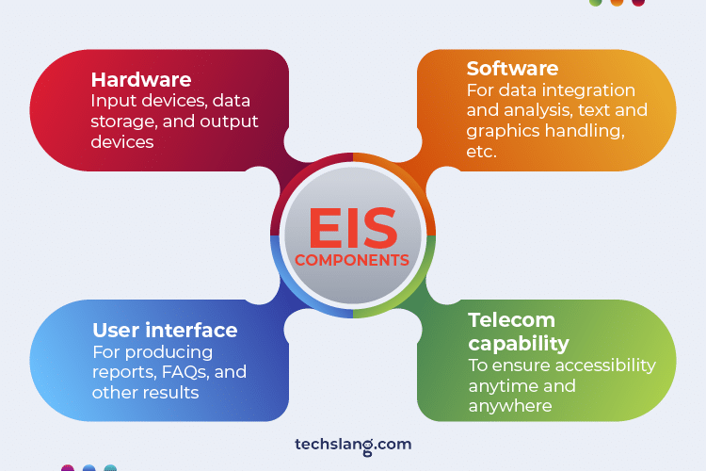
Figure 1 Executive Information System (Techslang, 2022)
The suggested Executive Information System (EIS) would consolidate all data in the five sites of Mitchum into one database, which executives could view at any time (McMillan and Overall, 2016). This kind of system would be able to facilitate real-time entries and updates of information to enrich the timeliness and accuracy of information flow (Pearlson et al., 2020). By incorporating the key performance indicators (KPIs) of all the functional areas, the system would enable the top management to have a holistic perspective of the operations, performance, and strategy of the company at any given time (Drozd et al., 2026). An EIS would enable the leadership of Mitchum to view the performance of various divisions on a real-time basis, and as such, it would be easy to determine underperformance, inefficiencies, or opportunities to enhance departments.

Key Benefits of the Proposed System
- Improved Decision-Making and Timeliness: The updates in real time and instant access to performance data would enable the executives to know gaps in performance and problems in real time (Safwan et al., 2016). The reason behind this is that the issues can be resolved quickly before they turn into anything. Executives do not have to wait until monthly reports to obtain an overview of quality, and it has to be done manually, which delays action (Atrill and McLaney, 2024).
- Better Co-ordination and Co-operation: The EIS would remove silos at Mitchum since it would integrate the information within the departments (Ţole, 2016). This would improve communication between the M/S and Service departments and would allow the latter to coordinate the resources more easily and better communicate with each other (Legner et al., 2017). With an integrated system, the divisional managers would be in a position to implement strategies and share performance measurements easily.
- Improved Performance Monitoring: The EIS would also give the executives up-to-date performance dashboards that are customised (Toni et al., 2017). These dashboards would display the real-time KPIs, financial performance, and operational measurements, and give indications about such aspects as sales performance, cost-efficiency, customer satisfaction, and inventory control.
- Increased Transparency: It would be more transparent because all the data is in one centralised performance measurement (Appelbaum et al., 2017). Considering the effects that it has on the overall company goals, it would be simpler to balance strategies and decide based on the data, as managers and executives could see the influence of the contribution of a single section to the company goals (Rossing et al., 2017).

Challenges and Risks
Though the suggested EIS brings about a lot of advantages, there are difficulties associated with its implementation (Drury and Tayles, 2025). The cost of setting up the system, software, hardware, and the training requirement could be expensive. Also, the current resistance to change among the workers who have used the existing systems may drag the process of implementing the new system. Finally, data quality is crucial as far as the success of the EIS is concerned (Yu et al., 2015). Data policies or imprecise information input can lead to misleading information and disrupt decision-making. The Executive Information System (EIS) proposed by Mitchum provides considerable advantages to the company in terms of better management of its performance. It would enhance the integration of data, provide real-time data, and ease decision-making at all levels of the organisation (Pearlson et al., 2020). The EIS would be a good inclusion in the performance management system of Mitchum since it would help it have a better tool in measurement and action towards the performance of the divisions.

Part 2: Indorex Footwear Brand
This would be an analysis of the growth crisis of Indorex Footwear Limited, as well as an analysis of how the company performs on the platform of the Balanced Scorecard approach. It discusses business process reengineering (BPR), which the company must solve its problems of inefficiency in operation, line of attack in the market, and survival (Arnold et al., 2019). These are monetary and non-monetary analyses that give a complete picture of the current issues and the potential strategic solutions.

The Growth Crisis Facing Indorex
As indicated by dwindling profits, operational pressures, and external market pressures, Indorex Footwear Limited is a medium-sized fashion retailer that is at risk of experiencing a growth crisis. Even as this firm has continued to expand and prosper since its founding in 2010, it fights against acute strategic, structural, and financial difficulties.

External Factors of Growth Crisis
It has been brought about by external factors as part of the growth crisis, both at Indorex and to some extent, the macroeconomic environment factors, and market conditions (Drozd et al., 2026).
Brexit and Exchange Rate Pressures: Crippling of the supply chain and trade barriers have been significant consequences for Indorex since the United Kingdom exited the European Union (Quesado et al., 2018). The maximum number of customers of the company is located in continental Europe and in particular Belgium, France, and the Netherlands, where the sales of Indorex had deteriorated by great margins due to increased tariffs and expenses incurred in administration (Haiss et al., 2016). The number of sales made by European customers has decreased to 40% of the overall turnover in 2024 (projected), as compared to 70% in 2021.
COVID-19 Pandemic: The situation was worsened by the COVID-19 pandemic. The year 2020 marked a reduction of half in the sales of the company due to the closure of the stores, a reduction in consumer expenditure, and a change in consumers' buying habits, too (Albuhisi and Abdallah, 2018). The pandemic caused the supply chain to be disrupted and resulted in delays as well as a high cost of sourcing materials. The company has regained its strength to some extent; however, consumer behavior is not certain, and thus, it is unclear what the future of retail foot traffic would be (Henttu-Aho, 2018).
Sourcing Issues and Cost Increases: In the past, Indorex had been buying raw materials in Uzbekistan, where the price of the material was low (Atrill and McLaney, 2024). However, due to the EU ban on Uzbek cotton and mounting ethical concerns regarding forced labor in the region, Indorex has been compelled to find alternative sources in Japan and other countries in Asia (EIM, 2024). These substitute sources have increased the cost of materials and the lead times.

Internal Factors of Growth Crisis
Even though external conditions have been the cause of the crisis, in this case of Indorex, the internal conditions are of importance in causing the decline of the company as well (Hedback, 2019).
Lacks of Strategy Focus and Positioning: Indorex has not managed to stick with the brand strategy. The company, which has already become a premium brand, has to face the emergence of mid-priced brands and shops in the luxury footwear market and the increase in competition (Henttu-Aho, 2018). The company is yet to generate a clear pricing tactic that could make it stand out amongst the rivals. Such ambiguity in the strategy has resulted in ambiguity on whether to stick with the luxury positioning or to change to penetration pricing as a strategy of attracting the market.
Over-Centralised Structure and Management Bottlenecks: The management structure adopted by the company is flat in that all the employees report directly to Jill Joyce, the owner (Wings and Harkonen, 2023). Despite the efficacy of this kind of structure in the early stage of formation of the company, the structure has remained a constraint as the company's size increases. Jill Joyce has been on top of every major decision being made in the entire organization, an aspect that has slowed down the medical speed at which the organization can strategically plan and execute its operations (Cuillier, 2022). The size of its ester has grown to 23 now in 2023, vs. 14 in 2021; but the flat structure has not yet been able to keep pace with the complexities of the expanded operations.
Lack of Operational Efficiency: The efficiency of operations in Indorex is also a concern. The company's supply chain management and inventory control systems and processes have not kept up with the expansion of the company (Hadid and Al-Sayed, 2021). The company still experiences long lead times of suppliers (on average, 60 days) and inventory management issues, resulting in delays in meeting customer orders. These shortcomings are evident in the decreasing client satisfaction ratings, which rose in 2021 with 69% and in 2023 with 82%, but appear to need some improvement.

Financial Symptoms of the Growth Crisis
Indorex is also showing signs of distress in terms of money. The company has experienced some variability in its turnover since 2021, and again in 2024, the company will experience a significant change (projected). Gross profit has decreased from £700,000 in 2021 to a projected £320,000 in 2024. The operating costs have been relatively unchanged; however, dwindling sales and gross profit have led to a falling profit before tax. By the year 2024, the firm is likely to mark a negative profit after taxes of £160,000, and this just serves to highlight the growing financial instability. These have led to a reduction in the profitability, open market positions, and low growth prospects (Hedback, 2019). These will only continue to exist as problems that may compromise the competitiveness of the company in a dynamic market situation unless they are dealt with in time.

Quantitative and Qualitative Performance Using the Balanced Scorecard
Balanced Scorecard can be defined as a management tool that evaluates business performance on four perspectives, which encompass: financial, customer, internal processes, and learning and growth (Mikula et al., 2020). Belonging to a broader picture of the performance as well, this quantifies and qualifies the indicators, projecting them onto the performance desired by the long-term, rather than directly against financial performances in the short run (Norreklit, 2000). This would be the most appropriate way of analysing the performance of Indorex, since this will be able to indicate the areas where it is performing well and what is happening in the company as reported by the financial measures.
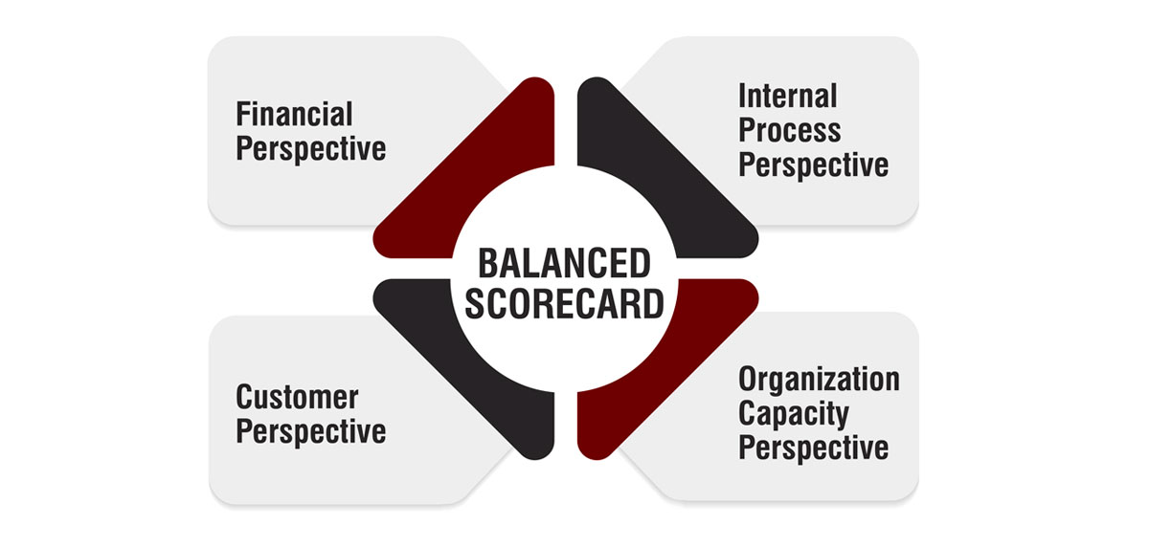
Figure 2 Balance scorecard (The Strategy Institute, 2024).

Financial Perspective
Profitability, increase in revenues, and cost control in terms of the financial aspect are anchored in the Balanced Scorecard (Hedback, 2019). This is a sensitive area in the case of Indorex, where it has been suffering financially.
Table 3 Financial Perspective.
Measure | 2021 | 2022 | 2023 | 2024 (projected)
Turnover (£'000) | 1,400 | 1,750 | 1,455 | 600
Cost of Sales (£'000) | 700 | 930 | 855 | 280
Gross Profit (£'000) | 700 | 820 | 600 | 320
Operating Expenses (£'000) | 400 | 448 | 495 | 495
Profit Before Tax (£'000) | 300 | 372 | 105 | -175
Profit After Tax (£'000) | 243 | 301 | 86 | -160

The turnover has been on the rise and decline, experiencing a high decline in 2024. This may be either external forces, such as Brexit and the pandemic, or internal issues, such as the positioning of the market and competition (Labosova et al., 2025). Gross profit has been falling, and this has been contributed to a large extent by the high cost of goods sold. The company has been experiencing a steady increase in all the operating costs, and profit margins are low, where profit before tax and profit after tax are falling at a very high rate, and this indicates the financial strains (Papík and Papíková, 2023). Further analysis of financial ratios would provide a clue to the financial health of Indorex. In 2021, the gross profit margin declined by half and currently stands at approximately 45% in 2024, and this does indicate that the company can certainly generate some profit on its core business. Also, the operating profit margin has dwindled, showing that the company is experiencing increased overheads as compared to its sales.

Customer Perspective
Customer view explores the extent of value-delivery it gives to the customers that the company provides, which ultimately drives sales and customer loyalty (Gifford and Newmeyer, 2019). In the case of Indorex, these are the measures of customer satisfaction, retaining customers, and the effectiveness of its marketing strategy.
Table 4 Customer Perspective.
Measure | 2021 | 2022 | 2023 | 2024 (projected)
Website Hits | 5,000 | 6,000 | 7,000 | N/A
Sales Conversion Rate | 10% | 15% | 18% | N/A
Customer Satisfaction | 69% | 72% | 82% | N/A
New Customers | 11 | 13 | 18 | N/A

It has also increased its customer satisfaction by 69% in 2021 to 82% in 2023, and this is a great indication that the organisation has a quality improvement aspect and customer loyalty. The number of hits on the websites and the rate of conversion of sales to online marketing have also increased, which signifies that online marketing is also helping to add additional traffic and convert it to sales (Hochstein et al., 2020). A growth in the number of new customers (11 people in 2021 to 18 in 2023) also shows that Indorex is receiving an increasingly diverse client base. However, despite these achievements, the sales are declining in 2024, and this signifies that the situation in the external markets is influencing its customers to spend.

Internal Process Perspective
Internal process perspective is about studying the efficiency of the company, and the opportunity to streamline its production and delivery, among other internal procedures (Dubetcky, 2024).
Table 5 Internal Process Perspective.
Measure | 2021 | 2022 | 2023 | 2024 (projected)
Error Rate | 111% | 9% | 4% | N/A
Job Completion Time (Days) | 14 | 10 | 7 | N/A

Indorex has also achieved remarkable reductions in error rates: from 111% in 2021 to 4% in 2023. It is a radical change in the quality and efficiency of operations for the positive (Gifford and Newmeyer, 2019). Moreover, job completion time has been shortened with successful handover of 14 days in 2021 to 7 days in 2023, implying that they have significantly achieved their aim of completing their job on time and have enhanced the efficiency of their practice. This is good internal betterment, though there are still several problems that prevail in the aspects of inventory, lead times, and reliance on suppliers (Labosova et al., 2025). The internal process perspective means that the operations transformations that have occurred up to Indorex have been advantageous. They require the growth to be able to handle the growth strains as well as the market pressures more effectively (Iyer et al., 2018).

Learning and Growth Perspective
The learning and growth view checks on the extent of internal development of the company (Mikula et al., 2020). Another area positively transforming at Indorex is employee participation and Continuing Professional Development (CPD). There has been an 82% and 89% in 2021 and 2023, respectively, thus creating a good working environment.
Table 6 Learning and Growth Perspective
Measure | 2021 | 2022 | 2023 | N/A
Employee Retention | 82% | 85% | 89% | N/A
CPDs per Employee | 5 | 9 | 12 | N/A

Similarly, an increase in participation in CPD points towards interest in improving the employees' skills that can improve performance and the delivery of innovation in the long term (CIPD, 2023). Nevertheless, the flat management system and the inability to scale the company are still issues, as the number of employees may pose bottlenecks without adequate development of management systems. Although customer satisfaction, internal processes, and employee retention are improving, financial performance is an urgent issue.

The Need for Business Process Reengineering (BPR)

Business Process Reengineering
It is a fundamental re-evaluation and overall reconstruction of the business processes to initiate radical modifications in cost, quality, service speed, and performance (Harika et al., 2021). In this instance, however, at Indorex Footwear Limited, BPR will play a key role in overcoming the crisis that the company is currently facing because of growth (Fetais et al., 2022). The causes behind BPR include inefficiencies of the current processes, fear of outdated management and patterns, alongside insensitivity to dynamism in reacting to evolving market forces.
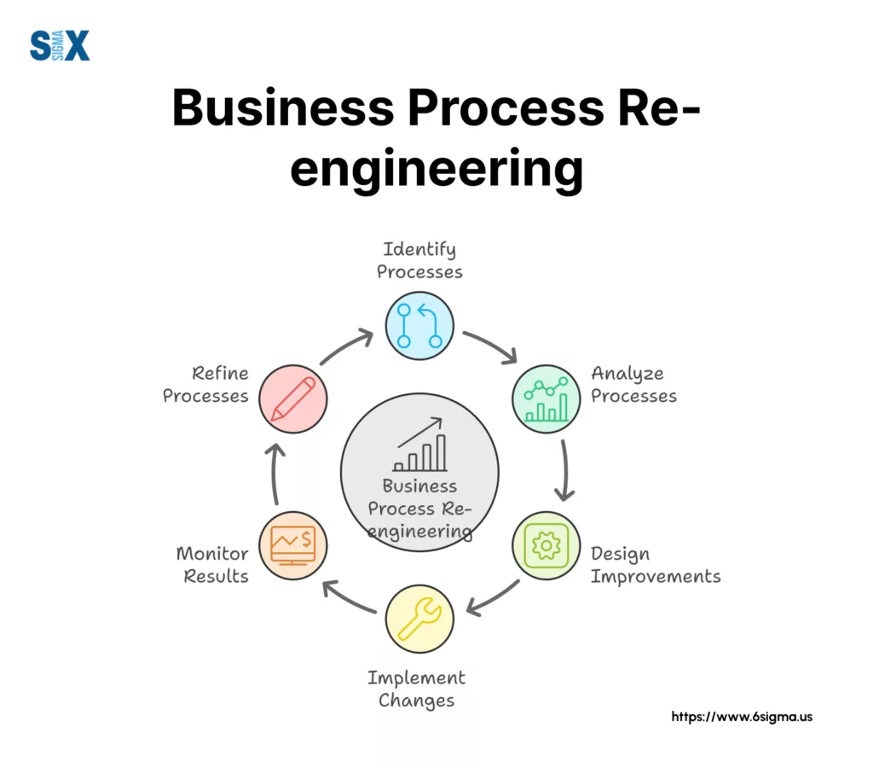
Figure 3 BPR (Peterka, 2024).

Identifying the Core Processes for Redesign
Procurement and Sourcing
Indorex has proved to be ineffective in its sourcing process and procurement process through its dependence on the Japanese suppliers and lengthy lead time (60 days). There are also disrupted supply chains and changes in exchange rates, which have sparked increased sourcing material prices (Bhaskar, 2018).
- Finding cheap manufacturers in such places as Vietnam, Thailand, or Benin.
- Minimisation of the lead times because of transactions with suppliers who have the ability to deliver in a few times (Harika et al., 2021).
- A compromise on saving money and conditions of supplier credit, as most suppliers, including suppliers in Japan, have better credit conditions than others.

Product Design and Market Strategy
Indorex has a luxury brand position as a strategic issue compared to having a less expensive product offering; it is one of the strategic issues that the company is facing (Tripathi and Gupta, 2020).
- Determining brand positioning- either Indorex is supposed to establish a luxury-brand image, or it can rebrand to a more popular brand positioning strategy.
- Product line consolidation with a view to focusing on the primary products that would satisfy customer needs and inventory (Hameed et al., 2021).
- The customer segmentation strategy will be designed based on the existing market trends and preferences of customers in the UK and Europe (Bhaskar, 2018).

Sales, Fulfillment, and Customer Service Process
Lack of integrations among different functions and slowness in response times of the old systems are constraining the sales and fulfillment processes of Indorex (Finio and Downie, 2024). The flat management structure and lack of integrated data systems in the company are the source of bottlenecks in managing the inventory and processing orders.
- Implementation of an integrated ERP with a view to centralizing the information in every function (Hameed et al., 2021).
- To ensure faster processing of orders and accuracy, automation of order processing is used to shorten lead time (Tripathi and Gupta, 2020).
- Improvement of customer service through improved communication of both delivery time and availability of products.

The Role of Technology in BPR
Technology, in the BPR, will be crucial to Indorex, particularly in integrating the operations of the business and automation (Bhaskar, 2018). By deploying an Enterprise Resource Planning (ERP) system, the company would be able to:
- Integrate all the business processes into a single platform where data flows between departments in real time.
- Minimise human error and automate the inventory controls and order preparation (Chang, 2016).
- Realize sales in real-time so that there will be an opportunity to plan better forecasting and inventory management.
Indorex can also invest in the data analytics tools and customer relationship management mechanism, which can enable it to interact with the customers more and predict their demands based on their buying patterns.

Expected Benefits of BPR
The BPR impact would be cataclysmic on the issues encountered by Indorex, both operationally and in regard to the market (Finio and Downie, 2024). Minimisation of the overall operation costs, achieved through sourcing at reduced costs as well as reducing lead times and internal operation cycle, will help Indorex to maximize the gross profit margins (Tripathi and Gupta, 2020). The process of automating the core processes will also cut down the time spent on meeting orders as well as lower the response time, which will generate an agile business model. Quickly delivered and increased communication with an integrated system will lead to better customer satisfaction and retention (Hameed et al., 2021). There will be less waste, lower costs of procurement, and a higher degree of sales, hence, this will inevitably result in an improvement in levels of profitability.

Implementation Challenges
Although the advantages of BPR are evident, the rollout of these changes will be associated with challenges (Chang, 2016). The changes to the set of workflows can be met with resistance among the employees, particularly with the new technology. The staff will need to be trained on the new systems and processes to ensure a smooth transition. Initial costs to BPR implementation, like investments in technologies, may be expensive (Hayes, 2022). This should be regarded as a long-term investment. This can be contributed to by an in-depth business process reengineering initiative, which would go a long way to get Indorex out of its growth crisis. Low prices, faster performance, improved customer service, and finally, profitability will be the outcomes of the BPR application. This change is essential in enabling Indorex to be competitive in the ever-dynamic market environment.

Conclusion
The two case studies have indicated that the most effective performance management is the one that is more tied to the strategy, fair evaluation, and long-term value creation. The main issue in Mitchum Fabrication Plc is the appropriateness of the divisional performance measures of a divisionalised structure. The analysis shows that ROI could be compared, though it is too limited to use it separately because it may misguide the managerial behavior and destabilize goal congruence. RI and EVA provide a closer insight into the way value is generated, and the transfer pricing must be designed in a way to facilitate coordination. The interaction of data, timeliness, and decision-making of the business would also be improved by the proposed executive information system, which would contribute to performance management.
At Indorex Footwear Limited, the report states that the company is facing a wider growth crisis that has been exacerbated by declining financial performance, sourcing pressure, confusion in strategy, and structural defects. Customer, process, and learning indicators have changed positively in a variety of views, according to the Balanced Scorecard, whereas financial performance has suffered a nosebleed. It means that operational benefits will not be possible without improved strategic alignment. This is how business process reengineering is needed in an attempt to improve planning, sourcing, coordination, and responsiveness. Comprehensively, the two instances affirm that proper management of performance should indeed be a blend of reasonable measurement, behavioral awareness, and strategy control.

Bibliography

Adler, R.W. (2022). Strategic Performance Management. Taylor & Francis. doi:https://doi.org/10.4324/9781003267195.
Albuhisi, A.M. and Abdallah, A.B. (2018). The impact of soft TQM on financial performance: The mediating roles of non-financial balanced scorecard perspectives. International Journal of Quality & Reliability Management, 35(7), pp.1360–1379. doi:https://doi.org/10.1108/ijqrm-03-2017-0036.
Appelbaum, D., Kogan, A., Vasarhelyi, M. and Yan, Z. (2017). Impact of Business Analytics and Enterprise Systems on Managerial Accounting. International Journal of Accounting Information Systems, [online] 25(25), pp.29–44. doi:https://doi.org/10.1016/j.accinf.2017.03.003.
Arnold, M.C., Gillenkirch, R.M. and Hannan, R.L. (2019). The Effect of Environmental Risk on the Efficiency of Negotiated Transfer Prices. Contemporary Accounting Research, [online] 36(2), pp.1122–1145. doi:https://doi.org/10.1111/1911-3846.12450.
Atrill, P. and McLaney, E. (2024). Management Accounting for Decision Makers. Pearson.
Bhaskar, H.L. (2018). Business process reengineering framework and methodology: a critical study. International Journal of Services and Operations Management, 29(4), p.527. doi:https://doi.org/10.1504/ijsom.2018.090456.
Bhimani, A., Datar, S.M., Horngren, C.T. and Rajan, M.V. (2019). Management and cost accounting. Harlow, United Kingdom: Pearson.
Chang, J.F. (2016). Business Process Management Systems. Auerbach Publications. doi:https://doi.org/10.1201/9781420031362.
Chang, K., Lasyoud, A.A. and Osman, D. (2023). Management accounting system: Insights from the decision making theories. Social Sciences & Humanities Open, [online] 8(1), p.100529. doi:https://doi.org/10.1016/j.ssaho.2023.100529.
Chen, J. (2024). Economic Value Added (EVA). [online] Investopedia. Available at: https://www.investopedia.com/terms/e/eva.asp [Accessed 15 Apr. 2026].
CIPD (2023). What Is Continuing Professional Development (CPD). [online] CIPD. Available at: https://www.cipd.org/en/learning/cpd/about/ [Accessed 15 Apr. 2026].
Coller, G., Frigotto, M.L. and Costa, E. (2018). Management control system and strategy: the transforming role of implementation. Journal of Applied Accounting Research, 19(1), pp.141–160. doi:https://doi.org/10.1108/jaar-01-2016-0002.
Cuillier, G. (2022). ADVANTAGES AND DISADVANTAGES OF CENTRALIZED VERSUS DECENTRALIZED INFORMATION SYSTEMS AND SERVICES FROM A PROJECT MANAGEMENT PERSPECTIVE. Electronic Theses, Projects, and Dissertations. [online] Available at: https://scholarworks.lib.csusb.edu/etd/1487/.
Curtis, A., Li, V. and Patrick, P.H. (2015). The Use of Adjusted Earnings in Performance Evaluation. SSRN Electronic Journal. doi:https://doi.org/10.2139/ssrn.2682652.
Datar, S.M., Rajan, M.V. and Horngren, C.T. (2021). Horngren’s cost accounting : a managerial emphasis. Essex, United Kingdom: Pearson.
Drozd, L.A., Kolasa, M. and Nosal, J.B. (2026). Pricing-to-market in business cycle models. Review of Economic Dynamics, [online] 60, p.101333. doi:https://doi.org/10.1016/j.red.2026.101333.
Drury, C. and Tayles, M. (2025). Management accounting for business. 9th ed. Andover: Cengage Learning.
Dubetcky, O. (2024). BSC: Internal Processes Perspective - Oleh Dubetcky - Medium. [online] Medium. Available at: https://oleg-dubetcky.medium.com/bsc-internal-processes-perspective-c71582974610 [Accessed 15 Apr. 2026].
EIM (2024). Business crises: when companies start to suffer. [online] EIM Group - Executive Interim Management. Available at: https://www.eim.com/business-crises-when-companies-suffer/ [Accessed 15 Apr. 2026].
Fetais, A., Abdella, G.M., Al-Khalifa, K.N. and Hamouda, A.M. (2022). Business process re-engineering: A literature review-based analysis of implementation measures. Information, [online] 13(4), p.185. doi:https://doi.org/10.3390/info13040185.
Finio, M. and Downie, A. (2024). Business process reengineering. [online] IBM. Available at: https://www.ibm.com/think/topics/business-process-reengineering [Accessed 15 Apr. 2026].
Gabrielli, L. and French, N. (2020). Pricing to market: property valuation methods – a practical review. Journal of Property Investment & Finance, ahead-of-print(ahead-of-print). doi:https://doi.org/10.1108/jpif-09-2020-0101.
Gifford, R. and Newmeyer, C.E. (2019). Insights into Long-Term Brand Success. Journal of Marketing Theory and Practice, 27(1), pp.1–18. doi:https://doi.org/10.1080/10696679.2018.1534215.
Hadid, W. and Al-Sayed, M. (2021). Management Accountants and Strategic Management Accounting: The Role of Organizational Culture and Information Systems. Management Accounting Research, 50(1), p.100725. doi:https://doi.org/10.1016/j.mar.2020.100725.
Haiss, P., Juvan, H. and Mahlberg, B. (2016). The Impact of Financial Crises on the Finance-Growth Relationship: A European Perspective. Economic Notes, 45(3), pp.423–444. doi:https://doi.org/10.1111/ecno.12067.
Hameed, N.S.S., Salamzadeh, Y., Abdul Rahim, N.F. and Salamzadeh, A. (2021). The impact of business process reengineering on organizational performance during the coronavirus pandemic: moderating role of strategic thinking. foresight, ahead-of-print(ahead-of-print). doi:https://doi.org/10.1108/fs-02-2021-0036.
Harika, A., Sunil Kumar, M., Anantha Natarajan, V. and Kallam, S. (2021). Business Process Reengineering: Issues and Challenges. Algorithms for Intelligent Systems, [online] pp.363–382. doi:https://doi.org/10.1007/978-981-15-6707-0_35.
Hayes, A. (2022). How Business Process Redesign (BPR) Works. [online] Investopedia. Available at: https://www.investopedia.com/terms/b/business-process-redesign.asp [Accessed 15 Apr. 2026].
Hedback, D. (2019). Magisteruppsats The impact of multi-year accounting data on bankruptcy prediction. [online] MID SWEDEN UNIVERSITY. Available at: https://www.miun.se/globalassets/forskning/center-och-institut/cer/cer-publikationer/magisteruppsatser/masters-thesis-dennis-hedback.pdf [Accessed 15 Apr. 2026].
Henttu-Aho, T. (2018). The Role of Rolling Forecasting in Budgetary Control systems: Reactive and Proactive Types of Planning. Journal of Management Control, [online] 29(3-4), pp.327–360. doi:https://doi.org/10.1007/s00187-018-00273-6.
Hnylianska, O. (2022). Rethinking the business process through reengineering. Vìsnik Harkìvsʹkogo nacìonalʹnogo unìversitetu ìmenì V.N. Karazìna, (103), pp.84–90. doi:https://doi.org/10.26565/2311-2379-2022-103-10.
Hochstein, B., Rangarajan, D., Mehta, N. and Kocher, D. (2020). An Industry/Academic Perspective on Customer Success Management. Journal of Service Research, 23(1), pp.3–7. doi:https://doi.org/10.1177/1094670519896422.
Iyer, P., Davari, A. and Paswan, A. (2018). Determinants of brand performance: the role of internal branding. Journal of Brand Management, 25(3), pp.202–216. doi:https://doi.org/10.1057/s41262-018-0097-1.
Kareem, H.M., Aziz, K.A., Maelah, R., Yunus, Y.M., Alsheikh, A. and Alsheikh, W. (2021). The Influence of Accounting Information Systems, Knowledge Management Capabilities, and Innovation on Organizational Performance . International Journal of Knowledge Management, 17(2), pp.72–103. doi:https://doi.org/10.4018/ijkm.2021040104.
Kumar, S., Pandey, N., Lim, W.M., Chatterjee, A.N. and Pandey, N. (2021). What do we know about transfer pricing? Insights from bibliometric analysis. Journal of Business Research, 134, pp.275–287. doi:https://doi.org/10.1016/j.jbusres.2021.05.041.
Labosova, V., Duricova, L. and Durana, P. (2025). One Model Fits All? Evaluating Bankruptcy Prediction Across Different Economic Periods. Economies, 13(12), p.361. doi:https://doi.org/10.3390/economies13120361.
Legner, C., Eymann, T., Hess, T., Matt, C., Böhmann, T., Drews, P., Mädche, A., Urbach, N. and Ahlemann, F. (2017). Digitalization: Opportunity and Challenge for the Business and Information Systems Engineering Community. Business & Information Systems Engineering, 59(4), pp.301–308. doi:https://doi.org/10.1007/s12599-017-0484-2.
Lewandowski, R.A. and Cirella, G.T. (2022). Performance management systems: Trade-off between implementation and strategy development. Operations Management Research, [online] 16(1). doi:https://doi.org/10.1007/s12063-022-00305-4.
McMillan, C. and Overall, J. (2016). Wicked problems: turning strategic management upside down. Journal of Business Strategy, 37(1), pp.34–43. doi:https://doi.org/10.1108/jbs-11-2014-0129.
Mikula, B., Vajdová, I., Koščák, P. and Jenčová, E. (2020). Learning and Growth Perspective in Balanced Scorecard. [online] IEEE Xplore. doi:https://doi.org/10.1109/NTAD51447.2020.9379091.
Norreklit, H. (2000). The balance on the balanced scorecard a critical analysis of some of its assumptions. Management Accounting Research, 11(1), pp.65–88.
Papík, M. and Papíková, L. (2023). Impacts of crisis on SME bankruptcy prediction models’ performance. Expert Systems with Applications, 214, p.119072. doi:https://doi.org/10.1016/j.eswa.2022.119072.
Pearlson, K.E., Saunders, C.S. and Galletta, D.F. (2020). Managing and using information systems: A strategic approach. 7th ed. S.L.: John Wiley.
Peterka, P. (2024). Business Process Reengineering (BPR): A Strategic Approach to Organizational Transformation. [online] SixSigma.us. Available at: https://www.6sigma.us/process-improvement/business-process-reengineering-bpr/ [Accessed 15 Apr. 2026].
Quesado, P., Guzmán, B.A. and Rodrigues, L.L. (2018). Advantages and contributions in the balanced scorecard implementation. Intangible Capital, [online] 14(1), p.186. doi:https://doi.org/10.3926/ic.1110.
Rossing, C.P., Cools, M. and Rohde, C. (2017). International transfer pricing in multinational enterprises. Journal of Accounting Education, 39, pp.55–67. doi:https://doi.org/10.1016/j.jaccedu.2017.02.002.
Safwan, E.R., Meredith, R. and Burstein, F. (2016). Towards a Business Intelligence Systems Development Methodology: Drawing on Decision Support and Executive Information Systems. [online] AIS Electronic Library (AISeL). Available at: https://aisel.aisnet.org/pacis2016/136/ [Accessed 13 Apr. 2026].
Szutowski, D. (2021). Management Control Systems, Decision-Making, and Innovation Development. Routledge.
Techslang (2022). What is an Executive Information System? — Techslang. [online] Techslang — Tech Explained in Simple Terms. Available at: https://www.techslang.com/definition/what-is-an-executive-information-system/ [Accessed 15 Apr. 2026].
The Strategy Institute (2024). A Comprehensive Guide to Implementing the Balanced Scorecard Framework. [online] www.thestrategyinstitute.org. Available at: https://www.thestrategyinstitute.org/insights/a-comprehensive-guide-to-implementing-the-balanced-scorecard-framework [Accessed 15 Apr. 2026].
Ţole, A. (2016). Executive Information Systems’ (Eis) Structure And Their Importance In Decision-Making. A Comparison Between Decision Support Computer Systems. Journal of Information Systems & Operations Management, [online] 10(1), pp.194–207. Available at: https://ideas.repec.org/a/rau/jisomg/v10y2016i1p194-207.html.
Toni, D.D., Milan, G.S., Saciloto, E.B. and Larentis, F. (2017). Pricing Strategies and Levels and Their Impact on Corporate Profitability. Revista de Administração, [online] 52(2), pp.120–133. doi:https://doi.org/10.1016/j.rausp.2016.12.004.
Tripathi, S. and Gupta, M. (2020). A framework for procurement process re-engineering in Industry 4.0. Business Process Management Journal, ahead-of-print(ahead-of-print). doi:https://doi.org/10.1108/bpmj-07-2020-0321.
Wings, S. and Harkonen, J. (2023). Decentralised or centralised management of data and products: influence on revenue-generating processes. International Journal of Management and Decision Making, 22(1), p.74. doi:https://doi.org/10.1504/ijmdm.2023.127687.
Yu, C.-P., Chen, H.-G., Klein, G. and Jiang, R. (2015). The roots of executive information system development risks. Information and Software Technology, 68, pp.34–44. doi:https://doi.org/10.1016/j.infsof.2015.08.001.

