Creative Practice 3 M5X01568
VFX Composting Sequence Reflective Account
Leah Williams (2005113)
For this assignment, I was tasked with composting a visual effects sequence using the tools and features available to me within Adobe After Effects, as well as other Adobe package software, in addition to Autodesk Maya.
To simplify the process of video creation, I brainstormed initial ideas for the content of my final video and decided on this; footage of a sports car with a 3D model of a spoiler edited on using greenscreen techniques, as well as several fake sponsor decal stickers attached to the car using 3D space techniques.
This is the first piece of footage I attempted to use for this project:
https://www.pexels.com/video/a-sports-car-on-display-outdoors-to-attract-potential-buyers-3066427/
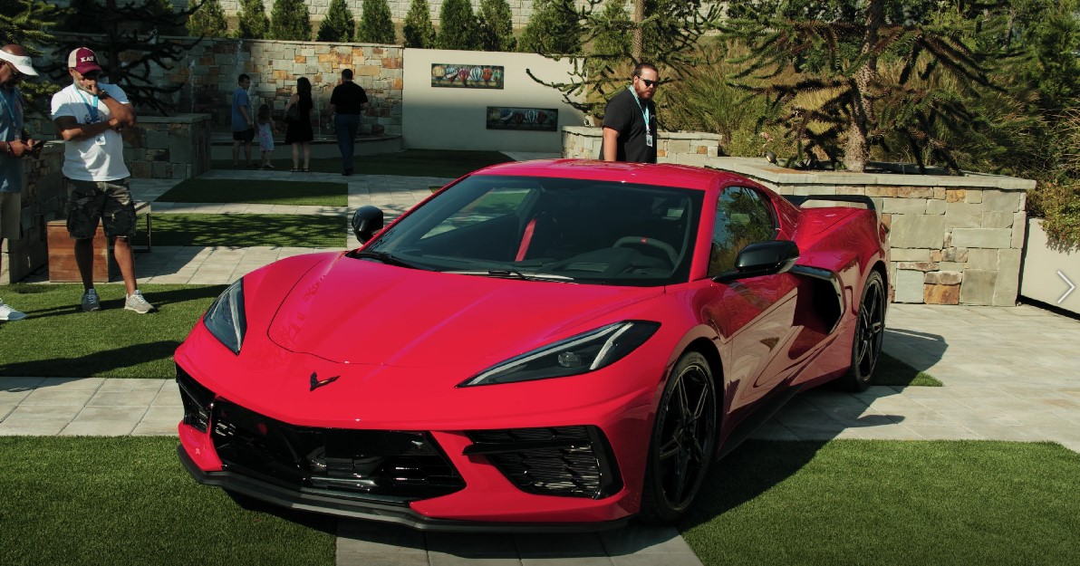
This piece of footage shows a bright red sports car in a domestic outdoor area; perhaps a modern suburban garden, with several people lingering around in the background. I chose this video for the base of my work because the camera movement is very minimal, but the contents are stive very active because of the movement of the people in the scene.
First, I prepare for production of the greenscreen by importing this footage into After Effects and using the ‘Track Camera’ feature in the ‘Tracking’ menu. After the analysis of the footage, I am presented with a large volume of crosshairs laid out throughout the frame. Next, I select a group of crosshairs in what appears to be a flat area in the scene, however, I am unable to select a large red target like the tutorial I am following claims I should be able to. After numerous attempts of redoing the ‘Track Camera’ analysis and configuring the camera tracking parameters in the ‘Effects’ menu, I decided to try the same process I had previously followed on a different piece of footage. I did this because several forums I had consulted online suggesting that the speed of the camera movement and the movement of foreground objects possibly affecting the quality of the analysis. This is the new piece of footage:
https://www.pexels.com/video/sports-car-on-the-desert-5673623/
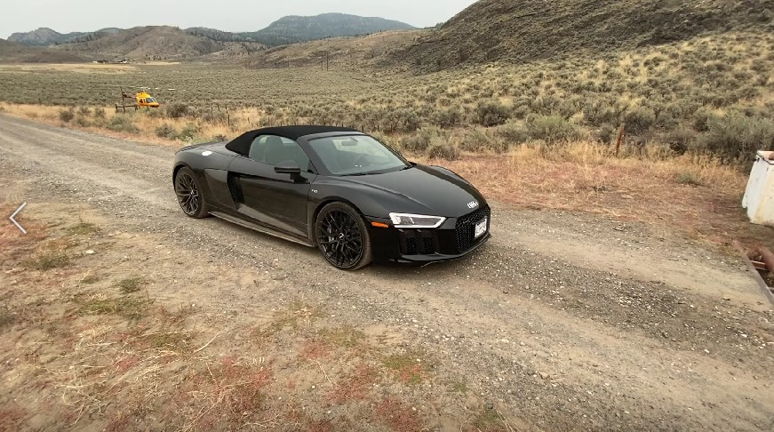
This alternative piece of footage depicts a black sports car in a desert, and a helicopter with the rotor blade actively spinning in the distant background. The camera movement in this clip is more active with more widespread angles, compared to the last piece of footage, with no moving foreground objects as well.
After importing the new footage, I proceeded to carry out the same steps as before, except this time I was able to successfully select a group of crosshairs with a visible red target. With the target now visible, I right clicked it and created a ‘track null’, plus a camera. Then, I adjusted the position of the track null using the 3D axis and then ran a script named ‘AE3DExport’. This is a script provided to everyone in my class for the production of a 3D tracked model that tracks the movement of the previously analysed footage. The output of this script is a Maya file with a camera pre-keyed with movement that follows that of the footage.
Upon opening the Maya file, I am presented with a scene with the default view cameras, as well as the exported AE3DExport camera, however, there is no sight of the footage for reference. In order to import the footage into Maya as a background video plane, I first imported the video into Photoshop and then exported into an image sequence. After this export, I went back to the Maya file and created a plane that follows the camera, then applied the image sequence as a texture.
Now that I had the camera set up and the reference material ready, I needed to import the model. For this assignment, I chose this 3D model of a car spoiler, which I was able to open within Blender and export into the FBX format:
https://sketchfab.com/3d-models/big-country-labs-style-spoiler-wing-a0e040a6c7aa40babe210e9e7637a846
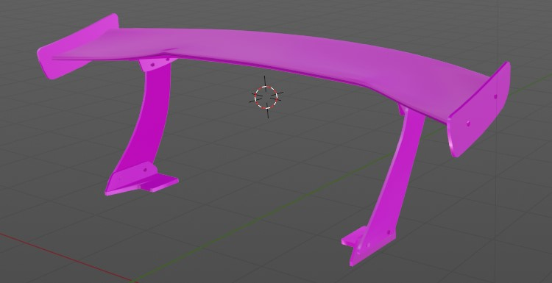
I then imported the model into the Maya scene, grouped together all the parts for easier management and applied an Arnold aiStandardSurface texture - with the ‘chrome’ preset and the colour changed to a non-pure black. With the model now thoroughly prepared, I then proceeded to align the position of the model with the reference material within the space created by the camera.
With the movement of the model set, I then generated the greenscreen video by creating a bright green plane and scaled it so it covered the entirety of the area behind the model. Then, I created a skydome light and exported the animation using the Arnold renderer. Finally, I imported the resulting keyframes from Maya into Adobe Premiere Pro to form a sequence, and then exported into a video after matching the appropriate frame rate (30 FPS).
This is the resulting video:
https://imgur.com/a/zP6xuVv
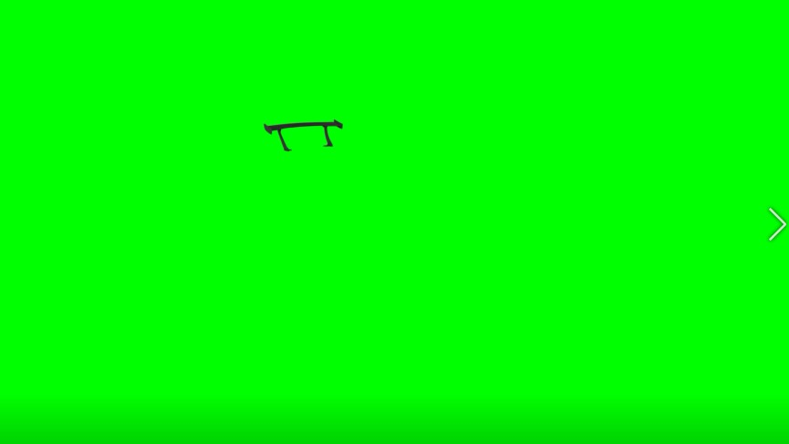
The new material is then imported into my After Effects file and the keylight effect is applied to it, to erase all the green within the video. Now the fake spoiler was in my scene, but there were points where it overlapped the car and the immersion was broken, so I created an inverted alpha mask on the parts of the car where the overlap occurred and keyed both the movement of the mask and the points created by the pen tool, for a clean masking.
With the greenscreen cleanly applied to the base footage, I then moved onto applying the fake sponsorship decals. I saved time during this process by using already existing images associated with the energy drink brand, Red Bull.
First, I gathered some images to apply to the car in the footage and edited them to remove the coloured backgrounds. I decided to use the two images below:
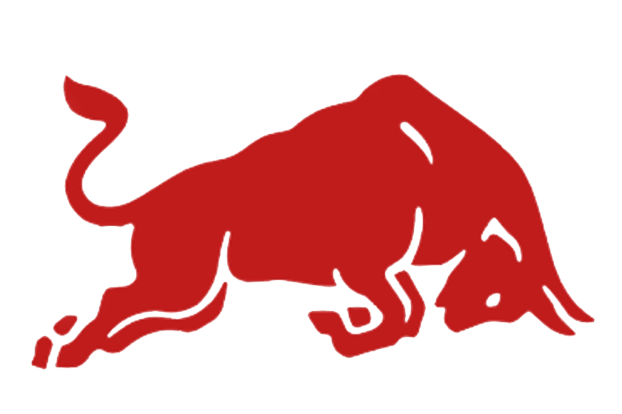
Next, I went through the same process that I did to create the track null, but I selected ‘create solid’ instead of ‘create null’, which create a square of a block colour with a null attached. To replace the coloured blocks with my images, I right clicked each and ‘pre-composited’ them. Then I double clicked each pre-composite to open it and replace the colour block by importing the image into the composite and using the composite settings to match the composite to the sizing of the imported image. After, I adjusted the positions of each pre-composite. Finally, the tracking and attachment of the images to the car is complete.
To complete the video, I did some final retouches, like analysing the inverted alpha mask one final time to check for obvious inconsistencies. I also changed the layer type on both tracked Red Bull images to ‘soft light’ so they fit in better with the colouring of the scene and to blend them into the cars shape.
This is the final video:
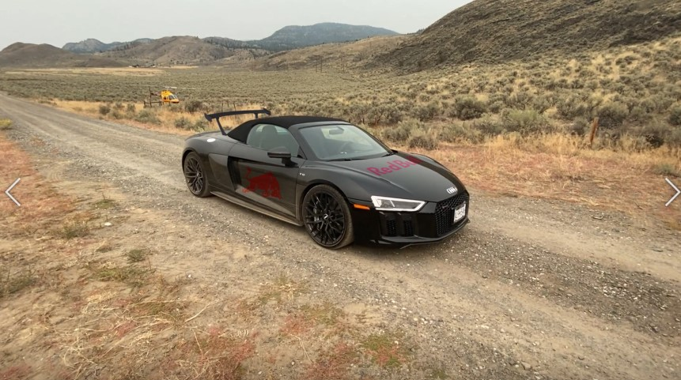
This is a very large video file at 2 gigabytes, so I compressed the size by re-exporting it through Premiere Pro.
Available here: https://imgur.com/a/GeuWoRX
Also here: https://uowtsd-my.sharepoint.com/:v:/r/personal/2005113_student_uwtsd_ac_uk/Documents/Assignments/Submitted/Year2/Creative%20Practice%203%20SUBMISSION/FINAL%20RedBull%20sports%20car%20-%20Compressed.mpeg?csf=1&web=1&e=YOJRR3

