

Steganography – The art and science of hiding messages within messages

by
Farhan Sajid Rahman

Supervisor: Nik Whitehead
Second Marker: Beverley Holland

Project submitted as part of the requirements for the award of
BSc (Hons) Software Engineering

April 2021

Table of Contents
Table of Contents 2
Abstract 4
Chapter 1 – Introduction 5
1.1 Goals 5
1.1.1 Aims & Objectives 5
Chapter 2 – Literature Review 6
2.1 History 6
2.1.2 Present 7
2.2 Different techniques 7
2.2.1 Image steganography 7
2.2.2 Text steganography 9
2.2.3 Audio steganography and Video steganography 9
2.3 Steganalysis 9
2.3.1 Steganalysis Techniques 10
2.5 Image Steganography software 11
2.5.1 Xiao Steganography 11
2.5.2 S-tools 11
2.5.4 Conclusion 11
Chapter 3 – Methodology 12
3.1 Research Methodology 12
3.1.1 Philosophy & Strategy 12
3.1.3 Approaches 12
3.1.4 Risks & Limitations 13
3.2 Development Methodology 13
3.2.1 Software Development Methodology 13
3.2.1.1 A list of main features that will be developed through the project: 13
3.3 Resources 13
3.3.1 Hardware Resources 13
3.3.2 Software Resources 13
3.3.3 Information Resources 13
3.3.4 Human Resources 13
3.4 Testing 13
Chapter 4 – Design & Implementation 14
4.1 Design 14
4.1.1 MoSCoW Prioritisation 14
4.1.2 Flowchart 15
4.1.3 User interface storyboard 15
4.2 Implementation 16
4.2.1 Testing 16
4.2.2 Success and Issues 16
4.2.3 Future Implementations 16
Chapter 5 – Evaluation 17
Chapter 6 – Conclusions and Recommendations 18
6.1 Suggestions for further work 18
Chapter 7 – Reflection 18
8. Appendices 20
8.1 Appendix A – Steganography Tools 20
8.1.1 Xiao Steganography 20
8.1.2 S-tools 23
8.1.3 Camouflage 23
8.1.4 Conclusion 23
8.2 Appendix B – Program Design 24
8.2.1 Flowchart 24
8.2.2 User interface Storyboard 26
8.3 Appendix C – Implementation Stage 29
8.3.1 SceneBuilder 29
8.3.2 Eclipse IDE 29
8.4 Appendix D - Evaluation of Survey results 30
References 39

Glossary
RGB – Red green blue
ICT – Internet communication technology
GIF – Graphic interchange format
JPEG - Joint photographic experts’ group
PNG - Portable network graphics format.
BMP – Bitmap
DCT – Discrete Cosine Transmission
DWT – Discrete Wavelet Transformation
Stego-Image – Image with hidden text encrypted
MoSCoW – Must Have, Should Have, Could Have, Will not have

Abstract
A delve into Steganography, giving an insight into the background and history but further holds emphasis towards digital steganography. Particularly it will be on hiding messages within images. Using the information found from comprehensive research allows for building and designing an image steganography program, the algorithm of choice is the altering of the least significant bits from the pixels of an image. The end will conduct a survey to summarise whether people can visually see the changes to the quality to recognize a hidden message within the image file.

Chapter 1 – Introduction
Steganography, the word derives from the Greek words ‘stegos’ and ‘grafia’, both together meaning ‘cover writing’. The definition of Steganography is the process of disguising a message, applying to both digital and non-digital data. In scope of the research, it will have primary focus on the digital aspect where the messages are hidden within a file due to today’s advances in ICT. Examples of disguising messages within digital data can be image, audio, video files and more. Non-digital could be through tattoo’s, sign language and any message that is hidden and require to be deciphered [1]. In the past, it was a synonym to cryptography and unused as a word but is now changed and refers to a type of digital cryptography [2], though it is technically not cryptography according to many.
Throughout the document, it will go over steganography and a dive into the background, the uses, different methods, how it is done and enough information to receive a strong idea behind the concept for a gathering of knowledge to assist in the result for the goal of having a developed system which accomplishes the notion of image steganography. In addition, discussion of the goals, development plan, methodology and requirements will be made.

1.1 Goals
The main goal of the project is to have the end goal of an implemented steganographic system which has the capability of taking in image files and allowing a message to be embedded and hidden from being seen by a user.

1.1.1 Aims & Objectives
The aims and objectives are primarily on the implementation of the software that will be created, the overarching aim and objective would be:
- To design and build a working steganographic software holding the ability to take in an image file and embed a written message by the user, with also capability of viewing the hidden message.
The build up to the overarching plan comprise of aims and objectives to:
- To research and obtain a background on the subject matter to develop a clear understanding.
- Find and review different steganographic software’s and see the approach taken to hide a message within an image.
- To complete thorough research on the different approaches, with the objective to receive ideas for implementation.
- Involve more than one algorithm to hide and retrieve a hidden message
- Devise the methodology approach for development, as well as the required resources involving software and hardware to accomplish the goal.
- Conduct a survey to test that people cannot notice the quality difference enough to notice there is a hidden message, using the LSB algorithm

Chapter 2 – Literature Review

2.1 History
A journal covering the past, present and future of steganography by James Judge tells us that the idea of steganography dates to over two thousand years ago, it was done in a number of methods and all of which is for getting across a hidden message unbeknownst to anyone but the recipient in mind. During the ancient Greece era it was mainly recorded of use with emperors, and further ahead in time the procedure was used within the world wars. Coming to the present day of a digital era, it has raised uses to prevent copyright with watermarking and hidden messages embedded within files [1].

2.1.1 Past of Steganography
Past literature shows that steganography has been a concept for a vast amount time, there is history towards it being done for different reasons, methods of which only grew to be cleverer and more developed as the years passed forward. This section will be a background giving insight of the past use of Steganography.

2.1.1.2 Ancient Greece and Rome
The word itself stems from the Greek language, and steganography is believed to be a concept that was first put into practice during the time of Ancient Greece. During this era, steganographic techniques that were recorded and told being used were primarily by rulers to send across hidden messages to other rulers for reasons such as war, threats, concerns or issues. It was documented that there was a method used of writing messages onto wood and with the use of wax tablets, the message would be covered over with a layer of fresh wax, requiring the receiver to scrape off the layer for the message to be read, meaning that it would be unsuspecting [2]. Further into the history during the times of ancient Greece, Histiaeus, a Greek ruler had made early use of Steganography through the process of shaving and then tattooing the head of a slave, having the hair regrow and then dispatching them out to deliver the message. Once arrived, the recipient would shave the hair of the slave to then read it, a reply given from them would also make use of the same method of steganography [3].

2.1.1.3 Middle ages
During the middle ages, Johannes Trithemius had the first recorded use of the word steganography from his book, translated from Latin, ‘“Steganography: the art through which writing is hidden requiring recovery by the minds of men”. It contains 3 volumes and is generally about magic and the use of spirits for communication through long distance, it is still though however, a treatise on cryptography and steganography [1] [4]. One of the occurrences recorded in the middle ages was with Mary Queen of Scots, to hide letters of messages she decided to combine cryptography and steganography to do so. The letters that were written was hidden within a beer barrel, placed in bunghole. It allowed it to pass throughout her prison in and out with ease [1] .

2.1.1.4 World War
According to a book by Gregory kipper, ‘Investigators Guide to Steganography’, for the duration of world war I and world war II, steganography was widely used successfully, in relation against spies and troops with unsuspecting methods.
One instance included a woman being presumably a worker for the German’s, which ended up true when it was found that she had contained a blank piece of paper within the sole of her shoe. It was quickly found out that the ‘blank’ piece of paper was not empty but written on with invisible ink of which was heat-based to be revealed. Steganography was such a widely used technique to get hidden messages across, but as it was used to spy and advantages, that prevention of it became important to the point that chess games by mail were banned, crossword puzzles were always analysed or removed and even knitting’s became an issue for the reasoning of secret messages being sent during the French Revolution [5].

2.2 Different techniques
The art of steganography possesses many techniques, some of which were mentioned throughout the discussion of the history, though this section will primarily be making an understanding of the digital techniques of steganography. When it comes to digital based steganography, the procedure of hiding the message is a simple process with having the software, though behind it is a technical process that is done in relation to the type of steganography. For the different types of digital steganography there are various methods used to accomplish a hidden message. This is being with image, text, audio, and video files. More emphasis towards image steganography will be made for the information needed when it comes to building a program. Mentions of robustness and fragility will be referring to how easily the hidden data can be lost [6].

2.2.1 Image steganography
Image steganography, this is the embedment of a hidden message or a type of file within an image file. When it comes to the procedure on how it is done, there are several techniques with each having different complexities, advantages, and drawbacks to one another; such as robustness and image quality being affected. The techniques are held into different classifications, spatial domain steganography and transform domain steganography [6] [7].

2.2.1.1 Image Files
To comprehend the different methods available, an understanding of image files is needed, primarily raster images. These images are made up of picture elements, known as pixels, and these pixels are small building blocks displaying row by row and horizontally up to the size of the image [8]. For every pixel in an image, each hold a number of bits to represent it, and this is known as bit depth [9]. In a colour scheme, the smallest bit depth would be 8 and for the colour of each pixel, there are 8 bits that are linked with it. For monochrome and greyscale images, each pixel generally embodies 8 bits, allowing for 256 different colours or shades of grey. Furthermore, digital images with colour are recognized to be saved using the RGB colour model and in 24-bit files, RGB being the colours red, green, and blue each comprise of 8 bits. In result, for any of the pixels it is capable of reaching 256 different shades of RGB and allows for 16 million colour combinations to be displayed [10]. The primarily used image file formats consist of ‘.png’, ‘.gif’ and ‘.jpg’ or ‘.jpeg’. The different steganographic techniques do make attempt to manipulate these formats, however due to simplicity regarding data structure, the ‘.bmp’ format is mainly used [11].

2.2.1.2 Spatial Domain Steganography

2.2.1.2.1 Least Significant Bit (LSB) Insertion
Least Significant Bit, also known as LSB, is seen as the simpler method that is generally utilized when it comes to implementing image steganography by changing the least significant bit of the image, as the name of the method already suggests. It is stated that as it is only switching the least significant bit, it can be seen as just altering random noise that is part of the image, preventing the human eye to notice that there could be a difference to recognize. In the approach of using this method, a lossless compression image format is recommended, the reason is because this approach does not entail bits from the pixels that were not compressed. In the case of it being a lossy compression image, the embedded data hidden would be lost [12].

2.2.1.2.2 Masking and Filtering
Another technique of image steganography is with masking and filtering, the process can only do so with images of 24-bits per pixel and can be on either colour or greyscale images. This technique can be contrasted to the idea of putting watermarks or markings on a picture, and this is because there would be text placed over an image, but in this case, only revealed when adjusting the luminosity and properties of it during the procedure of masking. The image and the message will not be anything of abnormality or noticeable to the human eye, making it unsuspecting to people. From the ability of masking and using the available aspects of the image, it is said LSB would not be as robust in comparison due to having the fault of losing the hidden data from an image format with lossy compression, example being JPEG [12]. With use of the algorithms and different formulae, it allows for specific pixels to be selected of the image, and then have the hidden message written to be embedded [13].

2.2.1.3 Transform Domain Steganography

2.2.1.3.1 Discrete Cosine Transformation and Discrete Wavelet Transformation
The technique of discrete cosine transformation and discrete wavelet transformation within image steganography serves a mathematical function that uses image data from the spatial domain to the frequency domain through transformation [14]. With the technique of DCT, it is used with JPEG compression, and embedding within this domain is completed through alteration of the DCT coefficients [15]. With DCT, once the transformation in the frequency domain is completed, that data is then embedded to the least significant bits of the medium frequency components and sets to be for lossy compression. In DWT however, the high frequency coefficients get the embedment of the secret written message which is said to provide a strong case of robustness [14].

2.2.1.3.1.1 Bitmap cover image format modification with DCT steps:
- Image breaks into data units, each of which hold 8x8 pixels
- To each pixel, beginning from the top left to bottom right, DCT is applied
- Each pixel is generated one DCT coefficient once it has applied
- In reference to a quantization table, the DCT coefficients are then quantized
- The DCT coefficients quantized can be replaced by a bit from the written hidden message
- A stego-image is then produced after the encoding of each altered quantized coefficient [15].

2.2.2 Text steganography
Text steganography is a method of hiding text within another text as a cover message, or through generating a cover message in relation to the initial hidden message written [16]. It is done by making alterations with the format of text or altering the elements of text which are the characters. A statement also mentioned that the methods of which are coded should be “reliably decodable yet largely indiscernible to the reader”, imposing that the method taken in performing text steganography should be effectively done to not be detected but have the retrieval be completed with ease. The techniques of approaches to text steganography include line-shift coding, word-shift coding, and feature coding [12].

2.2.2.1 Line-Shift Coding
The technique of line-shift coding holds the concept of text modification of a document by having the lines shift vertically, leading to a pattern in the text that a cover text is generated. Issues arise with the hidden message destroyed if any problem occurs during the transmission of the cover text and if the lines were shifted [17].

2.2.2.2 Word-Shift Coding
Rather than have the lines shifted, this idea is for shifting words within the text in a horizontal direction for the accomplishing of hiding a message. There is modification completed to distance words from each other to have the information hidden, the spaces within words will be different for generating a cover text. A similar limitation to line-shift, is that it would have an issue with losing the hidden message if there is a retype of the cover text [17] .

2.2.2.3 Feature Coding
The technique of feature coding is made in use with bitmap images of a document, where it will analyse through for features of text and depending on the codeword, it will decide to alter or not alter the text, example being to move a letter up or down, or it could be to increase or decrease the length in relation to the codeword and bits. It provides a sophisticated method for hiding messages within messages, as the editing of text can be done in different areas, meaning it would be unsuspecting to the reader. For decoding the message, it needs the original image or the plan it took to change pixels at a feature [17] [18].

2.2.3 Audio steganography and Video steganography
Audio steganography is accomplished through embedding a message in an audio signal, involves having slight alteration of the binary sequence of the file. As part of audio steganography there are several methods that are available.

2.3 Steganalysis
Steganalysis is the process of identifying an occurrence of steganography. Not all uses of steganography are to provide good, as discussed there are unlawful ways it is being applied, one being terrorist activity. Steganalysis offers a way to combat and detect malicious activity being undertaken, though as steganographic methods become more robust in hiding the message, the techniques of Steganalysis will also require becoming better for the detection. Moreover, Steganalysis holds more than being able to know there is an occurrence of steganography, it works to find information such as the approximate the length of hidden messages, locations within the data, and more of which retracts useful information. Being aware of the beneficial use Steganalysis has, to prevent such situations mentioned, it falls to be a component of cyber forensics, cyber warfare, and law enforcement with the possibility of finding criminal activity online and holding of evidence for investigations [19]. Although it provides good, the number of different methods there are applied for Steganography does pursue an issue for Steganalysis, as it would not be certain which one is used, being uncertain would mean not knowing what technique to work from, thus proving to be a challenging task to complete [20].

2.3.1 Steganalysis Techniques
For the techniques of steganalysis, there are two general classes they can be placed in, signature steganalysis and statistical steganalysis. It is said to be classified in this way, basing off whether it is the signature or statistics of the image that gave away the presence of steganography. Furthermore, the journal article states the steganalysis methods can be classed further, being in specific and universal methods. A steganalysis method being specific has knowledge towards the steganographic technique that it is dealing with, whereas a universal method is one to be capable of detecting many. Also mentioned, a universal method is said to be known as a blind method, due to not usually needing any information of the embedding operation [21].

2.3.1.1 Signature Steganalysis
The signature is what conveys that there is a hidden message, it is the repetitive and fixed patterns within the media file of where the information is embedded and hidden into. The developers of steganographic software often leave a track from the products output, unsuspectingly allowing a signature steganalysis tool to search for these fixed patterns within check of popular algorithms used for the embedment [21]. An example case is given with a steganography tool applied online, called Jpegx where a fixed set of numbers is put in after completing the process [22].

2.3.1.2 Statistical Steganalysis
For detection of hidden information, the technique behind statistical steganalysis is the detection of the mathematical aspect. In the process of the development of image steganalysis, researchers were successful in analysing different ways of for identifying hidden messages that were present in image data. From the image data they extracted statistical parameters from the spatial domain, in which came of use for viewing binary similarities and allowed for accurate detection for finding the known steganographic technique used to embed and hide the message. This especially works advantageous for detecting steganography within the spatial domain making use of the steganographic technique, LSB modification [23].

2.3.1.3 Specific statistical Steganalysis
The technique of a specific statistical steganalytic tool is to provide accurate results, it can do this due to it tailoring only towards specific steganography techniques that it already contains a detailed knowledge of. This technique is used to find the message hidden with steganography that made use of LSB embedment, meaning it has a drawback of no capability of use against certain steganography embedding methods, including against certain image formatting [24].

2.3.1.4 Universal statistical Steganalysis
The use of universal statistical steganalysis involve the methods of statistical steganalysis and is not favoured towards one particular steganography embedment technique. The strategy it follows is to learn and train itself based on the image steganography it is dealing with, making use of a neural network, clustering algorithms and tools of which allow building of a detection model with use of the data it is working with [21].

Chapter 3 – Methodology
Throughout this section, discussion of the methodological path will be taken in terms of the research and development. Such things involved will have talk of the aspects such the approaches, the ideas, requirements regarding resources, and thoughts of any underlying issues amongst more.

3.1 Research Methodology

3.1.1 Philosophy & Strategy
As part of the research methodology, the philosophy would be on the positivist path, justification for this reason is because the information found will be independent as well as objective, basing it on facts from already completed scientific research. A deductive strategy is then followed for the reason of being capable of looking at the facts researched and working out what can be deduced from them, then allowing measurements to be made to assure what is found is lined up with the current scientific theory.

3.1.3 Approaches
There will be three approaches involved which will be software development, document review and an experiment.

3.1.3.1 Literature Review
The literature review will behold the background information of the topic

3.1.3.2 Software Development
Implementation of an image steganography software will be done as part of the software development.

3.1.3.2.1 A brief process of the expectation of how it will function:
- Open and select a local image file of choice
- Enter a secret message to have embedded into the file
- Choose the steganographic technique
- Process the image with the chosen technique
- Output the stego-image in the same directory as the chosen one

3.1.3.3 Experiment
The experiment will be of a survey at the end to determine whether it is possible to visually see a change in the quality to recognize if there is a hidden message.

3.1.4 Risks & Limitations
- There are time and skill constraints, correct planning, and schedule of time to work and research as a preventative measure

3.2 Development Methodology

3.2.1 Software Development Methodology
For the software development methodology, a feature-driven direction will be followed, which is a type of agile development methodology that will be used. The nature of this will allow a continuous iteration of development and testing along the process.

3.2.1.1 A list of main features that will be developed through the project:
- Implement file system to open local image files
- Save text input from the user for the message to be embedded
- Implement at least two different image steganography techniques to choose from
- Use the message given to embed within the image steganography technique chosen
- Output image file to users file storage

3.3 Resources

3.3.1 Hardware Resources
The only required hardware will be a suitable PC connected to the network for the development.

3.3.2 Software Resources
Software will be taken from the internet as there are plenty of free integrated development environments to work with, also known as IDE’s. The language of choice will depend on which will be used. Current options include Visual Studio for the use of C++, Eclipse IDE, or IntelliJ.

3.3.3 Information Resources
Additional resources can be having books to provide further development assistance and information about steganography.

3.4 Testing
Once the development and implementation of the image steganography software comes towards completion, testing is an important requirement due to issues and or concerns that were missed during the process. The testing will be with use of people to find the information out, and also will also be compulsory to receive and find out information if the image steganography techniques have noticeable effect on the quality after being processed by the algorithm.

Chapter 4 – Design & Implementation
This section will go over the design and implementation of an Image Steganography program. Included throughout it will be a discussion of decisions that were made to provide a solution to problems and to portray how design decisions came to accomplishing objectives during implementation. Implementation follows thoroughly through the design aspects that were formed using flowcharts and a prioritization technique known as MoSCow for the software requirements.

4.1 Design
Firstly, an idea of how the program will be built is required. For the ease of performing image steganography, the choice is to make use of a simple graphical interface. Alongside how it will be built, a plan revealing what features are essential to implement is also needed. Using the knowledge developed from the literature review and engaging with existing free to use image steganography software, it allowed for brainstorming the software requirements.

For the image steganography being built, there are two parts of which is the encryption and decryption process. The route taken was to plan out the requirements with MoSCow and then creating a flowchart for both encryption and decryption stages. This was done to depict the process of the steps it will go through, and to convey the structure visually of what must be followed during the implementation stage. Furthermore, as a graphical user interface is planned to be made, a storyboard will be created to demonstrate how it can be implemented.

4.1.1 MoSCoW Prioritisation
Before implementation, a set of requirements must be planned to form a blueprint. MoSCoW is an acronym and measure of deciding the “Must haves, Should haves, Could haves and Will not have” [25]. This allows for requirements to be made while making considerations of what is most important and what would be unnecessary during the implementation stage.

4.1.1.1 Encryption Stage:
The requirements of the encryption stage follow largely in reference to the software which were reviewed, as well as some information garnered from journals about the process it follows.

4.1.1.1.1 The encryption stage process:
Based off the software that was looked at, a summary of the encryption stage mainly contains the steps of:
- Importing an image to hide a message in
- Entering text or importing a text file with a message to encrypt into the image
- A password that is used for the decryption process
- Choosing an output directory and specifying the file name
- Encrypting the image and producing the result to the chosen output directory

4.1.1.1.2 MoSCoW Encryption Stage
Using the steps listed and having in mind the image steganography techniques that were discussed, requirements can be formed and prioritised using MoSCoW.

4.1.1.1.2.1 Must Haves (M)
- Ability of importing an image
- Ability of choosing an output path
- Ability of entering text for the hidden message
- Ability of encrypting using the LSB method

4.1.1.1.2.2 Should Haves (S)
- Alert boxes to display when an error occurs

4.1.1.1.2.3 Could Haves (C)
- Entering password for stronger hidden message
- Multiple methods of encrypting

4.1.1.1.2.4 Will not have (W)
- N/A

4.1.1.2 Decryption Stage
Like the encryption stage, this stage will follow through what was discovered within the literature review.

4.1.1.2.1 The Decryption stage process:
Based off the software in the literature review that were looked at, a summary of the decryption stage mainly contains the steps of:
- Choosing the steganographic image
- Choosing a path to output the hidden message

4.1.1.2.2 MoSCoW Decryption Stage

4.1.1.2.2.1 Must Haves (M)
- Algorithm which can decrypt a steganographic image
- A way to display hidden message

4.1.1.2.2.2 Should Haves (S)
- Alert boxes to display when there is an error

4.1.1.2.2.3 Could Haves (C)
- Process of decrypting a steganographic image with a required password

4.1.1.2.2.4 Will not have (W)
- N/A

4.1.2 Flowchart
Flowcharts were created to illustrate how the process of the program will run, there are two parts of the program where it handles encryption and decryption, making it necessary to build a flowchart for each. Having the flowchart made was important to gather a clear view on the process of the program and what information will require to be stored. This also allows development during the implementation stage to follow a direction of what is to be completed.

4.1.2.1 Encryption Process
The encryption stage can be seen in Appendix B 8.2.1.1 Encryption Process.

4.1.2.2 Decryption Process
The decryption stage Appendix B 8.2.1.2 Decryption Process.

4.1.3 User interface storyboard
The user interface storyboard showing how the interface will be functioning and displaying.

4.1.3.1 Encryption Tab
The encryption tab and quick functionality is explained in Appendix 8.2.2.1 Encryption Process

4.1.3.2 Decryption Tab
The decryption tab and the functionality of the interface. See Appendix 8.2.2.2 Decryption Process

4.2 Implementation
Following from the design, implementation was completed using Java with the use of a library called JavaFX for the building of an interface. The choice behind the language is primarily due to experience. A goal from the beginning was to utilize a graphical interface for hiding text within an image, and this goal was easily achievable with a tool called Scenebuilder. This tool allows a GUI to be created from dragging and dropping an assortment of components that it offers [26], using this technique only required me to handle the functionality of the interface and not require adding code to place the buttons, text fields and more. This allowed me to save time and focus more on the main features before handling functionality. An image of SceneBuilder can be seen at Appendix 8.3.1 SceneBuilder. The IDE of choice is known as Eclipse which is an IDE for several languages but mostly known for Java [27], and this was advantageous due to integrated support of SceneBuilder. Appendix 8.3.2 Eclipse.

4.2.1 Testing
When it came to testing, the main strategy was to test features as they were developed. Making use of unit tests and thorough manual tests to see if the functionality works as intended, outputting information into the console to make sure the correct values and data is being stored.

4.2.2 Success and Issues
The main issue faced during the implementation of the project was building the LSB algorithm. Once the encoder was implemented, a decoder was required to be built to retrieve the message which was hidden in the image by the encoder. The issue which surfaced is that the decoder did not know when to stop trying to find and kept on forming messages until all pixels were looped through. It continued reading every least significant bit of the image and forming random characters from the values. The idea which came to mind was to append a key onto the hidden message and then during the decoding process, it can be identified when the last word of the hidden message has been found. This was done by checking every 8th increment to see if a message formed was of the key. Once the key was found, a function created to remove the key from the hidden message was implemented and the decoder would return the message. The key value was taken from a random generator website as commented on the program.

4.2.3 Future Implementations
Initial ideas hoped to have more than one algorithm to encrypt text into images. Future implementations can be to implement another image steganography algorithm such as masking and filtering. An addition to the interface can be made to select the type of encryption method the user would like to use.

Chapter 5 – Evaluation
Now the implementation of the image steganography program is completed, this allows for conducting a survey to evaluate whether the algorithm used creates visible changes to the quality of the image. The question asked will be if they can identify whether there is a hidden message between two paired images that will be shown. There will be 20 images, and the first 10 questions will have paired images with neither of them having a hidden message applied and the last 10 questions each hold one image which has been through the implemented program to hide a message. The assumption is that people will not notice a change and it can confirm that the LSB algorithm to perform image steganography is not detectable. In total there were 34 responses. All results shown appendix D 8.4 Survey Results.

From the first 10 questions, none of them contained a hidden message and resulted in 93% of the responses stating that they cannot see a hidden image. This gives a good indication that the majority of people are looking at the images carefully.

Onwards from questions 11 to 20, the paired images contain one image with a hidden message and 78% of people voted that they do not think there is a hidden message within them, meaning a percentage of 22 believed there is a hidden message within one of the images. However, it was calculated that only 16% of the people chose the right image that contained the hidden message. From that it can be suggested that some people were mistaking parts of the image showing poor quality or taking a guess.

Overall, from the survey conducted, the results which came back was expected to have more responses saying that they do not believe there is a hidden message. Although, in the end it can be said that it was largely unnoticeable that there were any steganographic images involved as the total number of responses which guessed the correct image from 11 to 20 was only 56 out of 340. From those results made clear, it can be said the aim made in the introduction stating that people cannot notice the quality difference, was met. If this survey were to be conducted again, more than one algorithm could use and paired together to further test the validation of whether a difference can be seen between the quality of steganographic images.

Chapter 6 – Conclusions and Recommendations
In conclusion of the project, image steganography has several algorithms with different complexities to provide the same end goal of hiding data within an image. Detailed research on the techniques to achieve image steganography was conducted during the literature review. This was most beneficial in reaching the main aim of the project which was clarified in the introduction. The main aim was to build a program that can embed a hidden message and retrieve it. The research throughout the literature review held the important information required in building the algorithm to hide the message. To also mention, reviewing through different image steganography applications gave ideas on how the interface should be created. Furthermore, another main contribution to meeting the aims and objectives was through the designing phase of the project. In the designing phase, flowcharts were made for both the encrypting and decrypting stage to illustrate the procedure of how it should function and work. Within the design process, the software requirements were thought out using a prioritising technique which was MoSCoW. Planning beforehand with the designing techniques allowed for a path to follow during the implementation process, making it clear what is required to be done and in what order. Involved during the designing process was also storyboard made to allow for building a visual idea of how the interface will look and function. From having an idea of how the interface will look like, it opened path for easily creating it with a tool called SceneBuilder. This tool was mentioned in the implementation stage and gives the possibility dragging and dropping down interface components to form the GUI. Moreover, once the implementation was finished it allowed for another objective to be completed. A survey was prepared to get a look at whether people can see visual changes between paired images. The reason behind this is to know if the algorithm degraded the image quality to a noticeable point and the results showed that mainly people do not notice a difference from 34 responses.

6.1 Suggestions for further work
Further work can be to implement in the aim that was not acquired. One aim was to involve more than one algorithm for encrypting a hidden message to an image. Due to the complexity of the different algorithms found from research, the amount of time to spare was not enough to learn them as well as have time for the different tasks required to be complete. In result, making the priority to at least have one algorithm that can be used to encrypt an image with a message.

Chapter 7 – Reflection
To reflect over the course of the project, the topic of choice was chosen out of interest and everything that was discussed surrounding Steganography was a new thing to me. It posed to be very daunting when discovering and learning the different ways of how the process of image steganography is completed, however it allowed me to begin getting out of my comfort-zone of trying to begin learning how some of the algorithms can be achieved. The goal in mind was to have at least two algorithms implemented of which can perform image steganography but due to the lack of skill, only one was achieved. Although, the one algorithm that was implemented taught me a good amount of knowledge about images regarding the different formats, and it also furthered knowledge about binary and conversion.

In thoughts of a next time, to improve and do a better job would require me improving my management of time and grab attention to important aspects of the project that should be focused on. An issue faced was spending time thinking about implementing unnecessary features rather than the algorithms to provide a solution to the problem first. This caused to be a big issue with time being lost. Additionally, overthinking and straying away from the more complex algorithms was a significant obstacle to face, with determination and further planning it could have been more beneficial of getting through the project.

8. Appendices

8.2 Appendix B – Program Design
The design techniques completed before implementation.

8.2.1 Flowchart
The flowchart design created for the encryption and decryption process of the program.

8.2.1.1 Encryption Process
The encryption stage in a flowchart to display the direction to follow during the implementation.

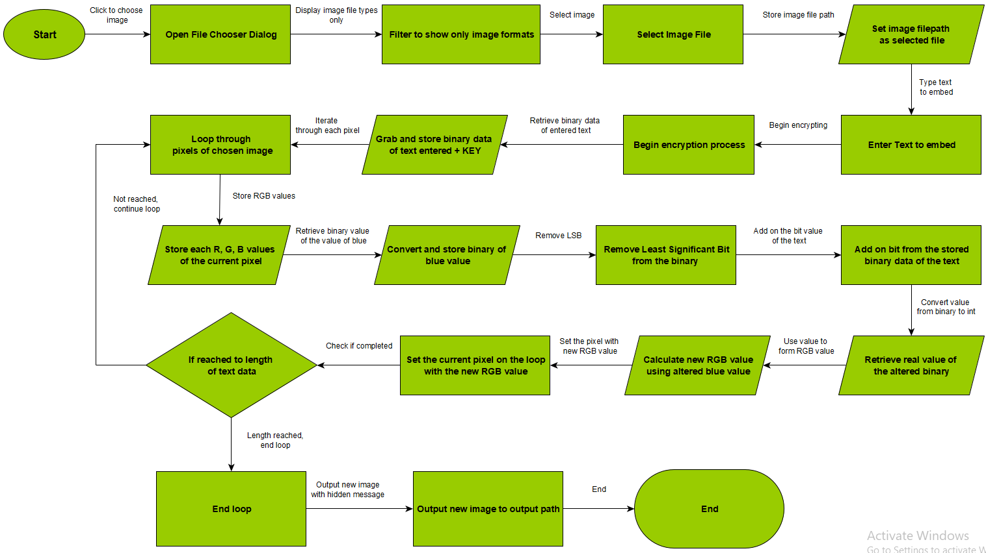

8.2.1.2 Decryption Process
The decryption stage in a flowchart to display the direction to follow during the implementation.
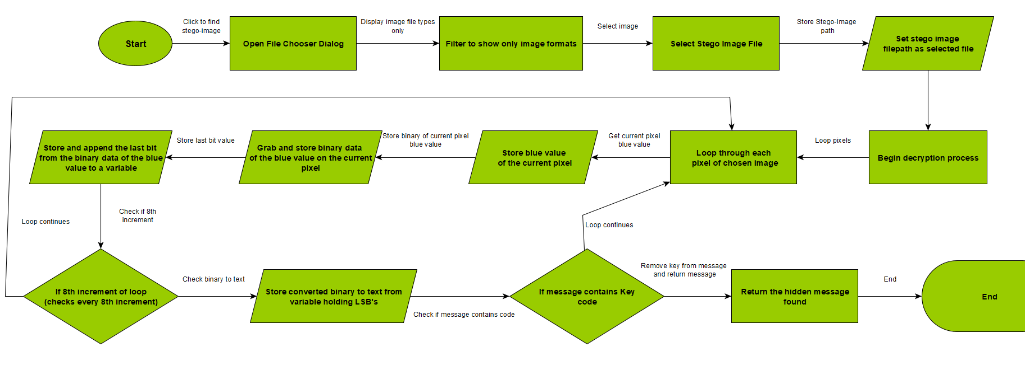

8.2.2 User interface Storyboard
A storyboard displaying how the interface will function and be like.

8.2.2.1 Encryption Process
The plan of the encryption process using the user interface.
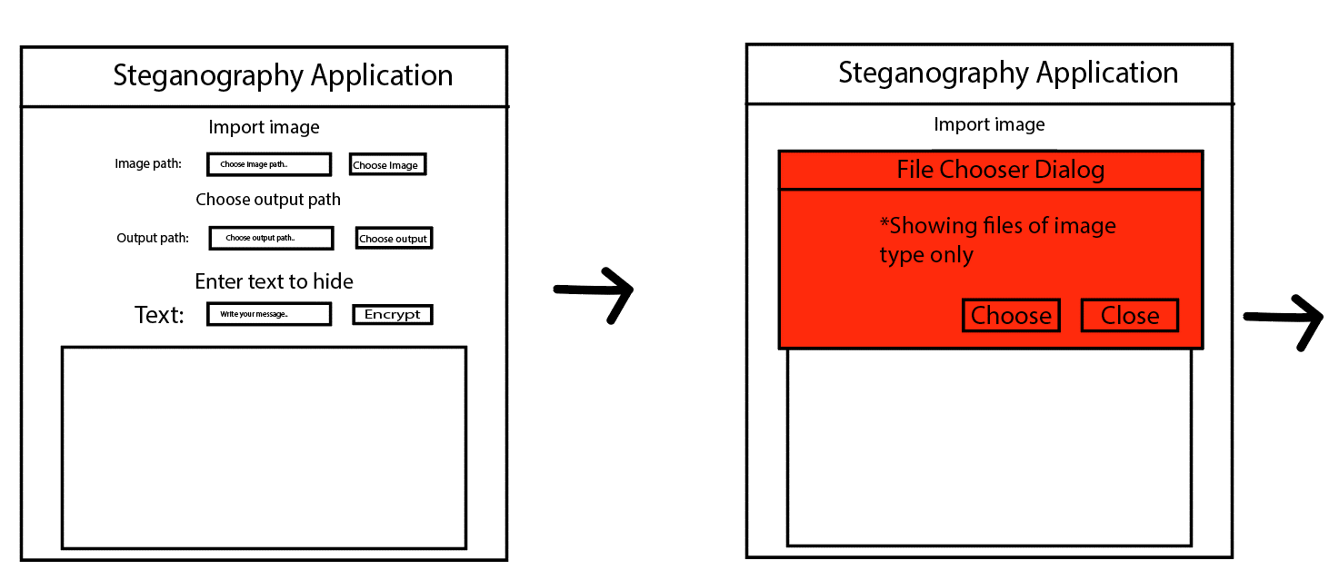
Clicking the choose image button opens the file chooser dialog to import the image.
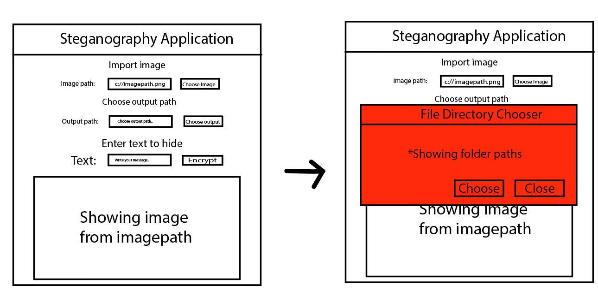
Updates path after choosing the file and displays image within the box. Clicking choose output button opens file directory chooser.
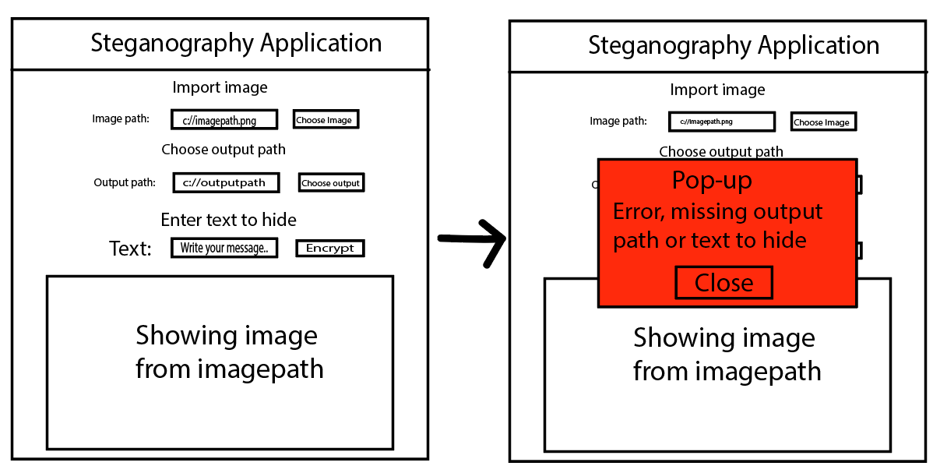
Output path is updated with chosen path from the file directory chooser. If the user then clicks encrypt without writing message it will send an error pop-up to alert them what to do.
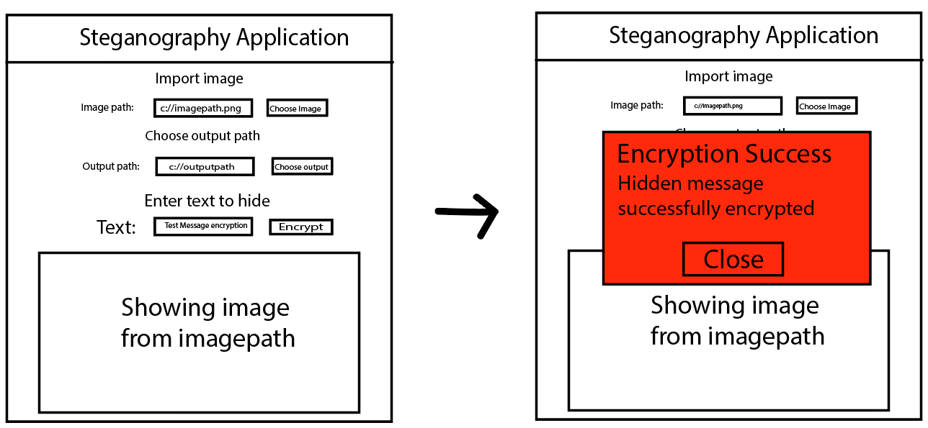
Once the file to encrypt with hidden text is imported, output path is chosen and a written message to hide is complete. User can encrypt and a pop-up will display whether it is successful or not.

8.2.2.2 Decryption Process
The plan of the decryption process using the user interface.
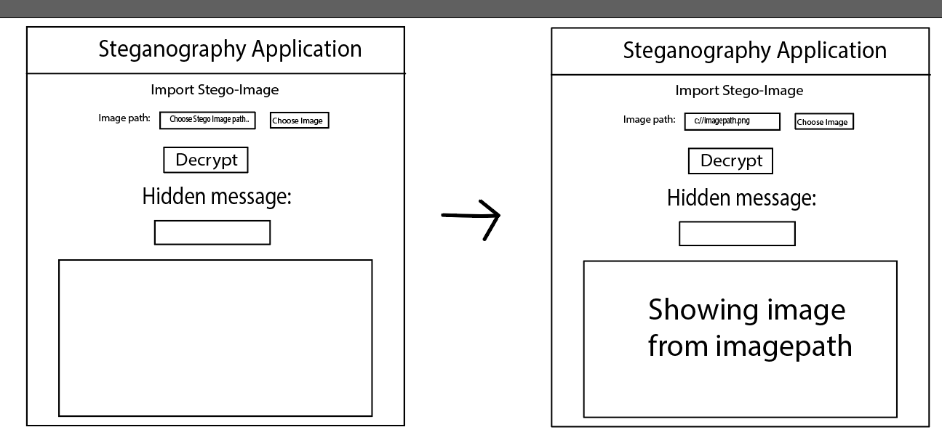
Selecting image path for the steganographic image.
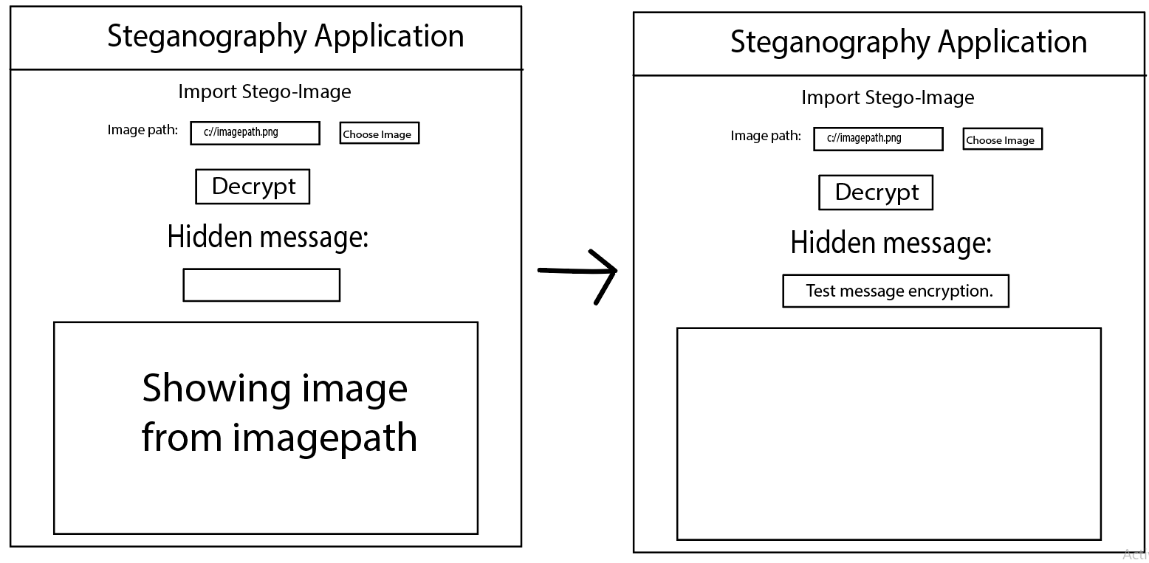
Decrypting image once steganographic image is selected. Displays the message within the box.
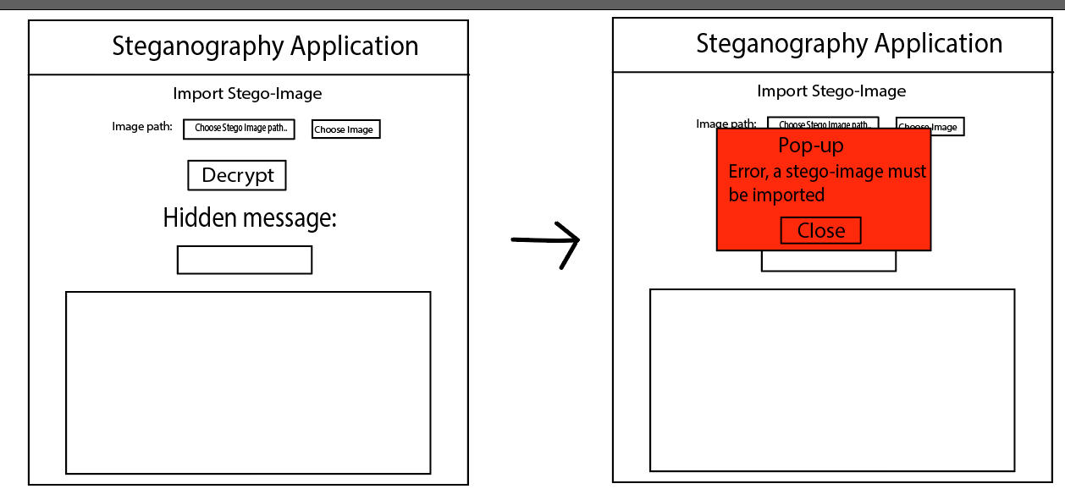
Clicking decrypt without a steganographic image selected.

8.3 Appendix C – Implementation Stage
Images during the implementation stage of building the program.

8.3.1 SceneBuilder
The scenebuilder program used for implementing a graphical interface.
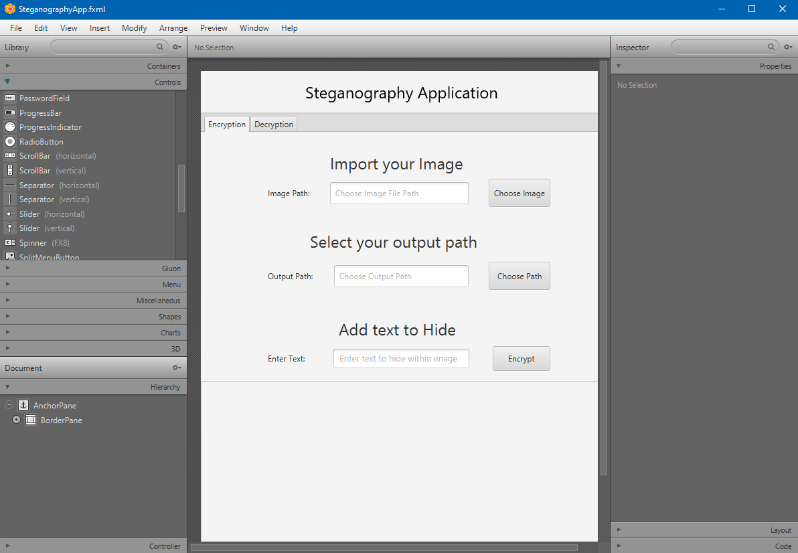

8.3.2 Eclipse IDE
The IDE used to build and implement the program.
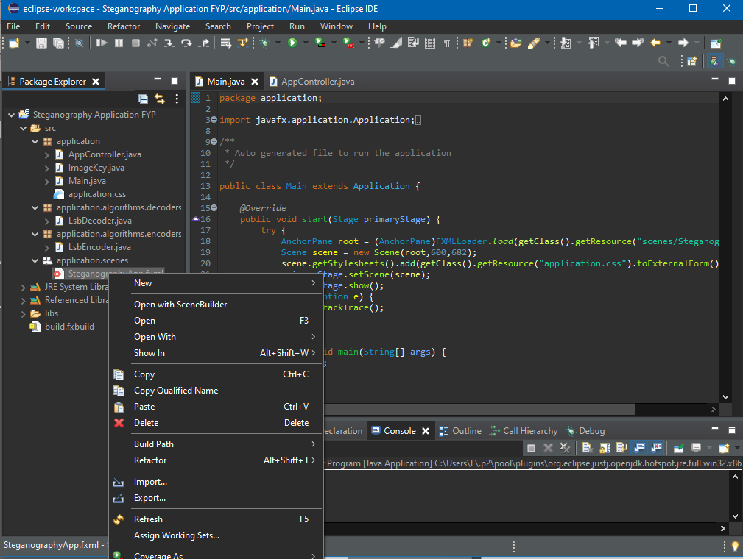

8.4 Appendix D - Evaluation of Survey results
Results of the survey conducted.
From questions 11 to 12, the correct images holding the hidden message are in the order of 2, 1, 2, 2, 1, 1, 2, 1, 1, 1.
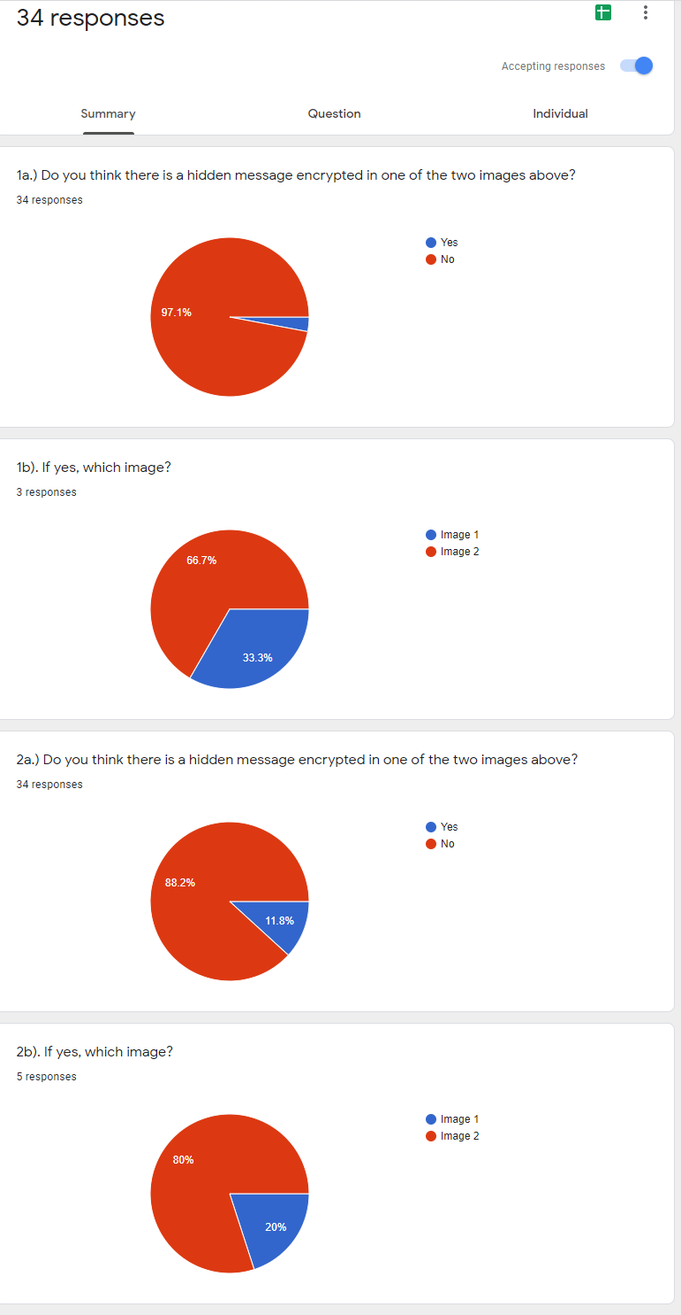

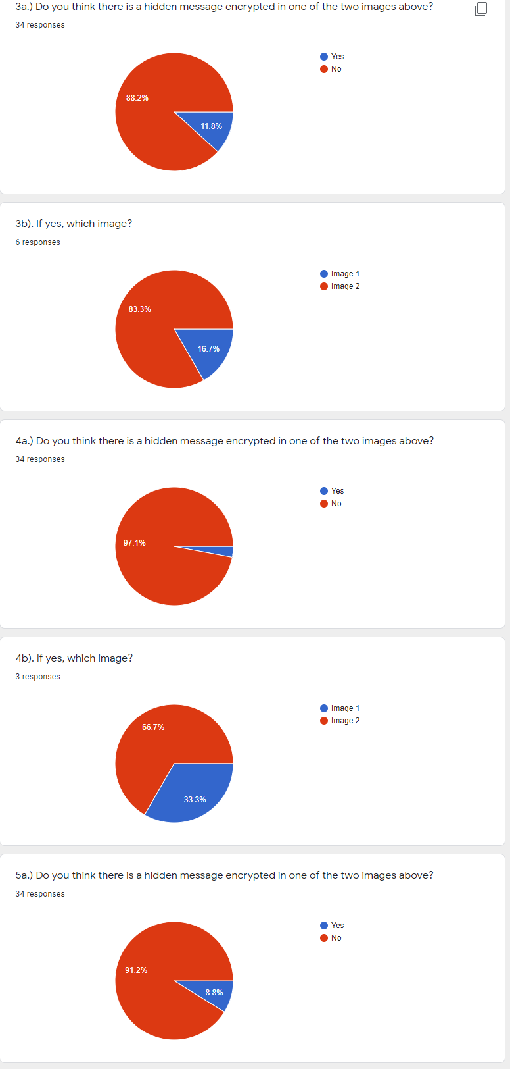
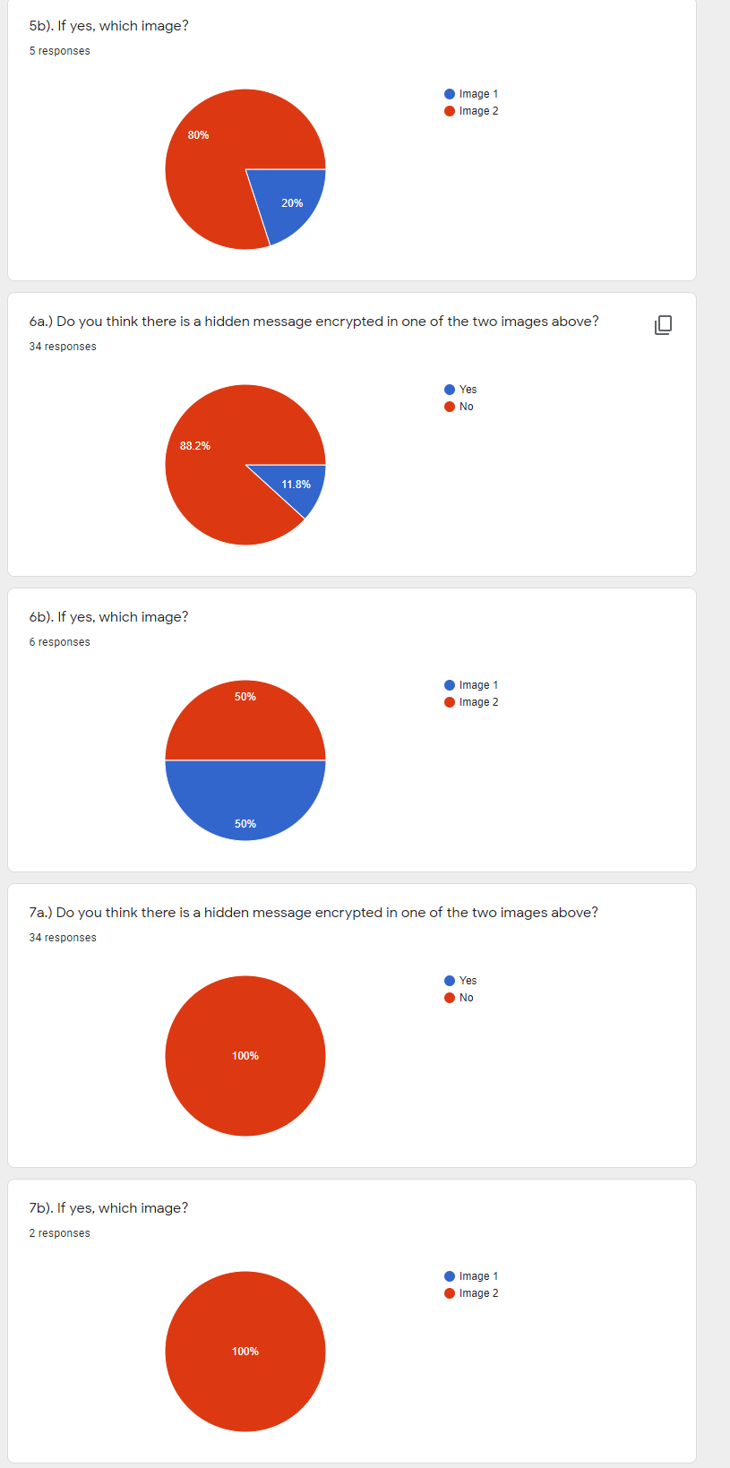
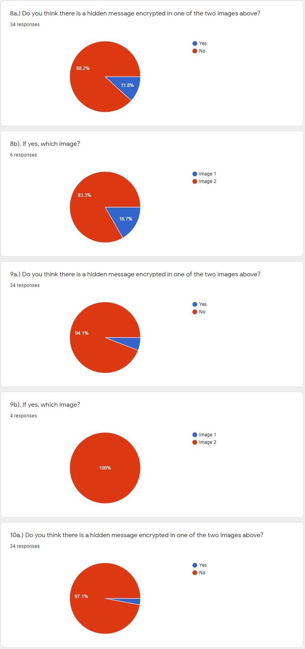
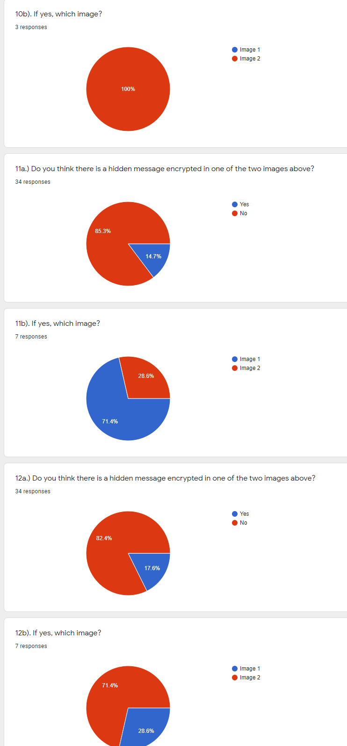
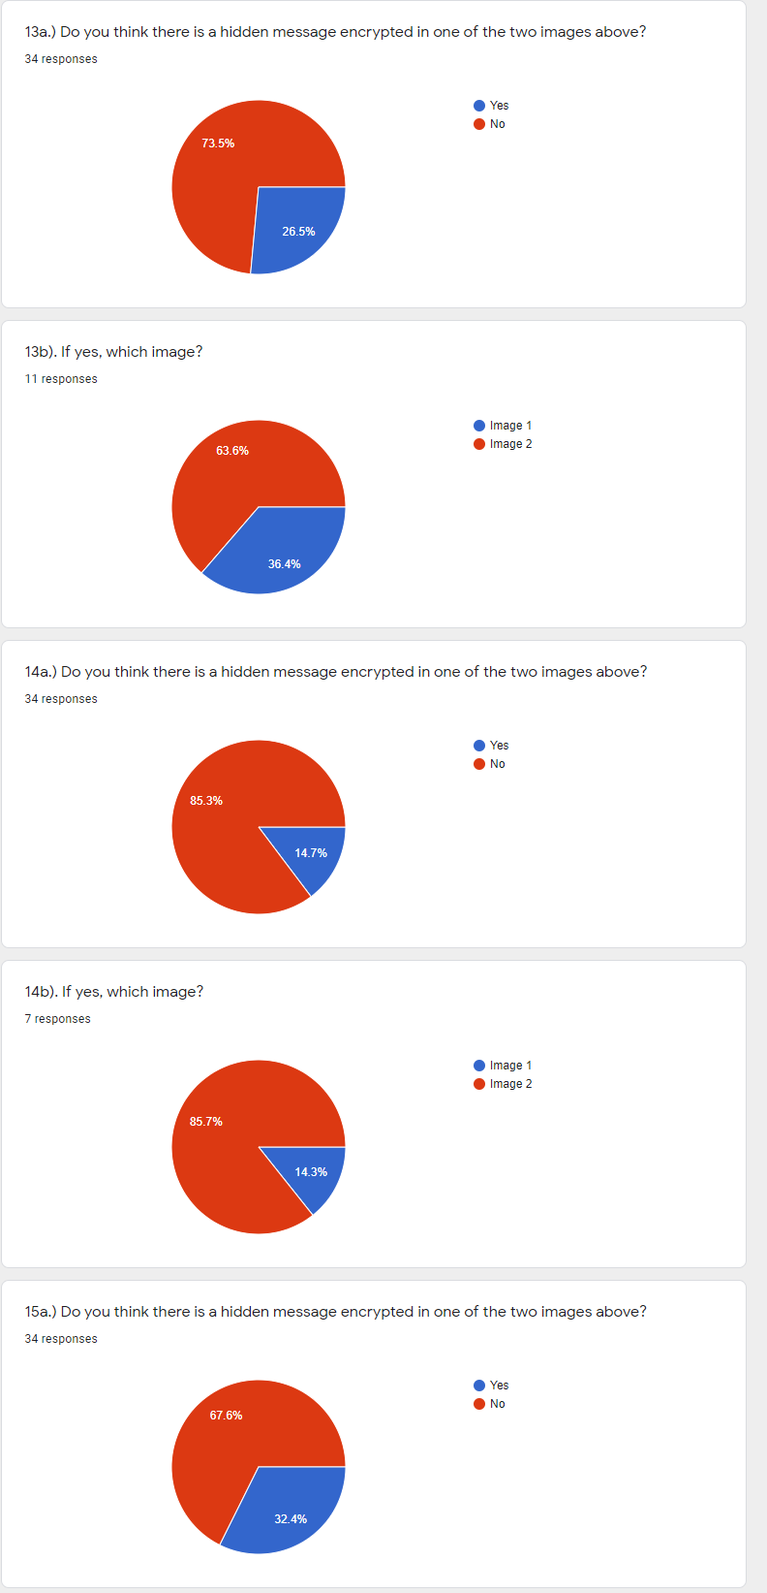
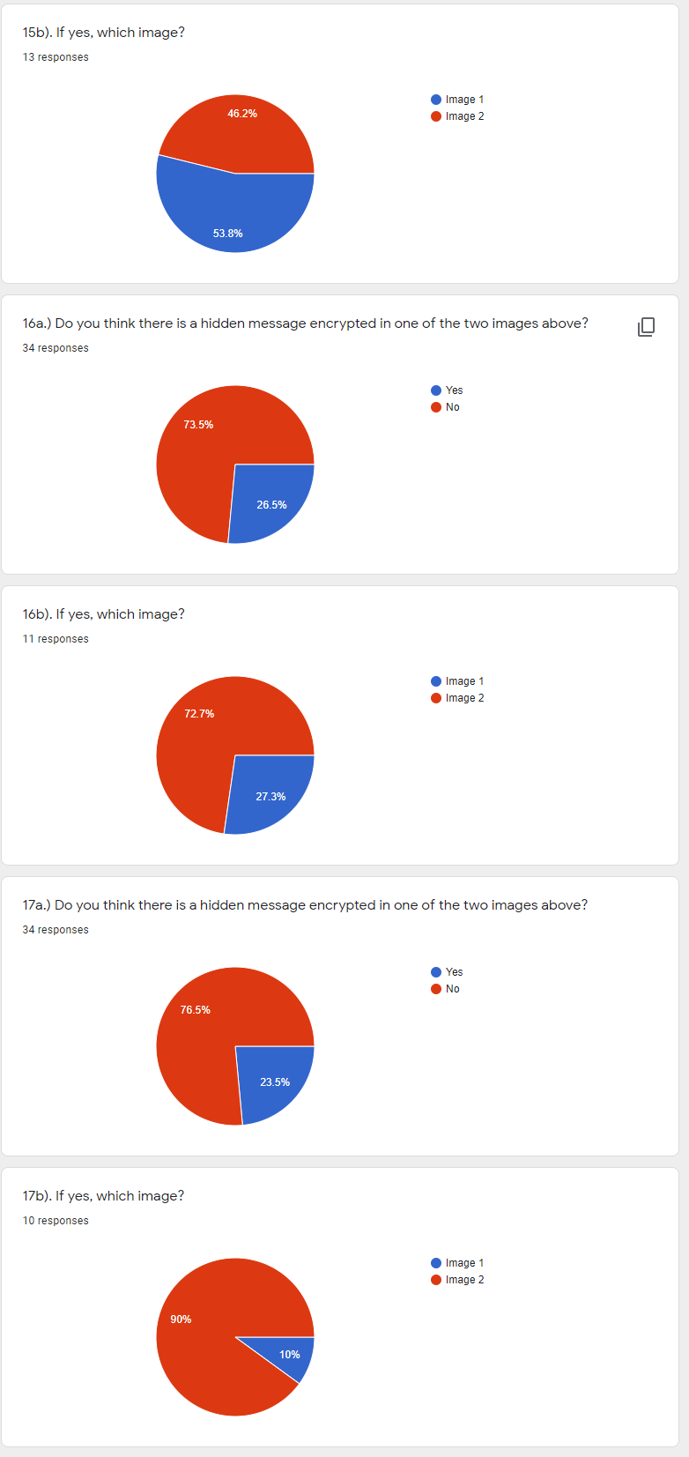
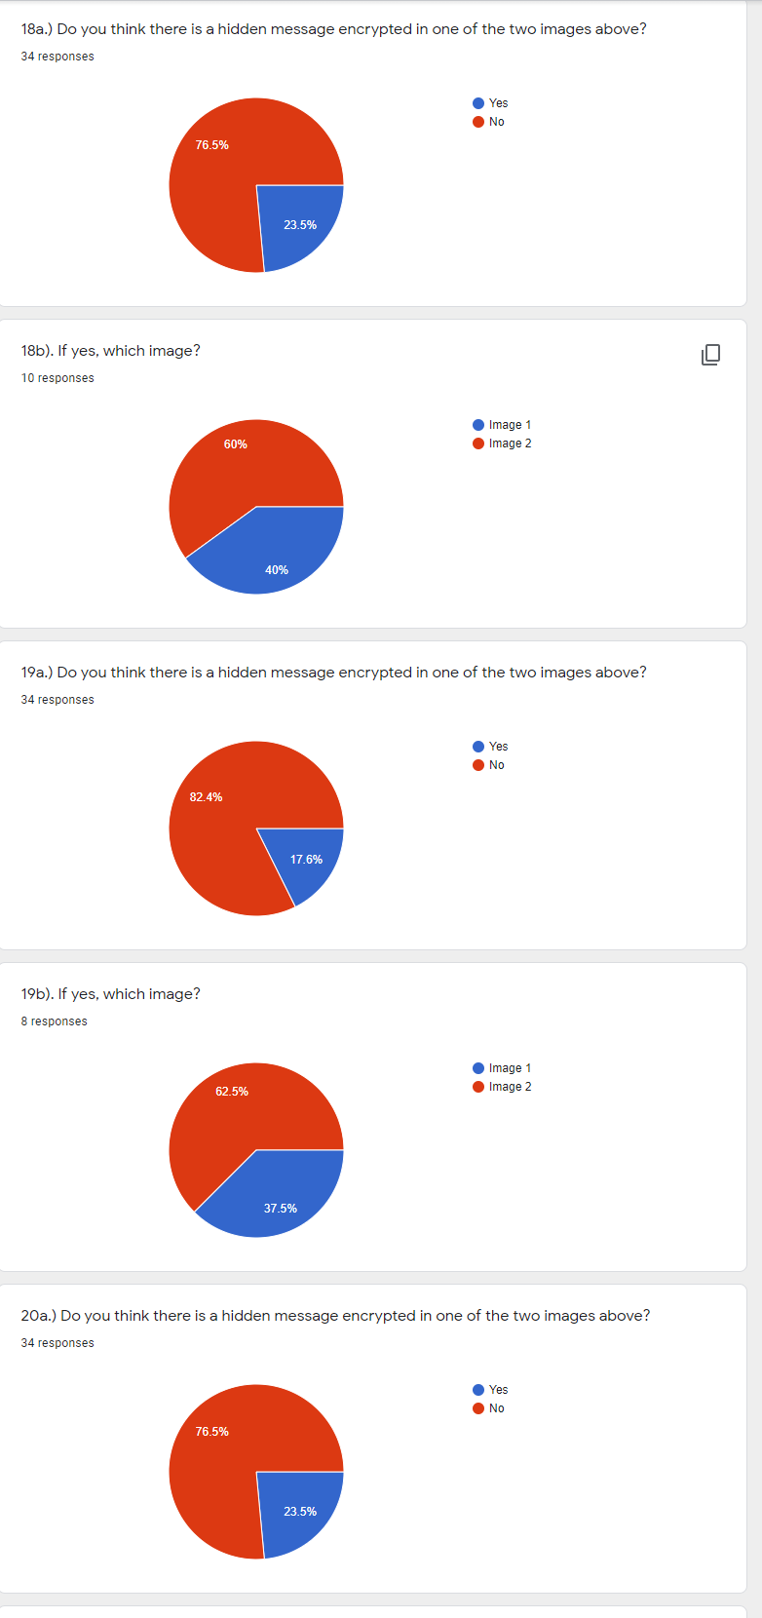
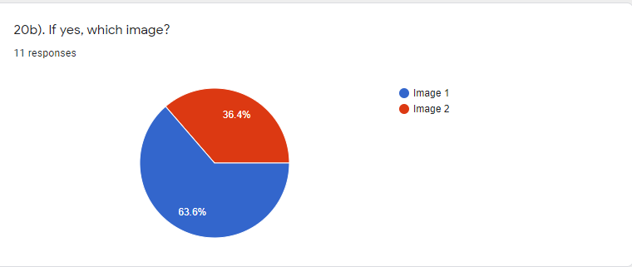

References

[1] | J. J. C., “Steganography: Past, Present, Future,” pp. 1-5, 2001.
[2] | A. Kumar and K. Pooja, “Steganography- A Data Hiding Technique,” International Journal of Computer Applications (0975 – 8887), vol. 9, no. 7, pp. 19-20, 2010.
[3] | A. Siper, R. Farley and C. Lombardo, “The Rise of Steganography,” Proceedings of Student/Faculty Research Day, p. D1.1, 2005.
[4] | J. Reeds, “Solved: The Ciphers in Book iii of Trithemius's Steganographia,” AT&T Labs, pp. 1-3, 1998.
[5] | G. Kippler, Investigators Guide to Steganography, CRC Press, 2003.
[6] | R. Poornima and R. Iswarya, “AN OVERVIEW OF DIGITAL IMAGE STEGANOGRAPHY,” International Journal of Computer Science & Engineering Survey (IJCSES), vol. 4, no. 1, pp. 1-5, 2013.
[7] | A. Fkirin, G. Attiya and A. El-Sayed, “Steganography Literature Survey, Classification and,” Communications on Applied Electronics (CAE), vol. 5, no. 10, pp. 13-15, 2016.
[8] | “All About Images,” M Library, 25 August 2020. [Online]. Available: https://guides.lib.umich.edu/c.php?g=282942&p=1885352. [Accessed 17 January 2021].
[9] | “Bit depth (image),” Digitization Guidelines Gov, 2 October 2008. [Online]. Available: http://www.digitizationguidelines.gov/term.php?term=bitdepthimage. [Accessed 2021 January 17].
[10] | R. Fisher, S. Perkins, A. Walker and E. Wolfart, “24-bit Color Images,” HIPR2, 1 February 2001. [Online]. Available: https://homepages.inf.ed.ac.uk/rbf/HIPR2/24bitcol.htm. [Accessed 17 January 2021].
[11] | O. Al-qershi, N. Hamid, A. Yahya and R. Ahmad, “Image Steganography Techniques: An Overview,” pp. 169-170, 2012.
[12] | M. Nosrati, R. Karimi and M. Hariri, “An introduction to steganography methods,” World Applied Programming, vol. 1, no. 3, p. 193, 2011.
[13] | A. J. CHRISTALINE and D. Vaishali, “IMAGE STEGANOGRAPHIC TECHNIQUES WITH IMPROVED EMBEDDING CAPACITY AND ROBUSTNESS,” Image Steganalysis, pp. 97-98, 2011.
[14] | S. Goel, A. Rana and M. Kaur, “A Review of Comparison Techniques of Image,” Global Journal of Computer Science and Technology, vol. 13, no. 4, pp. 1-2, 2013.
[15] | V. Nagaraj, D. V. Vijayalakshmi and D. V. Zayaraz, “Overview of Digital Steganography Methods and Its Applications,” International Journal of Advanced Science and Technology, vol. 60, p. 50, 2013.
[16] | A. Hamarsheh and A. M. A. Raja , “AH4S: An algorithm of text in text steganography using the structure of omega network,” Security and Communication Networks, p. 6005, 2017.
[17] | H. Singh, A. Diwakar and S. Upadhyaya, “A Novel Approach to Text Steganography,” International Congress on Computer, Electronics, Electrical, and Communication Engineering, vol. 59, p. 10, 2014.
[18] | M. N. Vaziri and B. S. Mahjour, “Steganography In Programming,” Australian Journal of Basic and Applied Sciences, vol. 5, no. 12, p. 1498, 2011.
[19] | Y. C. Jina, K. S. Manglem and T. Tuithug, “Image Steganography and Steganalysis: A Survey,” International Journal of Computer Applications (0975 – 8887), vol. 52, no. 2, pp. 1-2, 2012.
[20] | Q. Qi, “A Study on Countermeasures against Steganography: an Active,” The Graduate College at the University of Nebraska In Partial Fulfilment of Requirements, pp. 1-3, 2013.
[21] | M. Kaur and G. Kaur, “Review of Various Steganalysis Techniques,” International Journal of Computer Science and Information Technologies, vol. 5, no. 2, pp. 1745-1746, 2014.
[22] | L. Lin, “Hunting wild stego images, a domain adaptation problem in,” pp. 15-16, 2020.
[23] | M. Broda, V. Hajduk and D. Levick´y, “Universal statistical steganalytic method,” Journal of ELECTRICAL ENGINEERING, vol. 68, no. 2, p. 119, 2017.
[24] | T. Sarkar and S. Sanyal, “Steganalysis: Detecting LSB Steganographic,” pp. 1-2, 2014.
[25] | “MoSCoW Prioritization,” ProductPlan, 4 January 2019. [Online]. Available: https://www.productplan.com/glossary/moscow-prioritization/. [Accessed 18 April 2021].
[26] | “JavaFx Scene Builder,” Oracle, 26 October 2014. [Online]. Available: https://www.oracle.com/java/technologies/javase/javafxscenebuilder-info.html. [Accessed 18 April 2021].
[27] | “Desktop IDEs,” Eclipse Foundation, 16 June 2007. [Online]. Available: https://www.eclipse.org/ide/. [Accessed 18 April 2021].

