Managing Health and Safety in a Project

Jenny Stroud
2008886

Module Tutor:
Deborah Hughes
Contents

1.0 - Introduction 3
2.0 - Health and Safety Regulations 3
2.1 - Health and Safety at Work Act (1974) 3
2.2 - The Corporate Manslaughter and Corporate Homicide Act (2007) 3
2.3 - The Working at Height (2005) 3
3.0 - Construction, Design and Management Roles 4
3.1 - Comercial Clients 4
3.2 - Domestic Clients 4
3.3 - Designers 4
3.4 - Principle Designers 4
3.5 - Principle Contractors 5
3.6 - Contractors 5
3.7 - Workers 5
4.0 - Construction Phase Plan 5
5.0 - Conclusion 9
6.0 - References 10
7.0 - Appendices 11
7.1 - Risk Assessment 1 11
7.2 - Risk Assessment 2 12
7.3 - Risk Assessment 3 14
7.4 - Method Statement 1 15
7.5 - Method Statement 2
7.6 - Method Statement 3

1.0 - Introduction

This report is going to included the regulations that will affect the Construction Phase Plan and Risk and Method statements (RAM’S), the report will also included the different roles and their responsibilities are based on the Construction, Design and Management regulations 2015 (CDM)

2.0 - Health and safety regulations

These are regulations that all companies in the UK must follow to protect their workforce through every task they will complete.

2.1 - Health and Safety at Work Act (1974)

In 1974 the government made the Health and Safety at Work Act (HASAWA), this is an UK legislation outlining the health, safety and welfare requirements in the work place. This allows the employer to help keep all their employees, visitors and clients in a safe working environment. The act also requires that the company provide any ppe if required free of charge, the employer must also inform all employees of the health and safety rules in the company and give the required training needed to complete the tasks on the job safely. The act will then be enforced by the Health and Safety Executive, they are able to give penalties to the company not meeting the standards of the act (Naturalhr, 2020). The act doesn’t just fall down to the employer, the employees must
To help reinforce the Health and Safety at Work Act, they introduced the Management of Health and Safety at Work Regulations 1999. This regulation shows employers with more detail what they are required to complete in every work area, they also state that risk assessments must be completed if you have more than five workers at a job (Health and Safety Executive, 2020).
This legislation will be very relevant for the build of the caretakers house, as there will have to be measures in place for the builds to make sure their environment is safe to work at. The principle contractor will be in charge of making sure the site is up to date with all safety regulations and employees on the site will have all the necessary supplies, ppe and safety training required for the construction site.

2.2 - The Corporate Manslaughter and Corporate Homicide Act (2007)

The Corporate Manslaughter and Corporate Homicide Act was introduced in 2007, the act was first enforced in April 2008. Companies can be found guilty of manslaughter or homicide if there has been a “gross breach of a duty of care”(Health and Safety Executive 2, 2020). If found guilty then the corporate body would be prosecuted, but other individuals like the directors can still be prosecuted for different health and safety offences, (Health and Safety Executive 2, 2020).

2.3 - The Working at Height Regulations (2005)

This regulations helps to prevent injury or death from height. The employer or who is in charge of the work taking place must make sure the correct equipment is used and planned to help the workers be safe while at height. When planning to see if any requirements are needed the employer must also taken in to account the weather, as if there is bad weather this could mean more precautions are needed. This act will also cover being on a ladder to a hole in the ground, as well as the employer providing the correct equipment to protect them, they also must be given the correct training and knowledge on how to use any equipment given, (Health and Safety Executive 3, 2019), (Health and Safety Executive 6, 2014).

3.0 - Construction, Design and Management Roles (CDM 2015)

The construction, design and management regulations (CDM) first was enforced in 1994 and was updated in 2007 and later in 2015 which is the most up to date version. The CDM is in place to help improve the health and safety on a construction site for all its workers (Health and Safety Executive 4, 2020).

3.1 - Commercial Clients

A commercial client is an individual working as part of a business. The commercial clients are responsible for managing the project, making everyone aware of the time period for the project and all resources are available to the workers. They will also be responsible for the welfare facilities on site and the principle contractors and designers complete their jobs properly (Health and Safety Executive 5, 2020).

3.2 - Domestic Clients

The domestic client would be someone making improvements to their home for example adding an extension onto their house, this isn’t part of a business. As of 2015 the CDM transfers the duty of the job to the sub-contractor or the principle contractor of the site. The domestic client and the principle designer can also decided to have a written contract for the domestic client to have the clients duty (Health and Safety Executive 5, 2020).

3.3 - Designers

The designer is an individual that works for a company, they will be the ones making and/or modifying the designs for construction work. The designer when modifying the designs, the designer would try to eliminate or control potential risks that could arise on the construction site, they must then pass this information onto the team (Health and Safety Executive 5, 2020).

3.4 - Principle Designers

A principle designer will only be appointed if there is more than one contractor on the site, they will have the knowledge, have the ability to complete the role and the experience. Principle designers will be in charge of the health and safety at the pre-construction phase. They will need to identify potential risks and try to control it to help protect the workers. The risk assessments should then be passed to the principle contractor in a health and safety file, the risks assessments in the file should be reviewed regularly and be up dated if needed (Health and Safety Executive 5, 2020).

3.5 - Principle Contractors

Principle contractors will be appointed when there is more than one contractor, once they have received the health and safety file they will be responsible during the construction phase for the health and safety and must updated the file with any new risks that may arise during the construction phase, this file will then be given back to the. Client at the end of the construction. They are responsible for site inductions, stopping unauthorised access to the site, the welfare facilities are provided for the workers and workers are informed on their health and safety for the construction site (Health and Safety Executive 5, 2020).

3.6 - Contractors

The contractors role will be the people that would complete the actual construction work, they could be part of an organisation or an individual. The contractor will monitor and manage the work that is under their control to complete it to their best and without risk to themselves or others (Health and Safety Executive 5, 2020).

3.7 - Workers

These are the people under the control of the construction site contractor. The workers should be informed of matters that could affect their health, safety and welfare, report anything they believe could be a risk to theirs or someone else’s health and will need to take care of their own health and safety and anyone that could be potentially affected by their actions (Health and Safety Executive 5, 2020).

4.0 - Construction Phase Plan

Your Name: | Jenny Stroud
Company Name: | SS Constructions
Client Name: | University of Wales Trinity Saint Davids
Client Information:
Address: 1 Kings Road, Swansea SA1 8PH
Telephone Number: 01792 481000
Site Manager and Information: | David Lewis  07648 764581
Principle Contractor and Information: | Matthew Thomas  07895 125629
Contract title: | Kings Road, Caretakers House
Site Address: | Kings Road, Swansea  SA1 8PJ  Image below is where the build will be.
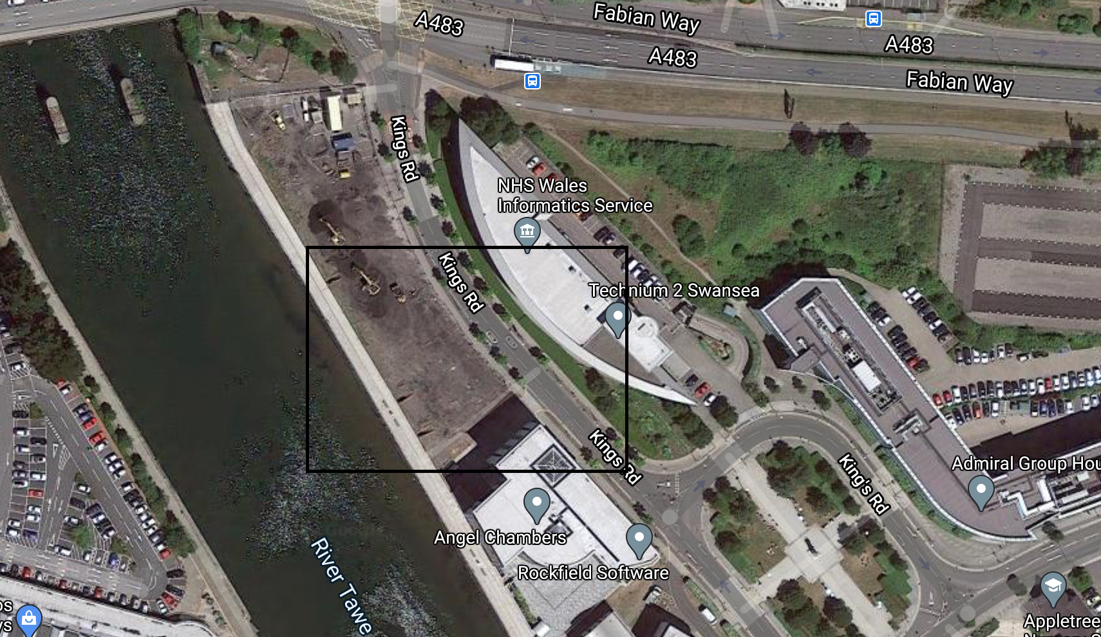
Image 1: Google Maps (Image Taken 2020)
Dates  - Start  - Finish | 6th May 2021  6th November 2021
Contract Duration: | 6 Months
Workers Facilities location: | As there is already works taking place the space around the site is very limited, the close area with enough space to hold all the facilities for workers is below with the black box around the area.
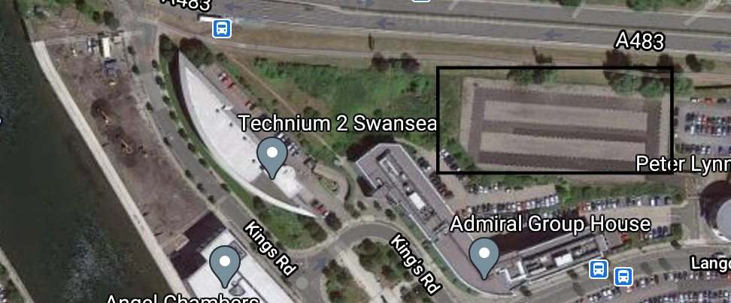
Image 2: Google maps (Image Taken 2020)
Project Description:
The caretakers house will be built next to the student accommodation that is currently at the construction phase.
It will be a two story building with standard cavity wall constructions.
Previous use for the Land: | The previous use for the land was industrial.
Existing Structures: | No existing structures on site.
Surrounding Facilities: | Located next to the River Tawe.  Fabian Way is a busy road in and out of Swansea from the M4, this road can become very busy in peak times.  Pubs and Restaurants near site, SA1 is becoming a really busy and popular drinking area during the night and day, this could cause a lot of public around the construction site.
Traffic System: | This is the main access to the site, it has a two way system, with a large roundabout that could help large lorries with deliveries turn around easier. Image below shows the main road for the site.
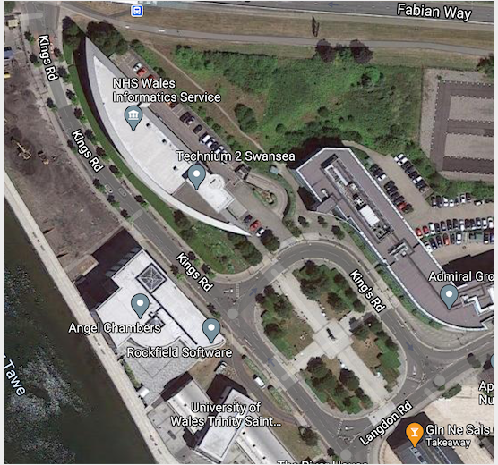
Image 3: Google Maps (Image Taken 2020)
Health and Safety:
To keep health and safety up to date and monitored we are going to enforce the health and safety risks identified in the health and safety file, also if any workers on site see anything they think could be a potential risk this will be reported to the site manager to look further into it and put precautions to prevent that risk harming anyone.

Each morning before work can commence three will be a toolbox talk, these talks will cover:
- First aid information
- Facilities location
- Identify the risks on site
- Accident reporting processes
- Ppe information
- Fire meeting point
First Aid: | On site there will be two first aid kits one location at the construction site and the other at the facilities.  There will always be one person appointed the first aider on site, the site manager should be trained/ qualified to be the first aider on site, if they are unable to be the first aider then someone else will be appointed and the workers and personnel will be told.
Hospital Information: | Morriston Hospital A&E  Address: Heol Maes Eglwys, Morriston, Cwmrhydyceirw, Swansea SA6 6NL  Telephone: 01792 702222  The fast way to get to the hospital from site would be on the M4 off at Llangyfelach and then follow the signs.
Accident Reporting: | Anything that fallings under the Reporting of Injuries, Diseases and Dangerous Occurrences Regulations 2013 (RIDDOR 2013) should be reported to the site manager even if no medical support has be received.
Fire Safety: | There will be a fire marshal on site that will be responsible for making sure that everyone meets at the fire meeting point, who ever notices the fire should try and raise the alarm as fast and safely as they can.  The fire marshal will also check that everyone is accounted for, when workers and visitors attended the site they are required to sign in and check out.  If safe to do so use a fire extinguisher.
Project Details: | Risk Assessments will be found in the appendices 7.1, 7.2 and 7.3  The method statements is also in appendices at 7.4, 7.5, 7.6

5.0 - Conclusion

This assignment was to state the relevant Health and Safety regulations involved with building a care takers house located in SA1, and state the risks and find suitable precautions of how to reduce the chance of harm to the workers on site.

6.0 - References

(Naturalhr, 2020), Naturalhr, https://www.naturalhr.com/2020/03/05/health-safety-work-act-1974/ Accessed on 15th October 2020

(Health and Safety Executive, 2020), HSE, https://www.hse.gov.uk/pubns/hsc13.pdf Accessed on 16th October 2020

(Health and Safety Executive 2, 2020), HSE, https://www.hse.gov.uk/corpmanslaughter/about.htm Accessed on 31st October 2020

(Health and Safety Executive 3, 2019) ,HSE, https://www.hse.gov.uk/work-at-height/the-law.htm Accessed on 28th October 2020

(Health and Safety Executive 4, 2020), HSE, https://www.hse.gov.uk/construction/cdm/2015/index.htm Accessed on 30th October 2020

(Health and Safety Executive 5, 2020), HSE, https://www.hse.gov.uk/construction/cdm/2015/summary.htm Accessed on 30th October 2020

(Health and Safety Executive 6, 2014), HSE, https://www.hse.gov.uk/pubns/indg401.pdf Accessed on 31st October 2020

Image 1: Google Maps (Image Taken 2020), Google Maps, https://www.google.co.uk/maps/@51.6211649,-3.9339493,301m/data=!3m1!1e3

Image 2: Google Maps (Image Taken 2020), Google Maps, https://www.google.co.uk/maps/@51.6211649,-3.9339493,301m/data=!3m1!1e3

Image 3: Google Maps (Image Taken 2020), Google Maps, https://www.google.co.uk/maps/@51.6211649,-3.9339493,301m/data=!3m1!1e3
7.0 - Appendices

7.1 - Risk Assessment 1
Activity to be Assessed |  |  |  |  |  |  |  |  |  |  |  |  |  |  |  |  | Assessment Number
Delivery From Suppliers |  |  |  |  |  |  |  |  |  |  |  |  |  |  |  |  | 1
Persons undertaking or affected by the activity
 |  | x | Employees |  | x | Contractor |  |  | x | Public |  |  |  |  | Service User
 |  |  | Other …………………………………………………………………………………………….
Identified Hazards and Associated Risks |  |  |  |  |  |  |  |  |  |  | Likelihood |  |  |  |  |  | Severity |  |  |  |  | Risk Level
1 | Poor road Access- main road traffic and narrow road |  |  |  |  |  |  |  |  |  | 3 |  |  |  |  |  | 5 |  |  |  |  | 15
2 | Unpacking the delivery using machinery or workers potential injury with both |  |  |  |  |  |  |  |  |  | 4 |  |  |  |  |  | 4 |  |  |  |  | 16
3 | Public, SA1 is a busy area, the walk paths will be blocked by the delivery and dropping items can injury them, there is also a chance of people being intoxicated. |  |  |  |  |  |  |  |  |  | 3 |  |  |  |  |  | 5 |  |  |  |  | 15
4 | Another construction area next to site, they could be having a delivery the same day, lots more employees around the site |  |  |  |  |  |  |  |  |  | 4 |  |  |  |  |  | 5 |  |  |  |  | 20
5
6
Existing Control Measures / Additional Control Measures Required
1 | Closure of the narrow road and traffic diversion for the main road during the delivery to prevent large traffic queues and the risk of workers being hit by traffic or a traffic accident.
2 | If workers are careful and only carry the amounts they can handle, this could prevent injuries from overload and reduce the chance of dropping and injuring someone else. If machinery is involved make sure the equipment is secure on the machinery before lifting and that the floor area the equipment will be placed is clear and safe.
3 | If the workers block of the walk paths and anyway the public would be able to get in the way or close to the delivery, this will prevent them being in an area that could cause potential harm.
4 | Discuss with the other site delivery days and times to prevent a bigger blockage in the road. Give all employees the correct training and inform them when deliveries are coming to help lower the amount of people at the delivery point. This can potentially lower the chances of being injured.
5
6
Reassessment of Activity Hazards |  |  |  |  |  |  |  |  |  |  | Likelihood |  |  |  |  |  | Severity |  |  |  |  | Risk Level
1 | Poor road Access- main road traffic |  |  |  |  |  |  |  |  |  | 2 |  |  |  |  |  | 5 |  |  |  |  | 10R
2 | Unpacking the delivery using machinery or workers potential injury with both |  |  |  |  |  |  |  |  |  | 1 |  |  |  |  |  | 3 |  |  |  |  | 3
3 | Public, SA1 is a busy area, the walk paths will be blocked by the delivery and dropping items can injury them, there is also a chance of people being intoxicated. |  |  |  |  |  |  |  |  |  | 1 |  |  |  |  |  | 3 |  |  |  |  | 3
4 | Another construction area next to site, they could be having a delivery the same day, lots more employees around the site |  |  |  |  |  |  |  |  |  | 2 |  |  |  |  |  | 4 |  |  |  |  | 8
5
6
Name Jenny Stroud  Position CDM Co-ordinator |  |  |  |  |  |  | Signed  J Stroud |  |  |  |  |  |  |  |  |  | Date of Completion:  28th October 2020
Reviews |  |  |  | Key
Review Date: |  |  |  | Likelihood |  |  |  | Severity |  |  | Severity of Injury |  | 5 | 5Y |  |  |  | 10R |  | 15 |  |  | 20 |  | 25
Reviewed by: |  |  |  | 1 very unlikely  2 unlikely  3 likely  4 very likely  5 certainty |  |  |  | 1 nuisance  2 minor  3 medical treatment  4 major  5 fatal |  |  |  |  | 4 | 4 |  |  |  | 8 |  | 12 |  |  | 16 |  | 20
Review Date : |  |  |  |  |  |  |  |  |  |  |  |  | 3 | 3 |  |  |  | 6G |  | 9 |  |  | 12 |  | 15
Reviewed by: |  |  |  |  |  |  |  |  |  |  |  |  | 2 | 2 |  |  |  | 4 |  | 6Y |  |  | 8 |  | 10Y
Review Date : |  |  |  |  |  |  |  |  |  |  |  |  | 1 | 1 |  |  |  | 2 |  | 3 |  |  | 4 |  | 5G
Reviewed by: |  |  |  |  |  |  |  |  |  |  |  |  | 0 | 1 |  |  |  | 2 |  | 3 |  |  | 4 |  | 5
Review Date : |  |  |  |  |  |  |  |  |  |  |  |  |  | Likelihood of Injury
Reviewed by: |  |  |  |  |  |  |  |  |  |  |  | Low Risk |  |  |  |  |  |  | Medium Risk |  |  |  |  | High Risk

7.2 - Risk Assessment 2
Activity to be Assessed |  |  |  |  |  |  |  |  |  |  |  |  |  |  |  |  | Assessment Number
Tiling a roof |  |  |  |  |  |  |  |  |  |  |  |  |  |  |  |  | 2
Persons undertaking or affected by the activity
 |  | x | Employees |  | x | Contractor |  |  | x | Public |  |  |  |  | Service User
 |  |  | Other …………………………………………………………………………………………….
Identified Hazards and Associated Risks |  |  |  |  |  |  |  |  |  |  | Likelihood |  |  |  |  |  | Severity |  |  |  |  | Risk Level
1 | Working at height |  |  |  |  |  |  |  |  |  | 5 |  |  |  |  |  | 4 |  |  |  |  | 20
2 | Falling tools/ materials |  |  |  |  |  |  |  |  |  | 3 |  |  |  |  |  | 4 |  |  |  |  | 12
3 | Chance of slipping |  |  |  |  |  |  |  |  |  | 4 |  |  |  |  |  | 5 |  |  |  |  | 20
4
5
6
Existing Control Measures / Additional Control Measures Required
1 | While working at the height the building should have scaffolding all the way around, this provides a more stable and flat surface.
2 | Each member of staff on the site should be equipped with a helmet, suitable footwear and gloves if necessary by the staff wearing the helmet if something was to fall from the roof this will help prevent a less severe accident. All workers should be making sure all materials are tied down to prevent them falling and tools are placed in suitable to appropriate places to try and prevent them falling.
3 | Workers should be fitted with a harness while tiling the roof, as if a member of the team were to slip or fall the harness will prevent them from falling off the roof to the ground.
4
5
6
Reassessment of Activity Hazards |  |  |  |  |  |  |  |  |  |  | Likelihood |  |  |  |  |  | Severity |  |  |  |  | Risk Level
1 | Working at height |  |  |  |  |  |  |  |  |  | 5 |  |  |  |  |  | 2 |  |  |  |  | 10
2 | Falling tools/ materials |  |  |  |  |  |  |  |  |  | 2 |  |  |  |  |  | 3 |  |  |  |  | 6G
3 | Chance of slipping |  |  |  |  |  |  |  |  |  | 2 |  |  |  |  |  | 3 |  |  |  |  | 6G
4
5
6
Name Jenny Stroud  Position CDM Co-ordinator |  |  |  |  |  |  | Signed  J Stroud |  |  |  |  |  |  |  |  |  | Date of Completion:  28th October 2020
Reviews |  |  |  | Key
Review Date: |  |  |  | Likelihood |  |  |  | Severity |  |  | Severity of Injury |  | 5 | 5Y |  |  |  | 10R |  | 15 |  |  | 20 |  | 25
Reviewed by: |  |  |  | 1 very unlikely  2 unlikely  3 likely  4 very likely  5 certainty |  |  |  | 1 nuisance  2 minor  3 medical treatment  4 major  5 fatal |  |  |  |  | 4 | 4 |  |  |  | 8 |  | 12 |  |  | 16 |  | 20
Review Date : |  |  |  |  |  |  |  |  |  |  |  |  | 3 | 3 |  |  |  | 6G |  | 9 |  |  | 12 |  | 15
Reviewed by: |  |  |  |  |  |  |  |  |  |  |  |  | 2 | 2 |  |  |  | 4 |  | 6Y |  |  | 8 |  | 10Y
Review Date : |  |  |  |  |  |  |  |  |  |  |  |  | 1 | 1 |  |  |  | 2 |  | 3 |  |  | 4 |  | 5G
Reviewed by: |  |  |  |  |  |  |  |  |  |  |  |  | 0 | 1 |  |  |  | 2 |  | 3 |  |  | 4 |  | 5
Review Date : |  |  |  |  |  |  |  |  |  |  |  |  |  | Likelihood of Injury
Reviewed by: |  |  |  |  |  |  |  |  |  |  |  | Low Risk |  |  |  |  |  |  | Medium Risk |  |  |  |  | High Risk

7.3 - Risk Assessment 3
Activity to be Assessed |  |  |  |  |  |  |  |  |  |  |  |  |  |  |  |  | Assessment Number
PPE Equipment |  |  |  |  |  |  |  |  |  |  |  |  |  |  |  |  | 3
Persons undertaking or affected by the activity
 |  | x | Employees |  |  | Contractor |  |  |  | Public |  |  |  |  | Service User
 |  |  | Other …………………………………………………………………………………………….
Identified Hazards and Associated Risks |  |  |  |  |  |  |  |  |  |  | Likelihood |  |  |  |  |  | Severity |  |  |  |  | Risk Level
1 | COVID-19 |  |  |  |  |  |  |  |  |  | 3 |  |  |  |  |  | 5 |  |  |  |  | 15
2 | Falling items |  |  |  |  |  |  |  |  |  | 3 |  |  |  |  |  | 4 |  |  |  |  | 12
3 | Moving vehicles, may not see anyone |  |  |  |  |  |  |  |  |  | 2 |  |  |  |  |  | 5 |  |  |  |  | 10
4
5
6
Existing Control Measures / Additional Control Measures Required
1 | With the new measures of a one way system on site, regular hand sanitising, limit the amount of people in each room and keeping the 2 metre distance unless your in your work bubble e.g the brick layers all stay in one group.
2 | Each employee should make sure they wear their hard helmet at all times on site and do regular checks on the date on the helmet, so its always in date.
3 | Everyone should wear a high visibility jacket, so even towards the end of the day when it gets darker they can also be seen. This will help moving vehicles see any employees on site.
4
5
6
Reassessment of Activity Hazards |  |  |  |  |  |  |  |  |  |  | Likelihood |  |  |  |  |  | Severity |  |  |  |  | Risk Level
1 | COVID-19 |  |  |  |  |  |  |  |  |  | 2 |  |  |  |  |  | 5 |  |  |  |  | 10
2 | Falling items |  |  |  |  |  |  |  |  |  | 2 |  |  |  |  |  | 3 |  |  |  |  | 9
3 | Moving vehicles, may not see anyone |  |  |  |  |  |  |  |  |  | 1 |  |  |  |  |  | 5 |  |  |  |  | 5
4
5
6
Name Jenny Stroud  Position CDM Co-ordinator |  |  |  |  |  |  | Signed  J Stroud |  |  |  |  |  |  |  |  |  | Date of Completion:  28th October 2020
Reviews |  |  |  | Key
Review Date: |  |  |  | Likelihood |  |  |  | Severity |  |  | Severity of Injury |  | 5 | 5Y |  |  |  | 10R |  | 15 |  |  | 20 |  | 25
Reviewed by: |  |  |  | 1 very unlikely  2 unlikely  3 likely  4 very likely  5 certainty |  |  |  | 1 nuisance  2 minor  3 medical treatment  4 major  5 fatal |  |  |  |  | 4 | 4 |  |  |  | 8 |  | 12 |  |  | 16 |  | 20
Review Date : |  |  |  |  |  |  |  |  |  |  |  |  | 3 | 3 |  |  |  | 6G |  | 9 |  |  | 12 |  | 15
Reviewed by: |  |  |  |  |  |  |  |  |  |  |  |  | 2 | 2 |  |  |  | 4 |  | 6Y |  |  | 8 |  | 10Y
Review Date : |  |  |  |  |  |  |  |  |  |  |  |  | 1 | 1 |  |  |  | 2 |  | 3 |  |  | 4 |  | 5G
Reviewed by: |  |  |  |  |  |  |  |  |  |  |  |  | 0 | 1 |  |  |  | 2 |  | 3 |  |  | 4 |  | 5
Review Date : |  |  |  |  |  |  |  |  |  |  |  |  |  | Likelihood of Injury
Reviewed by: |  |  |  |  |  |  |  |  |  |  |  | Low Risk |  |  |  |  |  |  | Medium Risk |  |  |  |  | High Risk

7.4 - Method Statements

