

Assessment 1 – Reading Task Template
PART 1: Upload your photo of your A3 in-class notes here:
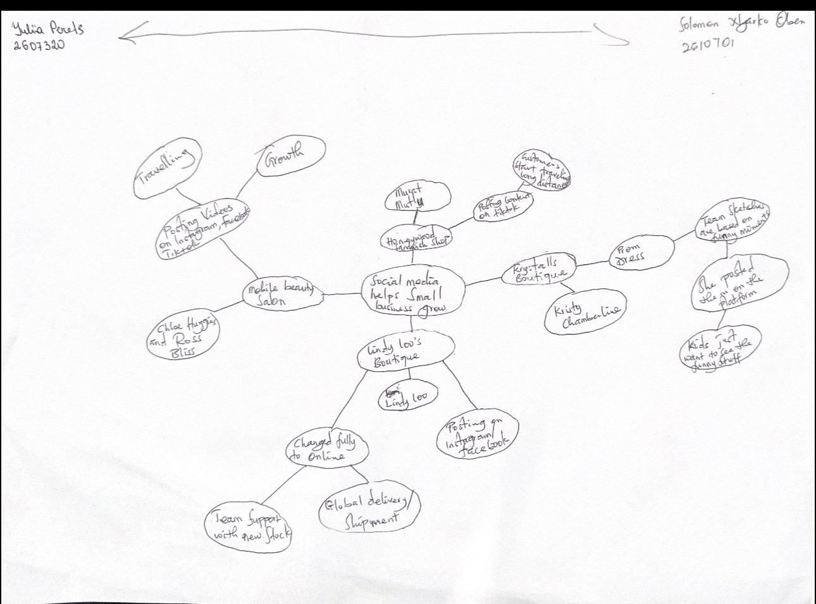

PART 2:
- Answer every question below in 1-3 full sentences.
- Use your own words. Do not use generative AI to answer these questions.
- Include a specific detail from the text when asked.
REMINDER
- The main idea is the overall message of the whole text.
- A key point helps to explain the main idea.
- A specific detail or example from the text shows that the key point is true.

- What is the main idea of the whole text?

Ans: social media help small business grow

- What is one key point that supports the main idea, and which specific example from the text shows this?
Ans: Transition from physical Markets full online operation by lindy loo.
Moving the business online through social media allowed her to expand reach beyond local market to shipping outfits.

- What is a different key point that supports the main idea, and which specific example from the text shows this?
Ans: massive growth and visibility.
Posting videos on platforms like tiktok,instagram,and facebook allowed the business to generate more views.

- Which part of the text do you think is most important, and why?
Ans: finding the main idea
- It helps us understand what we are reading
- It helps with note taking
- Makes summarising easier

Reflection:
- What did you find difficult in this task (including in-class components), and why was it difficult?
Ans: I was having difficulties in finding the key points

- What helped you with this difficulty, and how did it help you?

Ans : I skimmed through the text over and over before arriving at my key points

