Image recognition PID
Objectives
- A pretrained neural network will need to be retrained to suit the purposes of the project. This will be achievable by going through the ModelZoo [1] GitHub [2] repository to find a suitable network. The layers of the network will need to be studied to see how classifications are being made currently, and then modified to suit the specific needs. Information regarding the network model and the research paper of the developers is available on the GitHub [2] repository, and it generally requested that this information be cited in the metadata of the program which the model is used for.
- A set of training/testing data shall be collected in order to train the network and test the accuracy once trained. Pictures of each group member, providing consent is given, shall be used as part of this dataset. More images will be found online from royalty-free sources.
- A basic SQL server [3] shall be setup to act the register system to demonstrate the network. Using what has been taught in the database management systems module, this should be straight forward.
- Logic is to be written for updating records in the database based on the weighted predictions from the network. MATLAB [4] has documentation on connecting to a database, and the conditional logic itself shouldn’t prove too difficult.
Scope
- A minimal viable product will be manually passing images to the network for classification, and updating the database based on the results. The expectation, based on what will be spoken about in the pitch is real time image recognition, and while this is ultimately the aim it remains to be seen whether this will be viable. The initial pitch will need to be made very clear that while the end goal is real time detection, it isn’t necessarily realistic.
Constraints
- It is important that we think about what other assignments need to be completed alongside this one; assignment deadlines are known but the time management skills of everyone in the group are not.
- Given the nature of the project, in terms of difficulty level and the technologies involved, bugs are likely to arise in the code; there will be human error but it will be about ensuring that those working on the code are well rested to avoid easily avoidable mistakes.
- It is entirely possible that one of the group members computers will break, or data is lost in some other way; precautions are to be taken in the form of regular backups. If the desktop on the main developer breaks this will greatly affect the deadline; that computer is setup to use the specific technologies required for the project. The network training itself requires a computer with a suitable graphics card, the processing can be done on the CPU, but this would take significantly longer.
- Budget isn’t a big problem; the only real expense will be purchasing a webcam to be used for demonstration purposes. A decent camera could make putting together a test set of data easier, but it isn’t necessary.

Authority
- The lecturers would be considered the project sponsors, they dictate how much time we have available to work on the project, and any deadlines for various assignments relating to the project; James has control over equipment funding.
- Kieren Ayres is the project manager. While the initial project idea belongs to Amelia Moseley, the job of project manager has been delegated to Kieren as they have shown to be very organized and as such can, with Amelia’s say, further delegate tasks to the other group members.
- Stakeholders in the project include
  - Students
  - Lecturers
  - University technicians
  - University finance department
  - External investors (TechHub)
  - Other universities (may be interested to see how well it gets implemented at UWTSD)
  - UWTSD (having a more reliable attendance system will make attendance statistics more accurate)
  - Student services
  - Members of the group

Resources
- In terms of people, the groups resources include: a lead developer, developer, project manager, and the remaining 3 in research positions who can be brought in for development if need be
- Equipment will be a webcam, for a suitable model this would cost roughly £70. Setup for the full implementation would be significantly more costly.

Gannt chart and network diagram
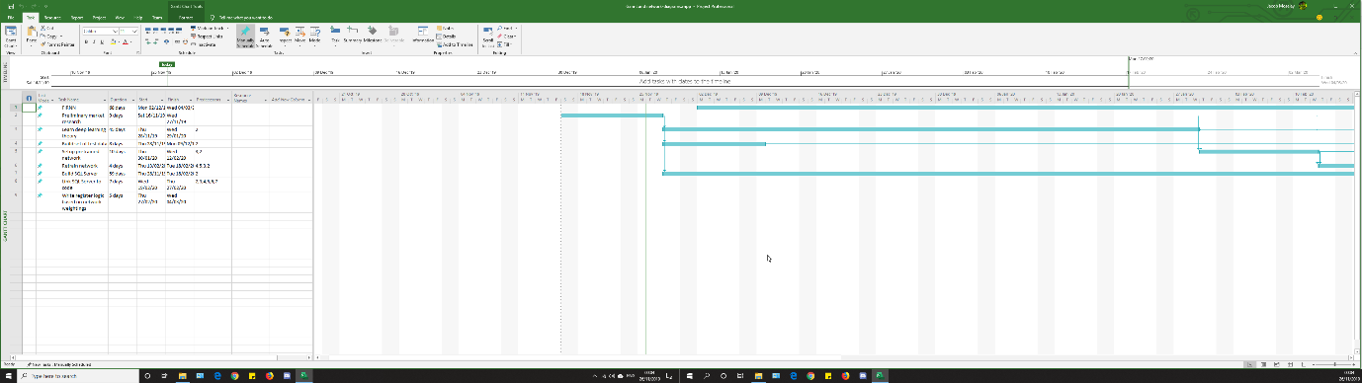

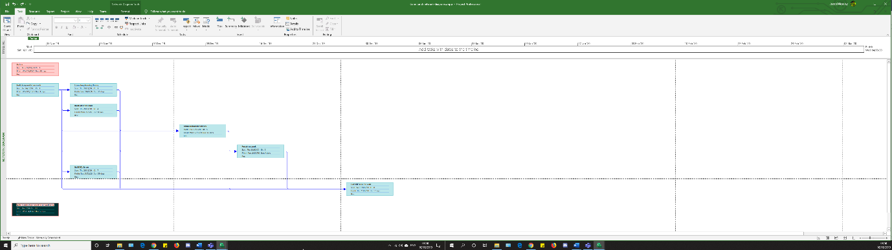

References

[1] | J. Y. Koh, "ModelZoo - Deep learning code and pretrained models for transfer learning," 2018. [Online]. Available: https://modelzoo.co/. [Accessed 16 November 2019].
[2] | S. Lapuschkin, "ModelZoo BVLC/caffe Wiki," GitHub, 25 April 2019. [Online]. Available: https://github.com/BVLC/caffe/wiki/Model-Zoo. [Accessed 16 November 2019].
[3] | Microsoft, "SQL Server 2019 | Microsoft," Microsoft, 2019. [Online]. Available: https://www.microsoft.com/en-in/sql-server/sql-server-2019. [Accessed 16 November 2019].
[4] | MathWorks, "MathWorks - Makers of MATLAB & Simulink," MathWorks, [Online]. Available: https://uk.mathworks.com/. [Accessed 16 November 2019].

