James Williams
UWTSD - Swansea
P150594
Motorsport Management
Social Trends and Consumerism
Social Networking
Carl Singleton

Assignment Task-
With reference to established Marketing concepts, critically evaluate the opportunities and challenges being presented to the Motorsport industry by the growth of social networking.

Introduction
This report will include a thorough evaluation of the affect in terms of the opportunities and challenges of which the motorsport industry has, and potentially will face due to the growth of social networking. The report will give reference to certain established marketing concepts, channels and advertising / targeting techniques in which have evolved or been invented due to the advancement in technologies surrounding social networking. Furthermore, the report will give examples of how the development within this sector creates new opportunities and challenges for motorsport businesses throughout the world.
Main body
To conduct an accurate report, we must understand the what exactly social networking is and what does it mean? ‘Social networking is the use of internet-based social media programs to make connections with friends, family, classmates, customers and clients. Social networking can occur for social purposes, business purposes or both through sites such as Facebook, Twitter, LinkedIn and Yelp. Social networking is also a significant target area for marketers seeking to engage users.’ (Staff, 2017)
Social networking allows motorsport businesses to communicate, strike new / previous connections, engage business followers, sell or advertise products/ services and transfer data via the web or online applications. It is certainly a useful tool which many motorsport businesses utilise and can be the heart of the business’s success but, on the other hand if not continuously kept up to date, maintained and updated - can become very costly to some business.
Marketing Concepts-
How the growth of social networking affects the established marketing concepts
Social networking has developed hugely in recent times, allowing for brands to re-create, continue or start fresh with a brand-new perspective on marketing. With technologies advancing at a rate of knots there are always fresh opportunities and challenges for businesses with every new day. In my opinion, promotion is one of the largest aspects to be affected but other factors such as big data patterns in estimation, ecommerce, marketing channels and segmentation/ targeting are all affected.
The use of insights and big data in reference to the marketing mix
The growth of social networking means the promotion of product is far easier than ever before, with specific targeting, segmentation and free of charge media sites available to use. Social networking allows businesses to use big data (insights) from searches, sales, or likes and shares on Facebook to recognise patterns of demand in certain areas of the customer’s needs.
For example, Pirelli Motorsport – who specialise in competition tyres may use big data to recognise which product is most popular in rallying. Pirelli take the big data collated from the years sales to compress and create data in which a pattern can be identified. Pirelli can now forecast roughly how many tyres they must manufacture before the next season starts or what compound tyre they should advertise to push sales and brand authenticity further. The use of big data through social networking sites such as Facebook gives a business insight into the influences behind customer engagement, customer retention / loyalty and marketing optimization which is a huge opportunity for any business looking to increase their conversion rate of customers browsing to buying. (Sas.com, 2009)
Furthermore, the use of insights and online surveys can be used as market research strategy to analyse and help define a price for specific goods or services. Motorsport businesses are also able to search opposition web pages to compare prices for similar goods/ services very quickly. Key words in a typical search engine such as google can deliver information in seconds making it very accessible for businesses to make decisions quicker than ever before. Having fast accountable and accurate (from the right resources) information on hand, creates an opportunity for businesses to make more informed decisions on prices, creating a recommendable service / good by giving the customer the price he/she would be willing to pay.
On the other hand, there are some challenges which using insights can pose; using untrustworthy sites can be corrupt data and without a large enough following the business will struggle to find patterns from the results- making the process pointless. However, insights are there as a guide for a business and do not instruct any decisions because of the findings. (Staff, 2017) An example of mis- leading information online can be found at Halfords. The in-store prices differ hugely from their online prices. They use this scheme to attract customers to online shopping- but confusingly in-store the prices are much higher. Businesses conducting surveys for instore prices could be sampling inaccurate information making it challenging to find accurate information. (Singletrack Magazine, 2018)
Online site ecommerce – the challenges and opportunities they pose to aspects of the marketing mix
The place, price and promotion of a product or service are also huge affected by the continuously evolving social networking platform. As the platform evolves with technologies, the factors must also follow suit. Businesses and private sellers can advertise and sell on the web. A recent development to Facebook saw the addition of Marketplace- where businesses or private sellers are able to advertise and sell their products without charge.
Marketplace is an example of a marketing channel within Facebook which is used either for customer to customer (c2c – a dealer or second-hand product sale) ecommerce and business to business (b2b) ecommerce, but more frequently c2c. Facebook has recently made this ecommerce channel addition to it’s ever growing social media site allowing for businesses and private buyers and sellers to advertise. Facebook is a very popular site- it occupies over 2.27 billion active users per month, which means the option of being able to market products or services on a site with huge following for free is a huge opportunity for any business. (Zephoria.com, 2018)
Figure 1.0 represents an example of Facebook marketplace. ("Buy and sell items from all categories in your town or city – Marketplace | Facebook", 2018)
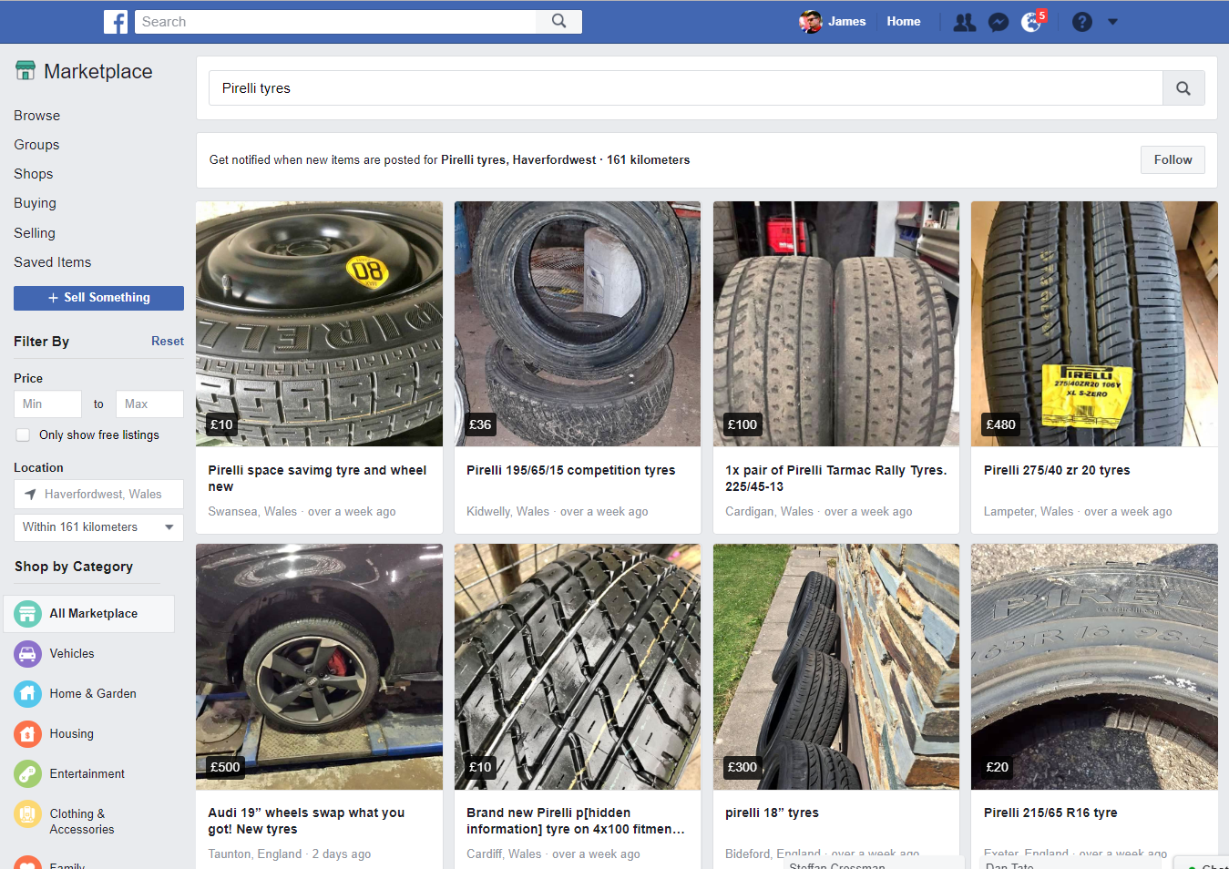
Figure 1.0 shows an example of an automotive search on the Facebook marketplace. It is a similar style layout to the likes of Ebay in terms of advertising products but poses an opportunity for motorsport industry sellers / buyers to interact with each other far easier and faster than that of many other advertising sites.
Within the motorsport industry c2c ecommerce occurs frequently on marketplace, with second hand parts and consumables being sold from customer to customer. Through this site, there is also the possibility for both synchronous interaction and asynchronous interaction via the messenger section- which automatically links to the market place add. This means customers and businesses can talk- or negotiate deals and share data with each other- in the form of a video, photo or file. Facebook has evolved from being a limited social site to be an online marketplace all in one place, allowing regular users – be it businesses or personal accounts to disregard other marketplace sites and simplify; having their entire business contained on one online business place.
Facebook also contains groups which specify in a sector at which a business would want to market its goods/services. Groups contain members which are interested in the specific content and this usually poses an opportunity for businesses or private sellers to by-pass time wasting enquiries and get the advertisements to genuinely interested parties.
Further to interaction through sites, advancements in social networking means portals such as email and MSN messenger allow businesses to interact on a quick an reliable basis. Email is a huge aspect in larger ecommerce negotiations as it provides a secure service in which businesses can interact.
In other online spaces, the evolution of social networking has meant sites such as Ebay, Gumtree and Amazon are now available as a mobile application, making it even quicker and easier to register an add or search a wanted item. With the likes of these sites setting up applications and marketplace sections, motorsport businesses can utilise the system to advertise their products and services in popular search locations- which is a huge opportunity to improve their conversion rate and through this, become a respectable and reliable dealer online.
However, on the other hand, it can be challenging for businesses or private accounts. Sales online can be used to perform acts of fraud which is a risk to any business and especially in the case of Facebook, - it is a regular occurrence to see fake accounts created, and identity theft occurring. It can also be fairly time consuming (costly) creating listings and replying to questions which will need to be answered as quickly as possible to remain updated with the customers needs.
The growth of social networking on promotional activities
Promotion is arguably the most influenced aspect of the marketing mix by the growth in social networking. Social networking has created opportunities for many different promotional activities to really enhance the way businesses within the motorsport industry area able to promote their brand and market their goods.
Social media is a huge part of a businesses branding and promotional activities. The opportunities social media poses to a business with the evolution of social networking can be detrimental to the success of the brand/ good / service. Social media sites such as Facebook, Twitter, Instagram allow businesses to promote their brand / product /service in a variety of different ways by putting the intended advert in the right place at the right time. Facebook specifically offers the opportunities to businesses via frequent posting algorithms, paid boosting, targeting and intended ads. (Hootsuite Social Media Management, 2018)
Social media
Social media is a huge part of the promotion of any successful products or services at the present moment. Social media sites see a huge following of individuals and businesses who interact online, whether it being ecommerce, asynchronous information or brand promotion. Sites like Facebook, Twitter and Instagram provide a massive scope of opportunity to businesses through giving them a popular platform to create ads, pages, post images / videos and text. Recently, advancements in this area now allow businesses to pay for advert promotion – targeting a specific area of a business’s target audience.
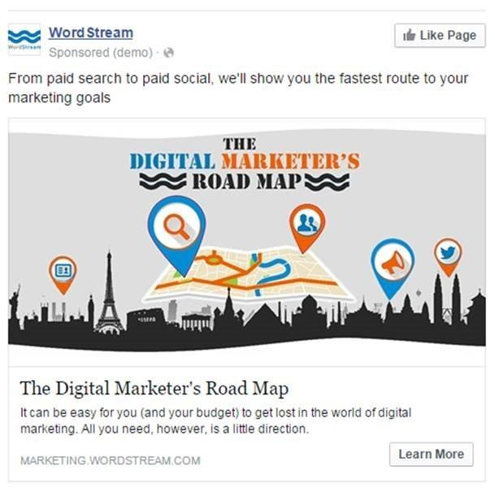
Below is figure 1.2 which shows, and example of a paid Facebook add. ("paid facebook ad - Google Search", 2018)

This add represent the opportunity Facebook creates for businesses looking to promote their brand.
Pages such as, Formula 1, Pirelli Motorsport and Formula E use this technique to increase page likes and engagement, thus allowing companies to increase their overall following and increase and brand authenticity.

Social media sites have evolved along with technology to provide mobile applications to allow a further audience to use their facilities. Instagram is a prime example of this;
Instagram is a great place to market a product. Many motorsport businesses- such as circuits like Silverstone, use Instagram to create live videos of race weekends, keep fans updated on events and market merchandise. Instagram is a fantastic tool to create further content without being too formal- pictures and videos are usually captioned with witty lines or tags with the addition of other marketable individuals. For example, Silverstone circuit may link with Lewis Hamilton’s Instagram account when leading up to a race weekend, this allows for excited fans on Hamilton’s page to be transferred to the circuit page – increasing overall engagement/ reach and keeping the circuit’s investors and sponsors happy.
Furthermore, Formula 1 has a YouTube account which can be cross-ported with any Facebook or other social media site to raise their profile on all bases. Youtube allows for businesses to connect with ‘brand ambassadors’ through creating vlogs where they may use the specific product or service in question. For example; Pirelli Motorsport may look to incorporate a Formula one drivers in their videos. If the 2018 Formula one champion Lewis Hamilton is seen to be recommending Pirelli tyres - it shows the brand is obviously a champions choice – which increases the popularity of the brand and will hopefully help to improve the conversion rates of sales and create a positive word of mouth recommendation. You tube also poses the opportunity for businesses to run their ads before popular videos by paying an advertising fee- this allows businesses to market their brand/ product/ service to any audience which the video may be applicable to.
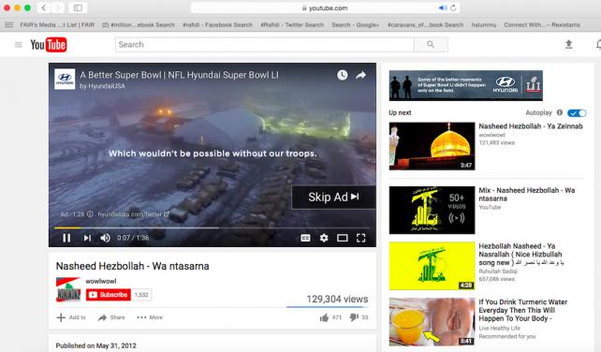
Figure 1.3 represents an example of a You Tube ad. ("youtube ads - Google Search", 2018)
In this add, Hyundai are promoting their support within the Super Bowl championships. You can see the video title- which has no direct link with the super bowl or American football in general.

Snapchat is a further opportunity for businesses to collaborate with the social media platforms by arranging deals to promote race events live. Formula one can be watched live via snapchat and with snapchat being a huge and popular platform it opens the gates for an even bigger global reach than ever before. Snapchat is mainly used by millennials which enables the coverage to be targeted at a certain demographic. (Blog et al., 2018)
Twitter’s social media site allows business to market their products in a more formal setting. It is commonly used in motorsport for race updates and general Q and A processes. Twitter allows customers to get in touch on subject matters or the release of a new product – by simple tweeting. Businesses tend to use twitter as a footing to allow customer service questions to be held – with a quick response and guidance provided- giving the customer a more satisfying service.
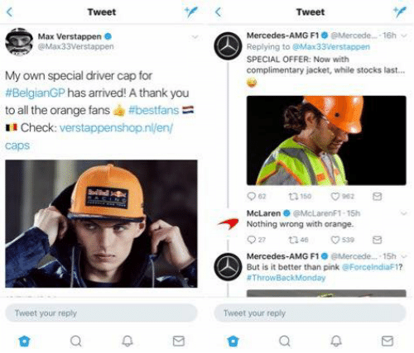
Figure 1.4 shows an example of the commerce between F1 teams ahead of the Belgian GP ("mercedes amg f1 twitter page replies - Google Search", 2018)
This figure demonstrates the power of social media interaction- with F1 teams having a discussion on the web, it allows fans to connect with the brand on a social level- thus increasing the popularity of the team.
It also poses the opportunity for fans to comment on decisions made throughout the race weekend or pre-season. This can be challenging for businesses because it can lead to bad publicity (which can damage the brand)- but it also gives the brand a chance to reply to comments made and create a quick response, just like a customer service panel.
Segmentation and targeting
With the use of the social networking sites through the development of social media, STP- segmentation, targeting and positioning can be implemented to maximise results.
Businesses can use the social networking sites to base their adverts, videos, photos or vlogs around the intended customers – making it very appealing to the specific audience. Segmentation is based on certain demographics- which a business aims to reach. For example, demographics such as age, culture, location, interests and consumer/brand relationships can help to target a specific type of audience. The aim of targeting is to prioritise propositions, develop and deliver personalised and relevant messages to engage with different audiences.
Formula 1, being a typically niche sport continuously uses targeting to reach it’s intended audience, whether it being millennials on snapchat or middle-aged men via Facebook, it has naturally contributed to Formula one being the fastest growing social media network in the world. (Blog et al., 2018)
However, targeting can limit the audience reach – with only specific target audiences available. It can pose challenges for businesses to ensure the promotional material meets the customers demands. (Smart Insights, 2018)
Conclusion
To conclude the growth of social networking has meant vast amount of opportunities and challenges for businesses within marketing. I can conclude that the use of big data and insights provided by software or social media sites are able to help businesses understand customer behaviour and predict a strategy in which to improve the conversion rates. The challenges facing the businesses using information such as big data is to ensure the information is reliable and appropriate to the subject matter.
Social networking growth has helped to improve ecommerce and online interaction between brands and customers. The likes of Facebook marketplace allow users to advertise on a very popular site for no charge. Customers and brands can share synchronous and asynchronous data easily – in the form of text, file, or photo like never before. Furthermore, these sites have become compatible with mobile- making the process faster and more applicable to a larger audience. It is important if a user of such sites and apps, safe guard to fraud is taken. Other challenges to users can be that the process can be temperamental with personal data exposed to hackers and the time taken to update and check the sites costly.
Social media and promotion have seen a huge boost with the growth of social networking. Activities like brand collaboration, live videos/ automatic posting, paid ads, boosting and cross-potation of sites has massively influenced brands and helped to improve overall engagement and reach massively. Social media sites gain by targeting specific audiences and using certain demographics to decide what sort of people they want to be viewing their adverts. This process helps to insure they get the best return on their boosting / advert investment.
The challenges which face brands using social media sites are to ensure return on investment is justified and, safe guard to a certain extent – in case of bad publicity potentially damaging the business’ reputation.
Overall, the affect of growth in social networking has been hugely positive on all aspects of the motorsport industry. Again, there are always negatives, but sometimes without risk there is no reward and to continuously improve businesses must take calculated risks.

Bibliography
References
Big Data, Bigger Marketing. (2009). Retrieved from https://www.sas.com/en_gb/insights/big-data/big-data-marketing.html
Blog, &., Sports, O., Racing, H., Games, C., Olympics, S., Games, X., & Blog, B. (2018). F1 enters partnership with Snapchat. Retrieved from http://www.espn.co.uk/f1/story/_/id/19986945/f1-enters-partnership-snapchat
Blog, &., Sports, O., Racing, H., Games, C., Olympics, S., Games, X., & Blog, B. (2018). F1 enters partnership with Snapchat. Retrieved from http://www.espn.co.uk/f1/story/_/id/19986945/f1-enters-partnership-snapchat
Blog, Sports, O., Racing, H., Games, C., Olympics, S., Games, X., & Blog, B. (2018). F1 sees increase in social media, TV figures. Retrieved from http://www.espn.co.uk/f1/story/_/id/21966301/f1-claims-fastest-growing-sport-brand-social-media
F1 sees increase in social media, TV figures. (2018). Retrieved from http://www.espn.co.uk/f1/story/_/id/21966301/f1-claims-fastest-growing-sport-brand-social-media
Facebook facts. (2018). Retrieved from https://zephoria.com/top-15-valuable-facebook-statistics/
Halfords in store pricing. (2018). Retrieved from https://singletrackworld.com/forum/topic/halfords-in-store-pricing/
How the Facebook Algorithm Works in 2018 (And How to Work With it). (2018). Retrieved from https://blog.hootsuite.com/facebook-algorithm/
Staff, I. (2017). Social Networking. Retrieved from https://www.investopedia.com/terms/s/social-networking.asp
The Segmentation, Targeting and Positioning model. (2018). Retrieved from https://www.smartinsights.com/digital-marketing-strategy/customer-segmentation-targeting/segmentation-targeting-and-positioning/
Figures
References
Buy and sell items from all categories in your town or city – Marketplace | Facebook. (2018). Retrieved from https://www.facebook.com/marketplace/?ref=bookmark

mercedes amg f1 twitter page replies - Google Search. (2018). Retrieved from https://www.google.co.uk/search?q=mercedes+amg+f1+twitter+page+replies&safe=active&source=lnms&tbm=isch&sa=X&ved=0ahUKEwiYw9Tk8NHeAhUkAcAKHcV6DxkQ_AUIDygC&biw=1920&bih=969#imgdii=b3kxR0jzqeq-JM:&imgrc=MJeUaQCBybtsxM

paid facebook ad - Google Search. (2018). Retrieved from https://www.google.co.uk/search?q=paid+facebook+ad&safe=active&source=lnms&tbm=isch&sa=X&ved=0ahUKEwiihYzM5tHeAhWMDcAKHSxrAvgQ_AUIDygC&biw=1920&bih=969#imgrc=DJKXmj5pj_0rnM:

youtube ads - Google Search. (2018). Retrieved from https://www.google.co.uk/search?q=youtube+ads&safe=active&source=lnms&tbm=isch&sa=X&ved=0ahUKEwjCovvBm9LeAhVKK8AKHZUbCsAQ_AUIDygC#imgrc=VsAaRLOZu2BFfM:

