Student number – 2304867
Student name – Jess Roberts
MA Illustration
Co-existent Perspectives
Research and Critically evaluate the role of the artist/designer in the context of ‘Space and Place’.
Creating a Recipe for public art that has the ability to unite or create a community; looking specifically but not exclusively at the works of Anthony Gormley and Banksy.

Abstract
Creating a Recipe for public art that enables it to successfully create or unite a community.
Antony Gormley’s iconic Angel of the North has fostered a sense of community and created a great sense of pride in the people of Gateshead. It has boosted tourism and stimulated the local economy. Banksy’s work has sparked conversations within communities around the world, encouraged dialogue around important topics as well as increasing tourism in areas where his pieces appear, benefitting local businesses and bringing attention to neighbourhoods that might not have received much notice otherwise. Through looking at the artwork of successful public artists such as Gormley and Banksy, as well as those that have been unsuccessful, this essay strives to decipher the ingredients used in some of our much loved pieces of public art.
Through researching using various sources (books, essays, articles), the artists and the artworks themselves, the intention of the artists, the materials used, the methodologies of both artists and looking at the publics responses to their work, this essay has uncovered a number of components needed for this recipe.
In conclusion, this essay has discovered that artists need to think about their art in a similar way to how a good chef would think about the food they serve. Customers/communities should be consulted about the ingredients to ensure there are no adverse reactions or after effects. Locally sourced ingredients and labour should be used wherever possible, and a consideration should be given to cost. Food and public art can be thought provoking as long as the overriding impression is food/work that tastes or looks good. And lastly, size does matter. Too big or too small, in relation to the environment in which the art work is placed can be jarring; likewise, too much food costs a lot of money and can leave you feeling uncomfortable, and too little leaves a customer hungry.

Introduction
Since 1998 travellers near Gateshead Tyne and Wear have been welcomed by the Angel of the North. This gigantic steel structure designed by Anthony Gormley, epitomises the industrial heritage of the region and is a source of great pride to local communities. It is increasingly being recognised that art in its broadest sense, from underpass murals to acclaimed achievements of architecture, can impact communities.
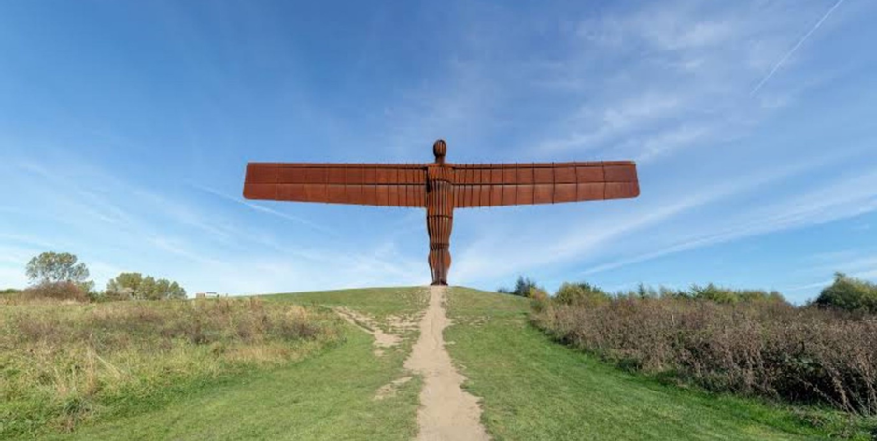
Figure 1 . Antony Gormley, Angel of the North 2000
‘Public art presents interactive and visionary scenarios. It challenges perceptions of the present and motivates people to openly engage while responsibly contributing to tomorrow. (Mary Mattingly 2023)
The term Public Art is relatively new, coined in the late 1960’s and associated with government Per Cent for Art programmes which provided funding for public artworks linked to capital development. It was also around this time that artists such as Richard Serra, Christo and Mary Miss began to break away from the constraints of white box galleries and began creating installations in the environment. This very public platform can be used to connect people to a place, the art itself and to each other but how the public will receive the artwork that they may feel has been ‘foisted’ upon them is indeterminable.
In this exploration I will endeavour to create a recipe for public art that has the ability to unite or create a community. I will be looking specifically at the works of Antony Gormley and Banksy in order to do this.

Understanding Successful Public Art
‘Public art can be a rallying point for communities, a visual testament to shared values and aspirations.’ (Frances Whitehead – 2017)
Art Historian Patricia C. Phillips offers some ideas for this. She states that ‘Public Art’s role serves multiple purposes often simultaneously. To aesthetically beautify space, to educate, to commemorate, to act as a tool of political or social propaganda, to activate, to document daily life and to represent a community……yet its main common denominator is its potential to be experienced within a discerned demographic and free sphere, bypassing the narrow and niche audiences of institutions and galleries.’
Successful public art needs to show artistic merit, encourage community engagement or have a social impact but it needs to do this without challenging its audience on too deep a level. Some people actively seek out art that challenges them, but others prefer art that is familiar, comforting, provides a sense of joy, perhaps stemming from a desire for escapism.
Initially public art in the 1960’s was dominated by the art in public places paradigm – modernist abstract sculptures that were often replicas of works found in galleries. The fact they were outside was enough to classify them as public art. Henry Moore commented ‘I don’t like doing commissions in the sense that I go and look at a site and then think of something for it. Once I have been asked to consider a certain place where one of my sculptures may be placed, I try to choose something suitable from what I’ve done, but I don’t try to create something especially for it’ (Kwon – 1973 p63). This did not allow the artists to connect to a community or allow a community to connect to the art work.
Many artists work within a community, creating collaborative works that enhance the environment by listening to the voices of a particular section of a community, such as a school or church group. These voices combine to generate ideas for an art work that represents their community, when in reality, it is representing only a small portion of the latter.
‘Assuming that an artist has acquired money and navigated cultural bureaucracy for a community art project, just how will he/she insinuate themselves into a community? The easiest way is to have the project mediated by a bureaucracy that claims to represent the community. A school, a community centre etc is selected as it is willing to participate in the project. The bureaucratic experts from the selected institution will represent the community and tailor the project to their specifications in a negotiation that also accounts for the desires of the artist (……) What is left is the representation of a representation (the bureaucratic opinion of the artist and his/her mediators).’ (Critical Arts Ensemble – 2002)
This view is very one sided, these projects having their obvious merits, engaging portions of a community with art and societal awareness, but they rarely speak for the wider community. This is not an easy task when communities across nations are diverse in age, ethnicity and religious leanings, but it is possible. Many contemporary public artworks are being designed with the relationship between the work and its audience in mind and this allows them to engage a wider community.
The Fourth Plinth in Trafalgar Square was originally meant for a statue that never reached completion. When Ken Livingstone became Mayor of London, he appointed a Fourth Plinth Commissioning Group to select artworks for the site. These artworks are selected by art experts, officials and stakeholders, overseen by the Forth Plinth Commissioning Group, with notably no public reference to the process in which the artworks were chosen. They use criteria such as artistic merit, innovation, relevance to the site and public appeal in order to approve any submissions for the plinth. Despite this, the Forth Plinth has displayed a number of artworks that have caused an outcry amongst the general public.
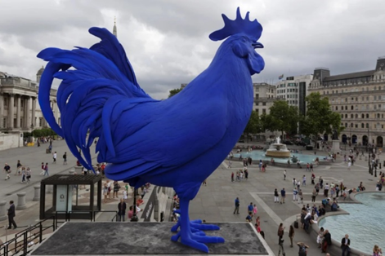
The plans to install a giant blue cockerel were opposed by a conservation group headed by one of the country’s most senior judges. The 14ft fibreglass bird was designed by German artist Katharina Fritsch. Campaigners against the installation claimed it was inappropriate to install a cockerel, the national symbol of France, in a place where it will be stared down by Admiral Lord Nelson, who led the British to victory over the French Navy at the battle of Trafalgar in 1805. This sculpture garnered its criticism due to it not representing the community or the place in which it was put and the artist herself even admitted to not giving this a thought. ‘I definitely never thought about the French thing, but it’s a nice humorous side-effect to have something French in a place that celebrates victory over Napoleon’ (Katharina Finch 2013). One would argue that the history of the site where an artwork is to be placed should have at least been considered by the artist.
Figure 2. Katharina Fritsch, Hahn/Cock 2013
Marc Quinn’s sculpture of Alison Lapper, a nude, heavily pregnant, disabled artist, also caused an outcry. Quinn carved this monumental nude from a 12ft block of Carrara marble specifically to communicate his modern ideal of heroism. Editor of the British Art Journal, Robert Simon said, ‘I think it is horrible.’ The Disability Rights Commission disagreed and said it was ‘powerful and arresting.’ Another, less positive take on the statue, particularly its depiction of disability, described it as evidence of ‘the new elite’s contempt for the public’, because the statue had been chosen by a committee rather than by ‘public consensus’ over who was worthy to be represented in such an important public space. ‘The introduction of a contemporary art scheme for the Fourth Plinth was an attempt by London authorities to shape national narratives by controlling the built environment of one of London’s best-known public places. Rather than allowing the discursive, vernacular or ‘democratic’ choice of heroes to emerge from below, the elites, represented by the Commissioning Group, were attempting to impose a top down version of the nation through the use of the Square’. (Brendan O’Neil ). This sentiment is echoed by Kate Monkhouse after attending a committee meeting with the RSA to discuss the future of the Forth Plinth when she states ‘the general sentiment was that the public, not the experts, should choose the artworks’.
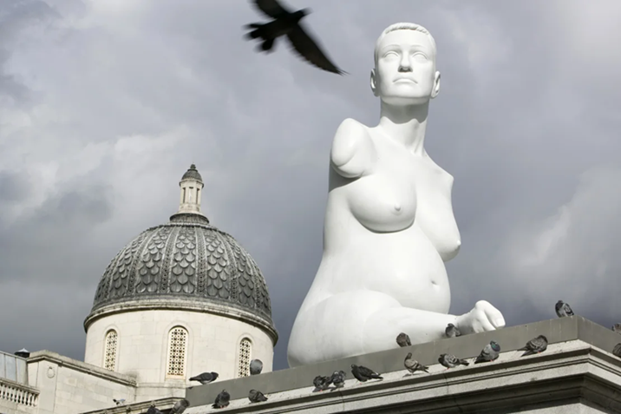
Figure 3. Marc Quinn, Alison Lappard Pregnant 2005
Interestingly, Lappard herself is an artist, but was never approached for a solo show or as an artist to display one of her works on the plinth. One could argue that this would have been a greater celebration of disability than a nude portrayal of herself carved by another male, able bodied artist.
So should the public themselves be choosing public art? One would think this an obvious criteria, but with a nation of such diverse cultures and tastes, reaching a decision may not be possible. Any art displayed in the public domain leaves itself open to scrutiny, and some would argue that there is a necessity for art to shock or surprise us, to start conversations, but does this always need to be the case? Perhaps Trafalgar Square is a place for showcasing contemporary and contextual art, as it is visited by roughly 15 million tourists each year, and isn’t necessarily a place with a local community. Should the criteria for these spaces be different?
Clearly the public should have a voice when artworks are on their doorstep; would you feel the same attachment to your home if a stranger walked in and redecorated it to their own taste? I’m not sure one would.
Antony Gormley - Success in Sculpting Communities
‘The occupation of the plinth by members of the public instead of the semblances of dead people seems brilliantly pure in conception. It’s a total rebuke of the whole moribund notion of the statuesque by using language of performance art. Instead of the dead we have the living: instead of the famous and lauded we get the anonymous and ordinary: instead of those decreed worthy we get a random selection’. (Lee Hall –2020 p25)
Antony Gormley used his time on the Fourth Plinth to offer the space to the general public. One and Other was a project in which 2,400 members of the public occupied the plinth for an hour each for 100 days and nights. A living portrait of the 21st century, Gormley’s concept put ordinary British people on centre stage. One and Other was open to anyone over 16, living or staying in the UK, and gained over 35,000 applicants. The applicants were selected based on geographical spread to ensure voices were heard from every corner of the country.
‘It was a firm expression of the democratic, of our commonness, our rich diversity’. (Lee Hall – 2020 p58)
‘…people could make a collective portrait of us now: subverting the object of art by their own presences, considering our values, considering what we hope for and what we fear’. (A. Gormley – 2014 p74)
In doing so he challenged the traditional notions of statues by celebrating the diversity and experiences of the participants. It also encouraged engagement and interaction from viewers.
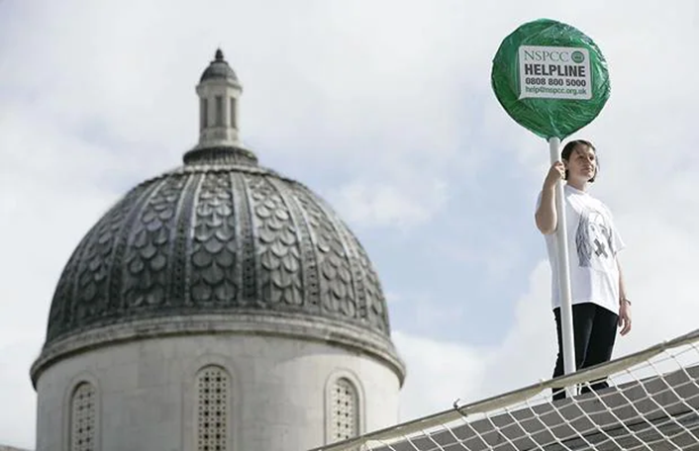
Figure 4. Antony Gormley, One and Other 2009
This isn’t the only occasion where Gormley has invited the public to be the artwork. Blind Light invited audiences to move around inside a room filled with mist, creating an immersive experience. Whilst walking around this space peoples visibility was significantly reduced, giving them a sense of disorientation and altering their perception of themselves and the environment around them. Encountering other people in the space created a sense of surprise but also captured them as part of the artwork itself. ‘You also become the immersed figure in an endless ground, literally the subject of the work.’ (Gormley 2007 p184)
Field for the British Isles was made by Gormley in 1993 with 100 volunteers each given a portion of clay and instructions for the size and shape he wanted for the figures. This and other Gormley ‘field’ sculptures have depended on the enthusiastic involvement of many. Each figure represents an anonymous and unique individual and when displayed, these thousands of figures create a powerful visual impact, representing the diversity and multitude of human forms. Gormely intended the viewers to ‘contemplate the significance of each individual within the collective whole’ (A Gormely – 2007 p72)
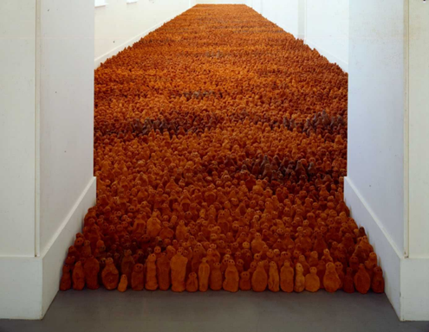
Figure 5. Antony Gormley, Field for the British Isles 2003
While ‘Field’ is not a piece of public art, necessarily, it did involve the public in its creation and therefore increased the demographic of interest in the work. This is something that Gormley does well. It serves as a catalyst for bringing people together and igniting a sense of shared identity or experience.
Consider his ‘Another Place’ instillation on Crosby Beach. It featured 100 life size cast iron figures spread across the bay and has become a gathering point for locals and visitors alike, fostering a sense of community and connection around the artwork. Also, ‘Event Horizon’ where Gormely displayed sculptures on rooftops in cities, prompted engagement among residents and tourists, sparking a dialogue within communities. Even if one does not understand these works as they were intended, as humans, we can all recognise ourselves in these artworks and take from them what we will.
Arguably Gormley’s most successful piece of public art is the afore mentioned ‘Angel of the North’. The Angel has become iconic in its status and has benefitted the people of Gateshead in many ways. Northumbria Police assured Gormley that ‘alcohol related crime on Tyneside had gone down by 14% since Angel was erected. Domestic abuse has decreased by 17% and car theft by 21%. Most memorably of all, employment has risen by 26% as a direct result of Antony’s sculpture.’ (Farley and Pollock – 2020). The Angel is deeply connected to the people of Gateshead. It represents the areas heritage, resilience and pride, embodying the spirit of the region. It was made for but also by, the people of the area. The 200 tonnes of steel originated in Hartlepool with much being recycled from dismantled ships. Using locally sourced materials and labour adds to the symbolic significance of the sculpture within the region.
‘many hands and minds worked on this sculpture: this inspires and humbles me. It means that even at this restless and fragmented time we can work together to make things that are not simply functional but feed our spirits: things done for the challenge of doing them’ (Gormley – 1998 p14)
Gormley’s collaborations with the public enhance his appeal by fostering a sense of connection among diverse communities. It also allows people to feel a more personal connection to his art, helping to create a sense of ownership and pride within any community.
Banksy – Success Amongst Controversy
Another prolific and popular artist, who also seems to be able to create work which is relatable and accessible to a diverse array of people and who has helped to foster a sense of community with his artworks is Banksy.
Banksy is an anonymous England based street artist. He uses stencils to create his work quickly and often combines social commentary with dark humour. His identity remains a closely guarded secret, creating an air of mystery and widespread fascination. His controversial works often capture huge attention from the media and this increased visibility has helped propel him to the heights of fame. The artworld critics have remained decidedly sniffy about him but the public don’t seem to care. In 2017 his ‘Girl with a Balloon’ which represents hope, peace and innocence, was voted best loved piece of art above The Hay Wain by Constable.
Banksy does not seek permissions for his artworks; they can appear anywhere and at any time, but they are always relevant to the people of the places he chooses.
‘When Banksy releases some artwork there is a huge reaction. Surprise, joy, unity, anger, plotting, subterfuge, theft. The fans questions, the authorities haplessly trying to deal with the aftereffects, the locals joy at having their own Banksy…’ (Marc Leverton – 2023 p13)
Banksy is known for being a catalyst for social awareness. His work ‘Seasons Greetings’ depicted a young boy playing in what looks to be snow but on closer inspection he is actually ingesting white particles rising from a burning oil drum nearby. This piece was sprayed on a garage wall in Port Talbot, an area of South Wales boasting some of the worst air pollution in the UK. Banksy’s work started conversations amongst local authorities and environmental groups, who have taken steps to address air quality concerns. ‘Magic Moments’, a Banksy piece in Cromer, tackles the local housing issues. In an area where there are 5000 second homes and 2000 holiday lets, Banksy showed hermit crabs without their shells, winning him the ‘Moment of the Year’ award from the North Norfolk News. These communities were united by the voice that Banksy gave them, providing a catalyst for the community to start speaking out about the issues effecting them and giving them a sense that someone, somewhere is listening to their concerns.

Figure 6. Banksy, Ukrainian postage stamp 2022
Banksy created 7 pieces of work in Ukraine, one of which shows a small child slamming a grown man to the ground, left on a wall partially destroyed by Russian artillery. Judo is reported to be the favourite sport of Russian President Vladimir Putin. An image of this work was issued by the Ukrainian postal service marking the first year of the invasion. Deputy Minister of culture, Kateryna Chuyeva, said ‘Banksy is known to every Ukrainian, and that their history and culture are under attack. She suggests that the seven pieces of work Banksy painted immediately became part of the cultural legacy of the country and will help with the eventual rebuilding of Ukraine’. (Marc Leverton – 2023 p87)
Banksy’s appeal spans a wide audience for many reasons. Graffiti is an art form that children and young adults often perceive to be ‘cool’. Children otherwise uninterested in art can access it; its vibrancy captivating their imagination, offering them a sense of freedom and creativity. It has a certain type of energy and its association with street culture is appealing. It is often found in unconventional spaces and can symbolise rebellion or non-conformity which is attractive to many youngsters.
For all generations, Banksy’s art often carries powerful social or political messages, which resonate across diverse backgrounds. He addresses the big issues but also local issues, giving those communities a voice that they may otherwise have felt they didn’t have.
His anonymity adds intrigue to his work creating curiosity and drawing people further into his art work. Moreover, his art is accessible and relatable and relevant to so many of us living in this constantly failing world. ‘I feel as though I have grown up in the same Britain as you have, and watched it get uglier and greedier and more vicious by the year. So by the law of inverse proportions, in a fucked up situation, people being positive just piss me off, and people having the courage to be negative, cheer me right up….’ (Pattrick Potter – 2021 p8)
His clever use of humour and irony creates an immediate connection with viewers, entertaining them but also making them think about the way we are living. While being interviewed about a piece of Banksy’s artwork in Palestine, Rory McCarthy from the Guardian said, ‘The Palestinian problem is full of contradictions and strange things: it’s like heaven for artists. For Westerners it is important that they see the Palestinian problem interpreted through art. It’s not like newspaper articles or speeches, art is something much stronger in getting a message to people’. (2021)
This sentiment rings true for much of Banksy’s artwork. It appears he has a conscience and his art is genuinely being created for the public. His charity work also underpins this. Banksy sold 175 limited edition prints, raising £80,000 towards legal funds for two imprisoned art activists in Russia. ‘Santa’s Ghetto’ a Banksy installation that appeared in Croydon in 2020, raised just under a million dollars, all of which went to charity projects in Palestine. He auctioned his own work to raise moneys for the People’s Republic of Stokes Croft, dumped original prints in an Oxfam shop, located near the Bristol Museum that was, at the time, hosting his own exhibition and has allowed his art works to be removed and sold to help institutions such as hospitals and schools.
That isn’t to say that Banksy doesn’t make any money from his art, now being sold at such places as Sotheby’s, but being part of the super educated, hedge fund ‘fine art’ market, is not his intention. ‘Exit Through the Gift Shop’, is a micky take of this world. ‘He attacks the establishment to remind you of your own power, not just for the sake of it. The point is Art should be truly democratic, truly a part of everybody’s life and not just a gang bang for the over privileged’. (Potter – 2021)
All of these things make Banksy’s work resonate with many. He has created an almost cult like following by modelling himself as a modern day Robin Hood with the elusiveness of Spiderman.
Case Studies of Unsuccessful Public Art
Not all public art is successful in uniting communities or even in gaining recognition as a reasonable piece of public art. Richard Serra’s Tilted Arc, is just one example of how public art can fail for contradicting some of the very reasons why Gormley and Banksy’s artworks have succeeded.
Placed immediately in front of the federal government agencies, Tilted Arc, a slightly tilted, unfinished steel plate, tried to force art in the face of those who attempted to eliminate it. The public were not consulted over the erection of this artwork and it soon became obvious they weren’t happy about it. Art critics in the New York Times and the Village Voice labelled it the city's ‘worst public sculpture, and many denounced it as an example of the elitism associated with art and as an obstacle to the use and enjoyment of the plaza.’(Balasz Takac – 2020)

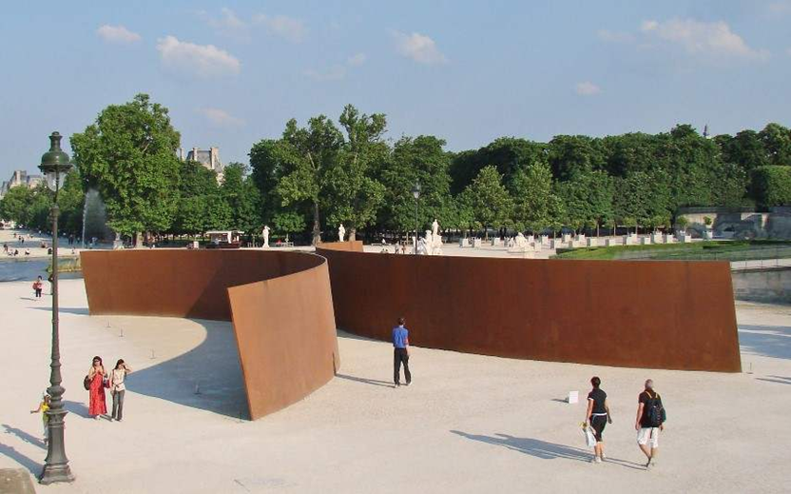
Figure 7. Richard Serra, Tilted Arc 1983
Tilted Arc disrupted the space in which it was placed and impeded pedestrian movement. It clashed with its environment and to many who garnered no meaning from the artwork itself, it was probably seen as just a large rusty steel wall. This controversy highlights a disconnect between the artist’s vision and the public’s reception.
‘The Spire’ by architect Ian Richie, in Dublin, received a very mixed reaction when erected in 2003. It was criticized for its price as well as its purpose. It has been called ‘ugly’ and an ‘eye sore’ and nick named ‘Syringe in the dinge’. It was erected on O’Connell street, an area renowned for drug users and serves as a constant reminder of this for some. It sits in the same street at statues dedicated to many Irish legendary political figures and many felt ‘the site should have been used to highlight a contemporary leader’. ( 2023 – Lovin Dublin) Perhaps it was seen as some to represent the excesses of contemporary Ireland, as it’s true meaning appears to be lost on many. Its maintenance costs have done little to redeem it over the past twenty years either. As a Reddit user phrased it, ‘It appears substantial but is innately hollow within. It represents nothing and commemorates nothing but itself’. (2023 – Lovin Dublin)
Damien Hirst’s ‘Verity’ faced a mixed reaction when placed on the harbour in Ilfracombe. Some loved it for its artistic merit and for discussions is sparked about life, birth and female empowerment. Others, mainly locals, found it visually unappealing and not in harmony with the town’s visual aesthetic. It certainly looks out of place in the quaint Devon sea front town and dwarfs all of the local architecture, including the chapel that is towers above. Interestingly, Hirst ‘gifted’ the sculpture to the town, motivated by his desire to contribute to the towns artistic landscape; a place where Hirst himself had longstanding connections, though ‘Verity’ had no historical or cultural link to the people or the landscape of Ilfracombe.
Comparative Analysis
While Gormley and Banksy are both renowned for their impactful public art, their approaches differ enormously. Gormley focusses on the human form creating work that engages with its environment and provokes thought on the human condition. Banksy, on the other hand, creates dialogue with the public using a blend of street art and social commentary. Gormley’ work is often large in scale and encourages interaction, whilst Banksy utilises walls, buildings and public spaces as his canvas. Despite these differences, both these artists engage the public by provoking thought and emotional responses, and in simple terms, they produce art that many people want to see. They are, of course, not without their critics, but the saying ‘you can’t please all the people all the time’, is very apt when it comes to displaying public art.
Conclusion
It seems that to create a recipe for successful public art, one must think a little like a good chef preparing a menu for a diverse group of people.
The first thing a chef needs to know is, are there an allergies amongst the group? This is like an artist understanding the community where the artwork will be placed. Engagement with local residents is crucial to ensure the artwork aligns with their values and meets their needs.
A good chef will consider using seasonal and locally sourced food, in the same way that an artists must ensure their art resonates with the environment in which it is placed. They should consider the cost, locality and durability of the materials used and plan for its maintenance. Public art should reflect local history, culture or contemporary issues in order to foster a sense of belonging and identity amongst residents.
Chefs often like to challenge their diners with unusual flavour combinations and some like to provide food that makes people think about what they are eating, but the food is only received well if its tastes good. Public art is more successful if it is aesthetically pleasing and easily accessible to all, regardless of age, ability or background.
The amount of food served is also a consideration for chefs; customers don’t want to leave still hungry and they also don’t want to create waste by serving too much. Scale should also be a consideration for artists; inappropriate scale or placement within its surroundings can lead to a jarring presence that doesn’t integrate harmoniously with the environment.
It is not easy fulfilling all of these requirements in one piece of art, but Gormley and Banksy have both found successful recipes for creating well received public art that can unite communities and help create a sense of identity amongst their viewers. And both, whether by design or coincidence manage to address each of these ingredients and like any good chef, tailor their recipes to suit the customers they are serving.

REFERENCE LIST
Images
Figure 1: Angel of the North (2000) – Anthony Gormley
Available at : https://www.anart4life.com/the-angel-of-the-north/
(Accessed November 30th 2023)

Figure 2 : Hahn/Cock (2013) – Katherina Fritsch
Available at : https://edition.cnn.com/style/article/trafalgar-square-the-fourth-plinth
(Accessed November 28th 2023)

Figure 3 : Alison Lapper Pregnant (2005) – Marc Quinn
Available at : https://edition.cnn.com/style/article/trafalgar-square-the-fourth-plinth
(Accessed November 28th 2023)

Figure 4 : One and Other – (2009) – Anthony Gormley
Available at : https://telegraph.co.uk/Living-Sculpture-Antony-Gormleys-One-and-Other
(Accessed November 29th 2023)

Figure 5 : Field for the British Isles - (2003) – Antony Gormley
Available at : https://www.artfund.org
(Accessed December 4th 2023)

Figure 6 : Ukrainian postage stamp –(2022) - Banksy
Available at : https://i24news.tv/en/news/international/culture
(Accessed December 4th 2023)

Figure 7 : Richard Serra – Tilted Arc – (1983)
Available at : https://www.widewalls.ch/magazine/rihard-serra-tilted-arc
(Accessed December 9th 2023)
Books
Banksy – You are an Acceptable Level of Threat – 2012 – Carpet Bombing Culture
Brent Adkins - Deleuze and Guattaris A Thousand Plateaus – 2015 – Edinburgh University Press
Gormley, A., Antony Gormley on Sculpture – 2014 Thames and Hudson
Gormley, A., One and Other - 2010 Jonathan Cape
Gormley, A., Making of an Angel – 1998 Booth Clibborn Editions
Kaye, N., Site Specific Art – Performance, Place and Documentation. 2000 Routledge
Kwon, M.,One Place After Another – Site Specific Art. 2002 The MIT Press
Leverton, M,. The Rise and Rise of Banksy – Myths and Legends Volume 3 – 2023 Carpet Bombing Culture
Lippard, LR., The Lure of the Local – A Sense of Place in a Multicentred Society. 1997 The New Press New York

Web links
Antony Gormley 2007 Blind Light, Hayward Gallery
https://www.antonygormley.com

Balazs Takac – Looking Back at Richard Serra’s Controversial Tilted Arc 2020
https://www.widewalls.ch/magazine/rihard-serra-tilted-arc

Blackman, Fiona, Maeve (2014) The Angel of the North – Public Art and Wellbeing Durham Thesis
https://ethesis.ac.uk/1-927/

France Whitehead 2018 Blog
https://www.chicagomanualofstyle.org

Kate Monkhouse 2013 Trafalgar Square’s Fourth Plinth as a model for social change
https://thersa.org/blog/2013

Katharina Fritsch 2013 Fourth Plinth, The Guardian
https://amp.theguardian.com/art

Lovin Dublin – The Uninspiring Spire
https://lovindublin.com/opinion/ why-do-most-dubliner-hate-the-monument

Mary Mattingly 2023 Blog
https://marumattingly.com/blogs

Patricia C. Phillips 2023 Public Art, The Art Story
https://www.theartstory.org/amp

Rebecca Farley and Venda Louise Pollock (2020) Size Isn’t Everything: The Failure of Big Public Art
https://doi.org/10.1080/21502552.2020.1794310

Articles
The Fourth Plinth: creating and contesting national identity in Trafalgar Square, 2013 Shanti Sumartojo. JSTOR

