Analysing strategic plan for Tesla Company in UK automotive sector
Component 1– Written Report

Ionel Stefan
Student ID: 2216967

LCBB6015 Strategic Management and Sustainability
Lecturer: Abdi Rahman
Date 05/03/2026

Executive Summary
Tesla Company introduced electric vehicles and clean energy solutions in the UK market in 2009. The company has continued to grow and expand its business operations and has become a dominant player in the UK’s EV and clean energy sectors. Its objectives include making electric vehicles and clean energy available to everyone and helping to minimise carbon emissions in the UK. This strategic management has explored the company’s business environment, including external and internal audits using various strategic management models, including PESTEL analysis and Porter’s Five Forces Model for external environmental audits, and value chain analysis, VRIO, and resource based view model for internal environment audit. SWOT analysis also helped to identify strengths and opportunities for Tesla. The company has established strong brand reputation and loyalty, as well, network of superchargers. The report found that occasional delays in production, increased completion, and vulnerabilities in supply chain have affected Tesla’s market share and sales in the UK. Based on the analysis, the report suggests that Tesla should consider introducing affordable EV models that for the UK’s urban people to increase its customer base. Also, Tesla should increase the number of it’s supercharges in the country to attract more people to buy EVs and increase sales.

Contents
1 Executive Summary 2
2 Introduction 4
2.1 Company Overview 4
2.2 Tesla’s Current Performance in the UK Automotive Sector 4
3 Strategy Analysis 6
3.1 External Environment Audit 6
3.1.1 PESTEL Analysis 6
3.1.2 Porter’s Five Forces Model 9
3.2 Internal Environmental Audit 9
3.2.1 Value chain analysis 9
3.2.2 Resource-Based View (RBV) 9
3.2.3 VRIO Analysis of Tesla 9
3.3 SWOT Analysis 10
4 Strategy Formulation 10
5 Conclusion and Recommendations 11
6 Reference List 12

Introduction
Strategic management is important for companies in enabling companies to understand their business environments. It is a process of continuous planning, implementing, monitoring, analysis, and assessment of organisational plans to help companies attain their objectives and goals (Barney and Hesterly, 2015). Therefore, strategic management decisions are important in determining companies’ long-term performance, thus require regular monitoring to identify changes in the external environment, the threats and opportunities that such changes create for the company (Mintzberg, Ahlstrand, and Lampel, 2020). Strategic management process begins with environmental analysis to understand a company’s current position in the industry, followed by formulation of strategies to improve its competitive advantage. Strategic implementation helps to turn strategy into action, and must be monitored to ensure everything goes as planned (Johnson, Scholes, and Whittington, 2010). More importantly, strategic management improves companies’ ability to swiftly adapt to market challenges and changes. This report covers the strategic plans of Tesla Company and recommends the various strategies that this company can adopt to improve its competitiveness in the UK automotive market.

Company Overview
Tesla was found in 2003 in California, US by Martin Eberhard and Marc Tarpenning to produce and sell electric vehicles (Akari, 2022). In 2004, Elon Musk invested in the company about $6.5 million, joining Tesla as one of the owners. In 2008, Musk became the company CEO (Akari, 2022). Tesla stared by introducing affordable Roadster to the market for mass production. The company went public in 2010 through its IPO (Gao, Jing, and Zhang, 2024). Tesla introduced Model 3 sedan and SUV Model Y to support its mass production strategy. In 2009, Tesla expanded its operations into the UK market. It opened a center in London’s Knightsbridge district and introduced model S to the UK market after opening its first supercharger in the country (Li, 2023). Tesla’s mission is to help the world move from diesel and petrol cars to electric vehicles and from carbon energy to clean energy by producing EVs and energy storage solutions.

Tesla’s Current Performance in the UK Automotive Sector
Table 1 below shows a company that has been struggling to maintain its competitiveness in the UK market after the entrance of more affordable Chinese electric vehicles in the UK. Tesla’s number of cars sold or registered in the UK has reduced from 1505 in 2025 to 647 in 2026, which is a reduction of about 57%. This reduction shows how Tesla is struggling to dominate the UK market, especially after the entry of Chinese EV brands like BYD that sell their EVs at low prices. In a bid to maintain its market share, Tesla was forced to cut its price which together with the high cost of product contributed to significant reduction in profitability.
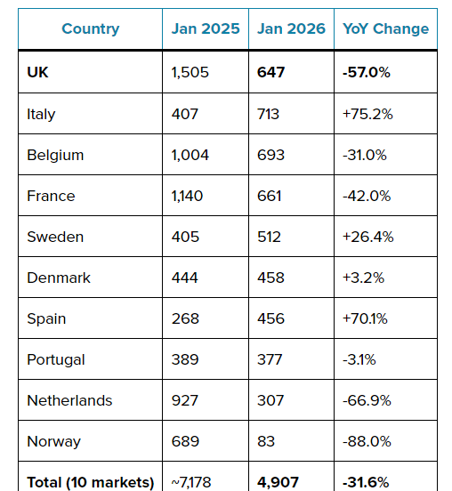
Table 1: Tesla registration in Europe
Source: (Lambert, 2026)

Strategy Analysis

External Environment Audit

PESTEL Analysis
Political Factors: They play an important role in the company’s strategic decisions, especially concerning the UK government’s incentives to promote clean energy, trade policies, and political stability in the country (De Sousa and Castañeda-Ayarza, 2022). The UK government offers tax rebate and plug-in grants to automotive companies to support the production and sell of electric vehicles in the country. Through its net zero mandate, the UK government is introducing measures and policies that support production of electric vehicles and adoption of clean energy which will create opportunities for Tesla. However, Brexit introduced new trade agreements between the UK and European markets which may affect Tesla’s export and import costs for materials and cars in this region (De Sousa and Castañeda-Ayarza, 20220). The geopolitical tensions between the United States and China also affected Tesla’s import and export in China, forcing it to build its Shanghai Gigafactory to localise production.
Economic Factors: the Company’s strategic decisions are usually affected by supply chain costs, interest rates, global inflation rates, a country’s economic policies, and economic cycles. The current high cost of living occasioned by the increasing inflation and interest rates in the UK has affected Tesla’s premium pricing strategies, as consumers lean towards more affordable cars (Gao, Jing, and Zhang, 2024). Furthermore, Tesla is also experiencing increased competition from electric vehicle producers like the China’s BYD, reducing its market share in the UK market. Also, the volatility of energy prices is making electricity prices to be more volatile affecting the company’s operational costs.
Social factors: Many consumers in the UK are concerned about climate change and want to contribute in addressing this problem. Therefore, they consider companies like Tesla which produce electric cars as being eco-friendly. Such consumers believe that buying Tesla’s cars will help to address the issues of climate change. This consumer value has is helping to increase the electric vehicles demand in the country, as shown below.
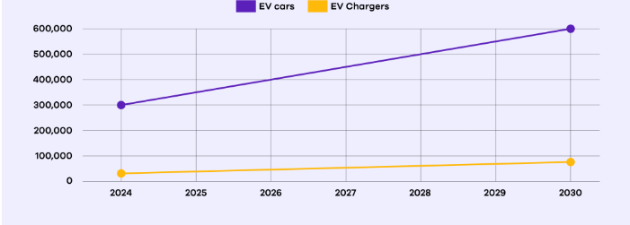
Figure 1: number of electric vehicles and EV charging stations in the UK (2024-2030)
Source: (CITA EV, 2025)
Technological factors: electric vehicle companies’ competitive advantage comes from their technological innovation, such as autonomous driving, artificial intelligence-based system, and battery development (Liang and Yubin, 2025). Tesla has outmanoeuvred its competitors by investing heavily in R&D, as shown in figure 2, to show how it has committed to continuous innovation, helping to maintain competitive advantage. The company is currently testing its full self-driving and autopilot systems to show its strategic change to a provider of tech-oriented mobility (Liang and Yubin, 2025). Moreover, the company’s technological focus has improved its capability to collect and use data analytics to improve decision-making and product improvement (Liang and Yubin, 2025). However, there is a need for the company to expand its charging infrastructure across the UK to speed up adoption of electric vehicle adoption.
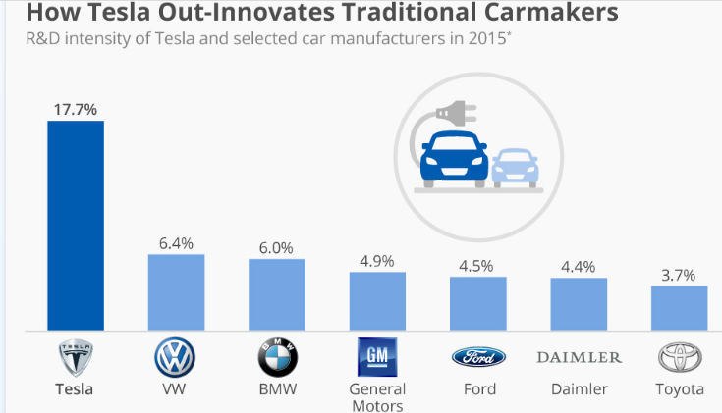
Figure 2: Tesla‘s investment in R&D Compared to its competitors
Source: (Richter, 2016)
Environmental factors: The UK’s net zero mandate that seeks to remove diesel and petrol vehicles from the road by 2050 or before, as shown in figure 3 below. Tesla seeks to benefit from the current environmental consciousness to by positioning its brand as the leader in sustainability mobility.
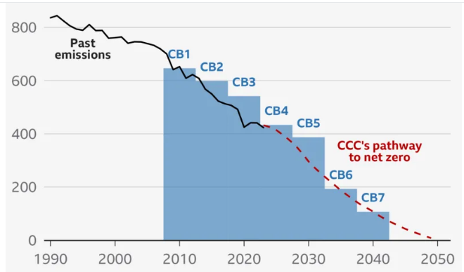
Figure 3: The UK’s Net Zero Target
Source: (Francis, 2025)

Legal Factors: Tesla must consider the UK’s regulations on safety standards in its vehicles to avoid penalties. Moreover, as the company collects data from drivers, it must consider the UK government’s data privacy law and the EU’s GDPR to avoid fines.

Porter’s Five Forces Model
Threat of New Entrants: Is low to moderate, as new entrants will require huge capital investment to start an electric vehicle company in the UK. Moreover, such companies will need to look for technological know-how to compete with established brands like Tesla. This aspect can be as a barrier to new entrants. Also, companies like Tesla have built strong brand reputation and loyalty that makes it difficult for new entrants to enter the market (Li, 2023).
Buyers’ bargaining power: buyers have a relatively moderate to high power, as there are many EV companies, where they can buy electric vehicle. Furthermore, the availability of information regarding the available EV companies makes it easier for buyers to compare quality, innovation, and prices, which can reduce brand loyalty.
Suppliers’ Bargaining Power: Suppliers’ bargaining power is moderate power, especially for suppliers that supply important raw materials. However, this company’s vertical integration approach of in-house manufacturing helps to reduce reliance on single supplier, which reduces suppliers’ power (Li, 2023).
Competitive Rivalry: Is high as there are many automobile companies competing for a market share in the UK market. Moreover, Chinese brands like BYD are selling their EVs at low prices, which has increased competition in this market. However, despite this high competition, Tesla has established a strong brand reputation and loyalty in the UK’s automotive market that maintains its competitive advantage (Mintzberg, Ahlstrand, and Lampel, 2020).
Threats of substitutes: It is relatively low, as the available alternatives include public transport, train, internal combustion engine vehicles. Car sharing companies like Uber offers a threat to Tesla as it reduces the demand for car ownership in the UK. However, the UK government’s strict policies compelling companies to adopt sustainability is making it difficult to shift towards electric vehicles’ alternatives, reducing the threat of substitutes.

Internal Environmental Audit

Value chain analysis
Value chain analysis models helps to understand how companies maximise the value they deliver to customers while improving their profitability (Gamble, Peteraf, and Thompson, 2023). These activities comprise primary activities that are involved directly involved in changing inputs into products and serving customers. Support activities help and support primary activities (David, 2003).
Primary Activities
Inbound logistics  -Vehicle receipts from Gigafactories to UK ports  - Global supply chain  -sources car components globally  Sources materials locally | Operations  -Automated vertically integrated production  -Local configuration  -Software updates  -superchargers |  | Outbound logistics  -Direct to consumer delivery through home delivery or service centers |  | Marketing and sales  -Uses digital platform to promote its products  -has established strong brand image  -Direct sales models through its website |  | Service  -Service centers in Manchester and London  -mobile service units  -Continue to expand its supercharger network in the UK
Support Activities
Firm infrastructure  -Lean organisational structure  -Vertically integrated with software  -tech-centric  -data-driven |  | HRM  -Employs specialised technicians  Has specialised service staff  -regular employee training |  | Technology Development  -Autopilot AI  -EV battery tech  -Over-the-air updates  -supercharger network software |  | Procurement  -Direct sourcing of materials

Resource-Based View (RBV)
Tangible Resources | Intangible Resources
-Broad network of superchargers  -Service infrastructure  -Direct sales  -High performing electric vehicle platform, including model 3 and model Y  -energy storage products | -Brand reputation and equity  -Software and over-the-air updates  -Proprietary battery technology  -Full self-driving data and artificial intelligence

VRIO Analysis of Tesla
Resources | Rare | Valuable | Organised | Imitable | Competitive implication
Brand reputation | Yes | Yes | Yes | Difficult | Sustained competitive advantage
Network of supercharger | Yes | Yes | Yes | Difficult | Sustained competitive advantage
Full self driving and AI data | Yes | Yes | Yes | Difficult | Sustained competitive advantage
Electric vehicle battery tech | No | Yes | Yes | Difficult | Competitive parity
Direct sales model | No | Yes | Yes | Difficult | Competitive parity

SWOT Analysis
Strengths  -Strong brand reputation and loyalty  -Vertical integration of hardware, battery, and software  -Network of superchargers  -Direct to consumer model | Weaknesses  -High reliance on key raw materials  -Delays in production  -Inventory management risks  - quality control issues  -High price points  -Dependence on key personnel
Opportunities  -Tesla can improve the stability of its supply chain  -Tesla can introduce affordable models to increase its market share  -Tesla can expand its charging network to increase adoption of EVs  -It can improve software and service to increase customer retention  -UK regulatory support for EVs and clean energy  -It can introduce an in-house battery production to reduce costs | Threats  - Intense competition from Chinese new entrants and other EV companies  - Volatility in supply chain  - Global economic slumps  - Limited charging infrastructure  - Distraction from the company’s controversial CEO  - Legal issues surrounding self-driving EVs

Strategy Formulation
Based on the strategic analysis of the company’s external and internal environments, it is facing intense competition and economic challenges in the UK’s automotive market. Tesla can improve its market share and sales in the UK market by introducing affordable electric vehicles for the UK’s city people. This approach will enable this company to increase its market share and sales revenues because of the high demand for affordable EVs in the country.
Moreover, there are only a few battery charging stations in the UK which continues to prevent the company from growing. Consequently, the company should invest heavily in the infrastructure expansion to grow its supercharger network across the country. Currently, there are no superchargers in retail areas and urban residential, forcing people to charge their EVs along major highways. Tesla can increase its market share and sales by establishing many superchargers within the retail areas and urban residential to encourage more people to own electric cars in the country.

Conclusion and Recommendations
This strategic management report provides lasting direction of Tesla’s goals and objectives in the UK’s automotive sector. Based on the company’s strategic management, Tesla’s strategic plan for sustainable growth and success in the UK rests on the blend of its technological innovation, vertical integration, and commitment to sustainability. The company controls its design, manufacturing, and distribution to help build its competitive advantage that conventional automobile firms are finding it difficult to match. However, the company is experiencing increased competition from other EV companies and new low cost Chinese companies which has contributed to the reduction in Tesla’s new company registration and market share. This report recommends that Tesla can improve its market position and ensure sustainable growth by adopting affordable strategy by launching affordable electric vehicle models designed for UK’s urban people. Moreover, Tesla should invest heavily in the infrastructure expansion to grow its supercharger network across the country to improve convenience and attract more people to acquire EVs in the UK.

Reference List
Akari, P. (2022) Tesla’s business operational activities — analyzing strategic issues. | by | medium. Available at: https://princessakari.medium.com/a-report-on-teslas-business-operational-activities-88d47c11c8a9 (Accessed: 24 February 2026).
Barney, J.B. and Hesterly, W.S. (2015) Strategic management and competitive advantage: Concepts and cases. Boston: Pearson. Available at: 978-1292060088 (Accessed: 24 February 2026).
CITA EV (2025) UK and Electric Cars - EV Market Statistics 2025 & insights, CITA Smart EV Charger. Available at: https://citaevcharger.co.uk/blog/uk-and-electric-cars-ev-market-stats-2024 (Accessed: 24 February 2026).
David, F.R. (2003) Strategic management: Concept & cases. Upper Saddle River, NJ: Prentice Hall. Available at: 978-0130479129 (Accessed: 25 February 2026).
De Sousa, G.C. and Castañeda-Ayarza, J.A. (2022) ‘PESTEL analysis and the macro-environmental factors that influence the development of the electric and hybrid vehicles industry in Brazil’, Case Studies on Transport Policy, 10(1), pp. 686–699. Available at: 10.1016/j.cstp.2022.01.030 (Accessed: 24 February 2026).
Francis, S. (2025) Net zero by 2050 ‘impossible’ for UK, says Kemi Badenoch, BBC News. Available at: https://www.bbc.com/news/articles/cly3pnjyzp4o (Accessed: 26 February 2026).
Gamble, J., Peteraf, M.A. and Thompson, A.A. (2023) Essentials of strategic management: The quest for competitive advantage. McGraw-Hill. Available at: 978-1260261547 (Accessed: 24 February 2026).
Gao, X., Jing, H. and Zhang, H. (2024) ‘Analysis of optimization strategies for Tesla’s cost management’, Highlights in Business, Economics and Management, 46, pp. 47–52. Available at: 10.54097/jqhyxj93 (Accessed: 25 February 2026).
Johnson, G., Scholes, K. and Whittington, R. (2010) Exploring corporate strategy. Harlow, England: Financial Times Prentice Hall. Available at: 9780273723196 (Accessed: 26 February 2026).
Lambert, F. (2026) Tesla UK Sales Plunge 57% in January as BYD races ahead, Electrek. Available at: https://electrek.co/2026/02/04/tesla-uk-sales-plunge-57-in-january-as-byd-races-ahead/#:~:text=Fred%20Lambert%20%7C%20Feb%204%202026,start%20to%202026%20in%20Europe (Accessed: 25 February 2026).
Li, H. (2023) ‘Based on the strategic research and analysis of Tesla’, Highlights in Business, Economics and Management, 23, pp. 1138–1146. Available at: 10.54097/t0qbn123 (Accessed: 24 February 2026).
Liang, L.Y. and Yubin, Z. (2025) ‘The impacts of digital transformation on firm performance: A case study of Tesla business model’, International Journal of Research and Scientific Innovation, XII(V), pp. 287–302. Available at: 10.51244/ijrsi.2025.120500023 (Accessed: 26 February 2026).
Mintzberg, H., Ahlstrand, B.W. and Lampel, J. (2020) Strategy safari: The Complete Guide through the wilds of strategic management. Harlow: FT Publishing International. Available at: 978-0273719588 (Accessed: 24 February 2026).
Richter, F. (2016) Infographic: How tesla out-innovates traditional carmakers, Statista Daily Data. Available at: https://www.statista.com/chart/6312/r-d-spending-tesla-vs-carmakers/?srsltid=AfmBOorXedb73hWBIyART7J1nwDB467wgVZu_lareLJJ6J2JSsTtqjnP (Accessed: 25 February 2026).

